Assignement 2

Name: Evan O'Keeffe
S#: 10324289

Question 1:

Part A:
1:Prime number(i.e only divisible by 1 and itself)
0:Non-Prime number

Part B:
Number | A | B | C | D | Y(Output)
0 | 0 | 0 | 0 | 0 | 0
1 | 0 | 0 | 0 | 1 | 0
2 | 0 | 0 | 1 | 0 | 1
3 | 0 | 0 | 1 | 1 | 1
4 | 0 | 1 | 0 | 0 | 0
5 | 0 | 1 | 0 | 1 | 1
6 | 0 | 1 | 1 | 0 | 0
7 | 0 | 1 | 1 | 1 | 1
8 | 1 | 0 | 0 | 0 | 0
9 | 1 | 0 | 0 | 1 | 0
10 | 1 | 0 | 1 | 0 | 0
11 | 1 | 0 | 1 | 1 | 1
12 | 1 | 1 | 0 | 0 | 0
13 | 1 | 1 | 0 | 1 | 1
14 | 1 | 1 | 1 | 0 | 0
15 | 1 | 1 | 1 | 1 | 0

Part C:
Expression : (¬A¬BC¬D)+(¬A¬BCD)+(¬AB¬CD)+(¬ABCD)+(A¬BCD)+(AB¬CD)

Part D:
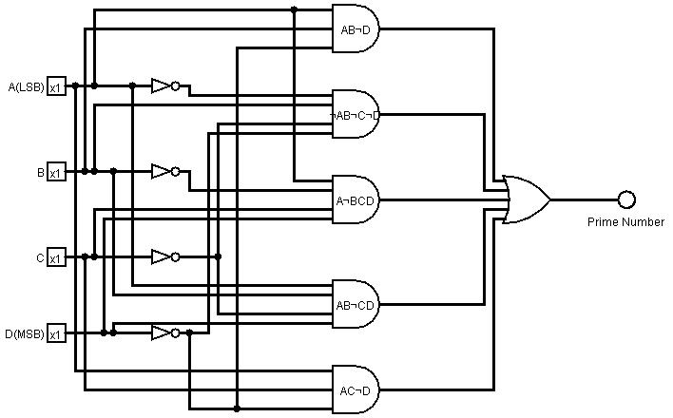
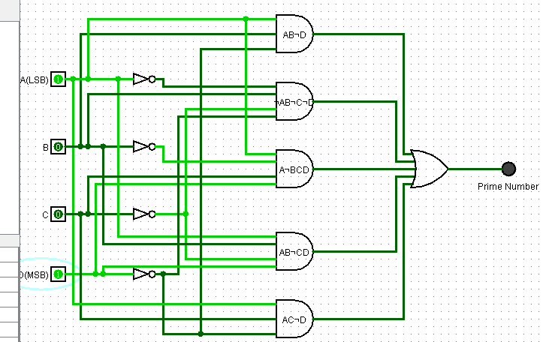

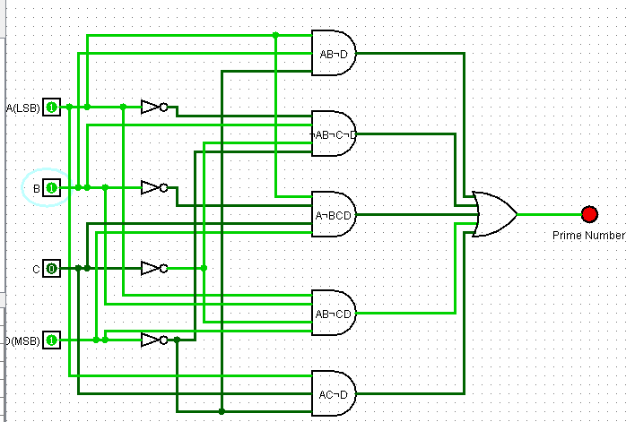
Question 2:

Part A:
Majority is when there are 3/4 inputs on 1 i.e (0,1,1,1)
My decision on output signals that would be required

1:majority of bits are 1
0:majority of bits are not 1

Part B:

A | B | C | D | Y(output)
0 | 0 | 0 | 0 | 0
0 | 0 | 0 | 1 | 0
0 | 0 | 1 | 0 | 0
0 | 0 | 1 | 1 | 0
0 | 1 | 0 | 0 | 0
0 | 1 | 0 | 1 | 0
0 | 1 | 1 | 0 | 0
0 | 1 | 1 | 1 | 1
1 | 0 | 0 | 0 | 0
1 | 0 | 0 | 1 | 0
1 | 0 | 1 | 0 | 0
1 | 0 | 1 | 1 | 1
1 | 1 | 0 | 0 | 0
1 | 1 | 0 | 1 | 1
1 | 1 | 1 | 0 | 1
1 | 1 | 1 | 1 | 1

Part C:
Expression: (¬abcd)+(a¬bcd)+(ab¬cd)+(abc¬d)+(abcd)

Part D:
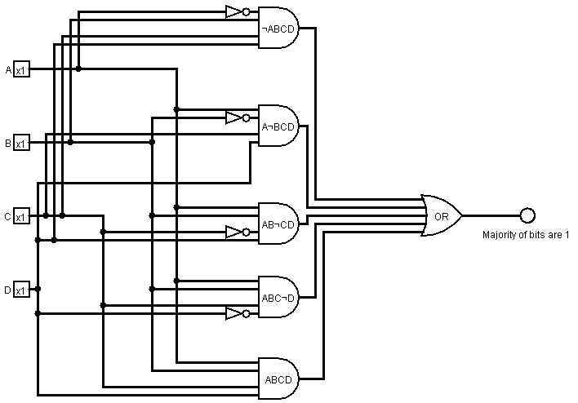

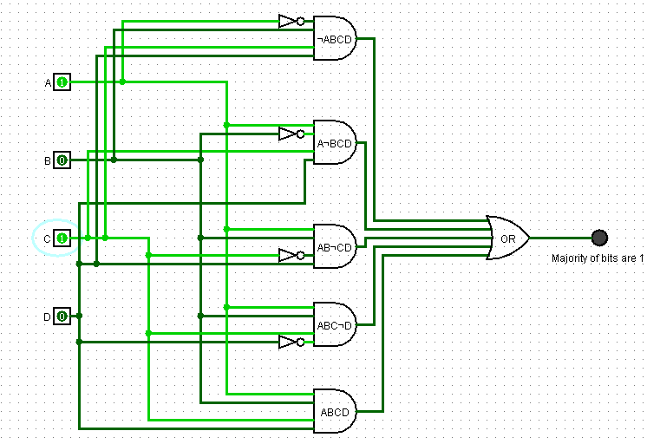
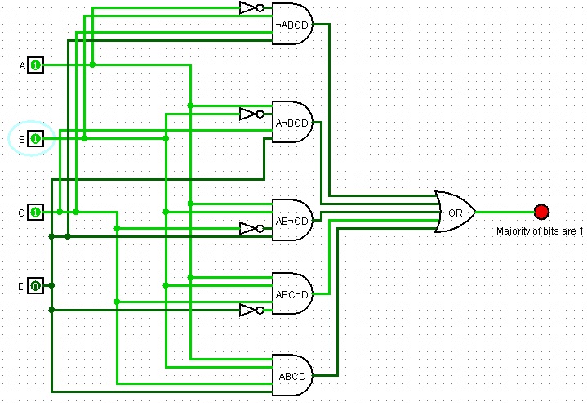

Part E:

Boolean Simplification of Circuit
(¬abcd)+(a¬bcd)+(ab¬cd)+(abc¬d)+(abcd)

Steps:
1.={And distribution over OR} three times

a(¬bcd+b(c(d+¬d)+¬cd))+¬abcd

2.={complement.o on d+¬d}

a(¬bcd+b(c+¬cd))+¬abcd

3.={absorbption.0 c+¬cd}

a( ¬bcd + b(c+d) ) + ¬abcd

4.={And distribution over OR}

a¬bcd + abc + abd + ¬abcd

5.={And distribution over OR}

b( ac + ad + ¬acd ) + a¬bcd {once}
b( d(a+¬ac) + ac ) + a¬bcd {twice}

6.={absorbption.0 a+¬ac},{And distribution over OR} twice

abd + bcd + abc + a¬bcd

7.={And distribution over OR}

ad(b+¬bc) + bcd + abc

8.={absorbption.0 b+¬bc},{And distribution over OR}

(abd)+(abc)+(bcd)+(acd)

Part F:
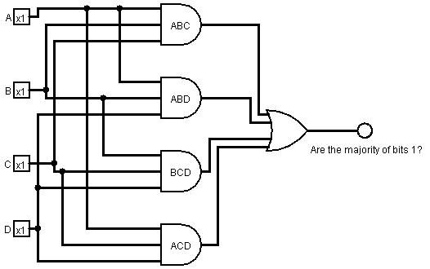
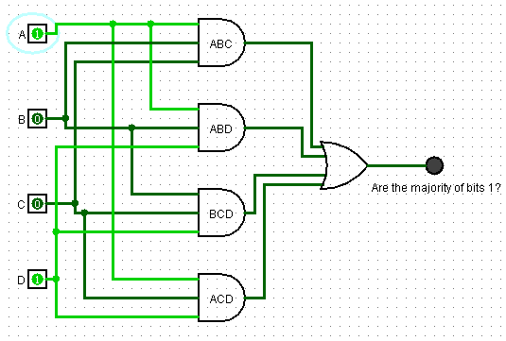

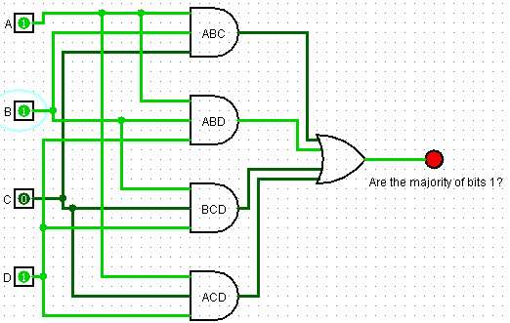

Part G:
By inspection :

the number of pins from the simplified view to real circuits generally follow
the N-1 rule , i.e 4 input And gate is equivalent to 3 2-input And gates

By inspection :

Circuit 1:
4 NOT gates = 4*(0.7) = 2.8 G.E

4 input AND gates => 3 2-input ANDS gates => 3*5*(1.3) = 19.5
5 input OR gate => 4 2-input OR gates => 4*(1.3) = 5.2

Total G.E = 2.8+19.5+5.2 = 27.5 G.E

Circuit 2:
AND Gates: 4*(2)*(1.3) = 10.4
OR Gates : 3*(1.3) = 3.9
Not Gates : None

Total Gate equivlance = 14.3 G.E

Difference of Gate equivalence :
Circuit 1 = 27.5 G.E
Circuit 2 = 14.3 G.E

Part H:

(14.3/27.5)*100 = 52 percent decrease in circuit area

