Topic of the site:

* A software developer’s portfolio

Target Audience

* Primary: Potential employers
* Secondary: People interested in our work (for example as an inspiration)

Website look and feel

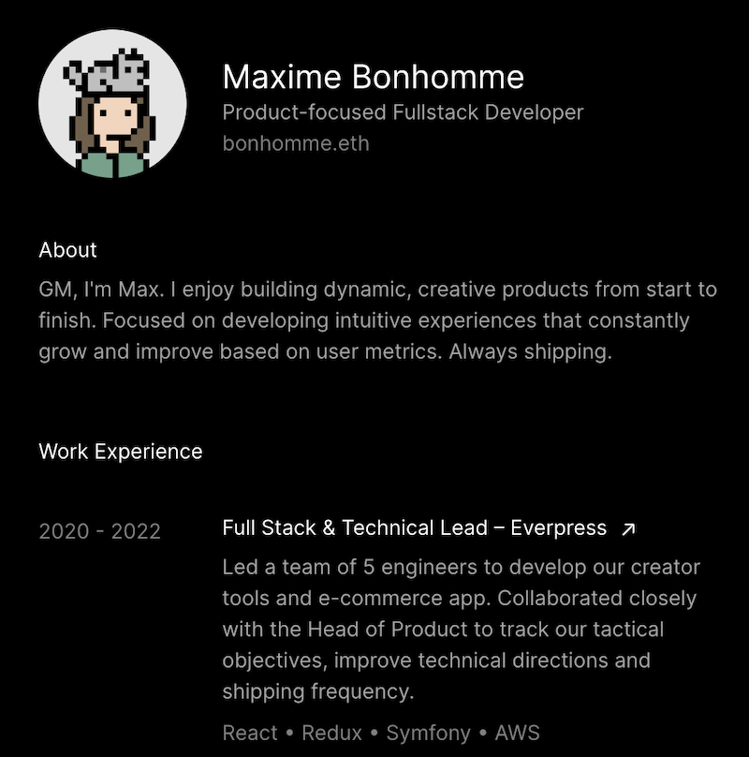

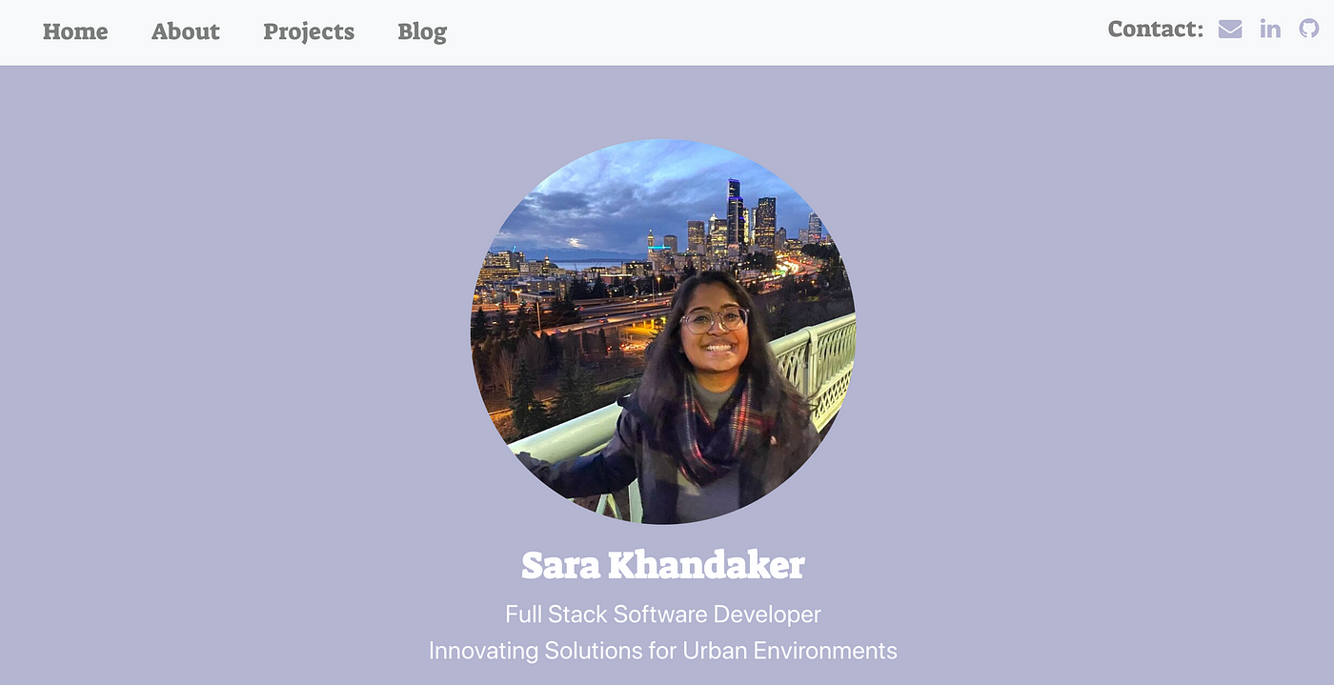

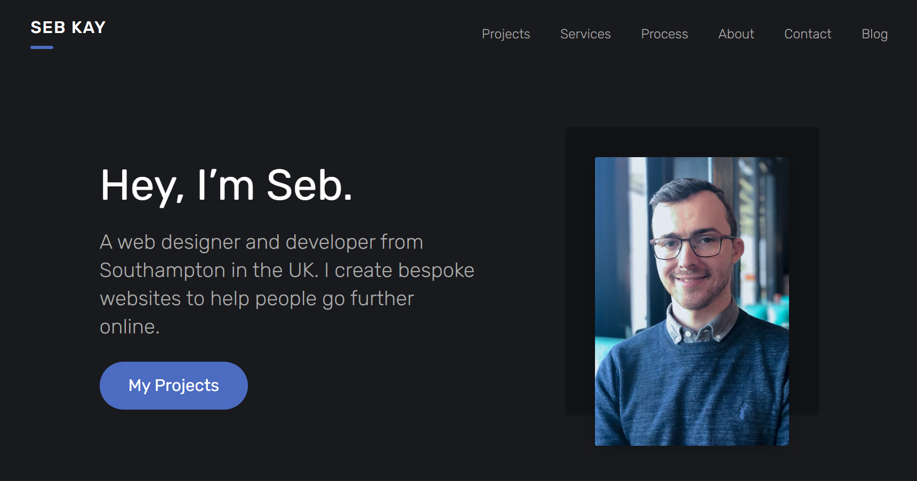

Color Palette

-gruvbox - to give the site a retro look and also make it visually appealing

Teamwork Practises

* the main part of communication happens on teams group chat
* we are working mainly online
* one daily meeting about our tasks and development progress
  + we divide tasks during a meeting and these tasks completion will be reviewed during next day meeting