CREST Phase 1 Technical Document
Metric-Response Validation, Reproducibility Specification, and Empirical Positioning

Framework: Alethian / Phenomenurgic Response-Field Program
Primary empirical branch: CREST galaxy-scale metric response
Prepared for: Ventress Kazan Seals II
Compiled: July 3, 2026
Status: Phase 1A technical consolidation with regenerated reproducibility-facing assets

Abstract
This document consolidates Phase 1 of the CREST validation campaign into a formal technical specification. CREST is treated here as a narrow galaxy-scale response-field model, not as a completed replacement for dark matter, MOND, or relativistic gravity. The document freezes the operational claim, declares the invariant roles chi, eta, I, F, defines the reserve and degraded-reserve constraints, states the weak-field galaxy projector, and records the existing SPARC benchmark position. The archived CREST II benchmark used the SPARC sample of 175 galaxies and 3391 radial points with fixed stellar mass-to-light ratios. In that benchmark, the fixed CREST backbone gave a grouped galaxy-held-out RMSE of 0.2039 in log10 g, compared with 0.1996 for a fixed MOND-style branch and 0.1998 for a fixed RAR-form branch. The shared CREST Huber residual layer gave 0.1959, improving overall on the fixed MOND/RAR branches while showing its strongest gains in structurally messier Q = 2 and Q = 3 subsets. Tuned pISO and NFW halo references remained much stronger as in-sample galaxy-by-galaxy fits. The correct Phase 1 conclusion is therefore mixed but useful: the backbone alone does not beat fixed MOND/RAR; a shared residual layer can improve held-out performance; tuned halo templates still define a substantial remaining empirical gap; and the next decisive work is not more unconstrained flexibility, but an independent, non-target-derived projector for the response and disequilibrium sectors. The final sections regenerate the missing public-facing bundle as a reproducibility specification: data manifest, frozen equations, train/test protocol, result tables, figure assets, notebook skeleton, falsification criteria, and Phase 1B execution checklist.

1. Phase 1 objective
The first public task for the framework is not to prove the entire Alethian ontology. The first task is to make one narrow empirical claim precise enough to be tested, criticized, reproduced, and potentially broken. CREST is the correct first branch because it maps the invariant grammar onto public galaxy data and can be compared against existing baselines. The technical posture is deliberately conservative: CREST is a response-layer hypothesis over observed residual structure. It does not claim that dark matter is false, that MOND is defeated, or that the relativistic completion is finished. It asks whether an organized metric-response projector captures a nontrivial portion of the galaxy residual field under held-out validation.
- Freeze the galaxy-facing CREST claim before further fitting or narrative expansion.
- Reconstruct the Phase 1 benchmark tables and figures from archived CREST records.
- Declare what counts as success, partial success, and failure.
- Separate proof-of-concept empirical results from future radical or cross-domain implications.
- Produce a document suitable for technical critique by readers familiar with rotation curves, RAR/MOND comparisons, and model validation.

2. Short verdict
Phase 1 should be stated as a disciplined partial result. The existing benchmark does not support the claim that the fixed CREST backbone already outperforms simple MOND/RAR baselines. It does support a narrower claim: a shared CREST residual layer, trained under grouped galaxy-held-out validation, improves the aggregate log-acceleration RMSE relative to the fixed one-parameter comparators, with the improvement concentrated in messier quality classes. This is compatible with the intended interpretation of the response layer as a secondary sector that activates when clean circular support is no longer the whole story.
The result is not final closure. Tuned pISO and NFW halo fits remain much stronger when fit galaxy by galaxy. The Phase 1 result therefore creates a credible empirical foothold, not a full astrophysical replacement theory.

3. CREST as a response-layer model
CREST is used here as a Covariant Relativistic Extended Scalar Theory branch of the larger Alethian / Phenomenurgic response framework. The core philosophical claim is translated into operational physics as follows: observations do not directly record unconstrained hidden conditions; they record projected response. A galaxy rotation curve is therefore not treated merely as matter producing acceleration, but as baryonic structure plus response capacity, ordered attachment, structural information, and irreversible loading projecting into an accessible acceleration record.
The four role variables are not arbitrary fit labels. Their division of labor is the guardrail that prevents the framework from becoming an unlimited residual absorber.
Symbol | Operational role in Phase 1
chi | Matter-conditioned metric-response amplitude or backbone response field. In the galaxy branch, chi projects into the residual acceleration g_chi.
eta | Ordered attachment or relational coupling of the response state to the baryonic host.
I | Stored structural information: gradients, curvature, branch thickness, and organized residual shape.
F | Irreversible loading, disequilibrium broadening, non-circular contamination, transport-sensitive departure.
R | Undegraded reserve, R = eta I - chi^2. It measures support margin inside the admissible response cone.
R_F | Degraded reserve, R_F = eta I exp(-lambda_F F) - chi^2. It measures response capacity after irreversible loading.
S_F | Logarithmic degraded reserve field, S_F = ln(eta I exp(-lambda_F F) / chi^2). The response boundary is S_F = 0.

4. Frozen mathematical core
The Phase 1 document freezes the following equations as the public technical core. Later work may improve estimators, but the paper should not change these definitions ad hoc after seeing validation outcomes.
Undegraded reserve:
R = eta I - chi^2

Degraded response capacity:
C_F = eta I exp(-lambda_F F)

Degraded reserve:
R_F = eta I exp(-lambda_F F) - chi^2

Admissibility condition:
chi^2 <= eta I exp(-lambda_F F)

Degraded logarithmic reserve field:
S_F = ln[ eta I exp(-lambda_F F) / chi^2 ]

Response boundary:
S_F = 0, equivalently chi^2 = eta I exp(-lambda_F F)

These equations impose a capacity condition. They do not by themselves fit a rotation curve. Observable predictions require a domain projector that maps the invariant response state into a measured quantity.

5. Galaxy projector and weak-field reduction
The response tensor is the parent object. A rotation curve only sees a projected scalar record. The Phase 1 galaxy projector maps the response state into a residual acceleration channel. The weak-field galaxy-facing relation is:
Observed acceleration decomposition:
g_obs(R) = g_bar(R) + g_chi(R)

Fixed CREST backbone prediction:
g_pred,0(R) = g_bar(R) + sqrt(a0 g_bar(R))

Residual response interpretation:
g_chi(R) = |grad Phi_chi(R)|

The fixed backbone is intentionally restrictive. It is not allowed to retune itself galaxy by galaxy. The residual layer must then prove that it adds organized, generalizable structure rather than absorbing targets by leakage.

6. Phase 1 data manifest
The Phase 1 validation package uses the SPARC/RAR/BTFR public galaxy records as the empirical base. Drive already contains the necessary source files and prior CREST records; the missing public-facing assets are regenerated here as document tables, figures, and a reproducibility specification.
Asset | Role | Status
SPARC_Lelli2016c.mrt.txt | Galaxy-level SPARC sample metadata and quality classes. | Located in Drive. Required for executable reproduction.
MassModels_Lelli2016c.mrt.txt | Radial rotation curve and baryonic component mass-model data. | Located in Drive. Required for executable reproduction.
RAR.mrt.txt | Radial acceleration relation comparison record. | Located in Drive. Required for RAR comparisons.
BTFR_Lelli2019.mrt.txt | Baryonic Tully-Fisher relation support record. | Located in Drive. Optional for Phase 1 context.
crest2_updated.pdf | Archived benchmark values, equations, tables, and interpretation. | Recovered from ALETHIAN archive. Used as numerical backbone.
CREST_metric_response_SPARC_paper.pdf | Earlier SPARC narrative consolidation and references. | Recovered from ALETHIAN archive. Used as supporting source.
CREST_IV_metric_response_projector.pdf | Projector discipline, degraded reserve, and falsification language. | Recovered from ALETHIAN archive. Used for technical framing.
Regenerated CSV tables | Machine-readable copies of Phase 1 benchmark values. | Regenerated as companion assets during compilation.
Regenerated figures | RMSE and baseline-reference plots. | Regenerated as companion assets during compilation.

7. Validation protocol
The benchmark protocol must be grouped by galaxy identity. Radial points from the same galaxy are not independent for model selection because they share mass-to-light assumptions, distance, inclination, surface-brightness structure, and unmodeled systematics. A fair held-out test trains on galaxies and evaluates on distinct galaxies.
- Primary target: y_i = log10(g_obs,i).
- Primary metric: RMSE in log10 g over held-out radial points.
- Grouping: galaxy-held-out folds, preferably grouped 5-fold cross-validation.
- Baryonic construction: gas, disk, and bulge contributions with fixed stellar mass-to-light ratios unless a separate sensitivity run is declared.
- Main fixed-branch comparators: CREST backbone, fixed MOND-style simple interpolation, and RAR-form branch.
- Reference halo baselines: pISO and NFW fits are treated as tuned in-sample references unless a matched hierarchical or held-out halo protocol is implemented.
- Leakage rule: no use of g_obs - g_bar as an oracle feature in a public predictive model. Diagnostic target-derived tests must be labeled as diagnostic only.

8. Baseline equations
The Phase 1 paper should keep the comparator equations explicit. The one-parameter MOND-style branch and RAR-form branch test whether CREST adds value beyond known acceleration-law behavior.
CREST backbone:
g_CREST0(R) = g_bar(R) + sqrt(a0 g_bar(R))

MOND-style simple interpolation comparator:
g_MOND(R) = 0.5 g_bar(R) [ 1 + sqrt(1 + 4 a0 / g_bar(R)) ]

RAR-form comparator:
g_RAR(R) = g_bar(R) / [ 1 - exp(-sqrt(g_bar(R) / a0)) ]

Residual-layer model family:
y_i = log10(g_pred,0(R_i)) + Delta_theta(features_i) + epsilon_i

The residual-layer model is acceptable only when its features are generated from baryonic structure, admissible response variables, or independent kinematic complexity records. It is not acceptable to build the public predictor from target-derived residuals unless the section is explicitly labeled diagnostic.

9. Reconstructed Phase 1 benchmark results
The following benchmark values are reconstructed from the archived CREST II technical paper. The SPARC sample is reported there as 175 galaxies and 3391 radial points. The fixed stellar mass-to-light assumptions are Upsilon_d = 0.5 and Upsilon_b = 0.7. The main result is mixed: the fixed CREST backbone does not beat fixed MOND/RAR, while the shared Huber residual layer improves the aggregate RMSE and performs best in Q = 2 and Q = 3 subsets.
Model | Full RMSE | Q=1 | Q=2 | Q=3
CREST backbone | 0.2039 | 0.1703 | 0.2192 | 0.4518
Fixed MOND-style branch | 0.1996 | 0.1700 | 0.2116 | 0.4329
Fixed RAR-form branch | 0.1998 | 0.1699 | 0.2121 | 0.4338
CREST Huber residual layer | 0.1959 | 0.1710 | 0.2030 | 0.4172

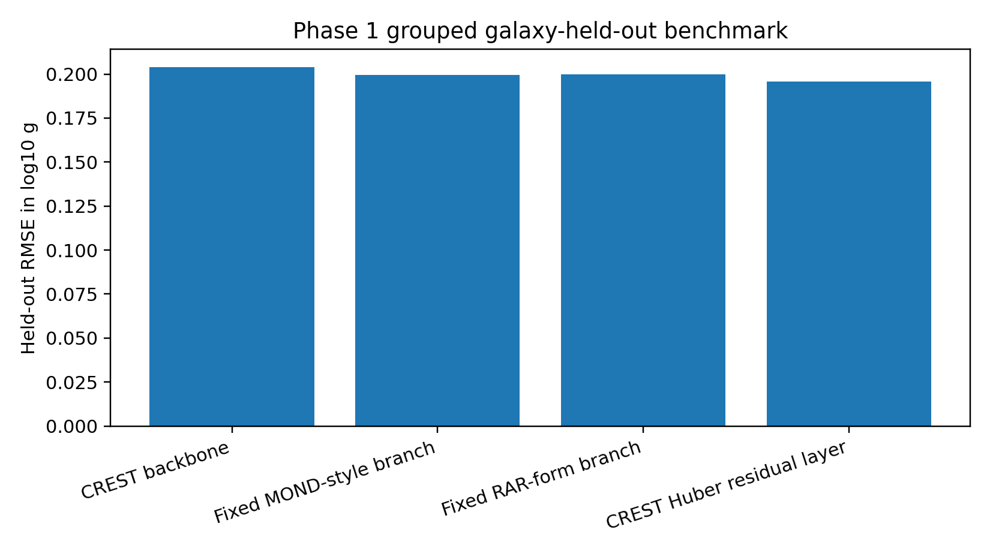
Figure 1. Full held-out RMSE in log10 g for the Phase 1 model hierarchy.
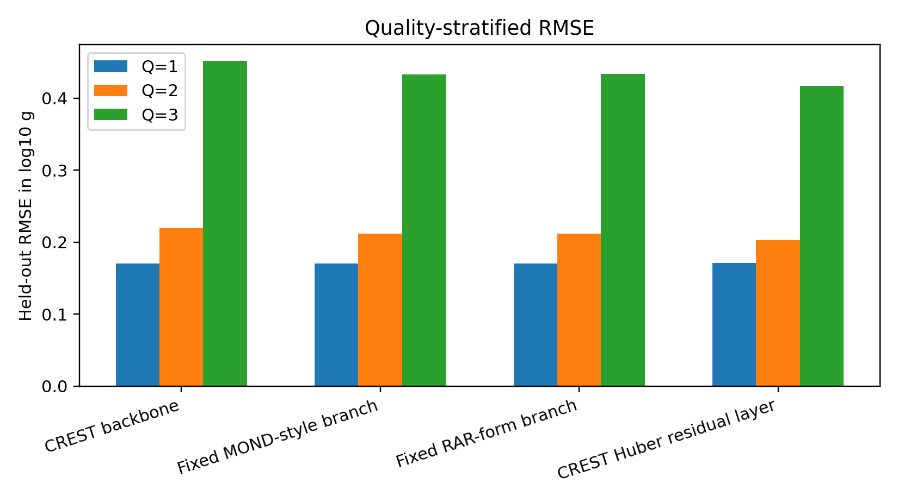
Figure 2. Quality-stratified RMSE. Lower values are better.

10. In-sample halo reference gap
The tuned halo references are not the same kind of predictive baseline as a fixed held-out law because they are fit galaxy by galaxy. They are still important because they show the empirical gap between a global response law and flexible galaxy-specific mass modeling. The correct conclusion is not that Phase 1 has defeated halo modeling. The correct conclusion is that the residual-layer branch has a measurable foothold while a large halo-reference gap remains.
Model | Median per-galaxy RMS (km/s)
CREST backbone | 12.88
Fixed MOND-style branch | 12.27
Tuned pISO halo | 3.42
Tuned NFW halo | 4.74

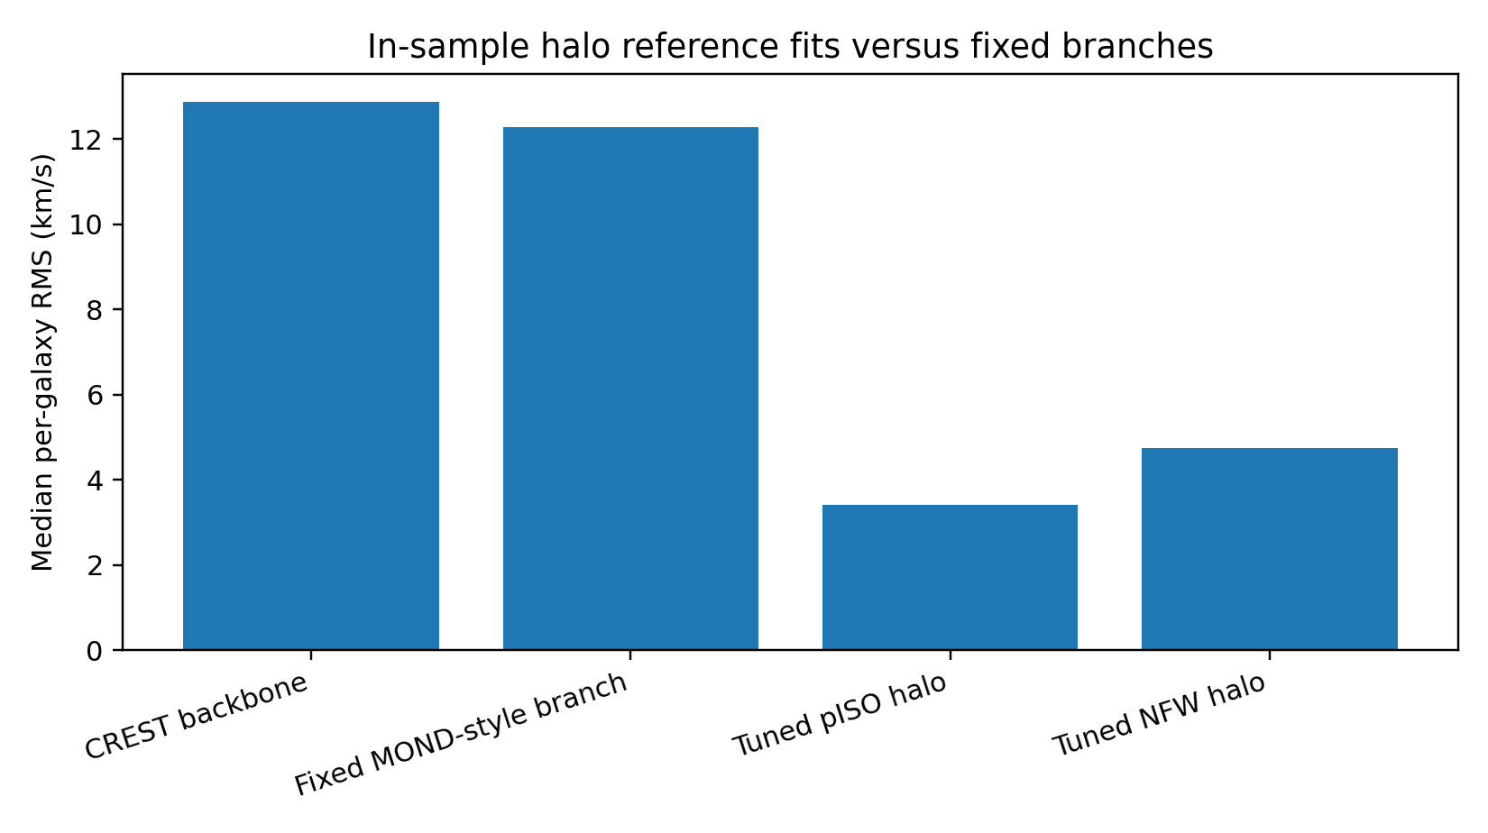
Figure 3. Tuned halo references remain much stronger as in-sample galaxy-by-galaxy fits.

11. Overlap cases and residual interpretation
A physically meaningful residual layer should eventually correlate with independent evidence for structural complexity, disequilibrium, non-circular flow, contamination, or branch thickness. The existing overlap cases are heterogeneous. DDO 168 and NGC 2403 show strong residual-layer gains. DDO 154 improves weakly. NGC 5055 worsens under the current shared residual term. This does not invalidate the whole branch, but it shows that a single blended residual regressor is too coarse.
Galaxy | Q | Backbone RMS | Huber RMS | Gain | External proxy summary
DDO 154 | 2 | 2.95 | 2.89 | +2.0% | V/sigma=5.09; eps=0.197; Cglob=1.108
DDO 168 | 2 | 7.06 | 5.21 | +26.2% | V/sigma=5.47; eps=0.183; Cglob=1.528
NGC 2403 | 1 | 8.57 | 6.22 | +27.4% | Vrot=107.9; Cglob=0.208
NGC 5055 | 1 | 35.79 | 38.22 | -6.8% | Vrot=169.9; Cglob=0.317

12. F-sector closure status
The F sector remains the most important unresolved empirical layer. Earlier cube/moment-map experiments found that raw map roughness and crude cube-derived moment structure did not close F. This is a useful negative result. It implies that F should not be defined as generic noise or roughness. It should be treated as irreversible or disequilibrium loading requiring true residual kinematic modeling.
- Bad F estimator: raw moment-map roughness alone.
- Better F estimator: residual velocity field after subtracting an axisymmetric or tilted-ring model.
- Stronger F estimator: 3DBarolo/BBarolo cube-level residual fields with beam, inclination, resolution, and non-circular-flow controls.
- Decisive Phase 1B target: demonstrate that an independently generated F estimator predicts where the residual layer helps or fails.

13. Required next closure: two-block residual law
The present residual layer is useful but blended. The next closure should split organized residual structure into two blocks: a structural-curvature block and a kinematic-disequilibrium block. The first corresponds mainly to the I sector; the second corresponds mainly to F. This split prevents the framework from treating every residual as the same kind of response.
Two-block residual decomposition:
Delta_theta(R) = Delta_I(R) + Delta_F(R)

Structural block:
Delta_I(R) = f_I[ surface-density gradients, curvature, branch thickness, Q_chi ]

Kinematic/disequilibrium block:
Delta_F(R) = f_F[ residual velocity field, dispersion load, asymmetry, non-circular flow ]

Admissibility link:
chi^2 + R_F = eta I exp(-lambda_F F)

14. Regenerated reproducibility bundle
The missing Phase 1 assets are regenerated here as a reproducibility specification. The present compiled PDF includes the reconstructed tables and figures. The companion CSV assets created during compilation are: phase1_rmse_table.csv, phase1_halo_reference_table.csv, and phase1_overlap_cases.csv. The executable notebook should be regenerated from the following skeleton.
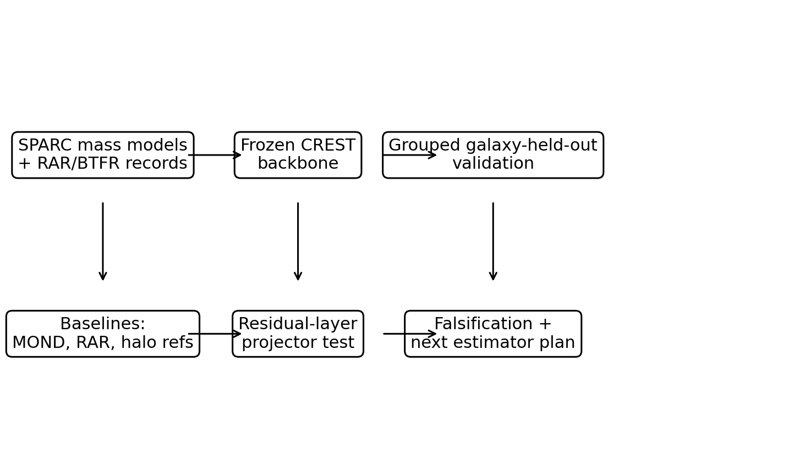
Figure 4. Phase 1 validation and regeneration workflow.
# CREST Phase 1 reproducibility skeleton
# Inputs: SPARC_Lelli2016c.mrt.txt, MassModels_Lelli2016c.mrt.txt, RAR.mrt.txt, BTFR_Lelli2019.mrt.txt

1. Load SPARC galaxy metadata and mass-model radial tables.
2. Construct g_obs = V_obs^2 / R after unit conversion.
3. Construct g_bar from gas, disk, and bulge contributions with fixed Upsilon_d and Upsilon_b.
4. Remove rows with invalid radii, missing velocities, missing uncertainties, or nonphysical accelerations.
5. Assign galaxy identity groups and Q quality flags.
6. Define frozen predictors:
CREST0 = g_bar + sqrt(a0 * g_bar)
MOND_simple = 0.5 * g_bar * (1 + sqrt(1 + 4*a0/g_bar))
RAR = g_bar / (1 - exp(-sqrt(g_bar/a0)))
7. Run grouped 5-fold cross-validation by galaxy identity.
8. Fit a0 on training galaxies only for MOND/RAR comparators when a fitted comparator is declared.
9. Train the shared CREST residual model using only allowed non-target-derived features.
10. Report held-out RMSE in log10 g overall and by Q flag.
11. Run null radial shuffling to test whether improvement depends on organized radial structure.
12. Run ablations removing I features and F features separately.
13. Save result CSVs and figures with software versions and random seed.

15. Acceptance, partial-success, and failure criteria
The Phase 1 claim must be falsifiable. The following criteria should be published before additional re-fitting.
Outcome | Criterion | Interpretation
Strong success | Global no-retuning CREST residual projector beats fixed MOND/RAR under grouped galaxy-held-out validation and survives radial-shuffle/null tests. | Supports a genuine organized response layer.
Partial success | CREST improves only in specific Q flags, morphology regimes, or kinematic-complexity classes. | Supports a regime-dependent response layer; narrows the domain of validity.
Negative but useful | CREST does not improve held-out RMSE, but failures correlate with missing F/I estimator limits. | Estimator is inadequate; the framework requires a better projector.
Failure of current branch | CREST improvement disappears under grouped splits, radial shuffling, non-target-derived features, or matched baselines. | Current galaxy branch should be rejected or rebuilt.
Failure against halo references | Matched effective-degree halo models beat CREST under the same held-out protocol. | CREST remains empirically subordinate unless it offers separate explanatory value.

16. Risk controls against overclaiming
The framework is unusually broad. Phase 1 must therefore be protected from speculative inflation. The following restrictions keep the public document credible.
- Do not claim that CREST has solved dark matter.
- Do not claim that CREST has defeated MOND in all senses; the fixed backbone does not beat the fixed MOND/RAR branches in the recorded benchmark.
- Do not compare tuned halo models against fixed global laws as if they were the same kind of test.
- Do not use target-derived g_obs - g_bar features in the public predictive model without labeling them diagnostic.
- Do not extend the Phase 1 evidence to consciousness, free energy, time machines, or radical endpoints.
- Do not present raw map roughness as a closed F estimator.

17. Phase 1B execution checklist
The next operational step is to turn this technical document into a public reproducibility release. The release should contain one notebook, one data manifest, one result folder, one figures folder, and one PDF paper.
- Recover or download the four public SPARC/RAR/BTFR data files into a clean data/ folder.
- Create scripts/load_sparc.py with deterministic parsing and unit conversion.
- Create scripts/build_features.py for g_bar, g_obs, CREST0, MOND, RAR, I proxies, and allowed F proxies.
- Create scripts/run_grouped_cv.py with grouped 5-fold validation and fixed random seed.
- Create scripts/run_nulls.py for radial shuffle and label-shuffle null tests.
- Create results/phase1_main_results.csv and results/phase1_q_stratified.csv.
- Create figures/phase1_model_hierarchy.png and figures/phase1_quality_strata.png.
- Create README.md explaining how to reproduce the figures.
- Update this PDF from Phase 1A technical consolidation to Phase 1B executable validation.

18. External critique package
The correct outreach posture is modest and technical. The message should ask reviewers to attack the assumptions, not to endorse the worldview. A useful target reviewer is someone who works with rotation curves, radial acceleration relation tests, MOND, halo fitting, galaxy dynamics, or statistical model comparison.
Suggested critique request:
I am testing whether a response-field residual model captures organized structure in public SPARC rotation-curve data under grouped galaxy-held-out validation. I am not claiming to have solved dark matter. I would value criticism of the split protocol, baseline comparison, feature admissibility, and whether the residual layer is physically assigned rather than target-leaking.

19. Conclusion
Phase 1 should be framed as the first credibility engine of the larger framework. It is not the whole theory and not the radical endpoint program. The archived benchmark gives a disciplined mixed result: fixed CREST backbone alone is weaker than fixed MOND/RAR, the shared residual layer improves aggregate held-out performance, Q-stratified behavior suggests activation in messier systems, tuned halo references remain a major empirical gap, and F-sector closure requires true independent kinematic modeling. This is enough to justify a public technical paper and reproducibility release, but not enough to claim final astrophysical closure.
The next strongest move is to publish the Phase 1A document as a specification, regenerate the executable notebook and CSV outputs as Phase 1B, and then ask technically hostile reviewers to break it.

Appendix A. Regenerated asset manifest
File | Description
phase1_rmse_table.csv | Reconstructed main held-out RMSE table.
phase1_halo_reference_table.csv | Reconstructed median RMS halo-reference table.
phase1_overlap_cases.csv | Overlap cases linking residual-layer behavior to external kinematic diagnostics.
figure_1_full_rmse.png | Full RMSE model hierarchy plot.
figure_2_q_stratified_rmse.png | Q-stratified RMSE plot.
figure_3_halo_reference.png | Tuned halo reference comparison plot.
figure_4_phase1_workflow.png | Phase 1 reproducibility workflow diagram.

Appendix B. Minimal public repository structure
crest-phase1/
README.md
environment.yml
data/
SPARC_Lelli2016c.mrt.txt
MassModels_Lelli2016c.mrt.txt
RAR.mrt.txt
BTFR_Lelli2019.mrt.txt
scripts/
load_sparc.py
build_features.py
run_grouped_cv.py
run_nulls.py
make_figures.py
notebooks/
CREST_Phase1_Reproduction.ipynb
results/
phase1_main_results.csv
phase1_q_stratified.csv
phase1_halo_reference.csv
phase1_null_tests.csv
figures/
phase1_model_hierarchy.png
phase1_quality_strata.png
phase1_halo_reference.png
paper/
CREST_Phase1_Technical_Document.pdf

Appendix C. Source basis
Source | Use in this document
crest2_updated.pdf | Primary benchmark values, grouped held-out comparison, halo reference table, two-block residual motivation.
CREST_metric_response_SPARC_paper.pdf | SPARC-facing metric-response framing, notation summary, and bibliographic references.
CREST_IV_metric_response_projector.pdf | Projector discipline, degraded reserve law, and falsifiability language.
CREST_metric_F_whitepaper.pdf | F-sector framing and disequilibrium interpretation.
Aletheian_Invariant_Projection_Architecture.pdf | Invariant role grammar and cross-domain projector orientation.

References
[1] Einstein, A. (1915). Die Feldgleichungen der Gravitation. Sitzungsberichte der Preussischen Akademie der Wissenschaften zu Berlin, 844-847.
[2] Milgrom, M. (1983). A modification of the Newtonian dynamics as a possible alternative to the hidden mass hypothesis. Astrophysical Journal, 270, 365-370.
[3] Milgrom, M. (1983). A modification of the Newtonian dynamics: implications for galaxies. Astrophysical Journal, 270, 371-383.
[4] Bekenstein, J. D. (2004). Relativistic gravitation theory for the modified Newtonian dynamics paradigm. Physical Review D, 70, 083509.
[5] Navarro, J. F., Frenk, C. S., and White, S. D. M. (1996). The structure of cold dark matter halos. Astrophysical Journal, 462, 563-575.
[6] Burkert, A. (1995). The structure of dark matter halos in dwarf galaxies. Astrophysical Journal Letters, 447, L25-L28.
[7] McGaugh, S. S., Lelli, F., and Schombert, J. M. (2016). Radial acceleration relation in rotationally supported galaxies. Physical Review Letters, 117, 201101.
[8] Lelli, F., McGaugh, S. S., and Schombert, J. M. (2016). SPARC: Mass models for 175 disk galaxies with Spitzer photometry and accurate rotation curves. Astronomical Journal, 152, 157.
[9] Lelli, F., McGaugh, S. S., Schombert, J. M., and Pawlowski, M. S. (2017). One law to rule them all: the radial acceleration relation of galaxies. Astrophysical Journal, 836, 152.
[10] Lelli, F., McGaugh, S. S., Schombert, J. M., Desmond, H., and Katz, H. (2019). The baryonic Tully-Fisher relation for different velocity definitions and implications for galaxy angular momentum. Monthly Notices of the Royal Astronomical Society, 484, 3267-3278.
[11] Seals II, V. K. (2026). CREST II: Reserve Geometry, Structural Information, Matched Galaxy-Held-Out Validation, and Provisional Late-Time Cosmology Checks. Internal technical archive.
[12] Seals II, V. K. (2026). CREST IV: Metric Response and Projector Closure. Internal technical archive.

