**SUMMARY**

## USC ID/s:

5362968124

7069339929

6118411150

|  |  |  |  |  |
| --- | --- | --- | --- | --- |
| M+N | Time in MS (Basic) | Time in MS (Efficient) | Memory in KB (Basic) | Memory in KB (Efficient) |
| 16 | 1.52 |  | 130596 |  |
| 64 | 0.735 |  | 130008 |  |
| 128 | 1.34 |  | 129944 |  |
| 256 | 0.668 |  | 130796 |  |
| 384 | 0.863 |  | 132328 |  |
| 512 | 0.632 |  | 132896 |  |
| 768 | 0.645 |  | 135548 |  |
| 1024 | 0.934 |  | 141196 |  |
| 1280 | 0.612 |  | 146972 |  |
| 1536 | 0.759 |  | 154416 |  |
| 2048 | 0.958 |  | 172748 |  |
| 2560 | 1.43 |  | 196660 |  |
| 3072 | 0.841 |  | 224512 |  |
| 3584 | 0.781 |  | 260896 |  |
| 3968 | 1.48 |  | 287216 |  |

## Datapoints

## Insights

### Graph1 – Memory vs Problem Size (M+N)

[Add Graph1 here]

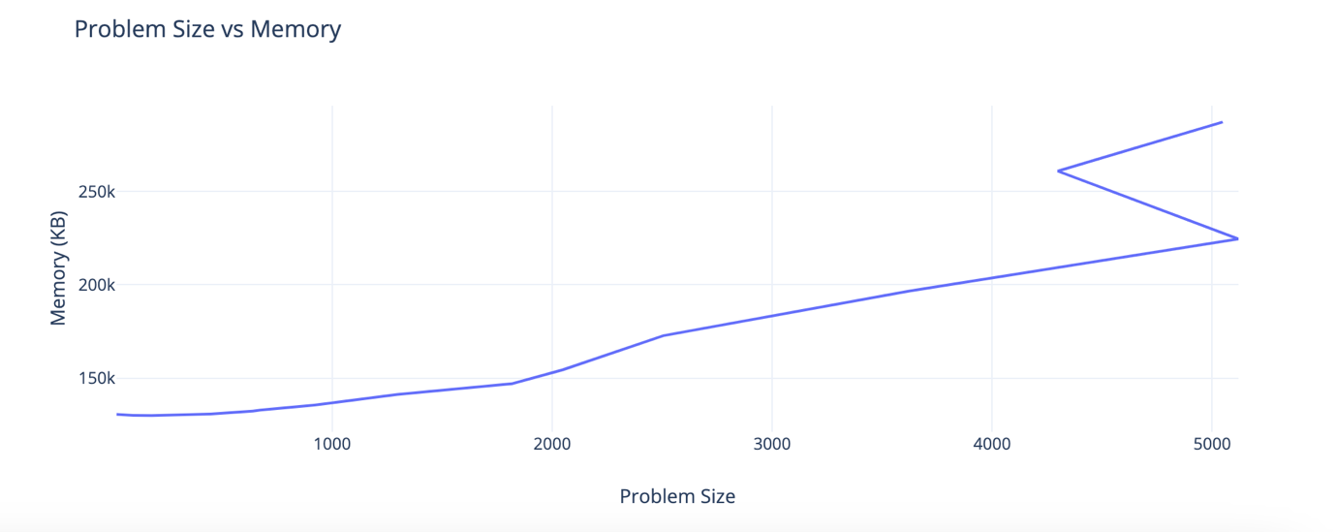

#### Nature of the Graph (Logarithmic/ Linear/ Polynomial/ Exponential)

Basic:

Efficient:

#### Explanation:

### Graph2 – Time vs Problem Size (M+N)

[Add Graph2 here]

#### Nature of the Graph (Logarithmic/ Linear/ Polynomial/ Exponential)

Basic:

Efficient:

#### Explanation:

## Contribution

(Please mention what each member did if you think everyone in the group does not have an equal contribution, otherwise, write “Equal Contribution”)

<USC ID/s>: <Equal Contribution>