**Modeling the Cost Effectiveness of Biologics for Systemic Lupus Erythematosus in Black Women in the United States: A Markov Analysis**

**Authors**

Elizabeth Osota

Georgia Institute of Technology

Email: [eosota@gatech.edu](mailto:eosota@gatech.edu)

Taofik Ahmed Suleiman

Georgia Institute of Technology

Email: [tsuleiman6@gatech.edu](mailto:tsuleiman6@gatech.edu)

# Abstract

**Importance:** Systemic lupus erythematosus (SLE) disproportionately affects Black women in the United States at higher rates and severity than the general population. Biologics are the newest treatment category for SLE, presenting greater efficacy with lower side effects, and our study seeks to evaluate their cost-effectiveness in this high-risk population.

**Objective:** To evaluate the long-term cost-effectiveness of biologics (Belimumab or Anifrolumab) in combination with standard of care (SOC) of glucocorticoids compared to SOC alone for the treatment of moderate-to-severe SLE in Black women in the United States.

**Methods:** We developed a Markov model with five health states (remission/mild, moderate, severe, organ damage, and death) and a six-month cycle length to simulate the disease progression and treatment effects over a lifetime horizon. We derived the transition probabilities from U.S. registries and clinical trials and stratified by race-specific hazard ratios. Our model incorporated both direct and indirect costs from a societal perspective. Outcomes included total costs, quality-adjusted life years (QALYs), and incremental cost-effectiveness ratios (ICERs). We conducted one-way sensitivity analyses using a willingness-to-pay threshold of $150,000 per QALY.

**Results:** SOC remained the most cost-effective strategy. Compared to SOC, Anifrolumab + SOC increased QALYs by 0.69 but exceeded the U.S. willingness-to-pay (WTP) threshold with an ICER of $195,814/QALY. Belimumab + SOC was more expensive and less effective than Anifrolumab, resulting in strong dominance. Sensitivity analysis identified the cost of Anifrolumab as the most influential parameter and requires a price reduction of 14.25% (from $22,430.46 to $19,234 per 6-Month supply) to meet the WTP threshold.

**Conclusion:** Over a lifetime horizon, Belimumab and Anifrolumab improve clinical outcomes for Black women with moderate-to-severe SLE, but neither is cost-effective at the current cost of treatment. Anifrolumab demonstrated the most effectiveness in terms of QALY but would require a price reduction to be economically viable compared to SOC. These findings signify the need for equitable pricing policies and the importance of considering demographic disparities in SLE treatment strategies.

# 1.0 Introduction

Systemic lupus erythematosus (SLE) is a chronic systemic autoimmune disease affecting an estimated 204,000 people in the United States, with an annual economic burden of $3.2 billion (Izmirly et al., 2021; Kariburyo et al., 2023). SLE primarily affects adults between 15 and 44 with 90% of cases occurring in women (Kariburyo et al., 2020). While SLE affects all populations, Black women experience incidence rates three times higher than White Women (230.9 versus 84.7 per 100,000 women in the United States). Further, compared to White women, Black women are also nine times more likely to progress to organ damage and die approximately 13 years earlier, which makes SLE a leading cause of death for Black women (Lim, 2019).

The potential reasons for these racial disparities include current treatment approaches, particularly the widespread use of glucocorticoids. While effective for managing inflammation, glucocorticoids can accelerate organ damage - a risk amplified in Black patients who often receive higher doses due to greater disease severity (Katarzyna et al., 2023). The newest category of SLE treatments, biologics, presents an opportunity for reducing glucocorticoid dependence. These newest SLE treatments of Belimumab and Anifrolumab target the immune system to suppress inflammation. When combined with standard of care, they have demonstrated efficacy in reducing disease progression, lowering adverse event rates, and decreasing glucocorticoid dosages (Bruce et al., 2023). While belimumab has a favorable cost-effectiveness ratio in other countries, biologics represent only 2% of SLE treatments within the United States (Petrou, 2022; Kariburyo et al., 2020). The cost-effectiveness of these treatments in the United States, particularly in Black women who face the highest disease burden, remains poorly understood. To our knowledge, there has been no cost-effectiveness analysis of Belimumab and Anifrolumab for SLE in the United States and existing cost-effectiveness analysis of lupus treatments has mainly been conducted without consideration of ethnicity, leaving a critical research gap for a disease with significant racial disparities in health outcomes.

The aim of this study is to evaluate the cost-effectiveness of biologic therapies combined with lower doses of the standard of care (SOC) compared to the use of standard doses of the SOC alone for Black women with SLE from a societal perspective over a lifetime horizon. To compare these interventions, we used a Markov model to estimate Quality-Adjusted Life Years (QALYs), mortality rates, treatment costs, and long-term healthcare costs of the cohort. This study represents the first comprehensive lifetime cost-effectiveness analysis of biologic therapy specifically focused on Black women with SLE, offering crucial insights for addressing racial disparities in SLE outcomes and guiding long-term treatment decisions.

# 2.0 Methods

## 2.1 Model Description and Markov States

A Markov model was developed to evaluate the cost-effectiveness of Belimumab/SOC vs. Anifrolumab/SOC vs. SOC alone in the treatment of Systemic Lupus Erythematosus (SLE) in Black women. There were 5 Markov health states: remission/mild, moderate, severe, organ damage, and death. Remission/mild, moderate, severe are based on the SLEDAI-2K categories where of Remission/mild is a score <3, moderate 3–6, and severe >6 (Speyer et al. 2020). As organ damage can occur in any state, the organ damage state was focused on end-stage organ damage, making it a penultimate state. The organ damage state was focused on End-Stage Renal Disease (ESRD) as it is the most common organ damage type resulting from SLE in Black Americans (Kallas et al., 2022). Different assumptions were made according to published literature and data sources. All patients entered the model after diagnosis through the moderate and severe, as both remission and lupus low disease activity state (LLDAS) are associated with improved long-term outcomes in SLE (Morand et al, 2025). Additionally, all the clinical trials utilized to derive intervention transition probabilities utilized a starting cohort of severe or both moderate and severe patients. All patients also started treatment at model entry. The Markov cycle length was set to six months to match physician assessment cycle of disease outcomes in clinical trials utilized to determine transition probabilities. Time horizon was set to the cohort lifetime to represent the lifetime condition of lupus and lifetime use thus far of the oldest lupus biologic: Belimumab (Wallace et al., 2019).

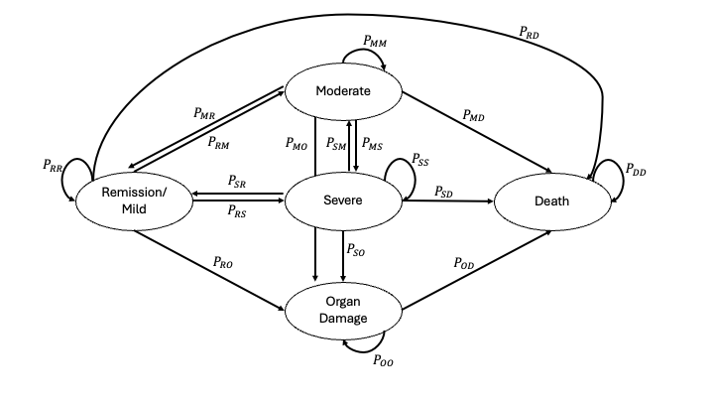

Figure 1. Diagram of the Markov model simulating disease progression in patients with SLE. Individuals enter the model through the moderate or severe health states and transition between remission/mild, moderate, severe, organ damage, and death in 6-month cycles. Organ damage serves as a penultimate state, and it is irreversible, with death as the absorbing state. The arrows indicate transitions within and between states, with associated probabilities representing disease progression.

## 2.2 Transition Probabilities Estimates

SOC six-month transition probabilities were derived from population-based registry of individuals with SLE including the California Lupus Surveillance Project (CLSP), U.S. End-Stage Renal Disease (ESRD) Registry, and Attikon’ lupus cohort (Table 1). Transition probabilities to death were age-dependent and were determined from the 2021 United States Life Tables and modified with mortality hazard ratios. As this model is specific to Black Women, hazard ratios were determined from the CLSP and used to determine the transition probabilities. As non-Hispanic Black people were found to have increased hazard ratios relative to white people for lupus nephritis, a 2.3 hazard ratio was utilized for all transitions from a lower to higher SLEDAI state (Maningding et al., 2020). Transition Probability calculations are found in Appendix #1.

From the SOC, treatment transition probabilities were derived using rate ratios and hazard ratios from phase 3 TULIP-1 and TULIP-2 trials for Anifrolumab/SOC and OBSErve US Study for Belimumab/SOC transition probabilities (Table 2). While the OBSErve US Study data were specific to African American Patients, the TULIP-1 and TULIP-2 trials were not. No additional hazard ratios were included here as no supporting evidence could be found.

## 2.3 Utility Estimates

Health Utility values were assigned to each state from 0(death) to 1(healthy) (Table 1). No singular source for SLE utility values specific to the United States was found in the literature. Therefore, utility values were derived using Canada from an SLE international cross-sectional study using the time-trade-off (TTO) method (Pollard et al., 2015). Canada was selected as the most appropriate proxy from the study due to its geographical proximity and similar demographic composition, providing a reasonable estimate for health state utilities for SLE in the United States.

|  |  |  |
| --- | --- | --- |
| Model Parameter | Base Case | Reference |
| Transition Probabilities | | |
| Start State: Remission/Mild | | |
| Remission/Mild | **0.79032\*** |  |
| Moderate | **0.124** | **Nikolopoulos et al. 2020** |
| Severe | **0.085** | **Nikolopoulos et al. 2020** |
| Organ Damage | **0.00068** | **Assumption** |
| Death | **Life Table** | **2021 US Life Tables** |
| Start State: Moderate |  |  |
| Moderate | **0.7706\*** |  |
| Remission/Mild | **0.1033** | **Assumption** |
| Organ Damage | **0.0011** | **Barber et al. 2020** |
| Severe | **0.125** | **Nikolopoulos et al. 2020** |
| Start State: Severe |  |  |
| Severe | **0.8223\*** |  |
| Moderate | **0.103** | **Assumption** |
| Remission/Mild | **0.053** | **Morand et al. 2025** |
| Organ Damage | **0.0217** | **Barber et al. 2020** |
| Start State: Organ Damage |  |  |
| Organ Damage | **1\*** |  |
|  |  |  |
| Rate Ratios | | |
| All Models: African American Lower state to Higher State HR | **HR 2.3** | **Maningding 2020** |
| All Models: Moderate to Death | **HR: 3.703** | **Campbell 2024** |
| All Models: Severe to Death | **HR: 7.153** | **Campbell 2024** |
| All Models: Organ Damage to Death | **HR 12.94** | **Johansen 2020**  **Sule 2014** |
| Belimumab: Lower state to Higher State | **HR .77** | **Ginzler 2021** |
| Belimumab: Higher State to Lower State | **OR 1.40** | **Ginzler 2021** |
| Anifrolumab: Lower state to Higher State | **HR .76** | **Morand 2025**  **Morand 2020** |
| Anifrolumab: Higher State to Lower State | **OR: 2.7** | **Morand 2025**  **Morand 2020** |
|  |  |  |
| Utility Values |  |  |
| Remission/Active Low | **0.705** | **Speyer 2020** |
| Active Moderate | **0.42** | **Speyer 2020** |
| Active Severe | **0.37** | **Speyer 2020** |
| Organ Damage (Renal) | **0.28** | **Speyer 2020** |
| Death | **0** | **Speyer 2020** |
| Lower Glucocorticoid Dosage | **+.03** | **Al Sawah et al., 2015** |
|  |  |  |
| Direct and Indirect Costs (per 6-month cycle) |  |  |
| SOC Remission/Mild | **20,239.96** | **Chen, 2015**  **Carls, 2009** |
| SOC Moderate | **24,317.58** | **Chen, 2015**  **Carls, 2009** |
| SOC Severe | **36,857.11** | **Chen, 2015**  **Carls, 2009** |
| Organ Damage | **161,209.52** | **Dall’Era 2022** |
| Belimumab | **20,325.3** | **U.S. VA Prices** |
| Anifrolumab | **22430.46** | **U.S. VA Prices** |
| Reduction for lower glucocorticoid dosage | **644.07** | **Chen, 2015** |
| Death (End-of-Life) | **7327.06** | **Inc. 2023** |

Table 1. Transition probabilities, hazard and rate ratios, utility, and cost model Inputs

*Life Table Dependent

## 2.4 Cost Estimates

Both direct and indirect costs were included to represent a lifetime societal perspective (Table 1). Direct SOC costs for each state were derived from the literature based on mean cost of expected glucocorticoid dosage of Intermittent, medium (7.5-15mg), and high(>15mg) for Remission/Mild, Moderate, and Severe states, respectively. The direct costs include in-patient, emergency department, outpatient, and pharmacy costs. Indirect SOC costs were derived from literature-reported mean cost of Absenteeism and Short-Term Disability claims for SLE patients. Belimumab and Anifrolumab treatment prices were derived from active April 2025 Pharmaceutical pricing data for all VA National Acquisition Center programs. Treatment costs were not incurred for time spent in Organ Damage state as Belimumab and Anifrolumab are not designated for patients with ESRD. All patients incurred a one-time end-of-life cost. Base costs from literature were adjusted to March 2025 USD costs using the U.S. Bureau of Labor Statistics overall CPI calculator.

## 2.6 Markov Cohort Population

A theoretical cohort was created by estimating the number of Black women in the United States who are diagnosed with moderate or severe SLE. There are around 57,450 Black women with SLE in the United States (Izmirly et al., 2021). Evaluation of Medicaid-insured SLE patients found that 77% of patients had moderate/severe SLE (Clarke et al., 2020). Furthermore, the Black starting cohort in the GSK OBSErve US study were 34.8% severe and 65.2% moderate (Bell et al., 2023). With these inputs, we calculated an approximate cohort of 15,394 severe and 28,842 moderate (44,236 total) patients for the model. The full cohort also entered the model at the average SLE diagnosis age of 31.4 (Merola et al. 2014).

## Sensitivity Analysis

One-way sensitivity analysis was performed on all transition probabilities, utilities, and costs. For most transition probabilities and utilities, an upper and lower bound of +/- 10% was used. For transitions (Moderate -> Remission, Severe -> Moderate, and Remission -> Organ Damage) which were more uncertain, an upper and lower bound of +/- 25% was used. All cost estimates included an upper and lower bound of +/- 25%, except Anifrolumab and Belimumab, which included only a lower bound of -50%.

All costs and effects were discounted at the recommended 3% annually, or approximately 1.49% per 6-month cycle. Lastly, all analysis was based on the United States’ willingness-to-pay threshold of $150,000 per QALY. The overall model was validated using the average mortality age for each strategy.

# 3.0 Results

## 3.1 Cost-Effectiveness Analysis

Outcomes for the cohort of Black women diagnosed with severe or moderate SLE over a lifetime period are shown in Table 2. SOC was superior to both Belimumab and Anifrolumab. Anifrolumab + SOC was the most clinical effective option, with an incremental gain of 0.69 QALYs compared to Standard Care, but with an ICER of $195,814 per QALY, this exceeds the United States established willingness-to-pay threshold of $150,000 per QALY (Figure 2). When compared to Anifrolumab + SOC, Belimumab shows less effectiveness (0.37 fewer QALYs) while being more expensive (additional cost of $9,678) resulting in domination by Anifrolumab + SOC as it was less effective and more expensive (Table 2).

Under SOC, a significant proportion of patients transitioned to the organ damage and death states over time, while Belimumab + SOC and Anifrolumab + SOC maintain more patients in the Remission and Moderate states (Figure 3). This resulted in higher average age of death of 55.6 years for Anifrolumab + SOC and 52.1 years for Belimumab + SOC compared to 49.7 years for SOC (Table 2). The model-predicted average mortality age outputs across all strategies are comparable to the actual reported mean mortality age of 51.8 years for Black women with SLE (Lim 2019).

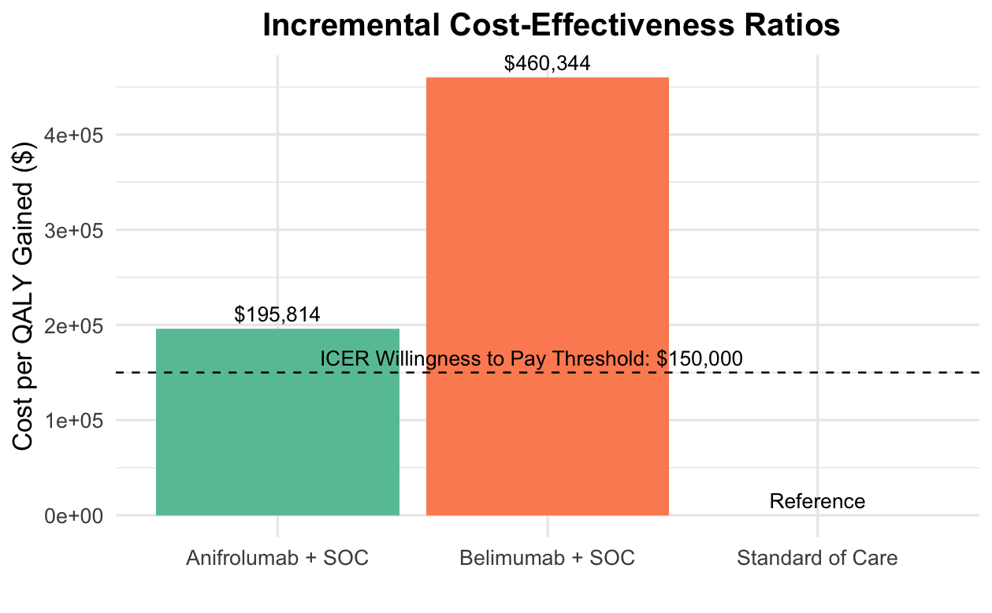

Figure 2. Incremental cost-effectiveness ratios (ICERs) for biologic treatment strategies compared to standard of care (SOC). The figure displays the cost per QALY gained for Anifrolumab + SOC and Belimumab + SOC relative to SOC alone. Anifrolumab + SOC exceeds the $150,000 willingness-to-pay (WTP) threshold but is more cost-effective than Belimumab + SOC, which shows a substantially higher ICER of $460,344/QALY. These findings suggest neither strategy is cost-effective under the U.S. WTP threshold of $150,000.

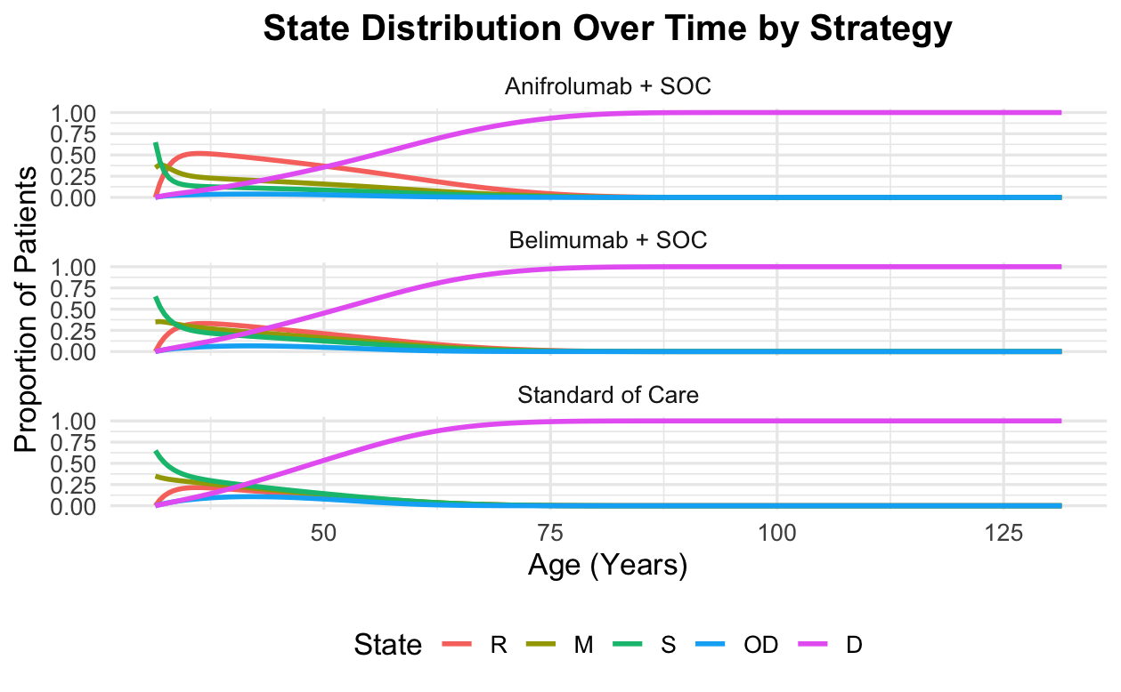

Figure 3. State distribution over time by treatment strategy. The figure shows the proportion of the SLE cohort occupying each health state over time under three strategies: Anifrolumab + SOC, Belimumab + SOC, and SOC alone. Across all strategies, the proportion of patients in the remission (R), moderate (M), severe (S), and organ damage (OD) states declines with age, while the proportion in the death (D) state increases. Biologic-based interventions demonstrate slightly delayed progression to organ damage and death compared to the standard of care.

|  |  |  |  |  |  |  |
| --- | --- | --- | --- | --- | --- | --- |
| Strategy | Cost ($) | Effectiveness (QALY) | Incremental Cost | Incremental QALY | Incremental ICER | Average Age of Death |
| SOC | **378,941** | **2.14** | **NA** | **NA** | **NA** | **49.7** |
| Anifrolumab + SOC | **513,420** | **2.82** | 134,479 | **0.69** | **195,814** | **55.6** |
| Belimumab + SOC | **523,098** | **2.45** | **Dominated** | **Dominated** | **Dominated** | **52.1** |

Table 2. Incremental cost-effectiveness results comparing Anifrolumab + SOC and Belimumab + SOC to Standard of Care (SOC) for moderate-to-severe SLE in Black women. The table reports total costs, QALYs, incremental values, ICERs, and average age of death. Belimumab + SOC is dominated, meaning it is more costly and less effective than Anifrolumab + SOC.

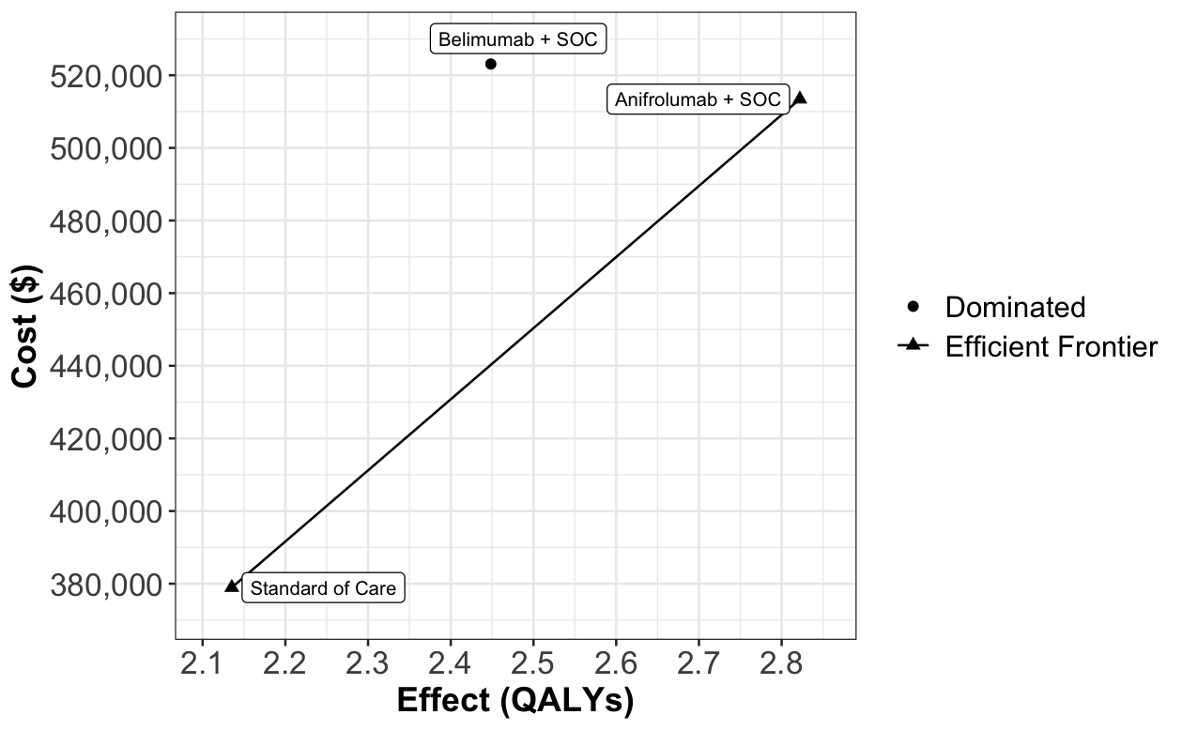

Figure 4. Cost-effectiveness plane comparing total cost and QALYs for each of the treatment strategies. The figure shows the efficient frontier formed by Standard of Care and Anifrolumab + SOC, which are non-dominated strategies. Belimumab + SOC is extendedly dominated as evident in the low QALYs at a higher cost compared to Anifrolumab + SOC. The two strategies on the efficient frontier are considered more cost-effective than the dominated strategy.

## 3.2 Sensitivity Analysis Results

The one-way sensitivity analysis highlighted the key drivers of uncertainty in the net monetary benefit (NMB) between SOC and Anifrolumab + SOC. Belimumab + SOC was not included in sensitivity analysis since it was dominated by Anifrolumab + SOC. The cost of the Anifrolumab emerged as the single parameter causing significant variation in NMB (Figure 5). Therefore, secondary analysis found that the cost of Anifrolumab would need to be reduced from $22,430.46 to $19,234 per 6-Month supply to be within the United States Willingness-to-Pay threshold of $150,000/QALY (Figure 6).

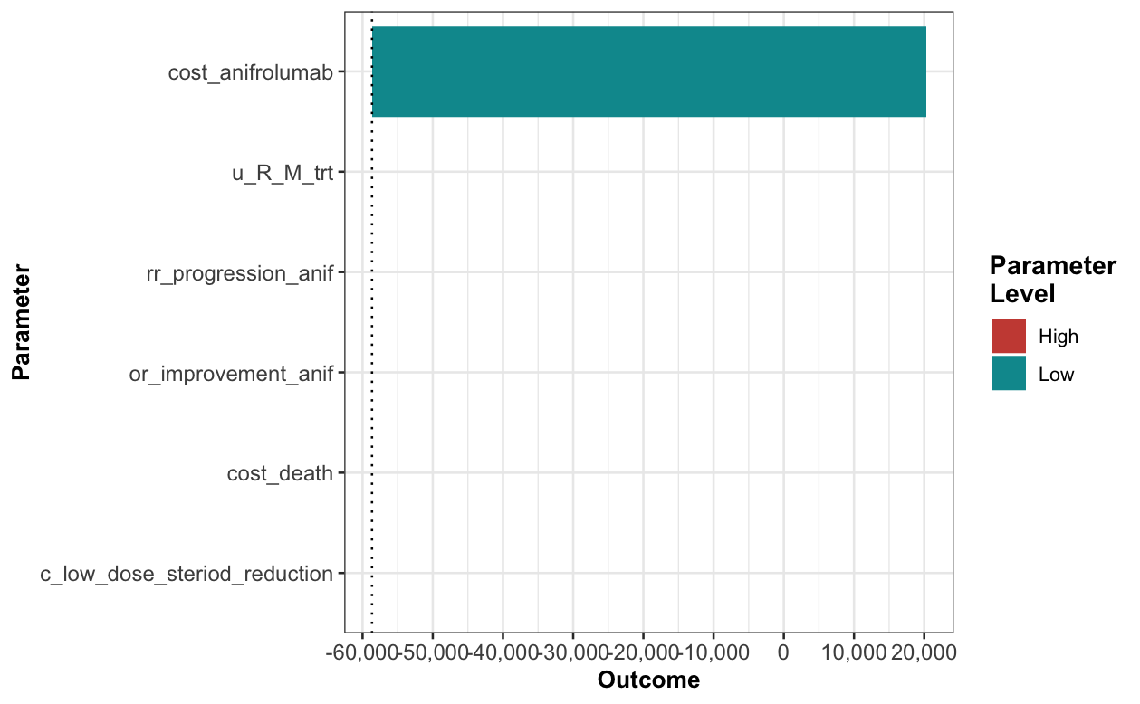

Figure 5. One-way sensitivity analysis using tornado plot for Anifrolumab + SOC. The figure illustrates the impact of varying individual model parameters on the Net Monetary Benefit (NMB). The cost of Anifrolumab had the greatest influence on NMB, while other parameters, including treatment-related utility gain (u_R_M_trt), progression rate ratios, and end-of-life costs, had comparatively smaller effects.

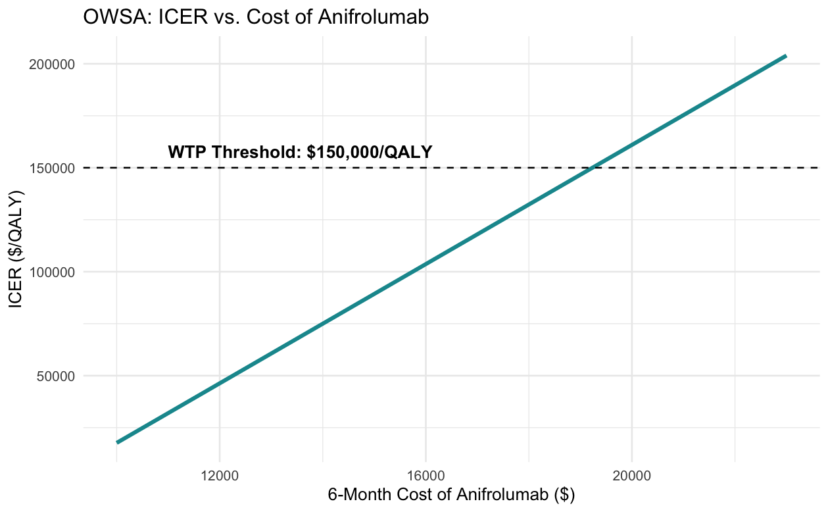

Figure 6. One-way sensitivity analysis showing the relationship between the 6-month cost of Anifrolumab and ICER. As the cost increases, the ICER also increases linearly. The dotted line represents the U.S. willingness-to-pay (WTP) threshold of $150,000 per QALY. The analysis indicates that Anifrolumab remains cost-effective only when the price is below $19,234 per 6-month cycle.

# 4.0 Discussion

Our study represented the first comprehensive cost-effectiveness analysis of biologics specifically focused on Black women with SLE, addressing a critical gap in the literature where racial disparities in treatment outcomes have been largely overlooked. we find that although Anifrolumab + SOC demonstrates greater clinical effectiveness versus SOC alone, SOC remains the more cost-effective option based on U.S. willingness-to-pay threshold of $150,000/QALY. Additionally, our results showed that Anifrolumab + SOC dominated Belimumab + SOC by being both more effective (.37 additional QALYs) and cheaper ($9,678 less cost). The domination of Belimumab + SOC by Anifrolumab + SOC aligned with previous cost effectiveness studies conducted in the United Arab Emirates and Italy though this study is the first to determine that SOC is more cost effective than Anifrolumab + SOC (Elsisi et al. 2024, Fortunato et al. 2024). These findings provide crucial insights for starting to fill in the earlier 13-year mortality age of Black people compared to white people, as our model projected average life year gains of 5.9 years with Anifrolumab + SOC versus SOC alone.

Our sensitivity analysis found the cost of Anifrolumab as the most impactful parameter affecting cost effectiveness. Further threshold analysis of Anifrolumab’s cost found a cost reduction of 14.25% (from $22,430.46 to $19,234 per 6-Month supply) would bring Anifrolumab + SOC within the cost-effectiveness ratio of $150,000/QALY. This finding highlighted that while biologics represent the first major advancement in SLE treatments after a 60-year drought, broader adoption is primarily limited by high costs rather than clinical efficacy. The recent approval of Anifrolumab with its higher net monetary benefit presents an opportunity for expanded treatment use especially if cost can be further lowered.

We acknowledge there are some study limitations to consider. First, our model contains data disparity between strategies. While Belimumab efficacy estimates are based on limited data specific to Black patients, Anifrolumab estimates are based on mixed trial populations, potentially biasing results in favor of Anifrolumab. This reflects a broader issue in SLE clinical trials, where despite Black people representing 43% of prevalent SLE cases in the United States, they comprise only 14% of clinical trial enrollees compared to 33% prevalence and 51% enrollment for white patients (Falasunnu et al. 2018). Additionally, our model assumes lifelong efficacy of biologics, despite limited long-term evidence, as Belimumab and Anifrolumab were approved in the U.S. in the last 15 years. Finally, although our model uses a societal perspective, non-healthcare costs were limited to Absenteeism and Short-term Disability claims, thereby underestimating full societal costs such as unpaid caregiver time and lost earnings due to unpaid time off.

Based on the findings, it is recommended that SOC remain the first-line treatment for Black women with SLE as it is the most cost-effective option. However, the higher efficacy of Anifrolumab + SOC shows it should be considered for second-line treatment, particularly for patients with high risk for glucocorticoid adverse events. Future work should focus on expanding Black patients’ participation in clinical trials or, at minimum, conducting a retrospective analysis of Anifrolumab’s TULIP studies, which would provide valuable data for a more refined cost-effectiveness analysis and treatment recommendations. While this model has limited applicability to non-Black populations with SLE, it provides a valuable framework for studying an important but underrepresented population in the U.S. and could inform future cost effectiveness studies of SLE in African countries where the disease burden may be similarly high but even less thoroughly characterized.

# 5.0 References

1. Al Sawah, S., Zhang, X., Zhu, B., Magder, L. S., Foster, S. A., Iikuni, N., & Petri, M. (2015). Effect of corticosteroid use by dose on the risk of developing organ damage over time in systemic lupus erythematosus—the Hopkins Lupus Cohort. *Lupus science & medicine*, *2*(1), e000066.
2. Barber, M. R., Hanly, J. G., Su, L., Urowitz, M. B., St. Pierre, Y., Romero‐Diaz, J., ... & Clarke, A. E. (2020). Economic evaluation of damage accrual in an international systemic lupus erythematosus inception cohort using a multistate model approach. *Arthritis Care & Research*, *72*(12), 1800-1808.
3. Bell, C. F., Chung, J., & Rubin, B. (2023). Real-world clinical outcomes in belimumab-treated US African American and Hispanic patients with systemic lupus erythematosus: a retrospective, observational study. *Rheumatology and Therapy*, *10*(2), 447-462.
4. Bruce, I. N., van Vollenhoven, R. F., Morand, E. F., Furie, R. A., Manzi, S., White, W. B., ... & Tummala, R. (2023). Sustained glucocorticoid tapering in the phase 3 trials of anifrolumab: a post hoc analysis of the TULIP-1 and TULIP-2 trials. *Rheumatology*, *62*(4), 1526-1534.
5. Campbell Jr, R., Cooper, G. S., & Gilkeson, G. S. (2008). Two aspects of the clinical and humanistic burden of systemic lupus erythematosus: mortality risk and quality of life early in disease. *Arthritis Care & Research*, *59*(4), 458-464.
6. Carls, G., Li, T., Panopalis, P., Wang, S., Mell, A. G., Gibson, T. B., & Goetzel, R. Z. (2009). Direct and indirect costs to employers of patients with systemic lupus erythematosus with and without nephritis. *Journal of Occupational and Environmental Medicine*, *51*(1), 66-79.
7. Chen, S. Y., Choi, C. B., Li, Q., Yeh, W. S., Lee, Y. C., Kao, A. H., & Liang, M. H. (2015). Glucocorticoid use in patients with systemic lupus erythematosus: association between dose and health care utilization and costs. *Arthritis care & research*, *67*(8), 1086-1094.
8. Clarke, A. E., Yazdany, J., Kabadi, S. M., Durden, E., Winer, I., Griffing, K., & Costenbader, K. H. (2020, August). The economic burden of systemic lupus erythematosus in commercially-and medicaid-insured populations in the United States. In *Seminars in arthritis and rheumatism* (Vol. 50, No. 4, pp. 759-768). WB Saunders.
9. Collins, C. E., Dall'Era, M., Kan, H., Macahilig, C., Molta, C., Koscielny, V., & Chang, D. J. (2016). Response to belimumab among patients with systemic lupus erythematosus in clinical practice settings: 24-month results from the OBSErve study in the USA. Lupus Science & Medicine, 3(1), e000118.
10. Dall’Era, M., Kalunian, K., Eaddy, M., Ogbonnaya, A., Farrelly, E., Turowski, E., ... & Mina-Osorio, P. (2023). Real-world treatment utilization and economic implications of lupus nephritis disease activity in the United States. *Journal of Managed Care & Specialty Pharmacy*, *29*(1), 36-45.
11. Elsisi, G. H., Abo Gamal, A., AlShehhi, W., & Farghaly, M. (2024). Microsimulation model of the cost-effectiveness of anifrolumab compared to belimumab in the United Arab Emirates. *Journal of Medical Economics*, *27*(sup1), 23-34.
12. Falasinnu, T., Chaichian, Y., Bass, M. B., & Simard, J. F. (2018). The representation of gender and race/ethnic groups in randomized clinical trials of individuals with systemic lupus erythematosus. *Current rheumatology reports*, *20*, 1-11.
13. Fortunato, A., Di Brino, E., Rumi, F., Basile, M., Antonini, D., Falasca, G., & Di Pippo, S. (2024). EE518 Economic Evaluations of Anifrolumab for the Management of Patients Affected by Systemic Lupus Erythematosus (SLE) in Italy. *Value in Health*, *27*(12), S158.
14. Ginzler, E., Guedes Barbosa, L. S., D'Cruz, D., Furie, R., Maksimowicz‐McKinnon, K., Oates, J., ... & Ji, B. (2022). Phase III/IV, randomized, fifty‐two–week study of the efficacy and safety of belimumab in patients of Black African ancestry with systemic lupus erythematosus. *Arthritis & Rheumatology*, *74*(1), 112-123.
15. Golder, V., Kandane-Rathnayake, R., Huq, M., Nim, H. T., Louthrenoo, W., Luo, S. F., ... & Morand, E. F. (2019). Lupus low disease activity state as a treatment endpoint for systemic lupus erythematosus: a prospective validation study. *The Lancet Rheumatology*, *1*(2), e95-e102.
16. Gómez‐Puerta, J. A., Feldman, C. H., Alarcón, G. S., Guan, H., Winkelmayer, W. C., & Costenbader, K. H. (2015). Racial and ethnic differences in mortality and cardiovascular events among patients with end‐stage renal disease due to lupus nephritis. Arthritis care & research, 67(10), 1453-1462.
17. Inc., S. (Ed.). (2023, July 28). *Cost of dying report: Funeral & cremation fees*. Self. <https://www.self.inc/info/cost-of-dying-in-america-report/#current-cost>
18. Izmirly, P. M., Parton, H., Wang, L., McCune, W. J., Lim, S. S., Drenkard, C., ... & Somers, E. C. (2021). Prevalence of systemic lupus erythematosus in the United States: estimates from a meta‐analysis of the Centers for Disease Control and Prevention National Lupus Registries. Arthritis & Rheumatology, 73(6), 991-996.
19. Johansen, K. L., Chertow, G. M., Foley, R. N., Gilbertson, D. T., Herzog, C. A., Ishani, A., ... & Wetmore, J. B. (2021). US renal data system 2020 annual data report: epidemiology of kidney disease in the United States. *American journal of kidney diseases*, *77*(4), A7-A8.
20. Kallas, R., Li, J., Goldman, D. W., Magder, L. S., & Petri, M. (2022). Trajectory of damage accrual in systemic lupus erythematosus based on ethnicity and socioeconomic factors. *The Journal of Rheumatology*, *49*(11), 1229-1235.
21. Kalunian, K. C., Furie, R. A., Morand, E. F., Bruce, I. N., Manzi, S., Tanaka, Y., ... & Lindholm, C. (2022, September). Long-term Safety and Efficacy of Anifrolumab in Adult Patients with Systemic Lupus Erythematosus: A Multicenter, Randomized, Double-blind, Placebo-controlled 3-year TULIP Extension Study. In ARTHRITIS & RHEUMATOLOGY (Vol. 74, pp. 3285-3288). 111 RIVER ST, HOBOKEN 07030-5774, NJ USA: WILEY.
22. Kariburyo, F., Xie, L., Sah, J., Li, N., & Lofland, J. H. (2020). Real-world medication use and economic outcomes in incident systemic lupus erythematosus patients in the United States. *Journal of Medical Economics*, *23*(1), 1-9.
23. Katarzyna, P. B., Wiktor, S., & Ewa, D. (2023). Current treatment of systemic lupus erythematosus: a clinician's perspective. Rheumatology International, 43(8), 1395-1407.
24. Lim, S. S. (2019). Racial disparities in mortality associated with systemic lupus erythematosus—Fulton and DeKalb Counties, Georgia, 2002–2016. MMWR. Morbidity and mortality weekly report, 68.
25. Lim, S. S., Kan, H., Pobiner, B. F., Bao, G., & Drenkard, C. (2019). Patient perceptions and preferences of biologic therapies in SLE. Lupus Science & Medicine, 6(1), e000322.
26. Maningding, E., Dall’Era, M., Trupin, L., Murphy, L. B., & Yazdany, J. (2020). Racial/ethnic differences in prevalence of and time to onset of SLE manifestations: the California Lupus Surveillance Project (CLSP). *Arthritis care & research*, *72*(5), 622.
27. Merola, J. F., Bermas, B., Lu, B., Karlson, E. W., Massarotti, E., Schur, P. H., & Costenbader, K. H. (2014). Clinical manifestations and survival among adults with (SLE) according to age at diagnosis. *Lupus*, *23*(8), 778-784.
28. Mian, A., Curtis, P., Henning, C., Khamashta, M., Cervera, R., Wallace, D. J., ... & Atsumi, T. (2023). AB0519 LONG-TERM SAFETY OF BELIMUMAB AMONG ADULT PATIENTS WITH SLE: POOLED DATA FROM THREE OPEN-LABEL EXTENSION STUDIES OVER 11+ YEARS.
29. Morand, E. F., Furie, R., Tanaka, Y., Bruce, I. N., Askanase, A. D., Richez, C., ... & Tummala, R. (2020). Trial of anifrolumab in active systemic lupus erythematosus. *New England Journal of Medicine*, *382*(3), 211-221.
30. Morand, E. F., van Vollenhoven, R., Furie, R. A., Kalunian, K. C., Manzi, S., Abreu, G., ... & Lindholm, C. (2025). LLDAS and remission attainment with anifrolumab treatment in patients with systemic lupus erythematosus: results from the TULIP and long-term extension randomised controlled trials. *Annals of* *the Rheumatic Diseases*.
31. Nikolopoulos, D. S., Kostopoulou, M., Pieta, A., Flouda, S., Chavatza, K., Banos, A., ... & Fanouriakis, A. (2020). Transition to severe phenotype in systemic lupus erythematosus initially presenting with non-severe disease: implications for the management of early disease. *Lupus Science & Medicine*, *7*(1), e000394.
32. Office of Procurement, A. and L. (2018, March 16). *Pharmaceutical Prices*. U.S. Department of Veterans Affairs. <https://www.va.gov/opal/nac/fss/pharmprices.asp>
33. Parodis, I., Lanata, C., Nikolopoulos, D., Blazer, A., & Yazdany, J. (2023). Reframing health disparities in SLE: A critical reassessment of racial and ethnic differences in lupus disease outcomes. Best Practice & Research Clinical Rheumatology, 101894.
34. Petrou, P. (2022). A systematic review of the economic evaluations of belimumab in systemic lupus erythematosus. *Value in Health Regional Issues*, *27*, 32-40.
35. Pollard, C., Hartz, S., Leage, S. L., Paget, M. A., Cook, J., & Enstone, A. (2015). Elicitation of health state utilities associated with varying severities of flares in Systemic Lupus Erythematosus. *Health and quality of life outcomes*, *13*, 1-10.
36. Speyer, C. B., Li, D., Guan, H., Yoshida, K., Stevens, E., Jorge, A. M., ... & Costenbader, K. H. (2020). Comparison of an administrative algorithm for SLE disease severity to clinical SLE Disease Activity Index scores. *Rheumatology international*, *40*, 257-261.
37. Sule, S., Fivush, B., Neu, A., & Furth, S. (2014). Increased risk of death in African American patients with end-stage renal disease secondary to lupus. *Clinical kidney journal*, *7*(1), 40-44.
38. Tanaka, Y. (2023). Viewpoint on anifrolumab in patients with systemic lupus erythematosus and a high unmet need in clinical practice. *RMD open*, *9*(3), e003270.
39. Tice, J. A., Mandrik, O., & Thokala, P. (2021). Belimumab and voclosporin for lupus nephritis: Effectiveness and value; evidence report. Institute for Clinical and Economic Review. Published March, 12.
40. Wallace, D. J., Ginzler, E. M., Merrill, J. T., Furie, R. A., Stohl, W., Chatham, W. W., ... & Heath, A. (2019). Safety and efficacy of belimumab plus standard therapy for up to thirteen years in patients with systemic lupus erythematosus. *Arthritis & Rheumatology*, 71(7), 1125-1134.

# Appendix 1. Transition Probability Calculations

* Remission/Mild to Moderate:
  + Monthly Rate = -ln(1-0.291)/36 = 0.0096
  + P(6-month) = 1-exp(-0.0096×2.3×6) = 0.124
  + African American SLE HR: 2.3
* Remission/Mild to Severe:
  + Monthly Rate = -ln(1-0.207)/36 = 0.0064
  + P(6-month) = 1-exp(-0.0064×2.3×6) = 0.085
  + African American SLE HR: 2.3
* Remission to Organ Damage:
  + Rate_to_prob (.00115 × 0.59) = 0.00068
  + HR 0.59 of Moderate to Organ Damage (Golder et al. 2019)
* Remission Mortality HR: Base from life table
* Moderate to Remission/Low:
  + Rate_to_prob(0.00209 × 2) = 0.1033
  + HR 2 of Severe to Remission
* Moderate to Severe:
  + Monthly Rate = -ln(1-0.294)/36 = 0.0097
  + P(6-month) = 1-exp(-0.0096×6×2.3) = 0.125
  + African American SLE HR: 2.3
* Moderate to Organ Damage:
  + Transmision from sdi 1 to min 4(end stage renal disease): 0.001
  + Rate_to_prob(Prob_to_rate(.001) × 0.5 × 2.3) = 0.0011
  + Annual to 6-Month Correction: 0.5
  + African American SLE HR: 2.3
* Moderate Mortality HR: African American HR × Moderate SLE HR = 2.3 × 1.61 = 3.70
* Severe to Moderate:
  + Rate_to_prob(Prob_to_rate(0.053) × 2) = 0.103
  + HR 2 of Severe to Remission
* Severe to Remission/Mild:
  + Weekly Rate: -ln (1- 0.354)/208 = 0.00209
  + P (6 months) = 1-exp(-0.00209 × 26) = 0.053
* Severe to Organ Damage:
  + Transmision from sdi 1 to min 4(end stage renal disease): 0.019
  + Rate_to_prob(Prob_to_rate(.019) × 0.5 × 2.3) = 0.0217
  + African American SLE HR: 2.3
  + Annual to 6-Month Correction: 0.5
* Severe Mortality HR: African American HR × Severe SLE HR = 2.3 × 3.11 = 7.15
* Organ Damage to Death: African American HR × SLE HR × Renal Disease HR = 2.3 × 1.85 × 3.04 = 12.94