Stalker Design Specifications

Mission
The project is about creating an Open Source Production Asset Management (ProdAM) System called Stalker which is designed for Vfx/Animation Studios. Stalker will have a very flexible design that lets the pipeline tds to customize it in a wide variety of perspectives. The out of the package installation will meet the basic needs of majority of studios without too much effort.

Introduction
I need to give information about:
- why an asset management system is so important for an organization that have a lot of people working in a collaborative environment.
- The benefits of an asset management system
- a proposal for a good asset management system

Design Specifications

Features and Requirements:
Features:
- Will be developed purely in Python (2.4 and over) using TDD (Test Driven Development) practices
- SQLAlchemy for the database back-end and ORM
- User should be able to select his/her preferred database like PostgreSQL-MySQL-Oracle-SQLite etc. (whatever SQLAlchemy supports)
- The user should be able to select both one or different databases for studio specific and project specific databases. It is mostly beneficial when the setup uses SQLite. The project specific data could be kept in project folder as an SQLite db file and the studio specific data can be another SQLite db file or another database connection to PostgreSQL/MySQL/Oracle etc. databases. In an SQLite setup, the database can be backed up with the project folder itself.
- (planned) PyQt for user interfaces. The interfaces will be discussed later. The priorities of the development phase is to create the core of the system.
- Configuration files to let the user to configure all the aspects of the project management. There are going to be interfaces for this setup processes and also it should be like setting up a Django or Trac project from the command line.

- The first design of the database schema is shown below:

In this first design all the basic data types tried to be created with an inherited structure. All the classes are derived from the Base data type.
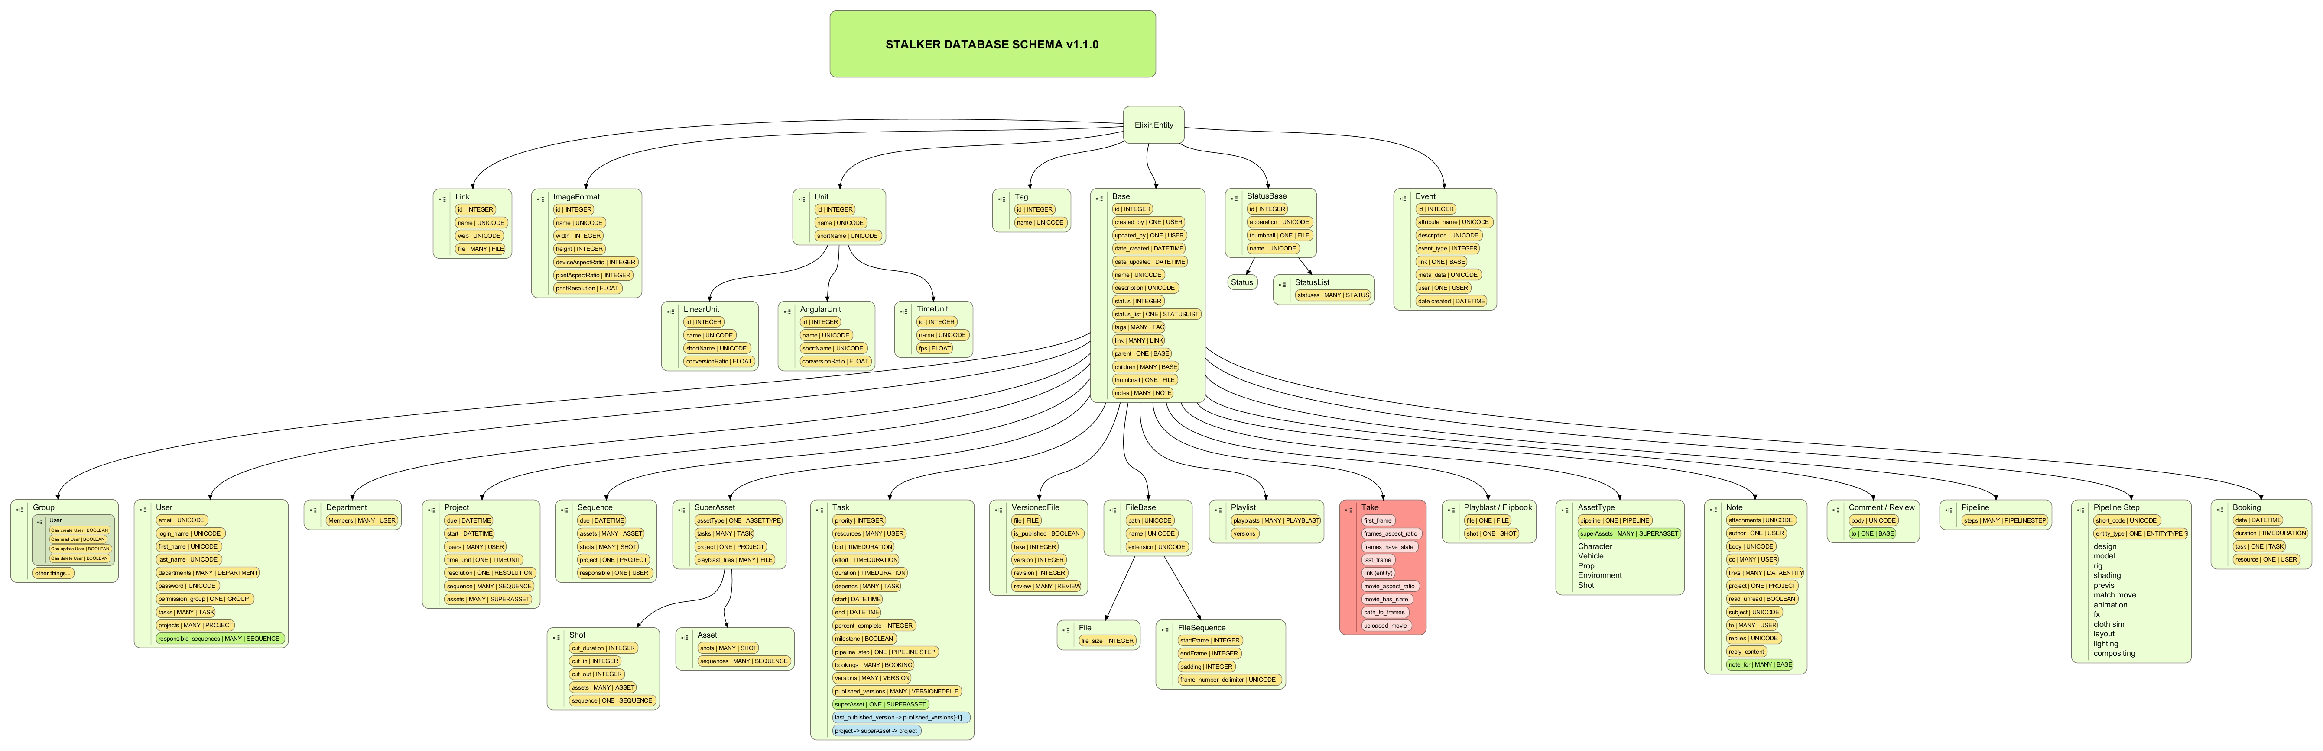Illustration 1: The first design of the Stalker Database Schema
- A templating system for the file and folder naming convention will be used like: {projectServer.path}/{project.name}/assets/{asset.name}/{pipelineStep.name}/{asset.variation.name}/{asset.name}_{asset.type.name}_v{asset.version}.{asset.fileFormat.extension}
- file and folders and file sequences could be uploaded to the server as assets, and the server decides where to place the folder or file
- there should be callbacks for every CRUD (create/insert, read, update, delete) step like before insert, after insert etc.
- pipeline steps should be hierarchically managed to let the project admin create pipeline dependencies between each step, so the system prevents the user to go to the next step before approving the previous ones (like rop dependencies in houdini), or it should keep track of the dependencies instead of preventing
- variations/takes of different versions of assets, a variation/take can be dependent to a specific asset version (variation root)

