Core Flight System

Command and Data Dictionary Utility

Tutorial

Engineering Directorate

Software, Robotics, and Simulation Division

Version 2.0

November

202

0

National Aeronautics and Space Administration

Lyndon B

.

Johnson Space Center

Ho

uston, Texas 77058

-

3696



**Contents**

1.0 Description 5

2.0 Requirements 5

3.0 Tutorial 5

3.1 Start CCDD 5

3.2 Create a project 6

3.3 Create a data table 7

3.4 Open a data table for editing 8

3.5 Edit a data table 8

3.5.1 Add a variable 8

3.5.2 Create an array variable 11

3.5.3 Rearrange the rows 12

3.5.4 Rearrange the column order 12

3.5.5 Enumerations 13

3.5.6 Padding for byte alignment 13

3.5.7 Data fields 15

3.6 Edit a table type 17

3.6.1 Table type data fields 20

3.7 Create a child table 21

3.8 Grouping tables 24

3.8.1 Group data fields 26

3.8.2 CFS applications 27

3.9 Create a script association 27

3.10 Execute a script association 31

3.11 Data types 32

3.12 Macros 34

3.13 Message IDs 36

3.14 Commands 37

3.14.1 Add a command argument to the Command table type 37

3.14.2 Create a command table and add command information 38

3.14.3 Execute a script using the command information 40

3.15 Importing and exporting tables 42

3.15.1 Create an import file 42

3.15.2 Import the table 43

3.15.3 Export the table 46

3.16 Telemetry scheduling 47

3.16.1 Telemetry rates 47

3.16.2 Assigning rates to variables 49

3.16.3 Linking variables 49

3.16.4 Bit length and bit-packing 49

3.16.5 Creating the housekeeping copy table **Error! Bookmark not defined.**

**Figures**

|  |  |
| --- | --- |
| Figure 1. | CCDD main application window ................................................................................................ 6 |
| Figure 2. | Create Project dialog ............................................................................................................. .. 6 |
| Figure 3. | New Table dialog ...................................................................................................................... 7 |
| Figure 4. | Edit Table dialog ........................................................................................................................ 8 |
| Figure 5. | Table editor .............................................................................................................................. 9 |
| Figure 6. | Empty row inserted into the data table .................................................................................... 9 |
| Figure 7. | Variable name and data type .................................................................................................. 10 |
| Figure 8. | Array definition and array member rows ............................................................................... 11 |
| Figure 9. | Variable “myArray1” moved above “myVar1” ....................................................................... 11 |
| Figure 10. | Enumerated variable ........................................................................................................... 12 |
| Figure 11. | Add/update/remove Padding dialog .................................................................................. 13 |
| Figure 12. | Padding applied to align the variables ................................................................................ 13 |
| Figure 13. | Data field editor .................................................................................................................. 14 |
| Figure 14. | Data field editor with row inserted ..................................................................................... 14 |
| Figure 15. | Data field editor with fields defined ................................................................................... 15 |
| Figure 16. | Table with data fields added ............................................................................................... 15 |
| Figure 17. | Table type editor ................................................................................................................. 16 |
| Figure 18. | Default structure table type ................................................................................................ 17 |
| Figure 19. | New structure table type column definition ....................................................................... 18 |
| Figure 20. | Structure table “myStruct” with the new “Lower limit” column ........................................ 18 |
| Figure 21. | New column with values entered ....................................................................................... 18 |
| Figure 22. | Table type with default field assigned ................................................................................ 19 |
| Figure 23. | Variable added to structure “myChildStruct” ..................................................................... 19 |
| Figure 24. | Child structure variable added to structure “myStruct” ..................................................... 20 |
| Figure 25. | A child table and its prototype ............................................................................................ 20 |
| Figure 26. | Overriding inheritance of a table cell .................................................................................. 21 |
| Figure 27. | Restoring a cell’s inheritance .............................................................................................. 21 |
| Figure 28. | Group manager ................................................................................................................... 22 |
| Figure 29. | Assigning a table to a group ................................................................................................ 22 |
| Figure 30. | Multiple groups ................................................................................................................... 23 |
| Figure 31. | Table tree, filtered by groups .............................................................................................. 23 |
| Figure 32. | Group data field .................................................................................................................. 24 |
| Figure 33. | Group with data field assigned ........................................................................................... 24 |
| Figure 34. | Script manager .................................................................................................................... 25 |
| Figure 35. | Script selection dialog ......................................................................................................... 26 |
| Figure 36. | Script associated with a table ............................................................................................. 27 |
| Figure 37. | Script associated with a group ............................................................................................ 28 |
| Figure 38. | Script output file ................................................................................................................. 29 |
| Figure 39. | Data type editor .................................................................................................................. 30 |
| Figure 40. | New data type ..................................................................................................................... 30 |
| Figure 41. | Added data type .................................................................................................................. 31 |
| Figure 42. | Macro editor ....................................................................................................................... 31 |
| Figure 43. | Added macros ..................................................................................................................... 32 |
| Figure 44. | Macro combo list ................................................................................................................ 32 |
| Figure 45. | Macro combo list; filtered................................................................................................... 32 |

|  |  |
| --- | --- |
| Figure 46. | Array size change via macro update ................................................................................... 32 |
| Figure 47. | Assign message IDs dialog ................................................................................................... 33 |
| Figure 48. | Reserve ID editor ................................................................................................................ 34 |
| Figure 49. | Command table type .......................................................................................................... 35 |
| Figure 50. | Command table type with second command argument columns ...................................... 36 |
| Figure 51. | Command information added to table “myCommand” ..................................................... 37 |
| Figure 52. | Script output file with commands ....................................................................................... 39 |
| Figure 53. | Table definition in a spreadsheet........................................................................................ 40 |
| Figure 54. | Spreadsheet saved in CSV format ....................................................................................... 41 |
| Figure 55. | Import Table(s) dialog ......................................................................................................... 42 |
| Figure 56. | Imported tables in the table editor ..................................................................................... 43 |
| Figure 57. | Export table(s) dialog .......................................................................................................... 44 |
| Figure 58. | Table exported in CSV format ............................................................................................. 45 |
| Figure 59. | Rate Parameters dialog ....................................................................................................... 46 |
| Figure 60. | Rate Parameters dialog with values entered ...................................................................... 47 |
|  |  |

# 1.0 Description

The Core Flight System (CFS) Command and Data Dictionary (CDD) utility, or CCDD, is a software tool for managing the command and telemetry data for CFS and CFS applications. See JSC-37494, Core Flight System Command and Data Dictionary Utility User’s Guide, for details on the CCDD application. This tutorial provides an example of setting up a project using CCDD, populating the project’s data tables, and using the project data to create output files.

Questions or comments concerning this document or the CCDD application should be addressed to:

Johnson Space Center

Software, Robotics, and Simulation Division

Spacecraft Software Engineering Branch, Mail Code ER6 Houston, TX 77058

# 2.0 Requirements

CCDD must be installed per the user’s guide, including access to a PostgreSQL server. The user must have a valid login role on the PostgreSQL server. This tutorial is valid for CCDD version 2.0.24

# 3.0 Tutorial

The following paragraphs lead the user through the basics of using the CCDD application, beginning with creating a new project, adding data tables to the project, entering data, and using a script to generate an output product from the project’s data. The paragraphs follow a specific order, with successive ones building on previous ones. The results may not be the ones expected if the steps are executed out of order.

## 3.1 Start CCDD

Start the CCDD application. The main application window appears (see Figure 1). A login dialog may also appear depending on the postgres server’s authentication settings; enter your postgres user login and password. In the **Project** column “*server*” is shown once a connection to the postgres server is established, or “*none*” if the connection to the server doesn’t exist. The server must be connected in order to proceed with the tutorial. The **User** column indicates the name of the user that is connected.

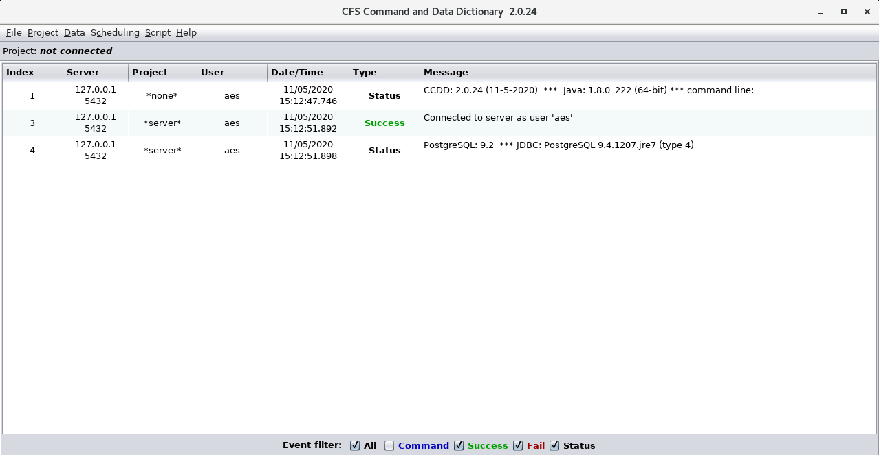

Figure 1. CCDD main application window

## 3.2 Create a project

In the main window’s menu bar select **Project | New**. A dialog appears similar to that shown in Figure 2 with the postgres and your user roles under the **Select project owner** heading (more roles may also be present if they exist on the postgres server).

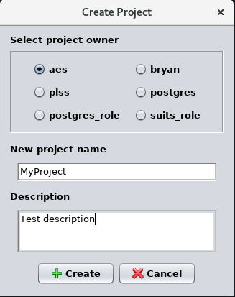

Figure 2. Create Project dialog

Select the radio button for your user as the project owner. Only the owner is allowed to make changes to the data stored in the project. It’s possible to assign a generic owner and then link the users to this generic owner, allowing multiple users to make changes. In the **New project name** input field type “MyProject” as the project name. The project name has constraints as to characters allowed, length, and uniqueness. Enter a description for the project in the **Description** field (this can be altered later if desired). Press the **Create** button to create the new project. The event log displays a message when the project is successfully created (or if an error occurs).

Now that the project exists data can be added to it. Data is stored as tables and table entries in the postgres database. The project isn’t entirely empty initially; aside from a number of necessary internal tables and postgres functions, the table types, data types, and reserved message IDs are populated with default information. CCDD handles all of the transactions with the database, reading and writing data to the tables as needed. These transactions are reflected in the main window’s event log entries.

A project must be opened before in order to alter the data within it. In the main window’s menu bar select **Project | Open**. The **Open project** dialog that appears displays all of the CCDD projects for which the current user has access. Select “MyProject” from the dialog and press the dialog’s **Open** button. The event log indicates that the project is open and locked. Locking the project prevents all but the current user from making updates to the project.

## 3.3 Create a data table

Most of the data within a database is stored within tables of type **Structure**, **Command** and **ENUM**. A **Structure** table mimics information commonly found in a C language structure. In the main window’s menu bar select **Data | New table(s)**; the **New table** dialog appears (Figure 3).

By default table types exist for **Structure**, **Structure: Cmd Arg Ref**, **Command** and **ENUM**. These table types may be modified or deleted, and additional types can be added. A table type serves as the template for new data tables, defining the columns and input constraints for that type of table. Select the **Structure** radio button under the **Select table type** heading. Enter “myStruct” as the table name in the **Table name(s)** field. A table name must begin with a letter or underscore, and can contain letters, numerals, and underscores. In the **Description** field enter “My structure table description”. Figure 3 shows the completed dialog. Press the **Create** button to create the table ‘myStruct’.

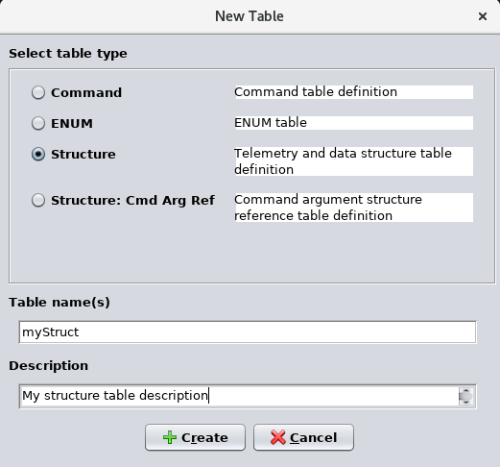

Figure 3. New Table dialog

## 3.4 Open a data table for editing

Now that a table exists in the project we can store data in it. The first table created represents a structure, so the data to be entered will be variable names, data types, etc. In the main window’s menu bar select **Data | Edit** **table(s)**, which causes the **Edit Table** dialog to appear (see Figure 4). Data tables are displayed using a tree format (similar to folders and files on a computer). The tables are arranged under two headings, **Prototypes** and **Parents & Children**. The tree is initially collapsed, so only these two headings are displayed. Select the **Expand all** check box below the tree, as shown in the figure, to display the tables under each heading.

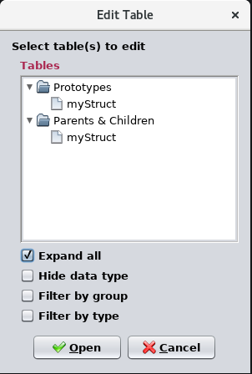

Figure 4. Edit Table dialog

All tables created using the **Data | New table(s)** command appear under the **Prototype** heading. A prototype can be thought of as a “rubber stamp” from which copies of the table are made. The copies are created when a table becomes the “child” of another table; that is, the child is referenced by the parent table. In practice this only occurs with structure tables since a structure can have a variable with another structure as the data type. The tables under the **Parents & Children** heading reflect this relationship. Any table that isn’t referenced by another table appears in the first level under the **Parents & Children** heading; these are referred to as “root” and “top-level” tables in the user’s guide. Child tables appear on subsequent “nest” levels. This nesting can extend to any depth, dependent on the structure references.

Use the mouse or keyboard to select the table “myStruct” from either heading (these represent the same table since “myStruct” is both a prototype and a root table). Press the **Open** button to open the table in a table editor.

## 3.5 Edit a data table

### 3.5.1 Add a variable

In the previous section the table “myStruct” was selected from the table tree in the **Edit table(s)** dialog for editing. The table editor, shown in Figure 5, appears. The editor can be resized if needed. The editor consists of a menu bar (along the top), the table (initially empty), the description field, a data field, and a number of buttons. A tab above the table displays the table’s name (if multiple table are open then a tab appears for each table). Notice that the table’s description, entered when the table was created, appears in the **Description** field.

The buttons provide a means of accessing some of the more commonly used editor commands; these (and other) commands can also be found in the editor’s menu bar. CCDD has a number of editor and manager dialogs for altering the project’s data. A common attribute of these editors and managers is that no data is actually stored in the project’s database until the user explicitly chooses to do so. As long as there are unstored changes an asterisk appears beside the table’s name in the tab. Also, if the table is closed and there are unstored changes a dialog appears allowing the user to choose between continuing (and discarding the changes) or returning to the editor.

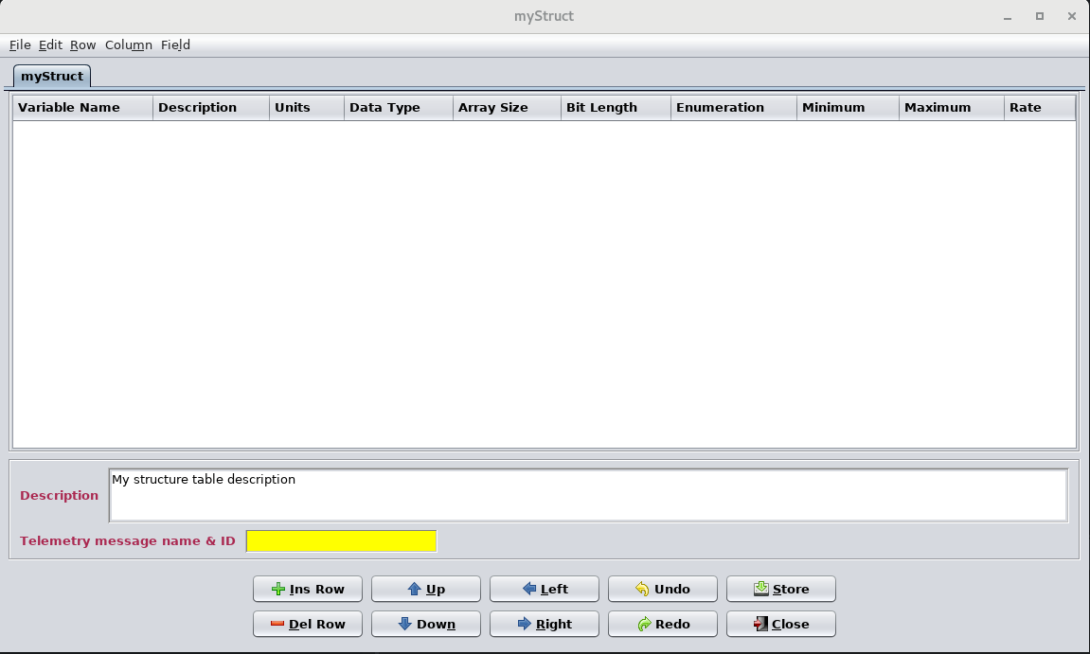

Figure 5. Table editor

A row must be inserted into the table before data can be entered, so press the **Ins Row** button (or alternatively, select **Row | Insert row** from the editor’s menu bar). An empty row appears in the table as in Figure 6.

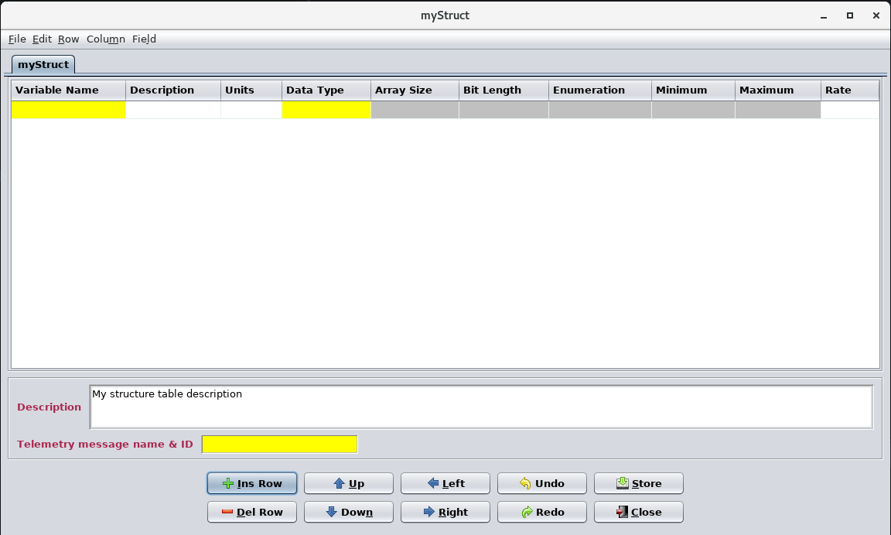

Figure 6. Empty row inserted into the data table

A cell with a gray background cannot be edited. Entering data into the other cells can determine if the grayed out cell becomes available for editing; if so, the cell’s background changes to white. A cell with a yellow background indicates that a value is required in the cell. “Required” in this context means that the row needs this information at a minimum under normal circumstances and serves as a reminder to the user – in general the CCDD application doesn’t enforce entering data into cells deemed as “required”.

Since this table represents a structure each row is a variable definition, so a variable name and data type are required at a minimum to define the variable. In the **Variable Name** cell enter “myVar1”. Notice that the **Array Size** cell is now editable. Select the **Data Type** cell using the mouse or keyboard; a combo box appears from which a data type is chosen (Figure 7).

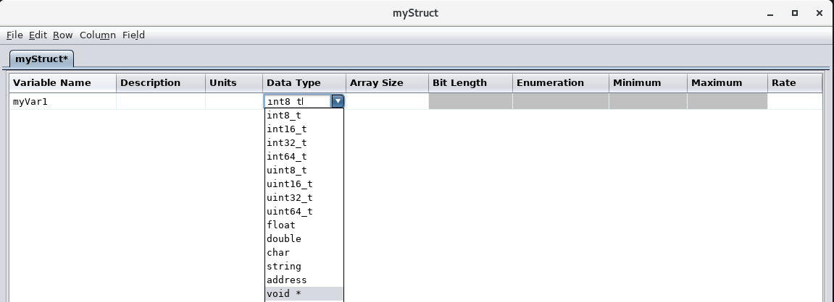

Figure 7. Variable name and data type

The choice of data type is constrained to those appearing in the list. There are two types of data type: primitive and structure. Primitive data types are those representing integers, floating points, characters, or pointers (a later section demonstrates changing the primitive data types). **Structure** data types appear if there are other **Structure**/**ENUM** tables defined – this is how child structures are created. Notice that “myStruct” doesn’t appear in the data type combo box. This is because a structure isn’t allowed to reference itself. In fact, CCDD prevents displaying any structure that would result in a circular reference, regardless of the depth of child structures involved. For this tutorial select “uint16_t”, a two byte unsigned integer as the data type for variable “myVar1”. The remaining cells that were grayed out are now editable.

Press the **Store** button to store the table, including the newly defined variable, into the project database. Press the **Okay** button when the confirmation dialog appears (Figure 8); the data is now stored (the event log records this action).

Figure 8. Store changes

### 3.5.2 Create an array variable

Continuing from the last section, press the **Ins Row** button again to insert a second row into the table. The new row appears below the original row. New rows appear at the bottom of the table unless a row in the table is highlighted (i.e., one or more cells in the row is selected), in which case the row is inserted immediately below the highlighted row.

In the new row enter “myArray1” as the variable name and select “float” as the data type. Notice that the **Bit Length** and **Enumeration** cells are grayed out since this information isn’t applicable to a floating point value. Enter “3” into the **Array Size** cell. This creates a single dimensional array with three members. The members aren’t visible by default; change this by selecting **Row | Expand arrays** in the editor’s menu bar (or by double clicking the right mouse button while the mouse pointer is in any row in the **Array Size** column). Three more rows, one for each array member, are displayed underneath the new row, which is the array’s definition row. Notice that many of the cells for the members cannot be edited since these are dependent on the definition, whereas others, such as the **Description**, can be assigned per member. See Figure 9.

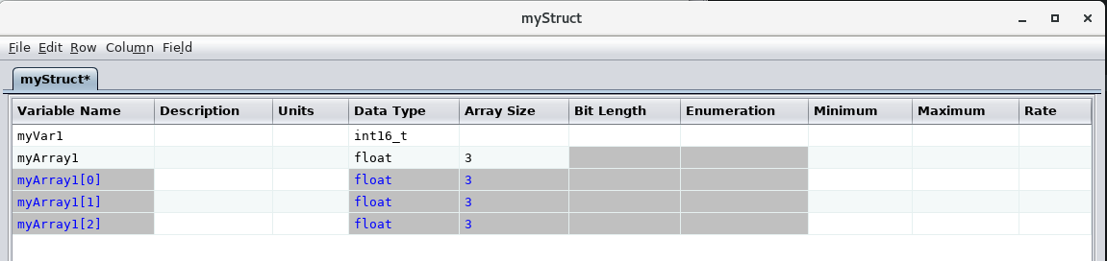

Figure 9. Array definition and array member rows

If the array definition row is changed then the array’s members are updated to reflect the change. Change the array size from “3” to “4” and note that another member row is automatically inserted with the array information in place. Change the array size back to ‘3” and the added member row is removed. Changing the variable name or data type for the array’s definition also updates the members accordingly. The array member rows can be hidden again performing the menu command or the mouse action again. Store the changes in the project database.

### 3.5.3 Rearrange the rows

A variable’s position within the table can be changed by selecting a cell in the row, then pressing the **Up** and **Down** buttons (or using the equivalent **Row** menu commands). Use the mouse or keyboard to highlight any cell in one of the “myArray1” rows, then press the **Up** button. The entire array, definition and member rows, is moved above the row containing the variable “myVar1” (Figure 10).

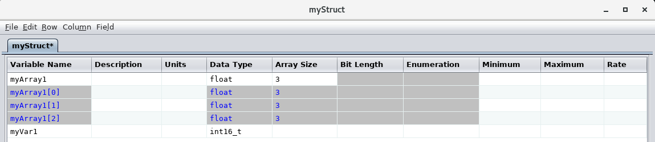

Figure 10. Variable “myArray1” moved above “myVar1”

Rows representing more than one variable can be moved as a block. The variables must be contiguous, so any intervening variables are moved as well. Store the changes in the project database.

### 3.5.4 Rearrange the column order

The order in which the columns are displayed can be changed if desired. This is accomplished by one of three methods: the **Left** and **Right** buttons, the equivalent **Column** menu commands, or dragging the column using the mouse. For the button or menu method highlight a cell in the column(s) to be moved, then issue the command. Note that intervening columns are moved as well if the selected columns aren’t contiguous. To use the mouse, position the mouse pointer over the column header, then press and hold the left or right mouse button. Move the mouse to reposition the column(s). Column order changes are recalled if stored in the project database. The ordering is stored by table and user; in other words, each user can order the columns in each table to their own liking and the columns appear in that order when the table is reopened.

### 3.5.5 Enumerations

The enumeration column provides a means of defining enumerated values and their corresponding text values (and, optionally, other information). Since the enumerations are based on integer values, the **Enumeration** column is editable only when the **Data Type** column is a type of signed or unsigned integer. The format for an enumeration isn’t fixed – the user is free to enter the data as desired as long as the separator characters are consistent within each enumeration. The script data access methods can then automatically detect the separation characters when parsing an enumeration.

In general the format has each enumerated value and its parameters separated from the next one by a separation character (or characters). The separation character could be a comma, for example. The individual parameters for each enumerated value are separated by another character (or characters); for example a vertical bar (|). At a minimum each enumerated value requires a text representation to go with it. Other parameters may also be added as parameters to each enumerated value; an example would be text and background colors for use when coloring the text on a display.

For the tutorial the variable “myVar1” will be given enumeration parameters for the values 0 and 1, with the value of 0 associated with the text “Off”, and the value 1 with “On”. This is done by entering “0 | Off, 1 | On” in the **Enumeration** cell for the variable “myVar1”. Figure 11 shows the table with the change entered. Store the changes in the project database.

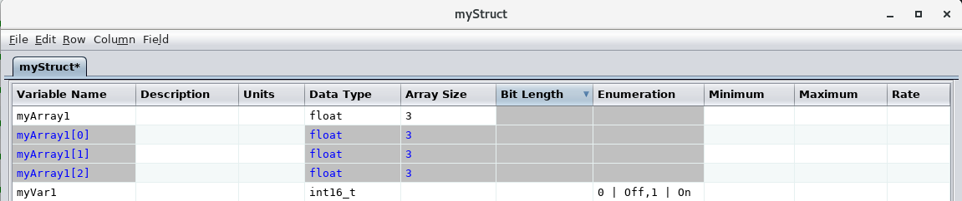

Figure 11. Enumerated variable

### 3.5.6 Padding for byte alignment

Byte alignment refers to positioning variables on word boundaries so that CPU requests can efficiently access the variable values in memory. However, when a structure is created, the variables may not naturally align as needed. The variables must be aligned based on the size of the largest element within the structure, including any referenced child structures and their variables (and their children, etc.). For example, if the first variable is a character and the second a 2-byte integer then the second variable would not be aligned properly – it needs to be shifted one byte so that it falls on the next alignment position. Or if the second variable is a float (4 bytes), then it needs to be shifted by 3 bytes to fall on the next word boundary.

Byte alignment requirements can be met by manually inserting dummy variables so as to force the next variable to align correctly. This process is prone to error, can consume a lot of time if a large number of variables and/or tables are involved, and needs to be updated as variables are inserted, deleted, moved, have their data types, array sizes, or bit lengths changed. To eliminate these issues, the CCDD application can perform the task of adding, updating, or removing padding variables upon user command.

Select the **Data | Padding** menu command. The dialog shown in Figure 12 appears. The table tree allows selection of the prototype structure table or tables that will have the padding adjusted. Select “myStruct” from the tree and press the **Add/Update** button; the table is automatically padded as needed to align the variables on the appropriate byte boundary. Note that the addition of the padding variables doesn’t register as an unstored change for the table. This is because padding adjustments are automatically stored when the padding operation is performed.

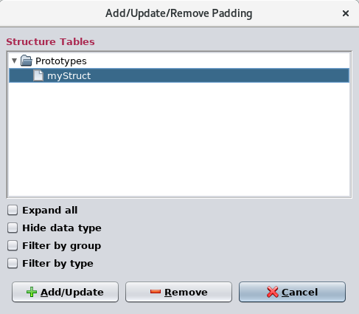

Figure 12. Add/update/remove Padding dialog

The structure table “myStruct” now appears as in Figure 13. A padding variable is added to “fill out” the structure’s size. The array “myArray1” contains three floats. Each of these occupies four bytes, so are already aligned. The next variable, “myVar1”, is also aligned since it immediately follows the last float in myArray1. The overall size of the structure, however, is two bytes deficient, so padding variables are appended – in this case as an array of two characters. Notice that the padding variable rows are highlighted for easy identification. Also notice that the padding variable name is in a specific format – this is how the application recognizes the padding variables.

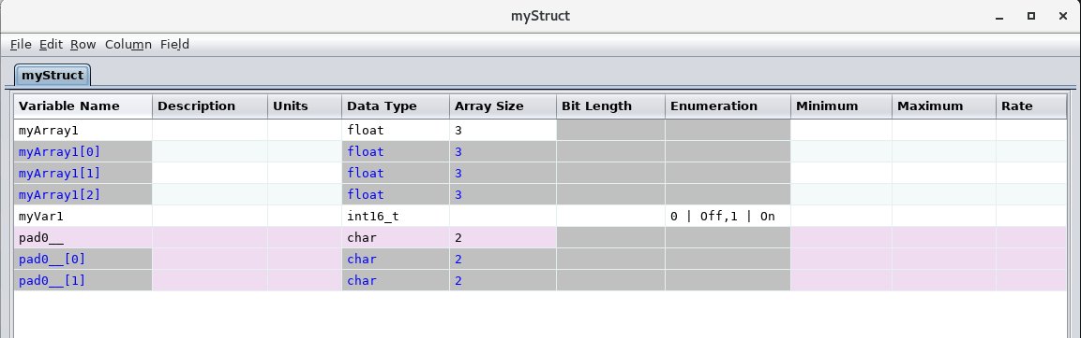

Figure 13. Padding applied to align the variables

Executing the **Padding** command and selecting **Add/Update** removes any padding variables currently in place in the table, then adds padding variables back in as needed. This should be done if variables are added, removed, or have their data type, array size, or bit length altered. Execute the menu command **Data | Padding**, choose the tables from which to remove the padding variables, and then select **Remove** to delete the selected table’s padding variables.

### 3.5.7 Data fields

Some data associated with a table may not be appropriate in a tabular format. For example, a value that is the same for every row, or a value that applies to the entire table (the table description falls into this category). To account for this type of information the CCDD application allows for one or more data fields to be assigned to each table. These fields appear between the table’s **Description** field and the buttons in the table editor. By default each root structure table is assigned a data field named “Telemetry message name & ID”; this can be seen in Figure 5. Default fields can be added, modified, or removed – this is covered in paragraph 3.6.1 of this tutorial.

Select the menu command **Field | Manage** **fields**. The **Data Field Editor**, shown in Figure 14, is displayed.

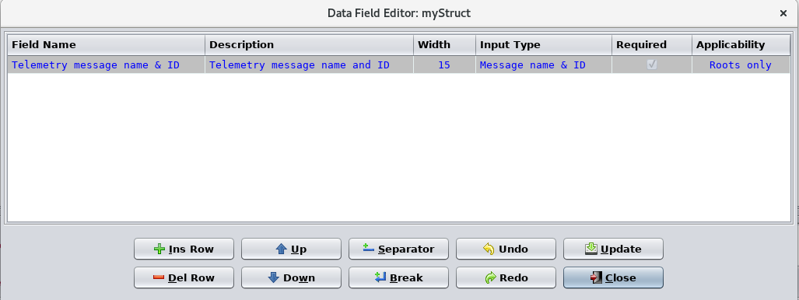

Figure 14. Data field editor

Since a default data field was assigned to “myStruct” the field editor is initially populated with this field’s definition. A data field is added by pressing the **Ins Row** button (Figure 15).

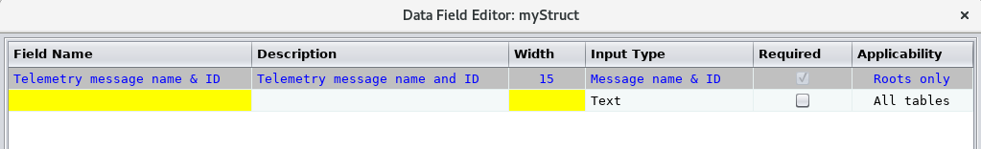

Figure 15. Data field editor with row inserted

Again, as with the table editor, a cell with a yellow background is considered required and a value must be entered for these cells. The **Field Name** is the text that appears beside the input field when it’s displayed. The **Description** cell is optional; its text appears as a tool tip when the mouse pointer is hovered over the field. The **Width** cell determines the width in characters of the field. Note that this doesn’t constrain the number of characters that can be entered into the field.

The **Input Type** cell, when selected, displays a combo box containing all of the available input types. The input type constrains the characters that can be entered into the data field once it’s created. A large number of types are provided, and custom types may be created. The default is “Text”, which allows any characters to be entered, though leading and trailing white space characters are automatically removed. Some of the data types have specific uses not associated with data fields (e.g., “Variable name” and “Array index”); these can be used to constrain the input value, but any additional meaning isn’t used by the data field. The default field, “Telemetry message and & ID”, has the input type

“Message name & ID”. This imposes the constraint on the field so that only a message name

(alphanumeric value) and/or message ID (hexadecimal value) can be entered in the field. This input type is recognized by the application when showing and assigning message IDs. This is discussed further in a section 3.13 of this tutorial.

The **Applicability** column determines when the field is displayed in the table editor. When the column is selected a combo box appears displaying the three types of applicability: “All tables”, “Roots only”, and “Children only”. If “All tables” is selected then this field is always displayed with the table in its editor.

For “Roots only” the field is displayed if the table is a root table, but not if it becomes a child table. Finally, for “Children only” the field appears in the editor if the table is a child table, but not if it’s a root table. The default field, “Telemetry message name & ID”, has the applicability set to “Roots only”, so this field appears for “myStruct” as it is a root structure table.

The **Required** cell contains a check box; if selected the field’s background color is yellow until a value is entered. This can be used to alert a user than a value is “required” for the field (though CCDD doesn’t enforce entering a value in this case).

For the tutorial an additional data field will be created. In the **Field Name** column type the field name, “Subsystem”. Use “7” for the field **Width**. For the **Input Type** use “Alphanumeric”. Select the **Required** check box. This field should appear whether the table is a root or child, so leave the **Applicability** set to “All tables”. The editor should appear as in Figure 16.

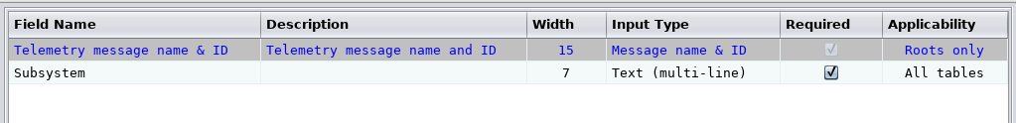

Figure 16. Data field editor with fields defined

Press the **Update** button. This causes the fields to be displayed into the table editor. It does not store the fields in the project’s database; this is done using the table editor’s **Store** button. Exit the data field editor by pressing its **Close** button. The table editor should now appear as in Figure 17.

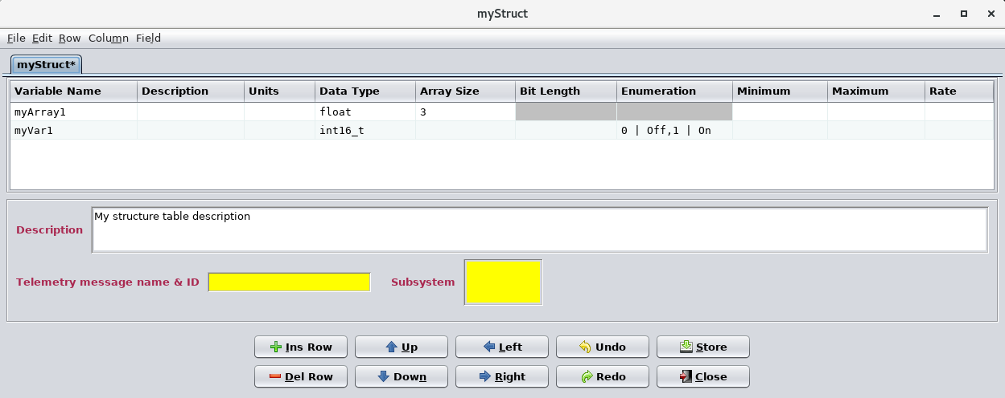

Figure 17. Table with data fields added

Since the **Required** check box was selected for the “Subsystem” field and the field is empty its background is yellow. The data fields can be edited the same as is done for the table cells and **Description** field. Enter “MySystem” in the **Subsystem** field and “MY_MSG_ID q” for the **Telemetry message name & ID** and press the **Store** button. A dialog appears indicating that the field contains invalid characters, and that a message name and ID is expected. Fields and cells with the “Message name & ID” input type expect to have a hexadecimal value (with or without the leading “0x”) for the ID portion. All table cells and data fields are checked for valid inputs based on their respective input types. Press the warning dialog’s **Okay** button. The “Message ID” field reverts to its former value, in this case empty. Leave the field empty and press the **Store** button to store the changes. Leave the table editor open for now.

## 3.6 Edit a table type

As demonstrated previously the table types are used as a template for creating tables. CCDD comes with four table types defined, **Structure**, **Structure: Cmd Arg Ref**, **ENUM** and **Command**. However, these types contain only the fundamental columns for these types of tables. The table type editor allows users to modify these base types. Required rows should never be deleted though as it could break certain aspects of CCDD.

Open the table type editor by selecting **Data | Manage table types** from the main window menu bar. The editor appears as shown in Figure 18.

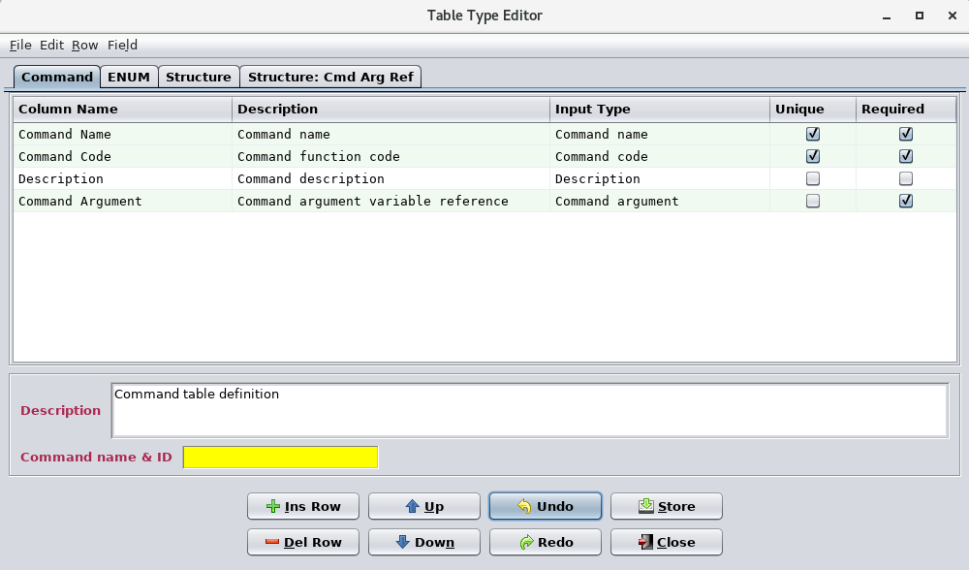

Figure 18. Table type editor

The table type editor appears very similar to the table editor, and operates in a similar manner. Each row in the table type editor table represents the definition of a column that is displayed in a table created from the table type. Select the **Structure** tab and the editor now displays the structure table type information (Figure 19).

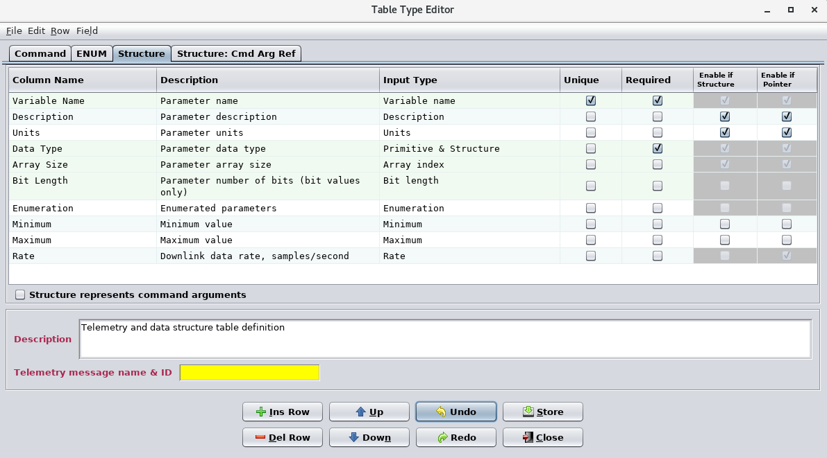

Figure 19. Default structure table type

Certain rows in the table type are highlighted (other than the standard alternating background that aids in delineating rows). These rows are considered fundamental for describing the table type (in this case a structure). For example, a structure, in order to be a structure, must contain a variable name and therefore must have a column definition for it.

Compare the rows in the structure table type to the columns in the “myStruct” table in the table editor (which should still be open). Notice that the text in the rows for the **Column Name** column match the columns names in the table editor’s column headers. The order of the column definitions determines the initial order of the columns when a table of the type is created (but recall that the order can be changed in the table editor if desired). The type editor’s **Description** column contains text that is used as tool tip text when the mouse pointer is hovered over the column’s header in the table editor.

The **Input Type** column performs like the one in the data field editor described previously. Input types are used to define and constrain the input in a table cell. Referring to Figure 19, the first row in the table type editor defines the column **Variable Name**. Its input type is “Variable name”, which constrains the value input to a valid C language variable name. It also acts as a flag to other parts of the application that this value is a variable name. A structure table type may only have a single variable name column defined. The name of the column may be anything, but the input type must be “Variable name” for it to be recognized as such.

The remaining columns are described in detail in the user’s guide.

For the tutorial a new column will be added to the **Structure** table type. In the table type editor press the **Ins Row** button; an empty row appears at the bottom of the table. Enter values in the row so that it appears as shown in Figure 20.



Figure 20. New structure table type column definition

The new column has the name “Lower Limit” and only accepts positive integer values (whole numbers > 0). The column is marked as “required”, so in the table editor its background is yellow until a value is entered into it. Press the **Store** button in the table type editor and confirm the update. Select the table editor containing “myStruct” and notice that the new column has been automatically added to the table Resize the editor or use the horizontal scroll bar at the bottom of the table if necessary for the column to be visible. Figure 21 shows the editor’s appearance with the new column.

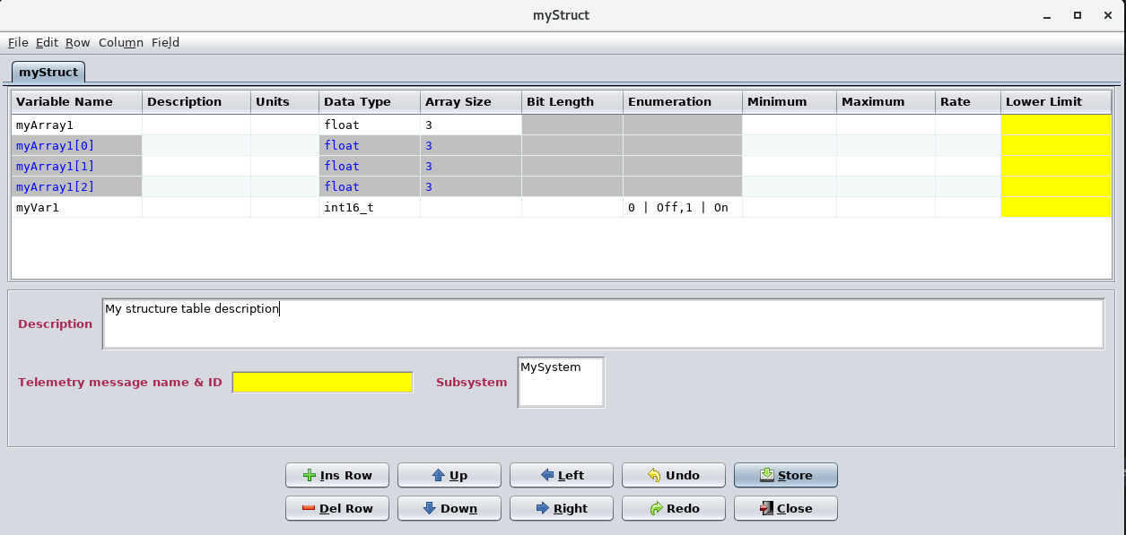

Figure 21. Structure table “myStruct” with the new “Lower limit” column

Notice that each “myArray1” array member can have its own value for the new column, as can the array definition row. If a value is entered in an array’s definition row it is automatically propagated to every member. Attempt to enter values that are not positive integers (the input type assigned to the new column); a warning dialog appears when cell editing ends and the cell reverts to its former value. Enter the values “1”, “2”, “3”, and “4” for the “myArray1” array members and “myVar1” respectively – see Figure 22. Store the updates.

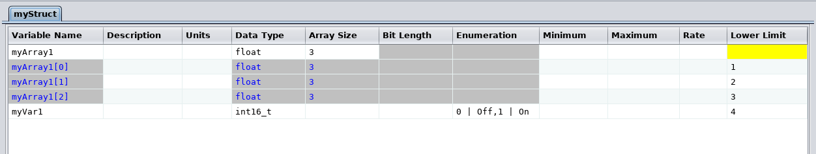

Figure 22. New column with values entered

### 3.6.1 Table type data fields

As with tables, data fields can be assigned to a table type. However, the purpose differs; data fields for a table type are used as part of the template for tables of the type. In other words, when a table is created of the type, the table also has data fields automatically assigned to it based on the ones in the type definition. Open the table type’s data field editor using the **Field | Manage fields** menu command. The data field editor appears. This **Applicability** column only appears if the table type references a structure, so if the data field editor is opened for the **Command** table type this column does not appear.

A single default field, “Telemetry message name & ID”, already exists for the **Structure** table type. For the tutorial a second default data field, named “Subsystem” (as was added to the table “myStruct”), should be included with all root tables. Press the **Ins Row** button to add a new row in which to define a new data field. Enter “SysID” for the **Field Name** and “10” as the **Size**, and leave the **Input Type** as “Text”. The **Applicability** column determines what tables are assigned the data field (both existing tables and any new ones). The three types of applicability are “All tables”, “Roots only”, and “Children only”. “All tables” means that any table of this type that’s created or exists is assigned the data field if it doesn’t already have it. For “Roots only” only root tables are assigned the field, but not child tables. Finally, “Children only” assigns the data field only when a child table is created. When the column is selected a combo box appears displaying the three choices. Select “Children only” from the list, then press the **Update** button to create the data field, which appears beneath the table in the table type editor (see Figure 23).

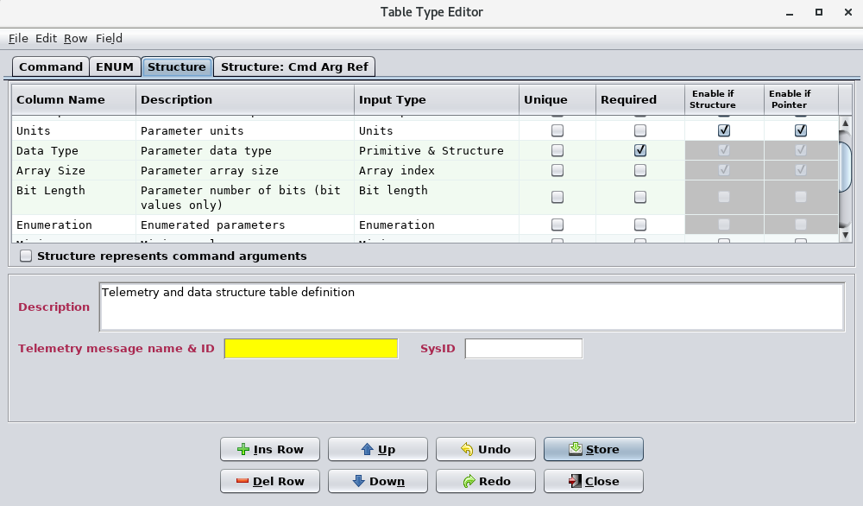

Figure 23. Table type with default field assigned

If a value is entered into the data field it is treated as a default value, so when a table of this type is created then the data field has the default value until changed by the user. Press the **Store** button to store the updates to the **Structure** table type. Note that the open table editor “myStruct” is unchanged; it’s a root table so the field doesn’t apply since we selected “Children Only”. Close the table type editor.

## 3.7 Create a child table

A table is a child table if it is referenced by another table. In practice this is when a structure table uses another structure as a data type for a variable. Create a new structure table named “myChildStruct”. To do this use the **Data | New table(s)** command, then select **Structure** as the table’s type and enter the name “myChildStruct” in the **Create Table** dialog. Press the **Create** button to create the table. Edit the table by executing the **Data | Edit table(s)** command and selecting the table from the **Prototypes** or **Parents & Children** headings in the table tree. At this point the new structure isn’t a child since it isn’t yet referenced by another structure, so for now it meets the classification of a root table and the data fields displayed reflect this (i.e., the “Telemetry message name & ID” field, applicable for root tables is displayed, whereas the “SysID” field, applicable to child tables only, is not). Notice that the table is opened in a separate table editor than the one for the table “myStruct”. When opening a table or tables via the main window menu command a new table editor is created. If you want the table to open in an existing editor use that editor’s **File | Edit table(s)** command instead. Also, by hovering the mouse pointer over the table’s tab in the editor, then pressing and holding the left mouse button, the tab may be dragged to another editor. Releasing the mouse button causes the table’s tab to move to the selected editor.

Add a variable to “myChildStruct” as shown in Figure 24. Remember to press the **Store** button to save the change to the database.



Figure 24. Variable added to structure “myChildStruct”

Select the table editor for “myStruct” and create a new variable “myChildVar”, then select its **Data Type** column. The combo box containing the data types appears and at the bottom of the list is the structure name “myChildStruct”. Select this structure as the data type, then store the change in the project database. The variable “myChildVar” is now a structure of type “myChildStruct” (see Figure 25).

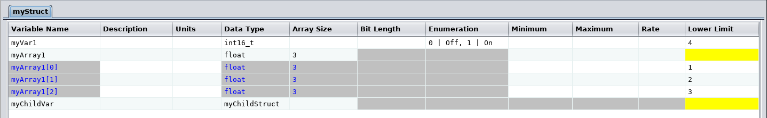

Figure 25. Child structure variable added to structure “myStruct”

Use **File | Edit table(s)** in the table editor displaying “myStruct” to open the table tree, then select the “Expand all” check box. Under the **Parents & Children** heading the table “myStruct” now has a substructure, “myChildStruct.myChildVar”. The form of the child’s name is *data type*.*variable name*. Select the child table in the tree and press the **Open** button. The child is opened under a separate tab in the same editor as “myStruct”. Notice that the tab contains the name of the root table (“myStruct”) and the variable (“myChildStruct.myChildVar”). This is the format even when there are multiple nest levels of structures referencing structures; however, hovering the mouse pointer over the tab provides a tool tip showing the full path to the variable (as well as the tables’ type name). Compare

“myChildStruct.myChildVar” to its prototype table, “myChildStruct”, in the other open table editor (see Figure 26).

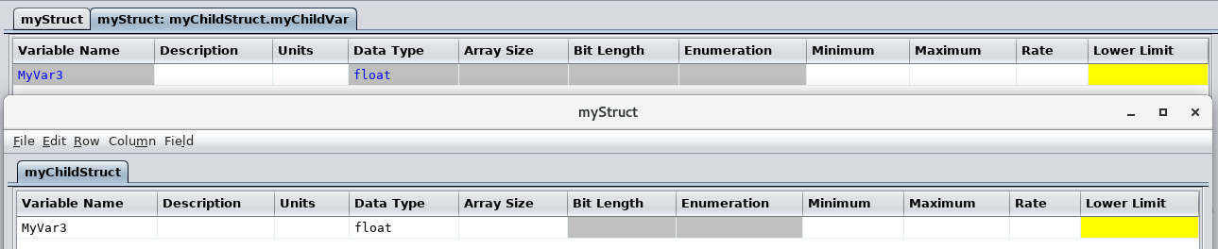

Figure 26. A child table and its prototype

“myChildStruct.myChildVar” represents an instance of the structure “myChildStruct”. As such, it inherits the characteristics of “myChildStruct”, such as variable names, data types, array sizes, data fields (and their values), etc. Some of these characteristics are immutable; in other words, these can’t be changed in “myChildStruct.myChildVar” since doing so would make it no longer an instance of “myChildStruct”. The cells containing the non-changeable items have gray backgrounds. The remaining cells can be altered. An instance of a table always inherits the values in its prototype’s cells, but if altered in the instance then the instance’s values override the inherited values. Data fields (and their values) are inherited only at the point when the instance is created. Data fields added, removed, or altered in the prototype afterwards are not propagated to existing child tables.

To demonstrate inheritance of table values, in “myChildStruct” enter the text “myVar3 description” in the **Description** column for variable “myVar3”, then store the update. Notice that the description for “myVar3” in the editor for “myChildStruct.myChildVar” is automatically updated as well. Now edit the **Description** column in “myChildStruct.myChildVar” for “myVar3” and change it to “Custom myVar3 description” and store the change. The contents of the two tables should appear as in Figure 27.

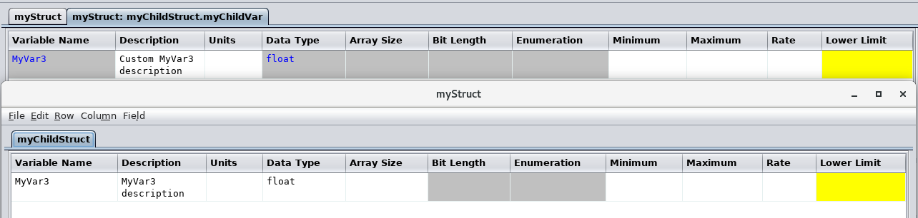

Figure 27. Overriding inheritance of a table cell

Close the editor for “myChildStruct.myChildVar” by selecting the **Close** button for its editor (the editor window remains since the table “myStruct” is still open in it; closing “myStruct” would cause the editor window to disappear as well). Reopen “myChildStruct.myChildVar”, but this time use the short cut method: position the mouse pointer over the data type cell for variable “myChildVar” in “myStruct”, then double click the right mouse button; “myChildStruct.myChildVar” is opened in the same editor window with “myStruct” as before. Notice that “myChildStruct.myChildVar” retains the custom value in the **Description** column that was entered previously, and no longer inherits the description from the prototype. Edit the description in “myChildStruct.myChildVar” again, delete the text from the **Description** cell, then store it, then close and reopen myChildStruct.myChildVar”. The description remains empty and doesn’t inherit from the prototype since a blank cell is considered an overriding value as well.

To restore inheritance to a cell, select the cell, then in the editor’s menu bar select **Edit | Replace selected | with prototype**. The contents of the cell is replaced with that from the prototype (“myVar3 description” in this case), preceded by a special flag character as shown in Figure 28. Store the change to restore inheritance to the description cell (note that the special flag character is removed).



Figure 28. Restoring a cell’s inheritance

## 3.8 Grouping tables

The number of data tables in a project can become large, making it more time consuming to locate a table and difficult to keep track of which tables are related. The group manager provides a means of more easily managing the tables. Open the group manager (Figure 29) using the main window’s menu bar **Data | Manage groups** command.

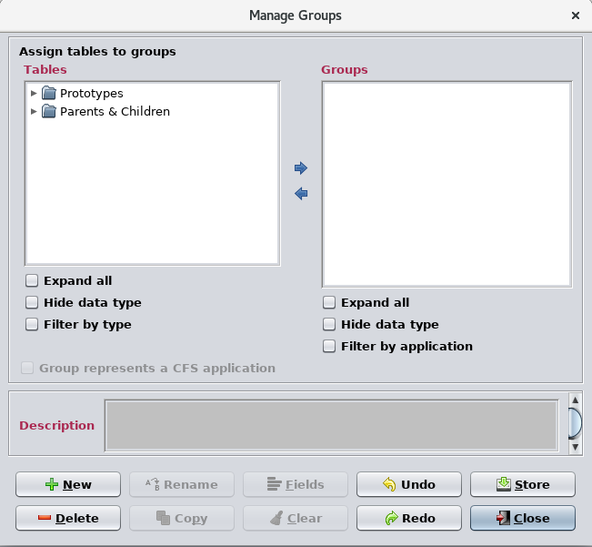

Figure 29. Group manager

The group manager allows tables, selected from the table tree in the upper left (and which acts just like the table tree when opening a table for editing), to be assigned to groups in the group tree in the upper right. A group must be created before a table can be assigned, so press the **New** button and in the dialog that appears enter the group name “MyGroup”, then press the **Okay** button. The group “My Group” appears in the group tree. Expand the table tree and from the **Parent & Children** branch of the tree select the table “myStruct” using the mouse or keyboard. In the group tree select “My Group”. Now press the right arrow button between the two trees – “myStruct” appears as a member of the group “My Group”. Notice that the child table of “myStruct”, “myChildStruct.myChildVar”, is included automatically. All tables that are descendants of a selected tree item are automatically included in the assignment. Figure 30 shows the result of assigning the table to the group.

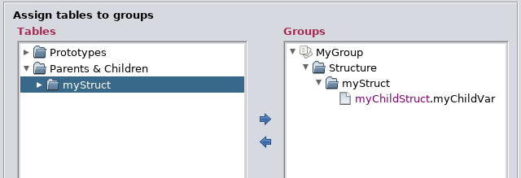

Figure 30. Assigning a table to a group

Any number of tables may be assigned to a group. Any number of groups may be created, and a table can belong to as many groups as desired. Deleting a group has no effect on the tables that were assigned to it.

Create a second group, “Working tables”, and assign “myStruct” and “myChildStruct” to it from the **Prototypes** branch. The group manager appears as in Figure 31. Since prototype tables were specifically chosen there are no child tables added.

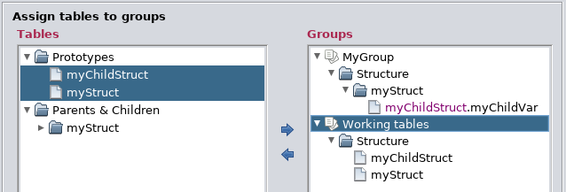

Figure 31. Multiple groups

Press the **Store** button to store the new groups in the project database, then exit the group manager by pressing the **Close** button. In the main window select **Data | Edit table(s)** to open the table tree for selecting a table to edit, then select the “Expand all” and “Filter by group” check boxes below the tree (see Figure 32; the dialog has been resized so that all of the tree is visible).

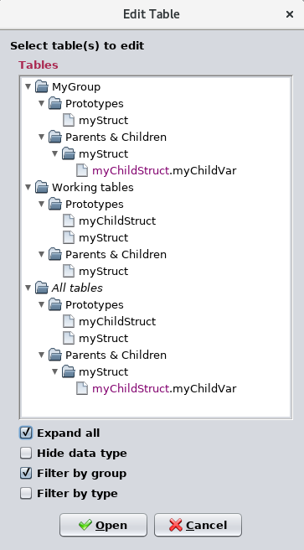

Figure 32. Multiple groups

The tree’s original headings, **Prototypes** and **Parents & Children** are now subheadings for the group headings, **My Group** and **Working tables**. Under the group heading are the tables that are assigned to the group. Notice that a third group, ***All tables***, also appears as a heading. This pseudo-group is automatically generated and displays every table. It becomes useful later, such as when associating tables and groups with scripts (see paragraph 3.9). A table can be selected from the filtered tree just as when it isn’t filtered – the filtering merely serves as an aid in arranging the tables in a meaningful way. Select **Cancel** to remove the dialog.

### 3.8.1 Group data fields

As with table types and data tables, data fields may be assigned to groups. These group data field assignments, as with table types and tables, can be accessed in the scripts and used in whatever way the user desires.

Select the group “MyGroup” from the group tree, then press the **Fields** button, which becomes active once a single group is selected. The data field editor appears; the editor behaves exactly as it does for the table type and table editors. Add the field as indicated in Figure 33.



Figure 33. Group data field

The group manager now appears as in Figure 34.

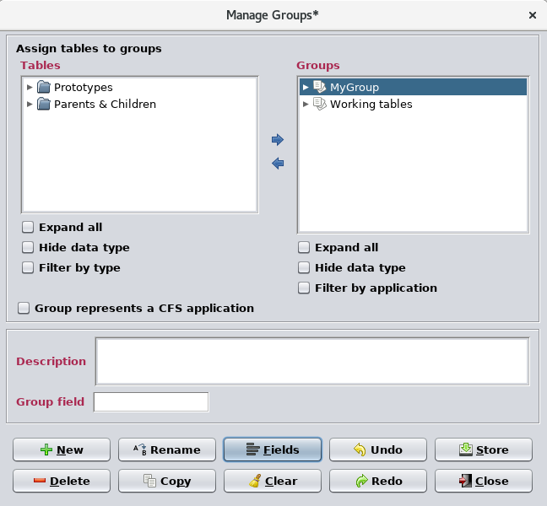

Figure 34. Group with data field assigned

Enter the text “My Group’s data field” into the “Group field” data field and store the changes. Close the group manager by pressing the **Close** button.

### 3.8.2 CFS applications

A specialized use of group data fields is in deeming a group as representing a CFS application. In the group manager, after selecting a group from the **Groups** tree, the check box “Group represents a CFS application” can be set. When this is done a number of data fields are automatically assigned to the group. The contents of these fields is used by the application scheduler and its companion script in order to create the CFS scheduler application’s (SCH) message definition and schedule definition tables. These fields can be modified, added to, or removed via the field editor as previously described.

## 3.9 Create a script association

In this section the data tables that have been created previously are “associated” with a JavaScript script. This association is then executed – the script is run using the data from the tables in order to produce an output file.

Associations are created using the script manager. In the main window command menu select **Script | Manage**; the script manager appears (Figure 35).

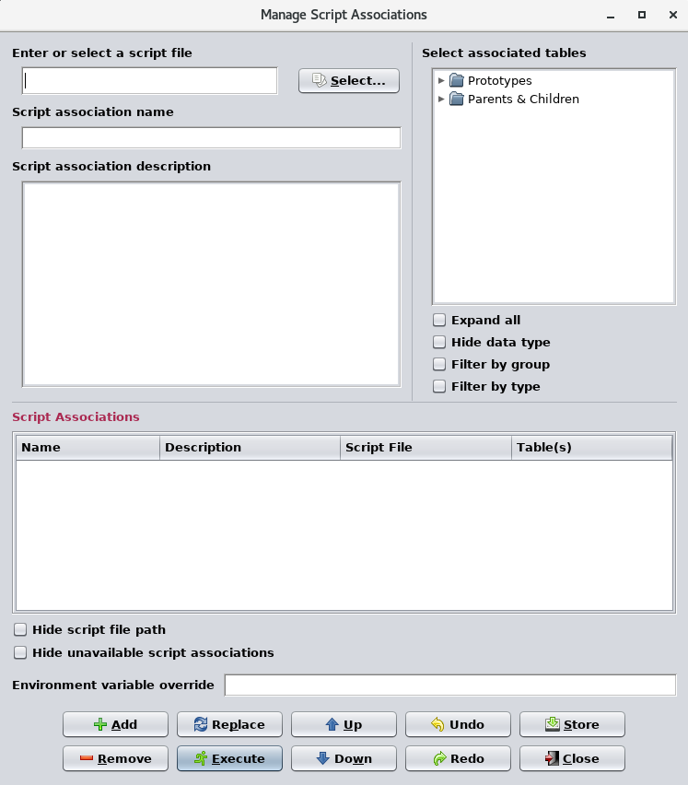

Figure 35. Script manager

The script manager is divided into five main parts: the script selection field and button, and the association name and description fields (upper left), a table tree (upper right), the table of associations (middle), and command buttons (bottom). At a minimum an association needs a script file. Not all scripts need a data table explicitly associated with them, but usually an association needs to be assigned one or more tables. A special script for this tutorial is provided as part of the CCDD installation files.

The script, tutorial.js, is found in the **scripts** folder, located in the folder in which CCDD is installed. Select the script by pressing the **Select…** button, then in the script selection dialog (Figure 36) navigate to the **scripts** folder and select the file tutorial.js.

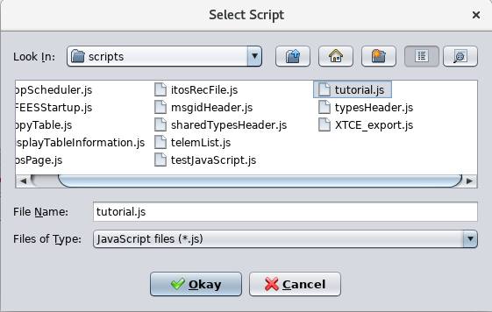

Figure 36. Script selection dialog

Press the **Okay** button. The script, including its full file path, appears in the script manager’s script field.

The table tree, located in the upper right of the script manager, acts the same as with other table trees already encountered in this tutorial. Expand the tree by using the mouse, keyboard, or by selecting the **Expand all** check box. Select the table “myStruct” from the **Parents & Children** heading, then press the **Add** button. The script associations table displays the new association (Figure 37). When a table is selected, all of the data from its child tables are automatically included, so these do not need to be explicitly selected when creating the association (though it doesn’t create any problems if they are selected). In this case the data from the child table “myChildStruct.myChildVar” will be provided to the script along with that from “myStruct”.

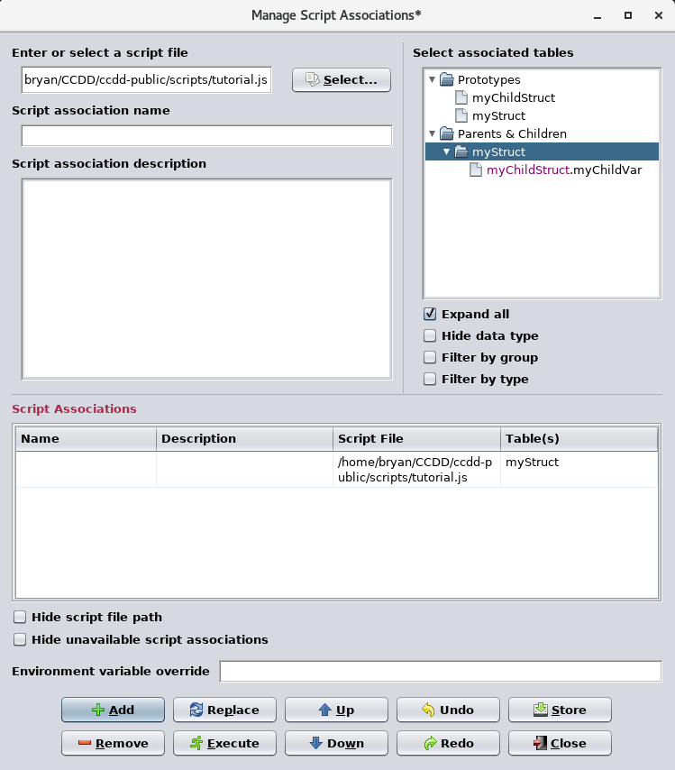

Figure 37. Script associated with a table

Select the **Filter by group** check box under the table tree and note that the two groups created earlier appear. A third group, “*All tables*”, also appears in the table tree; this group is created automatically and contains all tables. Select the group “My Group” and press the **Add** button. A second association is added to the table (Figure 38). In the Table(s) column for the first association created it shows “myStruct”, but for the new association it shows “Group:My Group”. At this point these associations are functionally identical; if executed both access the data from “myStruct” and it’ child table “myChildStruct.myChildVar”. The advantage of assigning a group instead of a table is that if the group member tables are altered the association doesn’t need to be changed; all tables belonging to the group are accessed by the script. In the case where a table is assigned to the script and another table is desired to be added, a new association must be created. The manager allows assigning both tables and groups to a script in a single association.

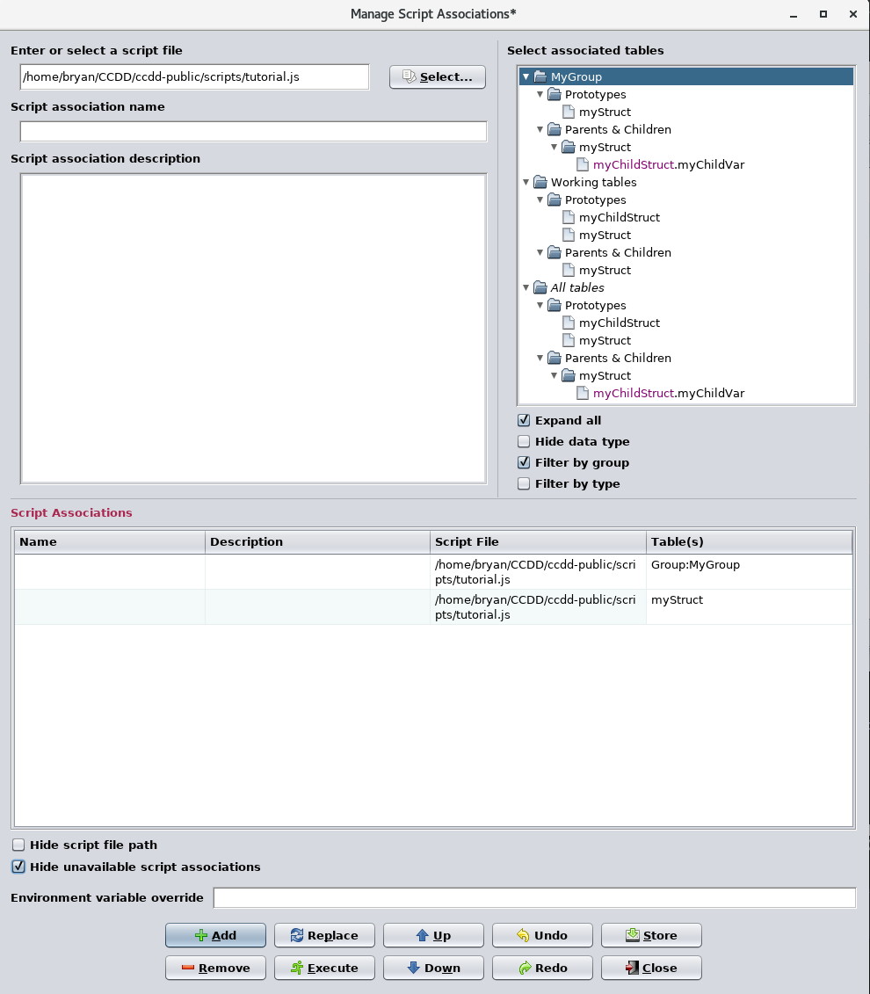

Figure 38. Script associated with a group

Press the **Store** button to store the associations in the project database. By storing the associations, these can be executed at a later time without having to recreate them.

## 3.10 Execute a script association

A script association may be executed from within the script manager or from the script executive (accessed using the main window **Script | Execute** command from the menu bar). The executive displays only the script association table and no changes can be made to the associations from this dialog. The manager and executive can’t be open simultaneously; opening one closes the other.

Select the association specifying the table “myStruct” using the mouse or keyboard. The entire line in the table is highlighted. Press the **Execute** button to execute this association. A dialog briefly appears while the script is running. This dialog allows halting execution of the script, returning control to the CCDD application. Halting a running script can be used, for example, to stop execution in the event the script contains an infinite loop.

The script, tutorial.js, creates an output file, tutorial.output, in the same folder from which the CCDD application was started. Use a file editor to locate and open the output file. Figure 39 shows the contents of the file.

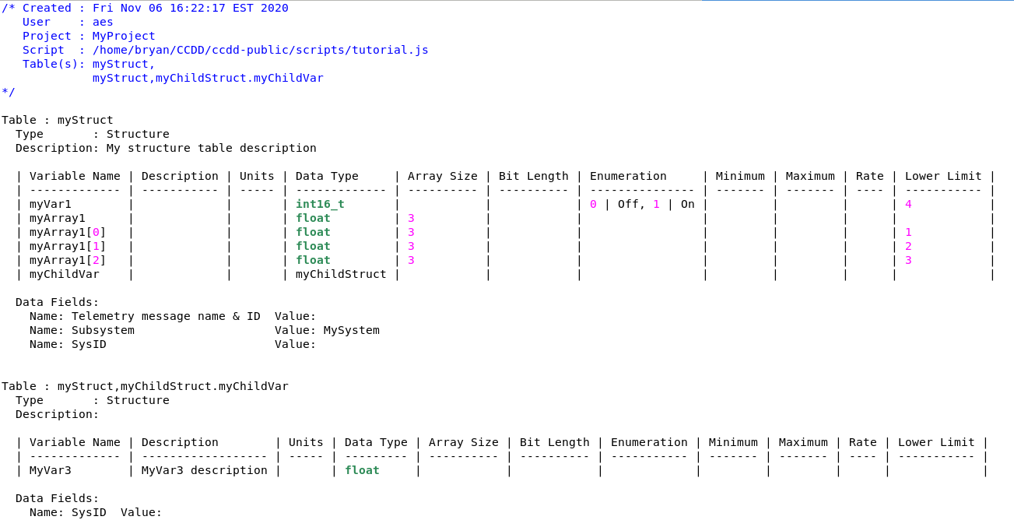

Figure 39. Script output file

## 3.11 Data types

CCDD provides a means of changing the primitive data types. This can be as simple as changing the names of the existing primitives, or can include the addition of new types, such as structure pointers. The changes are made via the data type editor, accessed using the main menu command **Data | Manage data types**. When executed the dialog shown in Figure 40 is displayed. A number of primitive types are provided by default.

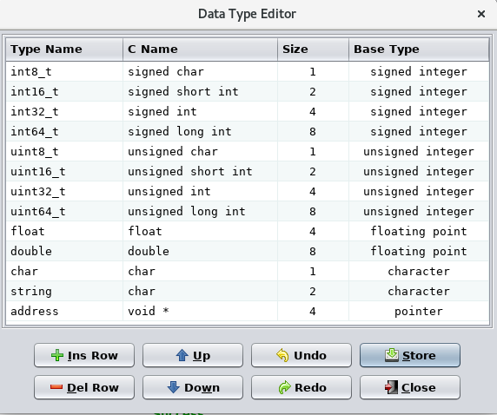

Figure 40. Data type editor

Each data type is constructed from one of seven base types and a byte size. For example, the first primitive in the editor, int8_t, has a base type of “signed integer” with a size of 1 byte. The type and C names are user definable; a minimum of one of these names must be entered (the reason for having two names is so that the information can be used to create #typedef statements in a C header file created by a script). CCDD uses the **Type Name** (if present; if not, then the **C Name**) for display in the Data Type column combo boxes. If the existing names, sizes, or base types are altered, then when the changes are stored any existing use of the data type is updated in the data tables.

For the tutorial create a pointer to structure “myChildStruct”. Insert a new line into the editor table using the **Ins Row** button. Select “pointer” as the base type in the **Base Type** combo box that appears when the cell is selected, and “4” as the size. Edit the **C Name** column. The structure name, “myChildStruct”, can be typed directly, but instead press the Ctrl-S keys. This causes a combo box to appear listing all of the structure table names. Choose “myChildStruct” from the list. The asterisk, denoting a pointer, is automatically appended to the name if not entered by the user. Enter “myChildStruct_ptr” for the **Type Name**. The result should look like Figure 41.



Figure 41. New data type

Press the **Store** button, then close the data type editor. Open “myStruct” in a table editor if not already open. Select one of the **Data Type** column cells in order to show the combo box (Figure 42) and notice that the new pointer type, “myChildStruct_ptr”, appears in the list. The list always displays the primitives before any structure references, and the order of the primitives is the same as in the data type editor.

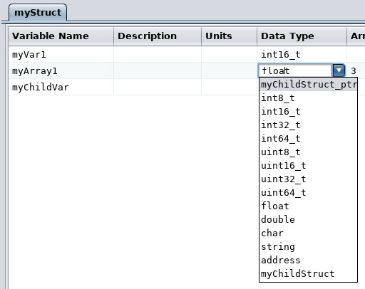

Figure 42. Added data type

## 3.12 Macros

Macros are text strings that are used to represent a numeric or text value. The CCDD utility allows macros to be inserted within the data table cells. The benefit of using a macro is that it can be used across numerous tables, and if the value needs to change it can be done in a single place rather than in each individual table. Macros are created and updated in the macro editor (Figure 43), accessible via the main menu **Data | Manage macros** command. Each macro consists of a macro name and a value, which may be blank.

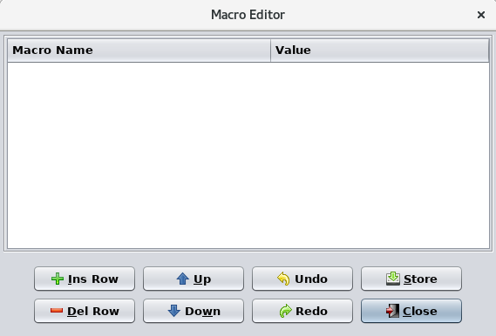

Figure 43. Macro editor

To add a macro, insert two rows into the macro editor table using the **Ins Row** button. In the first row enter “aNumber” in the **Macro Name** column and “5” in the **Value** column, and in the second row enter “someText” in the **Macro Name** column and “abc” in the **Value** column (see Figure 44). Store the changes and close the macro editor.

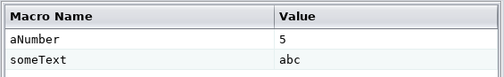

Figure 44. Added macros

Open “myStruct” in a table editor if not already open. Edit the description column for the variable “myVar1”. Type “myVar1 description ”, then press the Ctrl-M keys. A combo box appears displaying a list of macros (Figure 45).



Figure 45. Macro combo list

Select the macro “someText” from the list; the cell value displays “##someText##”, highlighted by a colored background. The leading and trailing “##” delimiting characters indicate to the application that a macro is in use. The macros can be typed directly (which must include the delimiter characters) in place of using the Ctrl-M sequence and combo box.

Expand the array “myArray1” by positioning the mouse pointer over an **Array Size** column cell and double clicking the right mouse button. Edit the array size for “myArray1” and delete the current value (3), then press the Ctrl-M keys. A combo box appears displaying a list of macros (Figure 46).

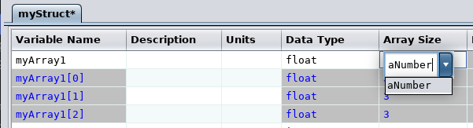

Figure 46. Macro combo list; filtered

Notice that only the macro “aNumber” appears in the list. Macros with values that are invalid based on the column’s input type are filtered from the list; in this instance the macro “someText” has a value of “abc”, which is not valid in the **Array Size** column, which only accepts array index values (in the format

#<,#<,…>>). Select “aNumber” from the list and press Enter to end editing in the cell. Notice that the **Array Size** entries for “myArray1”’s array definition and members all show the macro, and that the number of members has expanded to 5, the value of the macro (Figure 47).

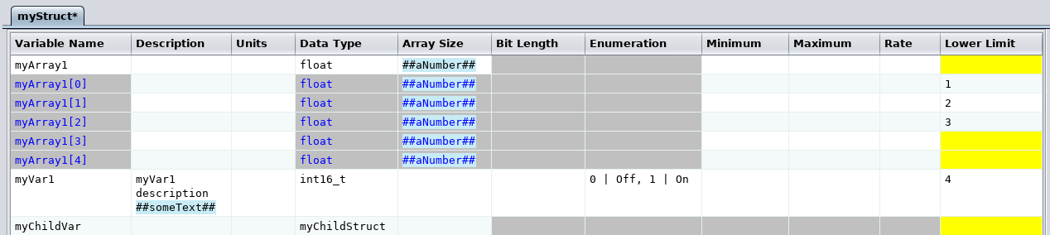

Figure 47. Array size change via macro update

Press and hold the keys Ctrl+Shift-M; the macros in the table are replaced by the macro values. Release the keys and the macro names are restored. Also, if the mouse pointer is hovered over a cell containing a macro a tip appears showing the cell value with the macro(s) replaced by the macro value(s).

Store the changes to the table, but leave the table editor open, and reopen the macro editor. Change the value for the macro “aNumber” from 5 to 3 and store the change; the array is restored to its former number of members.

## 3.13 Message IDs

CFS communicates within and between the core system and applications using messages. The message content depends on the information being transferred, such as telemetry values or commands. Each message is assigned an identification number, or message ID, that is used to identify the message to the listeners on the message bus so that the proper recipients can act on the message content. In general the IDs must be unique; otherwise a message could be mistaken for another and acted on erroneously. The CCDD application provides means for assigning message IDs (manually and automatically) and for detecting duplicate values. Input types are used to define a table cell or data field as containing a message ID or message ID name (recall these input types were used for the data fields created in section 3.5.6 of this tutorial), which CCDD can then use to locate these cells and fields.

IDs can be automatically assigned by selecting **Data | Message IDs | Assign IDs** from the main window menu. The dialog shown in Figure 48 appears.

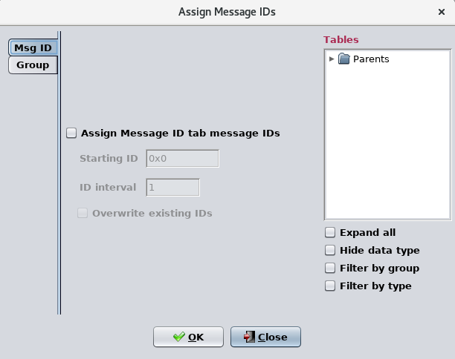

Figure 48. Assign message IDs dialog

The dialog has two tabs arranged on the left side. These allow assignment of IDs to the cells and data fields of selected tables and to data fields associated with groups.

Using the “MSG ID” tab select the check box labeled **Assign structure message IDs** and then click “Filter by group” before selecting the **Structure** table type. This indicates that structure table message ID references are to be updated. The two fields, **Starting ID** and **ID interval**, are now enabled. IDs are assigned beginning with the starting ID; subsequent ID values are spaced according to the ID interval. Set **Starting ID** to “0x110” (the ID values are in hexadecimal format; the leading “0x” can be omitted). The **ID interval** is a decimal value and with it set as “1” the first ID assigned will be “0x0110” followed by “0x0111”, “0x0112”, etc. The Overwrite existing IDs check box determines if message ID cells and fields already containing a value should retain the present value or receive a new one. Since no ID has been assigned yet the setting for this box irrelevant. Select the **Okay** button to assign the message IDs to the structure tables.

Open “myStruct” in a table editor if not already open. Below the table are the three data fields assigned earlier, one of which, names “Message ID”, has an input type of “Message ID”. Notice that the field, which had been empty, now contains the value “0x0110”.

Reopen the message ID assignment dialog and again check the **Assign structure message IDs** check box. For the starting ID enter “0x810”. Select the **Overwrite existing IDs** check box, then press the **Okay** button. Look again at the value of the “Message ID” data field for table “myStruct” – it shows “0x0900” and not “0x0810”. This is due to having ID values reserved.

In the main window execute the **Data | Message IDs | Reserve IDs** command. This produces an editor as shown in Figure 49.

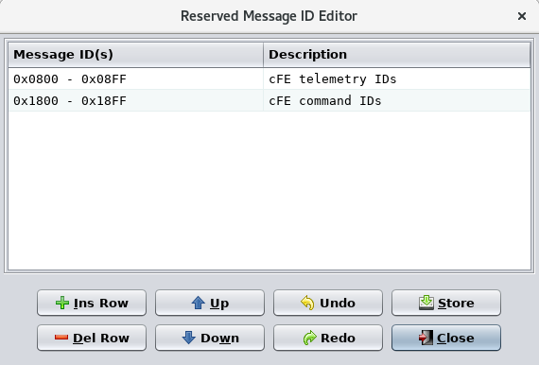

Figure 49. Reserve ID editor

The reserve ID editor allows defining single IDs or ranges of IDS that the automatic ID assignment feature ignores when assigning IDs. By default the ID ranges used by CFS telemetry and commands are reserved (these can be changed or deleted). In the example above the value “0x810” was entered as the starting ID value. The automatic assignment feature determined that this ID is reserved, so it added the interval value (1) to the ID to get “0x0811”. This value also falls within the reserved range, so the process is repeated until the value doesn’t fall within the reserved range, in this case “0x0900”, which is the first non-reserved value after the first reserved range.

## 3.14 Commands

### 3.14.1 Add a command argument to the Command table type

Command tables are used to store information pertinent to commanding the target vehicle or device. Command tables are created and edited exactly as is done for structure tables, except that the table type **Command** is selected in the **New Table** dialog (Figure 3) when a command table is created. Figure 50 shows the default command table definition in the table type editor.

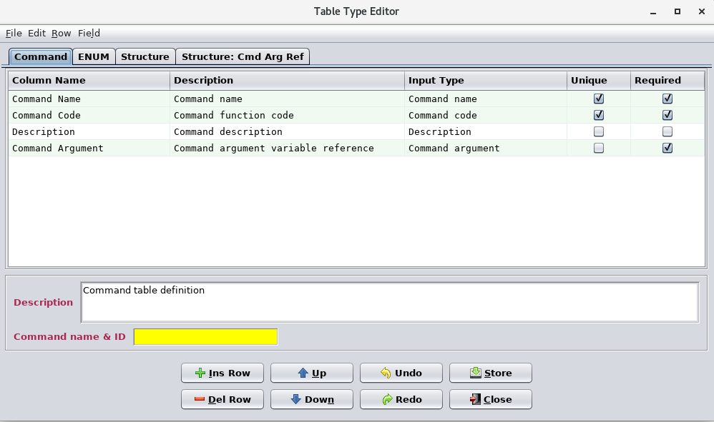

Figure 50. Command table type

Three columns are required to distinguish a command table, one with an input type of “Command name”, one of “Command code” and one of “Command Argument” (note that these three column definition rows are highlighted). The default type definition includes a column that allows you to assign a command argument. Before you can assign a command argument you will first need to define one. Other columns can be added to the definition.

### 3.14.2 Create a command table and add command information

To define a command argument select **Data | New table(s)**. Select **Structure: Cmd Arg Ref** and name the table “MyCmdArg” before selecting “Create”. Next select **Data | New table(s)** again and create another table of type **Command** with the name “MyCmd”. Once both tables have been created select  **Data | Edit table(s)** and open both of the tables as shown in Figure 51 below.

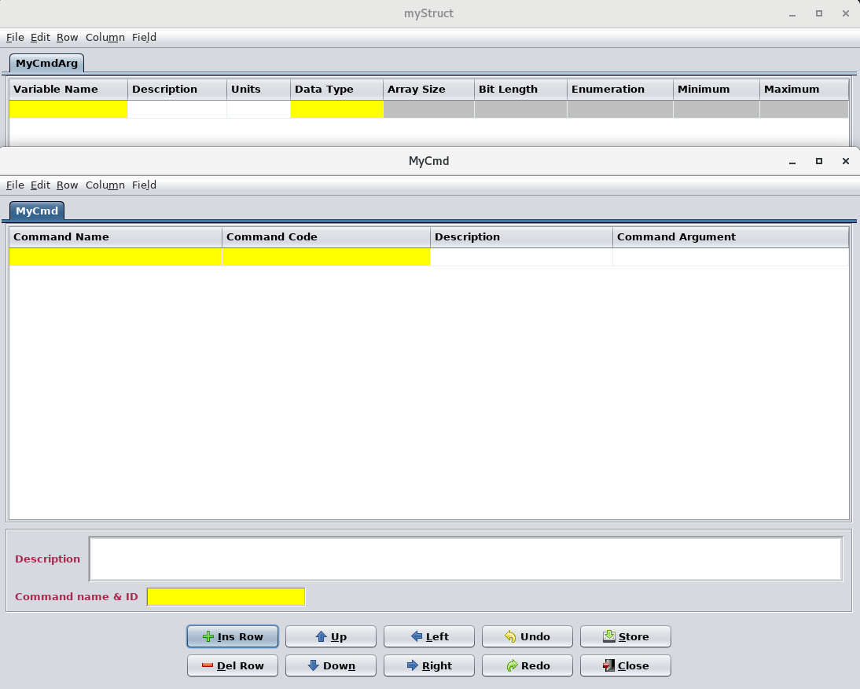

Figure 51. Command and Command Arg tables

Note that the “Command Argument” column of the **Command** table can remain blank if the argument doesn’t apply (such as with a “no-op” command like shown in Figure 52). Also notice that certain columns are grayed out. The minimum and maximum value cells become active once a numeric data type (e.g., float, uint16) is entered. The enumeration column only applies if the argument’s data type is an integer (signed or unsigned).

Insert two rows into the “MyCmd “ table and fill them with the information shown in Figure 52

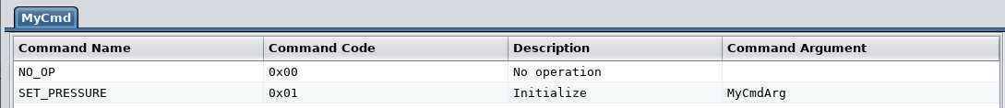

Figure 52. Command information added to table “MyCmd”

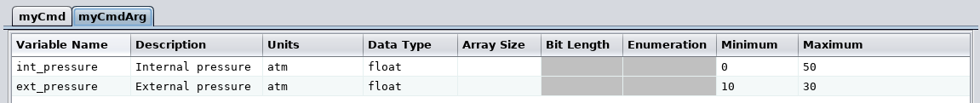Next insert two rows into the “MyCmdArg” table and fill them with the information shown in Figure 53.

Figure 53. Command Arg information added to table “MyCmdArg”

### 3.14.3 Execute a script using the command information

Open the group manager (**Data | Manage groups**) and assign the table “MyCmd” to the group “MyGroup”. Store the change and close the group manager.

Open the script executive (**Script | Execute**). Select the script association that specifies the group “My Group” in the **Table(s)** column. Since a group is used instead of specific tables (as in the other association shown in the associations table) the association doesn’t have to be altered in order to access the information in the new command table. Execute the selected association by pressing the **Execute** button.

When the script completes execution open the output file tutorial.output, located in the same folder from which the CCDD application was started. Figure 54 shows the contents of the file. Notice that the contents of the new command table, “MyCmd”, is included with the structure tables.

Below the table definitions the information for each command and its arguments (if any) are displayed.

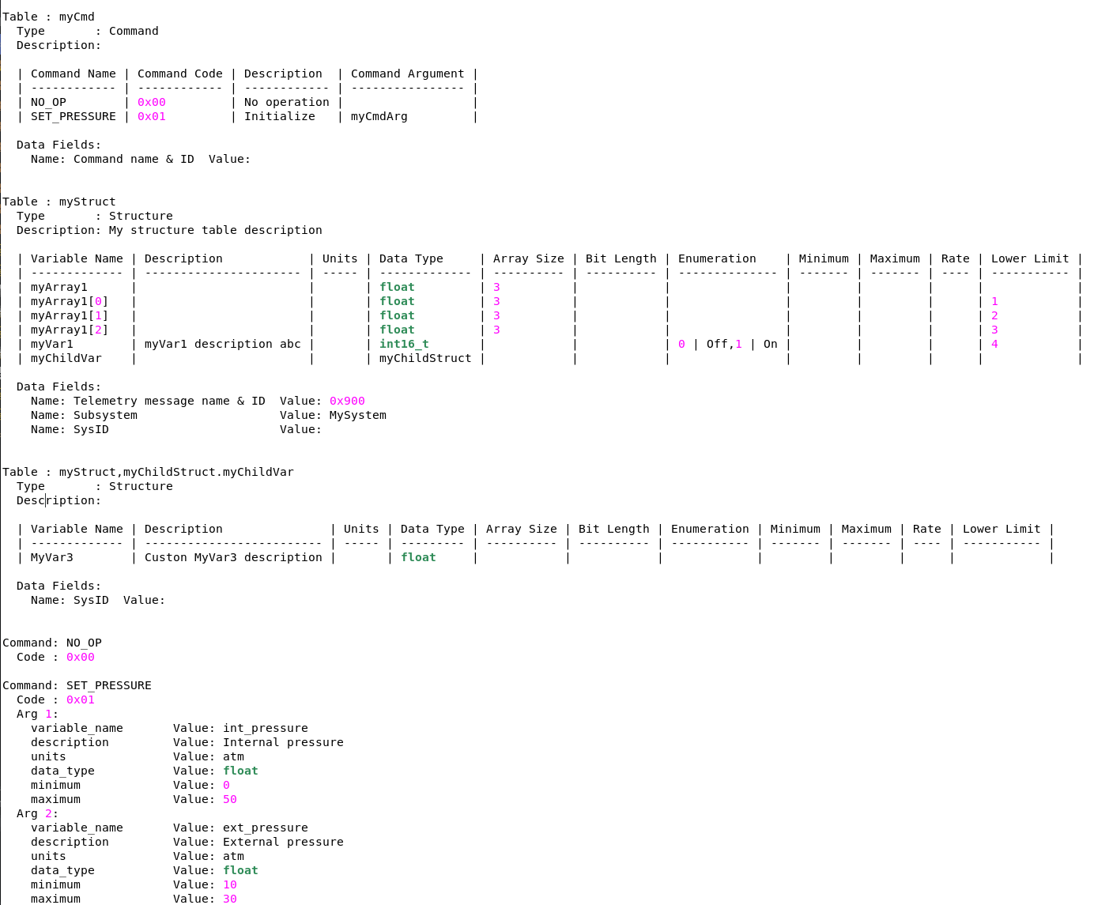Figure 53. Command Arg information added to table “MyCmdArg”

## 3.15 Importing and exporting tables

In this section a table definition is created external to the CCDD application. The table is imported into a project, then exported for comparison purposes.

### 3.15.1 Create an import file

It can be convenient at times (for example, when access to the CCDD application is unavailable) to be able to define a table and then import the information into the application. CCDD allows importing table definitions from files. The supported file formats are comma-separated values (CSV), electronic data sheet (EDS), JavaScript Object Notation (JSON), and Extensible Markup Language (XML) Telemetric and Command Exchange (XTCE). For this tutorial a table will be created in CSV format using a spreadsheet application and then imported into the CCDD project as a new table. Note that CCDD also can import data into an existing table in the project.

CCDD expects the information provided in CSV format to be parsed into sections, which define what data follows. Examples of the sections are those for the table definitions, table type definitions, and data type definitions. Each section consists of the section tag, which appears alone on a row, followed by the section contents on subsequent rows. The CCDD user’s guide provides details on the sections’ contents. Empty rows or rows beginning with a # character (a comment line) are ignored.

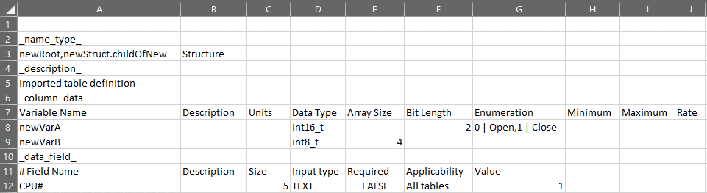Use a spreadsheet application and create a spreadsheet with the contents as shown in Figure 54.

Figure 54. Table definition in a spreadsheet

Four sections are used to define the table in this example: _name_type_ (cell A2), _description_

(cell A4), _column_data_ (cell A7), and _data_field_ (cell A10). The first section,

_name_type_, contains the table name (including a path if this is a child structure) and the table type, and must precede the remaining sections. If a second table definition is included in the spreadsheet then another _name_type_ section indicates the beginning of its sections. For the tutorial the table’s type is a structure (as indicated in column B3 in the figure). The table’s name is childOfNew, the last name in the table path (column A3). childOfNew has newStruct as its prototype structure table, and is a member of the root table newRoot. Notice that definitions for the tables newStruct and newRoot are not provided. These tables are automatically created if not already present in the project.

The second section, _description_ (cell A4), is followed by the description of the table (row 5 in the figure). This section is optional.

The next section, _column_data_ (cell A6), defines the columns names and the contents of each row and column in the table. The first non-empty, non-comment row following the section tag is the column names (row 7 in the figure). Each subsequent non-empty, non-comment row has the column values for that row of the table (rows 8 and 9 in the figure). The next section tag or the end of the file determines the number if rows in the table.

The last section, _data_field_ (cell A10), defines the data fields associated with the table. Each non-empty, non-comment row following the section tag creates a new data field. Row 11 is a comment line showing the names of the data field inputs for easy reference. Row 12 creates a data field, named “CPU #”, that accepts only positive integer values, requires an input, with an initial value of “1”. The applicability input, which only applies to data fields associated with a table type definition, may be empty.

Once the data is entered, save the spreadsheet in CSV format with the name tutorial.csv. The result should look similar to that in Figure 55. Notice that many rows end in one or more commas. These represent empty columns added by the spreadsheet application so that every row has the same number of columns. These extra columns are ignored by the CCDD application during the import operation.

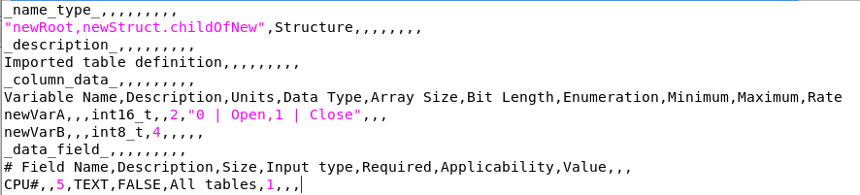

Figure 55. Spreadsheet saved in CSV format

### 3.15.2 Import the table

In the CCDD main window select the **Data | Import** command; the **Import Table(s)** dialog appears (Figure 56). The dialog displays import files in the current folder; the folder path can be changed as desired. Files for the four supported import types are displayed – the filter can be changed to show files of a single type. One or more files can be selected and the types of the chosen files do not have to be the same. For this tutorial select the tutorial.csv file created by the spreadsheet application.

42

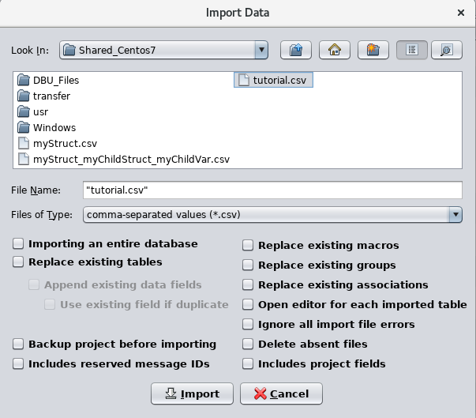

Figure 56. Import Table(s) dialog

Below the file selection controls are a number of check boxes. These control whether or not a table that already exists in the project is replaced by one of the same name in the import file (and how to treat data fields if replacement is selected), and if the project should be backed up prior to commencing with the import. Leave these unchecked for the tutorial. Press the **Import** button. A table editor appears as shown in Figure 57.

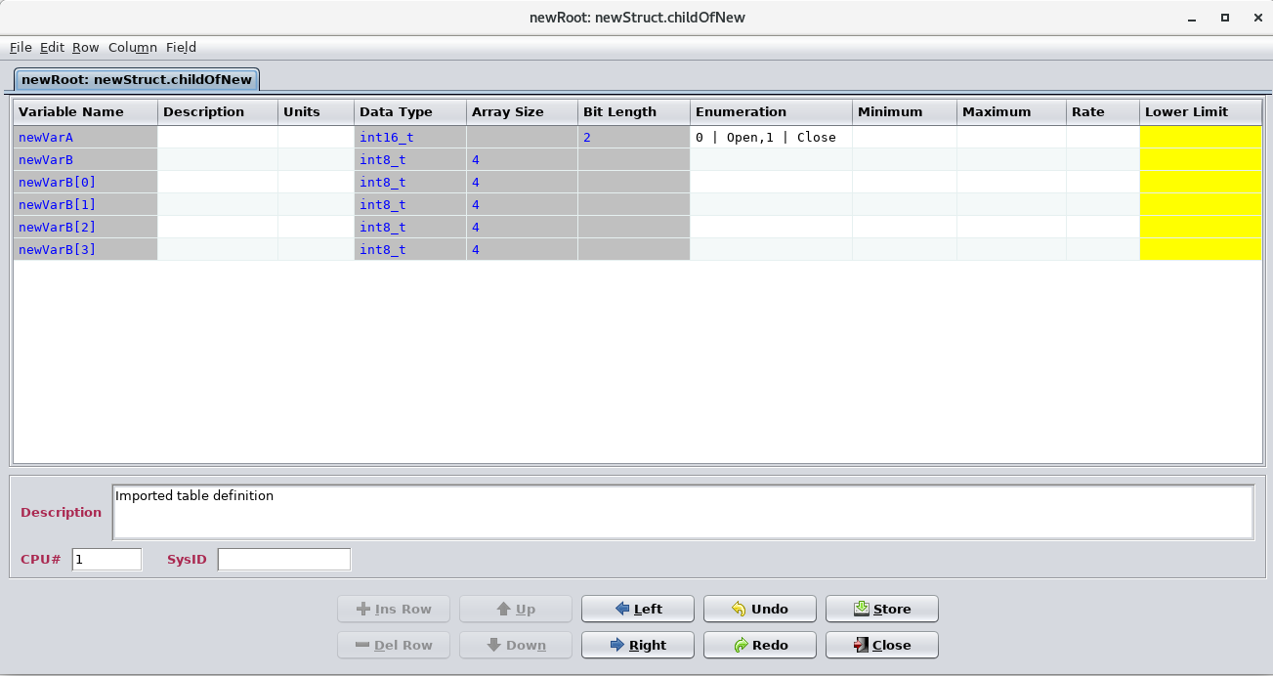

Figure 57. Imported tables in the table editor

Notice that the editor displays three tabs, one for each table created. The tab for the table **childOfNew** is initially selected. Since no prototype for this table existed in the project and wasn’t supplied in the import file, the prototype, **newStruct**, was automatically generated. Select the tab for **newStruct** and compare it to **childOfNew**. The tables are identical in most respects, except that the **newStruct** has no description (since the description was assigned specifically to **childOfNew**) and only the prototype allows changing the variable names, data types, etc. The other table created, **newRoot**, is the parent table for **childOfNew**; it’s also the root table for **childOfNew** (and a prototype table as well). Select its tab and note that it contains a single row that defines the variable **childOfNew** with the data type of structure **newStruct**.

Select the tab for **childOfNew**. In the CSV file the variable **newVarB** is defined as an array of type **int8_t** containing 4 members. The individual members are not specified in the CSV file; the members could have been entered into the import file, but since they weren’t they are generated automatically during the import process.

Note that the table editor for **childOfNew** also displays the data field that is defined in the CSV file.

### 3.15.3 Export the table

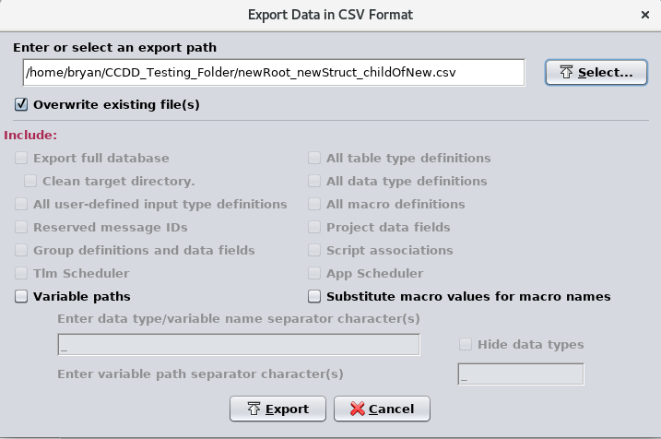Select the **File | Export table | CSV** command from the command menu in the open table editor for **childOfNew**. The Export Table(s) dialog, shown in Figure 58, appears.

Figure 58. Export table(s) dialog

Enter the path for where the exported table’s file should be placed, or press the **Select…** button to choose the path. The name of the export file is the table’s path, but with the commas and periods replaced by underscores. In this case the file name is newRoot_newStruct_childOfNew.csv. The remaining check boxes can be ignored for this tutorial; see the user’s guide for information on their use.

Press the **Export** button to export the table to the file. Using a text editor, open the export file. Its contents is shown in Figure 59.

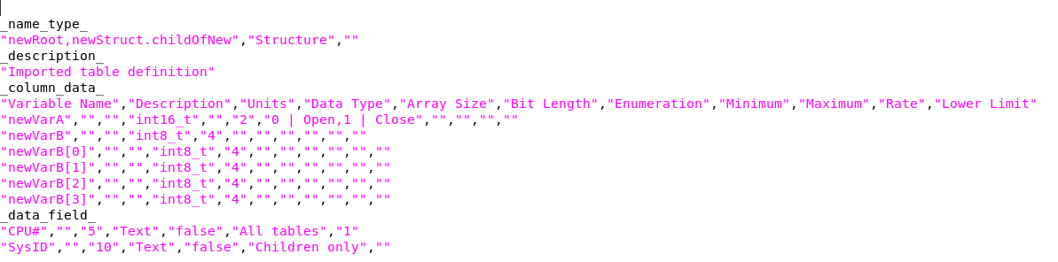Figure 59. Table exported in CSV format

The table’s definition appears first in the file. The information is almost identical to that in the import file that created the table. The differences are that the values are bounded by double quotes and the individual array members for the variable **newVarB** are included. The double quotes are included to account for any commas or other special characters within the individual values that could potentially affect parsing the file during an import operation.

## 3.16 Telemetry scheduling

Variables in the data structures can be assigned a rate (and possibly multiple rates if the structure has more than one column with the ‘Rate’ input type). This value is the variable’s desired transmission or downlink rate in samples per second (for example, between a spacecraft and the ground station).

Telemetry scheduling is the assignment of telemetered variables to telemetry messages. The CCDD telemetry scheduler is the means by which this is accomplished. This telemetry scheduler provides performing the assignment automatically and manually, and ensures that each telemetry message isn’t assigned more bytes than it can hold.

Once assignment is complete a script (provided as part of the CCDD package) uses the telemetry scheduler data to create the CFS housekeeping (HK) application’s copy table.

### 3.16.1 Telemetry rates

The telemetry rates available for assignment to a variable are dependent on a number of parameters supplied by the user. If multiple telemetry streams are present then the parameters must be assigned for each stream. The number of available streams is equal to the number of unique structure table columns with a ‘Rate’ input type. By default the structure table type definition includes a single rate column. To adjust the rate parameters in the CCDD main window execute the **Scheduling | Rate parameters** command; the **Rate Parameters** dialog (Figure 60) appears.

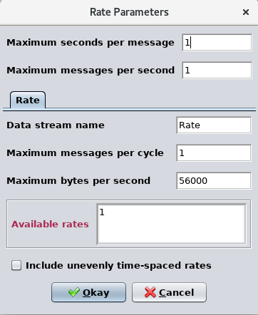

Figure 60. Rate Parameters dialog

Four parameters are required which in turn determine the available telemetry rates. The first two,

**Maximum seconds per message** and **Maximum messages per second**, are common to each stream. Below these inputs are tabs, one for each stream. The tab names are the rate column names defined in the structure table type(s). A **Data stream name** can be assigned to the stream. This defaults to the column name, but can be changed as desired. The data stream name is used in the script access methods that require the stream reference. Two other parameters, **Maximum messages per cycle** and **Maximum bytes per second**, must also be entered. These may differ for each stream. The available rate, based on the input parameters, are display in the **Available rates** field.

**Maximum seconds per message** defines the slowest rates allowed; those less than once per second. Enter 5 as the value and press the tab key. The available rates displayed are once per second, once every 2 seconds, etc. up to once every 5 seconds – the value entered.

**Maximum messages per second** is the maximum number of telemetry messages that can be downlinked in a single second. For a cycle time of one second this value is the same as the **Maximum messages per cycle** value. Enter 4 for both **Maximum messages per second** and **Maximum messages per cycle** - the rates 4 and 2 are added to the **Available rates** field. Only those rates that are evenly distributed are displayed by default. Given the values entered so far it’s possible to output a message three times per second (for example, in the first, second, and third messages of the four that are sent in a second), but the messages wouldn’t be evenly time-spaced. If these unevenly spaced rates are desired, then the **Include unevenly time-spaced rates** check box should be selected. Select the check box and notice that a rate of 3 is now added. Deselect the check box and the 3 samples/second rate is removed.

The **Maximum bytes per second** is the total number of bytes that can be transmitted in a single second. This value divided by the **Maximum messages per second** is the maximum number of bytes that each telemetry message can contain.

The dialog values at this point should be the same as shown in Figure 61. Press the **Okay** button to accept the values and store them in the project’s database.

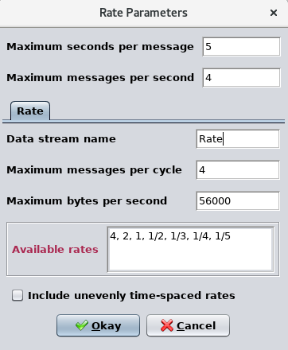

Figure 61. Rate Parameters dialog with values entered

### 3.16.2 Assigning rates to variables

### 3.16.3 Linking variables

In certain instances it’s critical that a message contains specific telemetry. For example, inertial measurement unit values for acceleration in each of three axes may be used to calculate a directional vector on the ground. If these values are returned in different telemetry messages the time difference between the messages needed to obtain the three values could produce in an error in the calculated result. The telemetry scheduler allows the variables to be assigned manually, so the user can control which telemetry values are in which messages; however this is prone to error. If automatic assignment is used then even this control is lost.

*Linking* ensures that specified variables remain together, so that if one variable is assigned to a message then any linked to it is assigned as well. The link manager, accessed via the main window’s **Scheduling | Manage links** command, provides the means of linking variables together. The link manager appears as in

### 3.16.4 Bit length and bit-packing

The **Bit Length** column allows assigning a specific number of bits to for the variable to occupy. When variables of the same data type are created adjacent to one another in the table and both are assigned bit lengths then the application assumes these variables are packed together as a bit field within the same byte or bytes (dependent on the data type) if the combined length of the bits doesn’t exceed the number of bits for the data type.