eDiscovery EDMS Uploader

and Process CFA Uploader

# Background

The **eDiscovery EDMS Uploader** is designed to ease the workflow of uploading files to: the Case File Archive; Appointed defense attorneys, including the Office of the Public Defender, Alternate Public Defender, Office of Assigned Counsel, and Multiple Conflicts Counsel via *eShare*; and to private retained attorneys via attachments in an Email that will be encrypted by the City’s server. Other paper documents should still be scanned using coversheets containing barcodes generated from CMS.

Instructions for the Process CFA uploader are generally identical, but eDiscovery options are not available.

# Procedure

Before any digital media files may be disclosed via *eShare*, the initial discovery with a coversheet containing barcodes (including a valid court case number!) generated from CMS should be scanned into the system using existing procedures.

Folders, digital media files, or compressed (zipped) folders may all be sent to the Case File Archive and *eShare* using the eDiscovery EDMS Uploader. To send a file:

1. 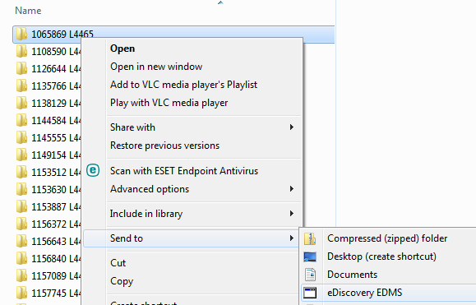Right-click on a file or a group of files and select the **Send to >** menu item, then **eDiscovery EDMS**.
2. 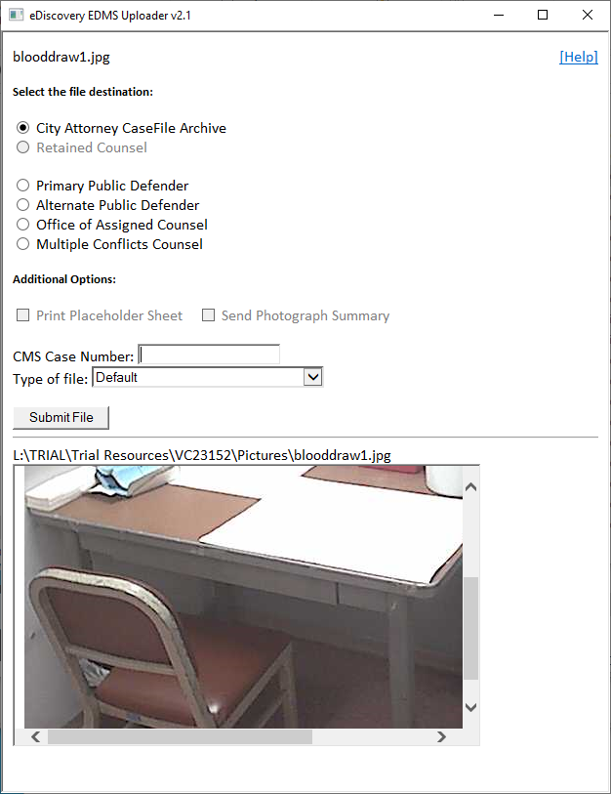 The Uploader window will appear with options for you to select. Depending on whether the file is already in the Case File Archive, some options will be disabled.
3. Select the destination office, or select **City Attorney CaseFile Archive** to add the file to only the Case File Archive.
4. Make sure that the correct CMS number is in the **CMS Case Number** field. It will often be automatically extracted from the file name.
5. Select the **Type of File** if you want it to go into a specific case subfolder. Most media files will automatically be placed in the correct folder by the server.
6. Select any additional options you need.
7. You can preview most files by clicking the **Preview** button.
8. Click the **Submit File** button once you have verified all information is correct.
9. Depending on the destination you selected, a window will open that will allow you to do further processing and verification of the file.
   1. If you selected an appointed attorney, including **Primary Public Defender**, **Alternate Public Defende**r, **Office of Assigned Counsel**, or **Multiple Conflicts Counsel** the L:\CaseFile_Archive\_FOR_DISCLOSURE folder will open so that you can wait for a log file to appear, verifying the upload.
   2. The **Retained Counsel** option is only available for files already in the Case File Archive. If you selected it, Outlook will open a preformatted Email with the new discovery as attachments. After you send the email, you will receive a message asking if you want to save the email in the Case File Archive (18_Private Attorney Share folder). Select “Yes” if your Unit’s discovery process requires you to save the email as proof of disclosure.
   3. If you selected **City Attorney CaseFile Archive**, the Case File Archive will open to the appropriate case so that you can wait for the file to appear in the appropriate folder, verifying the upload.
10. Depending on the Additional Options you selected, further actions will take place.
    1. If you selected a file already in the Case File Archive, and you selected **Print Placeholder Sheet**, a place holder for the case file will print on your default printer. This can be placed in the case file folder to indicate that there is other media available for the case.
    2. If you selected multiple image files, and you selected **Send Photograph Summary**, a pdf document summarizing the photographs will be generated and sent to the destination you selected. The original photographs will be not be sent, but will be uploaded to the CaseFile Archive along with the summary. This is useful to send numerous or large photographs, as the file size is greatly reduced and will be uploaded much faster.

## Help

This Help document can be opened by pressing the F1 key on the top row of your keyboard.