Cobra Power Regulator

Created Jun. 2024

By

Fred Crawford

Power Regulator

Introduction
The Cobra Power Regulator , regulates incoming power to 5 Volts and delivers it to the Power Rials of the Breadboard. After many years of developing with Microprocessors, I decided it was time to make a 5V. Regulator Board. The Regulator(Cobra) gets it’s name from the four Header pins on each side that mount into the breadboard, they look like Fangs of a snake.

Purpose
To be as Flexible and as useful as possible. Also to get developing quicker. I wanted something that could input AC or DC. It would also be nice if the PCB could hook directly to the Breadboard.

Theory of Operation
Most of the time I use the power from the computer to power the Microprocessors. But the USB port on the computer do not deliver much current. The Regulator will be able to convert 7 to 20 Volts DC or 15 to 30 Volts AC. Giving two ways to input the DC and a Terminal Block to input the AC. The Three inputs will be selectable via Jumpers. Only one input should be active at a time or else the Input voltages will buck each other. The output will be 5 volts, delivered by a LM7805, which with a heat sink can deliver 1.5A. The 5volt and ground will be delivered to the Left Power Rails of the Bread board. The Right Rail will be selectable as a ground, at J8.

Description of the Circuit

AC – The AC comes in on the screw down block J1 and is delivered to the Bridge Rectifier.
From the Bridge Rectifier it goes to the LM7812(12VDC rectifier). From there it is jumper selectable the final LM7805(5VDC rectifier). C1 and C2 are filter capacitors to filter out any ac noise the rectifier misses.

Barrel Input – Takes in any wall transformer 7 to 24VDC. From there it is jumper selectable the final LM7805(5VDC rectifier).

J2 Screw Down Block – This is intended for Inputs that don’t have a barrow connector, ex. A 9V battery.

Final – One and only one of the above are jumpered to the Final. The final is the LM7805(5VDC rectifier).

LM7805 – Vin max =30v, Vin min=7.5v @1.5A, LMS1585ACT -3.3/NOPB

Description of circuit

J1 – Surface mount 2 pin AC input connector, 9 to 35 VAC

J5 – DC input Barrow connector, 7 to 35 VDC

TP1-3 – Male to male short breakaway header pins used for Test Points.

KBP307 – Generic Bridge Rectifier

U1 – LM7805CT (note use good quality)

U2 – LMS1585ACT -3.3/NOPB (note use good quality)

C1 - .33mF crematic cap

C5,6 – 10mF electric cap

SW – Sparkfun ON – OFF Slide switch

J2,3,4 – Male to male short breakaway header pins used for

J2 – Selects AC or DC Input voltage

J3 and J4 – Select 3.3 or 5 Volts for the Left or Right Rails

D1 – Green ON LED indicator 3mm

R1 10K ohm resistor for led

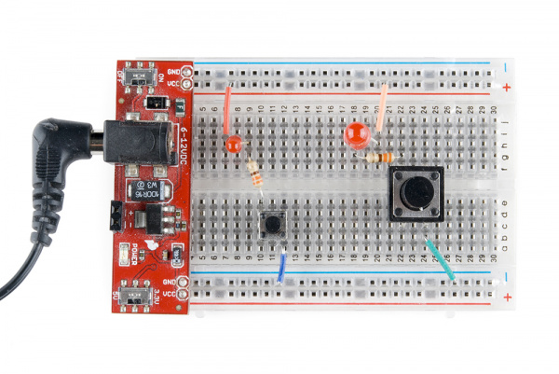
Example of a regulator that hooks onto the Breadboard.

