EpaDash Backend Technical Requirements and Core System Architecture
Document ID: | EPADASH-BE-ARCH-001 | Prepared: | 5 November 2026
Version: | 0.1 — Draft for technical review | Scope: | Original Assignment Task 5
Status: | Proposed; | ADR Reference: | ADR-0001 (Appendix A)

STATUS: PROPOSED — APPROVAL PENDING. This specification is based on the assignment brief. Company standards, providers, hosting and final business rules remain subject to technical review.
Review note: This specification is a reasoned technical proposal based on the EpaDash assignment brief. It does not claim that the stack, external providers, hosting environment, or architecture have already been approved by the company. Items marked TBD / approval required must be confirmed by the technical lead before implementation. The document intentionally separates confirmed assignment requirements from design recommendations.

Contents
1. Executive summary
2. Assignment scope and requirements
2.1 In-scope backend domains
2.2 Confirmed requirements from the assignment
2.3 Not specified by the assignment
3. Proposed technology stack
4. Architecture style and deployment shape
4.1 Recommended style: modular monolith
4.2 Logical request flow
4.3 Layer responsibilities
5. Logical module boundaries
6. Major data entities and relationships
6.1 Relationship and integrity principles
7. User roles and access-control model
7.1 Authorisation rules
8. Authentication and account security approach
8.1 Proposed authentication model
8.2 Required flows
8.3 Password and credential handling
8.4 Account statuses
9. API requirements and conventions
9.1 General conventions
9.2 Common response shape (proposal)
9.3 Domain API groups to specify
10. Core business workflow requirements
10.1 Merchant and product discovery
10.2 Order creation
10.3 Payment processing
10.4 Rider assignment and delivery
10.5 Notifications
11. Third-party integration strategy
12. Security, privacy and operational requirements
13. Testing and quality strategy
14. Proposed repository structure
15. Delivery and approval checklist — Task 5
15.1 Approval items before implementation
16. Immediate next step
Appendix A. ADR-0001 — Initial Backend Architecture
References

1. Executive summary
EpaDash requires backend capabilities for customer, merchant, rider and administrator management; merchant and product discovery; order processing; payments; delivery management; notifications; and administration. The recommended initial design is a modular monolith backed by PostgreSQL and exposed through a versioned REST API [1].
The proposed implementation stack is Node.js with TypeScript, Express.js, PostgreSQL, Prisma ORM, Zod validation, OpenAPI 3.1 documentation [2], and Vitest/Supertest testing (Table 1). This combination offers a straightforward development model, a relational data store for transactional workflows, typed application code, explicit validation and machine-readable API contracts.
The architecture keeps domain modules separated within one deployable service (Figure 1). This avoids the operational burden of microservices before there is evidence that independent deployment or scaling is needed. Payment, mapping and notification providers are accessed through adapters so that provider-specific code does not spread across domain logic.

2. Assignment scope and requirements

2.1 In-scope backend domains
1. Customer management: customer accounts, profiles, account status and customer-facing access.
2. Merchant management: merchant accounts and public merchant profiles, categories, operating status and delivery availability.
3. Rider management: rider accounts, verification/status information and delivery participation.
4. Product management: product catalogue, categories, publication state, price and availability.
5. Order processing: order creation, order items, pricing snapshots and order status lifecycle.
6. Delivery management: delivery assignment, rider association, delivery status and tracking events.
7. Payments: payment initiation/reference, provider verification, transaction status and reconciliation records.
8. Notifications: notification events and delivery through configured channels.
9. Administration: privileged account/platform operations and audit records.
10. Cross-cutting capabilities: authentication, authorisation, validation, consistent errors, logging, security, API documentation, tests and database migrations.

2.2 Confirmed requirements from the assignment
• Merchant listing, search, category filtering, profile retrieval, operating status and delivery availability.
• Product catalogue retrieval, product search, category filtering, details, pricing and availability.
• Public discovery must not expose unpublished products or merchant listings that are not active and intended for public display.
• Registration, login, logout, password recovery/reset, session/token management and role-based access.
• Customer, merchant, rider and administrator roles, profile management, account status, verification requirements and permission enforcement.
• Relational database entities, relationships, constraints, indexes, migrations and seed scripts.
• Order, payment, rider assignment and delivery workflows.
• API contracts for authentication, customer, merchant, product, order, payment, rider, delivery, notification and administration domains.
• Payment, mapping and notification integration requirements.

2.3 Not specified by the assignment
The assignment does not name a payment gateway, mapping provider, messaging provider, cloud host, deployment platform, frontend framework, expected traffic, service-level objectives, data-retention policy, or jurisdiction-specific compliance requirements. These are not to be guessed. Provider selection and operational policies remain approval items.

3. Proposed technology stack
Table 1 summarises the proposed backend technology choices across runtime, persistence, validation, contract documentation, security and testing layers.
Table 1: Proposed backend technology stack
Layer | Proposed choice | Reason / notes
Runtime | Node.js LTS [5] | Mature server-side JavaScript runtime
Language | TypeScript, strict mode [6] | Compile-time type checking and maintainability
HTTP framework | Express.js [7] | Small, flexible REST framework; keep layers explicit
Database | PostgreSQL [4] | Relational integrity and transactions for orders/payments
ORM / migrations | Prisma ORM [8] | Typed database access and migration workflow
Validation | Zod [9] | Runtime validation for request payloads and environment config
API contract | OpenAPI 3.1 [2] | Machine-readable contract usable by frontend and tooling
API explorer | Swagger UI | Human-readable interactive API reference
Tests | Vitest + Supertest [10] | Unit and HTTP integration testing
Logging | Pino | Structured logs; redact secrets and sensitive fields
Password hashing | Argon2id [3] | Password-specific one-way hashing
Source control | Git + GitHub | Branching, review and traceability
Local services | Docker Compose (proposed) | Repeatable local PostgreSQL environment

Approval required: Confirm that these choices align with company standards, deployment support and developer familiarity. If a company-mandated stack exists, that standard overrides this proposal. The final decision must be recorded in an Architecture Decision Record (ADR; see Appendix A).

4. Architecture style and deployment shape

4.1 Recommended style: modular monolith
One backend application is deployed as a single service. Internally, it is divided into domain modules with clear interfaces (Figure 1). Modules share one PostgreSQL database but should not reach into another module's internal implementation. Cross-module interaction should occur through service interfaces or explicit application-layer calls.
Why this is the recommended starting point
• The assignment describes a connected platform with transactional relationships across users, merchants, products, orders, payments and deliveries.
• One service simplifies local setup, deployment, debugging and end-to-end testing.
• Database transactions can be used directly for operations that must be atomic.
• Module boundaries preserve maintainability and leave room for later extraction if measurable needs arise.
Microservices are not recommended as the initial default because the assignment provides no traffic, scaling, independent release or organisational requirement that justifies distributed deployment complexity.
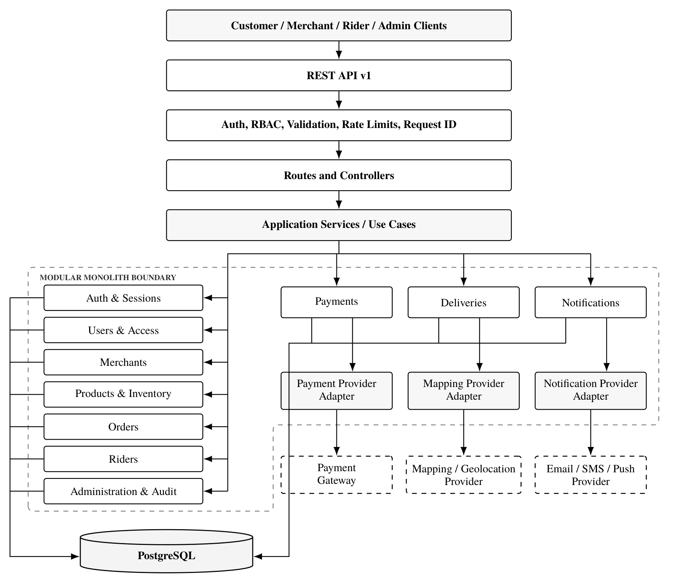
Figure 1: EpaDash backend system architecture and provider adapter context (architecture-context.mmd)

4.2 Logical request flow
Client application → API router → authentication middleware → request validation → controller → application/service layer → repository/data access → PostgreSQL. External provider interactions are performed by dedicated adapters. Responses use a common success/error envelope (Figure 2).
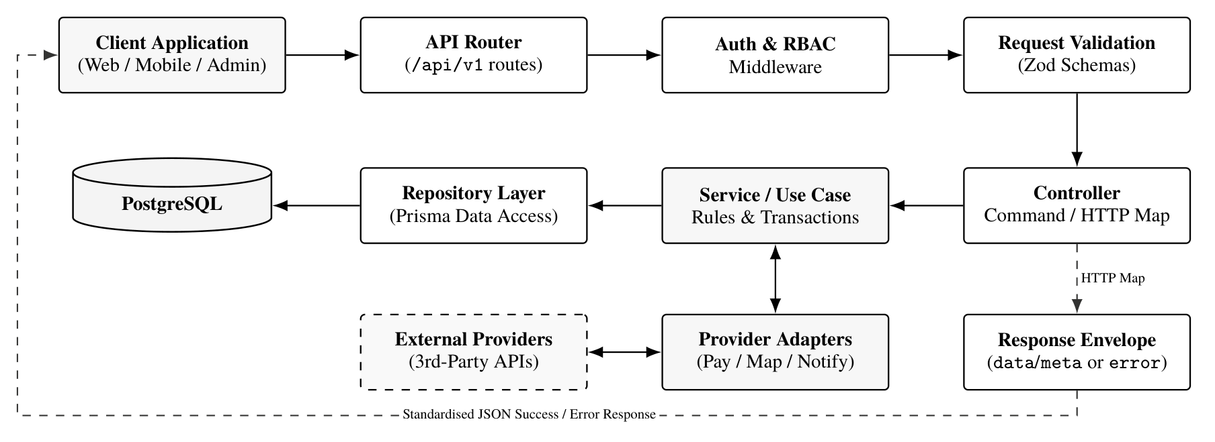
Figure 2: Logical HTTP request pipeline, persistence boundary and external adapter interaction

4.3 Layer responsibilities
• Routes: bind HTTP method/path to middleware and controller; no business rules.
• Middleware: authentication, permission checks, request IDs, rate limiting and common request concerns.
• Controllers: translate HTTP requests into application commands and map results to HTTP responses.
• Services / use cases: enforce business rules and coordinate transactions.
• Repositories: encapsulate database reads/writes.
• Provider adapters: wrap payment, mapping and messaging provider APIs.
• Schemas: validate request, response and environment configuration.
• Tests: verify domain rules, API behaviour, security boundaries and integration contracts.

5. Logical module boundaries
Table 2 defines the responsibilities and primary dependencies of each internal domain module within the modular monolith.
Table 2: Logical domain module boundaries and primary dependencies
Module | Responsibilities | Primary dependencies
Auth | Registration, login, logout, password reset, sessions/tokens | Users, email/SMS adapter
Users & Access | Profiles, roles, account status, verification state, permissions | Auth, audit
Merchants | Merchant profile, public visibility, categories, operating status, delivery coverage | Users, products, delivery rules
Products | Product details, categories, publication state, pricing | Merchants, inventory
Inventory | Stock/availability and safe stock adjustments | Products, orders
Orders | Cart/order validation, order items, pricing snapshot, lifecycle | Users, merchants, products, inventory, payments, delivery
Payments | Payment initiation, provider reference, verification, webhook handling, reconciliation | Orders, payment adapter, audit
Riders | Rider profile, availability and verification | Users
Deliveries | Assignment, rider allocation, delivery status and tracking events | Orders, riders, mapping adapter
Notifications | Notification event creation and channel dispatch | Users, messaging adapter
Administration & Audit | Privileged operations, audit trail and operational views | All modules through approved interfaces

Modules may be delivered in stages. The module list describes the target platform scope and does not imply that every capability must be built in one implementation increment.

6. Major data entities and relationships
This section is a conceptual outline (Table 3 and Figure 3). Task 3 will produce the detailed ERD, attributes, keys, constraints, indexes, migrations and seed data.
Table 3: Conceptual domain data entities and key relationships
Entity | Purpose | Key relationships (conceptual)
User | Shared login identity and account status | Has one or more role assignments; may own customer, merchant, rider or admin profile
Role / Permission / RolePermission | Access control model | Roles map to permissions; users receive roles
CustomerProfile | Customer-specific profile | Belongs to User
Merchant | Merchant business profile and public state | Belongs to User/merchant owner; has products and orders
MerchantCategory | Merchant classification | Many-to-many or association with Merchant
MerchantOperatingHour | Weekly opening schedule | Belongs to Merchant
DeliveryZone | Geographic delivery coverage | Belongs to Merchant; geometry/coverage representation TBD
Product | Product catalogue record | Belongs to Merchant; belongs to category; has inventory/availability
ProductCategory | Product classification | Products may map to one or more categories depending on approved rules
Inventory | Stock/availability | Belongs to Product; stock policy TBD
Order | Customer purchase and lifecycle | Belongs to Customer; contains OrderItems; references Merchant; may have Payment and Delivery
OrderItem | Purchased item and price snapshot | Belongs to Order and Product; stores quantity and agreed price at order time
OrderStatusHistory | Order lifecycle audit | Belongs to Order; records state transitions
Payment | Payment attempt/current state | Belongs to Order; references provider transaction
PaymentTransaction / WebhookEvent | Provider events and verification evidence | Linked to Payment; idempotency key unique
RiderProfile | Rider-specific information and status | Belongs to User
Delivery | Fulfilment record | Belongs to Order; assigned to Rider; has tracking events
DeliveryTrackingEvent | Location/status/time event | Belongs to Delivery
Notification | Message/event record | Recipient User; channel and delivery status
AuditLog | Security and administrative activity | Actor User where available; immutable event metadata

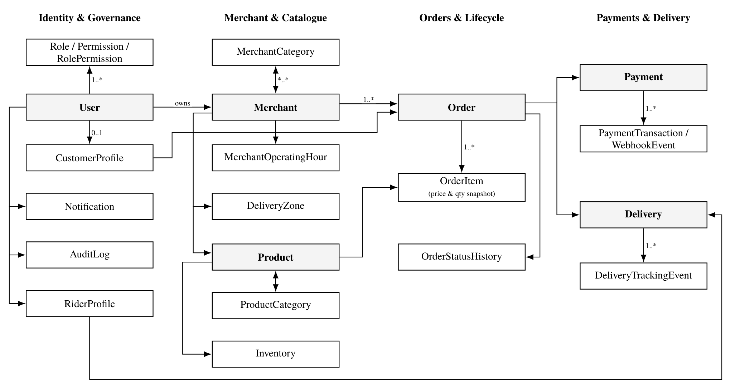
Figure 3: Conceptual entity-relationship overview across EpaDash domains (detailed schema deferred to Task 3)

6.1 Relationship and integrity principles
• Use stable primary keys and explicit foreign keys.
• Use unique constraints for login identifiers and provider references where appropriate.
• Preserve order-time product name, quantity and unit price in order items; do not rely only on the current product record for historical order totals.
• Represent payment attempts and provider events separately enough to support retries and reconciliation.
• Use transactions for order creation, stock reservation/decrement and other multi-row operations that must remain consistent.
• Use idempotency keys for payment webhooks and other retried external operations.
• Use timestamps consistently (UTC storage recommended); local display time is a presentation concern.
• Decide deletion/retention behaviour before adding cascading deletes to financial, order or audit records.
• Exact cardinalities, nullable fields, enum values, deletion policies and indexes belong in Task 3's detailed schema.

7. User roles and access-control model
The assignment explicitly identifies four roles. Table 4 sets out the proposed high-level permission boundary; detailed endpoint-by-endpoint permission mapping will be included in the API contract.
Table 4: User roles and intended access boundaries
Role | Intended access
Customer | Manage own profile; browse public active merchants and published products; create and view own orders; access own payment and delivery information
Merchant | Manage own merchant profile and authorised catalogue/inventory; view and process orders belonging to that merchant; access merchant-specific operational information
Rider | Manage permitted rider profile/status; view only deliveries assigned to that rider; update permitted delivery milestones and tracking
Administrator | Access approved platform administration functions, manage accounts/status and review operational/audit information

7.1 Authorisation rules
• Deny by default; explicitly grant only the permissions required [12].
• Authentication proves identity; authorisation decides whether the identity may perform the requested action.
• Enforce permissions on the server for every protected endpoint.
• Enforce resource ownership and tenant boundaries in addition to role checks. A merchant must not access another merchant's private resources; a customer must not access another customer's order; a rider must not update another rider's assignment.
• Administrative privileges should be narrowly defined and audited.
• Never trust a role, user ID, merchant ID or ownership claim supplied only in a request body; derive identity from the authenticated principal and verify resource relationships.

8. Authentication and account security approach

8.1 Proposed authentication model
Use short-lived signed access tokens and rotating refresh tokens, or a company-approved server-side session approach [11]. The final choice must consider frontend storage, deployment topology and security review. For a browser client, secure, HttpOnly, SameSite cookies are generally preferable to storing long-lived credentials in local storage. Native/mobile clients may require a different secure storage approach.

8.2 Required flows
1. Registration: validate fields, normalise login identifiers, hash password with Argon2id [3], create account in an appropriate initial status, and trigger required verification.
2. Login: verify credentials, check account status, issue access credential and refresh/session record, record security-relevant event.
3. Logout: revoke the refresh token/session; invalidate server-side session state.
4. Refresh: rotate refresh token, detect reuse where supported, revoke compromised token family/session.
5. Password recovery: return a non-enumerating response; send a single-use, expiring reset token through a configured channel.
6. Password reset: validate token, enforce password policy, update password hash, revoke existing sessions/refresh tokens as required.
7. Account activation/suspension: enforce status checks at authentication and protected operations; record actor, reason and time for administrative changes.
Figure 4 illustrates the authentication decision logic, account status gate and refresh-token rotation lifecycle.
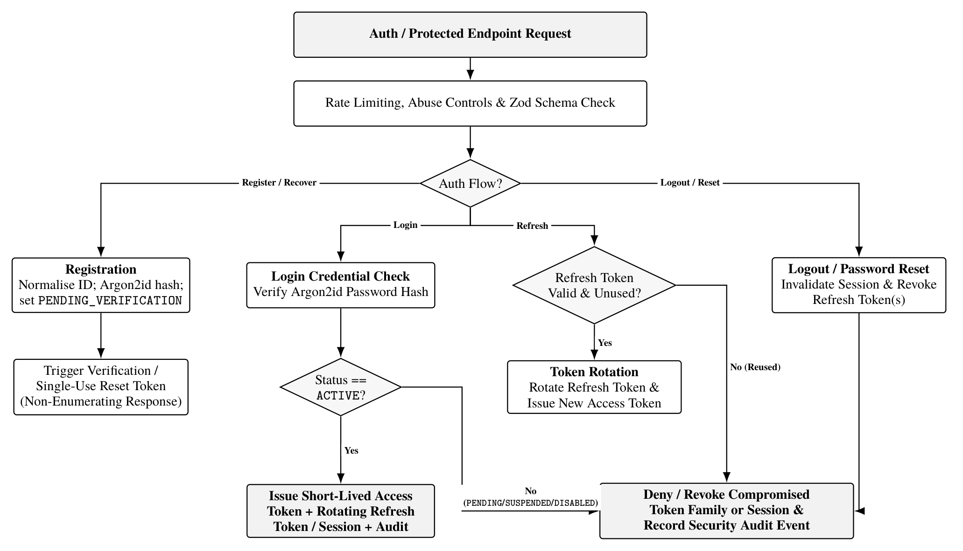
Figure 4: Authentication, account status enforcement and refresh-token rotation flowchart

8.3 Password and credential handling
• Store only password hashes, never plaintext or reversible passwords.
• Use Argon2id with parameters reviewed against deployment resources and current security guidance [3].
• Store secrets in environment/secret management, never source control.
• Do not log passwords, access tokens, refresh tokens, reset tokens, payment secrets or full sensitive payloads.
• Apply rate limits and abuse controls to login, registration, password recovery and verification endpoints.
• Use TLS for all non-local traffic.

8.4 Account statuses
Proposed user account states: PENDING_VERIFICATION, ACTIVE, SUSPENDED, DISABLED. Exact state transitions and whether all roles share the same state machine require review. Suspended/disabled accounts must not authenticate or perform protected actions. Public merchant visibility is also dependent on merchant-specific publication/approval state, not just user account state.

9. API requirements and conventions

9.1 General conventions
• Base path: /api/v1 (proposed).
• Use nouns for resources and standard HTTP methods [1].
• JSON request and response bodies, UTF-8.
• Validate query, path and body parameters.
• Use pagination for collection endpoints; choose cursor or offset strategy based on query needs and document it.
• Define stable sorting and filtering parameters.
• Use consistent response envelopes and a standard error shape.
• Do not expose internal database models directly as public API contracts.
• Publish OpenAPI specification and Swagger UI [2]; coordinate breaking changes with frontend.

9.2 Common response shape (proposal)
Success:
{
"data": {},
"meta": {
"requestId": "request-id"
}
}

Error:
{
"error": {
"code": "VALIDATION_ERROR",
"message": "The request could not be processed.",
"details": [],
"requestId": "request-id"
}
}

The exact envelope, pagination metadata and error codes should be agreed with the frontend developer before contract freeze.

9.3 Domain API groups to specify
• /auth: register, login, logout, refresh, forgot-password, reset-password, verification.
• /users/me: current profile read/update; administrative user management under protected routes.
• /merchants: public listing/search/category filters/detail; merchant-owned management endpoints.
• /products: public catalogue/search/category filters/detail; merchant-owned create/update/publication endpoints.
• /inventory: stock/availability management and order reservation operations.
• /orders: create/list/detail/cancel where allowed; merchant order processing/status transitions.
• /payments: initiate payment, retrieve payment state, provider webhook endpoint.
• /riders: rider profile/status and approved administrative operations.
• /deliveries: assignment, assigned delivery list, status updates and tracking events.
• /notifications: user notification list/read state and internal event dispatch.
• /admin: restricted platform administration and audit views.
This is a resource-group outline, not a final endpoint contract. Task 4 will specify method, path, role, request schema, response schema, validation, errors and workflow effects for each required endpoint.

10. Core business workflow requirements

10.1 Merchant and product discovery
Public merchant queries return only merchants approved for public display and currently eligible for public listing. Product queries return only published products belonging to eligible merchants. Availability must be represented explicitly; an unpublished product must not be exposed as a normal purchasable item. Search and category filtering must have documented semantics and pagination.

10.2 Order creation
Validate customer identity, merchant eligibility, product publication and availability, quantities, price and delivery eligibility. Recalculate prices server-side; never trust totals sent by the client. Persist an order and item price snapshots transactionally. Define when stock is reserved and when it is released. The precise order states and cancellation/refund rules require business approval.

10.3 Payment processing
Create a payment attempt associated with an order. Treat the provider callback/webhook as untrusted until signature/authenticity and provider transaction status are verified. Make webhook handling idempotent. Do not mark an order paid solely because the client reports success. Store provider references and verification outcomes; do not store card data or provider secrets in application tables. Reconciliation and refund rules require provider/business approval.

10.4 Rider assignment and delivery
A delivery record is associated with an order. Assignment must ensure the rider is eligible/available under approved rules. Only the assigned rider or an authorised administrator may update delivery state. Record state transitions and tracking events. Assignment algorithm, location precision, proof-of-delivery and failed-delivery policy are TBD.

10.5 Notifications
Domain events (registration verification, password reset, order updates, payment result, rider assignment and delivery updates) may trigger notifications. Store delivery status and retry outcomes. Notification failure should not silently corrupt the underlying order/payment state. Channel/provider selection and template ownership are TBD.
Figure 5 presents the end-to-end sequence across order creation, idempotent payment webhook verification, rider assignment, delivery tracking and asynchronous notification dispatch.
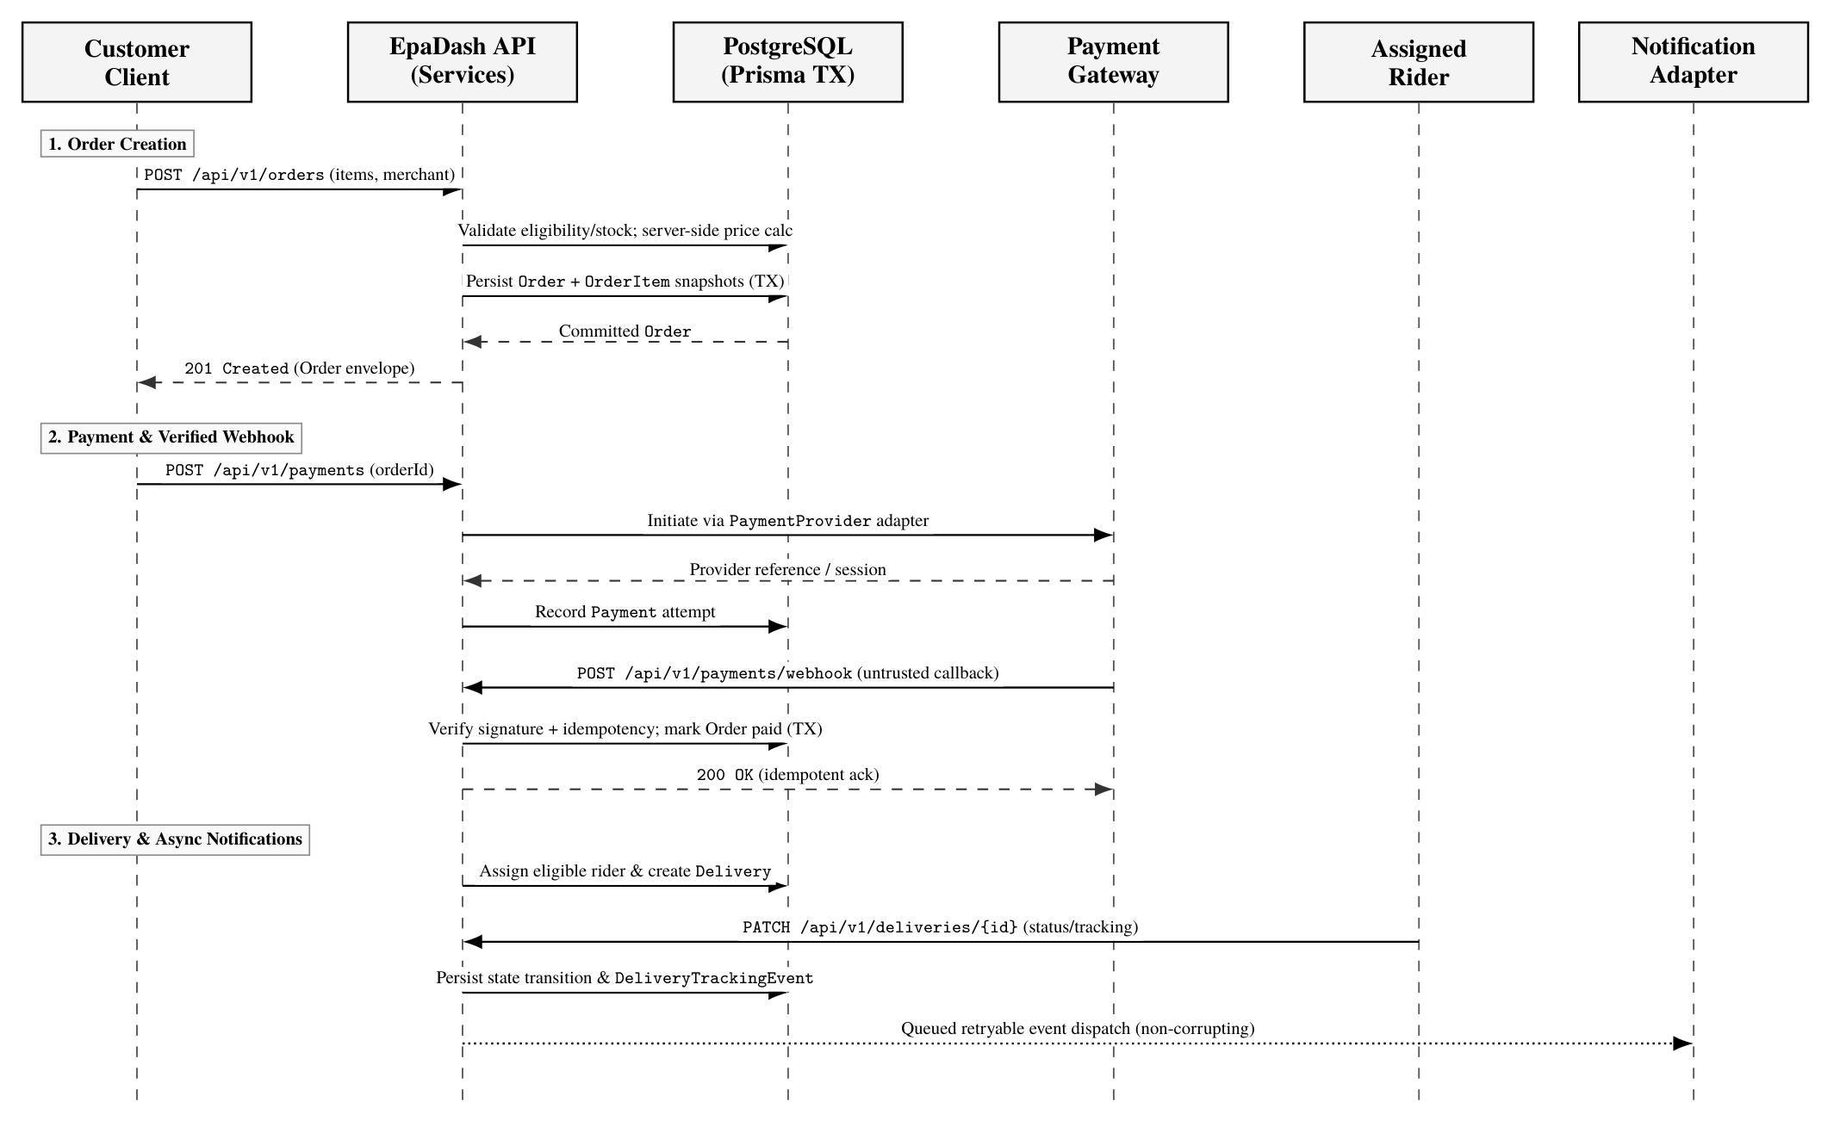
Figure 5: Sequence diagram for transactional order creation, verified payment webhook processing and delivery fulfilment

11. Third-party integration strategy
Table 5 summarises external provider capabilities, adapter isolation boundaries and open decisions requiring technical approval.
Table 5: Third-party integration boundaries and pending approval items
Integration | Required capability | Proposed boundary | Decisions still required
Payment provider | Initiate payment, verify status, receive callbacks/webhooks, support reconciliation | PaymentProvider adapter; provider-specific webhook verifier | Provider, currency support, fees, sandbox, signature method, refunds
Mapping / geolocation | Address/geocode, distance or route estimate, delivery-zone support | MappingProvider adapter; keep provider payloads out of domain model | Provider, coverage, pricing, maps/geocoding policy, location retention
Notifications | Email/SMS/push delivery for account and order events | NotificationProvider adapters and queued/retryable dispatch | Provider, channels, sender identity, templates, retry policy
File/media storage (if required) | Merchant/product images and related uploads | Storage adapter with validated file metadata | Provider, size/type limits, access policy, retention

Do not hard-code provider selection into business services. Use sandbox credentials during development and keep credentials in secret configuration. Verify webhooks cryptographically where the provider supports signatures. Apply timeouts, retries with backoff and idempotency where safe.

12. Security, privacy and operational requirements
• HTTPS/TLS outside local development.
• Strict request validation and safe output encoding.
• Authentication and resource-level authorisation on protected endpoints.
• Rate limiting and abuse protection for sensitive endpoints.
• CORS allowlist based on approved frontend origins; do not use permissive wildcard configuration with credentials.
• Secure headers and dependency updates.
• Environment-based secrets; least-privilege database credentials.
• Structured logs with request IDs and redaction.
• Audit records for privileged actions and sensitive state transitions.
• Backups and restore testing appropriate to the hosting environment.
• Database migrations reviewed and run in a controlled deployment process.
• Avoid unnecessary personal data collection; define retention and deletion policies with the organisation.
• Payment-card handling should remain with a compliant provider-hosted/tokenised flow unless the organisation explicitly approves a compliant alternative.
• Error messages must not disclose whether a particular account exists during password recovery/login where that creates an enumeration risk.
Specific legal/compliance obligations, data residency, retention durations, backup objectives and incident response procedures are TBD / require company review.

13. Testing and quality strategy
• Unit tests: service rules, state transitions, permission decisions, price calculation and availability rules.
• API integration tests: routes, middleware, validation, status codes and response contracts.
• Database tests: migrations, constraints, transactions and repository behaviour against PostgreSQL.
• Security tests: unauthenticated access, forbidden role, cross-user access, cross-merchant access, token expiry/revocation and rate-limit behaviour.
• Provider tests: adapter contract tests and sandbox tests; do not rely only on mocked provider responses.
• Workflow tests: order creation → payment verification → rider assignment → delivery completion.
• Documentation checks: OpenAPI validates and matches implemented endpoints.
Acceptance evidence should include reproducible test commands and test results. Do not describe a feature as complete solely because its route exists.

14. Proposed repository structure
epadash-backend/
├── docs/
│ ├── architecture/
│ │ ├── backend-technical-spec.md
│ │ └── architecture-context.mmd
│ ├── database/
│ │ ├── database-design.md
│ │ └── erd.mmd
│ ├── api/
│ │ └── openapi.yaml
│ ├── workflows/
│ ├── decisions/
│ │ └── ADR-0001-initial-architecture.md
│ └── reports/
├── prisma/
│ ├── schema.prisma
│ ├── migrations/
│ └── seed.ts
├── src/
│ ├── config/
│ ├── middleware/
│ ├── common/
│ └── modules/
│ ├── auth/
│ ├── users/
│ ├── merchants/
│ ├── products/
│ ├── inventory/
│ ├── orders/
│ ├── payments/
│ ├── riders/
│ ├── deliveries/
│ ├── notifications/
│ └── admin/
├── tests/
├── .env.example
├── .gitignore
├── package.json
└── README.md

This is a proposed structure. Adjust to company conventions without weakening module separation, testability or secret handling.

15. Delivery and approval checklist — Task 5
Table 6 maps each Task 5 acceptance criterion from the assignment brief to the corresponding section in this specification and its current review status.
Table 6: Task 5 acceptance criteria, specification evidence and approval status
Acceptance criterion from assignment | Evidence in this document | Status
Backend technology stack documented | Section 3 | Drafted; approval pending
Backend system architecture defined | Section 4 | Drafted; approval pending
Core system modules identified | Section 5 | Drafted
Major entities and relationships outlined | Section 6 | Conceptual outline; detailed design belongs to Task 3
Customer, merchant, rider and administrator roles defined | Section 7 | Proposed; permission review pending
Authentication and authorisation documented | Sections 7–8 | Proposed; security review pending
API requirements identified | Section 9 | High-level groups; detailed contracts belong to Task 4
Payment, mapping and notification integrations documented | Section 11 | Provider-agnostic approach; provider selection pending
Technical specification submitted for approval | This document | User must submit for technical review; not yet approved

15.1 Approval items before implementation
1. Approve or replace the proposed technology stack.
2. Approve modular-monolith architecture and module boundaries.
3. Confirm frontend API conventions and authentication storage/session expectations.
4. Select or confirm payment, mapping and notification providers (or explicitly defer provider-specific implementation).
5. Confirm business rules for merchant publication, product availability, order states, payment verification, rider assignment and delivery.
6. Confirm hosting, environment, secrets, backup and deployment requirements.
7. Review and approve this technical specification.

16. Immediate next step
Submit this draft technical specification to the assigned senior developer/technical lead for review, or keep it as the working proposal if approval is handled later. Record comments and decisions. Once the architecture and stack are accepted, proceed to Task 3's detailed relational schema and ERD, then Task 4's OpenAPI contracts and workflow specifications, followed by implementation and tests for Tasks 2 and 1.
Document status reminder: This is a comprehensive proposed technical specification for Task 5, not proof of approval, implementation, deployment or completed acceptance testing.

Appendix A. ADR-0001 — Initial Backend Architecture
Table A.1: Architecture Decision Record metadata (ADR-0001)
Field | Value
ADR ID | ADR-0001 (docs/decisions/ADR-0001-initial-architecture.md)
Status | Proposed; approval pending
Date | 2026-11-07
Context | EpaDash requires connected user, merchant, product, order, payment, delivery, notification and administration capabilities. No requirement in the assignment establishes a need for independently deployed microservices.

Decision proposed
Use a modular monolith: one deployable TypeScript backend application, separated into domain modules, with PostgreSQL as the primary relational database.
Proposed stack:
• Node.js LTS + TypeScript
• Express.js
• PostgreSQL + Prisma ORM
• Zod validation
• OpenAPI 3.1 + Swagger UI
• Vitest + Supertest
• Pino structured logging
• Argon2id password hashing

Rationale
This keeps deployment and local development simple while supporting relational transactions and clear module ownership. Provider adapters isolate payment, mapping and notification integrations.

Consequences
Modules must have explicit boundaries and avoid reaching into each other's internals. Microservices may be reconsidered only if measurable scaling, independent deployment or organisational needs justify them. Company standards override this proposal.

Approval
• Technical lead: Pending
• Developer: Pending
• Frontend/API convention review: Pending

