EpaDash Database Design — Schema, Relationships and Data Integrity (Task 3)
Document ID: | EPADASH-DB-001 | Prepared: | 6 November 2026
Version: | 0.1 | Scope: | Task 3 — Database schema & relationships
Status: | Proposed design, review required | Artefacts: | schema.prisma, erd.mmd, seed-data-plan.md

STATUS: DRAFT — PROPOSED DESIGN, REVIEW REQUIRED. Assumptions and open business decisions are explicitly listed. Validate the schema before using it in a shared or production database. Design artefacts are drafted; schema validation, migration generation and database integration tests remain pending.

Contents
1. Purpose and scope
2. Design assumptions requiring confirmation
3. Entity catalogue
3.1 Identity and access
3.2 Merchant and catalogue
3.3 Transactions and fulfilment
3.4 Operations
4. Relationship summary and full entity-relationship diagram
5. Integrity rules and constraints
6. Index strategy
7. Migration and seed plan
8. Required database tests
9. Review decisions still open
10. Completion status
Appendix A. Development seed-data plan
Appendix B. Task 3 project progress and readiness summary
References

1. Purpose and scope
This document defines the initial relational database design for the EpaDash backend [1]. It covers the entities named or implied by the assignment: customers, merchants, riders, administrators, products, categories, inventory, orders, order items, order status, payments/transactions, delivery assignment/tracking, notifications and audit logs. It also includes authentication/session records and customer delivery addresses needed to support the stated workflows.
The deliverables include a Prisma schema [2], an editable Mermaid ERD source (erd.mmd; Figure 1), this design note and a proposed seed-data plan (Appendix A). The schema is a starting implementation artefact; it must be validated against the approved business rules and company conventions before production use.

2. Design assumptions requiring confirmation
1. Shared identity: one User account can have one or more roles through UserRole. Role-specific profiles are separate records.
2. One merchant per order: an order belongs to exactly one merchant. If the product must support multi-merchant carts, the order model must be revised to use a parent checkout with merchant-specific sub-orders.
3. One delivery per order: an order has zero or one delivery record. Split deliveries require a different cardinality.
4. Product categories: products may belong to multiple categories. Merchant categories are also many-to-many.
5. Currency: GHS is the default currency [4], but currency is stored on monetary records. Monetary values use fixed-precision decimals, not floating point.
6. Geospatial boundaries: delivery zones store optional GeoJSON initially [3]. Add PostGIS geometry and spatial indexes if radius/polygon queries are required and the hosting database supports PostGIS.
7. Operating hours: one row per merchant per weekday; times use a consistent 24-hour HH:mm representation. Holiday/special hours are not yet modelled.
8. Inventory: quantityHeld represents reserved stock. The service layer must enforce 0 <= quantityHeld <= quantityOnHand transactionally; add database CHECK constraints in the migration.
9. Provider events: payment provider payloads are stored only when permitted and must be redacted/minimised. Never store card data or secrets.
10. Account verification: verification status is represented on User timestamps and account status; additional verification evidence/document tables may be needed if merchant/rider KYC requirements are defined.

3. Entity catalogue
Tables 1–4 catalogue all 25 relational entities across the four backend data domains.

3.1 Identity and access
Table 1: Identity and access entities
Entity | Key strategy | Purpose and modelled responsibilities
User | UUID PK; unique email/phone | Shared identity, login identifiers, password hash, account status and verification timestamps.
UserRole | Composite PK (userId, role) | Composite key assigning one or more roles to a user.
RefreshToken | UUID PK; FK userId | Hashed refresh token, expiry and revocation timestamp.
PasswordResetToken | UUID PK; FK userId | Hashed, expiring, single-use password reset token.
CustomerProfile | UUID PK; unique FK userId | Customer-specific information.
RiderProfile | UUID PK; unique FK userId | Rider-specific verification and availability.
Address | UUID PK; FK userId | Customer-owned delivery addresses with optional coordinates.

3.2 Merchant and catalogue
Table 2: Merchant and product catalogue entities
Entity | Key strategy | Purpose and modelled responsibilities
Merchant | UUID PK; unique slug | Business profile, owner, public visibility, approval/operating status and location.
MerchantCategory / MerchantCategoryLink | UUID PK / Composite PK | Merchant classification and many-to-many join link.
MerchantOperatingHour | UUID PK; FK merchantId | Weekly opening schedule (one row per merchant per weekday, HH:mm).
DeliveryZone | UUID PK; FK merchantId | Merchant delivery coverage metadata and optional GeoJSON boundary.
Product | UUID PK; unique (merchantId, sku/slug) | Merchant-owned item, SKU, price, publication and availability state.
ProductCategory / ProductCategoryLink | UUID PK (parentId self-FK) / Composite PK | Hierarchical product taxonomy and many-to-many product classification.
Inventory | UUID PK; unique FK productId | On-hand, held/reserved (quantityHeld) and low-stock quantities.

3.3 Transactions and fulfilment
Table 3: Order, payment and delivery fulfilment entities
Entity | Key strategy | Purpose and modelled responsibilities
Order | UUID PK; unique orderNumber | Customer, merchant, delivery address, lifecycle state and monetary totals.
OrderItem | UUID PK; FK orderId, productId | Purchased product reference plus immutable-at-purchase name/SKU/price snapshots.
OrderStatusHistory | UUID PK; FK orderId | Chronological state-transition audit.
Payment | UUID PK; FK orderId | Payment attempt, provider reference, amount, currency and status.
PaymentTransaction | UUID PK; unique provider event key | Verified/unverified provider event record; provider event idempotency.
Delivery | UUID PK; unique FK orderId | Order fulfilment and optional assigned rider.
DeliveryTrackingEvent | UUID PK; FK deliveryId | Status/location/time history.

3.4 Operations
Table 4: Platform notification and audit entities
Entity | Key strategy | Purpose and modelled responsibilities
Notification | UUID PK; FK userId | User-facing notification channel and delivery/read state.
AuditLog | UUID PK; optional FK actorId | Actor, action, target entity, metadata and timestamp.

4. Relationship summary and full entity-relationship diagram
• User 1 — 0..1 CustomerProfile, Merchant and RiderProfile; User 1 — many UserRole, Address, tokens (RefreshToken, PasswordResetToken), Notification and AuditLog entries.
• Merchant 1 — many Product, operating-hour rows (MerchantOperatingHour), delivery zones (DeliveryZone) and Order records.
• Merchant ↔ MerchantCategory is many-to-many through MerchantCategoryLink.
• Product ↔ ProductCategory is many-to-many through ProductCategoryLink; ProductCategory supports hierarchy via parent_of; Product 1 — 0..1 Inventory.
• CustomerProfile 1 — many Order records; Merchant 1 — many Order records; Address 1 — many historical Order records.
• Order 1 — many OrderItem, OrderStatusHistory and Payment attempts; Order 1 — 0..1 Delivery.
• Payment 1 — many PaymentTransaction rows; Delivery 1 — many DeliveryTrackingEvent rows; RiderProfile 1 — many Delivery assignments.
Table 5 formalises all 29 foreign-key relationships defined in erd.mmd, and Figure 1 renders the complete relational entity-relationship diagram across all four domain groups.
Table 5: Complete relational cardinality and foreign-key relationship matrix (erd.mmd)
Parent / Source Entity | Cardinality | Child / Target Entity | Relationship Role
USER | 1 : 0..* (||--o{) | USER_ROLE | has — role grants per user
USER | 1 : 0..1 (||--o|) | CUSTOMER_PROFILE | owns — customer profile
USER | 1 : 0..1 (||--o|) | MERCHANT | owns — merchant owner account
USER | 1 : 0..1 (||--o|) | RIDER_PROFILE | owns — rider profile
USER | 1 : 0..* (||--o{) | ADDRESS | saves — saved delivery addresses
USER | 1 : 0..* (||--o{) | REFRESH_TOKEN | receives — active/revoked sessions
USER | 1 : 0..* (||--o{) | PASSWORD_RESET_TOKEN | receives — single-use reset tokens
USER | 1 : 0..* (||--o{) | NOTIFICATION | receives — user notifications
USER | 1 : 0..* (||--o{) | AUDIT_LOG | performs — audited actor actions
MERCHANT | 1 : 0..* (||--o{) | MERCHANT_CATEGORY_LINK | classified_as — merchant join
MERCHANT_CATEGORY | 1 : 0..* (||--o{) | MERCHANT_CATEGORY_LINK | classifies — category join
MERCHANT | 1 : 0..* (||--o{) | MERCHANT_OPERATING_HOUR | opens — weekday schedule
MERCHANT | 1 : 0..* (||--o{) | DELIVERY_ZONE | serves — coverage boundaries
MERCHANT | 1 : 0..* (||--o{) | PRODUCT | lists — merchant catalogue
PRODUCT | 1 : 0..1 (||--o|) | INVENTORY | tracks — on-hand & held stock
PRODUCT | 1 : 0..* (||--o{) | PRODUCT_CATEGORY_LINK | categorized — product join
PRODUCT_CATEGORY | 1 : 0..* (||--o{) | PRODUCT_CATEGORY_LINK | classifies — taxonomy join
PRODUCT_CATEGORY | 1 : 0..* (||--o{) | PRODUCT_CATEGORY | parent_of — category hierarchy
CUSTOMER_PROFILE | 1 : 0..* (||--o{) | ORDER | places — customer orders
MERCHANT | 1 : 0..* (||--o{) | ORDER | receives — merchant fulfilment queue
ADDRESS | 1 : 0..* (||--o{) | ORDER | destination — delivery destination
ORDER | 1 : 1..* (||--|{) | ORDER_ITEM | contains — line items & snapshots
PRODUCT | 1 : 0..* (||--o{) | ORDER_ITEM | referenced_by — source product ref
ORDER | 1 : 0..* (||--o{) | ORDER_STATUS_HISTORY | records — lifecycle audit trail
ORDER | 1 : 0..* (||--o{) | PAYMENT | paid_by — payment attempts
PAYMENT | 1 : 0..* (||--o{) | PAYMENT_TRANSACTION | receives — provider webhook events
ORDER | 1 : 0..1 (||--o|) | DELIVERY | fulfilled_by — order delivery record
RIDER_PROFILE | 1 : 0..* (||--o{) | DELIVERY | assigned — assigned rider
DELIVERY | 1 : 0..* (||--o{) | DELIVERY_TRACKING_EVENT | tracks — status/location chronology

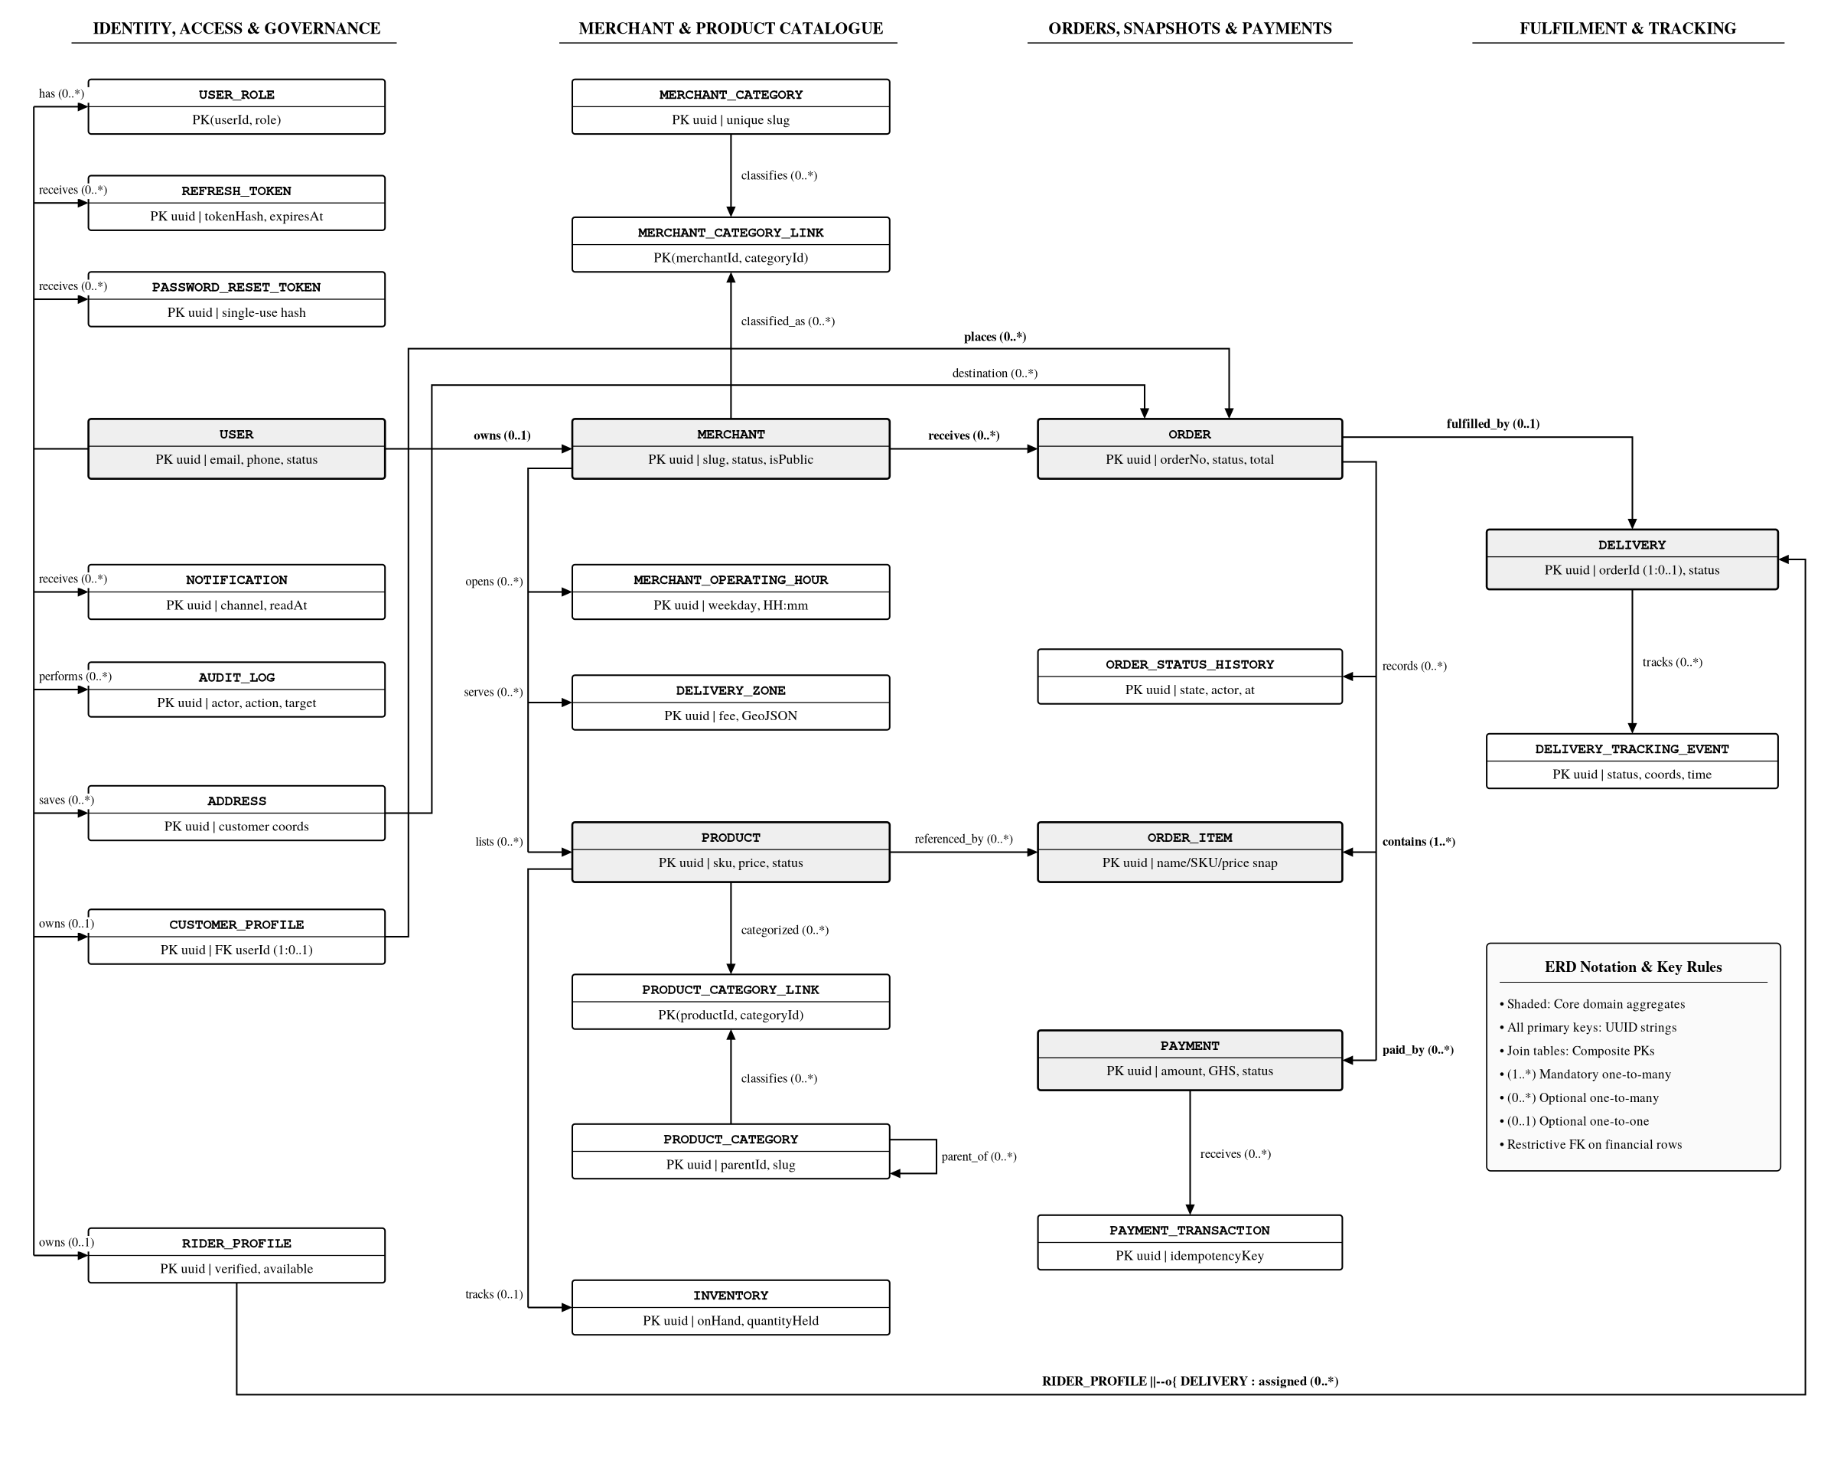
Figure 1: Complete EpaDash relational entity-relationship diagram across all 25 entities (erd.mmd)

5. Integrity rules and constraints
• Primary keys use UUIDs [5].
• Email, phone, merchant slug, category slug and order number are unique where defined.
• Product slug and SKU are unique within a merchant.
• Join tables use composite primary keys to prevent duplicate category assignments or role grants.
• Foreign keys protect relationships. Historical order/payment records use restrictive deletion behaviour; do not cascade-delete financial history.
• Quantity and money values must be non-negative; quantities must be whole numbers.
• OrderItem stores product name, SKU and price snapshots so catalogue edits do not rewrite purchase history.
• Payment webhook/provider events must be processed idempotently.
• Public discovery query rules must require active and public merchants, and published and available products.
• Service-level checks and database constraints must agree; application validation alone is not enough for critical integrity rules.
Table 6: Database constraint categories and dual service/database enforcement rules
Constraint category | Target tables / columns | Enforcement mechanism
Primary identity | All entity tables | UUID primary keys (uuid); composite PKs on UserRole, MerchantCategoryLink, ProductCategoryLink
Global uniqueness | User, Merchant, MerchantCategory, ProductCategory, Order | UNIQUE constraints on email, phone, slug, orderNumber
Scoped uniqueness | Product, MerchantOperatingHour | Composite UNIQUE(merchantId, slug), UNIQUE(merchantId, sku), UNIQUE(merchantId, weekday)
Non-negative & stock invariants | Product, Inventory, Order, OrderItem, Payment | Migration SQL CHECK constraints (amount >= 0, quantity > 0, 0 <= quantityHeld <= quantityOnHand)
Historical immutability | Order, OrderItem, Payment, PaymentTransaction, AuditLog | ON DELETE RESTRICT foreign keys + immutable OrderItem name/SKU/price snapshots
Webhook idempotency | PaymentTransaction | UNIQUE provider event/idempotency key + transactional state update

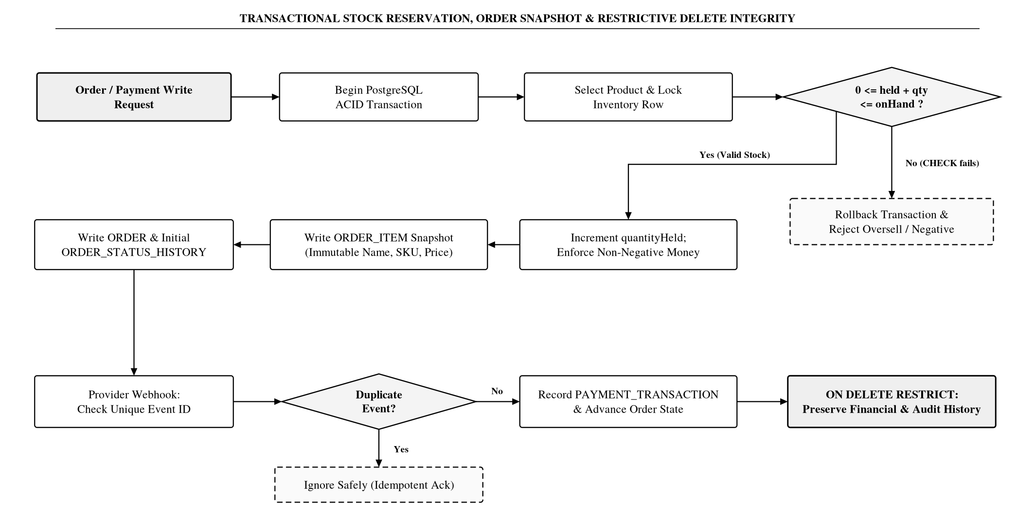
Figure 2: Transactional stock reservation, OrderItem price/SKU snapshot isolation and restrictive-delete integrity workflow

6. Index strategy
The Prisma schema includes initial indexes across the core read/filter paths summarised in Table 7.
Table 7: Initial Prisma schema index candidates by access pattern
Domain / Entity | Indexed attributes | Supported query / operational access pattern
User / UserRole | Account status, createdAt; role lookup | Authentication status checks, admin user filtering and role queries
Merchant | Status / isPublic flag, location fields, name | Public merchant discovery, geographic filtering and text search
Category join tables | MerchantCategoryLink, ProductCategoryLink | Fast reverse category filtering for merchants and products
Product | merchantId, publication status, availability, name | Public catalogue browsing, merchant catalogue views and product search
Inventory | On-hand / available quantity | Low-stock alerts and purchasable availability checks
Order | Customer ID, merchant ID, order status, chronology | Customer order history, merchant fulfilment queue and status filtering
Payment | orderId, payment status, provider reference | Order payment lookup, webhook reconciliation and status verification
RiderProfile / Delivery | Rider availability/verification; delivery rider/status | Eligible rider dispatch lookup and assigned rider delivery queue
DeliveryTrackingEvent | deliveryId + event timestamp | Chronological delivery milestone and tracking history retrieval
Notification | Recipient userId, read state, timestamp | User notification inbox and unread badge queries
AuditLog | Actor ID, target entity, action + timestamp | Administrative security review and chronological compliance queries

These are initial candidates. Review query plans against real endpoint queries before adding further indexes. Avoid indiscriminate indexing because indexes add write and storage cost.

7. Migration and seed plan
1. Initialise PostgreSQL database and Prisma.
2. Add enums and identity/access tables.
3. Add customer, merchant, category, operating-hours and delivery-zone tables.
4. Add products, product categories and inventory.
5. Add addresses, orders, order items and status history.
6. Add payments and provider transaction records.
7. Add rider, delivery and tracking records.
8. Add notifications and audit logs.
9. Add reviewed SQL constraints for non-negative money/quantity and inventory-held invariants.
10. Seed development-only roles, merchant/product categories and clearly fake demo accounts/products. Never seed real personal data or production credentials.
Use versioned Prisma migrations. Do not edit an already-applied migration in a shared environment; create a new migration for changes. Test both a clean database migration and an upgrade from the previous schema (Figure 3).
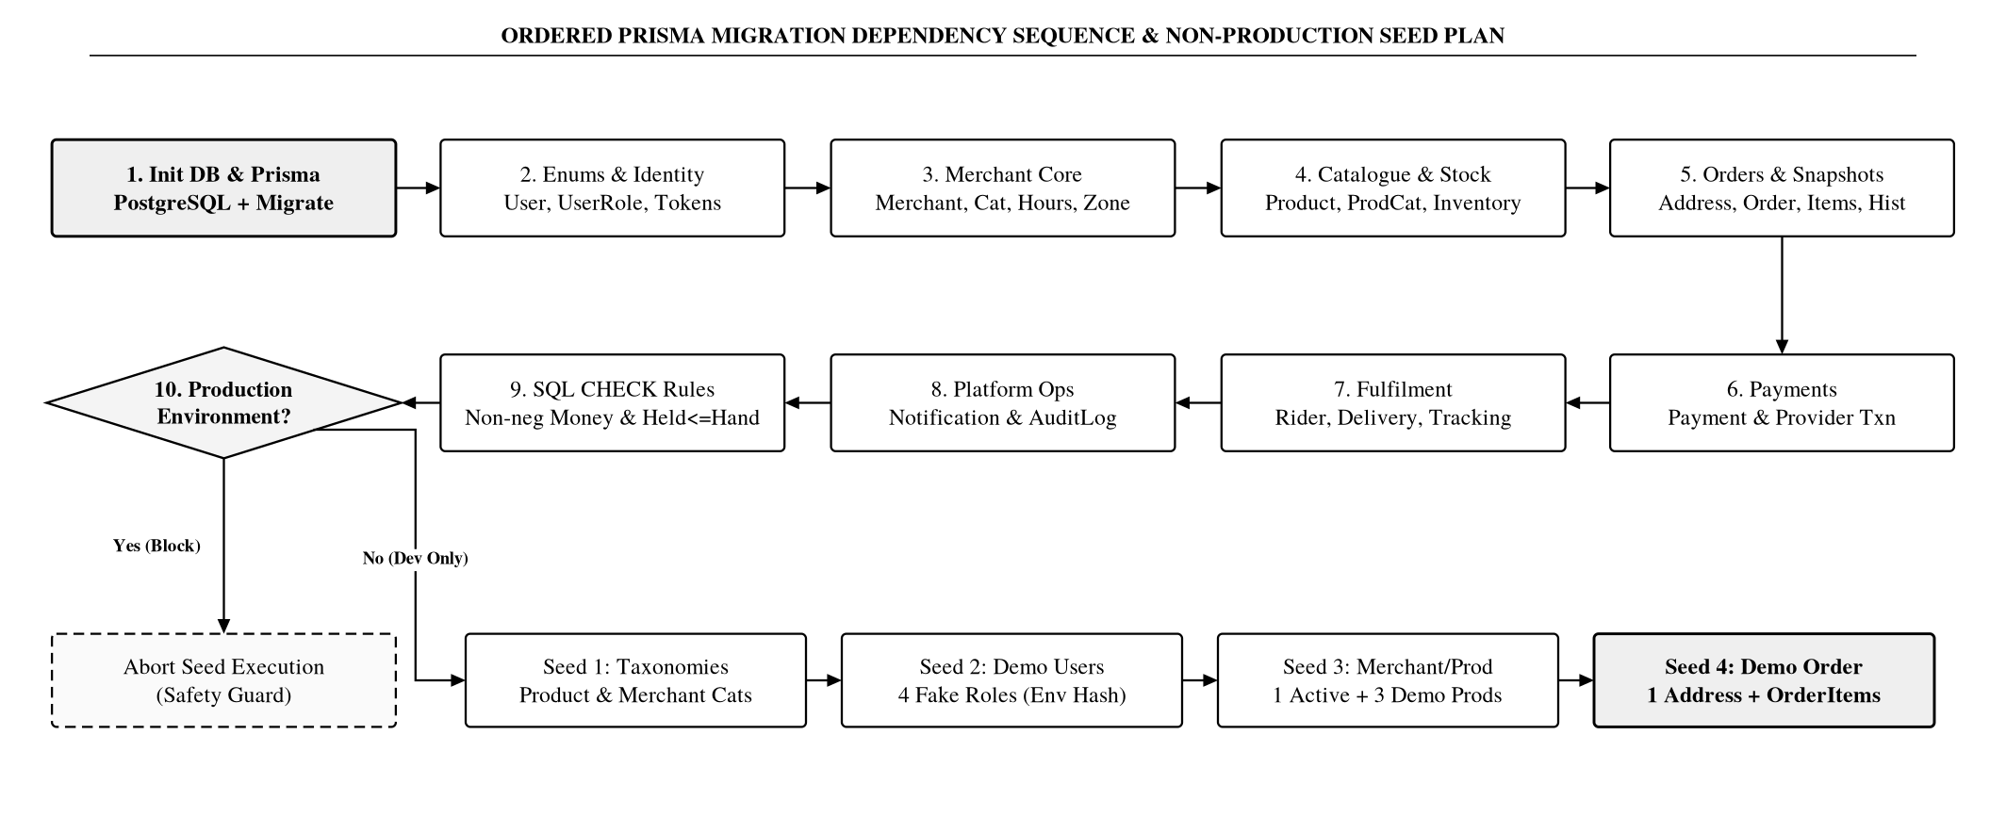
Figure 3: Ten-stage Prisma migration dependency sequence and non-production development seed execution flow

8. Required database tests
Table 8 specifies the required automated database verification suite, and Figure 4 illustrates the validation and sign-off gate prior to marking Task 3 implemented.
Table 8: Required PostgreSQL migration, constraint and concurrency verification suite
Test area | Required verification behaviour
Clean & upgrade migrations | All migrations apply cleanly to an empty PostgreSQL database and upgrade cleanly from prior schema state.
Uniqueness constraints | Unique constraints reject duplicate email/phone, slugs and order numbers.
Referential integrity | Foreign keys reject orphan records across all child tables.
Composite join keys | Join-table composite keys (UserRole, category links) reject duplicate links.
Restrictive deletion | Restrictive delete rules preserve historical order, payment and audit records.
Public visibility filters | Product publication and merchant visibility queries return only eligible active/public/published records.
Concurrent stock reservation | Inventory reservation logic prevents overselling under concurrent requests (transaction/locking test).
Order snapshot immutability | OrderItem snapshots remain unchanged after subsequent Product name, SKU or price edits.
Webhook event idempotency | Payment provider event idempotency prevents duplicate state transitions or double-crediting.
Repeatable seed safety | Seed script is repeatable (idempotent) or safely refuses duplicate insertion and blocks production runs.

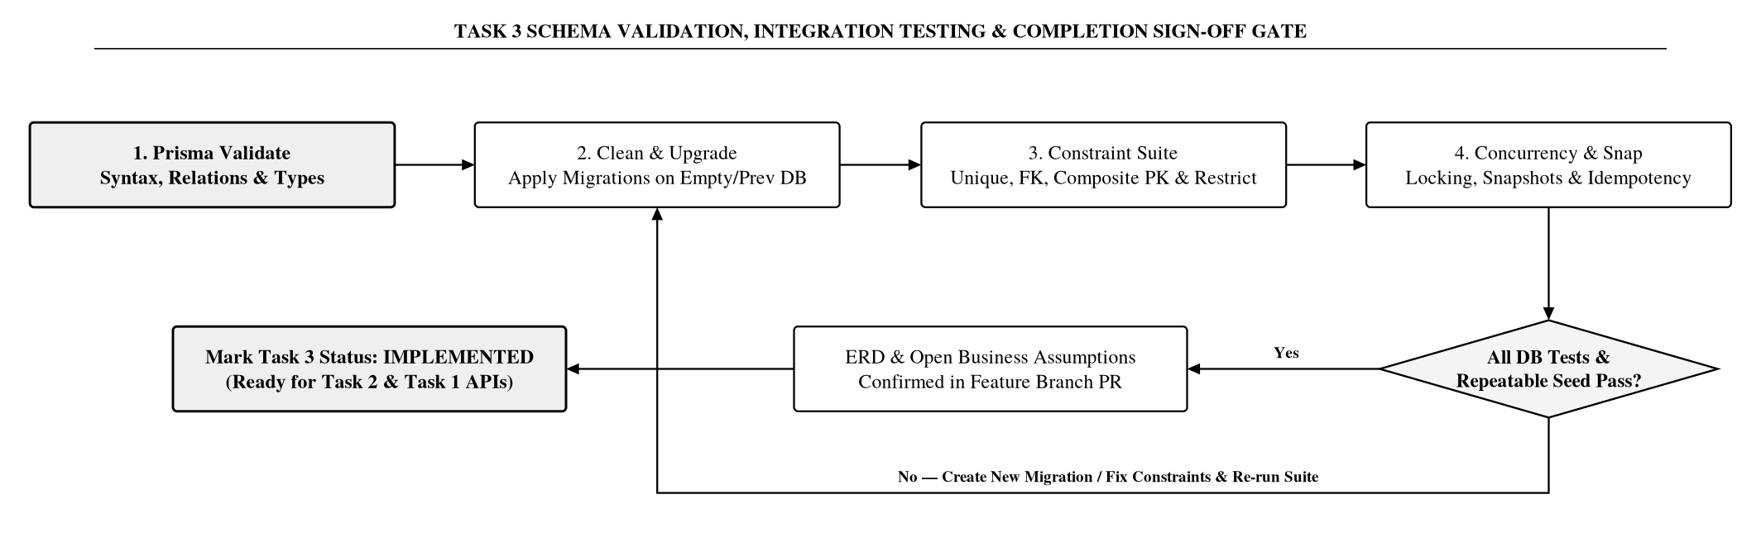
Figure 4: Schema validation, PostgreSQL constraint/concurrency test suite and Task 3 completion sign-off workflow

9. Review decisions still open
• Confirm one merchant per order and one delivery per order.
• Confirm whether customer accounts can hold multiple roles.
• Confirm whether product category assignment is single or multiple.
• Confirm product variants/options, taxes, promotions, tips and service fees.
• Confirm stock reservation timing and release rules.
• Confirm order cancellation, payment retry/refund and delivery failure lifecycle.
• Confirm KYC/document requirements for merchants and riders.
• Confirm geospatial database support and delivery-zone representation.
• Confirm data retention and deletion policies for accounts, payments, delivery coordinates and audit records.

10. Completion status
The conceptual schema and Prisma starting model are drafted. Task 3 should only be marked Implemented after the team validates the schema, generates and applies migrations, runs database tests, reviews the ERD and commits the artefacts.
Document status reminder: This document is not evidence of a deployed or production-validated database. Do not mark Task 3 complete until schema validation, migrations, ERD review and database tests pass.

Appendix A. Development seed-data plan
Use fake, non-personal development records only. Never put production credentials or real customer information in seeds.
Suggested seed order:
1. Product categories (e.g. Groceries, Meals, Drinks) and merchant categories (e.g. Restaurant, Grocery).
2. Four clearly fake user accounts with roles CUSTOMER, MERCHANT, RIDER and ADMIN.
3. One demo merchant with status=ACTIVE, isPublic=true, acceptsOrders=true.
4. One draft product and two published demo products with Inventory rows.
5. One demo customer Address and one example Order with OrderItems for local workflow tests.
Do not seed real passwords. For local-only accounts, use a documented development password supplied through environment variables, hash it with the same password service as registration, and ensure the seed cannot run in production by default.

B.1 Task 3 deliverable files
• EpaDash_Task3_Database_Design.docx — editable design document.
• EpaDash_Task3_Database_Design.pdf — review copy.
• schema.prisma — proposed Prisma data model.
• erd.mmd — editable Mermaid ERD.
• database-design.md — source documentation.
• seed-data-plan.md — development seed plan.

B.2 Immediate next steps before closing Task 3
1. Review the assumptions and database design.
2. Validate the Prisma schema using the selected Prisma version.
3. Generate and inspect migrations against PostgreSQL.
4. Add CHECK constraints for non-negative money/quantity and inventory invariants.
5. Implement seed data and database integration tests.
6. Commit reviewed files in a feature branch and open a PR.

