The software product to be outlined will control a mimicked robotized teller machine (ATM) having an attractive stripe reader for perusing an ATM card, a console or display for interaction with the client or customer, a space for storing envelopes, a dispenser for cash (in multiples of $10), a printer for printing client receipts, and a key-worked change to enable an administrator to begin or stop the machine. The ATM will speak with the bank's PC or server over a suitable communication link.

The ATM will benefit one client / customer at a time. A client will be required to put an ATM card and enter an individual distinguishing proof number (PIN) - both of which will be sent to the bank for approval as a major aspect of every transaction. The client will then have the capacity to perform at least one transaction. The card will be held in the machine until the point when the client demonstrates that he/she wants no further transactions, and soon thereafter it will be returned - with the exception of as noted beneath.

The ATM must have the capacity to give the following services to the client:

1. A client must have the capacity to make a money withdrawal from any reasonable account connected to the card, in multiples of $10.00. Endorsement must be gotten from the bank before money is dispensed.
2. A client must have the capacity to make a deposit to any account connected to the card, comprising of money as well as checks in an envelope. The client will enter the amount of the deposit into the ATM, subject to manual check when the envelope is expelled from the machine by an administrator. Endorsement must be gotten from the bank before physically tolerating the envelope.
3. A client must be able to make a balance inquiry of any account linked to the card.

The ATM will convey every transaction to the bank and get check that it was permitted by the bank. On account of a money withdrawal or deposit, a second message will be sent after the transaction has been physically finished (money dispensed or envelope acknowledged).

If the bank determines that the client's PIN is invalid, the client will be required to re-enter the PIN before a transaction can continue. In the event that the client can't effectively enter the PIN after three tries, the card will be for all time held by the machine, and the client should contact the bank to get it back

In the event that a transaction fails for any reason other than an invalid PIN, the ATM will show a clarification of the issue, and will then ask the client whether he/she needs to do another transaction.

The ATM will give the customer a printed receipt for each powerful transaction, exhibiting the date, time, machine zone, kind of transaction, account(s), total, and completing and available balance(s) of the influenced account.

The ATM will have an operator panel with a key-worked switch (situated "within the bank" side) that will enable an operator to begin and stop the servicing of clients. At the point when the change is moved to the "off" position, the machine will close down, so the operator may expel store envelopes and reload the machine with money, clear receipts, and so forth. The operator will be required to confirm and enter the money close by before starting the ATM machine from this panel.

**Class Diagram**

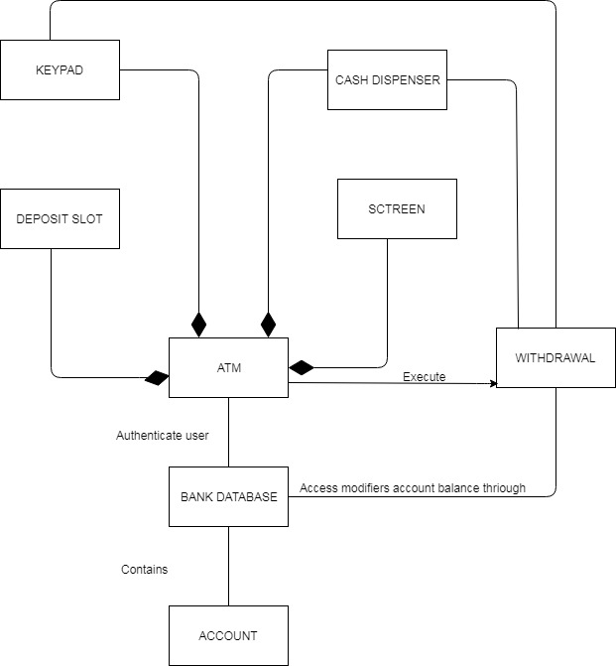

CRC cards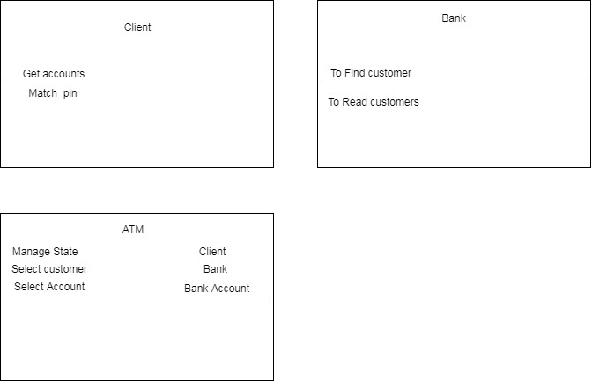

State Diagram

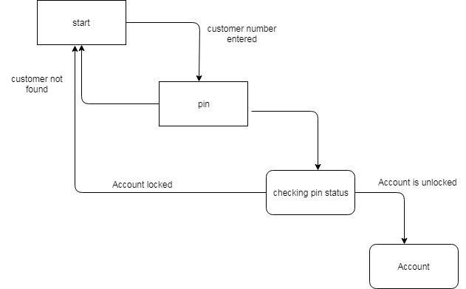

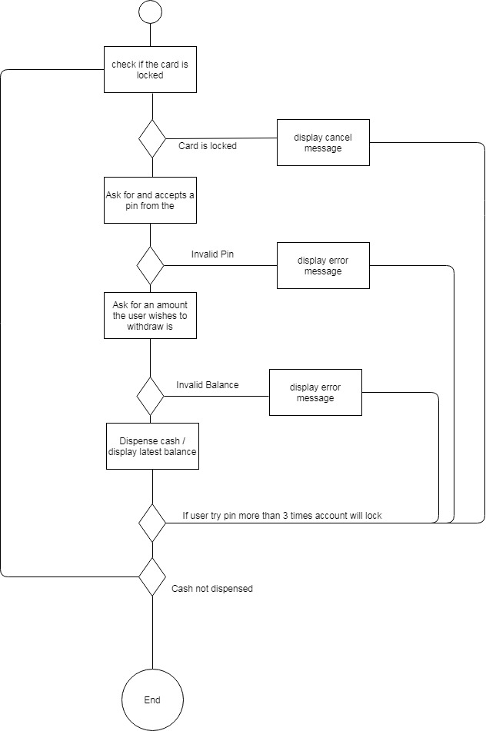

**User story**

**As a Customer**

I need to Login to my financial balance utilizing card So that I can play out the exchanges.

Acknowledgment Criteria –

• System must approve the card and stick code

• In case Customer enters wrong Pin code three times then the system bolts the card.

**As a Customer**

I need to check to adjust of my financial balance So that I can perform exchanges.

Acknowledgment Criteria

• Customer should be signed in before checking balance.

• Balances is shown. As a Customer

**As a Customer**

I need to check my financial balance through ATM So that I may spare my time and perform exchanges later

Acknowledgment Criteria

• Customer should be signed in before depositing money

• System ought to confirm the measure of money stored by checking with the client

• If the client doesn't concur then the system launches back the money

• If Ok the record adjust is refreshed and shown.

**As a Customer**

I need to store check in my financial balance through ATM So that I may spare my opportunity and perform exchanges later.

Acknowledgment Criteria –

• Customer should be signed in before storing check

• System ought to confirm the sum composed on the stored check by asking the client.

• If the client doesn't concur then the framework launches back the check.

• If Ok the record adjust is refreshed and shown.

**As a Customer**

I need to pull back money from my ledger through ATM So that I may save my time

Acknowledgment Criteria

•Customer should be signed in before pulling back money.

•System verifies whether the demand sum surpasses the actual amount

•If the input amount is more than system ask to put another amount

•If sum entered is not as much as the available the system respond with messages.

**As a Customer**

I want to logout from my bank account through ATM So that I may end up my ATM session

Acceptance Criteria

* System asks user if the user wants session report and receipt for the entire session.
* If yes then the receipt is dispensed
* User is logged off from the account

An Automatic Teller Machine — Source code analysis

In this software we have two classes account.java, atmcard.java. Account.java provides two functions the one is Boolean function debit serve as utility function to check an verify the enough amount is available for withdrawal and the other one is return back the available amount in account.

Atmcard.java provides us three functions first is pinok serve as always check the entered pin is matched in database, lockCard serve as to restrict the user if he fails to put right information in console, isLocked is a utility function give class user a flexibility to verify the account status of the user

TEST PLAN BASED

The current version of he program should use the computer’s monitor to simulate the ATM screen and the computer keyboard to simulate the ATM keypad. This proposal will discuss only dedicated item that is directly associated with the ATM transaction method, both directly and indirectly pretentious parts will be discussed. The scope of this strategy is to make sure that the ATM provides the authenticated and accurate information from the bank and offer a secured transaction to the existing customer using an ATM card.

Test Item The following list of the items to need be tested:

**Requirements specification**

* Classes
* Program files
* Interfaces
* Functions

**Features to Test Data flows**

Use-Cases

* State diagrams
* Activity diagram
* Functions
* Withdraw cash
* Balance inquiries

Transactions

* Deposit
* Sessions
* Operator panel / key operated switch o Screen