**ATM**

The robotized teller machine (ATM) having an engaging stripe pursuer for examining an ATM card, a console or show for relationship with the client or customer, a space for securing envelopes, an allocator for cash (in results of $10), a printer for printing client receipts, and a key-worked change to enable an administrator to begin or stop the machine. The ATM will chat with the bank's PC or server over a suitable correspondence associate.

The ATM will benefit one client/customer without a moment's delay. A client will be required to put an ATM card and enter an individual perceiving confirmation number (PIN) - both of which will be sent to the bank for underwriting as an essential piece of each trade. The client will then be able to play out no short of what one trade. The card will be held in the machine until the moment that the minute that the client shows that he/she needs no further trades, and after a short time it will be returned - with the exception of as noted underneath.

**HOW ATM Works**

A customer must have the ability to profit withdrawal from any sensible record associated with the card, in products of $10.00. Underwriting must be gotten from the bank before cash is apportioned.

A customer must have the ability to make a store to any record associated with the card, involving cash and in addition checks in an envelope. The customer will enter the measure of the store into the ATM, subject to manual check when the envelope is ousted from the machine by a head. Underwriting must be gotten from the bank before physically enduring the envelope.

A customer must have the capacity to make an adjust request of any record connected to the card.

The ATM will pass on each exchange to the bank and get watch that it was allowed by the bank. By virtue of a cash withdrawal or store, a moment message will be sent after the exchange has been physically completed (cash apportioned or envelope recognized).

On the off chance that the bank discovers that the customer's PIN is invalid, the customer will be required to re-enter the PIN before an exchange can proceed. If the customer can't adequately enter the PIN after three tries, the card will be forever held by the machine, and the customer should contact the bank to get it back

If an exchange fizzles for any reason other than an invalid PIN, the ATM will demonstrate an illumination of the issue, and will then ask the customer whether he/she needs to do another exchange.

The ATM will give the customer a printed receipt for each compelling trade, demonstrating the date, time, machine zone, kind of trade, account(s), indicate, and completing and open balance(s) of the affected record.

The ATM will have an administrator board with a key-worked switch (arranged "inside the bank" side) that will empower an administrator to start and stop the overhauling of customers. Exactly when the change is moved to the "off" position, the machine will shut down, so the administrator may remove store envelopes and reload the machine with cash, clear receipts, et cetera. The administrator will be required to affirm and enter the cash close by before beginning the ATM machine from this board.

**Class Diagram**

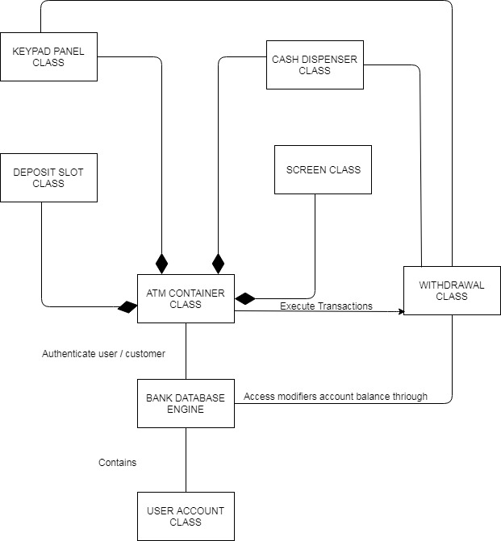

https://drive.google.com/file/d/1LyoomasHTmWksxSw-KB2tl2d_sClQ-OX/view?usp=sharing

**CRC cards**

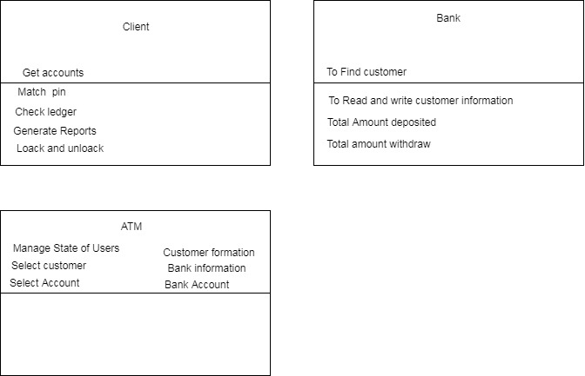

https://drive.google.com/file/d/11RXurVgc6v4iRogltiv9DwU4Aj-a3rRe/view?usp=sharing

‘

**State Diagram**

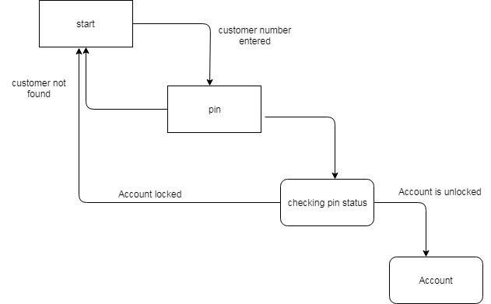

https://drive.google.com/file/d/1lis78lLqNPyoOgiPgLe-FwQaqUJvFidN/view?usp=sharing

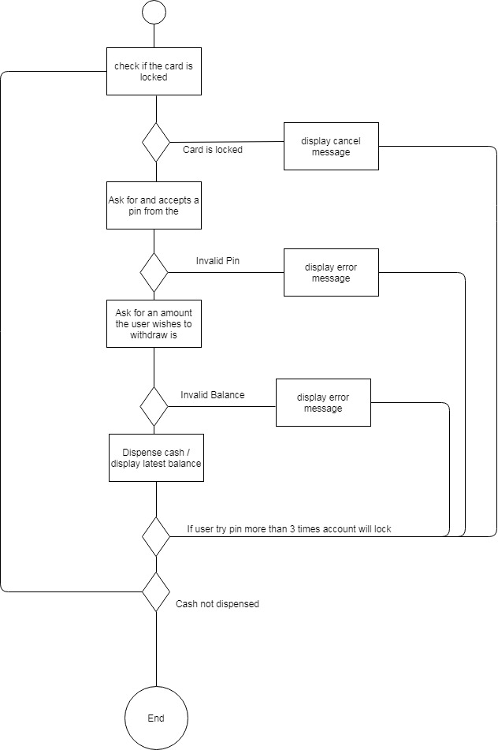

https://drive.google.com/file/d/1t2Sy-WGwXxptKvyCwUT5XepNhuhF1tZd/view?usp=sharing

**User stories**

**Customer story**

I have to Login to my monetary record I have to pay my specific add up to my customer.

How system behaves

• Programming must confirm the card and check and check existing parity

• In case Customer enters wrong Pin code in excess of three times then the product must end the execution.

**Customer story**

I have to check and confirm my record.

How system behaves

• Client ought to be marked in before checking balance.

• Balances is appeared to client and on the off chance that he needs exchange synopsis programming must produce a monetary report

**Customer story**

I have to check my money related report through ATM So that I may spare my chance and to go bank and get synopsis report

How system behaves

Customer should be signed in before depositing money

* Client ought to be marked in before keeping cash
* If the customer doesn't present the right data.
* If all the exchange is alright then programming must produce proper logs of customer use.

**As a Customer**

I need to logout from my financial balance through ATM So that I may wind up my ATM session

How system behaves

• Software send messages to client if the client needs current session synopsis report and receipt for the total session.

• If yes then the receipt is administered

• User is logged off from the record

**Source code analysis**

The two classes having methods of customer validation, pin code verification and card lock methods after analyzing the source code we have found two Boolean methods to lock and unlock card depends on the usage of card, if someone try to attempt three times at ATM machine and not give exact details of card like right pin code, the card must lock to make sure access not possible. Here we need more methods like if user try to get his financial sheet of month or week the developer must provide all the methods for customer reporting needs.

Other financial aspects are also important like if the customer wants to transfer his amount to other account, if customer wants to pay his utility bills from his ATM account the following aspects of ATM regarding to source code must be fulfilled.

We have purposed here more classes as because of the system needs more functionality like

• User ready to create diverse reports of his record.

• User last session must be put in database.

• Multiple endeavors on specific record must be put in database.

• Last pin code change must be put in database.

• How commonly client endeavor to pull back amount more than accessible.

• Ip address must be records in database.

**Test Plan**

Th**e** following hardware must be used to simulate the current purposed ATM system

* Desktop monitor
* Keyboard
* Java Virtual machine
* Normal computer System

**The following task must perform by the system**

* All classes and objects must behave like it has been written.
* There are is no flaw like if card is locked but grant the access to the user for login
* If pin will change must limit the user to access his account with previous key
* Session always terminated after user remove his card from the system

**Features to Test Data flows**

**Use-Cases**

* Pin lock mechanism must fulfill the state diagram
* All the activity must perform as stated in activity diagram
* Function must produce same result as written
* Withdrawal of amount may reduce user balance
* All reports must show latest balance and activity of account.

**Transactions**

* Deposit and withdrawal
* Card lock and unlock system work properly
* Pin code change system must work properly
* Keyboard work properly