**ATM Machine**

In this modern era the ATM machine is used to dispense and collect the customer cash, The machine in terms of general outlook having a console the keyboard and a display (computer monitor).

The machine works with help of customer magnetic card, before use the customer must insert his card on machine the machine will ask the user for his pin code after successful verification of the pin code the machine grant access the user to login and doing his business as usual.

The ATM machine may provide amount in multiple of (10$), the machine is also responsible to present the user with client receipts. The machine may also provide the user all customer specific support like pin change, daily, monthly and yearly report. The card held in machine until user closes the session or someone evil try to access the system with wrong information.

If the banking system seeks that the client entered information is invalid then system must respond to user to re-enter his information if the user fails to provide correct pin information for more than three times the card must be held in and the bank the responsible staff must check and verify the activity of his magnetic card

transaction fails for any reason other than an invalid PIN, the ATM will show a clarification of the issue, and will then ask the client whether he/she needs to do another transaction.

The Atm must provide following services to its customers.

* The cash withdrawal
* The cash deposit
* The customer history regarding the transactions
* Change pin code
* Amount transfer to different accounts.

**Class Diagram**

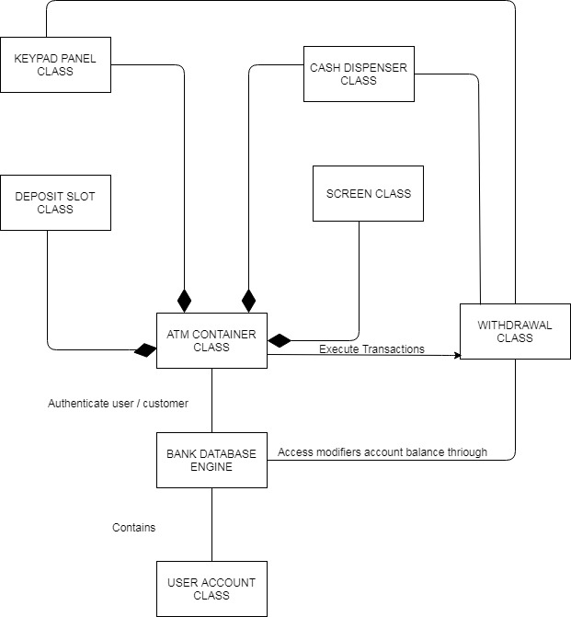

https://drive.google.com/file/d/1LyoomasHTmWksxSw-KB2tl2d_sClQ-OX/view?usp=sharing

**CRC cards**

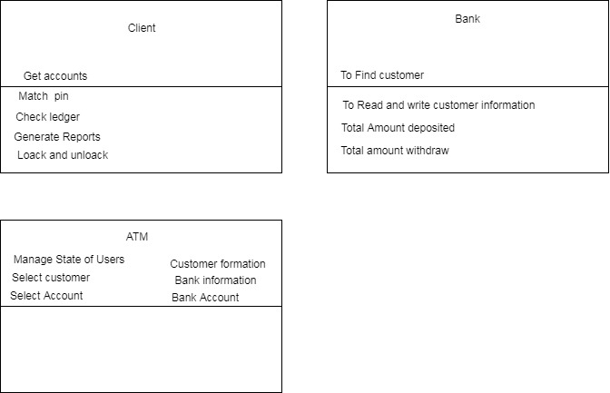

https://drive.google.com/file/d/11RXurVgc6v4iRogltiv9DwU4Aj-a3rRe/view?usp=sharing

‘

**State Diagram**

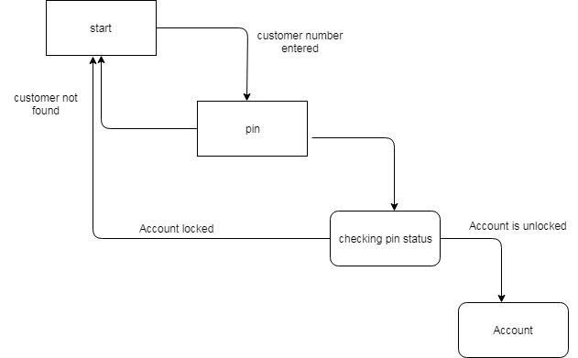

https://drive.google.com/file/d/1lis78lLqNPyoOgiPgLe-FwQaqUJvFidN/view?usp=sharing

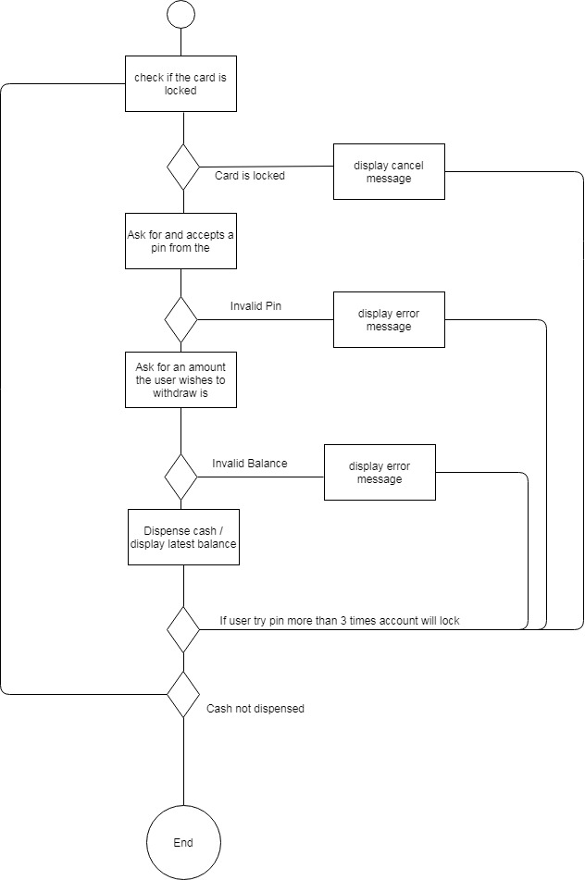

https://drive.google.com/file/d/1t2Sy-WGwXxptKvyCwUT5XepNhuhF1tZd/view?usp=sharing

**User stories**

**1)**

I need to login to check and verify the my balance.

* The card must be check and verify against database in bank
* Multiple tries with wrong pin code may block to access the machine software.

**2)**

I wat to pay some amount to my client I don’t want to go to bank but Atm is better option

* Customer login to ATM
* Customer see his balance and pay the amount to his customer

**3)**

I have to payback my loan to someone who is need of some real amount

Acknowledgment Criteria

Customer should be signed in before depositing money

* Customer check his ledger and pay the amount from his account
* If customer don’t have enough amount to payback his loan the system not doing any transaction
* If all the client access information is correct and the user have enough balance the amount must transfer to his client.

**4)**

I need to get all of my balance amount from the bank

* System must check his information.
* System verifies he have enough balance
* If the amount is not present in Atm machine the system must present with error message to user to running out of cash

**Source code Analysis**

The source code consists of two classes accout.java and atmcard.java both classes provides the multiple functions to help user for his day to day activity for example the customer will change his pin code, the customer will withdraw his amount the customer deposit his amount.

The both classes also provides function and methods to lock and unlock card and here class needs mores functions like customer reporting and customer log information.

The classes also responsible for IP information, last access, and user details

.

**Test Plan**

The current software or version must be check before to installed on machines any drawback in hardware or software may cause severe harm to customer financial wealth as well as bank reputation therefore the following components must be check before installed on any new machine

**Requirements specification**

* Classes
* Functions
* Properties
* Abstract classes

**Features to Test Data flows**

**Use-Cases**

* State diagram
* Activity diagram
* Methods work properly
* Withdraw impact
* Deposit impact

**Transactions**

* Deposit
* Withdraw
* Reports