OneDrive for Linux Architecture

Introduction
The goal of the project is to build a client for OneDrive for Business for Linux that would be able to fulfill the the functionality of the same, developed by Microsoft for Windows, and as future plans to provide access to OneDrive Personal and be multi-platform.
This document concentrates on the initial phase of the development and discusses only the aspects of the projects that are related to this phase.

Requirements
- File synchronization.
  - The client should properly resolve file conflicts.
  - Moves and copies should be handled efficiently.
- Reliability.
  - File corruption prevention.
The client should try hard to not corrupt the user’s files while working and in case of abrupt terminations.
  - Graceful termination.
- Command Line Interface.
  - Headless mode.
CLI should provide a way to use the client fully without GUI (including the authentication step).
- Performance.
  - Network connection should be used efficiently.

Resources

This section outlines the resources available that could be used in the development.

OneDrive API
- Has good documentation:
https://dev.onedrive.com/README.htm
  - It is hosted on GitHub:
https://github.com/OneDrive/onedrive-api-docs
  - If you want to search through it, search directly on GitHub, because the web-site doesn’t have it.
  - If you have a questions, you can create an issue on GitHub, authors usually respond quickly – within 24 hours.
- Has official SDKs for:
  - C#
  - Python
- Supports check-and-swap operations using headers “if-match” and “if-none-match”. Their usage is not fully documented though, see:
  - https://github.com/OneDrive/onedrive-api-docs/issues/607
  - https://github.com/OneDrive/onedrive-api-docs/issues/608
- Does not support methods for operating on file versions:
https://github.com/OneDrive/onedrive-api-docs/issues/559
- Delta method is recommended for querying for changes AND for listing files:
https://dev.onedrive.com/items/view_delta.htm

File changes monitoring libraries
- Python
  - Pyinotify
    - Popular.
    - Cross-platform.
    - Unmaintained.
    - Latest release and commit on 2015-06-04.
    - A lot of unanswered open issues on GitHub.
    - Some people do not recommend it:
http://www.serpentine.com/blog/2008/01/04/why-you-should-not-use-pyinotify/
  - inotify
    - Suggested by Artur.
    - Development stalled just recently.
    - Latest commit on Dec 15, 2016.
  - fsmonitor
    - Semi-actively developed.
    - Latest commit in 2017
- C
  - Inotify-tools
    - Popular.
    - Seems abandoned.
    - Latest commit on Nov 9, 2014.
- C++
  - fswatch
    - Popular.
    - Cross-platform.
    - Seems like it just entered the phase when developers do not develop it actively.
    - Latest commit on Jul 23, 2016.
  - efsw
    - Somewhat popular (hard to say with Bitbucket).
    - Maintained.
    - Latest commit 2017-03-29.
    - Cross-platform.

Architecture

Components overview
Figure 1.0
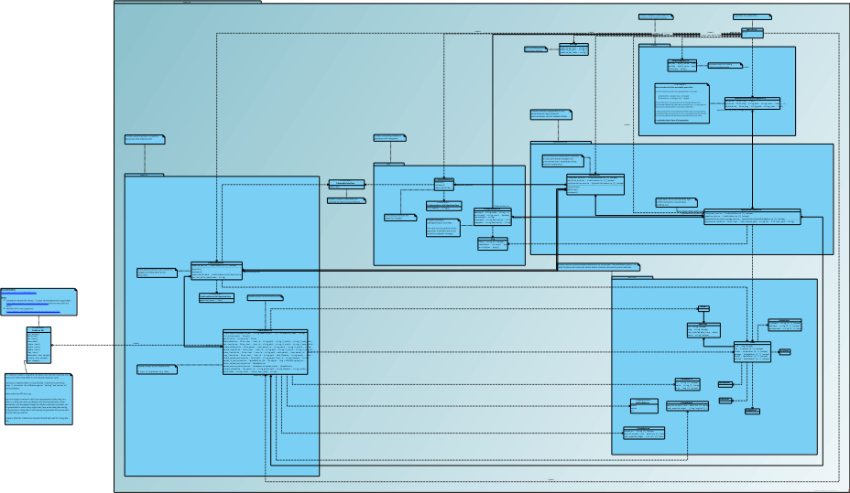
Highlights:
- SynchronizationStateStorageService stores metadata for last successfully synchronized files. It is required because otherwise it is impossible to make decisions about whether to overwrite a file or not (see the note in the diagram).
- Service-classes provide basic infrastructural and domain-specific operations that are needed by higher-level components.
- entities package contains entity-definitions that are 1 to 1 match to the OneDrive API entities.
- DataStorageService is used for storing arbitrary data. Currently it is required for storing last snapshot token returned by the API (see delta method).
- All the business logic related to how files are synchronized (e.g. conflict resolution, moves/copies handling) is encapsulated within SynchronizationService.
- Synchronizer service does not contain business logic, but instead assembles all the components required for synchronization, bootstraps a synchronization process and continuously monitors and synchronizes changes.
- The whole system is supposed to be built on cooperative concurrency execution model.
Most probably it will be gevent.
This choice was made because the project deals with events and I/O so a light-weight concurrency + task scheduler, that gevent provides “for free”, seems to fit perfectly.

Files synchronization
Here is a list of basic synchronization tasks/problems:
- Conflict resolution.
  - How to detect a conflict?
Let’s define “conflict” as mismatch between last known state of a synchronized remote or local file and the current state of the file when the opposite state initiated a change.
Let’s suppose we have fileA, that is synchronized between the local side and the remote side.
Conflict type #1:
- Remote file is changed.
- Local file, compared to the last known sync-state, is different.
Conflict type #2:
- Local file is changed.
- Remote file, compared to the last known sync-state, is different.
Conflict resolution logic:
- If conflict (type #1 or #2) occurred, local file should be renamed and put under synchronization. Remote file always “wins” since it represents synchronized file tree.
- In case if there is no conflict – remote or local file should be overwritten or a new file should be created if it doesn’t exist on the opposite side.
    - All that implies, that last known state of a synchronized files should be stored. This is the reason, why an embedded storage should be used.
Without using a storage of last known synchronized file state it is impossible to detect conflicts.
  - How a conflict should be solved?
Conflicts are resolved by creating file copies according to specific rules.
- Changes detection.
  - How to monitor local changes?
For that there is a number of existing libraries, and one of them should probably be used.
  - How to detect remote changes?
There are two solutions:
    - By using “delta” API method, which allows to create snapshot and retrieve a delta between the previous snapshot and the current state in one request-response cycle.
- Consistent writes.
  - For remote writes consistency CAS operations should be used. They are supported by the OneDrive API as “if-match” and “if-none-match” headers (see the docs for the details).
  - For local writes consistency OS-level or filesystem-level locks could be used.
- Startup synchronization.
  - How to initialize synchronization at startup?
At startup the client should compare all the files and propagate needed changes.
- Moves/copies handling.
  - Moves and copies should be handled efficiently by re-using existing remote and local files and avoiding redundant downloads/uploads.

