NFSTRACE

User and developer manual
Version 0.3.2

Copyright © 2014, 2015 EPAM Systems
NFSTRACE User and developer manual
EPAM Systems
Copyright © 2014, 2015 EPAM Systems
This documentation is free software; you can redistribute it and/or modify it under the terms of the GNU General Public License version 2 as published by the Free Software Foundation.
This program is distributed in the hope that it will be useful, but WITHOUT ANY WARRANTY; without even the implied warranty of MERCHANTABILITY or FITNESS FOR A PARTICULAR PURPOSE. See the GNU General Public License for more details.
You should have received a copy of the GNU General Public License along with this program; if not, write to the Free Software Foundation, Inc., 51 Franklin Street, Fifth Floor, Boston, MA 02110-1301 USA.
For more details see the file LICENSE in the source of nfstrace.

This manual provides basic instructions on how to use nfstrace to monitor NFS activity and how to develop pluggable analysis modules.
Table of Contents
1 Introduction 4
1.1 Portability 4
2 Usage 5
2.1 Options 5
2.2 Running modes 6
2.3 Packets filtration 7
2.4 Dump file format 7
2.5 Usage examples 7
2.5.1 Available options 7
2.5.2 Online tracing 8
2.5.3 Online analysis 8
2.5.4 Online dumping and offline analysis 8
2.5.5 Online dumping, compression and offline analysis 8
2.5.6 Online dumping with file limit, compression and offline analysis 9
2.5.7 Visualization 10
3 Analyzers 11
3.1 Operation Breakdown Analyzer (libbreakdown.so) 11
3.2 Watch (libwatch.so) 13
4 Implementation details 15
4.1 Payload filtration 15
4.2 Pluggable analysis modules 16
4.3 General schema 16
5 Glossary 18

Introduction
nfstrace performs live Ethernet 1 Gbps – 10 Gbps packets capturing and helps to determine NFS procedures in raw network traffic. Furthermore, it performs filtration, dumping, compression, statistical analysis, visualization and provides the API for custom pluggable analysis modules.
nfstrace captures raw packets from an Ethernet interface using libpcap interface to Linux (LSF) or FreeBSD (BPF) implementations. At the moment it is assumed that libpcap delivers correct TCP and UDP packets. Assembling of IP packets from ethernet frames and IP packets defragmentation are performed in the operating system's kernel.
The application has been tested on the workstations with integrated 1 Gbps NICs (Ethernet 1000baseT/Full).
Currently nfstrace supports the following protocols:
Ethernet ➔ IPv4 | IPv6 ➔ UDP | TCP ➔ NFSv3 | NFSv4

Portability
The application has been developed and tested on GNU/Linux (Fedora 20, OpenSUSE 13.2, Ubuntu 14.10, CentOS 7, Arch Linux, Alt Linux 7.0.4) and FreeBSD (FreeBSD 10.1). It is written in C++11 programming language and uses standard POSIX interfaces and the following libraries: libpthread, libpcap, libstdc++.

Usage

Options
-m, --mode=live|dump|drain|stat
Set the running mode (see the description below) (default: live).
-i, --interface=INTERFACE
Listen interface, it is required for live and dump modes (default: searches for the lowest numbered, configured up interface (except loopback)).
-f, --filtration="filter"
Specify the packet filter in BPF syntax; for the expression syntax, see pcap-filter(7) (default: "port 2049").
-s, --snaplen=1..65535
Set the max length of captured raw packet (bigger packets will be truncated). Can be used only for UDP (default: 65535).
-t, --timeout=milliseconds
Set the read timeout that will be used while capturing (default: 100).
-b, --bsize=MBytes
Set the size of the operating system capture buffer in MBytes; note that this option is crucial for capturing performance (default: 20).
-p, --promisc
Put the capturing interface into promiscuous mode (default: true).
-d, --direction=in|out|inout
Set the direction for which packets will be captured (default: inout).
-a, --analysis=PATH#opt1,opt2=val,...
Specify the path to an analysis module and set its options (if any).
-I, --ifile=PATH
Specify the input file for stat mode, '-' means stdin (default: nfstrace-{filter}.pcap).
-O, --ofile=PATH
Specify the output file for dump mode, '-' means stdout (default: nfstrace-{filter}.pcap).
--log=PATH
Specify the log file (default: nfstrace.log.{timestamp}).
-C, --command="shell command"
Execute command for each dumped file.
-D, --dump-size=MBytes
Set the size of dumping file portion, 0 means no limit (default: 0).
-E, --enum=interfaces|plugins|-
Enumerate all available network interfaces and and/or all available plugins, then exit; please note that interfaces can't be listed unless nfstrace was built against the recent version of libpcap that supports the pcap_findalldevs() function (default: none).
-M, --msg-header=1..4000
Truncate RPC messages to this limit (specified in bytes) before passing to a pluggable analysis module (default: 512).
-Q, --qcapacity=1..65535
Set the initial capacity of the queue with RPC messages (default: 4096).
-T, --trace
Print collected NFSv3 or NFSv4 procedures, true if no modules were passed with -a option.
-Z, --droproot=username
Drop root privileges after opening the capture device.
-v, --verbose=0|1|2
Specify verbosity level (default: 1).
-h, --help
Print help message and usage for modules passed with -a option, then exit.

Running modes
nfstrace can operate in four different modes:
- online analysis (--mode=live): performs online capturing, filtration and live analysis of detected NFS procedures using a pluggable analysis module or prints out them to stdout (-T or --trace options);
- online dumping (--mode=dump): performs online traffic capturing, filtration and dumping to the output file (specified with -O or --ofile options);
- offline analysis (--mode=stat): performs offline filtration of the .pcap that contains previously captured traces and performs analysis using a pluggable analysis module or prints found NFS procedures to stdout (-T or –trace options);
- offline dumping (--mode=drain): performs a reading of traffic from the .pcap file (specified with -I or --ifile options), filtration, dumping to the output .pcap file (specified with -O or --ofile options) and removing all the packets that are not related to NFS procedures.

Packets filtration
Internally nfstrace uses libpcap that provides a portable interface to the native system API for capturing network traffic. By so doing, filtration is performed in the operating system's kernel. nfstrace provides a special option (-f or –-filtration) for specifying custom filters in BPF syntax.
The default BPF filter in nfstrace is port 2049, which means that each packet that is delivered to user-space from the kernel satisfies the following conditions: it has IPv4 or IPv6 header and it has TCP and UDP header with source or destination port number equals to 2049 (default NFS port).
The reality is that this filter is very heavy and support of IPv6 is experimental, so if you want to reach faster filtration of IPv4-only traffic we suggest to use the following BPF filter: ip and port 2049.

Dump file format
nfstrace uses libpcap file format for input and output files so any external tool (e.g. Wireshark) can be used in order to inspect filtered traces.

Usage examples
In this sections some use cases will be explained. Every next example inherit something from the previous ones, so we suggest to read all of them from the beginning.

Available options
The following command demonstrates available options of the application and plugged analysis modules (attached with --analysis or -a options). Note that you can pass more than one module here.
nfstrace –-help --analysis=libbreakdown.so

Online tracing
The following command will run nfstrace in online analysis mode (specified with --mode or -m options) without a pluggable analysis module. It will capture NFS traffic transferred over TCP or UDP with source or destination port number equals to 2049 and will simply print them out to stdout (-T or --trace options). Capturing is over when nfstrace receives SIGINT (Control-C).
Note that capturing from network interface requires superuser privileges.
nfstrace -–mode=live \
--filtration="ip and port 2049" \
-T

Online analysis
The following command demonstrates running nfstrace in online analysis mode. Just like in the previous example it will capture NFS traffic transferred over TCP or UDP with source or destination port number equals to 2049 and then it will perform Operation Breakdown analysis using pluggable analysis module libbreakdown.so.
nfstrace –-mode=live \
-–filtration=”ip and port 2049” \
--analysis=libbreakdown.so

Online dumping and offline analysis
The following example demonstrates running nfstrace in online dumping and offline analysis modes.
At first nfstrace will capture NFS traffic transferred over TCP or UDP with source or destination port number equals to 2049 and will dump captured packets to dump.pcap file (specified with --ofile or -O options).
At the second run nfstrace will perform offline Operation Breakdown analysis using pluggable analysis module libbreakdown.so.
# Dump captured packets to dump.pcap
nfstrace –-mode=dump \
--filtration="ip and port 2049" \
-O dump.pcap

# Analyse dump.pcap using libbreakdown.so
nfstrace --mode=stat \
-I dump.pcap \
--analysis=libbreakdown.so

Online dumping, compression and offline analysis
The following example demonstrates running nfstrace in online dumping and offline analysis modes. Since dump file can easily exhaust disk space, compression makes sense.
At first nfstrace will capture NFS traffic transferred over TCP or UDP with source or destination port number equals to 2049 and will dump captured packets to dump.pcap file.
Note that compression is done by the external tool (executed in script passed with --command or -C options) and it will be executed when capturing is done. The output file can be inspected using some external tool as described in [2.4].
At the second run nfstrace will perform offline analysis. Again, the external tool (bzcat in this example) is used in order to decompress previously saved dump. nfstrace will read stdin (note the -I – option) and perform offline analysis using Operation Breakdown analyzer.
# Dump captured procedures to dump.pcap file.
# Compress output using bzip2 when capturing is over.
nfstrace –-mode=dump \
--filtration="ip and port 2049" \
-O dump.pcap \
-C "bzip2 -f -9"

# Extract dump.pcap from dump.pcap.bz2 to stdin.
# Read stdin and analyze data with libbreakdown.so module.
bzcat dump.pcap.bz2 | nfstrace –-mode=stat \
-I - \
--analysis=libbreakdown.so

Online dumping with file limit, compression and offline analysis
This example is similar to the previous one except one thing: output dump file can be very huge and cause problems in some situations, so nfstrace provides the ability to split it into parts.
At first nfstrace will be invoked in online dumping mode. Everything is similar to the previous example except -D (--dump-size) option: it specifies the size limit in MBytes, so dump file will be split according to this value.
At the second run nfstrace will perform offline analysis of captured packets using Operation Breakdown analyzer.
Please note that only the first dump file has the pcap header.
# Dump captured procedures to the multiple files and compress them.
nfstrace –-mode=dump \
--filtration="ip and port 2049" \
-O dump.pcap \
-D 1 \
-C "bzip2 -f -9"

# get list of parts in the right order:
# dump.pcap.bz2
# dump.pcap-1.bz2
parts=$(ls dump.pcap*.bz2 | sort -n -t - -k 2)
# Extract main dump.pcap and parts from dump.pcap.bz2 to stdin.
# Read stdin and analyze data with libbreakdown.so module.
bzcat “$parts” | nfstrace --mode=stat \
-I - \
--analysis=libbreakdown.so

Visualization
This example demonstrates the ability to plot graphical representation of data collected by Operation Breakdown analyzer.
nst.sh is a shell script that collects data generated by analyzers and passes it to gnuplot script specified with -a option.
breakdown.plt is a gnuplot script that understands output data format of Operation Breakdown analyzer and generates .png files with plots.
Note that gnuplot must be installed.
# Extract dump.pcap from dump.pcap.bz2 to stdin.
# Read stdin and analyze data with libbreakdown.so module.
bzcat trace.pcap.bz2 | nfstrace -m stat -I - -a libbreakdown.so

# Generate plot according to *.dat files generated by
# libbreakdown.so analyzer.
nst.sh -a breakdown.plt -d . -p 'breakdown*.dat' -v

Analyzers
All pluggable modules are implemented as external shared libraries.

Operation Breakdown Analyzer (libbreakdown.so)
Operation Breakdown (OB) analyzer calculates average frequency of NFS procedures and computes standard deviation of latency using one of two algorithms (two-pass or one-pass).
Two-pass algorithm returns correct standard deviation but requires a lot of memory during computations. One-pass algorithm is memory-efficient but it accumulates computation error in case of a large number of small latencies. It is possible to choose one of these algorithms by passing according parameter while attaching OB analyzer to nfstrace.
$ nfstrace -a libbreakdown.so -h
nfstrace 0.3.2 (release)
built on Linux-3.17.8-200.fc20.x86_64
by C++ compiler GNU 4.8.3
Usage: ./nfstrace [OPTIONS]...
...complete output has been omitted...
Usage of libbreakdown.so:
ACC - for accurate evaluation(default), MEM - for memory efficient evaluation. Options cannot be combined
So, say, in order to choose two-pass algorithm you have to pass ACC to OB analyzer:
$ nfstrace -m stat -a libreakdown.so#ACC
And the result of execution will look something like this:
Log file: nfstrace.log.1422286399
Loading module: 'libbreakdown.so' with args: []
Read packets from: nfstrace-port-2049.pcap
datalink: EN10MB (Ethernet)
version: 2.4
Note: It's potentially unsafe to run this program as root without dropping root privileges.
Note: Use -Z username option for dropping root privileges when you run this program as user with root privileges.
Processing packets. Press CTRL-C to quit and view results.
Detect session 10.6.137.79:949 --> 10.6.7.38:2049 [TCP]
### Breakdown analyzer ###
NFSv3 total procedures: 55. Per procedure:
NULL 0 0.00%
GETATTR 25 45.45%
SETATTR 0 0.00%
LOOKUP 16 29.09%
ACCESS 11 20.00%
READLINK 1 1.82%
...complete output has been omitted...
Per connection info:
Session: 10.6.137.79:949 --> 10.6.7.38:2049 [TCP]
Total procedures: 55. Per procedure:
NULL Count: 0 ( 0.00%) Min: 0.000 Max: 0.000 Avg: 0.000 StDev: 0.00000000
GETATTR Count: 25 ( 45.45%) Min: 0.001 Max: 0.001 Avg: 0.001 StDev: 0.00007312
SETATTR Count: 0 ( 0.00%) Min: 0.000 Max: 0.000 Avg: 0.000 StDev: 0.00000000
LOOKUP Count: 16 ( 29.09%) Min: 0.001 Max: 0.001 Avg: 0.001 StDev: 0.00006433
ACCESS Count: 11 ( 20.00%) Min: 0.000 Max: 0.001 Avg: 0.001 StDev: 0.00003829
READLINK Count: 1 ( 1.82%) Min: 0.001 Max: 0.001 Avg: 0.001 StDev: 0.00000000
...complete output has been omitted...
NFSv4 total procedures: 0. Per procedure:
NULL 0 0.00%
COMPOUND 0 0.00%
NFSv4 total operations: 0. Per operation:
ILLEGAL 0 0.00%
ACCESS 0 0.00%
CLOSE 0 0.00%
COMMIT 0 0.00%
...complete output has been omitted...
OB analyzer produces .dat file in the current directory for each detected NFS session:
$ ls -a *.dat
breakdown_10.6.137.79:949 --> 10.6.7.38:2049 [TCP].dat
As described in [2.5.7], produced .dat files can be visualized using nst.sh and breakdown_nfsv3.plt or breakdown_nfsv4.plt (according to NFS version).
nst.sh -a breakdown_nfsv3.plt -d . -f 'breakdown_10.6.137.79:949 --> 10.6.7.38:2049 [TCP].dat'

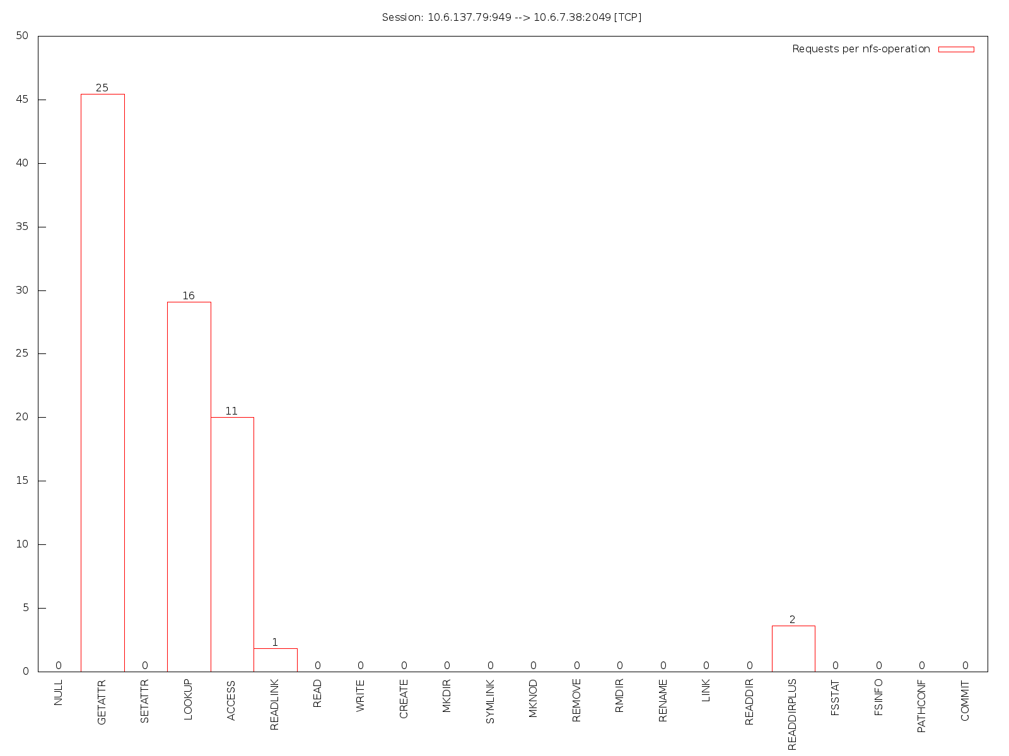
Figure 3.1 – Session visualization

Watch (libwatch.so)
Watch plugin mimics old nfswatch utility: it monitors NFS traffic and displays it in terminal using ncurses. It supports NFSv3 and NFSv4.
Important: at the moment watch plugin's output conflicts with standard nfstrace's output. You have to run nfstrace with -v 0 option so it will be silent and won't break ncurses output.
Nfstrace watch plugin. To scroll press up or down keys. Ctrl + c to exit.
Host name: epbyminw0059.minsk.epam.com
Date: 26.1.2015 Time: 19:19:79
Elapsed time: 0 days; 0:2:14 times

┌──────────────────────────────────────┌──────────────────────────────────────┐
│ NFSv3 total procedures: 23 │ NFSv4 total operations: 0 │
│ Per procedure: │ Per operation: │
│ NULL 0 0.00% │ ILLEGAL 0 0.00% │
│ GETATTR 10 43.48% │ ACCESS 0 0.00% │
│ SETATTR 0 0.00% │ CLOSE 0 0.00% │
│ LOOKUP 0 0.00% │ COMMIT 0 0.00% │
│ ACCESS 7 30.43% │ CREATE 0 0.00% │
│ READLINK 0 0.00% │ DELEGPURGE 0 0.00% │
│ READ 1 4.35% │ DELEGRETURN 0 0.00% │
│ WRITE 0 0.00% │ GETATTR 0 0.00% │
│ CREATE 0 0.00% │ GETFH 0 0.00% │
│ MKDIR 0 0.00% │ LINK 0 0.00% │
│ SYMLINK 0 0.00% │ LOCK 0 0.00% │
│ MKNOD 0 0.00% │ LOCKT 0 0.00% │
│ REMOVE 0 0.00% │ LOCKU 0 0.00% │
│ RMDIR 0 0.00% │ LOOKUP 0 0.00% │
│ RENAME 0 0.00% │ LOOKUPP 0 0.00% │
│ LINK 0 0.00% │ NVERIFY 0 0.00% │
│ READDIR 0 0.00% │ OPEN 0 0.00% │
│ READDIRPLUS 4 17.39% │ OPENATTR 0 0.00% │
│ FSSTAT 1 4.35% │ OPEN_CONFIRM 0 0.00% │
│ FSINFO 0 0.00% │ OPEN_DOWNGRADE 0 0.00% │
│ PATHCONF 0 0.00% │ PUTFH 0 0.00% │
│ COMMIT 0 0.00% │ PUTPUBFH 0 0.00% │
│──────────────────────────────────────│ PUTROOTFH 0 0.00% │
│ │ READ 0 0.00% │
│ NFSv4 total procedures: 0 │ READDIR 0 0.00% │
│ Per procedure: │ READLINK 0 0.00% │
│ NULL 0 0.00% │ REMOVE 0 0.00% │
│ COMPOUND 0 0.00% │ RENAME 0 0.00% │
│ │ RENEW 0 0.00% │
│ │ RESTOREFH 0 0.00% │
│ │ SAVEFH 0 0.00% │
│ │ SECINFO 0 0.00% │
│ │ SETATTR 0 0.00% │
│ │ SETCLIENTID 0 0.00% │
│ │ SETCLIENTID_CONFIRM 0 0.00% │
│ │ VERIFY 0 0.00% │
│ │ WRITE 0 0.00% │
│ │ RELEASE_LOCKOWNER 0 0.00% │
│ │ GET_DIR_DELEGATION 0 0.00% │
└──────────────────────────────────────└──────────────────────────────────────┘
By default watch plugin will update its screen every 2 seconds, you can specify another timeout in milliseconds:
$ nfstrace -v 0 -a libwatch.so#1000

JSON Analyzer (libjson.so)
JSON analyzer calculates a total amount of each supported application protocol operation. It accepts TCP-connections on particular TCP-endpoint (host:port), sends a respective JSON to the TCP-client and closes connection. Suggested to be used in live mode.
Available options:
host=HOSTNAME
Network interface to listen (default: listen all interfaces)
port=PORT
IP-port to bind to (default: 8888)
workers=WORKERS
Amount of worker threads (default: 10)
duration=DURATION
Max serving duration in milliseconds (default: 500)
backlog=BACKLOG
Listen backlog (default: 15)
In order to try this analyzer out you can start nfstrace in on terminal:
$ nfstrace -i eth0 -a libjson.so#host=localhost
And then you can make a TCP-request to nfstrace in another terminal to fetch current statistics:
$ telnet localhost 8888
Trying 127.0.0.1...
Connected to localhost.
Escape character is ’^]’.
{
"nfs_v3":{
"null":32,
"getattr":4582,
...
},
"nfs_v4":{
...
},
...
}Connection closed by foreign host.

Implementation details
This section may be interested for the developers who want to contribute or implement new pluggable analysis module.

Payload filtration
Each NFSv3 procedure consists of two RPC messages:
- call – request from client to server;
- reply – reply from server with result of requested procedure.
Both RPC messages may contain data useful for analysis. Both RPC messages may contain thousands of payload bytes useless for analysis. nfstrace captures headers of calls and replies and then matches pairs of them to complete NFS procedures.
The --snaplen option sets up the amount of bytes of incoming packet for uprising from the kernel to user-space. In case of TCP transport layer this option is useless because TCP connection is a bidirectional stream of data (instead of UDP that is form of interchange up to 64k datagrams). In case of NFS over TCP nfstrace captures whole packets and copies them to user-space from the kernel for DPI and performing NFS statistical analysis.
Finally, nfstrace filtrates whole NFS traffic passed from the kernel to user-space and detects RPC/NFS message headers (up to 4 Kbytes) within gigabytes of network traffic.
Detected headers are copied into internal buffers (or dumped into a .pcap file) for statistical analysis.
The key principle of the filtration here is discard payload ASAP.
Filtration module works in a separate thread and captures packets from network interface using libpcap. It matches packets to a related session (TCP or UDP) and performs reassembling of TCP flow from a TCP segment of a packet. After that the part of a packet will be passed to RPCFiltrator. In case of NFSv4 the whole packet will be passed to RPCFiltrator because it consists of several NFSv4 operations.
There are two RPCFiltrator in one TCP session. Both of them know the state of the current RPC message in related TCP flow. They can detect RPC messages and perform actions on a packet: discard it or collect for analysis.
The size of the kernel capture buffer can be set with -b option (in MBytes). Note that this option is very crucial for capturing performance.
wsize and rsize of an NFS connection are important for filtration and performance analysis too.

Pluggable analysis modules
nfstrace provides C++ api for implementing pluggable analysis modules. Header files provide definitions of IAnalyzer interface, NFS data structures and functions. The IAnalyzer interface is a set of NFS handlers that will be called by Analysis module for each NFS procedure. All constants and definitions of types will be included with <nfstrace/api/plugin_api.h> header.
A pluggable analysis module must be a dynamically linked shared object and must export the following C functions:
const char* usage (); // return description of expected opts for create(opts)
IAnalyzer* create (const char* opts); // create and return an instance of an Analyzer
void destroy (IAnalyzer* instance); // destroy created instance of an Analyzer
After the declaration of all these function there must be the following macro:
NST_PLUGIN_ENTRY_POINTS (&usage, &create, &destroy)
usage() function must return a C-string with module description and required parameters for creation of an instance of analyzer, this string will be shown in the output of --help option.
IAnalyzer* create(const char* opts) must create and return an instance of the analyzer according to passed options.
void destroy(IAnalyzer* instance) must destroy previously created analyzer instance and perform required cleanups (e.g. close connection to a database etc.).
All existing analyzers are implemented as pluggable analysis modules and can be attached to nfstrace with -a option.

General schema
The general schema of nfstrace is presented in the figure 4.1.
In this schema you can see how data flows in different modes:
- on-line analysis – green line ;
- on-line dumping – yellow line ;
- off-line dumping – blue line ;
- off-line analysis – orange line .
See [2.2] for more information about each mode.

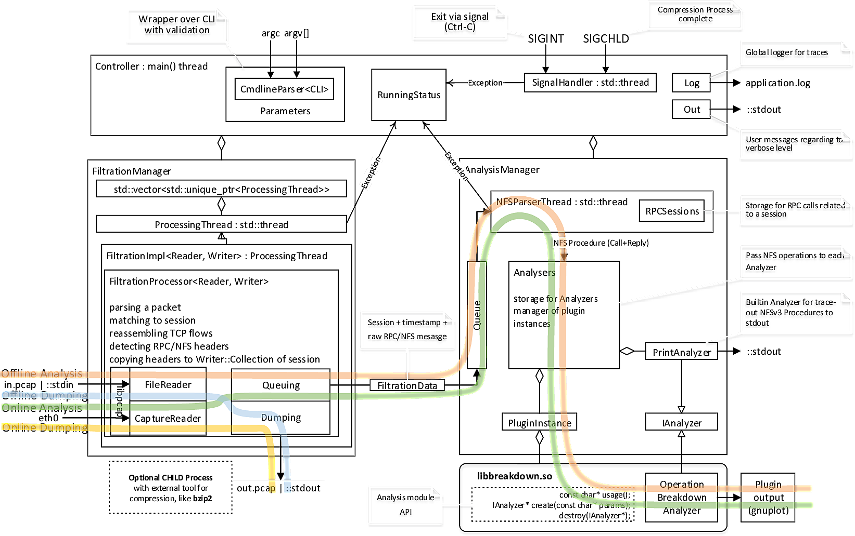
Figure 4.1 – General schema

Glossary
BPF
Berkeley Packet Filter 4p., 7
DPI
Deep Packet Inspection, nfstrace performs DPI of raw network traffic 13
gnuplot
CLI tool that can generate two- and three-dimensional plots of data 10
LSF
Linux Socket Filtering, is derived from the BPF 4
NFS
Network File System Protocol 4, 6pp., 11pp.
NIC
Network Interface Card 4
Payload
User’s data transferred by NFS protocol. It is useless in analysis 13
POSIX
Portable Operating System Interface for Unix 4
rsize
option of NFS client connection to a NFS server 13
Wireshark
Enterprise quality tool-set for network traffic analysis 7
wsize
option of NFS client connection to a NFS server 13

