Analysis framework functional and design specification

Analyzer accepts packets passed from filter and performs data processing depending on report type requested by user.
Analyzer framework contains of analysis modules, which can be either built-in or pluggable.
This module has 2 work modes:
- Online mode where analyzer gets packets for processing directly from filter.
- Offline mode where input data located in file in pcap format.
In both modes, input data is processed by filter manager. Then filtered data is appended to queue. This queue is input for analysis framework.

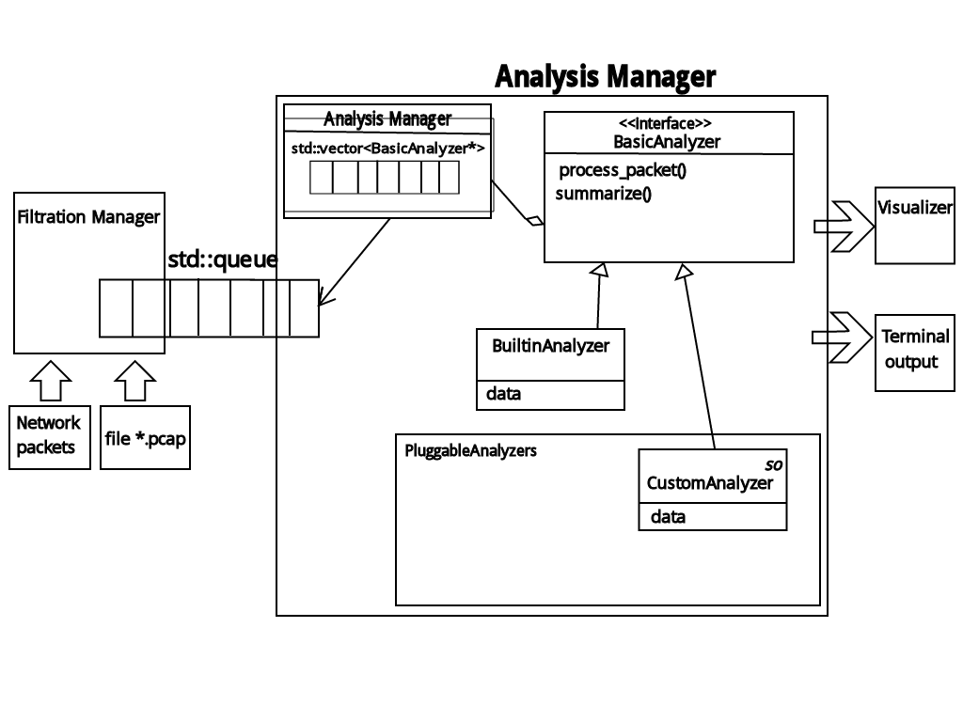
Structure of analysis framework is illustrated above. Interface BasicAnalyzer provides list of signatures that should be implemented by all analyzers modules.
Analyzer passes each filtered packet from queue to analysis modules in use. Then this packet is read by all modules in loop. Each module maintains own data structures, but produce resulting data in unified table format (TBD). It allows modules to work independently. It grabs necessary data from the packet and accumulates it or performs instant calculation.
Analyzer manager control work flow of analysis process. It contains all working modules in array, and for every packet it calls function process_packet with this packet as a parameter. After processing all packets, it command analyzers to prepare data for output. Output is processed by visualizer module where reports are generated depending on command-line option.

Packets query
Communication between filtration manager and analyzer is provided with the using of packets query. This query is implemented on the base of std::query container from Standart Template Library. Thread-safety is provided by the using of spin-locks for inserting and deleting.
Element of query is the object containing selected fields of IP, TCP, RPC and NFS packets headers. This fields contain data for various analysis modules to process information and make a report.
There is element's structure, described in C++ programming language:

struct CapturedData
{
// from TCP packet header
struct Session
{
ip_addr src_addr;
short src_port;
ip_addr dst_addr;
short dst_port;
};

// from RPC packet header
struct Rfc
{
uint32 msg_type;
uint32 xid; // for matching call and reply
};

// from NFS packet header
struct Nfs
{
NFR_OP op_id;
}

uint32_t time;
};
Structure CapturedData consist of 3 structures. Structure Session contains data from TCP header, structure Rpc – from RPC header, structure Nfs – from NFS header.

Analyzer modules
Each analyzer module should inherit abstract class BasicAnalyzer to be included in array of analyzers. Every subclass of BasicAnalyzer should implement following methods:
- constructor;
- virtual void process_packet(const Packet& p);
- virtual void summarize(result_type& r); //will be finally defined later
- destructor.
In constructor, analyzer module initializes itself, creates internal data structures, which should be correctly destroyed in destructor to avoid memory leaks.
In function process_packet analyzer takes all necessary data from the packet and append it to its data structures. If there is no need to store data up to the finish of input stream, fast calculation may be performed.
Method summarize is called when dumping is finished and all packets are processed. In this method analyzer module performs calculations based on data stored in its internal data structures. Results returned in internal data format, that will be defined later.
Analyzer module will contain several built-in analysis modules. Other modules will be defined in dynamic libraries and will be linked necessarily.

Operation breakdown analysis
Operation breakdown analyzer provides summary for all TCP sessions and per TCP session statistics. Summary includes types of NFS operations on a percentage basis.
For each TCP session computes the NFS operations breakdown and per operation summary:
- Average latency
- Minimum latency
- Maximum latency
- Standard deviation latency
Data structure for storing intermediate data is presented below:

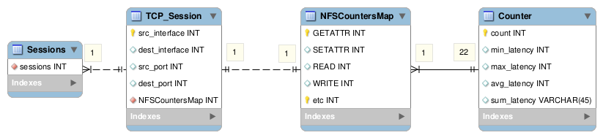
First, we divide packets among sessions, which are identified by source and destination interfaces and ports. Thus, array of sessions is stored in analyzer instance. Besides this fields, each session has a map, where operation name is associated with structure describing its count and parameters connected to latency.
While processing packets, we count its number for each operation of each session to give separate statistics for sessions. Every time current latency value is compared with max & min values. Besides, latencies are accumulated to get average latency after dividing by count of operations.
Summary on a percentage basis is calculated after finishing of packets processing.

