Jaewoo An
1. Draw the internal memory representation of the binary tree of Figure 5.15 using (a) sequential and (b) linked representations.
(a) Sequential Representation
[0] | -
[1] | A
[2] | B
[3] | -
[4] | C
[5] | D
[6] | -
[7] | -
[8] | E

(b) Linked Representation
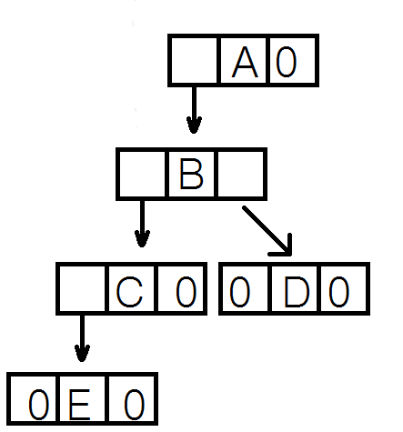

2. Write out the inorder, preorder, postorder, and level-order traversals for the binary trees of Figure 5.10.
Inorder
(a)EDCBA
Call of Inorder | Value in root | Action | Call of Inorder | Value in root | Action
1 | A |  | 4 | D | printf
2 | B |  | 8 | NULL
3 | C |  | 3 | C | printf
4 | D |  | 9 | NULL
5 | E |  | 2 | B | printf
6 | NULL |  | 10 | NULL
5 | E | printf | 1 | A | printf
7 | NULL |  | 11 | NULL
(b)HDIBEAFCG
Call of Inorder | Value in root | Action | Call of Inorder | Value in root | Action
1 | A |  | 11 | NULL
2 | B |  | 10 | E | printf
3 | D |  | 12 | NULL
4 | H |  | 1 | A | printf
5 | NULL |  | 13 | C
4 | H | printf | 14 | F
6 | NULL |  | 15 | NULL
3 | D | printf | 14 | F | printf
7 | I |  | 16 | NULL
8 | NULL |  | 13 | C | printf
7 | I | printf | 17 | G
9 | NULL |  | 18 | NULL
2 | B | printf | 17 | G | printf
10 | E |  | 19 | NULL
Preorder
(a)ABCDE (b)ABDHIECFG
Postorder
(a)EDCBA (b)HIDEBFGCA
Level-Order
(a)ABCDE (b)ABCDEHIFG

3. Write a C++ function swapTree that takes a binary tree and swaps the left and right children of every node. An example is given in Figure 5.20.
node* swapTree(node *original)
{
if (original)
{
node *temp = new node;
temp->leftChild = swapTree(original->rightChild);
temp->rightChild = swapTree(original->leftChild);
temp->data = original->data;
return temp;
}
return NULL;
}

4.
int getHeight(node *tree)
{
int hl, hr, h;
if (tree)
{
hl = getHeight(tree->leftChild);
hr = getHeight(tree->rightChild);
if (hl > hr)
h = 1 + hl;
else
h = 1 + hr;
return h;
}
return 0;
}

5. Write a program to start with an initially empty binary search tree and make n random insertions. Use a uniform random number generator to obtain the values to be inserted. Measure the height of the resulting binary search tree and divide this height by log₂(n). Do this for n = 100, 500, 1000, 2000, 3000, ... , 10,000. Plot the ratio height /log₂(n) as a function of n. The ratio should be approximately constant (around 2). Verify that this is so.

Value of n | Resulting Height | log₂(n) | Height / log₂(n)
100 | 11 | 6.6439 | 1.7
500 | 20 | 8.9658 | 2.2
1000 | 24 | 9.9658 | 2.4
2000 | 26 | 10.9658 | 2.4
3000 | 27 | 11.5507 | 2.3
4000 | 26 | 11.9658 | 2.2
5000 | 27 | 12.2878 | 2.2
6000 | 29 | 12.5507 | 2.3
7000 | 29 | 12.7731 | 2.3
8000 | 28 | 12.9658 | 2.2
9000 | 30 | 13.1357 | 2.3
10000 | 31 | 13.2877 | 2.3
Value of n vs. Height / log₂(n)
