Jaewoo An

Professor Choi

CS101

March 4, 2012

Homework 1

The following pictures show 20111051.py (Meeting Two Robots in a Maze) tested on maze1.wld, maze2.wld, maze3.wld, maze4.wld, and 20111051.wld.

maze1.wld maze2.wld

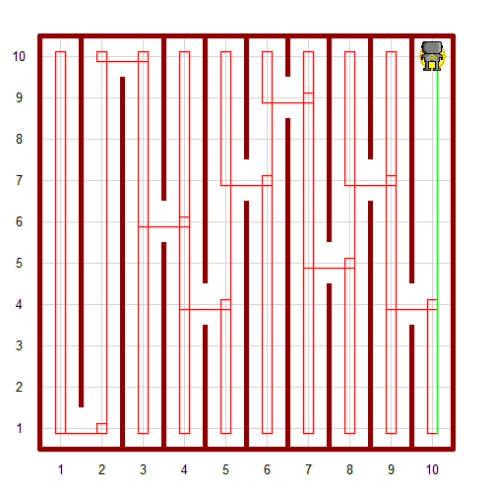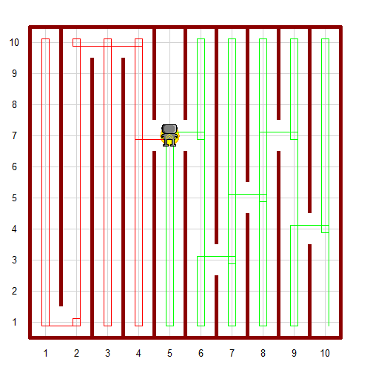

maze3.wld maze4.wld

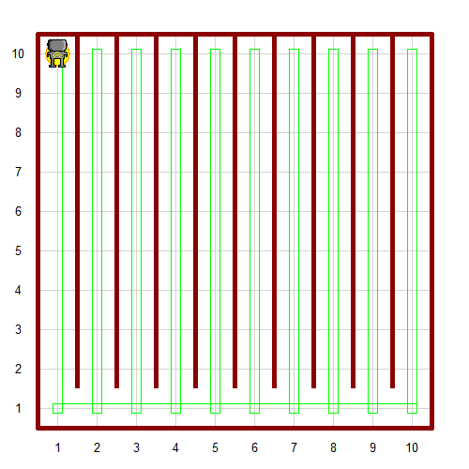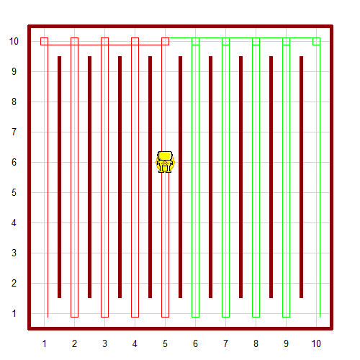

‘

20111051.wld

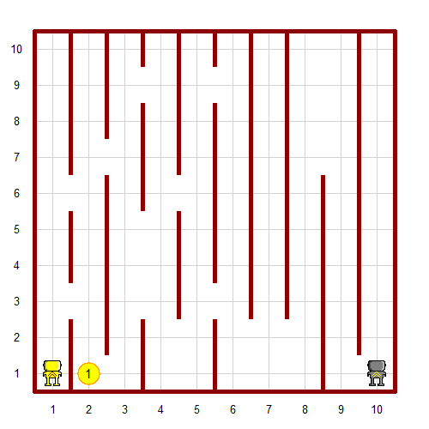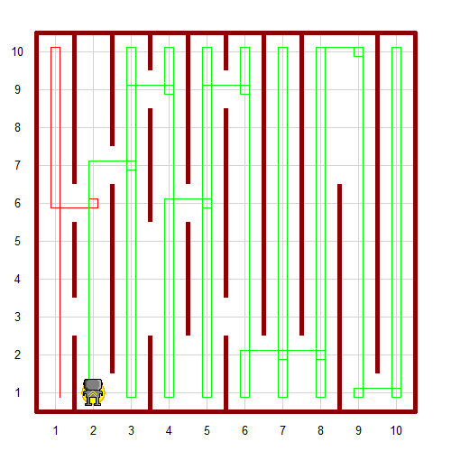

First, I set the trace of hubo as green and that of ami as red to easily recognize how they move.

Then, I defined turn_right function for parameter (Robot) so that I could use it for both hubo and ami. I also defined turn_around function for parameter (Robot) for the same reason.

Next, I defined a function ami_movement(). To make sure that ami stops right after ami arrives at the beeper, I used “while not ami.on_beeper()” as a condition to decide whether or not to continue ami’s behavior. Then, I wrote if ami.front_is_clear() so that ami will move until ami reaches street 10 of the avenue ami is located. Once ami’s way is blocked, ami will turn_around() and move() until ami’s left_is_clear() value is true. Then, ami will turn left and move to the next avenue. ami will go all the way down to street 1. This is the basic behavior of ami. Until ami finds the beeper (or until ami.on_beeper becomes true), ami will keep moving in this manner.

I created hubo_movement() function, which is basically the same as ami_movement() except that they turn in the opposite direction whenever they have to turn.

I did not have to define a face_north() function since ami will never stop while she is going down. ami only recognizes the beeper while she is going up, so her orientation at the end of her behavior is always north. Same thing applies to hubo.

Lastly, I executed ami_movement() and hubo_movement().