Elisha Parslow

CS374 Database Management

HW2

From Book

EX02_01

EX02_02

From Northwind Database

EX02_03

Select *

From dbo.Products

Where UnitPrice > 25.00;

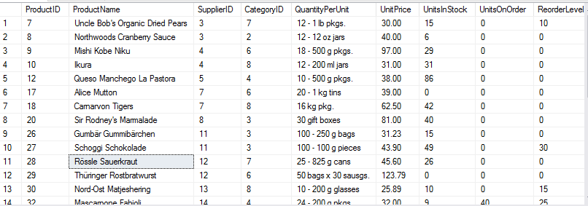

Ex02_04

Select CompanyName

from dbo.Customers

Where Customers.ContactTitle != 'Owner' AND Customers.City = 'Chicago';

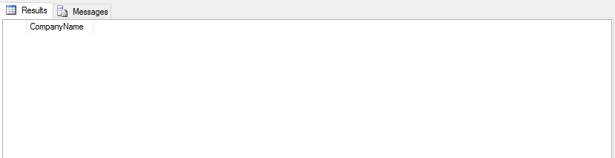

EX02_05

Select e.LastName, o.ShipName

from dbo.Employees e, dbo.Orders o

Where e.EmployeeID = o.EmployeeID AND e.City = 'Redmond';

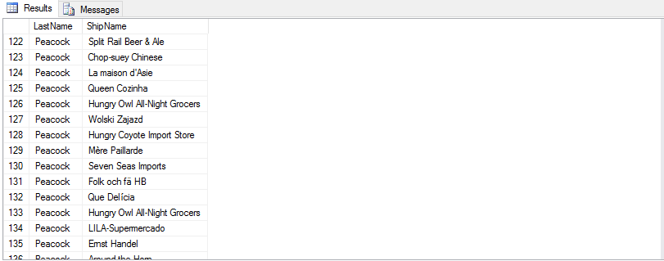

EX02_06

Select ProductName

from dbo.Categories c, dbo.Products p

Where c.CategoryName = 'Beverages' AND p.Discontinued != 1;

