# How to Contribute a parser to the RSA Log Parser community

1. Create GitHub account for free
   1. <https://www.GitHub.com>
2. Locate the RSA NetWitness project
   1. <https://github.com/netwitness>
3. Locate the log-parsers project
   1. https://github.com/netwitness/nw-logparsers
4. Create a fork (your copy of the full repo) from link on top right corner of page <https://github.com/netwitness/nw-logparsers>, This will create your own copy of the repository on github eg. <https://github.com/username/nw-logparsers>

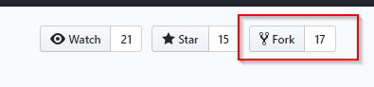

1. Open the community folder



1. Create a new branch in the community folder

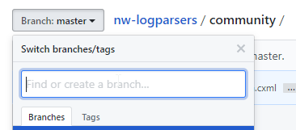

1. Create new Folder with the parser name



* 1. Each new parser should be kept in a new folder with its name. only add parser.xml file (not zip or .envision file).

1. Create a new folder for your parser by clicking new file button, when the box shows up add the folder name then a slash and then the file name (this creates a folder for your file which isn’t obvious from the UI)





1. Copy and paste the text of your parser into the editor
   1. Only include the .xml and .ini file and nothing else (no .envision or .zip)
   2. Add data to the Commit description at the bottom and click commit new file

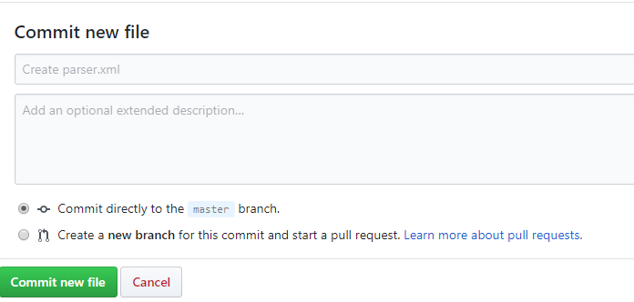

1. Raise pull request to merge your changes to NetWitness repo
   1. Open your repo page on github.com,
   2. Click create pull request



* 1. Name the pull request
  2. Request will go to content team for review and merging.

# How to Update your forked log-parsers repository to get latest version

1. Log into github account
2. Locate the forked nw-logparsers repository in your account

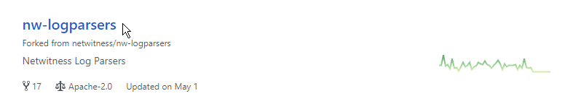

1. Click on compare (right side)
2. 
3. You will get a notification like this if it’s the first time for comparing

**There isn't anything to compare.**  
**someone:master** is up to date with all commits from **me:master**. Try **switching the base** for your comparison.

**Click on switching the base**

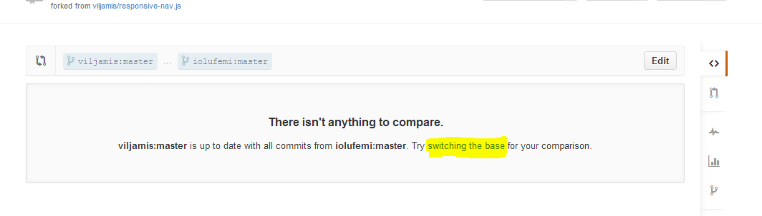

Or this if you have compared before

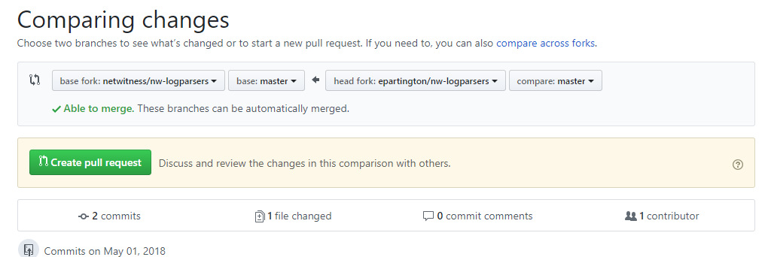

*** important ***

Github defaults to sync your changes to the upstream fork, in this case we want the opposite.

Change the base fork (left option) to be your fork (not the netwitness/nw-logparsers)

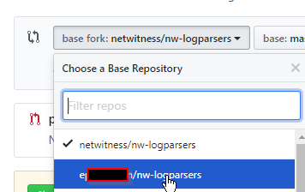

Now you will see a different comparing changes screen and a note about comparing the same two things

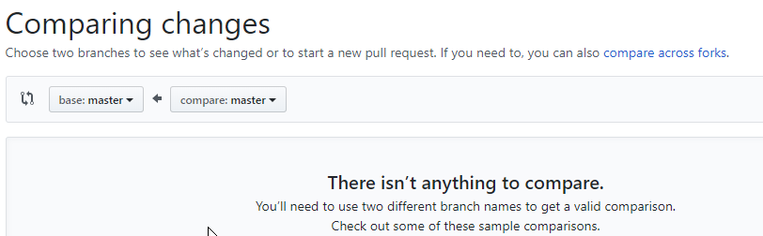

Click the compare across forks

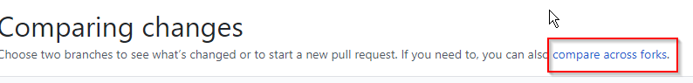

Now you get the base and head selections

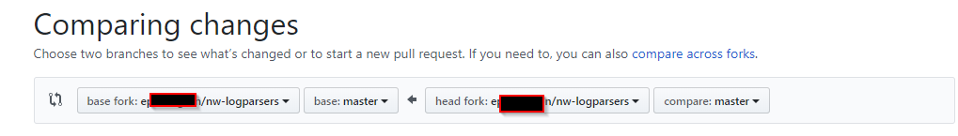

Click the head fork and change to the netwitness/ fork

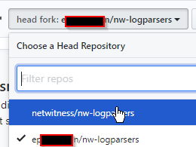

Now you see the commits since the repository was forked

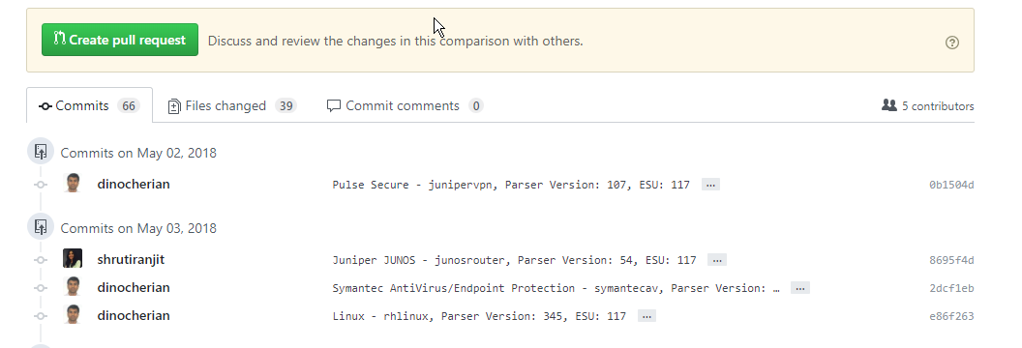

Click on Create pull request

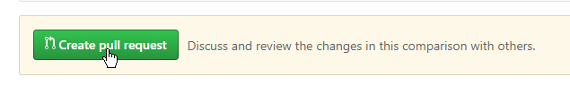

Give it a title and if required a description

Click **create pull request**

On the next page click Create pull request

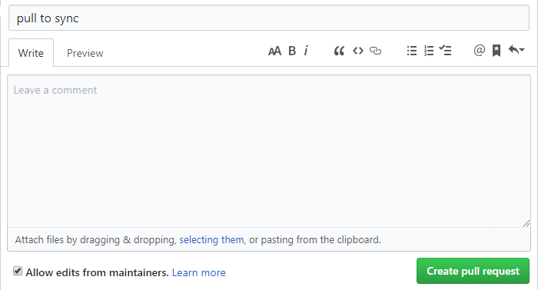

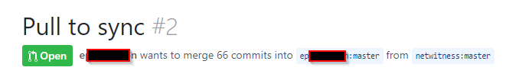

Click merge pull request

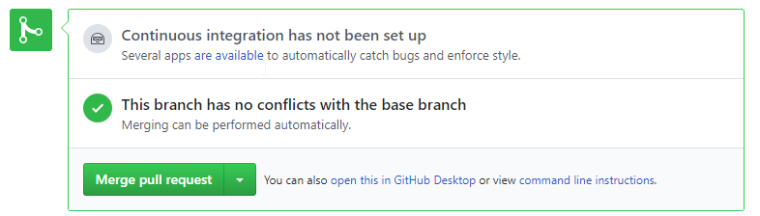

Click confirm merge

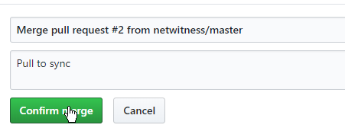

Your copy of the RSA Netwitness nw-logparsers repo is now updated



You can review the latest code and also submit new parsers or updates to your already submitted parsers using the above process.

Process what helped along with this very helpful GitHub link

<https://github.com/KirstieJane/STEMMRoleModels/wiki/Syncing-your-fork-to-the-original-repository-via-the-browser>