Final Project Rough Draft
Elliana Pastano
MSDS, Willamette University
Data 501
Professor Meunier
November 26, 2025
Introduction
How are democratic systems measured and ranked against each other? What factors create a good democratic governance system? Freedom House Index attempts to answer these by creating a series of questions that are labeled under the categories of Political Right (PR) and Civil Liberty (CL). While these two variables might seem to be interchangeable, there are some key distinctions. Broadly defined, civil liberties measure the extent of a country’s individual freedom of expression, association, and religion (Armstrong, 2011). The Freedom House Index further adds the categories of the rule of law, personal autonomy and individual rights, and access to information to their definition (Freedom House, 2024). Political rights measure the degree that citizens are allowed to participate in voting, running for office, and engage in political disclosure (Freedom House, 2024). The Freedom House Index categorizes political rights as free and fair elections, political pluralism, a functioning government, and minority group representation (Møller, 2014). A strong relationship between these two variables would validate the political theory that these are important factors linked with democracy. If these variables do not have a strong relationship to each other, then perhaps there should be another method of measuring freedom and democracy scores.
Adding in the other factors of education, internet users, and the economy, one can observe the changes in the strength of the relationship between Civil Liberties and Political Rights. These factors were chosen because some democratic theory suggests that investing in a country’s education and access to global internet will boost the overall democracy score (Hardi, 2025). Combining these factors to the dataset will allow us to examine the extent that political and socioeconomic variables that contribute to creating democratic structures.
Questions and Hypotheses:
This project plans to address two research questions:
- How strongly are Political Rights and Civil Liberties associated across countries and regions?
- Do the factors of economy, education, and internet access impact the relationship between Political Rights and Civil Liberties?
Null Hypothesis: Political Rights rating does not significantly predict Civil Liberties rating.
Alternative Hypothesis: Political Rights rating is positively associated with Civil Liberties ratings across countries and regions. Specifically, higher PR scores (less freedom) are associated with higher CL scores (less freedom). GDP per capita, the number of people who have access to the internet, and education levels also impact the association between Political Rights and Civil Liberties.
Methodology
This project looks at the relationship between CL and PR, as well as other indicators across countries and regions from the years 2013-2024. The research was conducted in R using the Freedom House Freedom in the World (FIW) dataset and three economic and social variables from the World Bank: GDP per capita, percentage of internet users, and lower secondary education completion rates (Freedom House, 2024, Arel-Bundock, 2025). These variables were merged to form a new dataset that was used in a logistical regression. To run a logistical model, the variable CL, was changed to a binary variable, where 1 = Not Free and 0 = Free.
The explanatory variables in this instance would be:
Political Rights – A numerical score (1-7) with 1 being a high score of political rights and 7 being a low score of political rights and is the primary explanatory variable.
GDP per capita – This is a continuous economic development variable.
Internet Users – This is a continuous variable that show digital access and freedom of information as a percentage of the population of a country.
Education – This is a continuous human development measure and looks at the lower secondary completion rate of countries.
Region – This is a categorical variable grouping countries into sub-categories.
Year – This is a continuous variable that was used to look at world economic and political trends over the time of 2013-2024.
The response variable in this test was:
Civil Liberties Rating (Binary) – This is a binary variable that measures free countries as 0 and not free countries as 1.
There was missingness in the data due to some countries not having education, GDP per capita, or internet users results for every year. To address this, list deletion was used to omit the rows of missing data. Because the data did not meet the criteria for normality and homoscedasticity, a logistical regression was run. Instead, multicollinearity was assessed using Variance Inflation Factor (VIF) and all the values were deemed acceptable, as they all measured under 5 (Fox, 2019).
Logistical Regression Model:
$$logit(P(Not Free))=β_{0}​+β_{1}​​(PR)+β_{2}​(GDPpc)+β_{3}​​(Internet)+β_{4}​​​(Education)+β_{5}​​(Region)+β_{6}​​(Year)$$
This model predicts the probability of a country not being free accounting for the political rights, GDP per capita, internet users, education, region, and year.

The packages used in this project include:
- tidyverse
- dplyr
- WDI
- car
- pscl
- caret
- janitor
- ggeffects
- pROC
Results

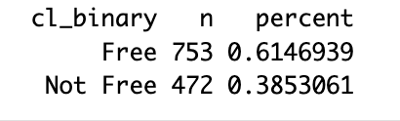
A look into the descriptive statistics of CL shows that from the years 2013 to 2024, there are more countries that have Free CL ratings than countries who do not have Free CL ratings (Firke, 2024). This means that of the countries measured from the years 2013 to 2024, 61.5% had a CL score ranging from 1 to 3, while 38.5% of the countries had a CL score ranging from 4-7.
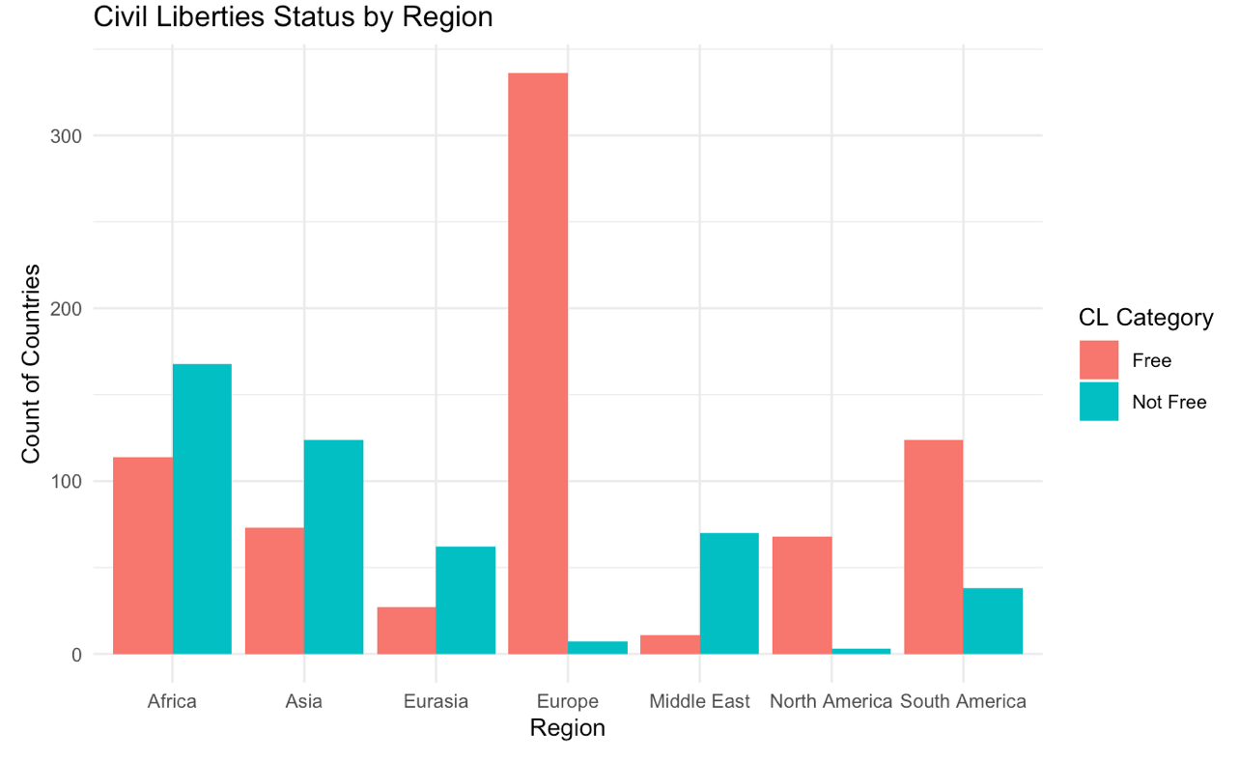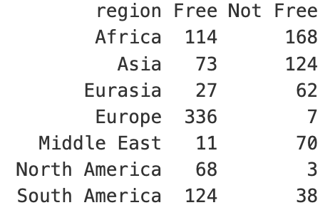
These figures show that there is a large variance of CL status between the regions. Europe has the highest count of Free countries, meaning that throughout the years of 2013 to 2024, this region had 336 Free countries and only 7 countries that had a status of Not Free. The regions of North and South America also had more countries that fall into the Free category than the Not Free category. Meanwhile, Asia and the Middle East had more countries that had CL that ranked Not Free than countries that had a Free status. This first glance at the descriptive statistics depicts a pattern that geography could play a factor in predicting CL status.

Logistical Regression Results:
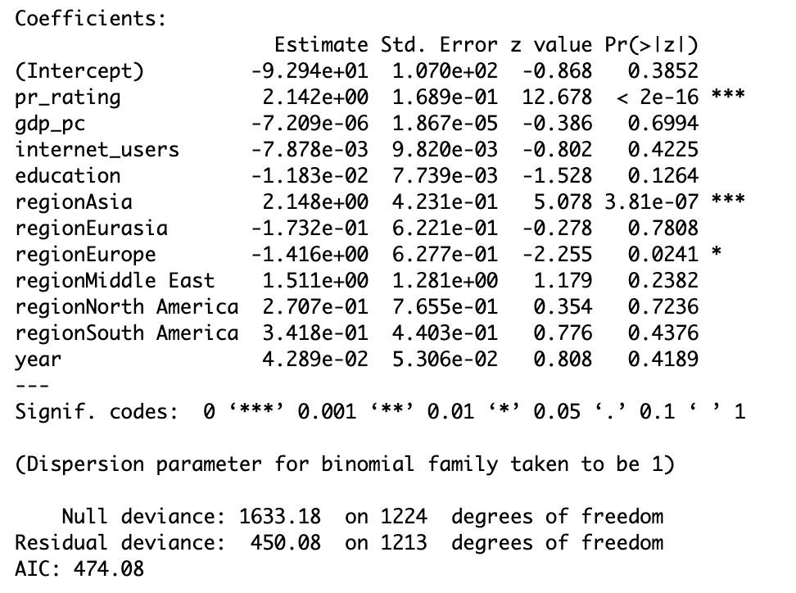
The linear regression shows that the strongest predictor of CL is PR. This is shown through the p-value being very small, meaning that the likelihood that one would see this example or more extreme is very small. The social and economic variables of GDP per capita, education, and internet access do not significantly predict the status of civil liberty after accounting for political rights. This means none of these variables alone can predict CL status. There are only two regions that show significance (when compared with the base of Africa): Asia being more likely to be Not Free and Europe being more likely to be Free. The variable of Year was not significant, showing that there is no global time trend from the years 2013-2024 for predicting CL after adjusting for PR. This model shows that PR and CL are closely associated across countries, which supports our alternative hypothesis.
McFadden $R^{2}$
0.7244124
In order to evaluate the fit of the model, a pseudo-R squared was computed, as a logistical regression does not calculate this statistic (Simon, 2024). This project used the McFadden $R^{2}$ and found that this logistical model explained 72.4% of the data from the datasets.
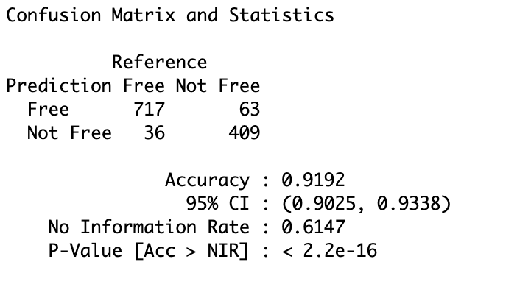
When evaluating the confusion matrix, one can see that this model correctly predicts a country’s CL status as Free or Not Free with 91.9% accuracy (Kuhn, 2008). Of the 753 countries that have a Free status, this model correctly identified 717 of them. Of the 472 countries that have a Not Free status, this model correctly identified 409. This means that this model has a strong ability to identify CL status based off political rating.
Discussion
This research project wanted to understand the relationship between PR and CL, as well as look at a few social and economic variables that could shape democratic governance. The findings of this study show that PR and CL are very connected. The logistical regression depicts that there is a strong, statistically significant, and predictable relationship between these two variables. Countries that do not have protected PR will also more than likely have restricted CL. This supports with the democratic theory that political openness and protection of rights will decline together (Møller, 2014). This strong relationship could mean that a deterioration in one variable could be seen as a warning sigh for the deterioration of the other.
The research shows that economic and human development variables do not significantly influence this relationship. While GDP, education, and access to the internet are often positively associated with higher democracies, this study shows that there was not a significant effect from these variables on CL. This suggests that economic developments in countries alone will not result in CL. The variable of the year was not statistically significant, suggesting that CL are not becoming stronger or weaker throughout the countries over time. This shows that people in the government that want to improve CL within a country should focus on political reforms, rather than economic ones, as this will yield higher results.
The study showed that the region of Asia had a higher probability of being Not Free, even when adjusting for economic and social indicators. The study also showed that the region of Europe had a higher probability of being Free. This suggests that there are qualitative factors that play an important role in the development of CL. Regions of the world that are strongly Not Free in both CL and PR might need more qualitative approaches to changing the status of freedom.
There were some limitations of this study, including making the variable of CL a binary variable, which limits the definition of free and not free, however, it was necessary to run a logistic model. There was missingness in the World Bank Data, which reduced the sample size that the study had to work with. There were also unobserved factors that the study did not take account for such as colonialism, conflict, and biases within the datasets.
Conclusion
Political rights proved to be the best indicator of civil liberties across the countries, far outweighing economic and social factors. While these developmental factors are important for broader societal improvements, this study showed that they do not make a significant difference when pitted against political rights and civil liberties. There is still work to be done to study political rights and civil liberties over time and perhaps diagnose democratic erosion.

References
Arel-Bundock V (2025). _WDI: World Development Indicators and Other World Bank
Data_. doi:10.32614/CRAN.package.WDI <https://doi.org/10.32614/CRAN.package.WDI>, R
package version 2.7.9, <https://CRAN.R-project.org/package=WDI>.
Armstrong, David A (2011). “Stability and change in the Freedom House Political Rights and Civil Liberties Measures.” Journal of Peace Research, vol. 48, no. 5, Sept. 2011, pp. 653–662, https://doi.org/10.1177/0022343311411744.
Firke S (2024). _janitor: Simple Tools for Examining and Cleaning Dirty Data_.
doi:10.32614/CRAN.package.janitor <https://doi.org/10.32614/CRAN.package.janitor>, R
package version 2.2.1, <https://CRAN.R-project.org/package=janitor>.

Fox J, Weisberg S (2019). _An R Companion to Applied Regression_, Third edition.
Sage, Thousand Oaks CA. <https://www.john-fox.ca/Companion/>.

Freedom House (2024). Freedom in the world 2024. https://freedomhouse.org/report/freedom-world
Hardi, Irsan, et al (2025). “Freedom and prosperity: The impact of political rights and civil liberties on Economic Complexity.” Ekonomikalia Journal of Economics, vol. 3, no. 2, 14 Aug. 2025, pp. 78–92, https://doi.org/10.60084/eje.v3i2.329.
Kuhn, M. (2008). Building Predictive Models in R Using the caret Package. Journal of
Statistical Software, 28(5), 1–26. https://doi.org/10.18637/jss.v028.i05
Møller, Jørgen, and Svend-Erik Skaaning (2014). “Respect for civil liberties during the third wave of democratization: Presenting a new dataset.” Social Indicators Research, vol. 117, no. 3, 9 July 2014, pp. 1069–1087, https://doi.org/10.1007/s11205-013-0391-y.
Simon Jackman (2024). pscl: Classes and Methods for R Developed in the Political
Science Computational Laboratory. Sydney, Australia. R package version 1.5.9. URL
https://github.com/atahk/pscl/
Soetewey, Antoine (2024). “Binary Logistic Regression in R.” Stats and R, 30 Jan. 2024, statsandr.com/blog/binary-logistic-regression-in-r/.
Warf, Barney (2012). “Global internet censorship.” SpringerBriefs in Geography, 1 Aug. 2012, pp. 45–75, https://doi.org/10.1007/978-94-007-1245-4_3.
Wickham H, Averick M, Bryan J, Chang W, McGowan LD, François R, Grolemund G, Hayes
A, Henry L, Hester J, Kuhn M, Pedersen TL, Miller E, Bache SM, Müller K, Ooms J,
Robinson D, Seidel DP, Spinu V, Takahashi K, Vaughan D, Wilke C, Woo K, Yutani H
(2019). “Welcome to the tidyverse.” _Journal of Open Source Software_, *4*(43),
1686. doi:10.21105/joss.01686 <https://doi.org/10.21105/joss.01686>.

Wickham H, François R, Henry L, Müller K, Vaughan D (2023). _dplyr: A Grammar of
Data Manipulation_. doi:10.32614/CRAN.package.dplyr
<https://doi.org/10.32614/CRAN.package.dplyr>, R package version 1.1.4,
<https://CRAN.R-project.org/package=dplyr>.

Appendix

Final Project Part 2

Elliana Pastrano

2025-11-25
library(tidyverse)
## Warning: package 'ggplot2' was built under R version 4.5.2
## ── Attaching core tidyverse packages ──────────────────────── tidyverse 2.0.0 ──
## ✔ dplyr 1.1.4 ✔ readr 2.1.5
## ✔ forcats 1.0.0 ✔ stringr 1.5.2
## ✔ ggplot2 4.0.1 ✔ tibble 3.3.0
## ✔ lubridate 1.9.4 ✔ tidyr 1.3.1
## ✔ purrr 1.1.0
## ── Conflicts ────────────────────────────────────────── tidyverse_conflicts() ──
## ✖ dplyr::filter() masks stats::filter()
## ✖ dplyr::lag() masks stats::lag()
## ℹ Use the conflicted package (<http://conflicted.r-lib.org/>) to force all conflicts to become errors
library(dplyr)
library (WDI)
library(car)
## Loading required package: carData
##
## Attaching package: 'car'
##
## The following object is masked from 'package:dplyr':
##
## recode
##
## The following object is masked from 'package:purrr':
##
## some
library(pscl)
## Classes and Methods for R originally developed in the
## Political Science Computational Laboratory
## Department of Political Science
## Stanford University (2002-2015),
## by and under the direction of Simon Jackman.
## hurdle and zeroinfl functions by Achim Zeileis.
library(caret)
## Loading required package: lattice
##
## Attaching package: 'caret'
##
## The following object is masked from 'package:purrr':
##
## lift
library(janitor)
##
## Attaching package: 'janitor'
##
## The following objects are masked from 'package:stats':
##
## chisq.test, fisher.test
library(ggeffects)
library(pROC)
## Type 'citation("pROC")' for a citation.
##
## Attaching package: 'pROC'
##
## The following objects are masked from 'package:stats':
##
## cov, smooth, var
#Read in Democracy scores from FreedomHouseIndex
freedom_house <- read_csv("/Users/ellianapastrano/Downloads/All_data_FIW_2013_2025/FIW13-25-Table 1.csv", skip = 1)
## Rows: 2723 Columns: 44
## ── Column specification ────────────────────────────────────────────────────────
## Delimiter: ","
## chr (5): Country/Territory, Region, C/T, Status, Add A
## dbl (39): Edition, PR rating, CL rating, A1, A2, A3, A, B1, B2, B3, B4, B, C...
##
## ℹ Use `spec()` to retrieve the full column specification for this data.
## ℹ Specify the column types or set `show_col_types = FALSE` to quiet this message.
#clean up FHI dataset so that the variables are renamed
freedom_house <- freedom_house %>%
rename(
country = `Country/Territory`,
year = Edition,
pr_rating = `PR rating`,
cl_rating = `CL rating`,
region = Region
)

#Get rid of territories
freedom_house <- freedom_house %>%
filter(`C/T` == "c")

#Clean FHI dataset so that it only has the columns I want and drop missing data
freedom_house <- freedom_house %>%
dplyr::select(country, region, year, pr_rating, cl_rating) %>%
filter(year != 2025 & !is.na(pr_rating) & !is.na(cl_rating))

#View the summary and dataset of FHI
view(freedom_house)
summary(freedom_house)
## country region year pr_rating
## Length:2340 Length:2340 Min. :2013 Min. :1.000
## Class :character Class :character 1st Qu.:2016 1st Qu.:1.000
## Mode :character Mode :character Median :2018 Median :3.000
## Mean :2018 Mean :3.464
## 3rd Qu.:2021 3rd Qu.:6.000
## Max. :2024 Max. :7.000
## cl_rating
## Min. :1.000
## 1st Qu.:2.000
## Median :3.000
## Mean :3.358
## 3rd Qu.:5.000
## Max. :7.000
#ggsave("sepal boxplot.pdf", width = 4, height = 4, units = "in", dpi = 1500)
#Create list of variables that I want to check
world_bank_var <- c("NY.GDP.PCAP.KD", "IT.NET.USER.ZS", "SE.SEC.CMPT.LO.ZS")

#get the values of the variables that I want for the years that I have from FHI
world_bank <- WDI(
country = "all",
indicator = world_bank_var,
start = 2013,
end = 2024,
extra = TRUE
)

world_bank <- world_bank %>%
rename(
gdp_pc = NY.GDP.PCAP.KD,
internet_users = IT.NET.USER.ZS,
education = SE.SEC.CMPT.LO.ZS
)

world_bank <- world_bank %>%
dplyr::select(gdp_pc, internet_users, education, country, year)%>%
filter(!is.na(country), !is.na(year), gdp_pc < 150000)

view(world_bank)
summary(world_bank)
## gdp_pc internet_users education country
## Min. : 253.4 Min. : 1.042 Min. : 8.887 Length:3030
## 1st Qu.: 2062.5 1st Qu.: 30.661 1st Qu.: 65.870 Class :character
## Median : 6224.1 Median : 60.147 Median : 87.111 Mode :character
## Mean : 14945.5 Mean : 56.090 Mean : 79.292
## 3rd Qu.: 18827.0 3rd Qu.: 81.116 3rd Qu.: 95.826
## Max. :117661.3 Max. :100.000 Max. :147.363
## NA's :534 NA's :1010
## year
## Min. :2013
## 1st Qu.:2015
## Median :2018
## Mean :2018
## 3rd Qu.:2021
## Max. :2024
##
#merge the data
ds <- freedom_house %>%
left_join(world_bank, by = c("country", "year"))

north_america <- c(
"United States", "Canada", "Mexico", "Greenland",
"Bermuda", "Saint Pierre and Miquelon", "St. Kitts and Nevis", "St. Lucia", "St. Vincent and the Grenadines", "Jamaica", "Trinidad and Tobago", "Antigua and Barbuda", "Barbados",
"Grenada", "Barbados")

south_america <- c(
"Argentina", "Bolivia", "Brazil", "Chile", "Colombia",
"Ecuador", "Guyana", "Paraguay", "Peru", "Suriname",
"Uruguay", "Venezuela", "French Guiana", "Dominican Republic", "Belize",
"Costa Rica", "Cuba", "Dominca", "Dominica","Dominican Republic", "El Salvador", "Guatemala",
"Honduras", "Panama")

ds$region <- dplyr::case_when(
ds$country %in% north_america ~ "North America",
ds$country %in% south_america ~ "South America",
TRUE ~ ds$region)

ds$cl_binary <- ifelse(ds$cl_rating <= 3, 0, 1)
ds$cl_binary <- factor(ds$cl_binary, levels = c(0,1), labels = c("Free", "Not Free"))

ds <- na.omit(ds)
view(ds)
ds <- ds%>% mutate(cl_rating_bi = ifelse(cl_rating <= 3, “Free”, “Not Free”)) ds <- ds %>% mutate(cl_binary_numeric = ifelse(cl_rating_bi == “Free”, 0, 1))
write.csv(ds, "cl_ds.csv", row.names = FALSE)
#Logit model
logit_model <- glm(cl_binary ~ pr_rating + gdp_pc + internet_users + education + region + year,
data = ds,
family = binomial(link="logit"))

summary(logit_model)
##
## Call:
## glm(formula = cl_binary ~ pr_rating + gdp_pc + internet_users +
## education + region + year, family = binomial(link = "logit"),
## data = ds)
##
## Coefficients:
## Estimate Std. Error z value Pr(>|z|)
## (Intercept) -9.294e+01 1.070e+02 -0.868 0.3852
## pr_rating 2.142e+00 1.689e-01 12.678 < 2e-16 ***
## gdp_pc -7.209e-06 1.867e-05 -0.386 0.6994
## internet_users -7.878e-03 9.820e-03 -0.802 0.4225
## education -1.183e-02 7.739e-03 -1.528 0.1264
## regionAsia 2.148e+00 4.231e-01 5.078 3.81e-07 ***
## regionEurasia -1.732e-01 6.221e-01 -0.278 0.7808
## regionEurope -1.416e+00 6.277e-01 -2.255 0.0241 *
## regionMiddle East 1.511e+00 1.281e+00 1.179 0.2382
## regionNorth America 2.707e-01 7.655e-01 0.354 0.7236
## regionSouth America 3.418e-01 4.403e-01 0.776 0.4376
## year 4.289e-02 5.306e-02 0.808 0.4189
## ---
## Signif. codes: 0 '***' 0.001 '**' 0.01 '*' 0.05 '.' 0.1 ' ' 1
##
## (Dispersion parameter for binomial family taken to be 1)
##
## Null deviance: 1633.18 on 1224 degrees of freedom
## Residual deviance: 450.08 on 1213 degrees of freedom
## AIC: 474.08
##
## Number of Fisher Scoring iterations: 8
exp(coef(logit_model))
## (Intercept) pr_rating gdp_pc internet_users
## 4.347876e-41 8.515879e+00 9.999928e-01 9.921533e-01
## education regionAsia regionEurasia regionEurope
## 9.882425e-01 8.571488e+00 8.410014e-01 2.427881e-01
## regionMiddle East regionNorth America regionSouth America year
## 4.533192e+00 1.310905e+00 1.407458e+00 1.043820e+00
exp(confint(logit_model))
## Waiting for profiling to be done...
## 2.5 % 97.5 %
## (Intercept) 2.196411e-132 9.364605e+50
## pr_rating 6.241363e+00 1.212089e+01
## gdp_pc 9.999593e-01 1.000032e+00
## internet_users 9.733533e-01 1.011641e+00
## education 9.731358e-01 1.003169e+00
## regionAsia 3.859127e+00 2.034762e+01
## regionEurasia 2.471641e-01 2.857222e+00
## regionEurope 6.866187e-02 8.179413e-01
## regionMiddle East 4.595947e-01 5.401120e+01
## regionNorth America 2.515202e-01 5.490522e+00
## regionSouth America 6.028776e-01 3.406471e+00
## year 9.404408e-01 1.158434e+00

Statistical Tests for Logit Tests
#Multicollinearity
vif(logit_model)
## GVIF Df GVIF^(1/(2*Df))
## pr_rating 1.261960 1 1.123370
## gdp_pc 1.624451 1 1.274540
## internet_users 4.488025 1 2.118496
## education 2.836549 1 1.684206
## region 4.213925 6 1.127346
## year 1.874048 1 1.368959
#Influential Observations
par(mfrow=c(2,2))
plot(logit_model)
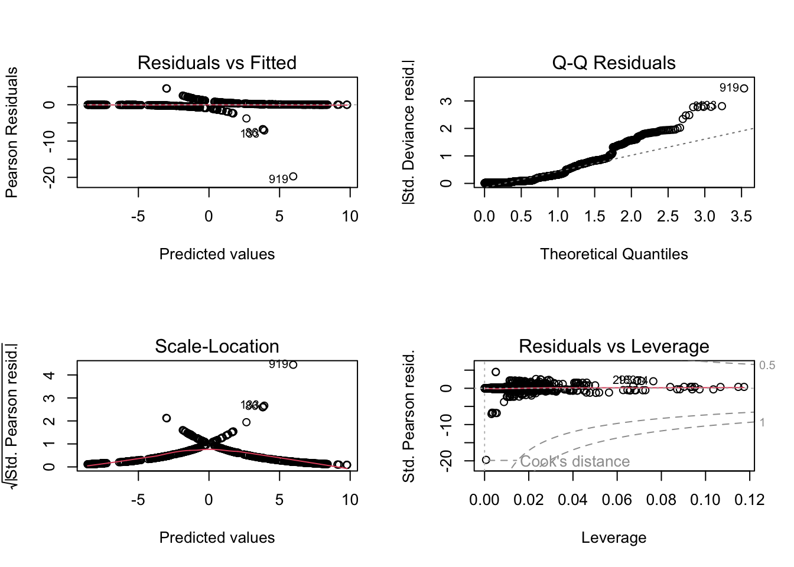

Model Fit Tests
#Likelihood ratio
anova(logit_model, test = "Chisq")
## Analysis of Deviance Table
##
## Model: binomial, link: logit
##
## Response: cl_binary
##
## Terms added sequentially (first to last)
##
##
## Df Deviance Resid. Df Resid. Dev Pr(>Chi)
## NULL 1224 1633.18
## pr_rating 1 1076.98 1223 556.19 < 2.2e-16 ***
## gdp_pc 1 2.71 1222 553.48 0.0995949 .
## internet_users 1 14.93 1221 538.55 0.0001117 ***
## education 1 0.37 1220 538.18 0.5411394
## region 6 87.44 1214 450.74 < 2.2e-16 ***
## year 1 0.65 1213 450.08 0.4192372
## ---
## Signif. codes: 0 '***' 0.001 '**' 0.01 '*' 0.05 '.' 0.1 ' ' 1
#Coming up with McFadden R^2 (uses package pscl)
pR2(logit_model)
## fitting null model for pseudo-r2
## llh llhNull G2 McFadden r2ML r2CU
## -225.0414330 -816.5875529 1183.0922398 0.7244124 0.6193175 0.8410425
#Classification Accuracy
ds$pred_prob <- predict(logit_model, type = "response")
#Confusion Matrix (uses caret library)
pred_class <- ifelse(ds$pred_prob > 0.5, "Not Free", "Free")
caret::confusionMatrix(factor(pred_class), ds$cl_binary)
## Confusion Matrix and Statistics
##
## Reference
## Prediction Free Not Free
## Free 717 63
## Not Free 36 409
##
## Accuracy : 0.9192
## 95% CI : (0.9025, 0.9338)
## No Information Rate : 0.6147
## P-Value [Acc > NIR] : < 2.2e-16
##
## Kappa : 0.8275
##
## Mcnemar's Test P-Value : 0.008973
##
## Sensitivity : 0.9522
## Specificity : 0.8665
## Pos Pred Value : 0.9192
## Neg Pred Value : 0.9191
## Prevalence : 0.6147
## Detection Rate : 0.5853
## Detection Prevalence : 0.6367
## Balanced Accuracy : 0.9094
##
## 'Positive' Class : Free
##

Figures
Tables
ds%>%tabyl(region)
## region n percent
## Africa 282 0.23020408
## Asia 197 0.16081633
## Eurasia 89 0.07265306
## Europe 343 0.28000000
## Middle East 81 0.06612245
## North America 71 0.05795918
## South America 162 0.13224490
ds%>%tabyl(pr_rating)
## pr_rating n percent
## 1 369 0.30122449
## 2 213 0.17387755
## 3 222 0.18122449
## 4 127 0.10367347
## 5 87 0.07102041
## 6 102 0.08326531
## 7 105 0.08571429
ds%>% tabyl(cl_binary)
## cl_binary n percent
## Free 753 0.6146939
## Not Free 472 0.3853061
ds%>% tabyl(region, cl_binary)
## region Free Not Free
## Africa 114 168
## Asia 73 124
## Eurasia 27 62
## Europe 336 7
## Middle East 11 70
## North America 68 3
## South America 124 38
ggplot(ds, aes(region)) +
geom_bar(fill = "seagreen") +
labs(title = "Count of Free Countries From 2013-2024 by Region") +
theme_minimal(base_size = 10)
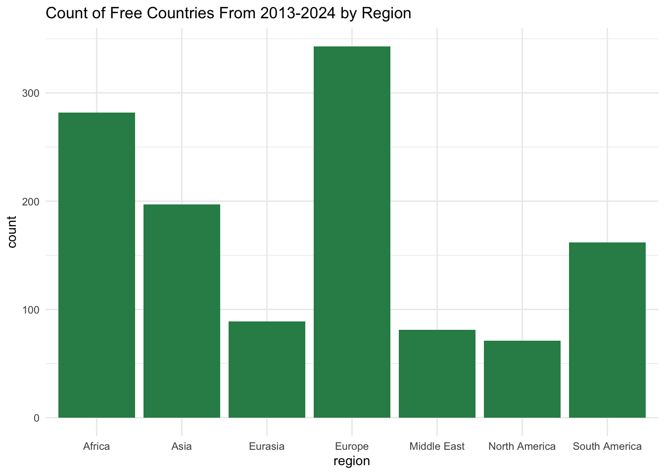
ggplot(ds, aes(region, fill = cl_binary)) +
geom_bar(position = "dodge") +
labs(title = "Civil Liberties Status by Region",
x = "Region", y = "Count of Countries", fill = "CL Category") +
theme_minimal(base_size = 10)
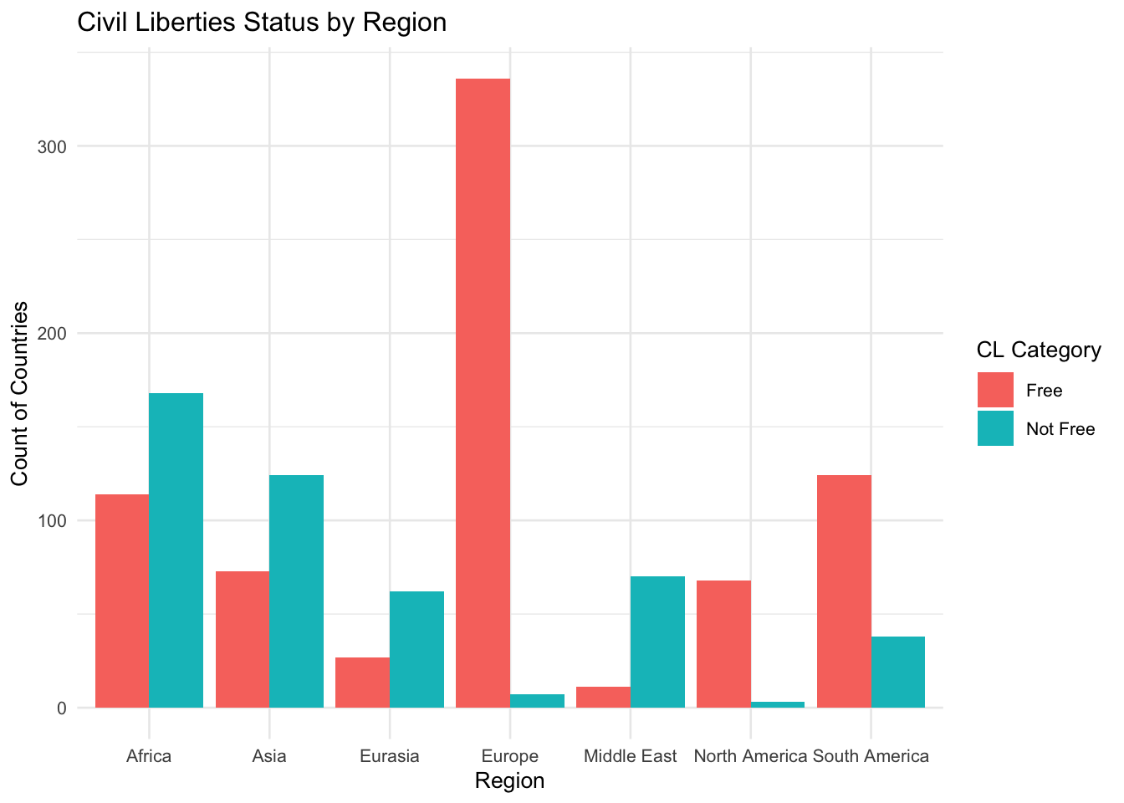
ggsave("CL_stat_region_bar.pdf", width = 4, height = 4, units = "in", dpi = 1500)
ggplot(ds, aes(cl_binary)) +
geom_bar(fill = "plum") +
labs(title = "Count of Free Countries to Not Free Countries",
x = "Civil Liberties") +
theme_minimal(base_size = 10)
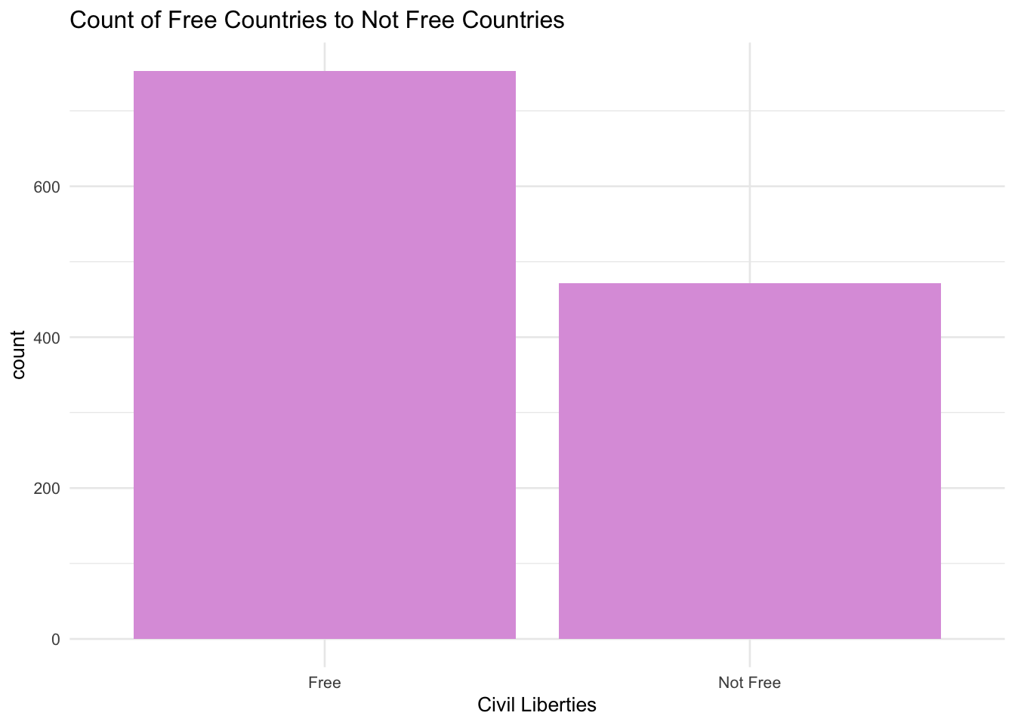
ggsave("CL_BarGraph.pdf", width = 4, height = 4, units = "in", dpi = 1500)

