**Attachment 4 to the Neonicotinoid Final Bee Risk Assessments**

**Residue Bridging Analysis for Seed Treatment Uses of Neonicotinoids**

Associated Chemicals Clothianidin (PC code 044309) Imidacloprid (PC code 129099) Thiamethoxam (PC code 060109)

January 14, 2020

U.S. Environmental Protection Agency Office of Pesticide Programs

Environmental Fate and Effects Division

Contents

Introduction 3

Methods 4

Results and Discussion 11

Corn 11

Influence of year and site on pollen residue values 14

Influence of chemical on pollen residue values 17

Relationship between pollen residue values and anthers 19

Relationship between pollen residue values and leaves 22

Summary of corn analysis and recommendations for risk assessment 25

Soybean 27

Influence of year, site and chemical on pollen residue values 30

Relationship between pollen residue values and other tissues (flowers and leaves) 30

Summary of anther residue data 31

Influence of year, site and chemical on nectar residue values 32

Relationship between nectar residue values and other tissues (flowers and leaves) 32

Influence of year, site and chemical on flower residue values 33

Summary of soybean analysis and recommendations for risk assessment 34

Cotton 36

Influence of site and chemical on pollen residue values 39

Influence of site and chemical on nectar (floral) residue values 39

Influence of site and chemical on nectar (extrafloral) residue values 39

Relationship between pollen and nectar residue values and flowers 40

Relationship between pollen and nectar residue values and leaves 40

Summary of cotton analysis and recommendations for risk assessment 41

Canola 43

Influence of year and site on pollen residue values 45

Influence of year and site on nectar residue values 45

Relationship between pollen and nectar residue values and flowers 46

Summary of canola analysis and recommendations for risk assessment 47

Comparison of residues among crops 48

Pollen 48

Nectar 49

Recommendations for additional crops 50

Revisiting BeeREX default 51

Summary 51

Citations 56

Introduction

In the bee risk assessment method (USEPA 2014), exposures and associated risks to bees from pesticides applied via seed treatments are assessed through dietary consumption of residues in pollen and nectar (of treated crops). Exposure is assessed to individual honey bees using the BeeREX model1. If no chemical-specific residue data are available for pollen and nectar, a default value of 1 mg a.i./kg (*i.e.,* 1 ppm) pollen or nectar is assumed. This value is based on a limited dataset for pesticide residues in plant tissues of treated-seed crops (Alix *et al*. 2009; EPPO 2010). EPA’s current guidance indicates that if empirical residue data for pollen and/or nectar are available for a chemical, those data may be used in place of the default to refine Tier I risk quotients (RQs). If the refined Tier I risk assessment indicates risk (*i.e.*, refined RQs exceed Levels of Concern (LOCs)), and colony-level effects data are available, a Tier II assessment may be conducted by comparing empirical residues in pollen and nectar to colony-level effects endpoints.

This analysis considers data for three nitroguanidine-substituted neonicotinoids (referred to as “neonicotinoids”): clothianidin, imidacloprid and thiamethoxam. Seed treatments of these three neonicotinoids are registered for use on several different crop groups. When considering usage data (based on Screening Level Use Analyses (SLUAs) provided by the Biological and Economic Analysis Division (BEAD)), the majority of the pounds applied of these three chemicals is as seed treatments, with corn being the dominant use, followed by soybeans, cotton and wheat (Table 1).

**Table 1. Estimated annual usage (lbs a.i. applied per year) of clothianidin, imidacloprid and thiamethoxam applied as seed treatment (source: SLUAs).**

|  |  |  |  |  |
| --- | --- | --- | --- | --- |
| **Crop** | **Clothianidin** | **Imidacloprid** | **Thiamethoxam** | **Total** |
| Corn | 1,400,000 | 30,000 | 300,000 | **1,730,000** |
| Soybeans | 30,000 | 400,000 | 300,000 | **730,000** |
| Cotton | 9,000 | 50,000 | 100,000 | **159,000** |
| Wheat | 4,000 | 100,000 | 50,000 | **154,000** |
| Potatoes | NA | 30,000 | 20,000 | **50,000** |
| Sorghum | 5,000 | 10,000 | 20,000 | **35,000** |
| Sugar beets | 10,000 | <500 | 2,000 | **12,000** |

NA = not applicable

Several studies of concentrations in nectar and/or pollen of treated- seed crops are available for imidacloprid, clothianidin and thiamethoxam. These studies were submitted by registrants of the individual chemicals or are available in the scientific literature. This document describes the available studies and an analysis of those data that are considered scientifically valid and suitable for quantifying residues. Additional scientifically valid data are available; however, they are not considered reliable in quantifying residues due to deficiencies in their study designs (*e.g.*, insufficient replication).

1 Model description and tool available online at:

[https://www.epa.gov/pesticide-science-and-assessing-pesticide-risks/models-pesticide-risk-](https://www.epa.gov/pesticide-science-and-assessing-pesticide-risks/models-pesticide-risk-assessment#beerex) [assessment#beerex](https://www.epa.gov/pesticide-science-and-assessing-pesticide-risks/models-pesticide-risk-assessment#beerex)

The purpose of this analysis is to develop an approach for quantifying dietary neonicotinoid exposure to individual bees (refined Tier I) and colonies (Tier II) from seed treatments. Consistent with the 2014 guidance on assessing risks to bees, these exposure estimates may be used to quantify risk using refined Tier I RQs. For acute exposures, conservative single sample residue levels are used to generate RQs, while chronic RQs are generated with conservative mean values from a given sampling period. For Tier II assessments, risks to honey bee colonies is a discussion of available data, which involves comparing residues over time to colony level endpoints. The results of this analysis are incorporated into the final bee risk assessments for imidacloprid, clothianidin and thiamethoxam (the refined Tier I and Tier II risk characterizations). This analysis considers whether:

1. variables related to site (*e.g*., soil) and year influence concentrations in pollen and nectar for a specific crop;
2. chemical data can be bridged for a specific crop;
3. there is a relationship between pollen and/or nectar and other plant tissues (*i.e*., whole flowers, leaves) for a specific crop; and,
4. concentrations in pollen and nectar are influenced by crop type.

Item 1 is relevant to understanding the certainty/uncertainty associated with the available pollen and nectar residue data for a given crop. The goal of this analysis is to identify crop-specific residue values that may be used in the risk assessment. Item 2 is important in determining whether chemical-specific data are needed or if data can be bridged across the three neonicotinoids. Item 3 is relevant to identifying potential bridging options in cases where insufficient data may be available for a given crop (*e.g.,* if flower data are available, but no pollen and nectar data are available). Item 4 is relevant to consider how to use available data for a given crop to represent other crops with no residue data (*i.e*., how to bridge the data available for corn, soybeans, cotton and canola to the other registered seed treatments).

When considering the major uses of neonicotinoids on seeds (**Table 1**), most are considered attractive to bees (USDA 2017). The notable exception is wheat, which is not considered attractive based on the USDA crop attractiveness publication. Therefore, a lack of residue data for this crop does not signify a data gap and there is no need to consider bridging. In addition, not all bee attractive crops provide pollen and nectar. For example, honey bees are attracted to cotton nectar (floral and extrafloral), but not cotton pollen. Also, corn produces bee attractive pollen, but no nectar. Other registered seed treatment crops are identified in the use characterizations of the risk assessments for clothianidin, imidacloprid and thiamethoxam.

Methods

Studies containing pollen and nectar residue data from crops treated as seeds with imidacloprid, clothianidin and thiamethoxam were compiled from registrant submissions and from the open literature. In total, 18 studies (all from registrant submissions) were identified as having data considered to be scientifically valid and suitable for reliable quantification of residues, representing 4 crops (corn, soybean, cotton, and canola; **Table 2**). Registrant-submitted studies or open literature that are considered qualitative or invalid were not considered for this analysis. Residue data are available for pumpkin, melon and sunflower; however, these data are not suitable for quantification of residues.

**Table 3** lists studies that have been submitted or are from the open literature that are excluded from this analysis and a rational for exclusion.

**Table 2. Master Record Identification (MRID) Numbers for studies with chemical-specific residues data in pollen and/or nectar, by crop, from seed treatments considered of quantitative value**

|  |  |  |  |
| --- | --- | --- | --- |
| **Crop** | **Imidacloprid** | **Clothianidin** | **Thiamethoxam** |
| Corn | 49511701 | 48298801  49073613  49073616  49073617  49073618  50154301 | 49158914  49158915  49158916  50265505 |
| Soybean | 50025901  50025902 | 50025901  50025902 | 49210901  49804104 |
| Cotton | none | 49904901 | 49686801 |
| Canola | none | none | 49755702 |

**Table 3. Residue studies across crops and chemicals that are excluded from quantitative bridging analysis along with rationale for exclusion. These studies are not considered in this analysis.**

|  |  |  |  |
| --- | --- | --- | --- |
| **MRID** | **Crop** | **Compound** | **Rational for exclusion** |
| 45422431 | Canola | Clothianidin | Insufficient replication (no replicate samples taken on same day, *i.e.,* n = 1) |
| 45422432 | Canola | Clothianidin | Insufficient replication (no replicate samples taken on same day) |
| 45422433 | Canola | Clothianidin | Insufficient replication (no replicate samples taken on same day) |
| 45422435 | Canola | Clothianidin, Imidacloprid | Samples collected from free foraging bees |
| 45422436 | Canola | Clothianidin | Insufficient replication (only 2 nectar samples were taken; study design only included 1 plot) |
| 45422437 | Canola | Clothianidin | Insufficient replication (only 2 nectar samples were taken; 1 sample of pollen; study design only  included 1 plot) |
| 45422438 | Corn | Clothianidin | Insufficient replication (one plot; 2 samples per plot); control contamination |
| 45422439 | Corn | Clothianidin | Insufficient replication (one plot; 1 sample per plot); control contamination |
| 46163104 | Sunflower | Thiamethoxam | Insufficient replication (one sample of nectar, three of pollen) |
| 46163105 | Sunflower | Thiamethoxam | Insufficient replication (no replicate samples taken on same day) |
| 46163106 | Sunflower | Thiamethoxam | Insufficient replication (2 time points for pollen, n = 2; 1 time point for nectar, n =3); no quantified residues |
| 46163107 | Sunflower | Thiamethoxam | Insufficient replication (no replicate samples taken on same day) |
| 46163108 | Sunflower | Thiamethoxam | Insufficient replication (no replicate samples taken on same day) |
| 46907802 | Canola | Clothianidin | 1 page summary. No details or raw data provided. |
| 47699414 | Corn | Imidacloprid | Qualitative classification |
| 47699416 | Corn | Imidacloprid | Qualitative classification |
| 47699417 | Corn | Imidacloprid | Not a residue study, this is a feeding study with contaminated pollen |
| 47699418 | Canola | Imidacloprid | Insufficient replication (one plot; no pollen data; 2 samples of flower nectar, 1 sample of bee nectar (tented)) |
| 47699419 | Canola | Imidacloprid | Nectar samples collected from bees (caged) and from flowers. Flowers also collected. Only 1 plot included in study. Only one sample was collected from each of the following: pollen, nectar (bee collected), flowers. Only 2 samples of flower nectar were collected. |
| 47699421 | Sunflower | Imidacloprid | Insufficient replication |
| 47699422 | Sunflower | Imidacloprid | Insufficient replication; no detections; study design not focused on residues from seed treated crop (Different crops treated and sunflower planted afterword) |
| 47699423 | Corn | Imidacloprid | Insufficient replication |

|  |  |  |  |
| --- | --- | --- | --- |
| **MRID** | **Crop** | **Compound** | **Rational for exclusion** |
| 47699424 | Corn | Imidacloprid | Insufficient replication |
| 47699425 | Canola | Imidacloprid | Qualitative classification |
| 47699426 | Canola | Imidacloprid | Pollen and nectar samples were collected from honey bee comb. Details are not available to describe how bees were maintained in the study. Since it is unknown whether bees were free foraging or maintained in enclosures, the utility of the data are uncertain. Information are also not available on  the mass ai per seed. |
| 47796301 | Sunflower | Imidacloprid | Qualitative classification |
| 47812303 | Sunflower | Imidacloprid | Qualitative classification |
| 47961202 | Melon | Clothianidin, Imidacloprid | No detects in pollen and nectar |
| 48077902 | Sunflower | Imidacloprid | Qualitative classification |
| 48711001  (Krupke et al.  2012) | Corn | Clothianidin, Thiamethoxam | Samples from free foraging bees |
| 49073605 | Canola | Imidacloprid | Samples from free foraging bees |
| 49073610 | Corn | Clothianidin | Insufficient replication (one plot, 2 samples) |
| 49073611 | Corn | Clothianidin | Insufficient replication (only 2 samples per site) |
| 49073620 | Sunflower | Clothianidin | Insufficient replication (only 1 plot; 1-2 samples collected per matrix) |
| 49073621 | Sunflower | Clothianidin | Insufficient replication (only 1 plot; 1-2 samples collected per matrix) |
| 49073626 | Canola | Clothianidin | Insufficient replication (2 or less samples taken per time point) |
| 49073627 | Canola | Clothianidin | Insufficient replication (2 samples taken per time point) |
| 49073628 | Canola | Clothianidin | Insufficient replication |
| 49073632;  49209301 | Canola | Clothianidin | Summary; no raw data |
| 49158906 | Sunflower | Thiamethoxam | Pollen data are invalid due to sample handling. |
| 49158907 | Canola | Thiamethoxam | Insufficient replication |
| 49158908 | Canola | Thiamethoxam | No replicates for pollen or flowers. Honey samples taken from hives. No nectar data. |
| 49158909 | Sunflower | Thiamethoxam | Residues not quantified (<Limit of Quantification (<LOQ, of 1 ng/g). |
| 49158910 | Canola | Thiamethoxam | Insufficient replication |
| 49719612  (Dively and  Kamal 2012) | Pumpkin | Thiamethoxam | No detects in study. Qualitative classification |

|  |  |  |  |
| --- | --- | --- | --- |
| **MRID** | **Crop** | **Compound** | **Rational for exclusion** |
| 49719614 | Corn | Imidacloprid | Raw data not available. |
| 49754401 | Canola | Clothianidin | Samples from free foraging bees |
| 49754402 | Corn | Clothianidin | Samples from free foraging bees  Hand-collected pollen data included; however, it does not appear that replicates were collected on the same field. |
| 49766206 | Sunflower | Imidacloprid | Insufficient replication |
| 49803701 | Soybean | Clothianidin | Insufficient replication (only two samples collected from each site) |
| 49819502 | Canola | Thiamethoxam | Study involves applications of treated potato seeds on year 1 followed by application of treated canola seeds on year 2. In control (canola seeds were untreated), residues of thiamethoxam and clothianidin were measured in nectar and pollen at all sites. This leads to uncertainty in whether residues in treated canola plants were due to canola seed treatment or treatment of potatoes. |
| Jiang et al. 2018 | Cotton | Imidacloprid, Thiamethoxam | Only parent was analyzed in pollen, nectar and leaf samples. Does not allow for comparison of residues among chemicals. Other studies indicate that degradates of concern may represent substantial proportion of total residues. |
| Cutler, and Scott- Dupree, 2014 | Corn | Clothianidin, Thiamethoxam | Samples from free foraging bumble bees |

The quantitative studies utilized different designs. Major differences included method for collecting samples, number of samples collected, number of time points included in sampling periods, inclusion of multiple years, and number of different sites. The available studies were conducted using two major methods: 1) tissue samples were collected directly from treated-seed plants and analyzed for clothianidin, imidacloprid, thiamethoxam and residues of concern (defined below); and 2) pollen and nectar samples were collected from bees foraging on treated-seed plants enclosed within tunnels. Some studies were conducted in the same year, with multiple sites sampled. Some studies focused on one study site with samples collected during successive cropping years. Most studies involved collection of three samples (n = 3) per time-period, with some studies only including one time-point, while others involved collection of samples from the same plot collected multiple time-points within the same season.

For all analyses, total residues of concern were calculated. For clothianidin applications, only the parent is of concern and included in the residue. For thiamethoxam, the residue of concern is parent and clothianidin (degradate of thiamethoxam). For imidacloprid, the parent and 5-hydroxyl and –olefin degradates represent the residues of concern. When a residue of concern is not detected, it is represented as ½ of the level of detection (LOD), which varies by study. When a residue of concern is detected at a level below the level of quantification (LOQ), the value is represented as the midpoint between the LOD and the LOQ. For each sample, the concentration of the residues of concern is represented as the sum of the parent and degradates of concern (including non-detections and non- quantifiable detections).

For imidacloprid, residues of degradates were adjusted using the molecular weight to be equivalent to the parent. For thiamethoxam, residues were adjusted to clothianidin equivalents to make the residues relevant to the units used in the risk assessment for thiamethoxam. Also, due to the similarities of the molecular weights of imidacloprid and clothianidin, this allows for a more standardized approach to compare residues across chemicals (*i.e*., differences in molecular weight will not impact chemical comparisons). Molecular weights of the parent molecules and degradates are included in **Table 4**. In summary, all residues described in this analysis are expressed as either imidacloprid-equivalents (*i.e*., imidacloprid, imidacloprid 5-hydroxyl and imidacloprid-olefin) or clothianidin equivalents (*i.e*., clothianidin only or thiamethoxam and clothianidin).

**Table 4. Molecular weights (MWs) of three neonicotinoids and degradates of concern included in this analysis.**

|  |  |
| --- | --- |
| **Chemical** | **MW (g-ai/mol)** |
| Clothianidin | 249.7 |
| Imidacloprid | 255.7 |
| Imidacloprid 5-hydroxyl | 271.7 |
| Imidacloprid –olefin | 253.7 |
| Thiamethoxam | 291.7 |

For each crop, influence of variables on residues are considered. In cases where multiple years were incorporated at the same site, influence of year is considered. In cases where multiple sites were included during the same year (in a single study), data are compared across sites. Comparisons involve mean and 95% confidence intervals. Mean residues across chemicals for the same crop are compared to understand the influence of chemical on residues. Mean pollen and nectar residue data are compared to mean residues in other plant tissues that are available. These include flowers, anthers and leaves. The

final analysis involves comparisons of residues in pollen across corn, soybean, cotton and canola and nectar across soybean, cotton and canola.

This analysis assumes that residues are transported from the treated seed to pollen, nectar and other matrices. The analysis does not consider influences of seed planting method (*e.g.,* gravity planters vs pneumatic planters) or seed coat ingredients (outside of the active ingredients.

In evaluating data for a given crop, residues are normalized to the maximum allowed treatment rate (not all studies were conducted at the same rate or at the maximum rate for a given chemical). Those values are provided in **Table 5**. When carrying out comparisons among crops, all residues are adjusted to a treatment rate of 0.1 mg a.i./seed. There are two studies available (MRID 49210901 and Jiang *et al*.

2018) that evaluate different treatment rates at the same site at the same time. These studies indicate that the difference in residue value in pollen and nectar is generally proportional to the difference in treatment rate (on a mass a.i./seed basis). Therefore, it is necessary to adjust residues to a consistent treatment rate in order to account for the influence of this variable.

**Table 5. Maximum allowed neonicotinoid treatment rates (mg a.i./seed) for crops with available residue data. Residue data normalized to these rates.**

|  |  |  |  |  |
| --- | --- | --- | --- | --- |
| **Crop** | **Clothianidin** | **Imidacloprid** | **Thiamethoxam1** | **Normalized rate** |
| Corn | 1.3 | 1.4 | 1.1 | 1.32 |
| Soybean | 0.13 | 0.38 | 0.16 | 0.163 |
| Cotton | 0.35 | 0.5 | 0.33 | 0.354 |
| Canola | 0.018 | 0.05 | 0.015 | 0.0155 |

**1**Values represent clothianidin-equivalents.

2Normalized to clothianidin’s rate, since this is the chemical with the most use on corn.

30.16 mg a.i./seed was used in majority of studies, so this was chosen for normalizing all soybean studies.

4Normalized to the rate of the available studies.

5Normalized to thiamethoxam (because this chemical is the only one with quantitative data for canola).

The results and discussion section describes the available residue data for corn, soybean, cotton and canola. For each crop, the analysis considers influence of site, year and chemical (as data allow). The analysis also considers the relationship between pollen and/or nectar and other plant tissues (*e.g*., anthers, flowers, leaves) for which residue data are available. For each crop, recommendations are made for residue values to use in Tier I (refined) and Tier II risk assessment (if needed). These recommendations are based on 90th percentile values of the means of available crop-specific residues. The 90th percentile was chosen to represent an upper bound value; which is a consistent practice with other EFED models (e.g., PWC). In cases where insufficient pollen and nectar data are available (*i.e*., for soybean), residues in surrogate tissue(s) (*e.g.,* anthers and flowers) are recommended.

For each recommendation, the certainty of the residue is described based on the robustness of the available data and any major gaps that may exist that would prevent consideration of a relevant factor (*e.g*., data available for only one chemical not allowing for consideration of chemical on residues). The recommended values are adjusted to the maximum treatment rate allowed per seed for a given chemical and crop (**Table 5**). For all other crops for which seed treatment is registered, but no empirical data are available for pollen and/or nectar, recommendations are also made based on the data available for canola, corn, cotton and soybean. Part of this recommendation is based on the analysis of the influence of crop on residues and the ability to confidently bridge across crops.

Results and Discussion Corn

Eleven studies are available, representing 22 different sites with neonicotinoid residue data from corn

plants treated as seeds with either clothianidin, imidacloprid or thiamethoxam. At some sites, residues were collected at two different years (consecutive). Several of the sites were located in the US, with others in France and Germany. Since corn does not produce nectar, this analysis focuses on residues in pollen. In all studies, pollen was collected, either directly from the plant or from bees kept within tunnels containing corn. Several studies also included analysis of leaves/plants and tassels. **Table 6** summarizes the mean, 95% confidence intervals and maximum values of pollen residues for each site. Note that some studies included multiple sampling periods (at different times during the bloom; MRIDs 49073616, 49073617, 49158914, 49158915, 49158916, 49511701, and 49073618). These values were

combined into an overall study mean in **Table 6**. **Figures 1-3** depict the mean values for individual sampling times. These data indicate that the sampling date does not have a major influence on the residues (*i.e*., 95% confidence intervals overlap for most sample means from the same site and year).

**Table 6. Summary of mean total residues of concern for clothianidin, imidacloprid and thiamethoxam in pollen from corn seed treatment studies.**

|  |  |  |  |  |  |  |  |  |  |  |
| --- | --- | --- | --- | --- | --- | --- | --- | --- | --- | --- |
| **Site** | **Year** | **Original treatment rate from study (mg**  **a.i./seed)** | **MRID** | **Chemical** | **Collected from** | **Mean (ng a.i./g; normalized to 1.3 mg**  **a.i./seed)** | **95% CI (±)** | **Maximum single value** | **Number of samples** | **% detections (quantifications)** |
| Dekalb Co., IL | 2015 | 0.5 | 50154301 | Clothianidin | Plant | 2.0 | 0.7 | 2.7 | 3 | 100 (33) |
| Washington Co.,  IA | 2015 | 0.5 | 50154301 | Clothianidin | Plant | 2.0 | 0.8 | 2.9 | 3 | 100 (33) |
| Chalons-en- Champagne, France | 2008 | 0.5 | 49073618 | Clothianidin | Plant | 2.2 | 0.6 | 7.8 | 32 | 78 (38) |
| Warren Co., IL | 2015 | 1.25 | 50154301 | Clothianidin | Plant | 2.2 | 0.2 | 2.3 | 3 | 100 (100) |
| Randolph Co., IN | 2015 | 0.25 | 50154301 | Clothianidin | Plant | 2.4 | 1.7 | 3.3 | 3 | 67 (0) |
| Schwanau, Germany | 2008 | 1.25 | 48298801 | Clothianidin | Plant | 3.0 | 0.3 | 5.2 | 50 | 98 (98) |
| Mullheim,  Germany | 2008 | 1.25 | 48298801 | Clothianidin | Plant | 3.0 | 0.4 | 5.5 | 50 | 98 (92) |
| Nimes, France | 2008 | 0.5 | 49073616 | Clothianidin | Plant | 3.3 | 1.0 | 15.6 | 36 | 72 (72) |
| Kippenheim, Germany | 2008 | 1.25 | 48298801 | Clothianidin | Plant | 3.5 | 0.4 | 9.7 | 50 | 100 (98) |
| Herbolzheim, Germany | 2008 | 1.25 | 48298801 | Clothianidin | Plant | 4.1 | 0.4 | 7.8 | 50 | 98 (98) |
| Buhl-Oberbruch,  Germany | 2008 | 1.25 | 48298801 | Clothianidin | Plant | 4.1 | 0.7 | 10.8 | 50 | 84 (84) |
| La Petite-Pierre, France | 2008 | 0.5 | 49073617 | Clothianidin | Plant | 8.4 | 1.1 | 10.4 | 9 | 100 (100) |
| St. Symphorien d'Ancelles, France | 2004 | 0.5 | 49073613 | Clothianidin | Plant | 25.4 | 7.9 | 36.4 | 4 | 100 (100) |
| Springfield, NE | 2013 | 1.34 | 49511701 | Imidacloprid | Plant | 2.2 | 0.6 | 5.2 | 20 | 100 (70) |
| Edgerton, KS | 2013 | 1.34 | 49511701 | Imidacloprid | Plant | 2.6 | 0.6 | 4.8 | 20 | 85 (80) |
| Springfield, NE | 2012 | 1.34 | 49511701 | Imidacloprid | Plant | 3.1 | 0.5 | 9.1 | 40 | 100 (95) |
| Edgerton, KS | 2012 | 1.34 | 49511701 | Imidacloprid | Plant | 4.2 | 1.9 | 42.5 | 42 | 100 (76) |
| York, NE | 2013 | 1.34 | 49511701 | Imidacloprid | Plant | 7.1 | 4.4 | 38.4 | 21 | 95 (67) |

|  |  |  |  |  |  |  |  |  |  |  |
| --- | --- | --- | --- | --- | --- | --- | --- | --- | --- | --- |
| **Site** | **Year** | **Original treatment rate from study (mg**  **a.i./seed)** | **MRID** | **Chemical** | **Collected from** | **Mean (ng a.i./g; normalized to 1.3 mg**  **a.i./seed)** | **95% CI (±)** | **Maximum single value** | **Number of samples** | **% detections (quantifications)** |
| York, NE | 2012 | 1.34 | 49511701 | Imidacloprid | Plant | 7.6 | 1.3 | 25.3 | 42 | 98 (98) |
| Richland, IA | 2015 | 1.1 | 50265505 | Thiamethoxam | Plant | 2.1 | 0.4 | 2.3 | 3 | 100 (66) |
| Germansville, PA | 2015 | 1.1 | 50265505 | Thiamethoxam | Plant | 2.7 | 1.4 | 4.2 | 3 | 100 (100) |
| Zellwiller, France | 2006 | 0.73 | 49158916 | Thiamethoxam | Bee | 3.7 | 1.1 | 6.6 | 11 | 100 (73) |
| Hinton, OK | 2015 | 1.1 | 50265505 | Thiamethoxam | Plant | 4.2 | 0.7 | 4.7 | 3 | 100 (100) |
| Blanzy la Salonnaise,  France | 2006 | 0.71 | 49158915 | Thiamethoxam | Bee | 4.2 | 0.5 | 6.8 | 27 | 100 (96) |
| Grisolles, France | 2006 | 0.79 | 49158914 | Thiamethoxam | Bee | 7.5 | 1.9 | 16.3 | 14 | 100 (100) |
| Blanzy la Salonnaise,  France | 2005 | 0.74 | 49158915 | Thiamethoxam | Bee | 7.5 | 0.6 | 11.3 | 27 | 100 (100) |
| Grisolles, France | 2005 | 0.81 | 49158914 | Thiamethoxam | Bee | 8.5 | 1.7 | 18.0 | 27 | 100 (100) |
| Zellwiller, France | 2005 | 0.74 | 49158916 | Thiamethoxam | Bee | 18.5 | 1.8 | 28.4 | 23 | 100 (100) |

Influence of year and site on pollen residue values

The thiamethoxam data included some studies where residues were collected by hand from corn plants and some were collected using confined bees. For clothianidin and imidacloprid, all samples were collected by hand.

When considering the available data for clothianidin (**Figure 1**), mean residues are similar for 11 of 13 sites, with means all ranging between 2 to 4.1 ng a.i./g-pollen. Mean residues (8.4 ng a.i./g) for one of the locations in France (La-Petite-Pierre) are slightly higher, but confidence intervals around this mean overlap with residues from another site in France (*i.e*., Nimes) sampled in the same year.

The site with the highest residues in France (St. Symphorien d’Ancelles) is higher than the others, with a mean of 25.4 ng a.i./g-pollen and confidence intervals that do not overlap with those of other sites. This suggests that residues are similar among most sites, with some sites having residue values that are an order of magnitude greater. It is unknown whether the higher residues in Symphorien d’Ancelles are due to the influence of site or due to influence of year, since no other data are available from 2004. In the studies conducted in France in 2008, residues were collected at multiple timepoints within a period of less than a week. Mean residues collected within the same season are similar, suggesting that pollen residues from plants treated at the same time do not vary substantially from one day to another.

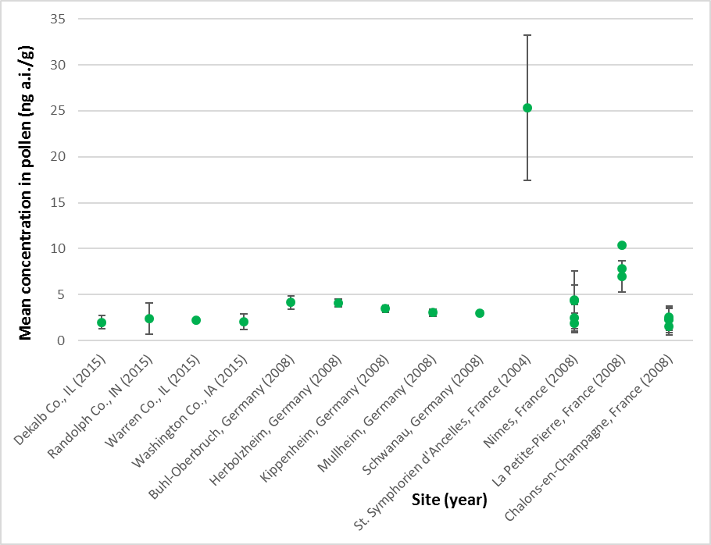

**Figure 1. Mean concentrations of clothianidin residues in corn pollen at different sites. Error bars represent 95% confidence intervals. Values normalized to 1.3 mg a.i./seed. Multiple values available for the same site and year represent multiple sampling periods.**

For imidacloprid (**Figure 2**), mean residues are similar for all three sites and both years. For both sites and years, pollen was collected over multiple days. The majority of the means are below 5 ng a.i./g- pollen. For all but one site/year, confidence intervals for residues overlap. This suggests that sampling day does not influence the concentration.

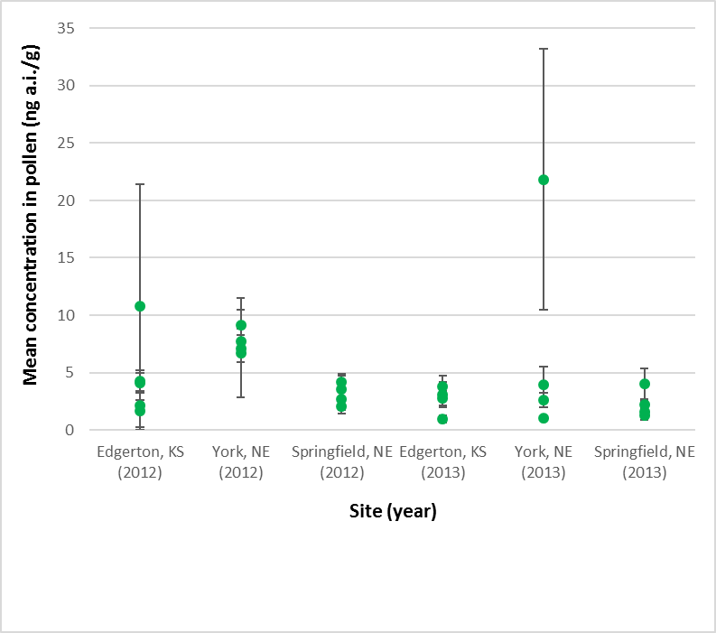

**Figure 2. Mean concentrations of total imidacloprid residues of concern in corn pollen at three different sites. Residues collected at each site over two different years. Error bars represent 95% confidence intervals. Values normalized to 1.3 mg a.i./seed. Multiple values available for the same site and year represent multiple sampling periods.**

The available data for thiamethoxam (**Figure 3**) were collected using two different methods: directly from plants and using bees (confined to tents). Six of nine site/year combinations had mean residue values <5 ng a.i./g-pollen. When considering the data from the three sites where samples were collected directly from the plants (Germanville, Hinton, Richland), mean residues do not suggest a difference in magnitude among sites. When considering the bee collected residue data from France, residue data collected in 2006 all overlapped, suggesting no influence of site. When considering residue data collected at the same sites the previous year, the mean from one site (Zellweiller; 15-22 ng a.i./g-pollen) is greater (95% confidence intervals do not overlap) than the other two sites collected in 2005 (3-11 ng a.i./g-pollen) and from residues collected at that same site in 2006 (3-4 ng a.i./g-pollen). This suggests that residues may differ from year to year. In the studies conducted in France, residues were collected at multiple timepoints within a period of less than a week.

In general, mean residues overlap over that sampling time period, suggesting that pollen residues from plants treated at the same time do not vary substantially from one day to another. Since the residues collected directly from plants and by bees were collected from different sites and years, it is unknown whether the collection method influenced the magnitude of the measured residues.

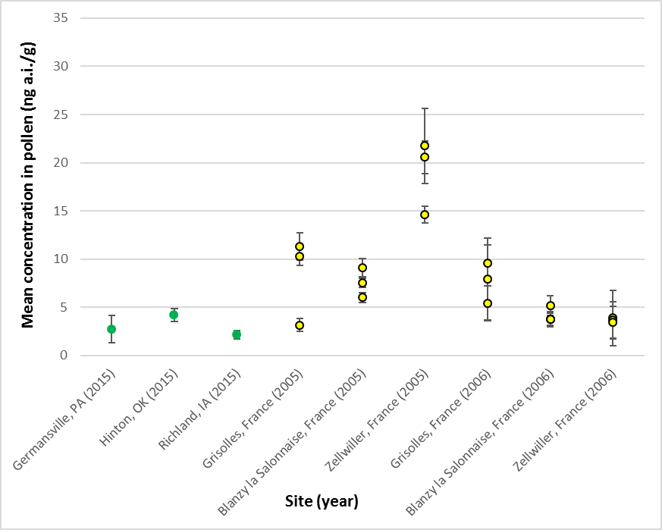

**Figure 3. Mean concentrations of total thiamethoxam residues of concern in corn pollen at six different sites. Pollen samples collected at three sites during two consecutive years. Error bars represent 95% confidence intervals. Values normalized to 1.3 mg a.i./seed. Green points represent samples collected directly from plants while yellow ones represent samples collected from bees kept within tents. Multiple values available for the same site and year represent multiple sampling periods.**

In summary, when considering available corn pollen residue data for the same chemical:

* the majority of sites have mean concentrations in pollen that are similar;
  + *i.e.,* most mean residues are <5 ng a.i./g-pollen;
* for each chemical, one site had residues an order of magnitude greater than the others;
  + *i.e.,* approximately 20-25 ng a.i./g-pollen
* for some years, residues for a given site were greater than other sites;
  + residues on the same site may differ by an order of magnitude between years;
* for the most part though, samples collected from the same fields at different days within the corn bloom period do not vary substantially.

Influence of chemical on pollen residue values

To determine whether the chemical influences residues in pollen, mean residues of clothianidin, imidacloprid and thiamethoxam from the trials listed in **Table 6** were ranked (**Figure 4**). As discussed above, samples collected on different days from the same trial did not generally influence the magnitude of the residue. To avoid biasing the distribution of mean residues based on multiple sample dates from a site, a grand mean was calculated per site and year. Since year may influence the magnitude of the residue in pollen, multiple years of data on the same site were assumed to be independent.

**Figure 4** depicts the mean (and 95% confidence intervals) of the 28 unique combinations of site/year; 26 of the 28 values were ≤8.5 ng a.i./g-pollen, with the 90th percentile mean at 8.4 ng a.i./g-pollen. The median of the mean values is 3.6 ng a.i./g-pollen. Mean values from the three chemicals were evenly distributed throughout the ranked means, with no obvious trend in value attributed to any one chemical. Therefore, chemical does not appear to influence the magnitude of the residue in pollen following corn seed treatment.

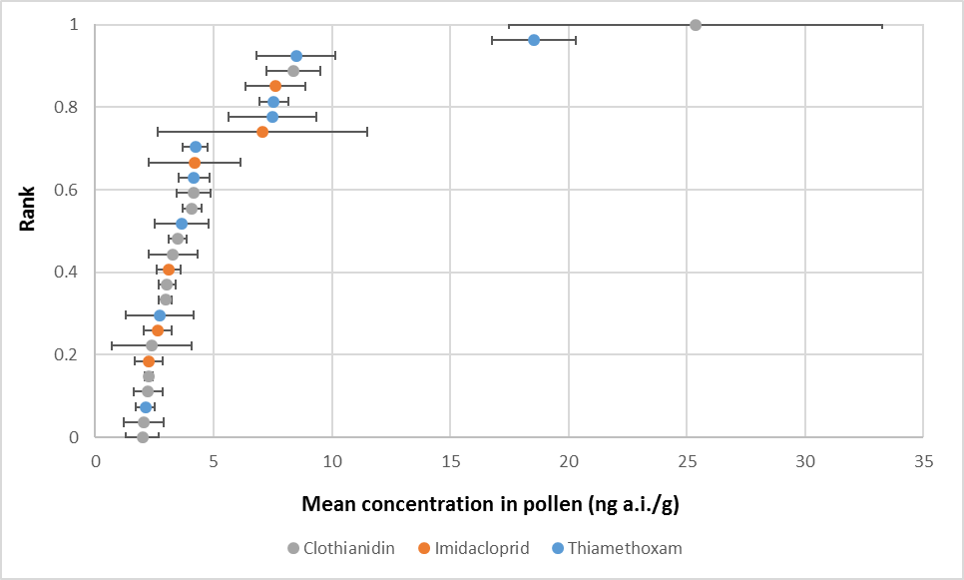

**Figure 4. Mean concentrations of total clothianidin, imidacloprid and thiamethoxam residues of concern in corn pollen. Error bars represent 95% confidence intervals. Values normalized to 1.3 mg a.i./seed.**

Since maximum values are used to generate acute RQs in the refined Tier I assessment, these values were also compiled from the 28 unique site/year combinations (**Figure 5**). Similar to mean residues, there is no obvious influence of chemical on the maximum values. The 90th percentile maximum concentration measured in a single sample from a given site/year is 30.8 ng a.i./g-pollen.

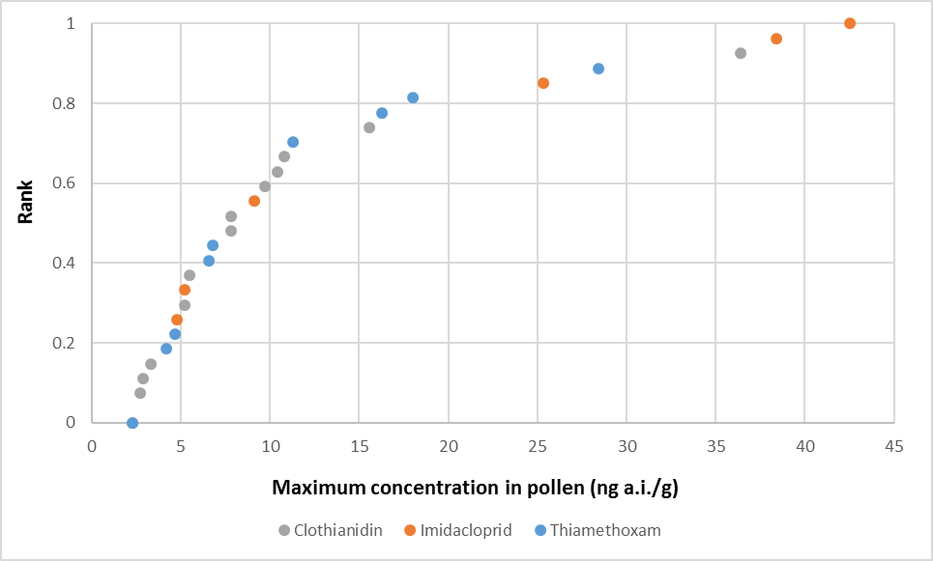

**Figure 5. Maximum concentrations of total clothianidin, imidacloprid and thiamethoxam residues of concern in corn pollen. Values normalized to 1.3 mg a.i./seed.**

Given the large availability of corn pollen residue studies for the three chemicals and the conclusion that chemical does not influence the magnitude of the residue, the collective data are sufficient in characterizing exposures to bees through dietary exposure. Therefore, data for clothianidin, imidacloprid and thiamethoxam (**Figures 4** and **5**) will be combined to represent the potential dietary exposure of bees to these chemicals following seed treatments of corn. Given that residues in corn pollen may vary by as much as an order of magnitude greater relative to the overall mean (based on a certain site on a given year), for risk assessment purposes, it is appropriate to select a high-end value from the distributions of means and maximum values. To that end, a 90th percentile is used, based on typical practices in EFED.2

In summary,

* chemical does not appear to influence the magnitude of the residue in corn pollen;
* the available residue data for corn pollen are combined across all three chemicals;
* it is recommended that for mean residue, the 90th percentile of 8.4 ng a.i./g-pollen be used for refined Tier I (chronic RQs) and Tier II (if necessary);

2 Note: This differs from the comparisons of individual means, which involves consideration of whether the 95% confidence intervals around mean values overlap. 95% CI was chosen as a typical metric for describing confidence around mean values.

* If needed, for characterization purposes in the Tier II assessment, the median of the means (*i.e*, 3.6 ng a.i./g-pollen) may also be useful;
* it is recommended that for maximum residue, the 90th percentile of 30.8 ng a.i./g-pollen be used for the refined Tier I assessment (acute RQs).

Relationship between pollen residue values and anthers

One study is available with residues in anthers (*i.e*., tassels) and pollen (MRID 49511701; ai imidacloprid). Overall, residues in anthers tend to be on the same order of magnitude as those in pollen. Mean residue values for pollen and anthers collected on the same day at the same site were plotted in **Figure 6**. There appears to be a quantifiable relationship between the residues in the two matrices; however, it varies in reliability from one site to another. At the Springfield, NE site, the R2 value is 0.56, suggesting that residues in pollen may be predicted somewhat reliably from residues in anthers (with the regression suggesting that anther residues are roughly 2.4x higher than pollen residues). Conversely, residues from Edgerton, KS have a weak relationship, with an R2 value of 0.14. The regression of residues from the 3rd site, York, NE, had correlations intermediate between the other sites (R2 of 0.34), but in contrast to the Springfield, NE site suggested higher residues in pollen then anthers.

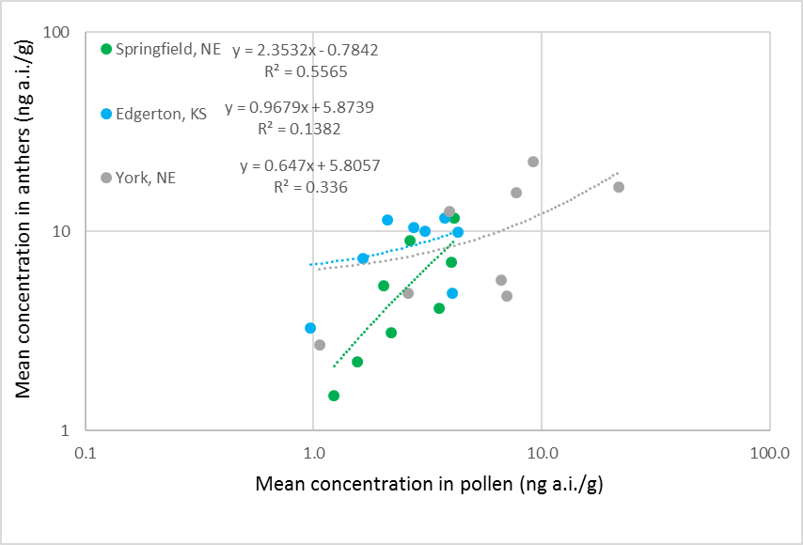

**Figure 6. Relationship between residues of imidacloprid in pollen and anthers (MRID 49511701).**

**Figure 7** depicts the mean (and 95% confidence intervals) of anther and pollen residue data collected from the same site on the same day. For the most part, residues in pollen and anther are different (*i.e*., 95% confidence intervals do not overlap) and residues measured in anthers are greater than those in pollen by a factor of 2.4 (on average) and as much as a factor of 5.4x (**Table 7**). There are some cases where residues in anthers may under-predict those in pollen; however, those values are still on the same order of magnitude. This information suggests that if data are not available for pollen, residues in

anthers may represent a reasonable surrogate, with residues that are on the same order of magnitude of those in pollen, but somewhat greater (*i.e*., protective). Since sufficient information are already available for corn pollen residues following neonicotinoid seed treatments, anther data will not be used quantitatively to represent exposures to bees from corn pollen.

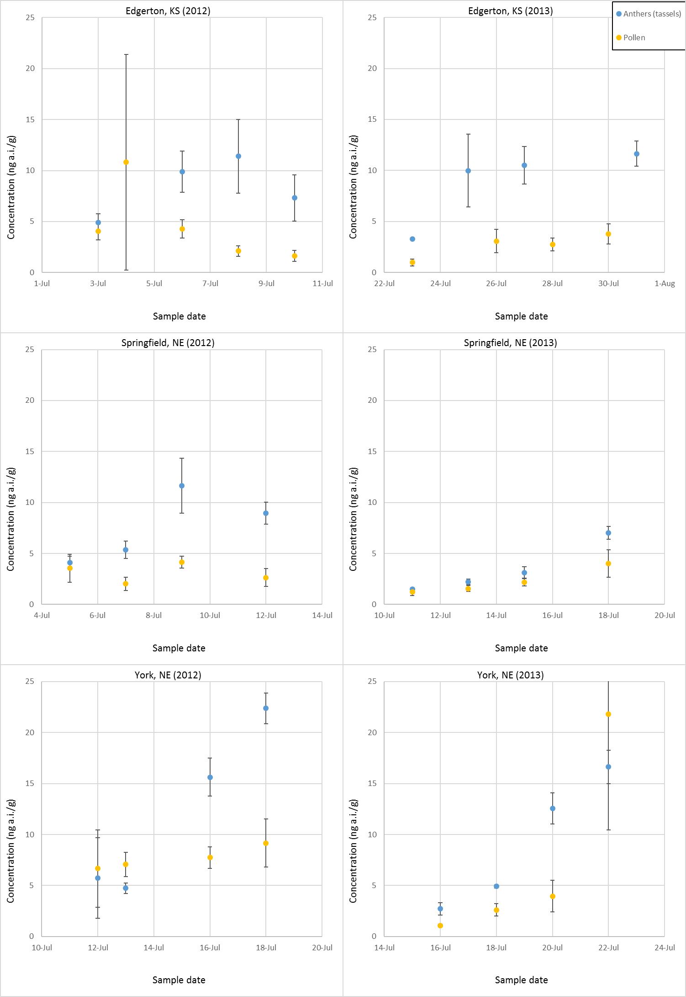

**Figure 7. Mean total imidacloprid residues of concern measured in pollen and anthers on the same day at three sites (York, NE; Springfield, NE and Edgerton, KS) during two different years (2012 and 2013; MRID 49511701).**

**Table 7. Mean concentrations of total imidacloprid residues of concern in anthers and pollen collected on the same date and site (MRID 49511701).**

|  |  |  |  |  |
| --- | --- | --- | --- | --- |
| **Location** | **Sample date** | **Mean concentration (ng a.i./g)** | | **Factor difference** |
| **Anthers** | **Pollen** |
| Edgerton, KS | 7/3/2012 | 4.9 | 4.1 | 1.2 |
| 7/6/2012 | 9.9 | 4.3 | 2.3 |
| 7/8/2012 | 11.4 | 2.1 | 5.4 |
| 7/10/2012 | 7.3 | 1.6 | 4.5 |
| 7/23/2013 | 3.3 | 1.0 | 3.4 |
| 7/25/2013 | 10.0 | 3.1 | 3.2 |
| 7/27/2013 | 10.5 | 2.7 | 3.8 |
| 7/31/2013 | 11.6 | 3.8 | 3.1 |
| Springfield, NE | 7/5/2012 | 4.1 | 3.5 | 1.2 |
| 7/7/2012 | 5.4 | 2.0 | 2.6 |
| 7/9/2012 | 11.7 | 4.2 | 2.8 |
| 7/12/2012 | 9.0 | 2.6 | 3.4 |
| 7/11/2013 | 1.5 | 1.2 | 1.2 |
| 7/13/2013 | 2.2 | 1.6 | 1.4 |
| 7/15/2013 | 3.1 | 2.2 | 1.4 |
| 7/18/2013 | 7.0 | 4.0 | 1.8 |
| York, NE | 7/12/2012 | 5.7 | 6.7 | 0.9 |
| 7/13/2012 | 4.7 | 7.1 | 0.7 |
| 7/16/2012 | 15.6 | 7.7 | 2.0 |
| 7/18/2012 | 22.4 | 9.2 | 2.4 |
| 7/16/2013 | 2.7 | 1.1 | 2.5 |
| 7/18/2013 | 4.9 | 2.6 | 1.9 |
| 7/20/2013 | 12.6 | 3.9 | 3.2 |
| 7/22/2013 | 16.6 | 21.8 | 0.8 |

Relationship between pollen residue values and leaves

The available information suggests that residues in leaves are not representative of those found in corn pollen and that they may overpredict residues in pollen by an order of magnitude. In the thiamethoxam study conducted in the US in 2015 (MRID 50265505), leaf samples were collected on the same day as pollen at all three sites. Mean residues in leaves were an order of magnitude greater than those in pollen, with factors ranging 7-16x (**Figure 8**).

When considering the imidacloprid study used to compare pollen and anther data (above; MRID 49511701); the difference between leaves and pollen varies by site and by year (on the same site). At the Edgerton site, residues in leaves taken on the same day at the differ from pollen by 19-32x in 2012 and 4-10x in 2013. At the Springfield site, leaves were 5-8x greater in 2012 and 2-6x greater in 2013. At the York site, leaves were 4 x greater in 2012 and equal to 13x greater than pollen in 2013 (**Figure 9**). When mean residues for leaves and pollen are regressed (**Figure 10**) a reliable relationship cannot be derived between leaves and pollen (R2 values range 0.05-0.28).

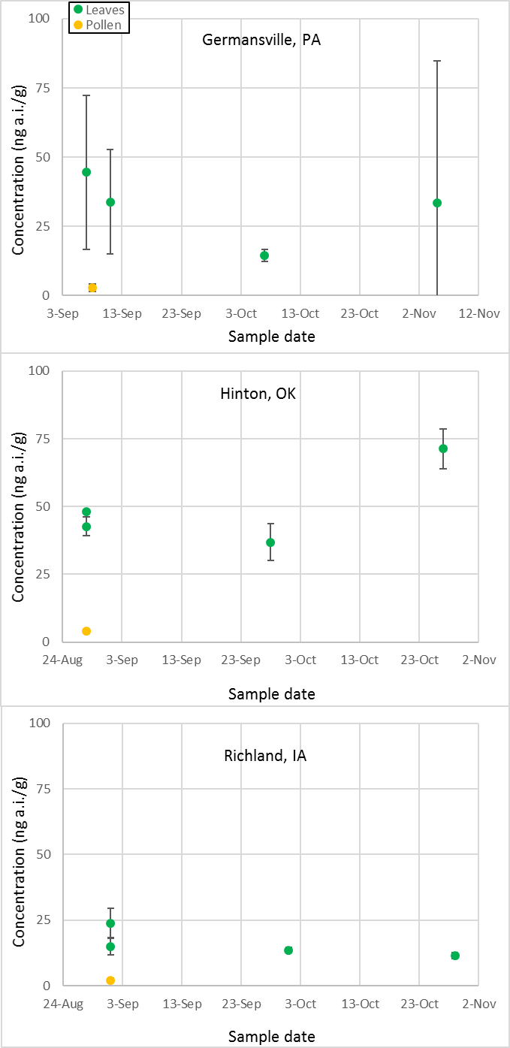

**Figure 8. Mean total thiamethoxam residues of concern measured in pollen and leaves on the same day at three sites (Germansville, PA; Hinton, OK and Richland, IA) in 2015 (MRID 50265505). Values normalized to 1.3 mg a.i./seed rate, expressed as clothianidin equivalents.**

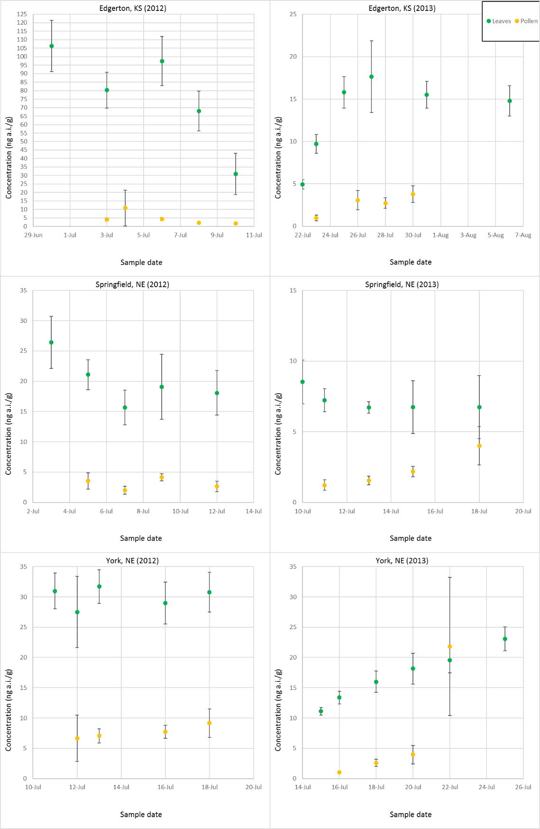

**Figure 9. Mean total imidacloprid residues of concern measured in pollen and leaves on the same day at three sites (York, NE; Springfield, NE and Edgerton, KS) during two different years (2012 and 2013; MRID 49511701). Note that scale of y-axes differs among figures.**

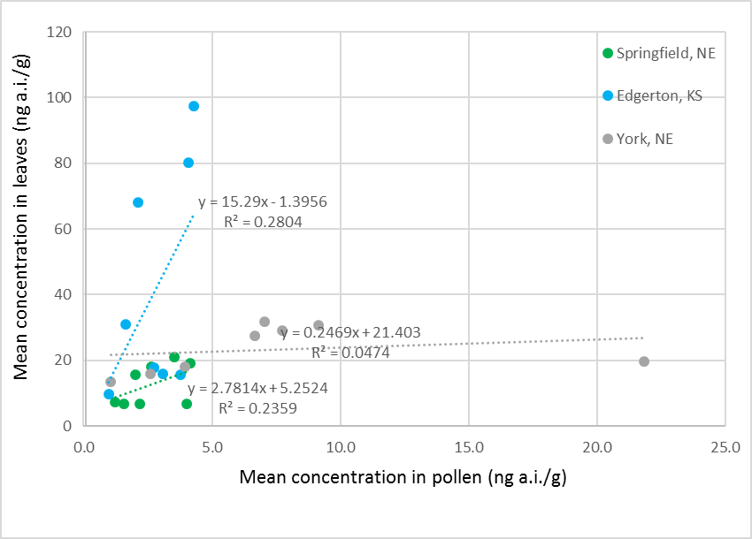

**Figure 10. Relationship between mean total imidacloprid residues of concern in pollen and leaves (MRID 49511701).**

### Summary of corn analysis and recommendations for risk assessment

Summary of analysis:

* chemical does not appear to influence the magnitude of the residue in pollen;
  + the available residue data for corn pollen can be combined (bridged) across all three chemicals;
* residues may differ across sites at some years;
* residues in anthers may represent a reasonable surrogate for pollen,
  + a reliable, quantitative relationship could not be derived;
  + residues in anthers are on the same order of magnitude of those in pollen, but somewhat greater (*i.e*., protective).
* Residues in leaves do not represent a reasonable surrogate for pollen,
  + a reliable, quantitative relationship could not be derived;
  + the magnitude difference between pollen and leaves varies from site to site and year to year (on the same site);
  + residues in leaves are often at least an order of magnitude greater than in pollen;
    - residues in leaves may represent a screening-level estimate; however, they are expected to overestimate residues in pollen.

Recommendations for risk assessment:

* For refined Tier I (chronic RQs) and Tier II characterization (if necessary):
  + it is recommended that for mean residue, the 90th percentile of 8.4 ng a.i./g-pollen be used for clothianidin and thiamethoxam (maximum treatment rate of 1.3 mg a.i./seed);
  + for imidacloprid, that value is 9.0 (based on maximum treatment rate of 1.4 mg a.i./seed);
* For refined Tier I (acute RQs):
  + it is recommended that for maximum residue, the 90th percentile of 31 ng a.i./g-pollen be used.
    - This value is based on the maximum treatment rate for clothianidin and thiamethoxam (*i.e*., 1.3 mg a.i./seed).
  + When adjusted for imidacloprid’s maximum treatment rate (1.4 mg a.i./seed), the 90th percentile value is 33 ng a.i./g-pollen.
* The values suggested above have a high level of confidence due to the robustness of the corn pollen database
  + 22 different sites are represented, some with multiple years;
  + data are available for multiple trials for each of the three neonicotinoids;
  + also, there is a high detection frequency in pollen samples (**Table 6**), leading to confidence in the magnitude of residues quantified in the studies;
* Since sufficient information are available for the neonicotinoids for corn pollen, anther data will not be used quantitatively to represent exposures to bees from corn pollen.
* **Table 8** summarizes the recommendations for risk assessment.

**Table 8. Summary of recommendations for risk assessment for corn seed treatment. Residue values are adjusted to chemical-specific maximum seed treatment rates.**

|  |  |  |  |  |  |
| --- | --- | --- | --- | --- | --- |
| **Chemical** | **Maximum seed treatment rate**  **(mg a.i./seed)** | **Matrix** | **Tier I (acute)** | **Tier I (chronic)** | **Tier II\*** |
| Clothianidin | 1.3 | Pollen | 31 | 8.4 | 0.42 |
| Nectar | 0 | 0 |
| Imidacloprid | 1.4 | Pollen | 33 | 9.0 | 0.45 |
| Nectar | 0 | 0 |
| Thiamethoxam | 1.3 | Pollen | 31 | 8.4 | 0.42 |
| Nectar | 0 | 0 |

*Total nectar equivalents calculated as Cnectar + Cpollen/20 (see Appendix x for details on how this equation was derived), based on 90th percentile mean residues in nectar (Cnectar) and pollen (Cpollen).

Soybean

Only two registrant-submitted studies are available with residue data for pollen (**Table 9**), with three studies with data for nectar (**Table 10**). As discussed below, due to limitations of the available data, there are insufficient data to consider variability in the pollen residues and influences such as site and chemical. Since the analysis above indicates that anther concentration data may represent a surrogate for pollen, albeit a conservative one, anther data are also discussed (**Table 11**). Residues in nectar are quantified in multiple samples at two sites for one chemical. Given the limited availability of reliable data for nectar, comparisons are made to whole flower data (**Table 12**). As discussed below, whole flower residues appear to represent reasonable surrogates (although they also may be conservative) for soybean nectar. Therefore, whole flower data are also discussed. For all studies, nectar and pollen were both collected using bees (kept in tents); anthers and flowers were collected directly from the plants.

Note that some studies included multiple sampling periods (at different times during the bloom; MRIDs 50025901, 50025902 49804104). These values were combined into an overall study mean in **Tables 9**- **12**.

**Table 9. Summary of mean pollen total residues of concern for clothianidin, imidacloprid and thiamethoxam soybean seed treatment studies.**

|  |  |  |  |  |  |  |  |  |  |  |
| --- | --- | --- | --- | --- | --- | --- | --- | --- | --- | --- |
| **Site** | **Year** | **Original treatment rate (mg a.i./seed)** | **MRID** | **Chemical\*** | **Collected from** | **Mean (ng a.i./g; normalized to 0.16 mg**  **a.i./seed)** | **95% CI (±)** | **Maximum single value\*\*** | **Number of samples** | **% detections (quantifications)** |
| Itapeva, Brazil | 2014 | 0.088 | 50025901 | clothianidin | Comb*** | <LOD (0.27) | NA | <LOD (0.27) | 16 | 0 (0) |
| Itapeva, Brazil | 2015 | 0.088 | 50025902 | clothianidin | Bees | <LOD (0.27) | NA | <LOD (0.27) | 14 | 0 (0) |
| Itapeva, Brazil | 2015 | 0.18 | 50025902 | imidacloprid | Comb*** | 1.2 | 0.36 | 3.3 | 12 | 100 (42) |
| Itapeva, Brazil | 2014 | 0.18 | 50025901 | imidacloprid | Bees | 1.5 | 0.51 | 3.6 | 15 | 93 (40) |

*The original treatment rates were 0.088 mg a.i./seed for clothianidin and 0.18 for imidacloprid. This lower rate for clothianidin may have led to the lack of detections.

**When sample was below the LOD, value was represented as ½ LOD. When sample was below LOQ, value was represented as midpoint between LOD and LOQ.

***Sample collected from honey bee comb. This may represent a mixture of pollen and sucrose solution (bee bread), which could potentially dilute concentrations of pollen.

**Table 10. Summary of mean nectar total residues of concern for clothianidin, imidacloprid and thiamethoxam soybean seed treatment studies.**

|  |  |  |  |  |  |  |  |  |  |  |
| --- | --- | --- | --- | --- | --- | --- | --- | --- | --- | --- |
| **Site** | **Year** | **Original treatment rate (mg a.i./seed)** | **MRID** | **Chemical** | **Collected from** | **Mean (ng a.i./g; normalized to**  **0.16 mg**  **a.i./seed)** | **95% CI (±)** | **Maximum single value\*** | **Number of samples** | **% detections (quantifications)** |
| Lime Springs, IA | 2015 | 0.0756 | 49804104 | thiamethoxam | Bees | < LOD (0.46) | NA | < LOD (0.46) | 9 | 0 (0) |
| Itapeva, Brazil | 2014 | 0.088 | 50025901 | clothianidin | Bees | <LOD (0.27) | NA | <LOD (0.27) | 15 | 0 (0) |
| Itapeva, Brazil | 2015 | 0.088 | 50025902 | clothianidin | Bees | <LOQ (1.2) | NA | <LOQ (1.2) | 26 | 4 (0) |
| Itapeva, Brazil | 2015 | 0.18 | 50025902 | imidacloprid | Bees | 0.62 | 0.16 | 1.2 | 11 | 45 (9) |
| Itapeva, Brazil | 2014 | 0.18 | 50025901 | imidacloprid | Bees | 0.69 | 0.14 | 1.3 | 15 | 60 (7) |
| Cheneyville, LA | 2015 | 0.0756 | 49804104 | thiamethoxam | Bees | 0.97 | 0.52 | 2.4 | 9 | 33 (33) |
| Mebane, NC | 2015 | 0.0756 | 49804104 | thiamethoxam | Bees | 2.7 | 2.5 | 11.7 | 9 | 56 (56) |

*When sample was below the LOD, value was represented as ½ LOD. When sample was below LOQ, value was represented as midpoint between LOD and LOQ.

**Table 11. Summary of mean anther total residues of concern for thiamethoxam soybean seed treatment studies.**

|  |  |  |  |  |  |  |  |  |  |  |
| --- | --- | --- | --- | --- | --- | --- | --- | --- | --- | --- |
| **Site** | **Year** | **Original treatment rate (mg a.i./seed)** | **MRID** | **Chemical** | **Collected from** | **Mean (ng a.i./g; normalized to 0.16 mg**  **a.i./seed)** | **95% CI (±)** | **Maximum single value** | **Number of samples** | **% detections (quantifications)** |
| Mebane, NC | 2015 | 0.0756 | 49804104 | Thiamethoxam | Plant | 1.9 | 1.9 | 7.2 | 9 | 22 (22) |
| Lime Springs, IA | 2015 | 0.0756 | 49804104 | Thiamethoxam | Plant | 2.4 | 1.7 | 7.4 | 9 | 44 (44) |
| Cheneyville, LA | 2015 | 0.0756 | 49804104 | Thiamethoxam | Plant | 3.0 | 2.6 | 10 | 9 | 33 (33) |

**Table 12. Summary of mean whole flower total residues of concern for clothianidin, imidacloprid and thiamethoxam soybean seed treatment studies.**

|  |  |  |  |  |  |  |  |  |  |  |
| --- | --- | --- | --- | --- | --- | --- | --- | --- | --- | --- |
| **Site** | **Year** | **Original treatment rate (mg a.i./seed)** | **MRID** | **Chemical** | **Collected from** | **Mean (ng a.i./g; normalized to 0.16 mg**  **a.i./seed)** | **95% CI (±)** | **Maximum single value\*** | **Number of samples** | **% detections (quantifications)** |
| Itapeva, Brazil | 2014 | 0.088 | 50025901 | Clothianidin | Plant | <LOD (0.27) | NA | <LOD (0.27) | 12 | 0% (0) |
| Itapeva, Brazil | 2015 | 0.088 | 50025902 | Clothianidin | Plant | <LOD (0.27) | NA | <LOD (0.27) | 15 | 0% (0) |
| Itapeva, Brazil | 2014 | 0.18 | 50025902 | Imidacloprid | Plant | <LOQ (1.0) | NA | <LOQ (1.0) | 12 | 88% (8) |
| Itapeva, Brazil | 2015 | 0.18 | 50025901 | Imidacloprid | Plant | <LOQ (1.0) | NA | <LOQ (1.0) | 15 | 73% (7) |
| Lime Springs, IA | 2015 | 0.0756 | 49804104 | Thiamethoxam | Plant | 1.6 | 1.1 | 4.1 | 9 | 33% (33) |
| Mebane, NC | 2015 | 0.0756 | 49804104 | Thiamethoxam | Plant | 4.2 | 2.6 | 9.0 | 9 | 56% (56) |
| Cheneyville, LA | 2015 | 0.0756 | 49804104 | Thiamethoxam | Plant | 6.2 | 3.0 | 14.0 | 9 | 89% (89) |
| Fisk, MO | 2012 | 0.082 | 49210901 | Thiamethoxam | Plant | 9.3 | 5.7 | 15.1 | 3 | 33 (33) |
| Richland, IA | 2012 | 0.156 | 49210901 | Thiamethoxam | Plant | 10.9 | 8.6 | 19.6 | 3 | 100 (100) |
| Oregon, MO | 2012 | 0.156 | 49210901 | Thiamethoxam | Plant | 11.1 | 2.5 | 13.5 | 3 | 100 (100) |
| Richland, IA | 2012 | 0.080 | 49210901 | Thiamethoxam | Plant | 11.5 | 6.7 | 18.1 | 3 | 66 (66) |
| Oregon, MO | 2012 | 0.080 | 49210901 | Thiamethoxam | Plant | 20.4 | 21.6 | 42.2 | 3 | 66 (66) |
| Fisk, MO | 2012 | 0.154 | 49210901 | Thiamethoxam | Plant | 25.5 | 21.8 | 45.6 | 3 | 100 (100) |

*When sample was below the LOD, value was represented as ½ LOD. When sample was below LOQ, value was represented as midpoint between LOD and LOQ.

### Influence of year, site and chemical on pollen residue values

**Table 9** summarizes the available pollen residue data for soybean. These data come from a study involving two different years of treatment at the same site in Brazil (MRIDs 50025901 and 50025902). No other pollen data are available for soybean; therefore, influence of site cannot be determined.

In the fields sown with clothianidin-treated seed, clothianidin was not detected in any of the pollen samples collected in 2014 or 2015. Since the seed treatment rate used in this study (0.088 mg a.i./seed) is almost 2x lower than the maximum rate allowed on the label for clothianidin (0.13 mg a.i./seed), there is uncertainty regarding the relevance of these data to exposures to bees at the maximum rate.

Imidacloprid was detected in the majority (93-100%) of pollen samples that were collected; with mean residues of 1.5 (95% CI: 1.0-2.0) and 1.2 (0.87-1.6), in 2014 and 2015, respectively. The overlapping confidence intervals of these values suggest that there was no difference in the magnitude of residues in pollen from year-to-year. There is uncertainty associated with the mean residue values because imidacloprid and/or its degradates of concern were only quantified in 40% of pollen samples. In addition, pollen samples were collected using different methods during the different years, which may impact the comparability of the residues (*i.e*., directly from bees in 2014 and from comb in 2015). There is some concern that comb samples may contain a mixture of pollen and uncontaminated sucrose solution (*i.e.,* bee bread), which would potentially dilute the concentrations measured in pollen.

Given that only two studies are available for soybean, both for one chemical at a single site, over two different years, the variability in soybean pollen residues in the environment is unknown. Therefore, there is uncertainty associated with using the available data in risk assessment, due to the uncertainties associated with the data and because it is unknown where they may fall on the distribution of exposures.

Relationship between pollen residue values and other tissues (flowers and leaves)

In the clothianidin trials conducted in Brazil in 2014 and 2015 (MRIDs 50025901 and 50025902), clothianidin was not detected in any of the pollen, flower or leaf samples collected. Therefore, the relationship between these matrices cannot be evaluated.

In the imidacloprid trials from the same two studies, imidacloprid was detected in 73-83% of flower samples (depending upon the year); however, it was not quantified in any of the samples (**Table 12**). Therefore, pollen and flower concentrations cannot be accurately compared. In leaf tissues, imidacloprid was detected in 80-100% of samples, in 2014 and 2015. In 2014, imidacloprid was not quantified in any of the leaf samples; however, it was quantified in 73% of the 2015 leaf samples.

Therefore, pollen and leaf tissue data can be compared from the 2015 data as follows: the mean pollen residue of 1.2 ng a.i./g (95% CI: 0.87-1.6; 42% quantified samples) does not appear to differ from the mean residue in leaves, which was 1.4 ng a.i./g (95% CI: 1.2-1.6).

These means represent multiple sample dates. **Table 13** lists the means and their confidence intervals for the pollen and leaf samples collected on the same day in 2015. During 2 of the 4 sampling dates, means for pollen and leaves were similar (95% confidence intervals overlap). At two sampling dates, imidacloprid was not quantified in pollen while it was above the LOQ in leaves. Therefore, in this single study, leaf tissue is comparable to pollen.

**Table 13. Comparison of mean concentrations of imidacloprid total residues of concern in pollen and leaf samples collected on the same day (MRID 50025902). Three samples collected on each day for each matrix.**

|  |  |  |
| --- | --- | --- |
| **Date** | **Mean concentration (ng a.i./g)** | |
| **Pollen** | **Leaf** |
| 2/3/2015 | <LOQ (1.0) | 1.8 (1.2-2.3) |
| 2/4/2015 | 1.4 (0.69-2.2)* | 1.5 (1.2-1.8) |
| 2/6/2015 | 1.8 (0.9-2.8) | 1.4 (1.2-1.6) |
| 2/9/2015 | <LOQ (1.0) | 1.2 (0.8-1.7)* |

*Quantified in ⅔ of the samples.

### Summary of anther residue data

Similar to corn, residues in anthers represent a reasonable surrogate for residue in pollen. As observed for other crops (corn, cotton), residues in leaves often overpredict residues in pollen by at least an order of magnitude. Given the analysis of the corn anther data and its representativeness of pollen data and the fact that anthers contain mostly pollen (with other vegetative tissue) and are more representative of pollen compared to leaves (which do not contain pollen), anther data are considered here suitable for risk assessment (specifically, for estimating pollen concentrations).

Anther residue data are available from three sites where thiamethoxam was applied to soybean seeds (*i.e*., MRID 49804104). Thiamethoxam (and clothianidin) was quantified in 22-44% of samples (depending upon the site). Mean residues of individual data collected at three different time points were 1.9 (95% CI: 0-3.8), 2.4 (95% CI: 0.7-4.1) and 3.0 (95% CI: 0.4-5.6) ng a.i./g-anther at the Mebane, NC, Lime Springs, IA and Cheneyville, LA sites, respectively. Given the similarity of means and the overlap of confidence intervals, this suggests that concentrations in anthers do not vary substantially from site to site. When considering means of individual time points (**Figure 11**), means are similar across the sites, with some time points having no detections in all samples (n=3 per time point).

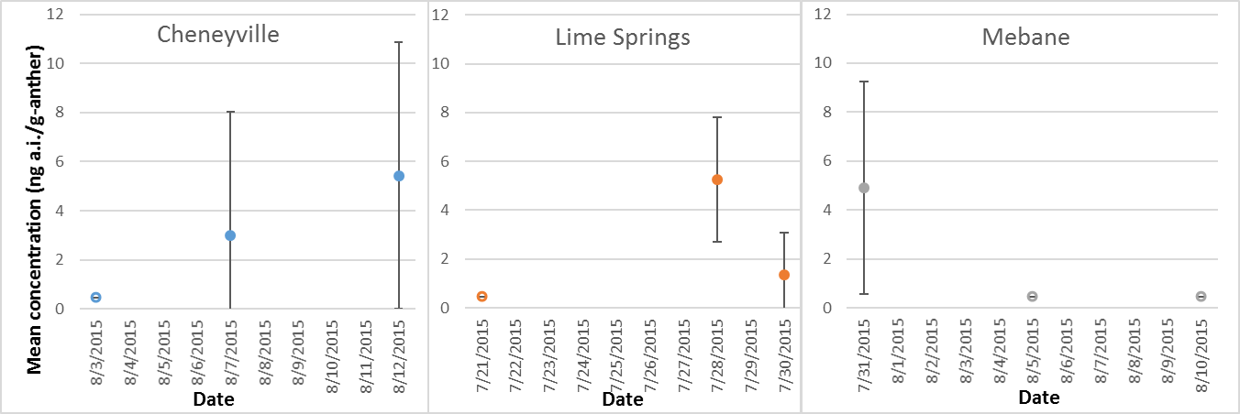

**Figure 11. Mean concentrations of total thiamethoxam residues of concern measured in anthers of soybeans at three different sites (MRID 49804104). Open circles represent values where all samples were <level of detection (LOD).**

### Influence of year, site and chemical on nectar residue values

In the clothianidin and imidacloprid trials conducted in Brazil in 2014 and 2015 (MRIDs 50025901 and 50025902), clothianidin was only detected in one nectar sample and imidacloprid was only quantified in one nectar sample during each year. Given the low treatment rates associated with these studies relative to US rates (discussed above in the pollen section), there is uncertainty in using the nectar residue data to represent exposures relevant to these two chemicals. Therefore, the influence of year and chemical on nectar residue levels cannot be evaluated quantitatively.

Relationship between nectar residue values and other tissues (flowers and leaves)

In the clothianidin trials conducted in Brazil in 2014 and 2015 (MRIDs 50025901 and 50025902), clothianidin was not detected in any of the flower or leaf samples collected and was only detected in a single nectar sample (but not quantified). In the imidacloprid trials that were part of the same studies, imidacloprid was only quantified in one sample during each year. Therefore, the relationship between these matrices cannot be evaluated for clothianidin or imidacloprid.

In MRID 49804104, thiamethoxam was applied to soybean seeds at three different sites (*i.e.*, Cheneyville, LA; Mebane, NC and Lime Springs, IA). Since thiamethoxam was not detected in nectar samples from Lime Springs, this site is not considered in comparing nectar residues to those of other tissues.

At the Mebane and Cheneyville sites, thiamethoxam was quantified in 56% and 33% (respectively) of the nectar samples. **Table 14** includes the data from the Mebane, NC site, including the means of thiamethoxam (and clothianidin) measured in nectar, whole flower, and leaf samples collected within a day of each other. The 95% confidence intervals of mean values for nectar and whole flower samples overlap in two of the three sample days. The mean leaf tissue data are an order of magnitude greater than those measured in nectar and whole flowers.

At the Cheneyville site (**Table 15**), residues in whole flowers were somewhat higher than those in nectar, without overlapping confidence intervals. Residues in leaves were an order of magnitude greater than those in flowers and 1-2 orders of magnitude greater than those in nectar. The information from these two sites indicates that concentrations in leaves do not represent a reasonable surrogate for concentrations in soybean nectar. Flowers may represent a relevant surrogate; however, they may overpredict residues in nectar.

**Table 14. Mean concentrations of thiamethoxam (and clothianidin) detected in samples of nectar, whole flower and leaf tissues collected within a single day at Mebane, NC (MRID 49804104).**

|  |  |  |  |
| --- | --- | --- | --- |
| **Date** | **Mean concentration (ng a.i./g)** | | |
| **Nectar** | **Flower** | **Leaf\*** |
| 8/1/2015 | 0.93 (0-1.9) | 8.8 (8.4-9.2) | 44.9 (22.3-67.6) |
| 8/6/2015 | 1.3 (0.41-2.2) | 1.3 (0-3.0) | 18.3 (13.6-23.0) |
| 8/11/2015 | 5.9 (0-12.3) | 2.5 (0-6.5) | 11.7 (5.1-18.2) |

*samples collected on day before nectar and flower samples.

**Table 15. Mean concentrations of thiamethoxam (and clothianidin) detected in samples of nectar, whole flower and leaf tissues collected within a single day at Cheneyville, LA (MRID 49804104).**

|  |  |  |  |
| --- | --- | --- | --- |
| **Date** | **Mean concentration (ng a.i./g)** | | |
| **Nectar** | **Flower** | **Leaf** |
| 8/3/2015 | < LOD (0.46) | 5.8 (2.7-9.0) | 17.7 (14.2-21.2) |
| 8/7/2015 | 1.6 (0.44-2.7) | 3.7 (2.7-4.7) | 12.1 (0.84-23.3) |
| 8/12/2015 | 0.88 (0.05-1.7) | 9.0 (9.0-17.3) | 49.6 (1.4-97.8) |

Influence of year, site and chemical on flower residue values

As discussed above, residues in soybean flowers appear to be a reasonable surrogate for nectar. However, clothianidin and imidacloprid mean residues were not quantified in the available flower samples. Therefore, influence of chemical on flower residues cannot be considered.

Flower residue data are available from two different thiamethoxam studies (MRIDs 49210901 and 49804104; **Figure 12**). At a given site, residues do not appear to differ across time points (Lime springs, Cheneyville and Mebane sites) or with treatment rates (Fisk, Richland and Oregon sites). During the same year (*i.e*., 2012 or 2015), mean residues do not appear to vary, although there were fewer detections at the Lime Springs site compared to the other two sites that were sampled in 2015 (Cheneyville and Mebane). Mean residues measured in 2012 appear to be somewhat greater than those in 2015; however, the confidence intervals overlap for some of the sites at different years. This suggests that site does not influence residues in whole flowers, but year might have an influence for some sites.

The available whole flower data will be used as a surrogate for residues in nectar. The 90th percentile mean value from all of the flower data (**Figure 12**) is 17 ng a.i./g. The 90th percentiles for all of the maximum values from each site (**Table 12**) is 44 ng a.i./g.

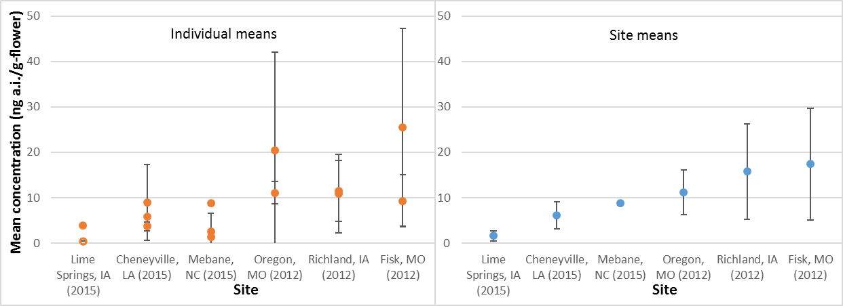

**Figure 12. Mean residues of thiamethoxam measured in soybean flowers (MRIDs 49210901 and 49804104). Open circles (see Lime springs data in left graph) represent samples where concentrations were not detected (*i.e*., <LOD). Error bars represent 95% confidence intervals. Residues normalized to**

**0.16 mg a.i./seed treatment rate for soybeans. Graph on left represents individual means from different time points or treatment rates. Right graph represents means across all samples from a given site.**

### Summary of soybean analysis and recommendations for risk assessment

Summary of analysis:

* Quantified residues in soybean pollen are only available for one site and one chemical (over two years).
  + There are insufficient data to consider variability pollen and influences such as site and chemical.
* Given that the corn analysis indicates that anther data represents an appropriate surrogate for pollen, residues in anthers are considered here.
  + Residues do not appear to vary across sites. Data are only available for thiamethoxam. Mean residues in anthers on a given day range from less than the LOD (*i.e*., <0.46 ng a.i./g) to 5.4, with a maximum single value of 10 ng a.i./g (all normalized to thiamethoxam’s maximum seed treatment rate of 0.16 mg a.i./seed).
* Residue data for whole flowers do not appear to be strongly influenced by site; however, they may differ by year on some sites.
  + Mean residues in whole flowers range from 1.6-17.4 ng a.i./g across sites.

Recommendations for risk assessment:

* Based on preceding analysis, available data for thiamethoxam residues in soybean pollen can be bridged to imidacloprid and clothianidin as an appropriately conservative surrogate.
* **Table 16** summarizes the recommendations for soybean seed treatment.
* For pollen: given the low availability of residue data, and the analysis with corn indicating that anthers represent a reasonable surrogate for pollen, residue data for anthers are used.
  + There is uncertainty in this approach in that it is unknown how soybean pollen and anthers compare (there are no studies that allowed for comparisons of both matrices)
  + Also, there is uncertainty in that the corn analysis suggested that anthers may overpredict residues in pollen; therefore, the concentration in anthers may be conservative.
  + Given that data are only available for one year, variability across time is unknown.
  + Since only three sites are available, the maximum single mean (on a given day) and single concentration is used. Those values are 5.4 and 10 ng a.i./g, respectively, normalized to 0.16 mg a.i./seed. The values adjusted for imidacloprid and clothianidin’s rates are provided in **Table 16**.
* For nectar: given the low availability of residue data and the analysis indicating that whole flower data represent a reasonable surrogate for nectar, flower residue data are used.
  + There are notable uncertainties in using the available flower data as a surrogate for nectar.
    - These data are based on thiamethoxam only.
    - The comparison of nectar and whole flower data is only possible from two trials.
    - The majority of the data suggest that residues in whole flowers overpredict those in nectar. The median factor difference is 5.9x. This is used to adjust the flower residues to “nectar equivalents.”
  + The 90th percentile mean value from all of the flower data is 17 ng a.i./g (normalized to 0.16 mg a.i./seed). When adjusted using the factor of 5.9x, this value is 2.9 ng a.i./g nectar.
  + The 90th percentiles of all of the maximum values from each site is 44 ng a.i./g (normalized to 0.16 mg a.i./seed). When adjusted using the factor of 5.9x, this value is

7.5 ng a.i./g nectar.

* + The values adjusted for imidacloprid and clothianidin’s rates are provided in **Table 16**.

**Table 16. Summary of recommendations for acute and chronic exposure concentrations in pollen and nectar for thiamethoxam, clothianidin, and imidacloprid to support risk assessment for soybean seed treatments.**

|  |  |  |  |  |  |
| --- | --- | --- | --- | --- | --- |
| **Chemical** | **Maximum seed treatment rate (mg a.i./seed)** | **Matrix** | **Tier I (acute)** | **Tier I (chronic)** | **Tier II\*** |
| Clothianidin | 0.13 | Pollen | 8.1 | 4.4 | 2.6 |
| Nectar | 6.1 | 2.3 |
| Imidacloprid | 0.38 | Pollen | 23.8 | 12.8 | 7.5 |
| Nectar | 17.7 | 6.8 |
| Thiamethoxam | 0.16 | Pollen | 10.0 | 5.4 | 3.2 |
| Nectar | 7.5 | 2.9 |

*Total nectar equivalents calculated as Cnectar + Cpollen/20 (see Appendix x for details on how this equation was derived), based on 90th percentile mean residues in nectar (Cnectar) and pollen (Cpollen).

## Cotton

Pollen, floral nectar and extra-floral nectar data are available for treatments of clothianidin and thiamethoxam from two studies, representing 5 different sites (**Tables 17-19**). No data are available to inform year-to-year variability on the same site. The analysis below considers influences of site and chemical on residues in pollen and the two types of nectar. Residue data are also available for whole flowers for the thiamethoxam study. Therefore, the relationship between flowers and pollen and flowers and nectar are considered. Note that the clothianidin study (MRID 49904901) included multiple sampling periods (at different times during the bloom). These values were combined into an overall study mean in **Tables 17-19**.

It should be noted that cotton pollen is not attractive to honey bees (USDA 2017). These data are analyzed here for consideration of bridging residue data to other crops with honey bee attractive pollen. In the bee risk assessment, exposure from consumption of cotton pollen will not be included in quantitative exposures to honey bees.

**Table 17. Summary of mean pollen residues of clothianidin and thiamethoxam total residues of concern from cotton seed treatment studies.**

|  |  |  |  |  |  |  |  |  |  |  |
| --- | --- | --- | --- | --- | --- | --- | --- | --- | --- | --- |
| **Site** | **Year** | **Original treatment rate (mg a.i./seed)** | **MRID** | **Chemical** | **Collected from** | **Mean (ng a.i./g; normalized to 0.35 mg a.i./seed)** | **95% CI (±)** | **Maximum single value\*** | **Number of samples** | **% detections (quantifications)** |
| Fresno, CA | 2015 | 0.35 | 49904901 | Clothianidin | Plant | 0.98 | 0.95 | 4.53 | 9 | 56 (22) |
| Willacy, TX | 2015 | 0.35 | 49904901 | Clothianidin | Plant | 0.48 | 0.36 | 1.80 | 9 | 44 (11) |
| Tulare Co., CA | 2013 | 0.30 | 49686801 | Thiamethoxam | Plant | 0.71 | 0.33 | 1.05 | 3 | 33 (0) |
| Madera Co., CA | 2013 | 0.30 | 49686801 | Thiamethoxam | Plant | <LOD (0.54) | NA | <LOD (0.54) | 3 | 0 (0) |
| Fresno Co., CA | 2013 | 0.30 | 49686801 | Thiamethoxam | Plant | <LOD (0.54) | NA | <LOD (0.54) | 3 | 0 (0) |

*When sample was below the LOD, value was represented as ½ LOD. When sample was below LOQ, value was represented as midpoint between LOD and LOQ.

**Table 18. Summary of mean nectar (floral) residues of clothianidin and thiamethoxam total residues of concern from cotton seed treatment studies.**

|  |  |  |  |  |  |  |  |  |  |  |
| --- | --- | --- | --- | --- | --- | --- | --- | --- | --- | --- |
| **Site** | **Year** | **Original treatmen t rate (mg a.i./seed)** | **MRID** | **Chemical** | **Collected from** | **Mean (ng a.i./g; normalized to**  **0.35 mg a.i./seed)** | **95% CI (±)** | **Maximum single value\*** | **Number of samples** | **% detections (quantifications)** |
| Fresno, CA | 2015 | 0.35 | 49904901 | Clothianidin | Plant | <LOD (0.1) | NA | <LOD (0.1) | 9 | 0 (0) |
| Willacy, TX | 2015 | 0.35 | 49904901 | Clothianidin | Plant | <LOD (0.1) | NA | <LOD (0.1) | 9 | 0 (0) |
| Tulare Co., CA | 2013 | 0.30 | 49686801 | Thiamethoxam | Plant | 1.74 | 0.22 | 1.97 | 3 | 100 (33) |
| Madera Co., CA | 2013 | 0.30 | 49686801 | Thiamethoxam | Plant | 1.18 | 0.27 | 1.46 | 3 | 100 (33) |
| Fresno Co., CA | 2013 | 0.30 | 49686801 | Thiamethoxam | Plant | 1.05 | NA | <LOQ  (1.05) | 2 | 100 (0) |

*When sample was below the LOD, value was represented as ½ LOD. When sample was below LOQ, value was represented as midpoint between LOD and LOQ.

**Table 19. Summary of mean nectar (extrafloral) residues of clothianidin and thiamethoxam total residues of concern from cotton seed treatment studies.**

|  |  |  |  |  |  |  |  |  |  |  |
| --- | --- | --- | --- | --- | --- | --- | --- | --- | --- | --- |
| **Site** | **Year** | **Original treatment rate (mg a.i./seed)** | **MRID** | **Chemical** | **Collected from** | **Mean (ng a.i./g; normalized to 0.35 mg a.i./seed)** | **95% CI (±)** | **Maximum single value\*** | **Number of samples** | **% detections (quantifications)** |
| Fresno, CA | 2015 | 0.35 | 49904901 | Clothianidin | Plant | <LOD (0.1) | NA | <LOD (0.1) | 5 | 0 (0) |
| Willacy, TX | 2015 | 0.35 | 49904901 | Clothianidin | Plant | 1.02 | 0.44 | 2.30 | 9 | 100 (33) |
| Tulare Co., CA | 2013 | 0.30 | 49686801 | Thiamethoxam | Plant | 1.28 | 0.46 | 1.75 | 3 | 100 (33) |
| Madera Co., CA | 2013 | 0.30 | 49686801 | Thiamethoxam | Plant | 1.05 | NA | <LOQ (1.05) | 3 | 100 (0) |
| Fresno Co., CA | 2013 | 0.30 | 49686801 | Thiamethoxam | Plant | <LOD (0.54) | NA | <LOD (0.54) | 3 | 0 (0) |

*When sample was below the LOD, value was represented as ½ LOD. When sample was below LOQ, value was represented as midpoint between LOD and LOQ.

Influence of site and chemical on pollen residue values

For pollen (**Figure 13**), there is no substantial difference in concentrations of clothianidin residues among the two treated sites or at different time points within the same site (and year). Considering the thiamethoxam data (**Table 17**), residues were only detected at one of three sites (in only one of three samples). Since the confidence interval of the clothianidin data (representing all time points) overlaps with the LOD and the detected value from the thiamethoxam, it does not appear that chemical influences residues in pollen.

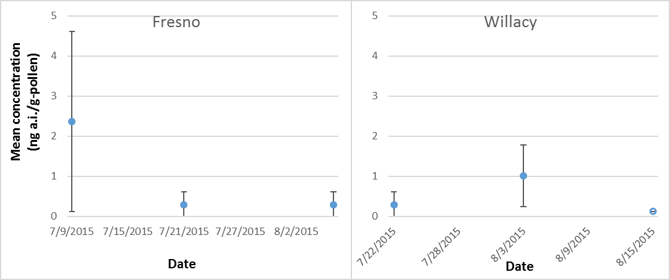

**Figure 13. Mean residues of clothianidin in cotton pollen at different time points (MRID 49904901). Open circle represents concentration less than the limit of detection (LOD). Error bars represent 95% confidence intervals. Residues normalized to 0.35 mg a.i./seed treatment rate.**

Influence of site and chemical on nectar (floral) residue values

**Table 18** summarizes mean residues in floral nectar. In the clothianidin study, residues were less than the LOD in floral nectar samples from either site. In the thiamethoxam study, 95% confidence intervals of means overlapped in two of three sites. This suggests that residues are generally similar among sites but may differ for some sites. Based on these data, the chemical may influence residues in nectar (floral); however, it is unknown whether the difference is due to the chemical or to a difference in years where residues were sampled. As discussed for corn and canola, residues vary from year to year in samples collected from the same site.

Influence of site and chemical on nectar (extrafloral) residue values

**Table 19** summarizes mean residues in extrafloral nectar. Residues were not detected in extrafloral nectar at one of the clothianidin sites and one of the thiamethoxam sites. Residues at the other clothianidin site and the two remaining thiamethoxam sites had similar means, with overlapping 95% confidence intervals. This suggests that there may be differences in residues in extrafloral nectar among sites, but that chemical may not influence those residues.

Relationship between pollen and nectar residue values and flowers

Residue data are available for whole flowers for the thiamethoxam study. At each site, flower samples were collected from all matrices on the same day. In the Fresno site, residues were not detected in either floral or extra floral nectar, preventing a quantitative comparison of differences in residues among matrices. At the Tulare and Madera County sites, residues in flowers were greater than those in pollen and nectar by approximately an order of magnitude (3x – 18x different compared to pollen and nectar values).

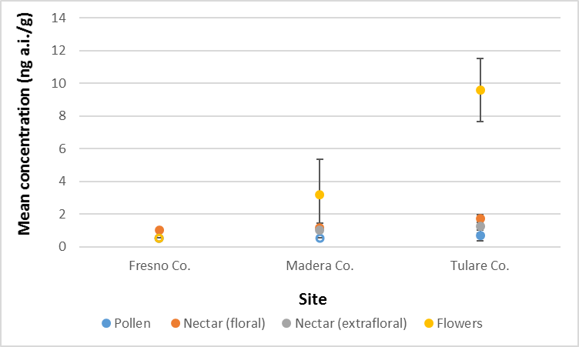

**Figure 16. Mean residues of thiamethoxam measured in different cotton pollen, nectar (floral and extrafloral) and whole flowers (MRID 49686801). Open circles represent samples where concentrations were not detected (*i.e*., <LOD). Error bars represent 95% confidence intervals.**

**Residues normalized to 0.35 mg a.i./seed treatment rate.**

Relationship between pollen and nectar residue values and leaves

Residue data are available for leaves for the thiamethoxam study. At the Madera and Tulare sites, leaf residues are at least an order of magnitude greater than those in pollen and nectar (**Figure 17**). Residues in leaves are not representative of those in nectar. For both clothianidin sites (**Figure 18**), residues in leaves are similar to those in pollen. At both sites, clothianidin was less than the LOD in nectar (floral); therefore, residues in leaves are greater than those in floral nectar.

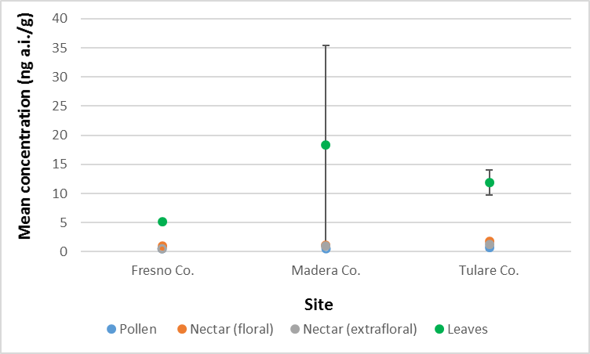

**Figure 17. Mean residues of thiamethoxam measured in different cotton pollen, nectar (floral and extrafloral) and leaves (MRID 49686801). Open circles represent samples where concentrations were not detected (*i.e*., <LOD). Error bars represent 95% confidence intervals. Residues normalized to 0.35 mg a.i./seed treatment rate.**

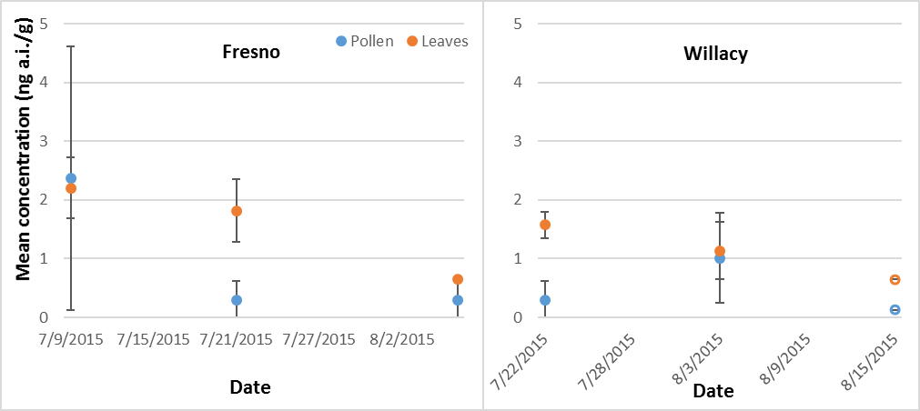

**Figure 18. Mean residues of clothianidin measured in cotton pollen and leaves (MRID 49904901). Open circles represent samples where concentrations were not detected (*i.e*., <LOD). Error bars represent 95% confidence intervals. Residues normalized to 0.35 mg a.i./seed treatment rate.**

### Summary of cotton analysis and recommendations for risk assessment

Summary of analysis:

* Residue data are available for pollen, nectar and extra-floral nectar from seed treated cotton for clothianidin and thiamethoxam.
* It does not appear that site or chemical have a strong influence on residue levels.
* At some sites, concentrations in whole flowers and leaves are an order of magnitude greater than those in pollen and nectar, suggesting that they would be over protective. At others, residues in leaves are similar to those in pollen.

Recommendations for risk assessment:

* Since honey bees do not consume cotton pollen, no residue value is recommended for pollen concentrations.
* For floral nectar, the 90th percentile mean (chronic) and maximum (acute) values are 1.5 and 1.8 ng a.i./g, respectively (normalized to 0.35 mg a.i./seed). This is used for determining the refined Tier I and Tier II values for risk assessment.
  + This value is adjusted for each chemical based on the maximum allowed seeding rate (**Table 20**).
* For extra-floral nectar, the 90th percentile mean and maximum values are 1.2 and 2.1 ng a.i./g, respectively (normalized to 0.35 mg a.i./seed). This is used for determining the refined Tier I and Tier II values for risk assessment.
  + This value is adjusted for each chemical based on the maximum allowed seeding rate (**Table 20**).
  + Given how close the floral and extrafloral nectar values are, only the extra floral nectar values will be used for risk assessment.
* Values have a medium level of confidence, due to the following:
  + Residue data are not available for multiple years for the same chemical,
  + Only two trials were available for clothianidin and three for thiamethoxam;
  + No data are available for imidacloprid;
  + The representativeness of the 90th percentile values based on only 5 sites is uncertain.
* **Table 20** summarizes the recommendations for cotton seed treatment.

**Table 20. Summary of recommendations for acute and chronic exposure values in pollen and nectar (floral and extra-floral) for use in risk assessment for cotton seed treatments.**

|  |  |  |  |  |  |
| --- | --- | --- | --- | --- | --- |
| **Chemical** | **Maximum seed treatment rate**  **(mg a.i./seed)** | **Matrix** | **Tier I (acute)** | **Tier I (chronic)** | **Tier II\*** |
| Clothianidin | 0.35 | Pollen | 0 | 0 | 1.5 |
| Nectar | 2.1 | 1.2 |
| Imidacloprid | 0.5 | Pollen | 0 | 0 | 2.1 |
| Nectar | 3.0 | 1.7 |
| Thiamethoxam | 0.33 | Pollen | 0 | 0 | 1.4 |
| Nectar | 2.0 | 1.1 |

*Total nectar equivalents calculated as Cnectar + Cpollen/20 (see Appendix x for details on how this equation was derived), based on 90th percentile mean residues in nectar (Cnectar) and pollen (Cpollen). Since mean in floral nectar is higher, this value is used in Tier II value.

Canola

One study is available for canola seed treatments with residue data that are considered quantitative (MRID 49755702). In this study, 7 field trials were conducted in different Canadian provinces.

Thiamethoxam was applied at a rate of 0.015 mg a.i./seed (clothianidin equivalents), which is consistent with the maximum treatment rate allowed in the US for thiamethoxam. **Tables 21** and **22** summarize the pollen and nectar residue data from the different trials. For each year at each site, data were only collected at one time-point. Since data are only available for thiamethoxam, the influence of chemical on residues cannot be investigated for canola. Data are available for nectar, pollen and whole flowers from canola plants resulting from treated seed. Therefore, residues in nectar and pollen were compared to those of whole flowers. Since no leaf data are available, no comparisons are made involving leaves.

**Table 21. Summary of mean residues of thiamethoxam in pollen from canola seed treatment studies.**

|  |  |  |  |  |  |  |  |  |  |
| --- | --- | --- | --- | --- | --- | --- | --- | --- | --- |
| **Site** | **Year** | **MRID** | **Chemical** | **Collected from** | **Mean (ng a.i./g; normalized to 0.015 mg a.i./seed)** | **95% CI (±)** | **Maximum single value** | **Number of samples** | **% detections (%**  **quantification)** |
| Dundurn, SK | 2013 | 49755702 | Thiamethoxam | Plant | 0.20 | NA | 0.20 | 3 | 0 (0)* |
| Alvena, SK | 2013 | 49755702 | Thiamethoxam | Plant | 0.20 | NA | 0.20 | 3 | 0 (0)* |
| Josephburg, AB | 2013 | 49755702 | Thiamethoxam | Plant | 0.20 | NA | 0.20 | 3 | 0 (0)* |
| Brandon, MB | 2013 | 49755702 | Thiamethoxam | Plant | 0.35 | 0.63 | 0.63 | 3 | 33 (0) |
| Alvena, SK | 2012 | 49755702 | Thiamethoxam | Plant | 1.13 | NA | 1.13 | 3 | 100(0)** |
| Josephburg, AB | 2012 | 49755702 | Thiamethoxam | Plant | 4.70 | 2.42 | 6.09 | 3 | 100 (100) |
| Dundurn, SK | 2012 | 49755702 | Thiamethoxam | Plant | 5.32 | 1.93 | 87.20 | 3 | 100 (100) |

*Mean and max values represent ½ LOD

**Mean and max values represent midpoint between LOD and LOQ.

**Table 22. Summary of mean residues of thiamethoxam in nectar from canola seed treatment studies.**

|  |  |  |  |  |  |  |  |  |  |
| --- | --- | --- | --- | --- | --- | --- | --- | --- | --- |
| **Site** | **Year** | **MRID** | **Chemical** | **Collected from** | **Mean (ng a.i./g; normalized to 0.015 mg a.i./seed)** | **95% CI (±)** | **Maximum single value** | **Number of samples** | **% detections (%**  **quantification)** |
| Alvena, SK | 2013 | 49755702 | Thiamethoxam | Plant | 0.20 | NA | 0.20 | 3 | 0 (0)* |
| Josephburg, AB | 2013 | 49755702 | Thiamethoxam | Plant | 0.20 | NA | 0.20 | 3 | 0 (0)* |
| Dundurn, SK | 2013 | 49755702 | Thiamethoxam | Plant | 0.437 | 0.33 | 0.70 | 3 | 33 (0) |
| Josephburg, AB | 2012 | 49755702 | Thiamethoxam | Plant | 0.63 | NA | 0.63 | 3 | 100 (0)** |
| Brandon, MB | 2013 | 49755702 | Thiamethoxam | Plant | 0.63 | NA | 0.63 | 3 | 100 (0)** |
| Alvena, SK | 2012 | 49755702 | Thiamethoxam | Plant | 0.86 | 0.44 | 1.31 | 3 | 100 (33) |
| Dundurn, SK | 2012 | 49755702 | Thiamethoxam | Plant | 1.65 | 0.60 | 2.25 | 3 | 100 (100) |

*Mean value represent ½ LOD

**Mean and max values represent midpoint between LOD and LOQ.

Influence of year and site on pollen residue values

For pollen, there is no substantial difference in concentrations of thiamethoxam residues among sites. When considering site-to-site variability during the same year, residues detected in pollen overlap for the most part, with the exception of residues from 1 site in 2012 (Alvena; **Figure 17**).

When considering residues sampled during different years from the same site, residues vary from year- to-year. In this case, residues in 2012 were greater than in 2013, with a lower detection frequency in 2013.

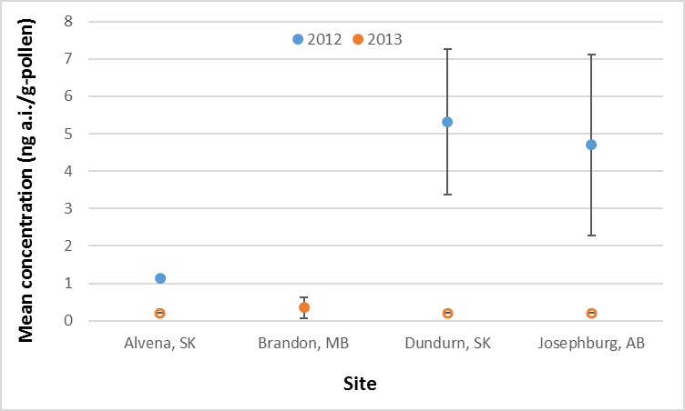

**Figure 17. Mean residues of thiamethoxam measured in canola pollen. Open circles represent samples where concentrations were not detected (*i.e*., <LOD). Error bars represent 95% confidence intervals.**

**Residues normalized to 0.015 mg a.i./seed treatment rate (expressed as clothianidin equivalents).**

Influence of year and site on nectar residue values

Similar to pollen, nectar residues sampled from different sites on the same year did not vary (**Figure 18**). When considering residues sampled during different years on the same site, concentrations measured in 2012 were greater than in 2013.

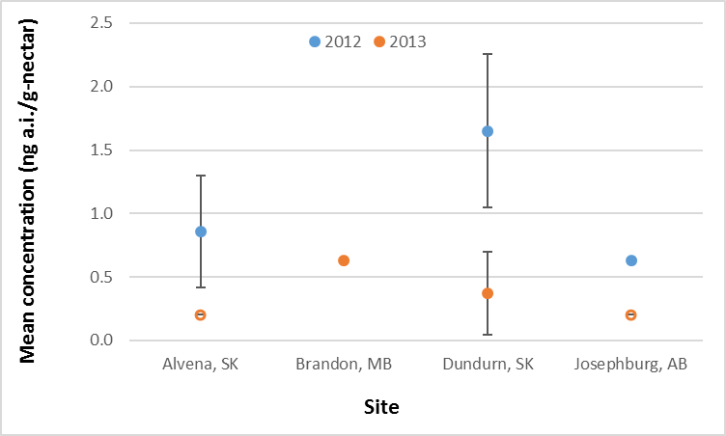

**Figure 18. Mean residues of thiamethoxam measured in canola nectar. Open circles represent samples where concentrations were not detected (*i.e*., <LOD). Error bars represent 95% confidence intervals.**

**Residues normalized to 0.015 mg a.i./seed treatment rate (expressed as clothianidin equivalents).**

Relationship between pollen and nectar residue values and flowers

Residues in pollen appear similar to those of whole flowers while residues of nectar are lower, but still within the same order of magnitude of those in pollen and whole flowers. When considering data from 2012, thiamethoxam total residues of concern in pollen and whole flowers overlapped, indicating that flowers may be an appropriate surrogate for pollen (**Figure 19**). Residues in nectar are lower than both pollen and whole flowers for 2 of the three sites; however, residues are still within a factor of 8.

Therefore, residues in flowers and pollen may be a protective surrogate for nectar.

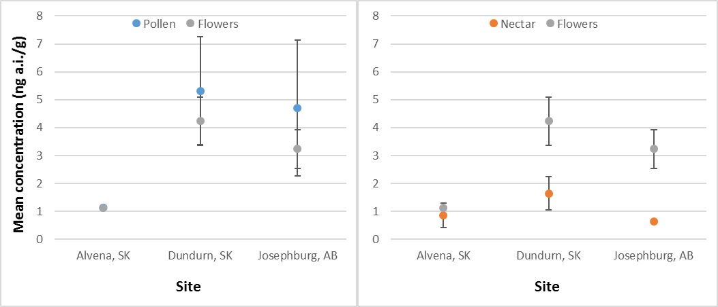

**Figure 19. Mean concentrations of thiamethoxam total residues of concern detected in canola pollen, nectar, whole flowers in 2012.**

### Summary of canola analysis and recommendations for risk assessment

Summary of analysis:

* Residue data are available for thiamethoxam for 3 sites across multiple years and an additional year at a 4th site;
* Insufficient data are available for clothianidin and imidacloprid to evaluate the influence of chemical on residues in canola;
* When considering data from the same year, there does not appear to be a difference in residues in pollen and nectar;
* When considering data from the same site at different years, it appears that residues may vary from year-to-year in both nectar and pollen.
* Residues in whole flowers appear to be similar to pollen and somewhat protective of residues in nectar.

Recommendations for risk assessment:

* Based on available data, residues for thiamethoxam can be bridged to imidacloprid and clothianidin.
  + Data for corn and cotton do not suggest that chemical impacts residues in pollen or nectar.
* The 90th percentile maximum (of all trials) and mean values from the available data are 1.7 and

1.2 ng a.i./g (respectively) for nectar and 6.5 and 4.9 ng a.i./g (respectively) for pollen. These values are based on the application rate of 0.015 mg a.i./seed (for thiamethoxam; expressed as clothianidin-equivalents).

* Recommendations for adjusting these values for clothianidin and imidacloprid based on their maximum seed treatment rates for canola are provided in **Table 23**.
* The values suggested above have a medium level of confidence;
  + Residues are available for 4 different sites, with 3 sites sampled on two different years;
  + No residue data are available for clothianidin or imidacloprid.
* Since data were available for 7 trial/date combinations, whole flower data are not necessary.
* **Table 23** summarizes the recommendations for risk assessment for canola seed treatments.

**Table 23. Summary of recommendations for acute and chronic exposure estimates in pollen and nectar to support risk assessment for canola seed treatments.**

|  |  |  |  |  |  |
| --- | --- | --- | --- | --- | --- |
| **Chemical** | **Maximum seed treatment rate**  **(mg a.i./seed)** | **Matrix** | **Tier I (acute)** | **Tier I (chronic)** | **Tier II\*** |
| Clothianidin | 0.018 | Pollen | 7.8 | 5.9 | 1.7 |
| Nectar | 2.0 | 1.4 |
| Imidacloprid | 0.05 | Pollen | 21.7 | 16.3 | 4.8 |
| Nectar | 5.7 | 4.0 |
| Thiamethoxam | 0.015 | Pollen | 6.5 | 4.9 | 1.4 |
| Nectar | 1.7 | 1.2 |

*Total nectar equivalents calculated as Cnectar + Cpollen/20 (see Appendix x for details on how this equation was derived), based on 90th percentile mean residues in nectar (Cnectar) and pollen (Cpollen).

## Comparison of residues among crops

### Pollen

When considering the mean residue values for pollen, normalized to the same treatment rate (0.1 mg a.i./seed; **Figure 20**), residues in corn, cotton and soybean appear to be similar, with values overlapping. The canola values that were quantified are higher than all three other crops, suggesting that residues in canola may be higher than corn, cotton and soybean. This suggests that the crop may influence residues in pollen. The influence of crop on residues in pollen is uncertain in that residues were only quantified in 6 trials covering canola, cotton and soybean (2 trials each).

**Rank**

**Figure 20. Ranked mean pollen concentration data for corn, cotton and canola. Data normalized to 0.1 mg a.i./seed rate. Open circles represent non-detects in all samples representing mean. Stars represent cases where chemical was detected but not quantified in at least one sample.**



1

0.9

0.8

0.7

0.6

0.5

0.4

0.3

0.2

0.1

0

0.01

0.1

1

10

100

**Mean concentration (ng a.i./g per 0.1 mg a.i./seed)**

Corn Soybean Cotton Canola

### Nectar

When considering the mean residue values for nectar, normalized to the same treatment rate (0.1 mg a.i./seed; **Figure 21**), residues in soybean and cotton nectar appear to be similar, with values overlapping. The highest mean residue in nectar for soybean overlaps with one of the canola means (where samples were quantified). Since both canola residues are ranked higher than the cotton and soybean data and one quantified mean does not have overlapping confidence intervals with the other crop residues, there is a possibility that crop influences residues. Given that residues were only quantified in 8 trials (across all three crops), it is uncertain whether crop influences concentrations in nectar.

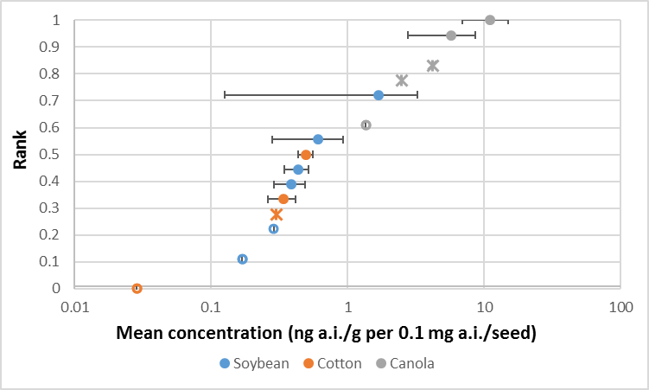

**Figure 21. Ranked mean nectar concentration data for soybean, cotton and canola. Data normalized**

**to 0.1 mg a.i./seed rate. Open circles represent non-detects in all samples representing mean. Stars represent cases where chemical was detected but not quantified in at least one sample.**

## Recommendations for additional crops

An appropriate default value can be assigned based on the available data. For this case, the 90th percentile mean and maximum concentrations available for pollen and nectar across all crops are recommended. **Table 24** summarizes the 90th percentile residue data from corn, cotton, canola and soybean data (for pollen) and cotton, canola and soybeans (for nectar). These data are normalized to 0.1 mg a.i./seed. When considering the pollen values, the 90th percentile is represented by corn and canola values. For nectar, the 90th percentile is represented by the canola residues.

In order to use these values for risk assessment, they can be multiplied by the maximum seeding rate allowed for the crop and chemical of interest. This approach is proposed here for the neonicotinoids for crops where measured residue data are not available.

**Table 24. Treatment rate normalized 90th percentile residues recommended for use in neonicotinoid assessments for crops that do not have crop-specific recommendations.**

|  |  |  |
| --- | --- | --- |
| **Matrix** | **90th percentile concentration**  **(ng a.i./g-normalized to 0.1 mg a.i./seed)** | |
| **Mean** | **Maximum** |
| Pollen | 1.8 | 3.2 |
| Nectar | 4.5 | 7.6 |

One approach that could be considered here would be to use the crops with available residue data to represent other crops within the same crop group (*e.g*., corn would represent crops within the “cereal grains” group). This approach was not recommended because: 1) there were no other crops within the cereal grain or legume vegetable groups to determine the representativeness of corn and soybean (respectively) of these crop groups; and, 2) although cotton and canola are both within the oilseed group, available data suggest that the two crops differ in the magnitude of residues in pollen and nectar (**Figures 20** and **21**). Therefore, all of the available data are used here to represent residue in crops without specific residue data.

## Revisiting Bee-REX default

As discussed in the introduction, the BEE-REX model’s default concentration for both pollen and nectar is 1,000 ng a.i./g, *i.e*., 1 ppm. Based on the analysis carried out above, available residue data for pollen and nectar of seed treated plants suggest that this default overestimates exposure.

Given that treatment rate may impact the magnitude of the residue in pollen and nectar (MRID 49210901 and Jiang *et al*. 2018), it would be useful to revise the default approach so that it can account for the mass of active ingredient applied to the seed. It would also be useful to consider using the values included in **Table 24** as the Bee-REX default. This approach has the advantage that it is based on empirical data for pollen and nectar from seed treated crops, compared to the uncertainty associated with the current default which does not include empirical data for pollen and nectar. One uncertainty associated with applying this approach for all chemicals is that it is based on residues for only one chemical class. Arguably, this uncertainty is probably outweighed by the increased certainty in having pollen- and nectar-specific data. In addition, given that these chemicals are prone to systemic translocation in plants, they will likely be representative of chemicals that exhibit similar systemicity.

# Summary

Available residue data for corn pollen suggest that chemical and site does not influence residues in pollen, however, year-to-year variability may influence the magnitude of residue. Sufficient residue data are available to recommend residue concentrations for corn pollen.

For soybeans, sufficient residue data are not available for pollen and nectar to set a concentration based on these matrices. Surrogate tissues (*i.e*., anthers and flowers) are used for pollen and nectar (respectively). Anther data are used for pollen based on comparisons between corn pollen and anthers that suggest the residue levels are comparable. Whole flower data are used for nectar based on comparisons between nectar and pollen for two sites.

Cotton data also indicate that chemical and site does not influence residues. Cotton-specific residues are used in the nectar recommendations for all three chemicals.

Canola data for thiamethoxam indicate that site may not matter within a year; however, residues on the same site may vary from one year to another. Canola-specific residues are used in the nectar and pollen recommendations for all three chemicals.

When considering pollen and nectar mean residue data (normalized to the same treatment rate), canola data appear to be higher compared to other crops. This suggests that for seed treatments, residues may

be influenced by crop. This conclusion should be caveated by the fact that there are only a limited number of trials for canola, cotton and soybean where residues were quantified.

Due to the limited number of sites per study (with the same year and crop), this analysis did not consider what factors lead to site-specific differences in residues.

**Tables 25-27** summarize the recommendations for clothianidin, imidacloprid and thiamethoxam, including a discussion of the certainties associated with the recommended values.

**Table 25. Summary of Tier 1 (refined) and Tier II recommendations for residue concentrations in pollen, nectar and extra-floral nectar for clothianidin.**

|  |  |  |  |  |  |  |
| --- | --- | --- | --- | --- | --- | --- |
| **Crop** | **Maximum seed treatment rate**  **(mg a.i./seed)** | **Matrix** | **Tier I (acute)** | **Tier I (chronic)** | **Tier II** | **Comments** |
| Corn | 1.3 | Pollen | 31 | 8.4 | 0.42 | Pollen residue based on pollen specific data from 22 trials over different years. Data available for all three chemicals. Detection frequency is high among pollen samples, leading to confidence in quantified levels.  Corn does not produce nectar, so exposure is not relevant for this  matrix. |
| Nectar | 0 | 0 |
| Cotton | 0.35 | Pollen | 0 | 0 | 1.5 | Residue data are not available for multiple years for the same chemical, only two trials were available for clothianidin and three for thiamethoxam; the representativeness of the 90th percentile values based on only 5 sites is uncertain. |
| Nectar - extrafloral | 2.1 | 1.2 |
| Soybean | 0.13 | Pollen | 8.1 | 4.4 | 2.6 | Residues in pollen and nectar are based on surrogate tissues, *i.e*., anthers and flowers, respectively. The relationship between soybean pollen and anthers is unknown; however, based on the corn analysis, it is assumed that anther concentrations are representative of pollen. Data from two sites are available to compare the residues in nectar and whole flowers. These comparisons suggest that flower data represent a reasonable surrogate for nectar; however, they appear to overpredict residues (by as much as an order of magnitude). The recommended values represent the 90th percentile of sites for flower data, with adjustment of the median factor difference between flowers and  nectar (5.6x). |
| Nectar | 6.1 | 2.3 |
| Canola | 0.018 | Pollen | 7.8 | 5.9 | 1.7 | No data are available for imidacloprid or clothianidin, therefore, data for thiamethoxam are used as a surrogate. Available data for corn and cotton do not suggest that chemical influences magnitude of residues.  See certainties below associated with thiamethoxam data. |
| Nectar | 2.0 | 1.4 |
| All other crops | 0.1 | Pollen | 3.2 | 1.8 | 4.6 | Recommendations based on available residue data for corn, cotton, canola and soybean. Crop appears to influence residue levels, with canola representing the greatest values compared to other crops. Recommendations based on 90th percentiles. Pollen data are  predominantly represented by corn. |
| Nectar | 7.6 | 4.5 |

**Table 26. Summary of Tier 1 (refined) and Tier II recommendations for residue concentrations in pollen, nectar and extra-floral nectar for imidacloprid.**

|  |  |  |  |  |  |  |
| --- | --- | --- | --- | --- | --- | --- |
| **Crop** | **Maximum seed treatment rate**  **(mg a.i./seed)** | **Matrix** | **Tier I (acute)** | **Tier I (chronic)** | **Tier II** | **Comments** |
| Corn | 1.4 | Pollen | 33 | 9.0 | 0.45 | Pollen residue based on pollen-specific data from 22 trials over different years. Data available for all three chemicals. Detection frequency is high among pollen samples, leading to confidence in quantified levels.  Corn does not produce nectar, so exposure is not relevant for this  matrix. |
| Nectar | 0 | 0 |
| Cotton | 0.5 | Pollen | 0 | 0 | 2.1 | Residue data are not available for multiple years for the same chemical, only two trials were available for clothianidin and three for thiamethoxam; No data are available for imidacloprid; the representativeness of the 90th percentile values based on only 5 sites  is uncertain. |
| Nectar | 3.0 | 1.7 |
| Soybean | 0.38 | Pollen | 23.8 | 12.8 | 7.5 | Residues in pollen and nectar are based on surrogate tissues, *i.e*., anthers and whole flowers, respectively. The relationship between soybean pollen and anthers is unknown; however, based on the corn analysis, it is assumed that anther concentrations are representative of pollen. Data from two sites are available to compare the residues in nectar and flowers. These comparisons suggest that flower data represent a reasonable surrogate for nectar; however, they appear to overpredict residues by as much as an order of magnitude. The recommended values represent the 90th percentile of sites for flower data, with adjustment of the median factor difference between  flowers and nectar (5.6x). |
| Nectar | 17.7 | 6.8 |
| Canola | 0.05 | Pollen | 21.7 | 16.3 | 4.8 | No data are available for imidacloprid or clothianidin, therefore, data for thiamethoxam are used as a surrogate. Available data for corn and  cotton do not suggest that chemical influences magnitude of residues. See certainties below associated with thiamethoxam data. |
| Nectar | 5.7 | 4.0 |
| All other crops | 0.1 | Pollen | 3.2 | 1.8 | 4.6 | Recommendations based on available residue data for corn, cotton, canola and soybean. Crop appears to influence residue levels, with canola representing the greatest values compared to other crops. Recommendations based on 90th percentiles. Pollen data are  predominantly represented by corn. |
| Nectar | 7.6 | 4.5 |

**Table 27. Summary of Tier 1 (refined) and Tier II recommendations for residue concentrations in pollen, nectar and extra-floral nectar for thiamethoxam.**

|  |  |  |  |  |  |  |
| --- | --- | --- | --- | --- | --- | --- |
| **Crop** | **Maximum seed treatment rate**  **(mg a.i./seed)** | **Matrix** | **Tier I (acute)** | **Tier I (chronic)** | **Tier II** | **Comments** |
| Corn | 1.3 | Pollen | 31 | 8.4 | 0.42 | Pollen residue based on pollen-specific data from 22 trials over different years. Data available for all three chemicals. Detection frequency is high among pollen samples, leading to confidence in quantified levels.  Corn does not produce nectar, so exposure is not relevant for this matrix. |
| Nectar | 0 | 0 |
| Cotton | 0.33 | Pollen | 0 | 0 | 1.4 | Residue data are not available for multiple years for the same chemical, only two trials were available for clothianidin and three for thiamethoxam; the representativeness of the 90th percentile values based on only 5 sites is uncertain. |
| Nectar | 2.0 | 1.1 |
| Soybean | 0.16 | Pollen | 10.0 | 5.4 | 3.2 | Residues in pollen and nectar are based on surrogate tissues, *i.e*., anthers and flowers, respectively. The relationship between soybean pollen and anthers is unknown; however, based on the corn analysis, it is assumed that anther concentrations are representative of pollen. Data from two sites are available to compare the residues in nectar and flowers. These comparisons suggest that flower data represent a reasonable surrogate for nectar; however, they appear to overpredict residues by as much as an order of magnitude. The recommended values represent the 90th percentile of sites for flower data, with adjustment of the  median factor difference between flowers and nectar (5.6x). |
| Nectar | 7.5 | 2.9 |
| Canola | 0.015 | Pollen | 6.5 | 4.9 | 1.4 | Data available for thiamethoxam from 4 sites, with three sites with multiple years. Residues represent 90th percentiles of measured values in pollen and nectar. Residue values representing 90th percentile of distribution had high detection frequency, leading to increased certainty in magnitude of 90th percentile estimates.  Treated rate is representative of maximum rate allowed for thiamethoxam. |
| Nectar | 1.7 | 1.2 |
| All other crops | 0.1 | Pollen | 3.2 | 1.8 | 4.6 | Recommendations based on available residue data for corn, cotton, canola and soybean. Crop appears to influence residue levels, with canola representing the  greatest values compared to other crops. Recommendations based on 90th percentiles. Pollen data are predominantly represented by corn. |
| Nectar | 7.6 | 4.5 |

# Citations

Alix, A., M. P. Chauzat, S. Duchard, G. Lewis, C. Maus, M. J. Miles, E. Piling, H. M. Thompson, and K. Wallner. 2009. Guidance for the assessment of risks to bees from the use of plant protection products applied as seed coating and soil applications – conclusions of the ICP-BR dedicated working group. Pages 15 – 27 *in* P. A. Oomen and H. M. Thompson (editors) Hazards of

Pesticides to Bees, 10th International Symposium of the ICP-BR Bee Protection Group, Bucharest (Romania), October 8 – 10, 2008. Julus Kühn Arch 423.

Cutler G. C. and C. D. Scott-Dupree. 2014. A field study examining the effects of exposure to neonicotinoid seed-treated corn on commercial bumble bee colonies. Ecotoxicology 23(9):1755-63.

EPPO. 2010. Environmental risk assessment scheme for plant protection products: Chapter 10, Honey bees. European and Mediterranean Plant Protection Organization (EPPO). Bulletin OEPP/EPPO Bulletin 40, 323–331.

Jiang, J., Ma, D., Zou, N., Yu, X., Zhang, Z.Q., Liu, F., Mu, W., Concentrations

of imidacloprid and thiamethoxam in pollen, nectar and leaves from seed-dressed cotton crops and their potential risk to honeybees (*Apis mellifera* L.), *Chemosphere* (2018), doi: 10.1016/ j.chemosphere.2018.02.168.

USEPA/PMRA/CDPR. 2014. Guidance for Assessing Pesticide Risks to Bees. Office of Pesticide Programs, United States Environmental Protection Agency, Washington, D.C.; Health Canada Pest Management Regulatory Agency Ottawa, ON, Canada California Department of Pesticide Regulation, Sacramento, CA. June 19. (available at: [http://www2.epa.gov/pollinator](http://www2.epa.gov/pollinator-protection/pollinator-risk-assessment-guidance)- [protection/pollinator-risk-assessment-](http://www2.epa.gov/pollinator-protection/pollinator-risk-assessment-guidance) [guidance](http://www2.epa.gov/pollinator-protection/pollinator-risk-assessment-guidance)).

USDA. 2017. Attractiveness of agricultural crops to pollinating bees for the collection of nectar and/or pollen. Available online at: [https://www.ars.usda.gov/ARSUserFiles/OPMP/Attractiveness%20of%20Agriculture%20Crops%20to%2](https://www.ars.usda.gov/ARSUserFiles/OPMP/Attractiveness%20of%20Agriculture%20Crops%20to%20Pollinating%20Bees%20Report-FINAL_Web%20Version_Jan%203_2018.pdf) [0Pollinating%20Bees%20Report-FINAL_Web%20Version_Jan%203_2018.pdf](https://www.ars.usda.gov/ARSUserFiles/OPMP/Attractiveness%20of%20Agriculture%20Crops%20to%20Pollinating%20Bees%20Report-FINAL_Web%20Version_Jan%203_2018.pdf)

|  |  |
| --- | --- |
| MRID | Citation |
| 45422431 | Schmuck, R.; Schoning, R. (2000) Residues of TI 435 in Nectar. Blossoms, Pollen and Honey Bees Sampled from a Summer Rape Field in Sweden and Effects of These Residues on Foraging Honeybees: Lab Project Number: E370 1361-1: 110282. Unpublished study prepared by Bayer AG. 30 p. |
| 45422432 | Schmuck, R.; Schoning, R. (2000) Residues of TI 435 in Nectar. Blossoms, Pollen and Honey Bees Sampled from a British Summer Rape Field and Effects of These Residues on Foraging Honeybees: Lab Project Number: E 370 1657-6: 110024. Unpublished study prepared by Bayer AG. 31 p. |
| 45422433 | Schmuck, R.; Schoning, R. (2000) Residues of TI 435 in Nectar. Blossoms, Pollen and Honey Bees Sampled from a French Summer Rape Field and Effects of These Residues on Foraging Honeybees: Lab Project Number: E 370 1359-8: 110046. Unpublished study prepared by Bayer AG. 29 p. |

|  |  |
| --- | --- |
| 45422435 | Scott-Dupree, C.; Spivak, M.; Bruns, G. *et al*. (2001) The Impact of GAUCHO and TI-435 Seed-Treated Canola on Honey Bees, *Apis mellifera* L: Lab Project Number: 110403.  Unpublished study prepared by University of Guelph, University of Minnesota, and Enviro- Test Laboratories. 131 p. |
| 45422436 | Maus, C.; Schoning, R. *et al*. (2001) Residue Levels of TI-435 FS 600 and its Relevant Metabolites in Nectar, Blossoms, and Pollen of Summer Rape from Dressed Seeds and Effects of These Residues on Foraging Honeybees (Test Location: Farmland Laacher Hof): Lab Project Number: 110295: E 319 1839-4. Unpublished study prepared by Bayer AG. 34 p. |
| 45422437 | Maus, C.; Schoning, R. *et a*l. (2001) Residue Levels of TI-435 FS 600 and its Relevant Metabolites in Nectar, Blossoms, and Pollen of Summer Rape from Dressed Seeds and  Effects of These Residues on Foraging Honeybees (Test Location: Farmland Hofchen): Lab Project Number: E319 1836-1: 110177. Unpublished study prepared by Bayer AG. 36 p. |
| 45422438 | Maus, C.; Schoning, R. *et al*. (2001) Residue Levels of TI-435 FS 600 and its Relevant Metabolites in Pollen of Maize Plants from Dressed Seeds (Test Location: Farmland Laacher Hof): Lab Project Number: E319 1840-: 110023. Unpublished study prepared by Bayer AG. 30 p. |
| 45422439 | Maus, C.; Schoning, R. *et al.* (2001) Residue Levels of TI-435 FS 600 and its Relevant Metabolites in Pollen of Maize Plants from Dressed Seeds (Test Location: Farmland  Hofchen): Lab Project Number: E319 1835-0: 110048. Unpublished study prepared by Bayer AG. 30 p. |
| 46163104 | Satter, P. (2003) Determination of Analytes Thiamethoxam (CGA 293343) and its Metabolite CGA 322704 in or on Pollen, Nectar and Honey from Sunflower Collected in Study 991567. Project Number: 02/N015, 991567. Unpublished study prepared by Syngenta Crop Protection, AG. 13 p. |
| 46163105 | Mair, P. (2000) Report on Analytical Study 106/00 Determination of Analytes Thiamethoxam (CGA 293343) and CGA 322704 in Sun Flower (Heads and Flowers), Honey, Nectar, and Pollen Collected in Study 31061/00: Final Report. Project Number: 106/00, 31061/00.  Unpublished study prepared by Syngenta Crop Protection, AG. 8 p. |
| 46163106 | Mair, P. (2000) Report on Analytical Study 107/00 Determination of Analytes Thiamethoxam (CGA 293343) and CGA 322704 in Sun Flower (Heads and Flowers), Honey, Nectar, and Pollen Collected in Study 31062/00: Final Report. Project Number: 107/00, 31062/00.  Unpublished study prepared by Syngenta Crop Protection, AG. 8 p. |
| 46163107 | Mair, P. (2000) Report on Analytical Study 104/00 Determination of Analytes Thiamethoxam (CGA 293343) and CGA 322704 in Sunflower (Heads and Leaves), Honey, Pollen, and Bee (Honey Stomach Content) Collected in Study 99332/S1-BFEU: Final Report. Project Number:  104/00, 99332/S1/BFEU. Unpublished study prepared by Syngenta Crop Protection, AG. 10 p. |
| 46163108 | Hohl, J. (2001) Report on Analytical Study 103/01; Determination of Analytes Thiamethoxam (CGA 293343) and CGA 322704 in Sunflowers (Flowers, Leaves), Honey, Honey Stomach Content and Pollen, Collected in Study 20001072/I1-BFEU. Project Number: 103/01, 20001072/I1/BFEU. Unpublished study prepared by Syngenta Crop Protection, AG. 8 p. |
| 46907802 | Cutler, C.; Scott-Dupree, C. (2006) Spring 2006 Assessment of Overwintered Colonies Studied in an Investigation of the Potential Long-Term Impact of Clothianidin Seed Treated Canola on Honey Bees, *Apis mellifera* L. Project Number: 2005/CSD/EBTIX064/2, EBTIX064/2. Unpublished study prepared by University of Guelph. 4 p. |
| 47699414 | Maus, C. (2002) Evaluation of the Effects of Residues of Imidacloprid FS600 in Maize Pollen from Dressed Seeds on Honeybees (*Apis mellifera*) in the Semi-field. Project Number:  E/319/2046/5, MAUS/AM018, M/052238/01/2. Unpublished study prepared by Bayer Ag. 61 p. |
| 47699416 | Maus, C.; Schoning, R. (2001) Effects of Residues of Imidacloprid in Maize Pollen from Dressed Seeds on Honey Bees (*Apis mellifera*). Project Number: E/319/1912/6, M/052637/01/2, MAUS/AM/012. Unpublished study prepared by Bayer Ag. 53 p. |

|  |  |
| --- | --- |
| 47699417 | Schmuck, R.; Schoning, R. (1999) Effects of Imidacloprid Residues in Maize Pollen on the Development of Small Bee Colonies Under Field Exposure Conditions. Project Number: E/370/1595/0, 109494, M/016845/01/2. Unpublished study prepared by Bayer Ag. 52 p. |
| 47699418 | Schmuck, R.; Schoning, R. (1999) Residue Levels of Imidacloprid and Imidacloprid Metabolites in Nectar, Blossoms, Pollen and Honey Bees Sampled from a Summer Rape Field in Sweden and Effects of these Residues on Foraging Honeybees. Project Number: E/370/1360/0, 109492, M0/03/011933. Unpublished study prepared by Bayer Ag. 32 p. |
| 47699419 | Schmuck, R.; Schoning, R. (1999) Residues of Imidacloprid and Imidacloprid Metabolites in Nectar, Blossoms, Pollen and Honey Bees Sampled from a French Summer Rape Field and Effects of these Residues on Foraging Honeybees. Project Number: E/370/1358/7, 109496, M/006815/01/2. Unpublished study prepared by Bayer Ag. 31 p. |
| 47699421 | Schmuck, R.; Schoning, R.; Schramel, O. (1999) Residue Levels of Imidacloprid and Imidacloprid Metabolites in Nectar, Blossoms and Pollen of Sunflowers Cultivated on Soils with Different Imidacloprid Residue Levels and Effects of these Residues on Foraging Honeybees. Project Number: E/370/1552/3, 109495, M0/03/011939. Unpublished study prepared by Bayer Ag. 45 p. |
| 47699422 | Schmuck, R.; Schoning, R.; Schramel, O. (1999) Residue Levels of Imidacloprid and Imidacloprid Metabolites in Nectar, Blossoms and Pollen of Sunflowers Cultivated on Soils with Different Imidacloprid Residue Levels and Effects of these Residues on Foraging Honeybees. Project Number: E/370/1549/9, 109563, M0/03/006522. Unpublished study prepared by Bayer Ag. 48 p. |
| 47699423 | Schmuck, R.; Schoning, R.; Schramel, O. (1999) Residue Levels of Imidacloprid and Imidacloprid Metabolites in Pollen of Maize Plants Cultivated on Soils with Different Imidacloprid Residue Levels. Project Number: E/370/1550/1, 109567, M0/03/006517. Unpublished study prepared by Bayer Ag. 41 p. |
| 47699424 | Schmuck, R.; Schoning, R.; Schramel, O. (1999) Residue Levels of Imidacloprid and Imidacloprid Metabolites in Pollen of Maize Plants Cultivated on Soils with Different Imidacloprid Residue Levels. Project Number: E/370/1551/2, 109569, M0/03/006519. Unpublished study prepared by Bayer Ag. 39 p. |
| 47699425 | Schmuck, R.; Schramel, O.; Schoning, R. (1999) Residue Levels of Imidacloprid and Imidacloprid Metabolites in Nectar, Blossoms and Pollen of Summer Rape Cultivated on Soils with Different Imidacloprid Residue Levels and Effects of these Residues on Foraging Honeybees. Project Number: 109566, E/370/1548/8, SXR/AM/008. Unpublished study prepared by Bayer Ag. 46 p. |
| 47699426 | Schoning, R. (2001) Determination of Residues of Imidacloprid and Relevant Metabolites in Nectar, Pollen and Honey of Winter Rape. Project Number: MR/147/01, E/370/1887/4, M/052524/02/2. Unpublished study prepared by Bayer Ag. 21 p. |
| 47796301 | Stadler, T.; Gines, D.; Buteler, M. (2003) Long-Term Toxicity Assessment of Imidacloprid to Evaluate Side Effects on Honey Bees Exposed to Treated Sunflower in Argentina. Bulletin of Insectology 56(1): 77-81. |
| 47812303 | Schmuck, R.; Schoning, R.; Stork, A.; *et al*. (2000) Risk Posed to Honeybees (Apis mellifera L, Hymenoptera) by an Imidacloprid Seed Dressing of Sunflowers. Pest Management Science 57: 225-238. |
| 47961202 | Bocksch, S. (2010) Determination of Residues of Clothianidin and Imidacloprid and their Metabolites in Melon following an Application of Clothianidin & Imidacloprid WS 56.25 + 18.75 as Seed Treatment: Final Report. Project Number: M/361798/01/1, S08/01369, M/361798/01/2/OCR. Unpublished study prepared by Eurofins - GAB GmbH. 196 p. |

|  |  |
| --- | --- |
| 48077902 | Laurent, F.; Rathahao, E. (2003) Distribution of (Carbon 14) Imidacloprid in Sunflowers (*Helianthus annuus* L.) following Seed Treatment. Journal of Agricultural and Food Chemistry 51(27):8005-8010. |
| 48298801 | Staedtler, T. (2009) Determination of the Residue Levels of Clothianidin and its Metabolites TZMU and TZNG in Pollen Harvested from Maize Plants Grown in Commercial Practice from Poncho Pro Dressed Seeds (Nominally 1.25 mg Clothianidin/Seed) in the Upper Rhine Valley in Germany: Final Report. Project Number: 071, R08188/2, EBTOL040. Unpublished study prepared by RIFCon GmbH. 140 p. |
| 48711001 | Krupke, C.; Hunt, G.; Eitzer, B. *et al*. (2012) Multiple Routes of Pesticide Exposure for Honey Bees Living Near Agricultural Fields. PloS One 7(1). |
| 49073605 | Schuld, M. (2002) Field Test: Side Effects of Oil-Seed Rape Grown from Seeds Dressed with Imidacloprid and *Beta*-Cyfluthrin FS 500 on the Honey Bee (*Apis mellifera* L.). Project Number: M/066846/01/2, 99398/01/BFEU. Unpublished study prepared by Arbeitsgemeinschaft GAB Biotechnologie. 77p. |
| 49073610 | Maus, C. (2002) Residue Levels of TI 435 and its Relevant Metabolites in Pollen of Maize Plants from Dressed Seeds. Project Number: M/067021/01/2 MAUS/AM/013 E/370/2055/2. Unpublished study prepared by Bayer AG. 26p. |
| 49073611 | Schoning, R. (2005) Determination of Residues of Clothianidin and Metabolites in/on Corn Pollen after Seed Treatment of TI 435 (600 FS) in the Field in Germany, Northern France and Southern France. Project Number: M/243318/01/2, MR/161/04, P672044714. Unpublished study prepared by Bayer CropScience Ag. 55p. |
| 49073613 | Schoning, R. (2005) Determination of the Residues of TI 435 in/on Corn After Seed Treatment of TI 435 (600 FS) in the Field in Northern France. Project Number: R/2004/1003/4, RA/2154/04, M/255334/01/2. Unpublished study prepared by Bayer CropScience AG. 47p. |
| 49073616 | Claben, C. (2009) Clothianidin FS 600B G: A Residue Study with Clothianidin FS 600B G Treated Maize Seed, Investigating Residues in Crop, Soil and Honeybee Products in Languedoc-Roussillon (France). Project Number: M/347742/01/2, S08/01377, S08/01377/01/BZEU. Unpublished study prepared by Eurofins - GAB GmbH. 250p. |
| 49073617 | Claben, C. (2009) Clothianidin FS 600B G: A Residue Study with Clothianidin FS 600B G Treated Maize Seed, Investigating Residues in Crop, Soil and Honeybee Products in Alsace (France). Project Number: M/347727/01/2, S08/02437, S08/02437/01/BZEU. Unpublished study prepared by Eurofins - GAB GmbH. 236p. |
| 49073618 | Claben, C. (2009) Clothianidin FS 600B G: A Residue Study with Clothianidin FS 600B G Treated Maize Seed, Investigating Residues in Crop, Soil and Honeybee Products in Champagne (France). Project Number: M/347748/01/2, S08/02438, S08/02438/01/BZEU. Unpublished study prepared by Eurofins - GAB GmbH. 242p. |
| 49073620 | Maus, C. ; Schoning, R. (2001) Residue Levels of TI 435 FS 600 and Its Relevant Metabolites in Nectar, Blossoms and Pollen of Sunflowers from Dressed Seeds and Effects of these Residues on Foraging Honeybees - Test Location: "Laacher Hof". Project Number: M/031709/01/2, MAUS/AM/005, E/319/1838/3. Unpublished study prepared by Bayer AG.  34p. |
| 49073621 | Maus, C.; Schoening, R. (2001) Residue Levels of TI 435 FS 600 and its Relevant Metabolites in Nectar, Blossoms and Pollen of Sunflowers from Dressed Seeds and Effects of these Residues on Foraging Honeybees - Test Location: Farmland "Hoefchen". Project Number: M/031715/01/2, MAUS/AM/008. Unpublished study prepared by Bayer AG. 33p. |
| 49073626 | Nikolakis, A. (2012) Determination of the Residue Levels of Clothianidin, TZNG and TZMU in Bee Relevant Matrices of Two Different Varieties of Spring Rape at Bayer CropScience AG Experimental Farm Hoefchen, Germany. Project Number: M/421571/01/2, E/319/3892/5,  EBTIL076. Unpublished study prepared by Bayer CropScience AG. 83p. |

|  |  |
| --- | --- |
| 49073627 | Nikolakis, A.; Gladbach, D. (2012) Determination of the Residue Levels of Clothianidin, TZNG and TZMU in Bee Relevant Matrices of Two Different Varieties of Winter Rape at Bayer CropScience AG Experimental Farm Hoefchen, Germany. Project Number: M/421561/01/2, E/319/3754/2, EBTIL076. Unpublished study prepared by Bayer CropScience AG. 88p. |
| 49073628 | Maus, C. (2002) Determination of the Residue Levels of TI 435 and its Relevant Metabolites in Nectar and Pollen of Winter Rape from Dressed Seeds Test Location: Farmland "Laacher Hof". Project Number: M/058143/01/2, MAUS/AM/015, E/319/1916/0. Unpublished study prepared by Bayer AG. 31p. |
| 49073632 | Henderson, C. ; Bromenshenk, J. ; Fischer, D. . (2013) Clothianidin Exposure Levels from Bee-Collected Pollen and Nectar in Seed-Treated and Canola Plantings. Project Number: M/462673/01/1. Unpublished study prepared by Bee Alert Technology, Inc. and Bayer Cropscience LP. 27p. |
| 49158906 | Sole, C. (2006) Thiamethoxam: Residue Study with Thiamethoxam (CGA 293343) in or on Sunflower in North of France. Project Number: 110/01 TK0180580. Unpublished study prepared by ADME Bioanalyses. 31p. |
| 49158907 | Hohl, J. (2001) Thiamethoxam: Determination of Analytes Thiamethoxam (CGA 293343) and CGA 322704 in Oil Seed Rape (Flowers), Honey, Honey Stomach Content and Pollen Collected in Study 00 10 48 016: Final Report. Project Number: 112/01, TK0180573.  Unpublished study prepared by Syngenta Crop Protection, AG. 9p. |
| 49158908 | Hohl, J. (2001) Thiamethoxam: Determination of Analytes Thiamethoxam (CGA 293343) and CGA 322704 in Winter Rape (Leaves, Blossoms), Honey, Honey Stomach Content and Pollen Collected in Study 99393/01-BFEU: Final Report. Project Number: 102/01, TK0180572. Unpublished study prepared by Syngenta Crop Protection, AG. 9p. |
| 49158909 | Mair, P. (2000) Thiamethoxam: Determination of Analytes Thiamethoxam (CGA 293343) and CGA 322704 in Sunflower (Heads), Honey and Pollen Collected in Study S99NCB1556VO46. Project Number: 102/00, TK0180571. Unpublished study prepared by Syngenta Crop Protection, AG. 9p. |
| 49158910 | Mair, P. (2000) Thiamethoxam: Determination of Analytes Thiamethoxam (CGA 293343) and CGA 322704 in Rape (Flowers, Honey, Pollen) and Bee Honey Stomach Collected in Study 99125/01-BFEU: Final Report. Project Number: 103/99, TK0180570. Unpublished study prepared by Syngenta Crop Protection, AG. 12p. |
| 49158914 | Hecht-Rost, S. (2007) Thiamethoxam: Thiamethoxam (CGA 293343) and its Metabolite (CGA322704) - A Residue Study with A10590C Treated Maize Seed, Investigating Residues in Crop, Soil and Honeybee Products in Southern France: Final Report. Project Number: 20061138/F1/BFEU, 2032754, TK0180412. 154p. |
| 49158915 | Hargreaves, N. (2007) Thiamethoxam: Thiamethoxam (CGA293343) and its Metabolite (CGA322704) - A Residue Study with A10590C Treated Maize Seed, Investigating Residues in Crop, Soil and Honeybee Products in Northern France. Project Number: T003256/05/REG, TK0180410. Unpublished study prepared by Syngenta Jealotts Hill International Research Centre. 127p. |
| 49158916 | Hecht-Rost, S. (2007) Thiamethoxam: Thiamethoxam (CGA293343) and its Metabolite (CGA322704) - A Residue Study with A10590C Treated Maize Seed, Investigating Residues in Crop, Soil and Honeybee Products in Alsace, France: Final Report. Project Number: 20051149/F1/BZEU, 2032748, TK0180389. Unpublished study prepared by Eurofins - GAB GmbH. 149p. |
| 49209301 | Henderson, C.; Bromenshenk, J.; Fischer, D. (2013) Clothianidin Exposure Levels from Bee- Collected Pollen and Nectar in Seed-Treated and Canola Plantings. Project Number: M/462673/01/1. Unpublished study prepared by Bayer CropScience LP. 27p. |

|  |  |
| --- | --- |
| 49210901 | Grant, J. (2013) Thiamethoxam (A9765N) - Magnitude of the Residues in Whole Flowers, Leaves, and Reproductive Organ Tissues (Structures) of Soybean from Plants Grown from Cruiser 5FS-Treated Seed: Final Report. Project Number: 68697, TK0101341. Unpublished study prepared by ABC Laboratories, Inc. and Syngenta Crop Protection, LLC. 136p. |
| 49511701 | Miller, A.; Bowers, L.; Dyers, D.; et al. (2014) Determination of the Residues of Imidacloprid and its Metabolites 5-Hydroxy Imidacloprid and Imidacloprid Olefin in Bee Relevant Matrices Collected from Seed Treated Field Corn During Two Successive Years and in White Clover Planted after Seed Treated Field Corn: Final Report. Project Number: EBNTY009, M/500863/01/1. Unpublished study prepared by Bayer CropScience LP. 1156p. |
| 49686801 | Rice, F.; Jacobson, B.; Grant, J. (2015) Thiamethoxam: Thiamethoxam 40 WG (A11963C) and 5FS (A9765N) - Magnitude of Residues in Leaves, Flowers, Pollen, Nectar and Extra Floral Nectar of Cotton Plants After Foliar Application with Centric(R) 40WG in California or After Application as a Seed Treatment with Cruiser(R) 5FS: Final Report. Project Number: TK0177223, 796/84, ABC/80013. Unpublished study prepared by Syngenta Crop Protection, LLC, Waterborne Environmental, Inc. (WEI) and ABC Laboratories, Inc. 447p. |
| 49719612 | Dively, G.; Kamel, A. (2012) Insecticide Residues in Pollen and Nectar of a Cucurbit Crop and Their Potential Exposure to Pollinators. J. Agric. Food Chem. 2012, 60, 4449¿4456. |
| 49719614 | Donnarumma, L.; Pulcini, P.; Pochi, D.; *et al*. (2014) Preliminary study on persistence in soil and residues in maize of imidacloprid. Journal of Environmental Science and Health, Part B (2011) 46, 469¿472. |
| 49754401 | Henderson, C.; Bromenshenk, J. (2015) Assessment of Exposure of Honey Bees (*Apis* mellifera) to Clothianidin in Nectar and Pollen from Canola, Summer, 2011 Final Report. Project Number: EBTIP048. Unpublished study prepared by Bee Alert Technology, Inc. 190p. |
| 49754402 | Bromenshenk, J.; Henderson, C. (2015) Assessment of Exposure of Honey Bees (Apis *mellifera*) to Clothianidin from Corn in Illinois and Indiana, Summer 2010; Nebraska, Summer, 2011 Final Report. Project Number: EBTIP048. Unpublished study prepared by Bee Alert Technology, Inc. and Bayer CropScience LP. 272p. |
| 49755702 | Sagan, K. (2014) Thiamethoxam/Difenoconazole/Metalaxyl-M/Fludioxonil FS (A11642A) - Residue Levels in or on Canola (Flowers, Pollen and Nectar) from Trials Conducted in Canada During 2012 and 2013: Final Report. Project Number: TK0116694, 14SYN342/REP. Unpublished study prepared by Syngenta Canada, Inc. and ALS Environmental. 457p. |
| 49766206 | Schmidt, H.; Schmuck, R.; Schoning, R. (1998) The Impact of Gaucho 70 WS Seed Treated Sunflower Seeds on Honey Bees. Project Number: BF/1/98, BF/1/98/MO/03/011208.  Unpublished study prepared by Bayer AG. 26p. |
| 49803701 | Jerkins, E.; Murphy, I. (2015) PONCHO/VOTiVO- Magnitude of the Residues in/on Bee Relevant Matrices Collected from Soybean: Final Report . Project Number: EBTIP060. Unpublished study prepared by Bayer CropScience LP. 152p. |
| 49804104 | Lange, B.; Rice, F. (2015) Thiamethoxam 5FS (A9765N)- Magnitude of Residues in Leaves, Flowers, Anthers, Pollen, and Nectar of Soybean Plants Grown from Treated Seed: Final Report. Project Number: TK0222529, LR14058, 140569. Unpublished study prepared by Golden Pacific Laboratories, LLC (GPL), SGS North America, Inc., and Lange Research and Consulting, Inc. 216p. |
| 49819502 | Sagan, K. (2015) Thiamethoxam SC (A9795B) and Thiamethoxam/Difenoconazole/Metalaxyl- M/Fludioxonil SU (A11642D): Residue Levels in or on Canola (Pollen and Nectar) from Trials Conducted in Canada During 2013 and 2014. Project Number: TK0116695, 05/S508, 127/97. Unpublished study prepared by Syngenta Canada, Inc., University of Guelph, ALS  Environmental. 262p. |

|  |  |
| --- | --- |
| 49904901 | Gould, T.; Jerkins, E. (2016) Determination of Clothianidin Residues in Bee Relevant Matrices Collected from Cotton Plants Following Seed Treatment and Foliar Applications: Final Report. Project Number: M/553755/01/1, EBTIN115, MAR/15/8/4. Unpublished study prepared by Bayer Crop Science LP, Valent U.S.A. Corporation, MoArk Agricultural Research LLC, South Texas Agricultural Research- RGV Inc., California Agricultural Research, Inc. Critical Path Services, LLC. 998p. |
| 50025901 | Bocksch, S. (2016) Determination of Residues of Imidacloprid and Clothianidin in Flowers, Leaves, Soil, Nectar and Pollen of Soybean after Seed Treatment with Gaucho FS (Imidacloprid 600 FS) or Poncho (Clothianidin 600 FS), or Foliar Application with Connect (Imidacloprid & Beta-Cyfluthrin 112.5 SC) in a Semi-Field Study in Brazil. Project Number: M/525757/02/2, S13/05010. Unpublished study prepared by Eurofins Agroscience Services EcoChem GmbH. 813p. |
| 50025902 | Bocksch, S. (2015) Determination of Residues of Imidacloprid and Clothianidin in Flowers, Leaves, Soil, Nectar and Pollen of Soybean after Seed Treatment with Gaucho FS (Imidacloprid 600 FS) or Poncho (Clothianidin 600 FS), or Foliar Application with Connect (Imidacloprid & Beta-Cyfluthrin 112.5 SC) in a Semi-Field Study. Project Number:  M/529672/02/2, S13/05011. Unpublished study prepared by Eurofins Agroscience Services EcoChem GmbH. 1175p. |
| 50154301 | Newcombe, A.; Bondarenko, S. (2017) Exposure of Pollinators to Residues of Clothianidin, TZNG, and TZMU in Pollen Following In-Furrow Application to Corn at Planting Study (2015). Project Number: 201700041, AUS/0035, VP/39071. Unpublished study prepared by Arcadis U.S., Inc. 416p |
| 50265505 | Trask, J. (2017) Magnitude of Residues in Pollen and Leaves of Corn Plants After Application as a Seed Treatment with Cruiser 5S and After Foliar Application with Endigo ZC or Endigo ZCX: Final Report. Project Number: TK0258214, 796/110, 110G1111. Unpublished study  prepared by Waterborne Environmental, Inc. (WEI). 318p. |