Eric Paulz

CPSC 4140-001

**Design Journal**

Week 1

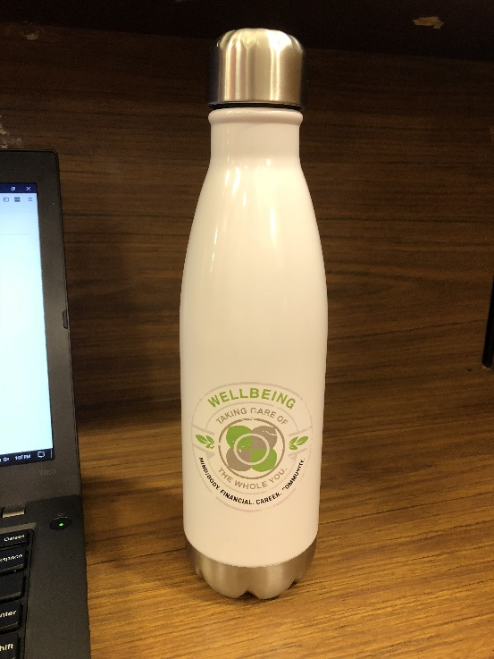

**Description:** Vacuum Insulated Water Bottle

**Good**

* Aesthetically pleasing design with soft, rounded shapes.
* Slim and compact.
* Keeps water very cold for many hours (have not tested with hot liquids).
* Fairly rigid… has survived a few minor drops/falls.
* The sealed cap lets absolutely no liquid out, even if it's only loosely screwed on.

**Bad**

* Exterior paint is very slippery when it gets wet.
* No hook or handle makes it awkward to carry around.
* Logo is beginning to wear away after only a month or two of use.
* Difficult to clean.
* Definitely requires two hands to remove the lid and get a sip of water.

**Improvements**

* Better quality exterior paint with more grip.
* A handle of some kind would be nice, but it might ruin the pleasing design.
* Make the bottom removeable and sealed just like the top, so that cleaning is easier.
* Find a way to keep the same seal quality but make it easy to open with one hand.

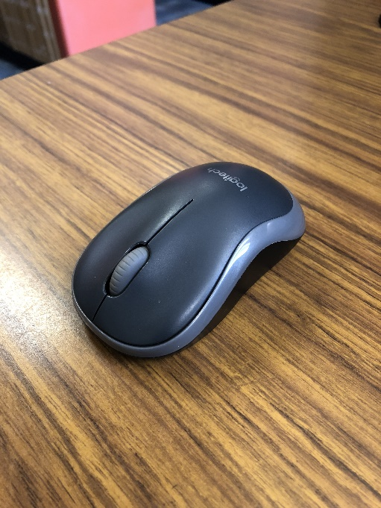

**Description:** Logitech wireless mouse

**Good**

* Compact/portable.
* Easy to turn on/off.
* Convenient storage compartment for USB receiver.
* Very long battery life.
* Aesthetically pleasing design with smooth curves and nice color scheme.
* Responsive.
* Able to change sensitivity in settings.
* Plug and play… easy setup.

**Bad**

* Not exactly ergonomic… it's a bit short and I find that I have to claw my hand slightly to use the buttons.
* Durability has not been an issue for me but I think if it were to take a heavy fall it would likely break.

**Improvements**

* Elongate it just slightly to improve ergonomics.
* Use stronger material.

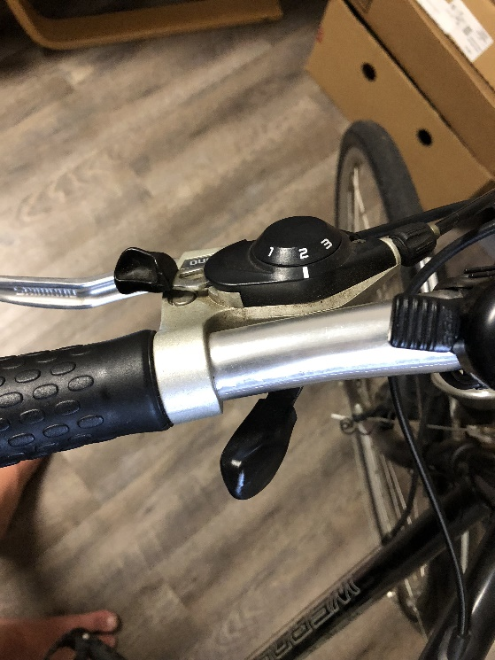

**Description:** Gear tier shifter on my 1989 bicycle.

**Good**

* Simple and intuitive.
* Lower button is placed exactly where your thumb naturally rests and upper button easily accessible with index finger.
* Buttons are easy to press and respond quickly.
* Gives a satisfying click as confirmation when it's been fully engaged.

**Bad**

* Nothing. (Highly subjective because I love this bike)

**Improvements**

* This bike almost 30 years old, so the only improvement I could suggest would be to install some more modern components. However, I've kept it in good shape and it still performs wonderfully.

Week 2

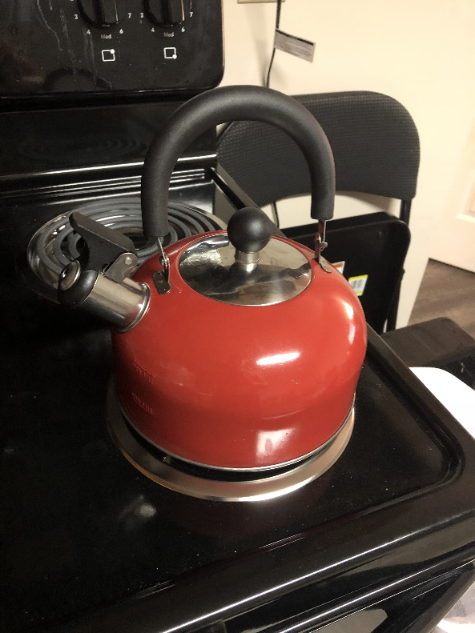

**Description:** Tea kettle.

**Good**

* Simple.
* Does not need instructions… it is clear how to use it.
* Sleek design.
* Works as intended.

**Bad**

* Very thin metal makes it feel cheap (which is was).
* Very loud when boiling water.
* Handle feels really cheap as well.

**Improvements**

* Use better quality materials.

Backspace 
up 
Shift 

**Description**: Unicomp Keyboard.

**Good**

* Old-school design.
* Nice contrasting colors.
* Very sturdy build.
* Number pad.
* Satisfying clicking sound when keys are pressed

**Bad**

* Large, not very portable.
* Heavy.
* Loud clicking of keys is satisfying for me but annoying for others… I only use this keyboard when I'm alone.

**Improvements**

* Reduce weight without sacrificing build quality.

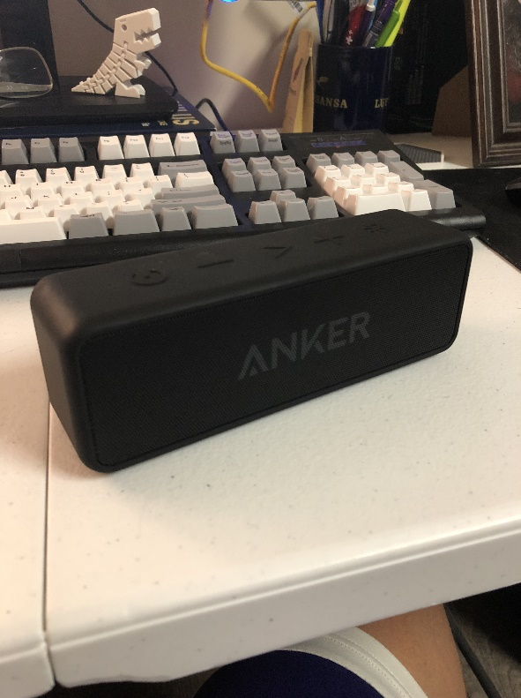

**Description**: Anker bluetooth speaker.

**Good**

* Sleek, minimal design.
* Highly portable, fits easily in one hand.
* Great sound for its size.
* Intuitive, simple control buttons on top.
* Water resistant.
* Great battery life.

**Bad**

* Bluetooth pairing issues sometimes.

**Improvements**

* None.

Week 3

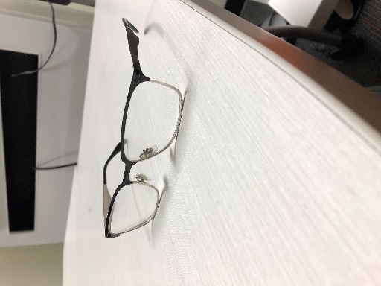

**Description**: Ray Ban eyeglasses.

**Good**

* Stylish.
* Flexible yet sturdy.
* Rounded edges give them a sleek look while also maintaining a slightly square shape.

**Bad**

* Nose pads can be slippery and slide down.

**Improvements**

* Put some kind of textured material on the nose pads to keep them in place.

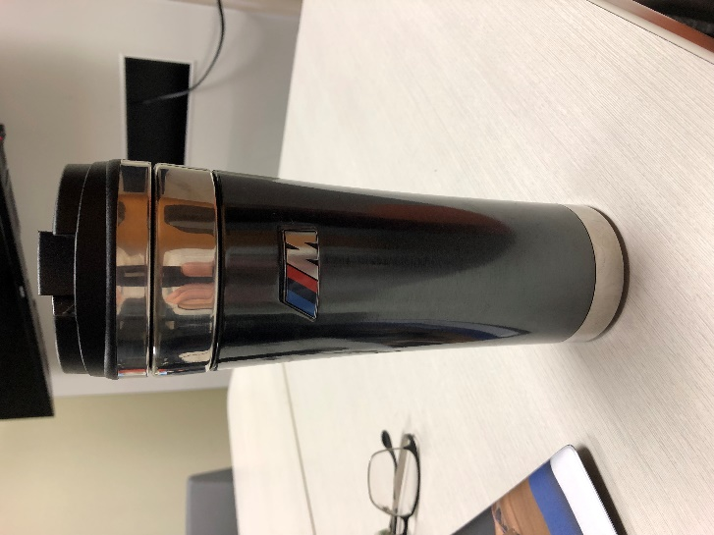

**Description**: Thermos.

**Good**

* Slim/compact.
* Slick design, visually appealing.
* Lid seals tightly and does not leak.
* Bottom is grippy so it doesn’t slide around.

**Bad**

* So slim that it is very difficult to clean the inside.

**Improvements**

* Make it just slightly wider so cleaning is easier but it is still compact.

Week 4

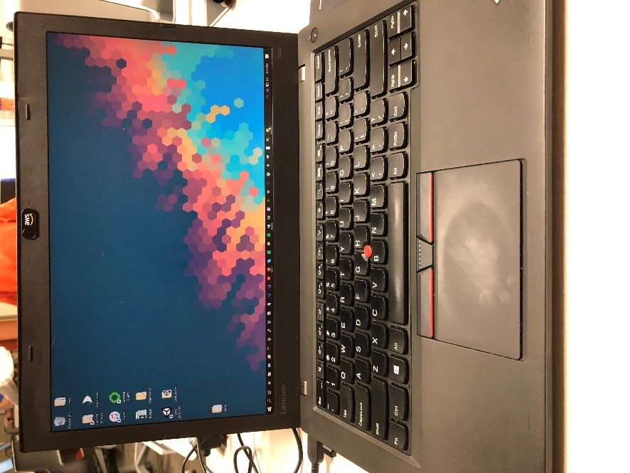

**Description**: Lenovo ThinkPad.

**Good**

* Rugged/durable construction.
* Keyboard feels great to type on.
* 2 batteries so one can be changed and therefore longer lifespan.
* Reliable.
* Good performance.

**Bad**

* Not very pretty.
* Trackpad is cumbersome.
* Display is not very crisp.

**Improvements**

* Work on aesthetics.
* Make trackpad more responsive.

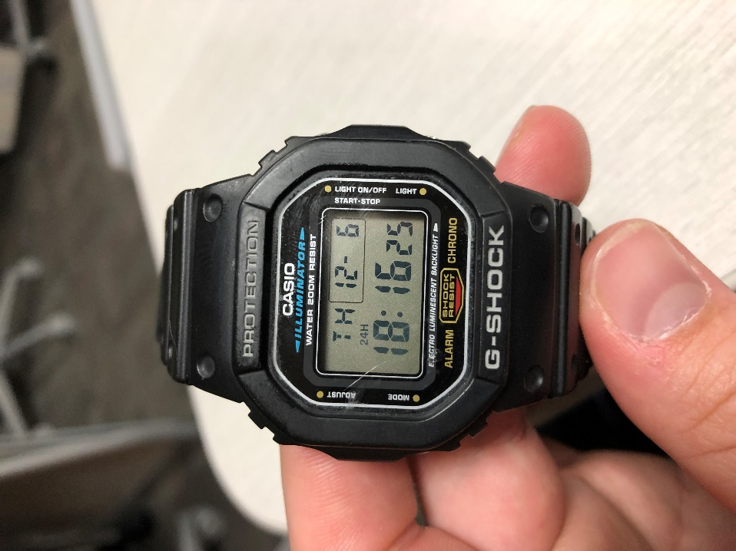

**Description**: Casio G-shock wristwatch.

**Good**

* Rugged/durable design.
* Waterproof.
* Display is easily readable.
* Lots of different configuration settings.
* Comfortable to wear all day.

**Bad**

* Difficult to know how to perform certain actions with only 4 buttons (have to consult the user manual for many functions).

**Improvements**

* None.