Eric Paulz

ECE 4930-004

**HW1**

1. Derive a reliability function R(t) for each system.
   1. System A
 $$R_{parallel}\left(t\right)=1-\prod_{i=1}^{n}{\left(1-R_{i}\left(t\right)\right)}$$

 $$R_{A}\left(t\right)=1-[(1-R_{series}\left(t\right))(1-R_{series}\left(t\right))]$$

 $$R_{A}\left(t\right)=1-{[(1-(R}_{cpu}\left(t\right)*R_{mem}(t)))(1-(R_{cpu}\left(t\right)*R_{mem}(t)))]$$

$$R_{A}\left(t\right)=1-{{[1-(R}_{cpu}\left(t\right)*R_{mem}(t))]}^{2}$$

$$R_{A}\left(t\right)=1-{[1-\left(e^{-λ_{cpu}t}*e^{-λ_{mem}t}\right)]}^{2}$$

$$R_{A}\left(t\right)=1-{[1-\left(e^{-(λ_{cpu}t+λ_{mem}t)}\right)]}^{2}$$

2. System B
$$R_{series}\left(t\right)=\prod_{i=1}^{n}{R_{i}(t)}$$

$$R_{B}\left(t\right)=(R_{parallel}\left(t\right)){(R}_{parallel}(t))$$

$$R_{B}\left(t\right)=\left[1-(1-R_{cpu}(t))(1-R_{cpu}(t))\right]\left[1-(1-R_{mem}\left(t\right))(1-R_{mem}\left(t\right))\right]$$

$$R_{B}\left(t\right)=\left[1-(1-e^{-λ_{cpu}t})(1-e^{-λ_{cpu}t})\right]\left[1-(1-e^{-λ_{mem}t})(1-e^{-λ_{mem}t})\right]$$

$$R_{B}\left(t\right)=\left[1-{(1-e^{-λ_{cpu}t})}^{2}\right]\left[1-{(1-e^{-λ_{mem}t})}^{2}\right]$$

2. Determine which system is more reliable. (MTBFcpu = 9hrs, MTBFmem = 6 hrs)

*plot 1-(1-(e^(-((1/9)t+(1/6)t))))^2, (1-((1-e^(-((1/9)t)))^2))*(1-((1-e^(-((1/6)t)))^2)), t=0 to 25*

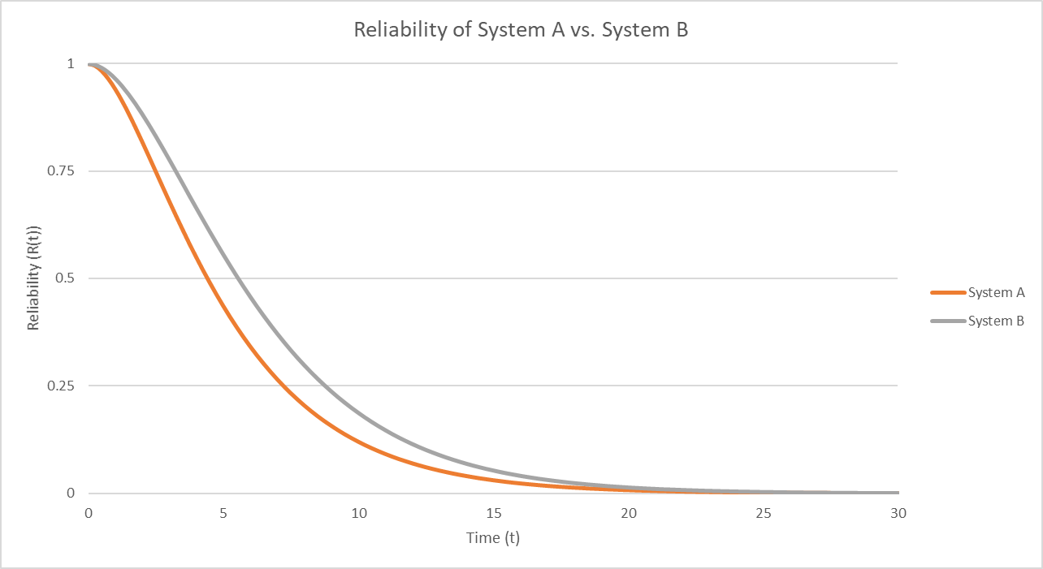

**Figure 1: Plot of reliability functions from System A and System B; λcpu = , λmem =**

After replacing λcpu with $\frac{1}{9}$ and λmem with $\frac{1}{6}$ in the appropriate places, the plot of the two reliability equations is shown in Figure 1. We can see that the reliability of System B decreases slightly slower than that of System A. Therefore, we can say that System B is the more reliable of the two based on the given MTBF values.

1. What would the MTBF of a memory module need to be to change your decision (if at all)? Explain.

To determine what MTBF for memory modules may make System A more reliable, first I tried doubling the original. Plugging in $\frac{1}{12}$ for λmem gives the following result:

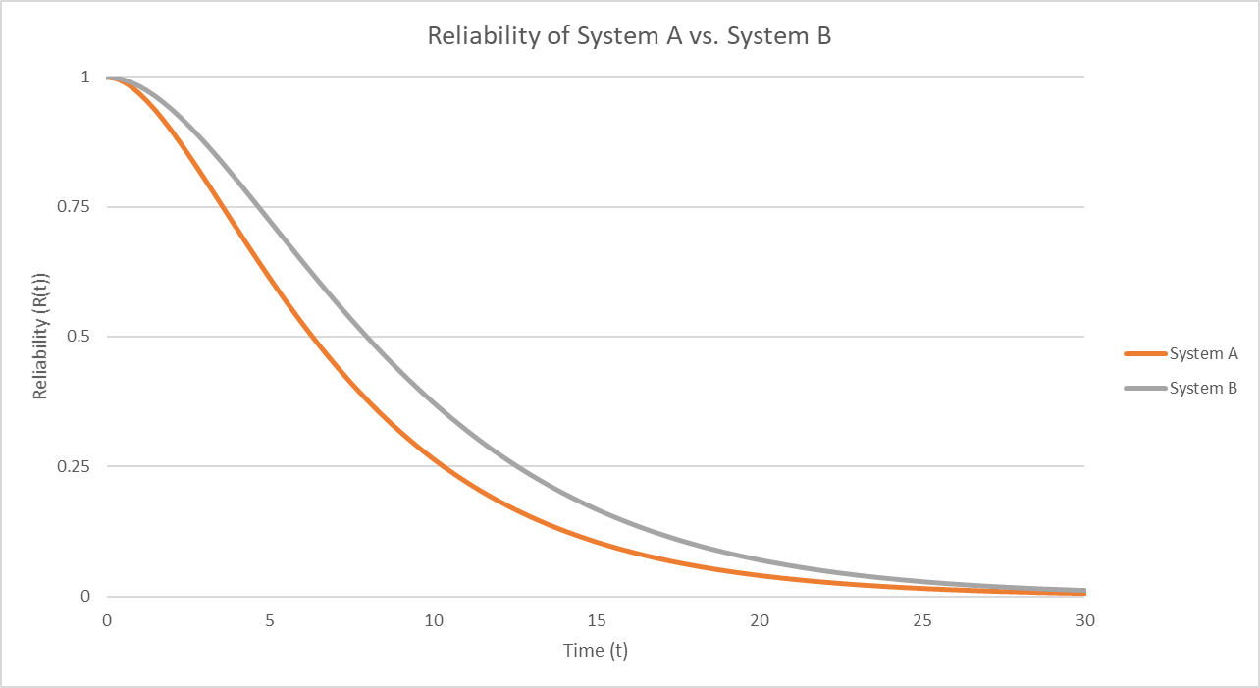

**Figure 2: Plot of reliability functions from System A and System B; λcpu = , λmem =**

Since System B is even more reliable than System A in this case, I tried reducing the MTBF for memory modules to 1, plugging in 1 for λmem, which gives us the following:

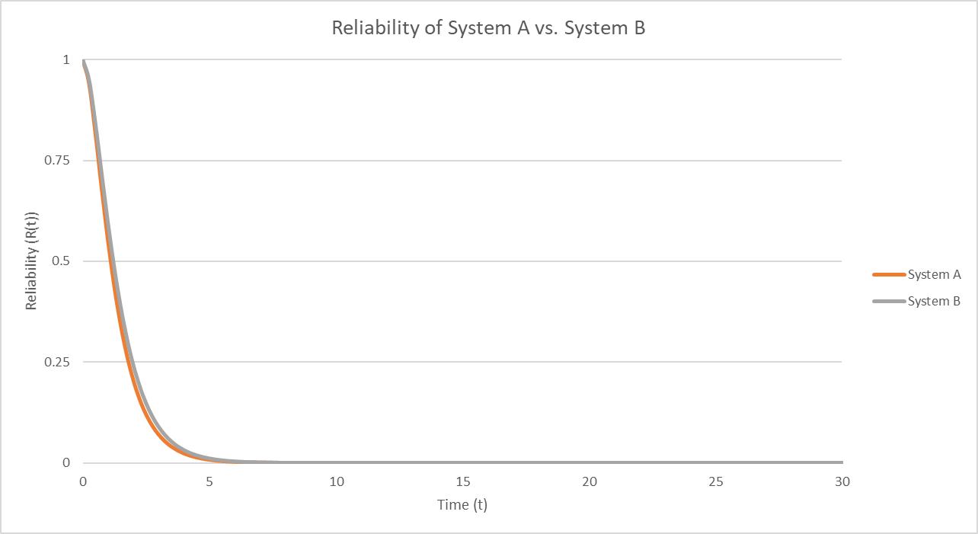

**Figure 3: Plot of reliability functions from System A and System B; λcpu = , λmem = 1**

After testing these two extreme alternatives, I still conclude that System B will be more reliable than System A regardless of the MTBF for memory modules.