*Training Management System*

*User Manual*

*Important Note:*

*Please do the following settings in case of Internet Explorer.*

*Go to Settings -> Compatibility View Settings*

*Uncheck Display Intranet sites in Compatibility View*

*Uncheck Use Microsoft compatibility lists*

*Close and Refresh Page*

***Purpose of the document:***

*Intention of this document is to guide the user to effectively use the application. The logical arrangement of the information and screen prints shall enable the user to understand the sequence and navigation of the system.*

1. *Connecting to the application :*

*You must connect to the application using the following address:*

*http://ctsc00849530701:9000/Training*

1. *Authentication :*

*User can login as Admin, Trainer or Trainee. Refer screen print below for the Training Management System.*

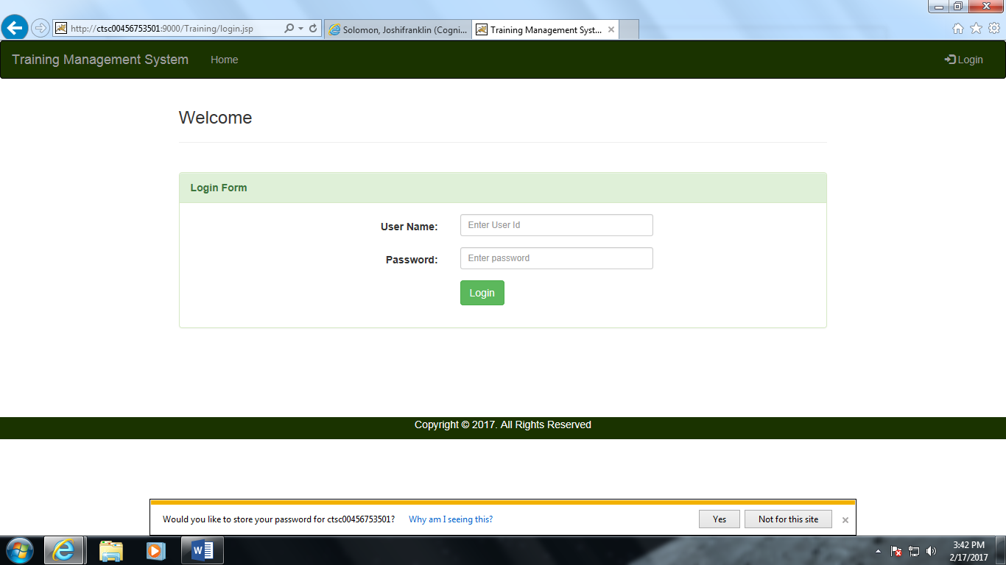

*fig 1*

1. *Dashboard Page:*

*Administrator will be able view all the trainees details and training phases completed by each trainee with the feedback provided by the trainer.*

* *Phase ID*
* *Courses Name*
* *Ratings*
* *Evaluation comments*

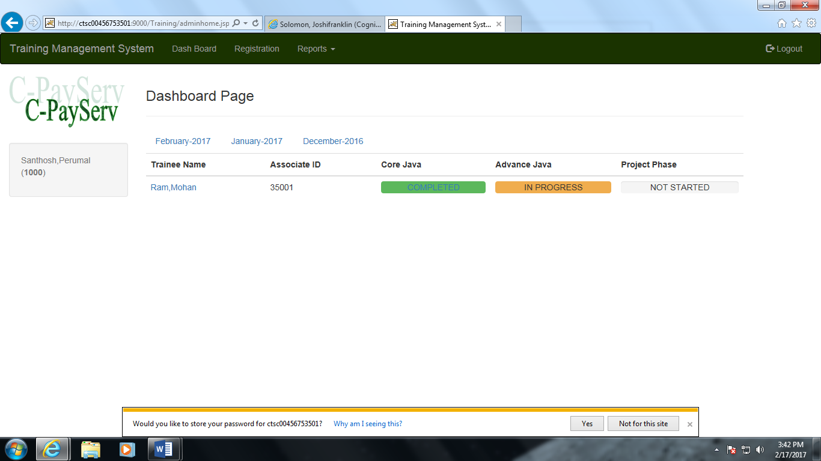

*Fig 2*

*4. Registration Details*

*Administrator will able to add trainer information. The Trainer Details Page will have following fields to capture trainer information.*

* *Trainer ID or Associate ID*
* *Password*
* *First name*
* *Last name*
* *Hire date*
* *Designation*
* *Technology Competency or vertical*
* *Location*
* *Phone*
* *Role (As Trainer)*

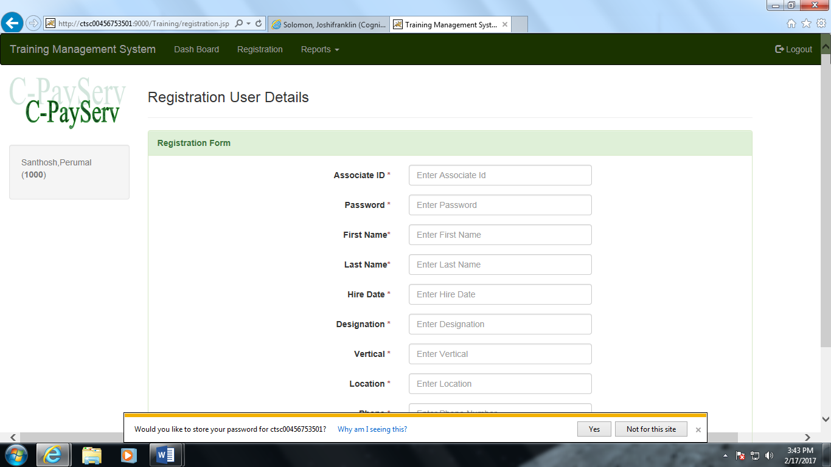

*Fig 3*

*5.Search Details by trainee*

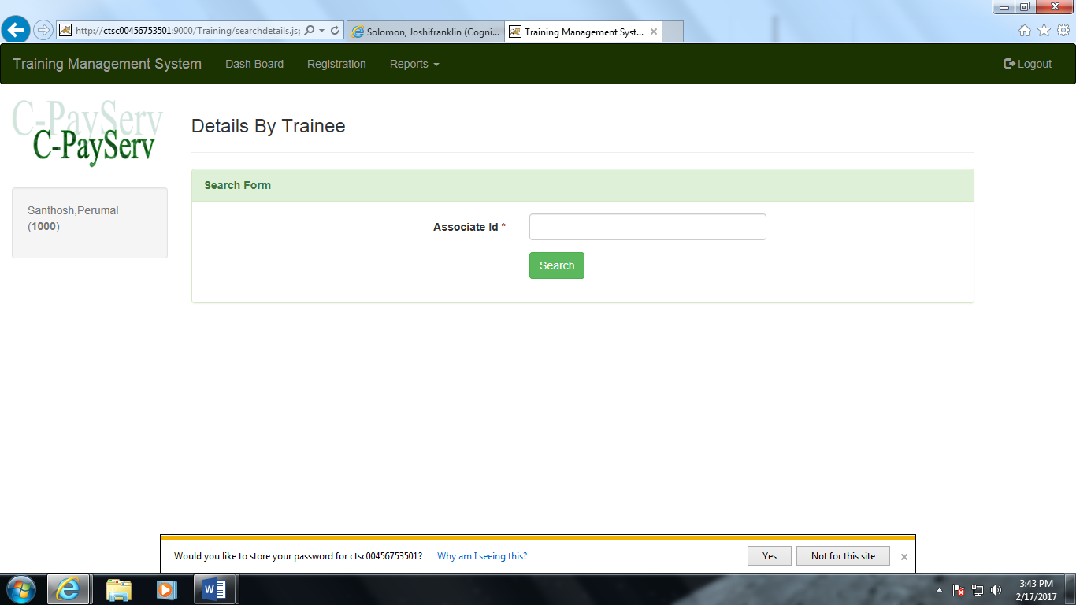

***Fig 4***

*6.Trainee details*

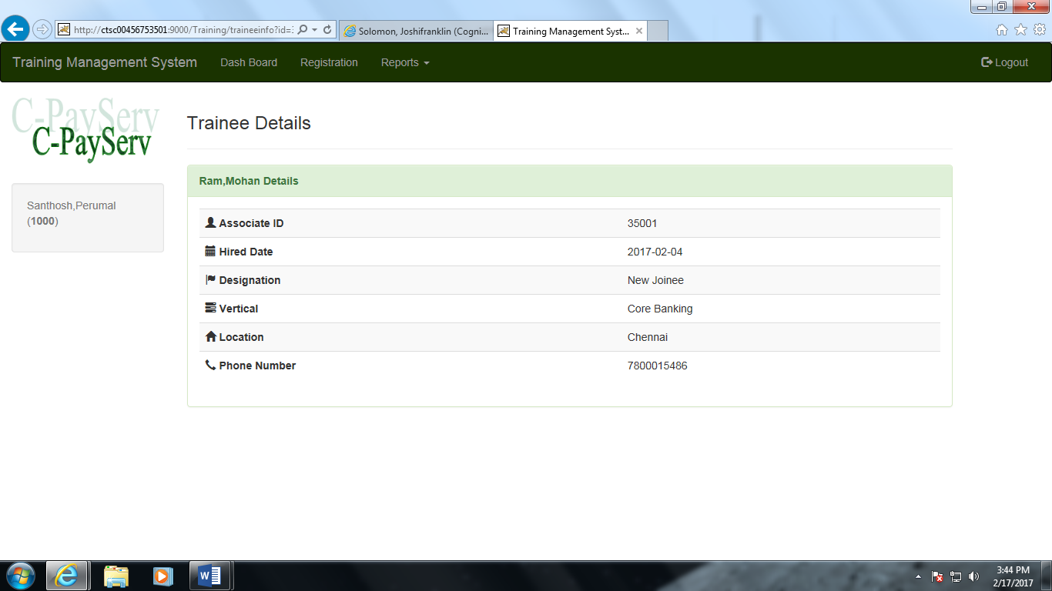

*Fig 5*

*7. Search Training phase completed Report*

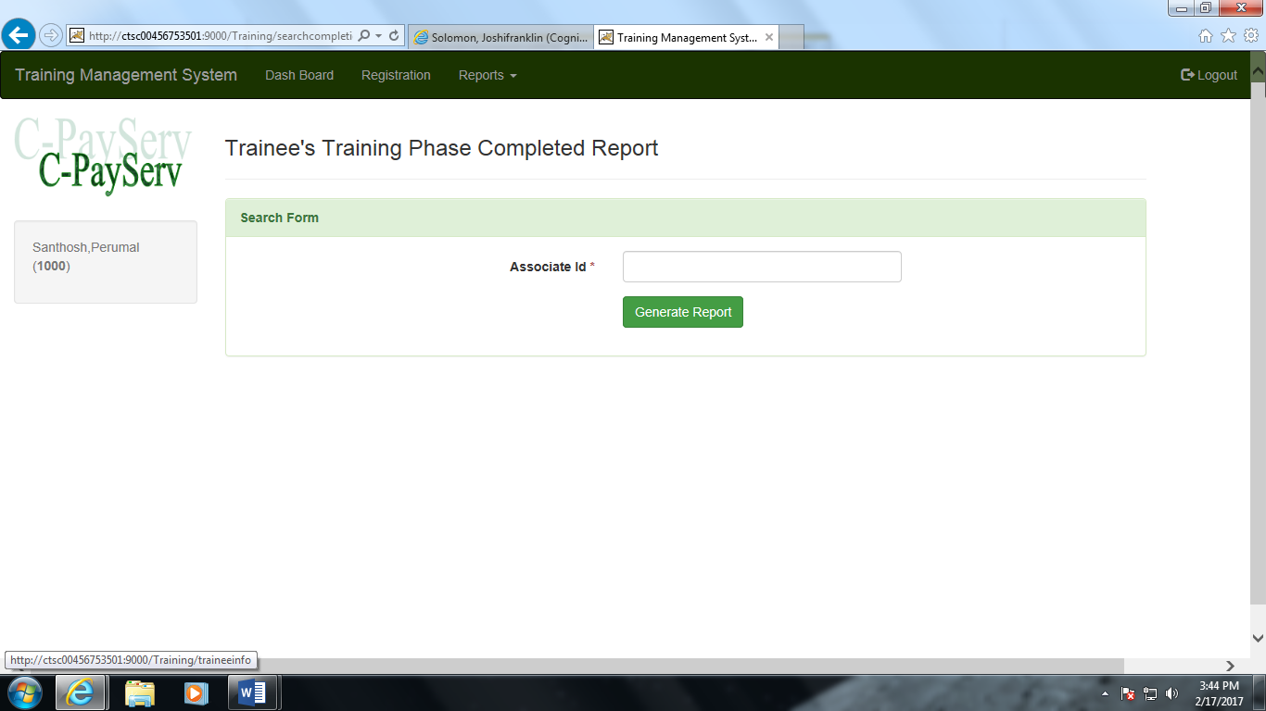

*Fig 6*

*8.Training Phase Completion Report*

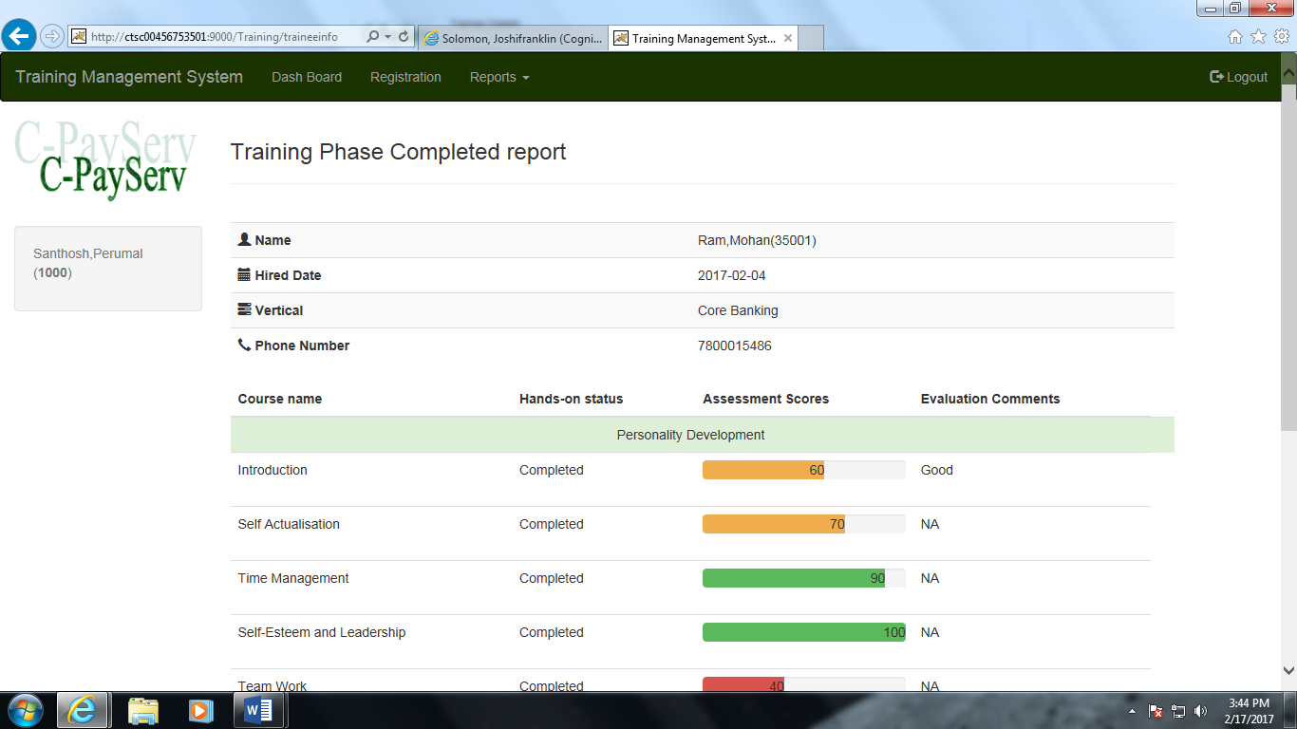

*Fig 7*

*9.Search Evaluation details*

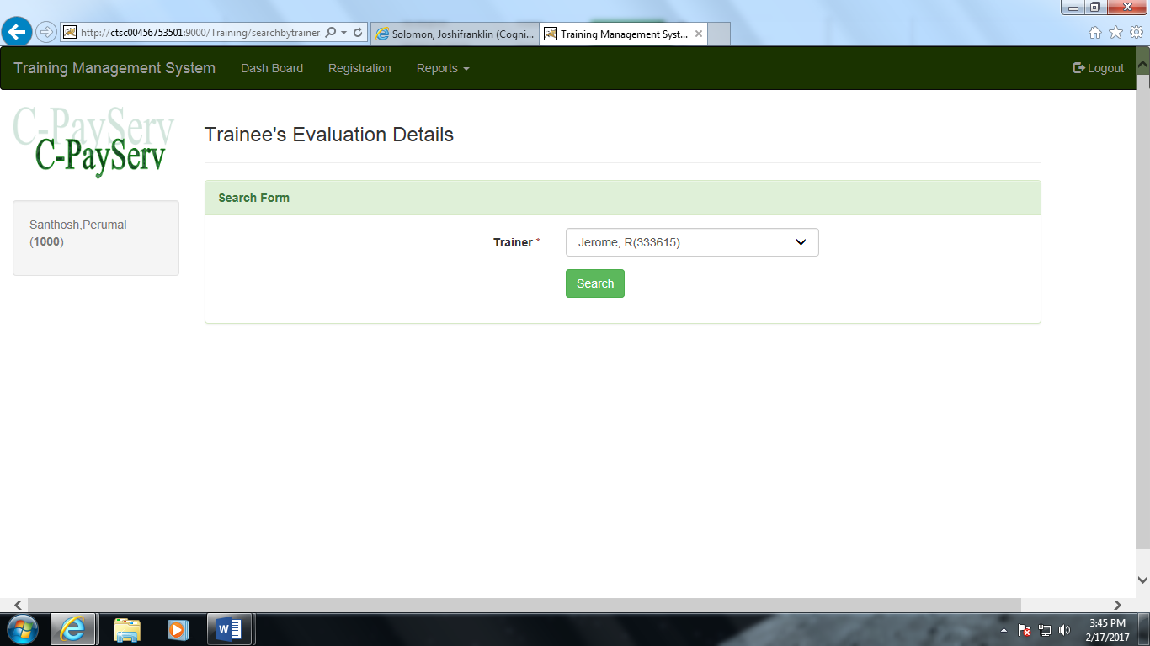

***Fig 8***

*10.Trainee’s Evaluation details report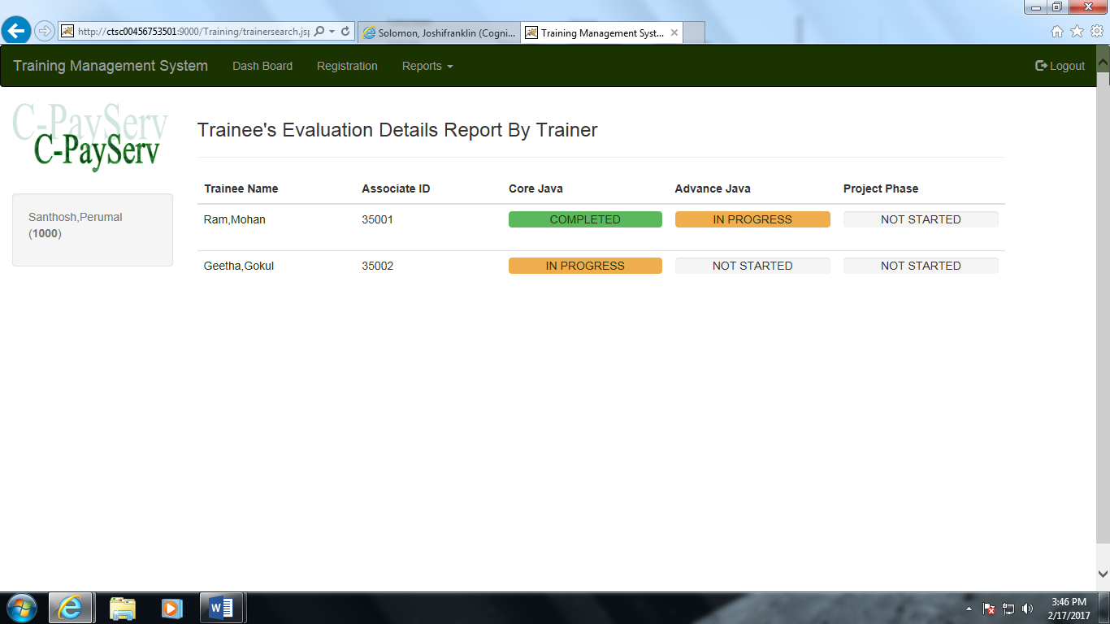*

*Fig 9*

*11.Login:*

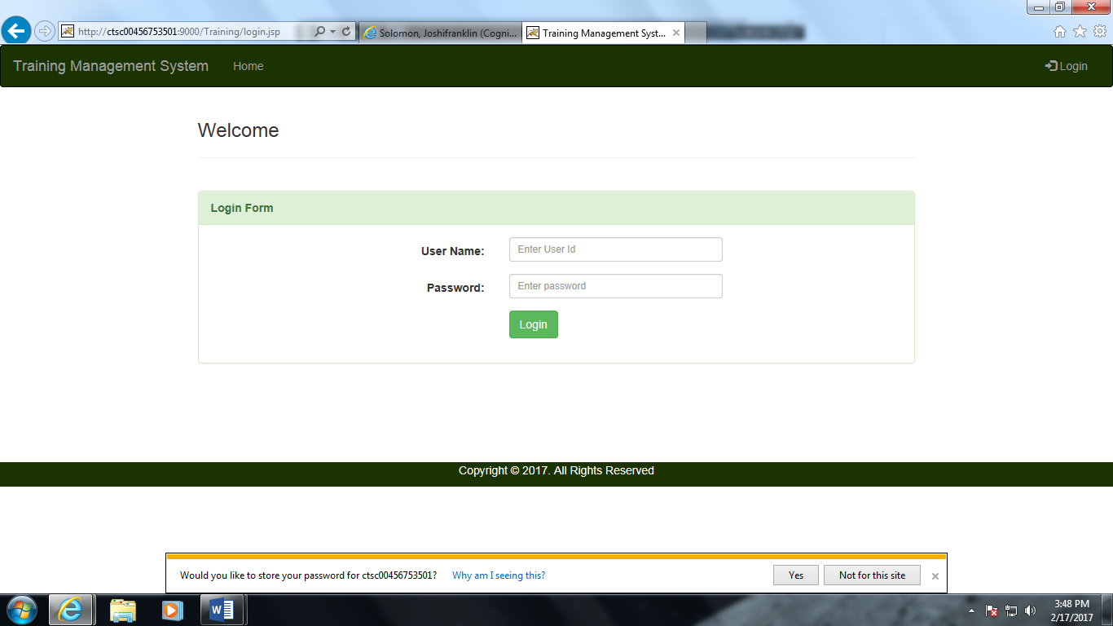

***Fig 10***

*12.Dashboard page-Trainer*

*Trainer will be able to provide evaluation rating for each courses completed by the trainee like hands-on, assessment along with evaluation comments by click on particular training phase.*

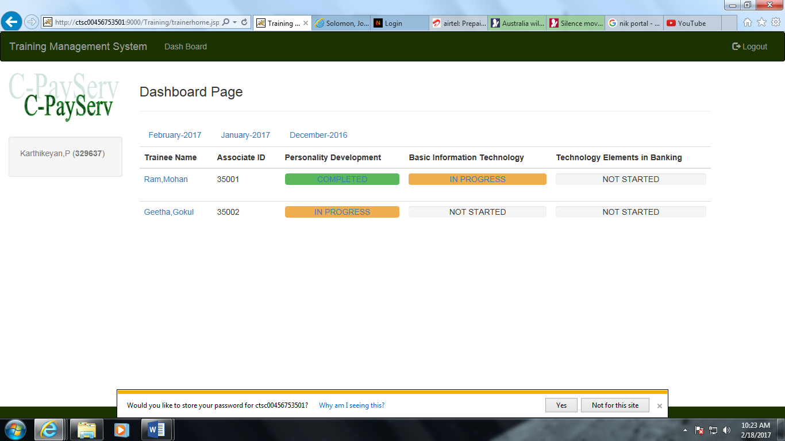

***Fig 11***

*13.Login – Trainee*

*Trainee will be able to view his/her evaluation comments provide by the trainer for each courses completed in training phase & also trainee can check the status whether he/she is promoted to next phase of the training by the trainer.*

**

*Fig 12*

*14.Dashboard page*

*Trainer will be able to provide evaluation rating for each courses completed by the trainee like hands-on, assessment along with evaluation comments by click on particular training phase.*

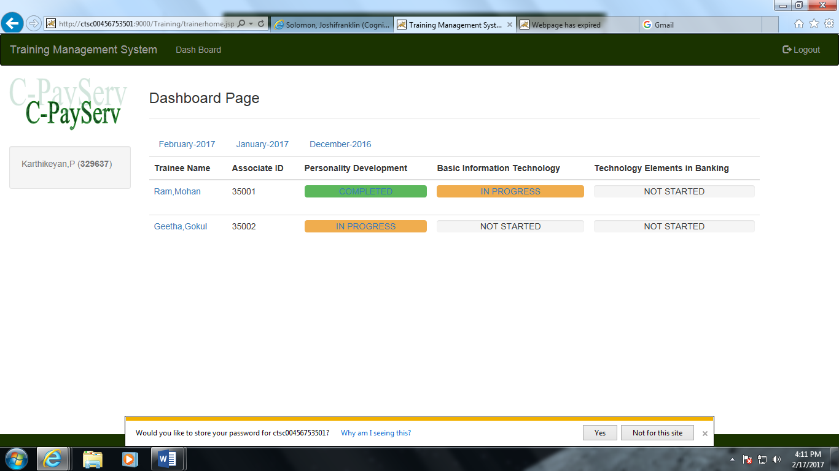

*Fig 13*

*15.Trainee’s dashboard page – Personality development*

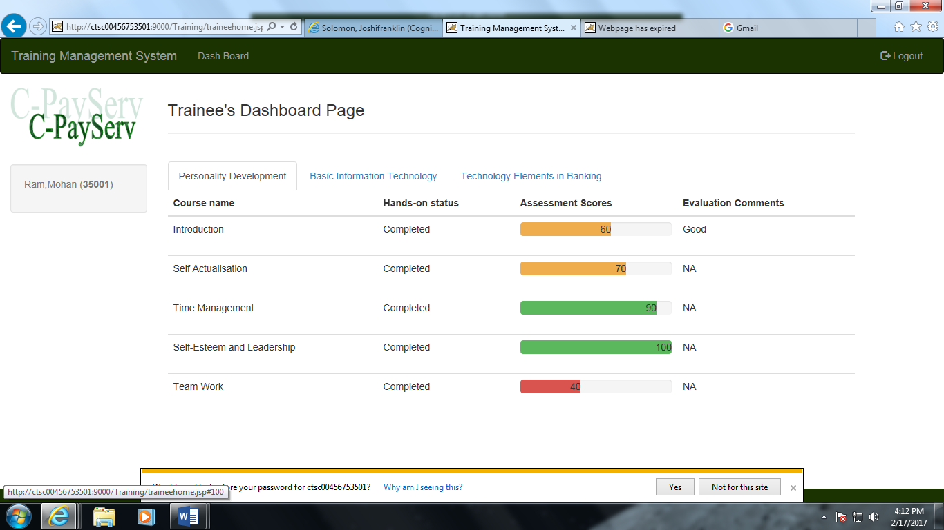

*Fig 14*

*16.Trainee’s dashboard page- Basic information technology*

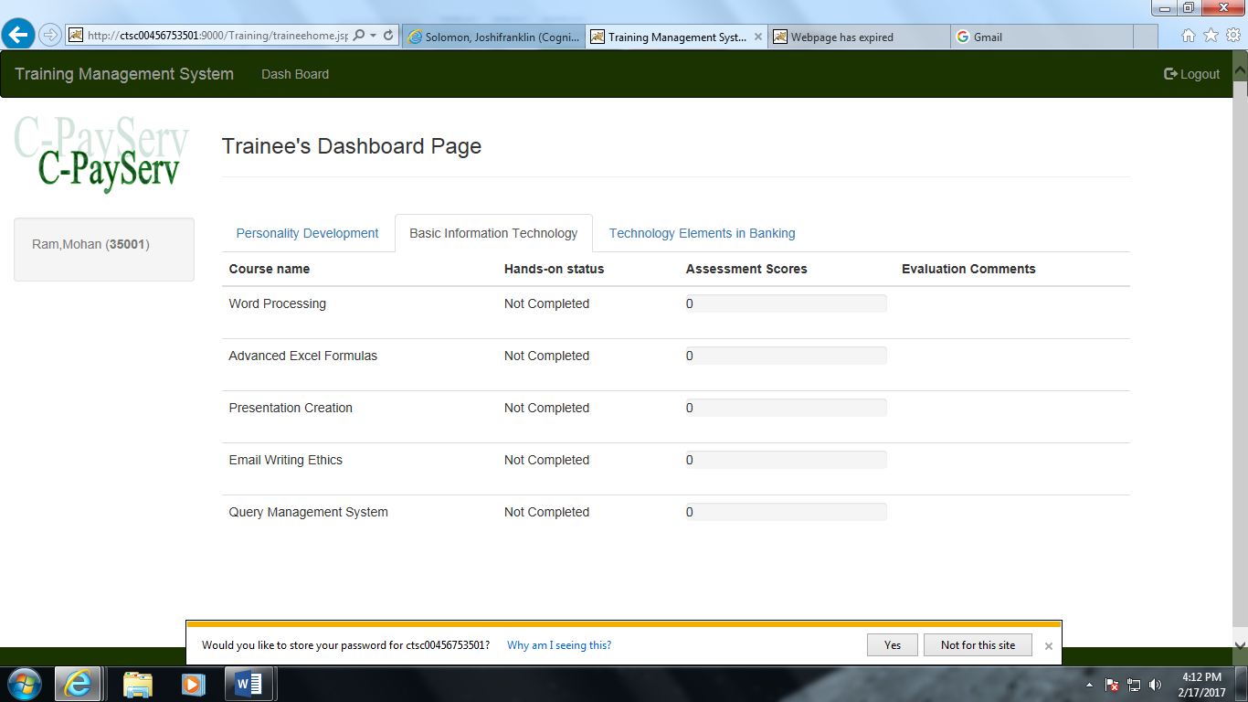

*Fig 15*

*17.Trainees dashboard page- Technology elements in banking*

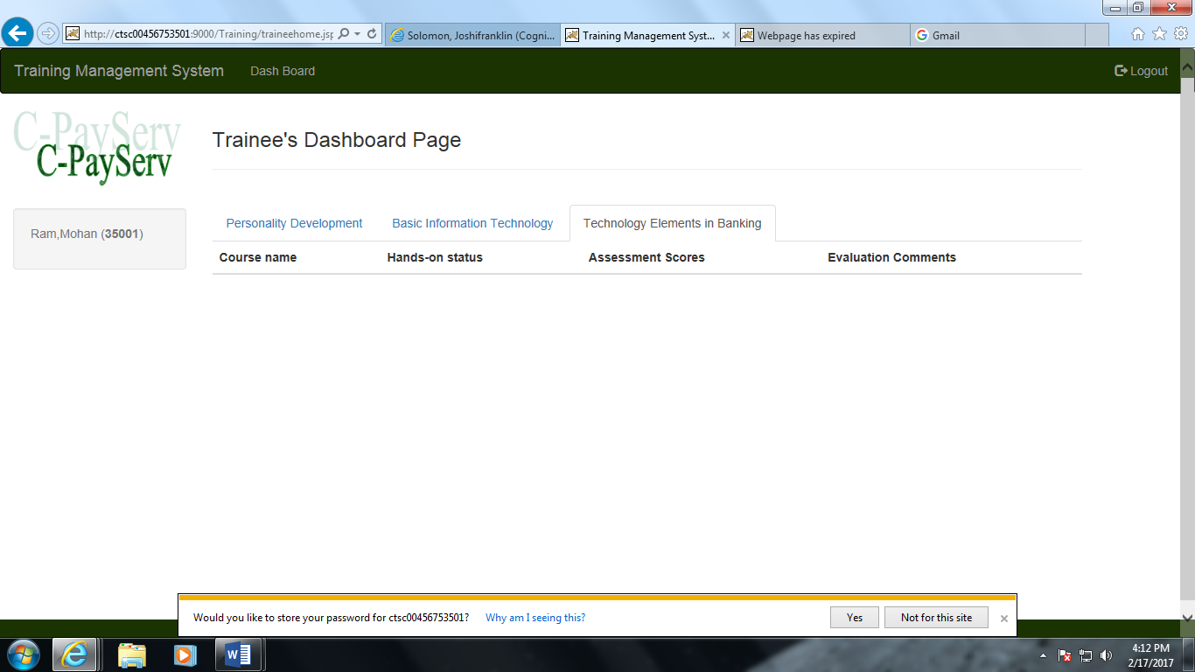

*Fig 16*