**VOR regressions**

*CPER*

* 58 site-years (n)
  + 679 quadrats
* 8 years
* R2-adj = 0.83
* RMSE = 834.12 kg ha­­-1

*Thunder Basin*

* 256 site-years (n)
* 5 years* (only 2 sites in 2015)
* R2-adj = 0.63
* RMSE = 710.99 kg ha­­-1

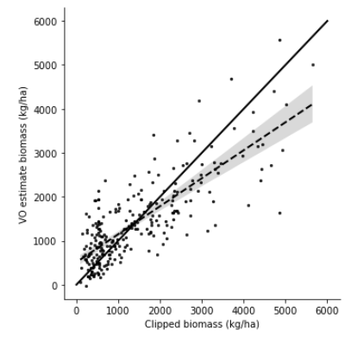

**Satellite models**

*CPER*

*Thunder Basin*

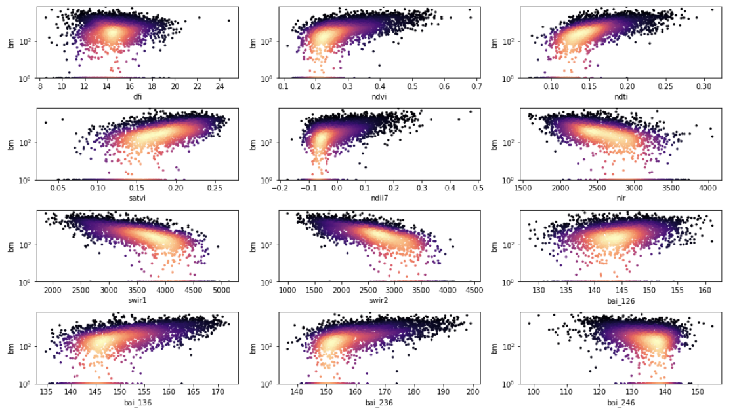

**Existing model**

*CPER*

* MAE: 182-199 kg/ha
* Relative MAE: 21-23 %

*Thunder Basin*

*Using the CPER model*

* MAE: 424.76 kg/ha
* Relative MAE: 56.74 %
* Correlation: 0.61

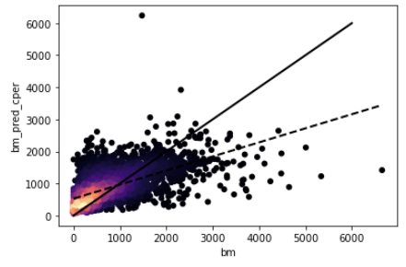

*Using same variables as CPER, model fit to entire TB dataset*

* MAE: 430.17 kg/ha
* Relative MAE: 57.46 %
* Correlation: 0.52

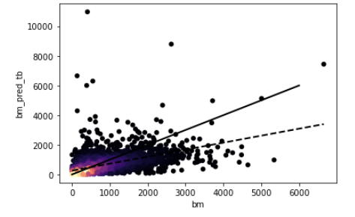

**Model selection**

*CPER*

* Max variables = 3
* Top model: NDII7 + NIR + BAI_236
* Most important variables: SWIR2, NIR, NDII7
* Relative MAE: ~21%
* R2: 0.75

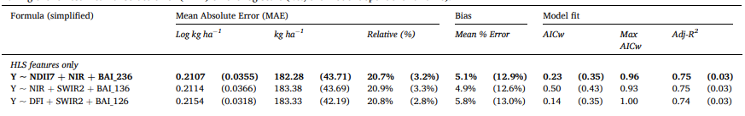

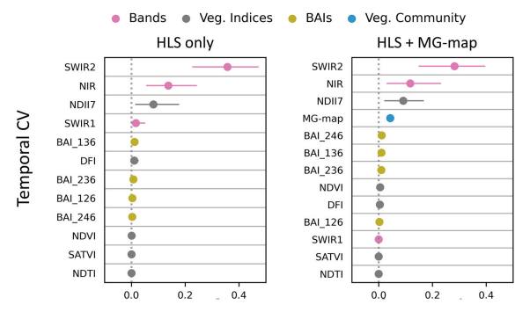

*Developing a TB-specific model from model selection*

* Max variables = 3?
* Top model: SATVI + SWIR1 + BAI_126
* Most important variables: SWIR1, SATVI, BAI_126
* MAE: 410.87 kg/ha
* Relative MAE: ~55%
* R2: 0.53
* NOTES:
  + Not selected with temporal cross-validation. Instead used k-fold stratified by project and year (so each fold has 1/5 of the data from each project/year combination)

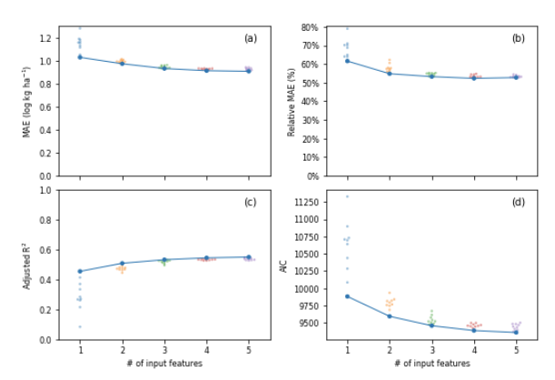



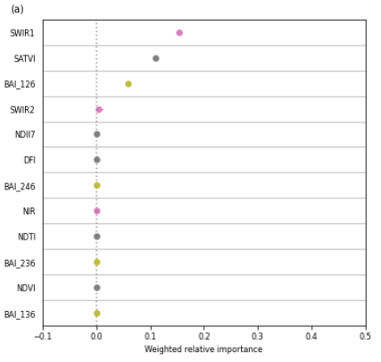

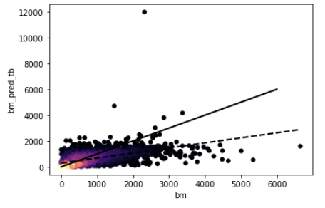

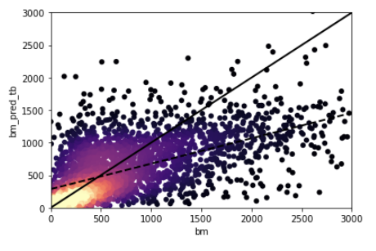

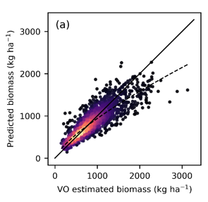

***Thunder Basin – by project***

*NEX*

* Years = 7
* No models with AICw > 0.50 (used 0.30 cutoff)
* R2: 0.60
* MAE: 423 - 432 kg/ha (29 - 30 %)
* Most important variables: SWIR2, SWIR1, BAI_246, NIR

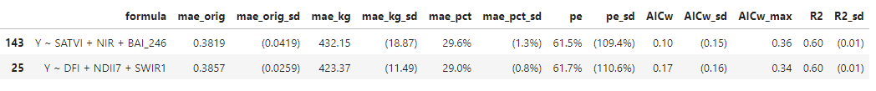

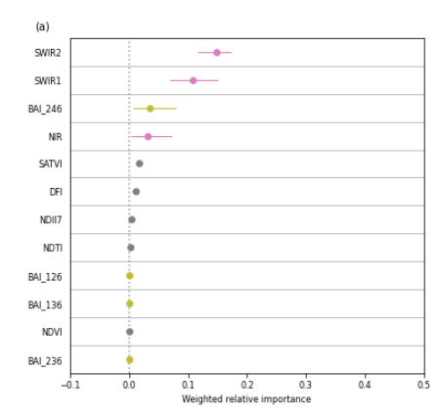

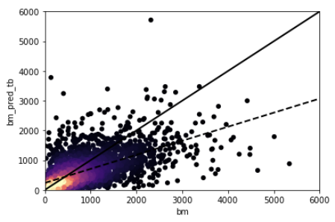

*PDOG*

* Years = 4
* R2: 0.56
* MAE: 88 kg/ha (37 %)
* Most important variables: BAI_246, SWIR1, NIR, NDVI



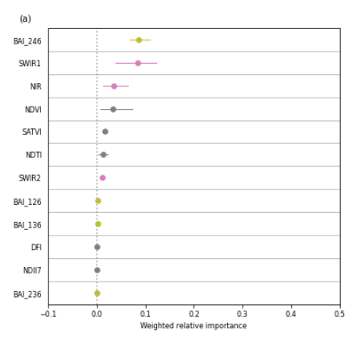

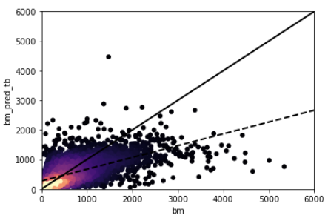

*BIRD*

* Years = 5
* R2: 0.57
* MAE: 348 kg/ha (52 %)
* Most important variables: SWIR2, NDII7, DFI



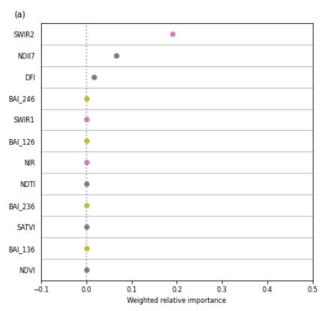

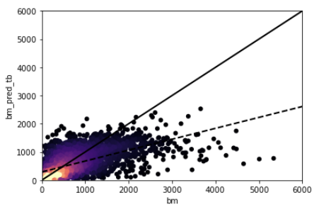

*WTGN*

* Years = 3
* No models with AICw > 0.50 (used 0.30 cutoff)
* R2: 0.22 - 0.23
* MAE: 418 - 423 kg/ha (46 - 47 %)
* Most important variables: SATVI, NDTI, NDVI, NDII7



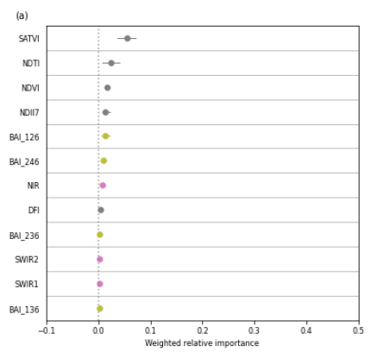

*FIRE*

* Years = 1
* R2: 0.29 – 0.37
* MAE: 79 - 105 kg/ha (26 - 34 %)
* Most important variables: NDII7, SATVI, BAI_236, NDVI



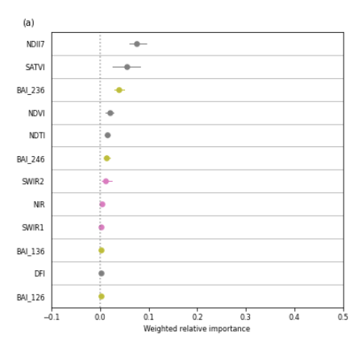

**Next steps and things to try:**

* Just use NEX and BIRD?
* WTGN
  + Clipping should be good, VO is less certain
* Try a model with only clipping data