**VOR regressions**

*CPER*

* 58 site-years (n)
  + 679 quadrats
* 8 years
* R2-adj = 0.83
* RMSE = 834.12 kg ha­­-1

*Thunder Basin*

* 256 site-years (n)
* 5 years* (only 2 sites in 2015)
* R2-adj = 0.63
* RMSE = 710.99 kg ha­­-1

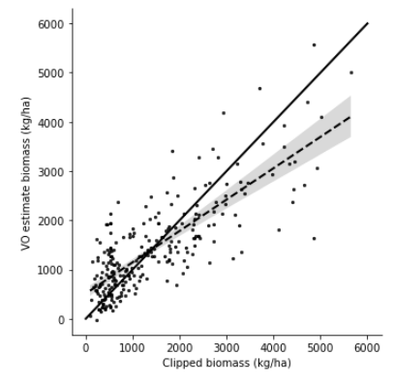

**Satellite models**

*CPER*

*Thunder Basin*

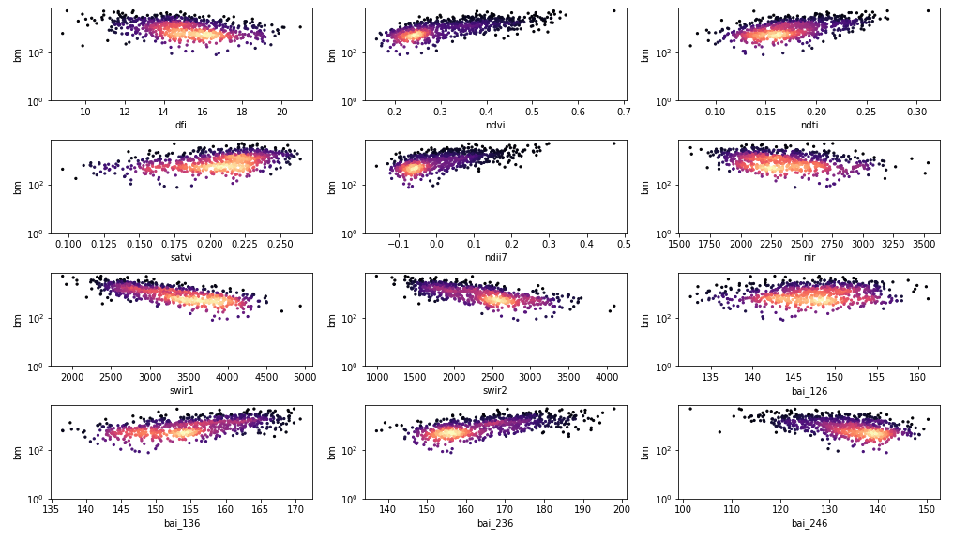

**Existing model**

*CPER*

* Info
  + 1,764 plots
  + 8 years
  + Consistent repeat sampling: June/Oct
  + ~6,000 ha site
  + 300 ~ 3000 kg/ha
* Results:
  + MAE: 182-199 kg/ha
  + Relative MAE: 21-23 %

*Thunder Basin*

* Info
  + 2,806 plots
  + 7 years
  + Inconsistent sampling over space and time
  + ~50X larger site!
  + 0 ~ 6000 kg/ha

*Using the CPER model*

* Results
  + MAE: 500.39 kg/ha
  + Relative MAE: 70.72 %
  + Correlation: 0.60

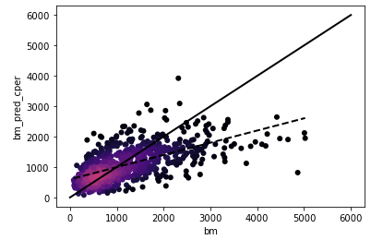

*Using same variables as CPER, model fit to entire TB dataset*

* MAE: 454.89 kg/ha
* Relative MAE: 37.02 %
* Correlation: 0.67

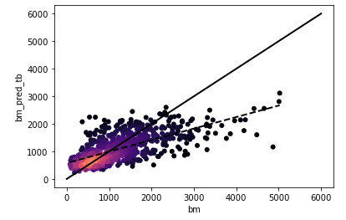

**Model selection**

*CPER*

* Max variables = 3
* Top model: NDII7 + NIR + BAI_236
* Most important variables: SWIR2, NIR, NDII7
* Relative MAE: ~21%
* R2: 0.75

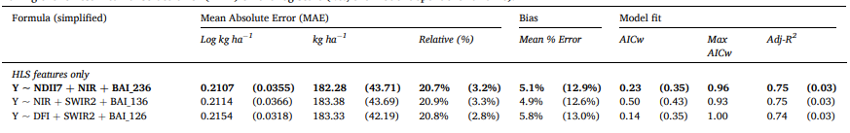

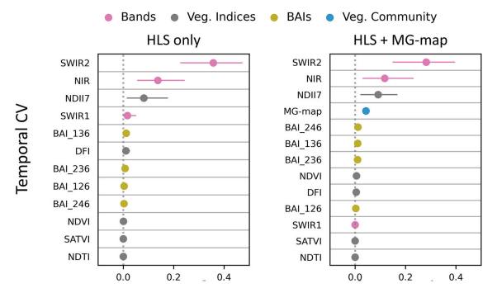

*Developing a TB-specific model from model selection*

* Max variables = 3?
* Top model: SATVI + SWIR1 + BAI_246
* Most important variables: SWIR1, BAI_246, NIR, NDTI
* MAE: 445 kg/ha
* Relative MAE: ~36.2%
* R2: 0.51
* NOTES:
  + Not selected with temporal cross-validation. Instead used k-fold stratified by project and year (so each fold has 1/5 of the data from each project/year combination)

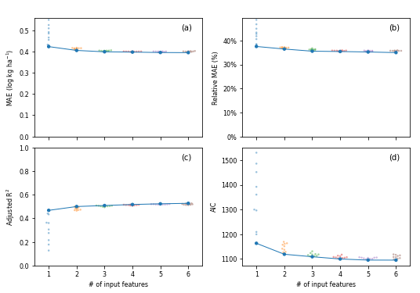

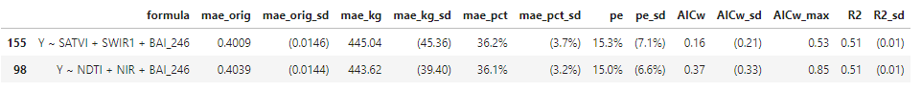

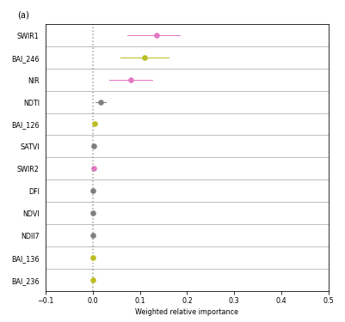

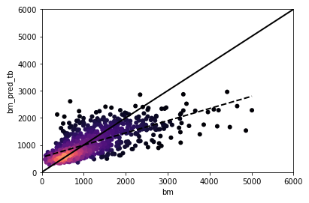

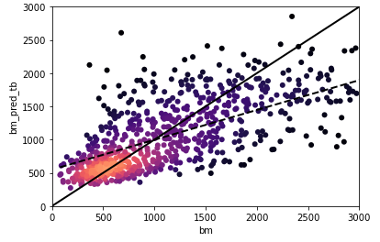

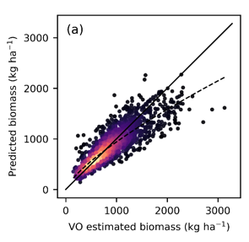

***Thunder Basin – by project***

*NEX*

* Years = 7
* No models with AICw > 0.50 (used 0.30 cutoff)
* R2: 0.60
* MAE: 423 - 432 kg/ha (29 - 30 %)
* Most important variables: SWIR2, SWIR1, BAI_246, NIR

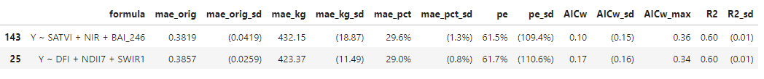

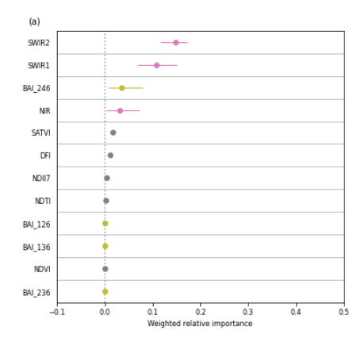

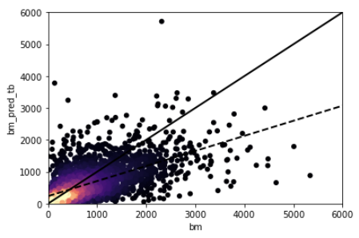

*PDOG*

* Years = 4
* R2: 0.56
* MAE: 88 kg/ha (37 %)
* Most important variables: BAI_246, SWIR1, NIR, NDVI



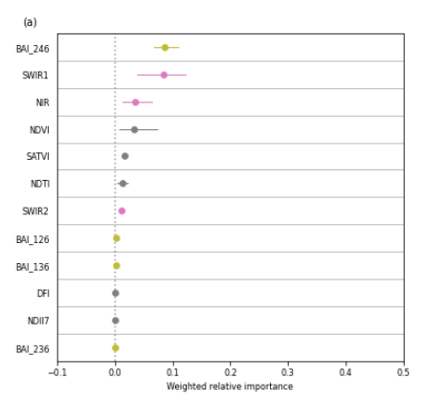

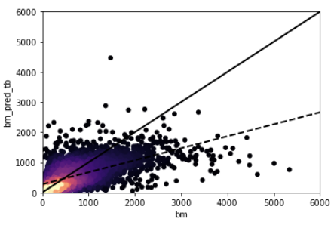

*BIRD*

* Years = 5
* R2: 0.57
* MAE: 348 kg/ha (52 %)
* Most important variables: SWIR2, NDII7, DFI



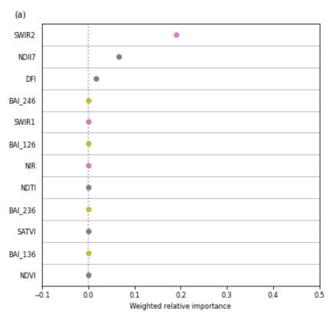

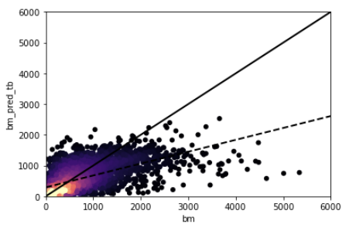

*WTGN*

* Years = 3
* No models with AICw > 0.50 (used 0.30 cutoff)
* R2: 0.22 - 0.23
* MAE: 418 - 423 kg/ha (46 - 47 %)
* Most important variables: SATVI, NDTI, NDVI, NDII7



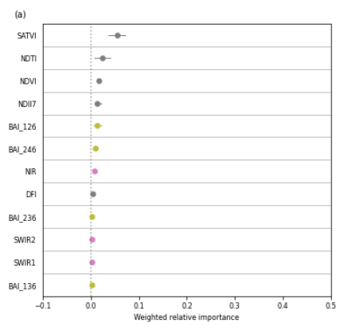

*FIRE*

* Years = 1
* R2: 0.29 – 0.37
* MAE: 79 - 105 kg/ha (26 - 34 %)
* Most important variables: NDII7, SATVI, BAI_236, NDVI



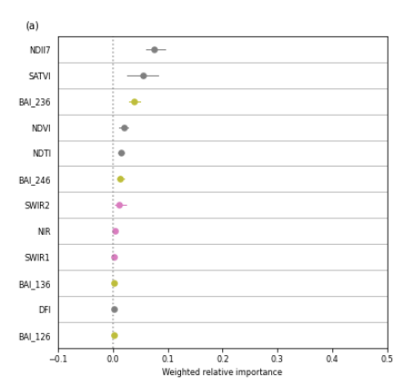

**Next steps and things to try:**

* Just use NEX and BIRD?
* WTGN
  + Clipping should be good, VO is less certain
* Try a model with only clipping data

Next-next steps:

* Try lower cutoff (1500 kg)
  + *This didn’t really help. Use whole dataset going forward and try other changes.*
* Trying a non-linear model
  + Trying a non-gaussian approach (poisson? NGB?)
* Spatial vs. Temporal model fit
  + Investigate whether issue is variability in temporal conditions or spatial conditions
* Try MSAVI/MSATVI as additional index?
  + Adjusts MSATVI for soil color based on avail. data
* Investigate soil type (ecosite)
  + As co-variate
  + Stratify (or make separate models)
  + 7 common soil types (could reduce to 5 as follows):
    - Lump shallows together
    - Saline upland
    - Loamy, Sandy, Clayey
  + Clay and silt were strong predictors of plant community in Lauren’s paper
    - Sagebrush cover higher in Clayey soils
    - Could try Polaris?
* Use Dave’s shrub cover map and look at residuals by shrub cover?
  + Use high shrub cover as a mask and ignore those areas?