TB VOR Modelling summary

* Transformation is necessary
  + Y-transform at a minimum (Shapiro ok after only Y-transform)
  + Better result with all variables transformed
* Low and High needed
  + No interaction
* Adding precipitation slightly improves model
  + Must be binned (continuous variable doesn’t change model much)
  + No interaction
  + Cumulative (last water year + up to current Jun-1) seems best, but has some odd results for 2021
  + Current seems better than lagged
* Something going on between projects
  + Appears to be spatial based on site locations

**VOR only, untransformed**

Q('Total_Weight_(g/m^2)') ~ Low_cm + High_cm

Shapiro: 0.6908

Adj. R2: 0.562

**VOR only, Y-transformed**

np.power(Q('Total_Weight_(g/m^2)'), 0.5) ~ Low_cm + High_cm

Shapiro: 0.9652

Adj. R2: 0.544

**VOR only, transformed**

np.power(Q('Total_Weight_(g/m^2)'), 0.5) ~ np.power(Low_cm, 0.5) + np.power(High_cm, 0.5)

Shapiro: 0.9649

Adj. R2: 0.568

P < 0.001 (compared to LOW only)

**LOW only, transformed**

np.power(Q('Total_Weight_(g/m^2)'), 0.5) ~ np.power(Low_cm, 0.5)

Shapiro: 0.9715

Adj. R2: 0.528

**VOR + binned cumulative precip with lag (using long-term data from TB center)**

np.power(Q('Total_Weight_(g/m^2)'), 0.5) ~ np.power(Low_cm, 0.5) + np.power(High_cm, 0.5) + ppt_binned

Shapiro: 0.94718

Adj. R2: 0.614

Error: 28%

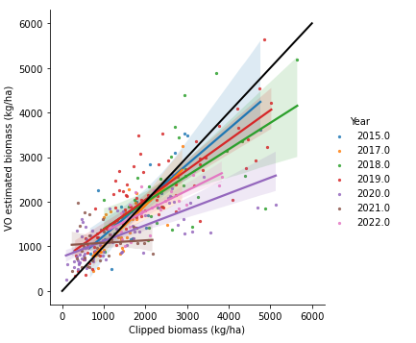

**VOR + binned cumulative precip with lag (using observed data)**

np.power(Q('Total_Weight_(g/m^2)'), 0.5) ~ np.power(Low_cm, 0.5) + np.power(High_cm, 0.5) + ppt_yr_binned

Shapiro: 0.9669

Adj. R2: 0.572

Error: 31%

**VOR + binned precip lag only (using observed data)**

np.power(Q('Total_Weight_(g/m^2)'), 0.5) ~ np.power(Low_cm, 0.5) + np.power(High_cm, 0.5) + ppt_lag_binned

Shapiro: 0.9647

Adj. R2: 0.580

Error: 30%

**VOR + binned precip current spring only (using observed data)**

np.power(Q('Total_Weight_(g/m^2)'), 0.5) ~ np.power(Low_cm, 0.5) + np.power(High_cm, 0.5) + ppt_current_binned

Shapiro: 0.9501

Adj. R2: 0.623

Error: 29%

Single value vs pixel for PRISM

**MLRA58B or 5 county area (in THunderBasin SSURGO)**