COMPANY CONFIDENTIAL

Monday, December 15, 2003


400W METROLIGHT-DELTA COMPARISON
Parameter | Units | METROLIGHT | DELTA | Notes
Ignition Voltage | KV | 3,2-3,5 | 2-2.3 | 3.2kV is ANSI required ignition voltage
Ignition Time | t1/t2/t3¹ | 1.5s/15s/20m | 1s/10s/∞ | Fig 1 (DELTA)
Warm-up current | A | 5 | 4 | DELTA has visible flicker and audible noise during warmup phase (Fig 2)  5A is the min required for color stability during life time
Nominal output power | W | 400 | 350
Measured output power | W | 400 | 335
Line regulation | % | <1 | <1 | During mains volage variation
Case to ambient overheat | °C | 20 @ 400W | 31 @ 350W
Nominal input Voltage | V | 180-305 | 180-305 | Flicker start at 280V (DELTA)
Losses | W | ~25 (23@350W) | ~30
Efficiency | % | 94 | 92
Power Factor |  | 0,95-0,98 | 0.96
Microcontoller control |  | Yes | No
Protections
Output to input (Earth) |  | Yes | Yes
Short load |  | Yes | No
Lamp end of life |  | Yes | No
Thermal |  | Yes | Yes | METROLITE has power derating in overheat before shut down
Analog 0..10V dimming |  | Yes | Yes | DELTA has 10..0V input
Digital communication (dimming) |  | Yes | No
Size | Mm | 65x133x206 | 62x150x183
Weight | Kg | 0.6 | 0.75

¹ t1 - Burst time/t2 - burst period/t3 - ignition duration

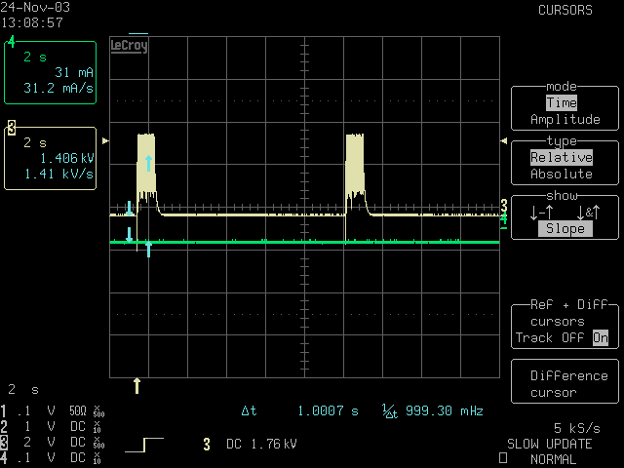 | 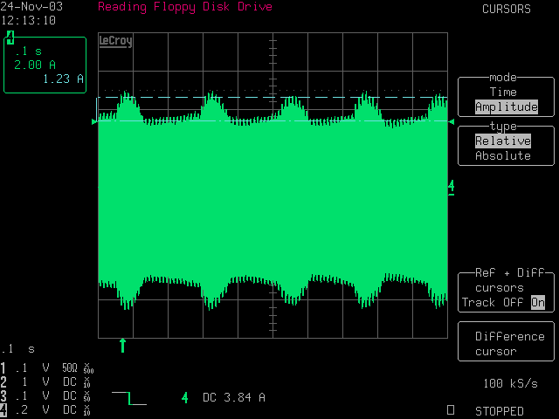
Fig .1 | Fig. 2

