1. Link github repository  
   <https://github.com/epenuts/tp_mod4>
2. Screenshot hasil run  
   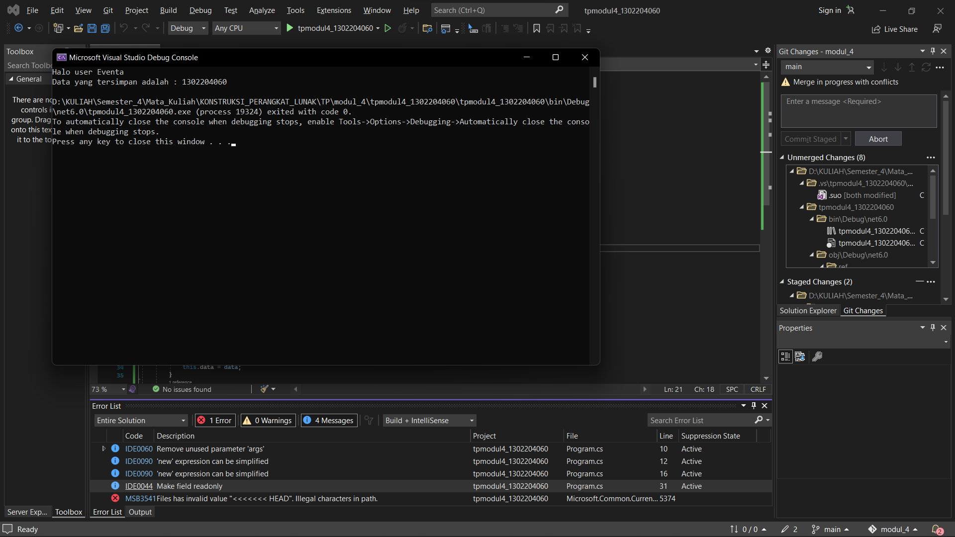
3. Penjelasan code  
   