Ethan Perdieu and Arthur Prete
CIT-37300
W8A1 Mood Board
October 20th, 2025

Keywords:
- Authentic
- Organized
- Family-Oriented
- Traditional
- Community Focused
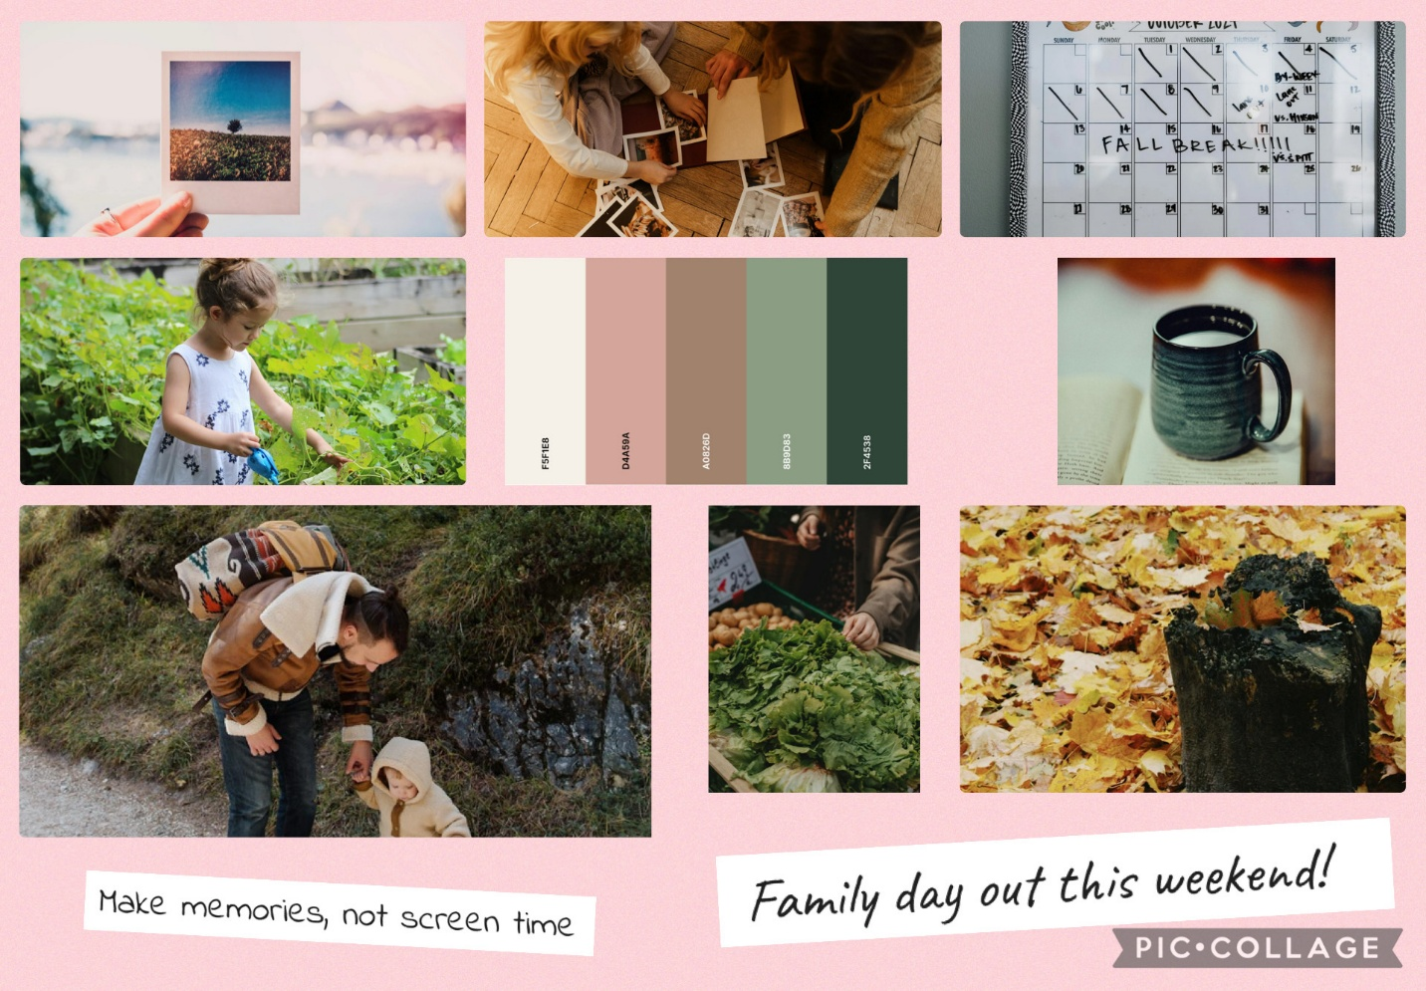

This mood board captures Elena, our ideal client, being a busy, organized mother in the suburban area of London. The images focus on family moments such as hiking and gardening and community connections shown in the farmers market photo. Her love for photography is captured in a Polaroid photo and the calendar showing her meticulous planning. I included a lot of outdoor oriented pictures to show her love for outdoors and nature connections to get away from her screen time frustrations. I choose an earthy color palette to reflect Elena’s preference for natural experiences over the corporate colors. These colors help create a sense of warmth and reflect her love for nature. The fonts I chose were Caveat and Indie flower which follow her personal touch in an authentic handwritten style. This reflects the genuineness and trustworthiness she offers.

