Ethan Perdieu and Arthur Prete
CIT-37300
Typography Decisions
October 28th, 2025

Ethan –
As a group, we decided to pick Merriweather and Open Sans for our font combination. The Merriweather font help convey the authentic farm experience that our Ideal persona is looking for. This helps establish the feeling of a warm and genuine family farm rather than a corporate attraction. This font has a rustic style which also aligns with the farm/country style. The Open sans font is a friendlier type of font that has emphasis on clear visual cues that make critical information readily readable. This aligns with our ideal persona because they do not want critical information to be hard to find or read.

Original Logo:
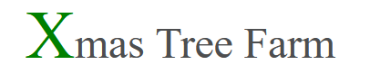

Remade:
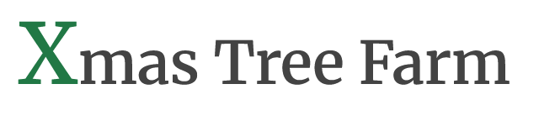
Changed font to Merriweather semibold for a cleaner and friendlier feel.

Headline/Title: Merriweather Bold
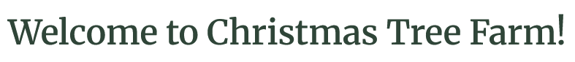
It uses 32 font size with a darker green (2F4538), so it does not look like an eye sore like it was on the website. The website used a very dark black which did not contrast with any of the other colors. Capitalized every first letter of each major word.

One Typeface (The rest): Open Sans
Open Sans Bold – 32px
Open Sans Semi Bold – 28px
Open Sans Bold – 20px
Open Sans Semi Bold – 18px
Open Sans Regular – 16px

RULES:
#2F4538 (Deep Forest Green) – Primary emphasis such as headings, prices etc.
#8B9D83 (Sage) – Secondary emphasis for subheadings, section labels and links
#3D3229 (Charcoal) – Body text, descriptions and labels
#D4A59A (Muted Coral) – Alerts and Special info, closures and warnings
#F5F1E8 (Cream) – Will be used for our backgrounds and/or section breaks

Rough Layout
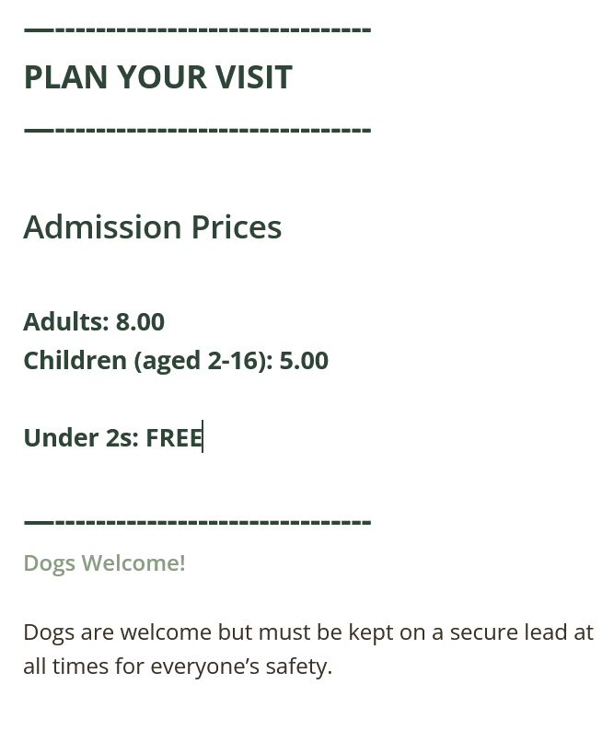

Subhead:
- Open Sans Bold – 32px
- Open Sans Semi-Bold – 28px
- Open Sans Bold – 20px
- Open Sans Semi-Bold – 18px
H2 – Major Sections: Open Sans Bold (32px) All caps will be used for some of the headers as shown above for PLAN YOUR VISIT.

H3 Important Subsections: Open Sans Semi-Bold (28px) For important information such as Admission Prices.

H4 Secondary Subsections: Open Sans Bold (20px) will be used for listing off the adults, children and under 2 pricing.

H5 Minor Subheadings: Open Sans Semi-Bold (18px) Less important sub headers such as welcoming dogs etc.

Body Copy: Open Sans Regular (16px, #3D3229)
Using normal sentence capitalization structure. Shown above in the rough layout.

Buttons: Open Sans Bold (18px)
Will display the buttons in ALL CAPS with white text and the forest green background. (#2F4538) Could be buttons such as GO, or LOCATIONS
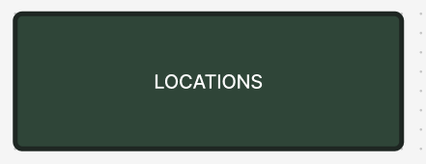
Close to this but using Open Sans bold.

Arthur -
Captions
Open Sans Italic – 16px (#3D3229) Captions will be used for photo descriptions and supporting visuals. We chose italicized text to differentiate them from the main body content without drawing too much attention. Using a sentence case maintains readability and a consistent visual tone across the site.
Labels
Open Sans Semi-Bold – 16px (#8B9D83) All Caps Labels will be used for navigation links, form fields, and section tags. Using ALL CAPS helps them stand out while still fitting within the minimalist and natural style of the site. The sage color (#8B9D83) aligns with the secondary palette and keeps a calm, farm-inspired aesthetic.
Emphasis
Merriweather Bold – 20px (#2F4538) Pull quotes and key messages will use Merriweather to maintain the same authentic, rustic tone used in the headlines. These will use normal capitalization with quotation marks for readability and impact. Inline emphasis (within paragraphs) will use Open Sans Bold (16px, #D4A59A) to highlight critical words or short phrases, aligning with the site’s alert/special information color rule.
Footer
Open Sans Regular – 14px (#8B9D83) Sentence case the footer text will use the lighter sage color to maintain visual balance and a softer contrast against the cream background (#F5F1E8). Links (such as “Contact,” “Privacy Policy,” or “Terms”) will use Open Sans Semi-Bold (14px, #3D3229) and will slightly darken when hovered to create interactive feedback while staying aligned with the brand palette.

