Ethan Perdieu and Arthur Prete
CIT-37300
W9A2 Art Direction
November 4th, 2025

CHRISTMAS TREE FARM
Brand Standard Guide (Ethan)


Website Goals
Create a transparent, real experience that builds trust with London families that seek an authentic farm experience. Our website eliminates the frustrations of hidden information such as pricing, hours and location. We want to create a gateway for families across London to discover an authentic farm experience which fosters lasting memories, and meaningful connections. Our website serves as a steppingstone in transforming curiosity into tradition.

Target User
Budget-aware London mother (35) seeking genuine outdoor experiences for her family, frustrated by unclear pricing and corporate attractions. She is sociable and a meticulous planner, so readily available detailed information is of high priority.

Typography System (Ethan)

TYPEFACE Family -
Primary: Merriweather (Headlines ONLY)
Secondary: Open Sans
Source: Google Fonts

HEADLINE FONT: Merriweather
Merriweather Bold | 40px | #2F4538
Use: H1, Main page headlines


Merriweather Bold | 32px | #2F4538 | ALL CAPS
Use: H2 Major Section Headers

BODY TYPEFACE: Open Sans

Open Sans Semi-Bold | 28px | #2F4538 | Title Case
Use: H3, Important Subsections


Open Sans Bold | 20px | #2F4538
Use: H4, Secondary Subsections, Buttons


Open Sans Semi-Bold | 18px | #8b9d83 | Title Case
Use: H5, Minor Subheadings

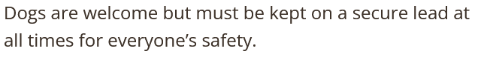
Open Sans Regular | 16px | #3D3229 | Sentence Case
Use: Body Copy, Paragraphs, Descriptions, Footers

Typography Rules

DO:
- Use Merriweather only for headlines
- Use Open Sans for all other text
- Maintain a minimum text font of 16px
- Use ALL CAPS sparingly (Headings and Buttons)
DON’T:
- Mix two or more typefaces
- Use another font

Logo
Font: Merriweather Bold
“X” Color: #2F4538 (Deep Forest Green)
“mas Tree Farm” Color: #3D3229 (Charcoal Brown)

Logo Rules
- Maintain clear space around the logo
- Use cream (F5F1E8) or white background
- Do not stretch or distort
- Do not change colors
- Do not add effects
- Do not rotate logo
- Do not place on busy photo backgrounds

Color Palette
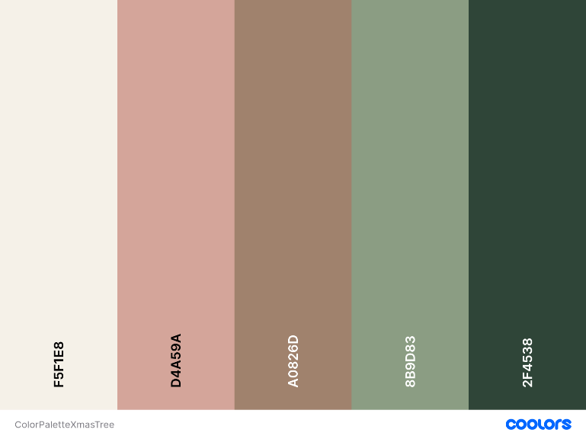

PRIMARY COLORS
Deep Forest Green - #2F4538
RGB: 47, 69, 56
Use: Headlines, Primary Buttons, Logo, Key information
Conveys: Trust, Nature, Establishment

Soft Sage Green - #8B9D83
RGB: 139, 157, 131
Use: Subheads, Links, Secondary Elements
Conveys: Calm, Approachability

Charcoal Brown - #3D3229
RGB: 61, 50, 41
Use: Body text only
Conveys: Readability, Warmth

ACCENT COLORS
Muted Coral - #D4A59A
RGB: 212, 165, 154
Use: Alerts, Warnings, Special Callouts
Conveys: Attentions

Warm Cream - #F5F1E8
RGB: 245, 241, 232
Use: Backgrounds, Section Breaks
Conveys: Warmth and Openness

Color Usage Rules
DO:
- Use #2F4538 for all primary elements
- Use #8B9D83 for secondary hierarchy
- Use #3D3229 ONLY for body text
- Reserve #D4A59A for alerts/warnings only
- Use #F5F1E8 for backgrounds, never text
DON’T:
- Use more than 3 colors on one element
- Use coral for positive messages
- Use light text on light backgrounds
- Introduce new colors outside the color palette

Photos
Photography should reflect the farm’s authentic outdoor experience and the warmth of family connection. Imagery must be natural, inviting, and consistent in tone across all pages.
- Lighting: Natural sunlight preferred (morning or golden hour).
- Color Tone: Warm and soft with mild contrast.
- Focus: Candid family moments, nature details, authentic experiences.
- Editing: Minimal retouching. Maintain accurate colors of trees, sky, and skin tones.
- Cropping: Center focus on subjects; keep compositions uncluttered.
- Consistency: All photography should feel part of the same story — rustic, warm, welcoming.

Photo treatments
- Optional slight vignette for warmth (#F5F1E8 tint).
- Avoid filters or extreme saturation.
- Maintain balance between subject and environment.
DO:
- Use warm natural tones (soft greens, browns, creams).
- Capture real families interacting with trees or farm activities.
- Maintain consistent lighting direction and exposure.
- Ensure photos complement the page’s background tone.

DON’T:
- Use stock or staged photography with corporate poses.
- Over-edit or apply high-contrast filters.
- Use dark or moody color tones inconsistent with the theme.
- Place text directly over complex photo backgrounds.

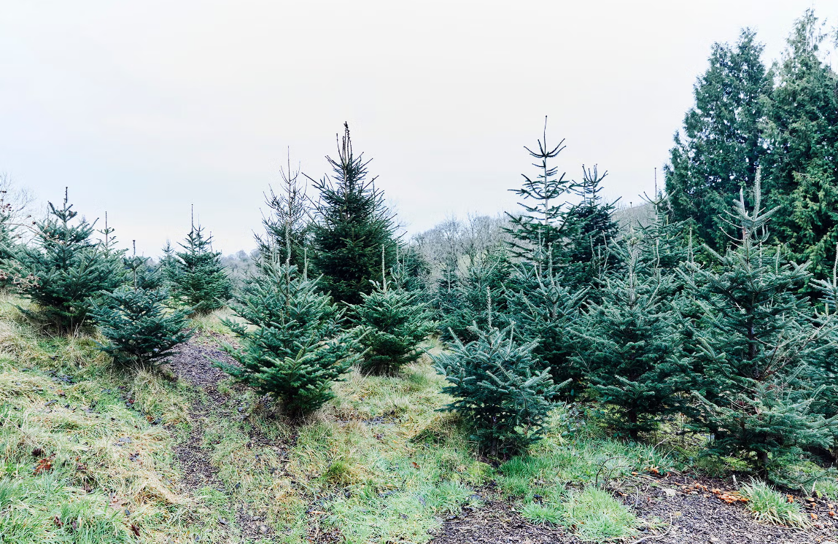

Buttons
Button Style and Behavior
Buttons act as clear visual anchors for navigation and actions. Their design reflects the same natural and approachable tone as the site’s typography and color system.
Button Font: Open Sans Bold | 20px | ALL CAPS | #F5F1E8
Shape: Rounded Rectangle | 12px Border Radius
Padding: 12px Vertical / 24px Horizontal
States:
- Normal: Background #2F4538 | Text #F5F1E8
- Hover: Background #8B9D83 | Text #FFFFFF
- Active/Pressed: Background #3D3229 | Text #F5F1E8
- Disabled: Background #8B9D83 | Text #CFCFCF
Icons: If used, keep left-aligned, 24px size, and color-matched to text.
Usage Examples:
- “BOOK YOUR VISIT”
- “SEE PRICING”
- “FIND US”
DO:
- Use consistent button shapes and colors throughout.
- Ensure contrast between text and background.
- Keep text short, clear, and action-oriented.
- Use ALL CAPS for every button label.
DON’T:
- Add shadows, bevels, or gradients.
- Change button sizes inconsistently across pages.
- Use lowercase or decorative text.
- Apply bright or unapproved colors.


