Ethan Perdieu
CIT-37300
W10A1 Storyboards
November 4th, 2025

Main Page:
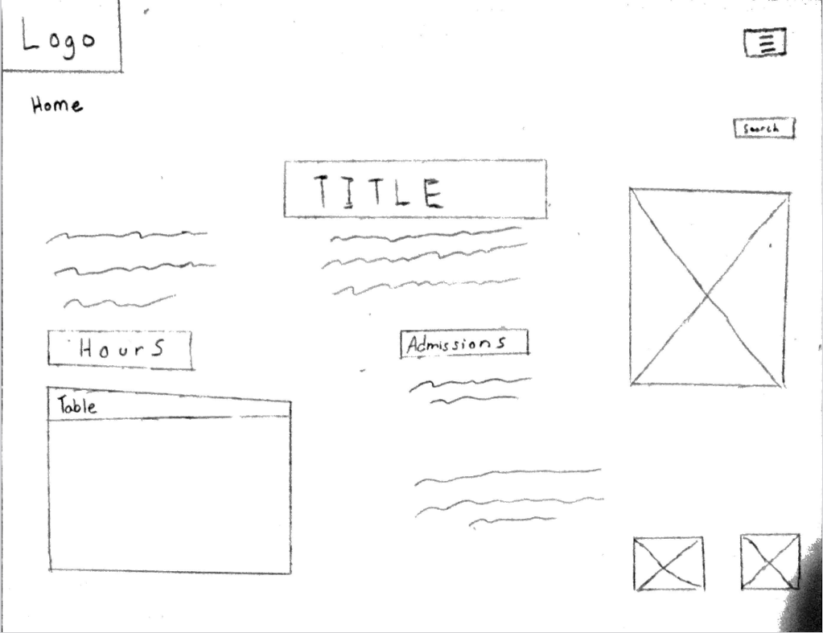

The placement of items relates to the needs of our user in two ways, the authenticity assurance and the need for readily accessible basic information. The video to the right of the title immediately shows the animals and the farm atmosphere, which proves to our ideal user that it is not a corporate attraction. This also tackles her frustration of websites hiding basic information by having two prominent areas displaying the hours and admission prices. The design principle I used was emphasis by having the title “Welcome to Christmas Tree Farm” be the focal point. This immediately communicates what the site offers while the video provides the visual interest standpoint. I also tried to incorporate some balance and alignment by having text content balanced with the video on the right-hand side.
Interior Page:
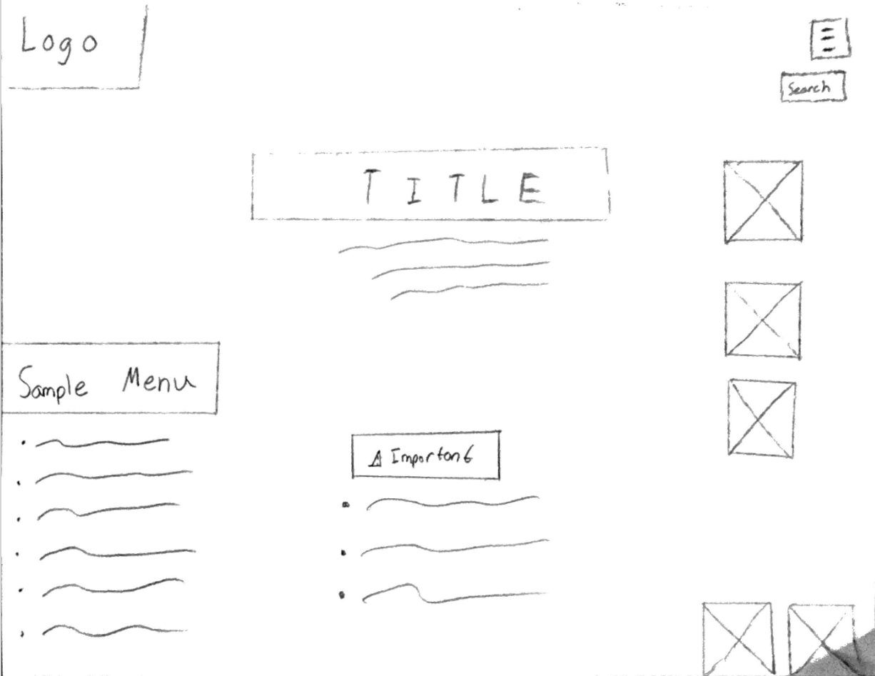

The refreshments page once again helps with her frustration of hidden costs and other important information. I created two separate areas to appease this issue, the sample menu then an IMPORTANT labeled box in the middle. This also helps with her meticulous planner trait so she can plan her meal costs before the trip. Some design principles I used were emphasis to draw immediate attention to the webpage she is on. I also used balance and alignment with the photos on the right-hand side of the webpage. I will also be using repetition when it comes to the typography I am using.

