Ethan Perdieu
Design Principles
CIT-37300
September 29th, 2025

Design Principle 1 – Contrast
Link: https://www.nike.com/
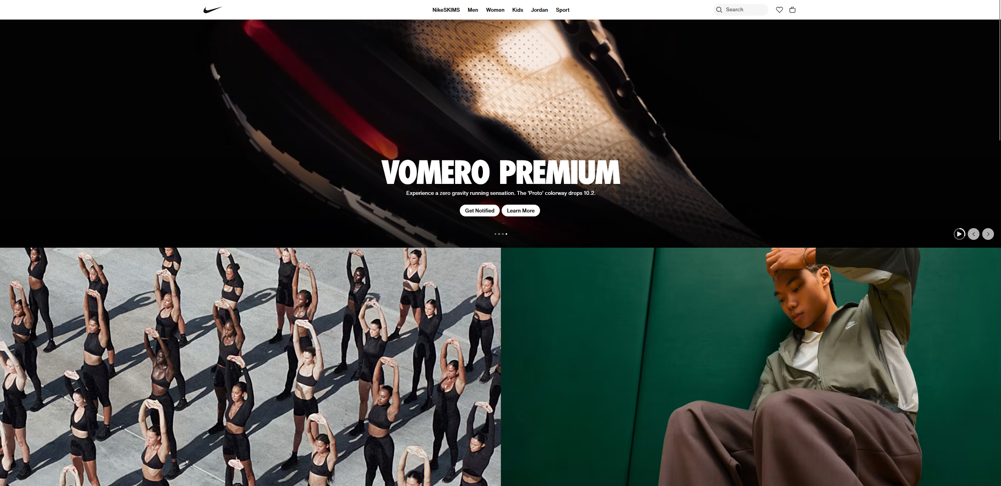
Nike’s website follows the Contrast design principle in more ways than one. It uses both color contrast and size contrast as shown in the screenshot above. Each “box” features a different color which makes the product or message stand out to the user. Another feature of the contrast design principle is shown in the size of the “boxes”. Each box varies in size which can create a visual checkbox. For example, I am instantly drawn to the Vomero Premium box due to the bolded letters and larger scale of the box, then I go and look at the two smaller boxes below.

Design Principle 2 – White Space
Link: https://www.google.com/

The first thing that came to mind when finding a website that encompassed the white space design principle was Googles search engine. The page removes all the “clutter” that other websites fall victim to by surrounding the search bar with white space. This immediately directs users’ attention towards the main purpose of the page, being to search the web. Therefore, this makes the users’ experience very efficient and easy.

Design Principle 3 – Emphasis
Link: https://www.dropbox.com/
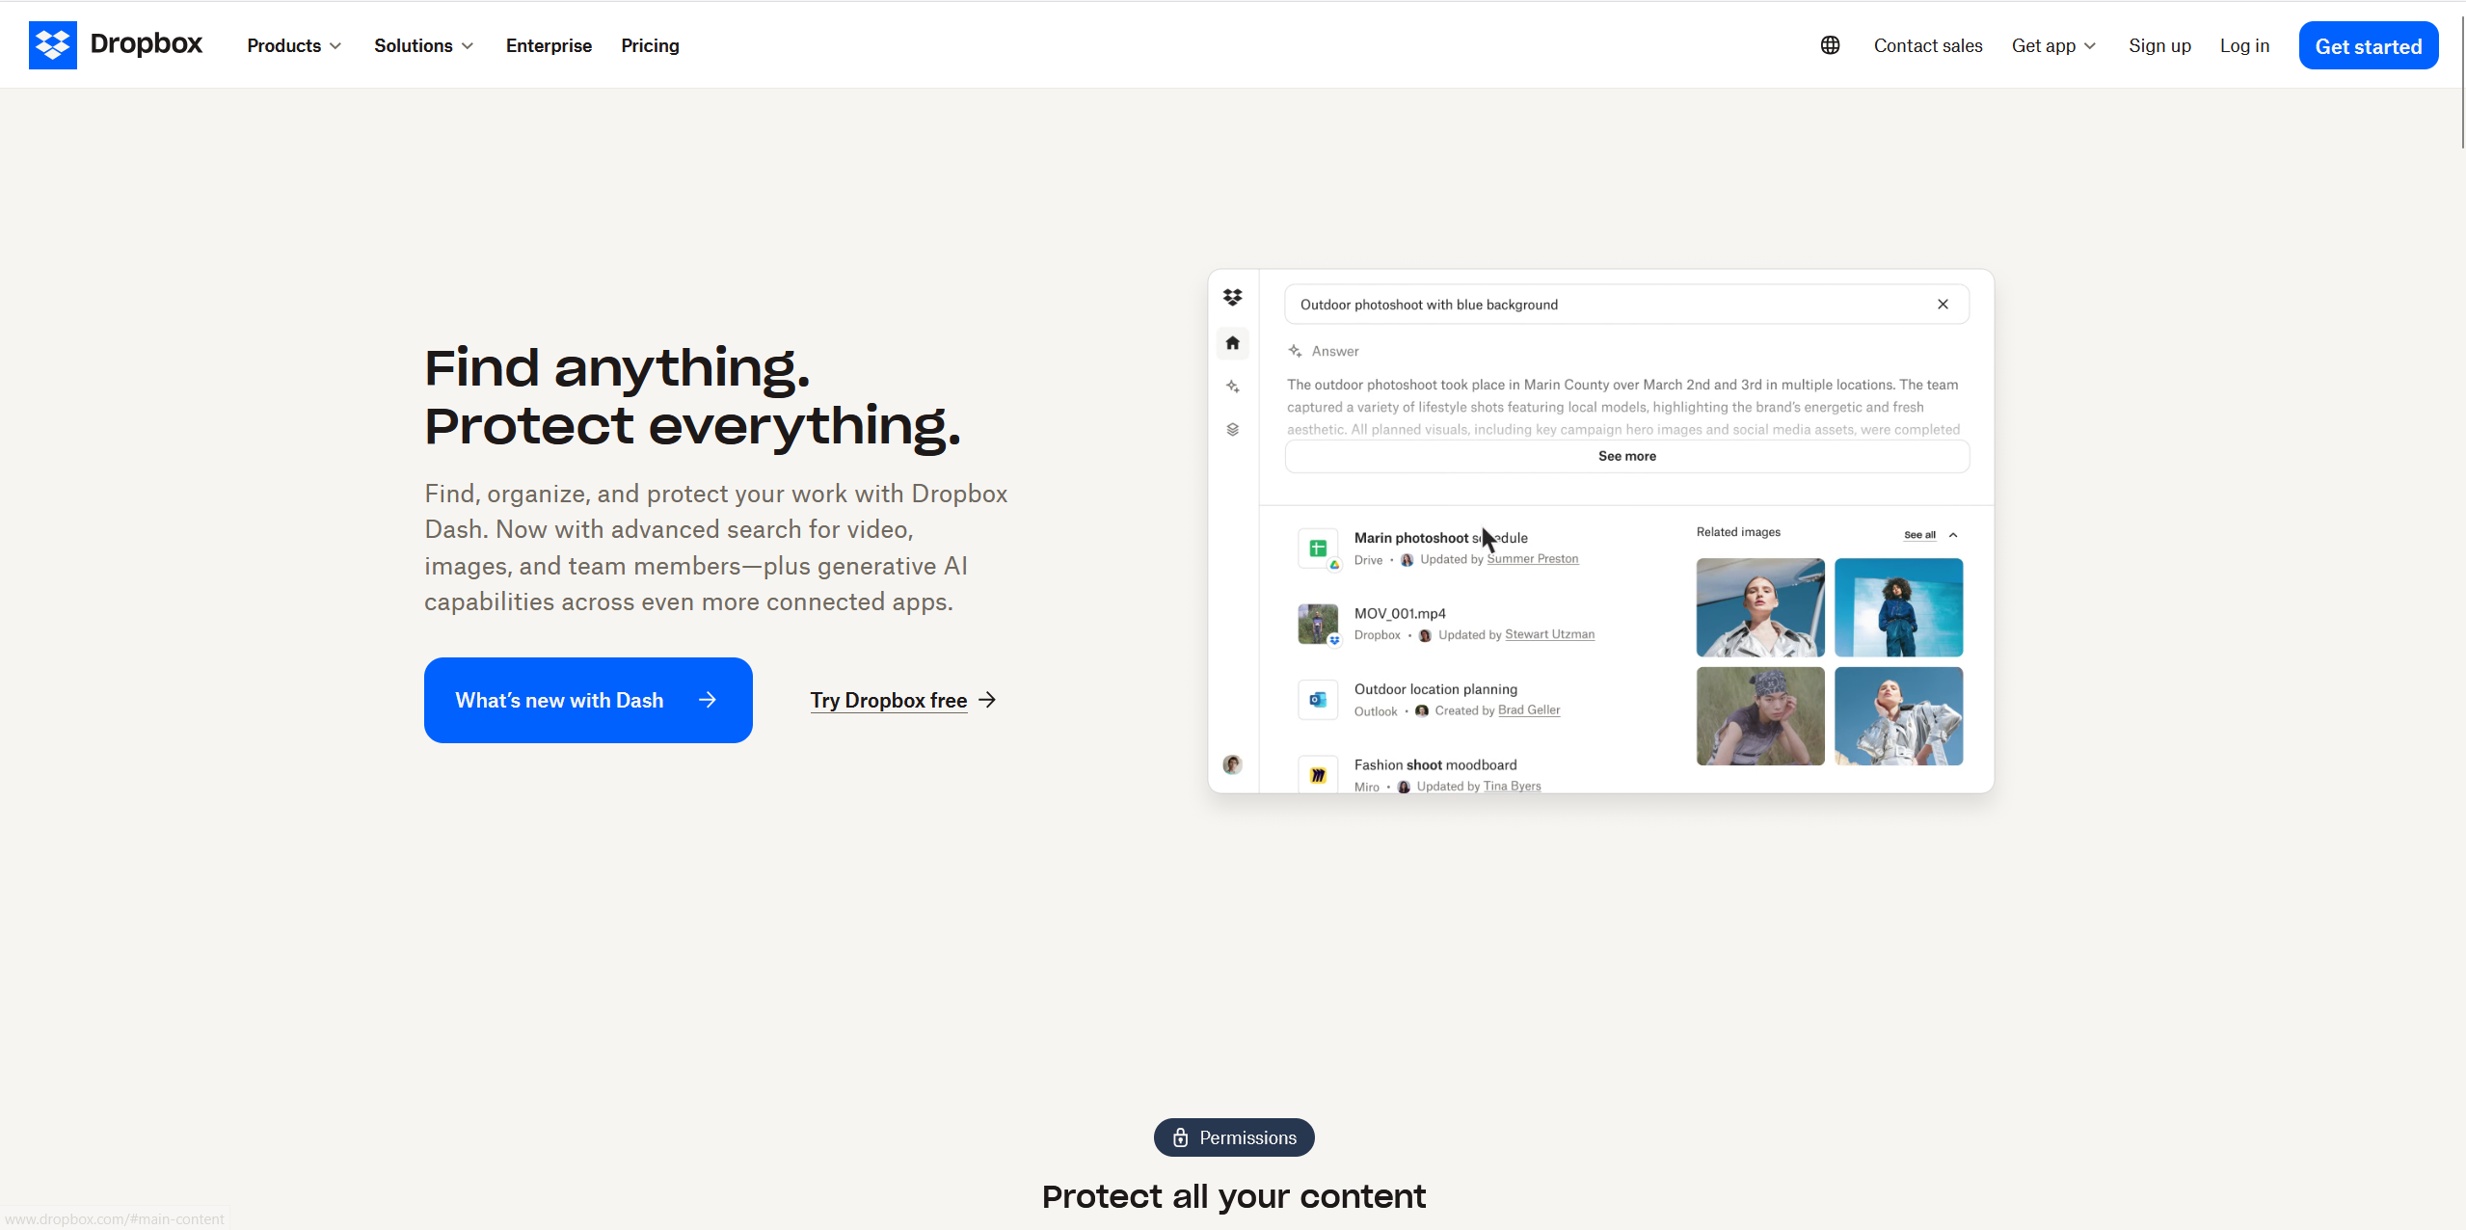
I decided to choose Dropbox as my option for the Emphasis Design Principle due to the way it leverages this principle. The main purpose of Dropbox’s main page is to get users to create an account with Dropbox. This is shown by a large highlighted brightly colored blue button that says get started. This offers an eye-catching look at these buttons which is usually what the user will end up noticing first. They also have another brightly colored box named “What’s new with Dash” which takes you to an alternative page that speaks about their new product, Dropbox Dash. This can draw in the attention of users who are familiar with Dropbox and wonder what improvements and changes were made. That webpage then has another brightly colored box that says, “Try a Demo.”

Design Principle 4 – Repetition
Link: https://open.spotify.com/
I chose Spotify as my representative for the Repetition Design Principle due to my familiarity with the UI. The main feature of Spotify’s main page is the consistent UI elements located at the bottom. These will constantly show up even if you look at lyrics, new artists, playlists and many more different pages. This makes it easy for users to transition between different web pages without having to worry or put too much thought into the new pages.

Design Principle 5 – Balance and Alignment
Link: https://www.cisco.com/
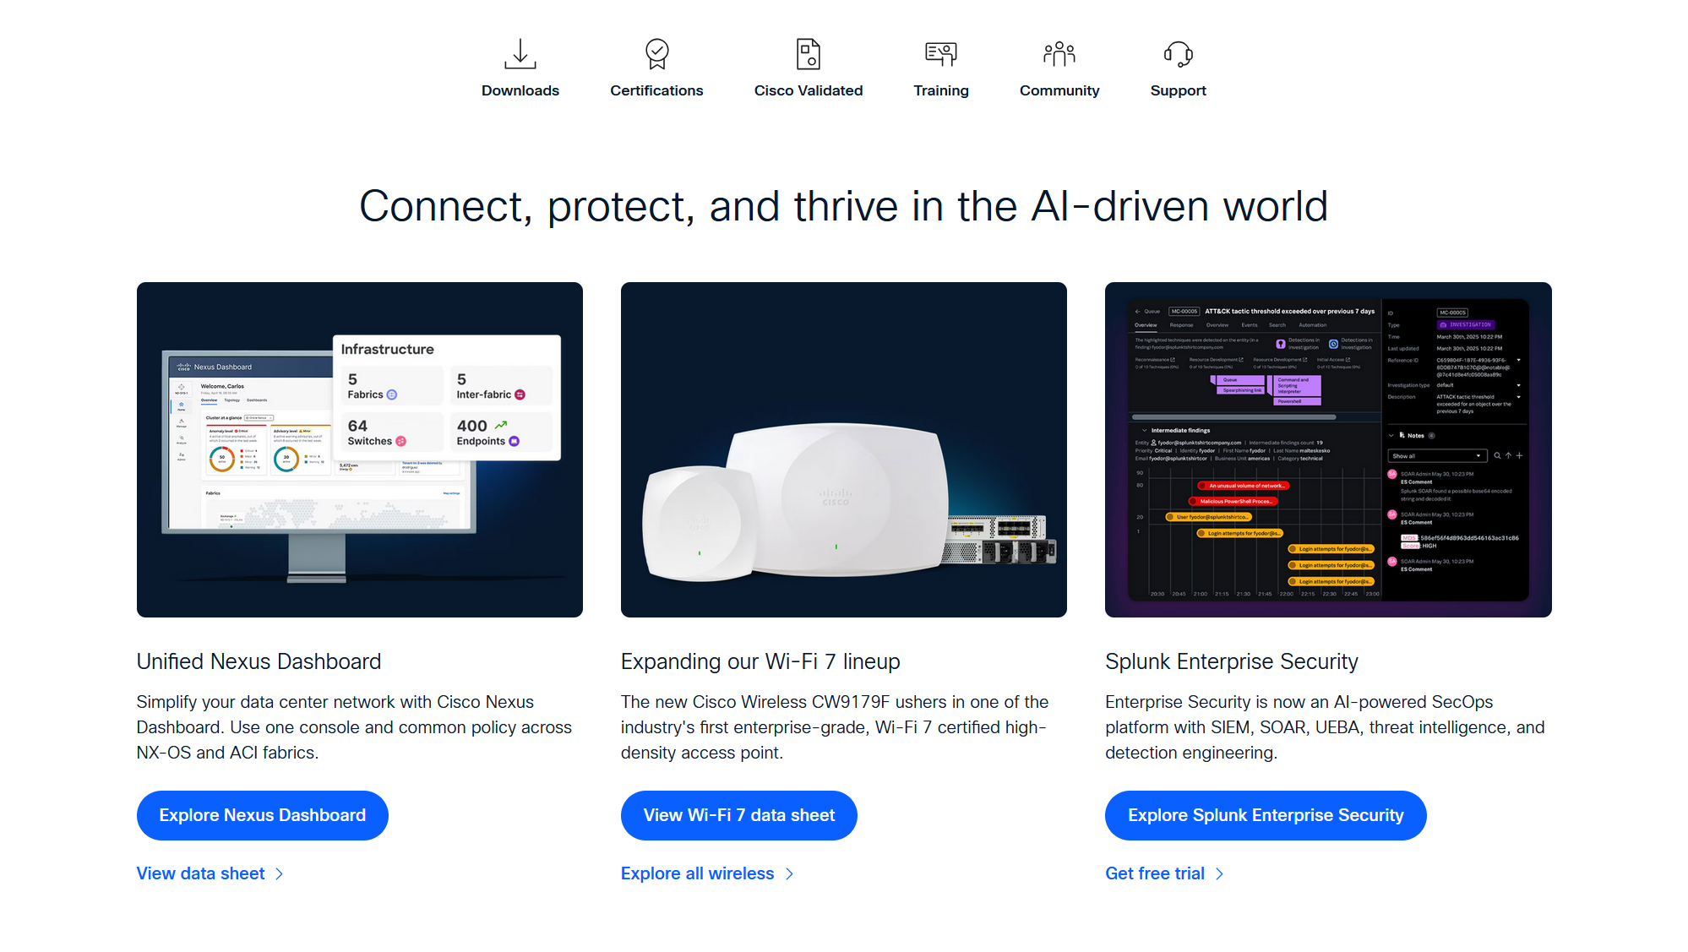
For the Balance and Alignment principle, I went with Cisco which is a familiar website in the Cybersecurity world. This website displays symmetrical balance to the products that they offer. This helps establish a professional look without taking away from other products or elements. The headers are centered, and the products are mirror images of each other when it comes to the photos, text and highlighted buttons. This allows the user to have a sense of control since it creates a predictable and secure environment which is fitting for a Cybersecurity oriented website.

