Ethan Perdieu
W5A2 Figma Tutorials
CIT-37300
September 29th, 2025

Constrains and Grids
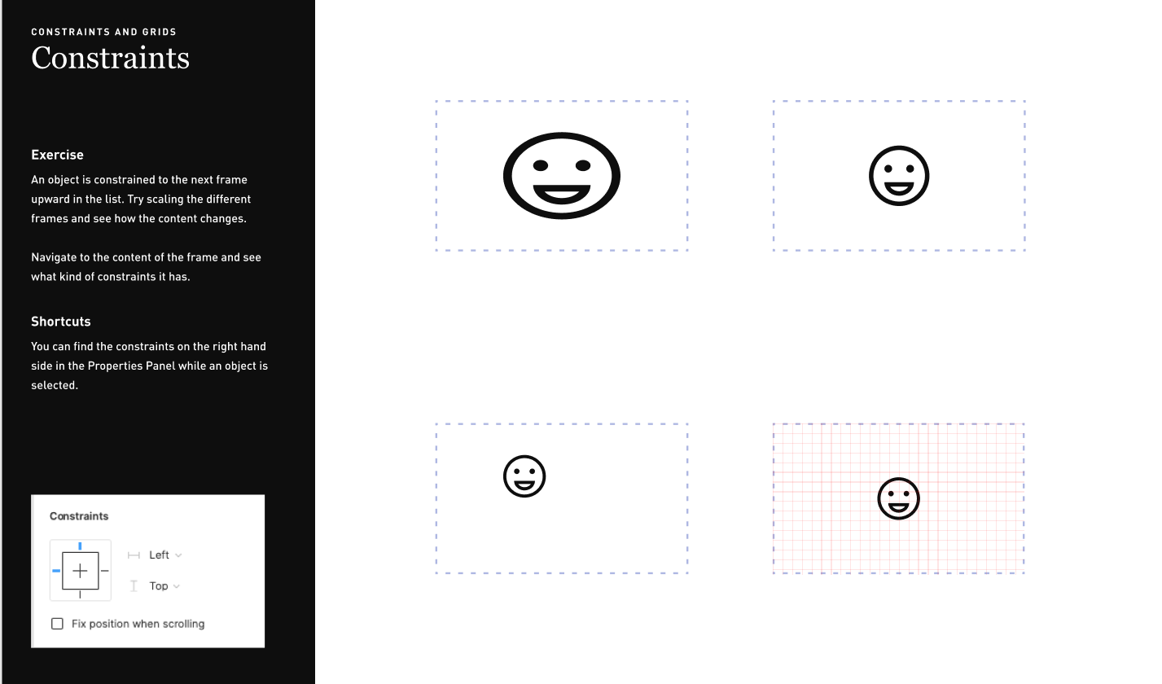

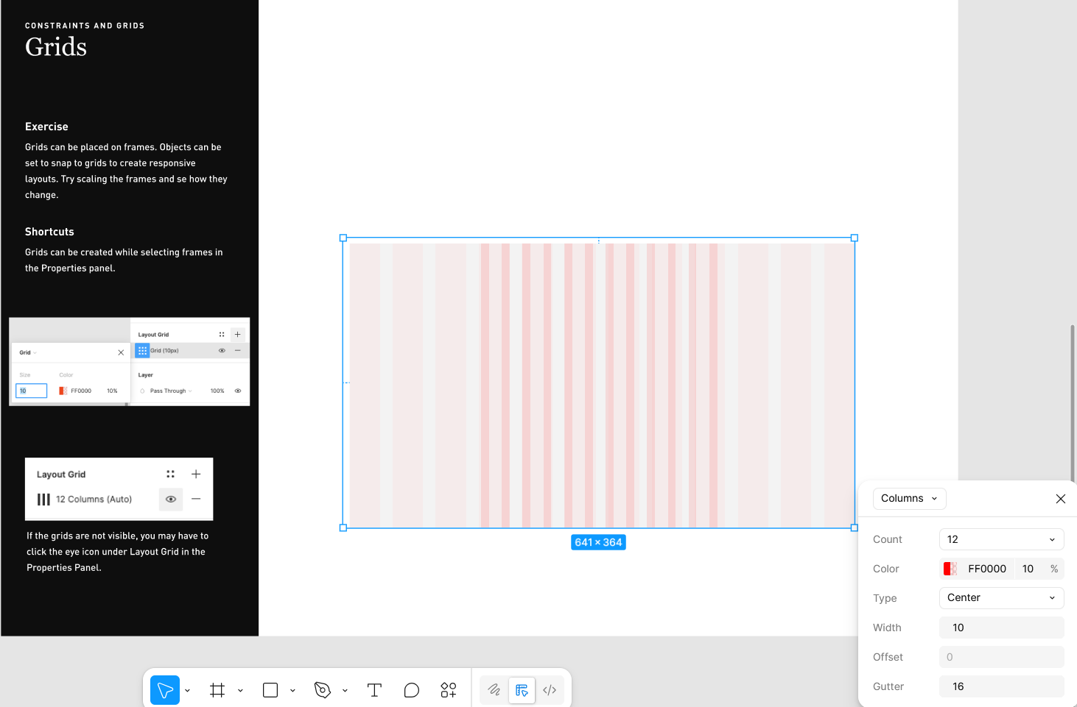
Components
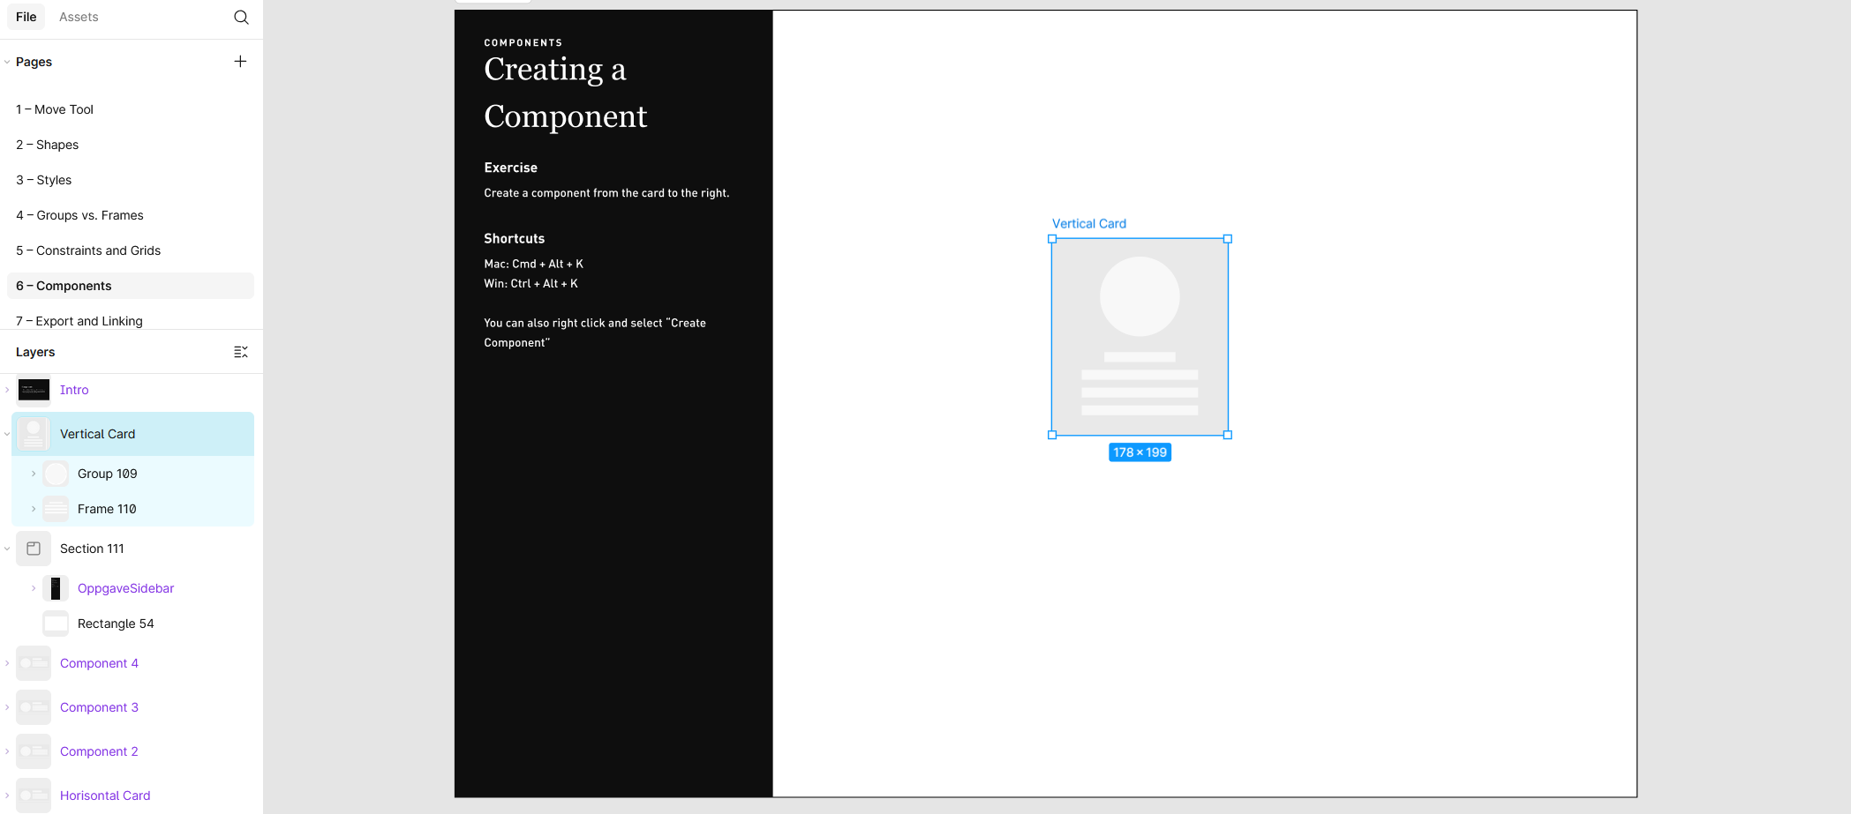
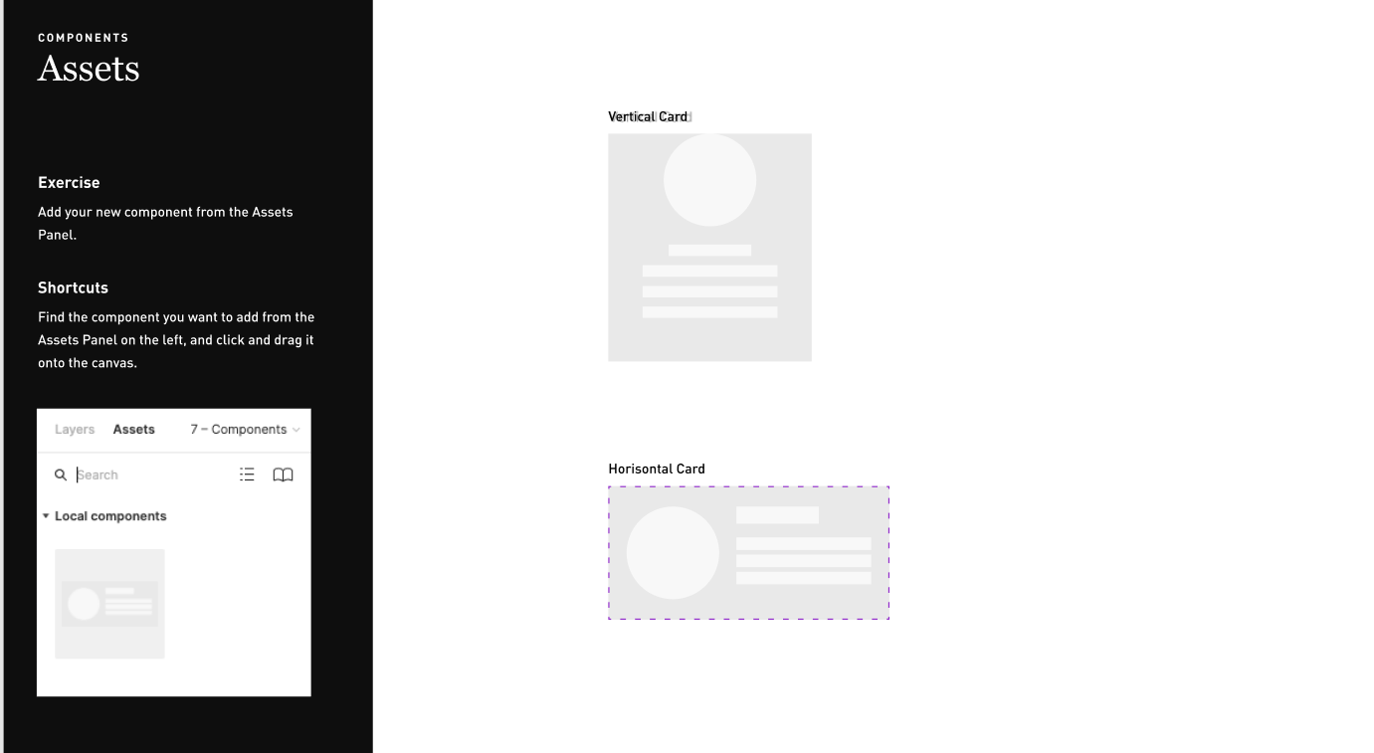


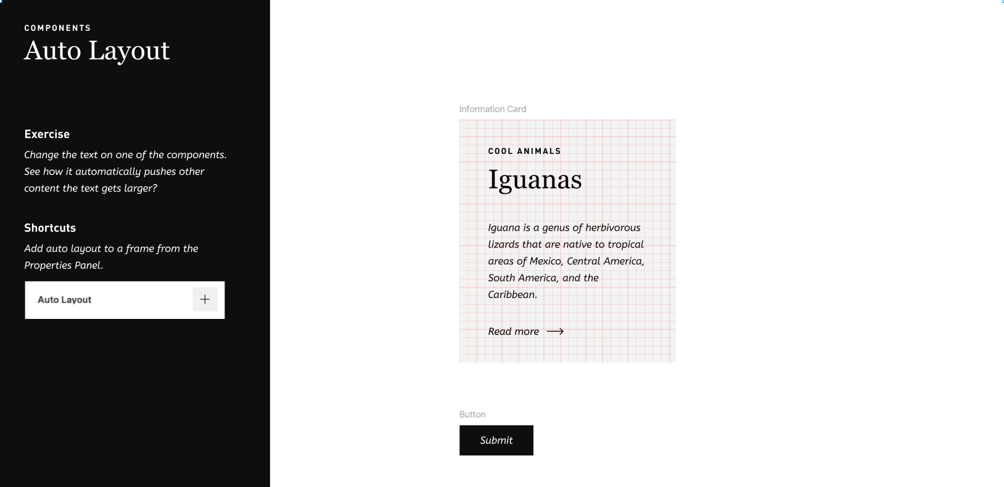

Exporting and Linking
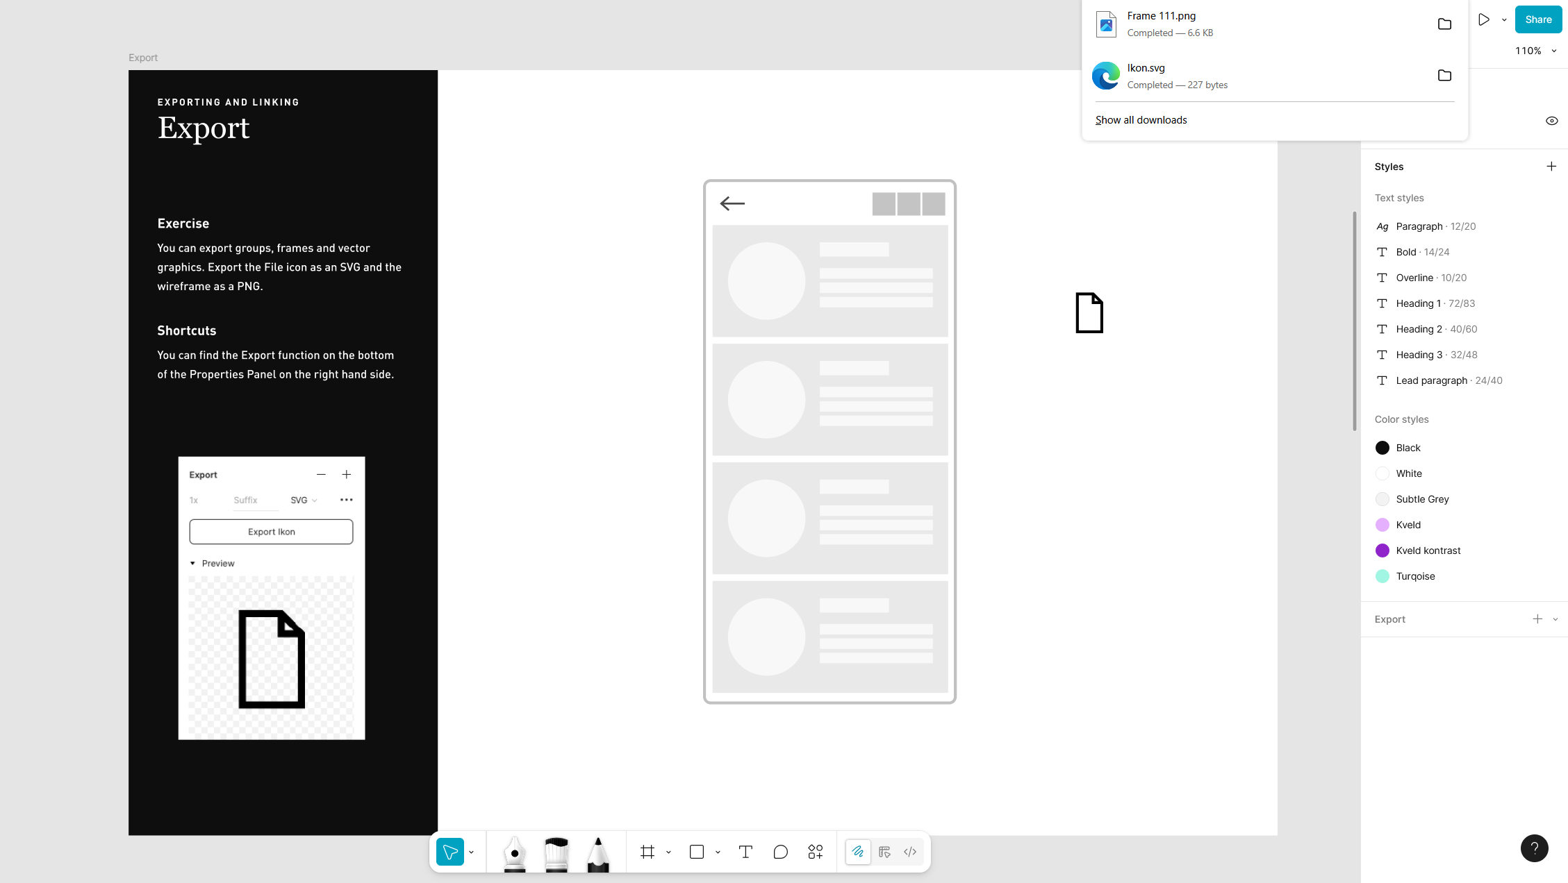
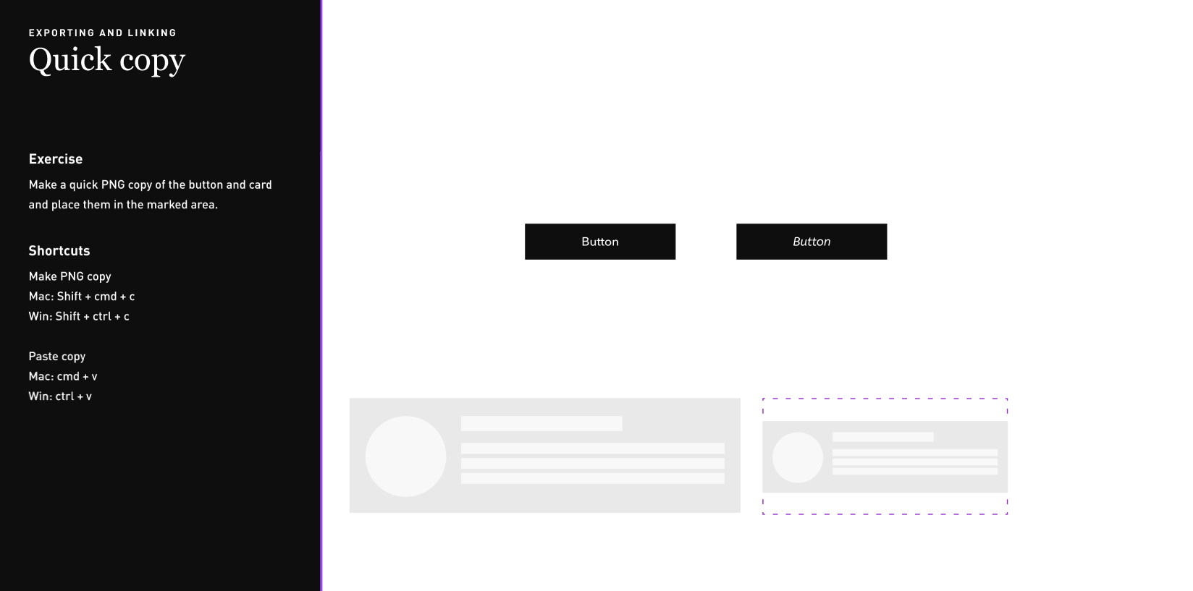

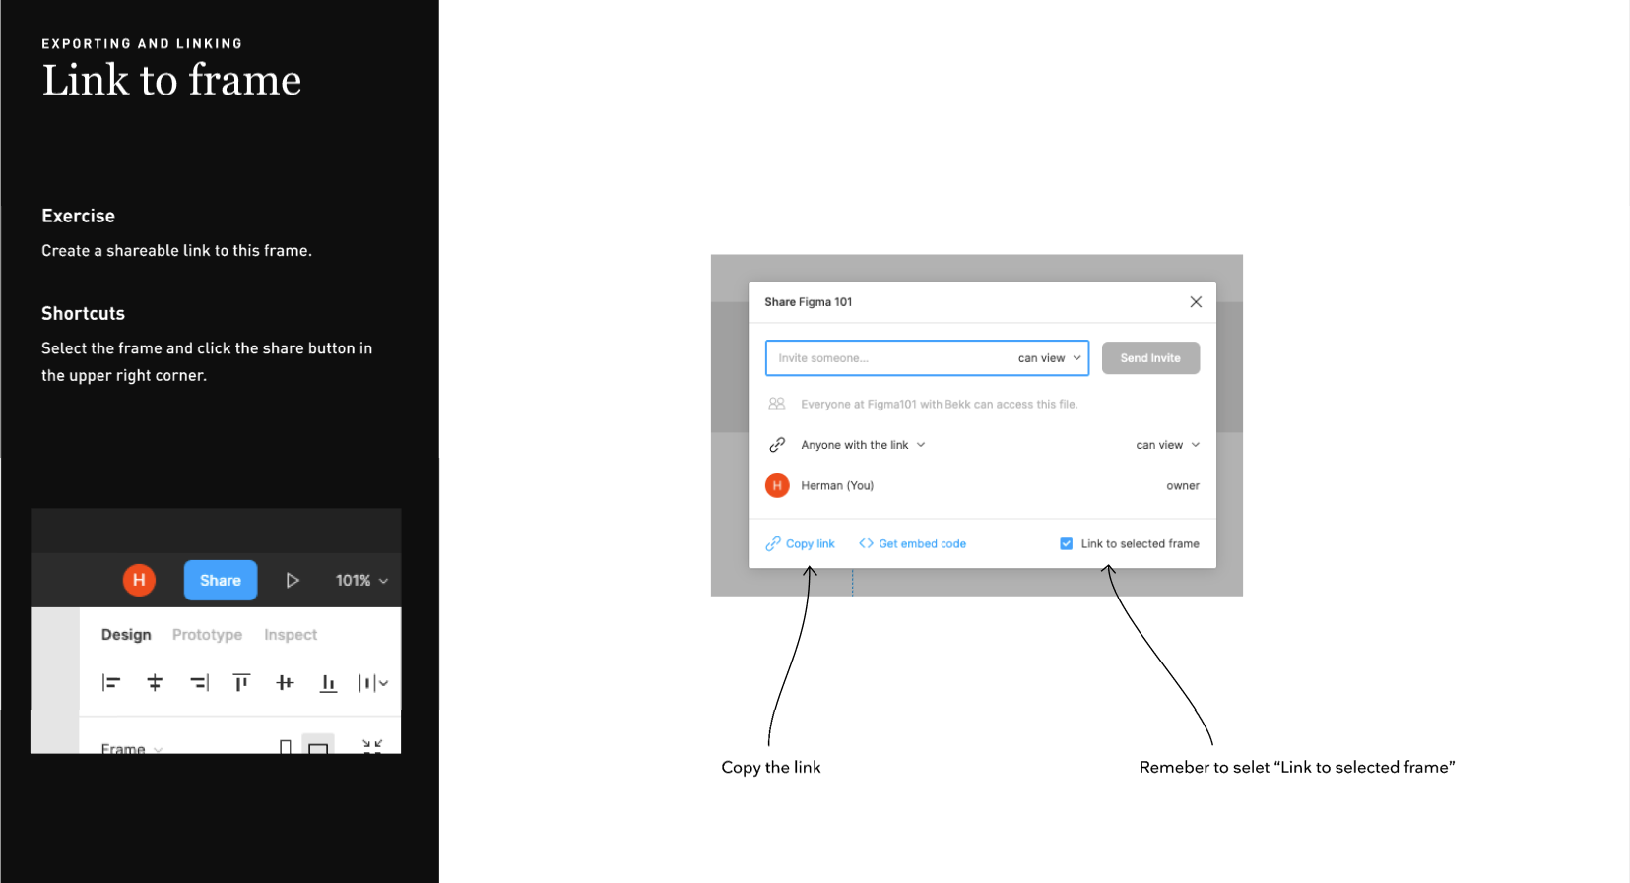
SHAREABLE LINK: https://www.figma.com/design/xI84sXZed8XQBWU7Rxcatu/Figma-101--Community-?node-id=3-625&t=NxUAmilGo0QACsOn-1

Inspect and View Access
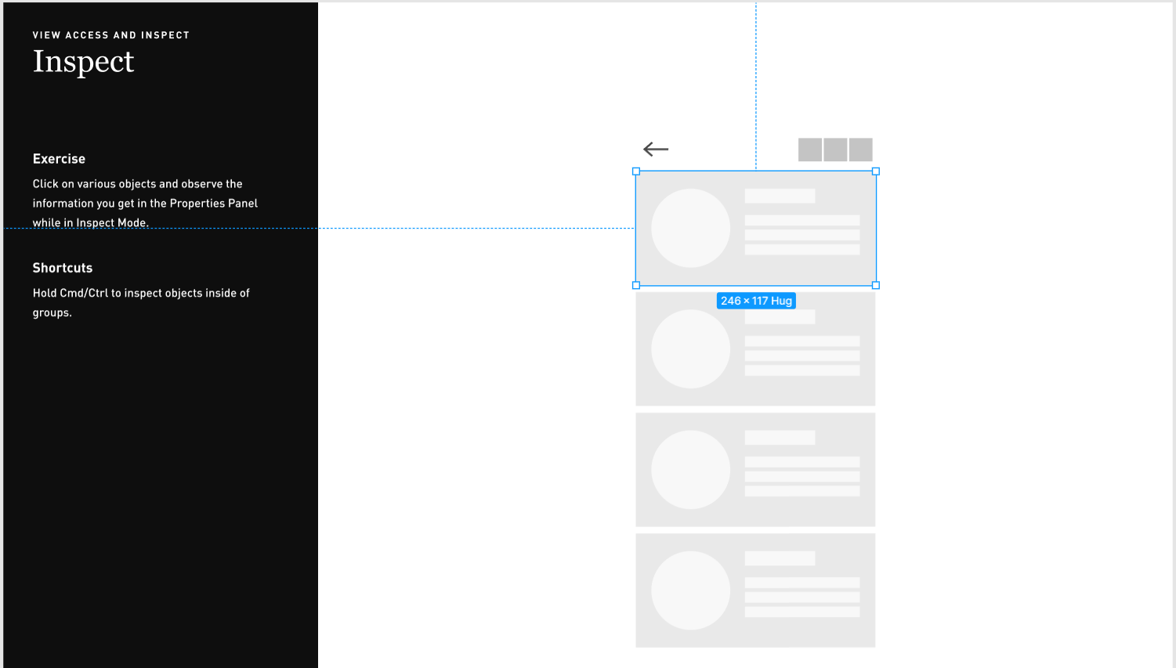
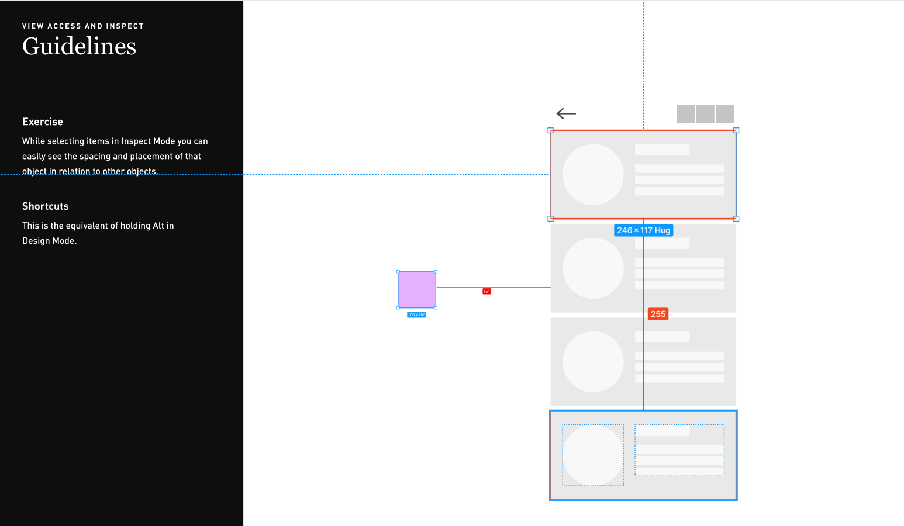
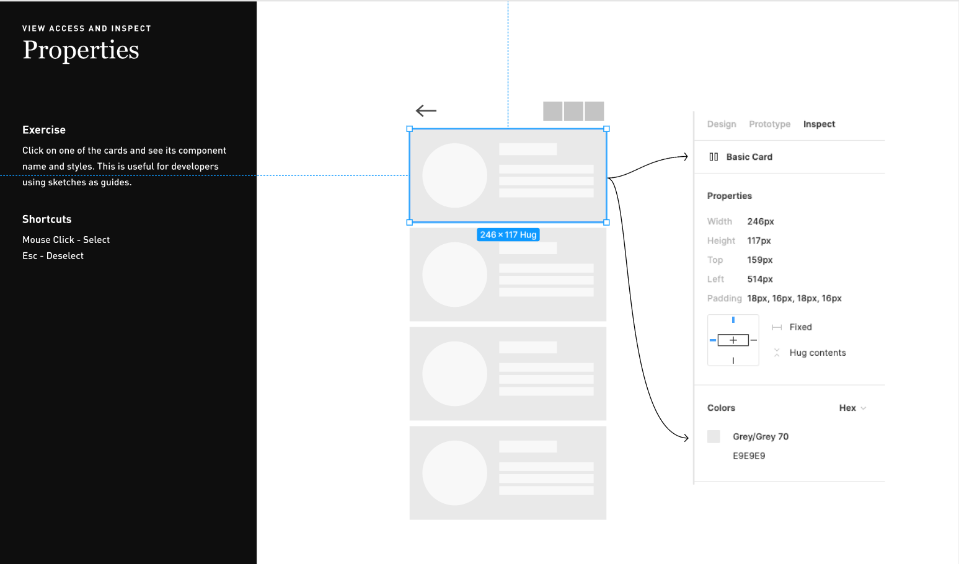
You can no longer inspect without dev mode which needs the professional version. Therefore, half of these tasks are not possible unless you inspect in design mode which was done in the screenshots aboved. The link below proves that:
https://help.figma.com/hc/en-us/articles/22012921621015-Guide-to-inspecting
Version History
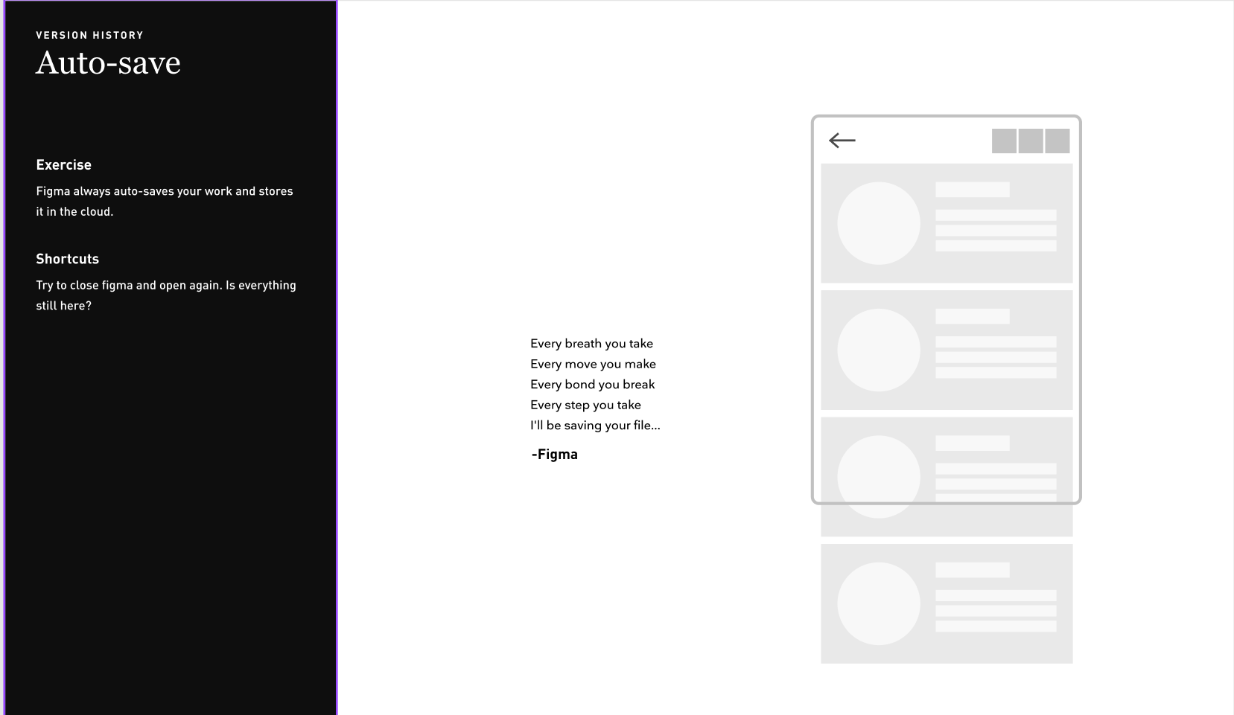
Yes, auto-save worked.


