Ethan Perdieu
CIT-38100
T8A2 Typography 101
October 20th, 2025

Headline Font: Merriweather
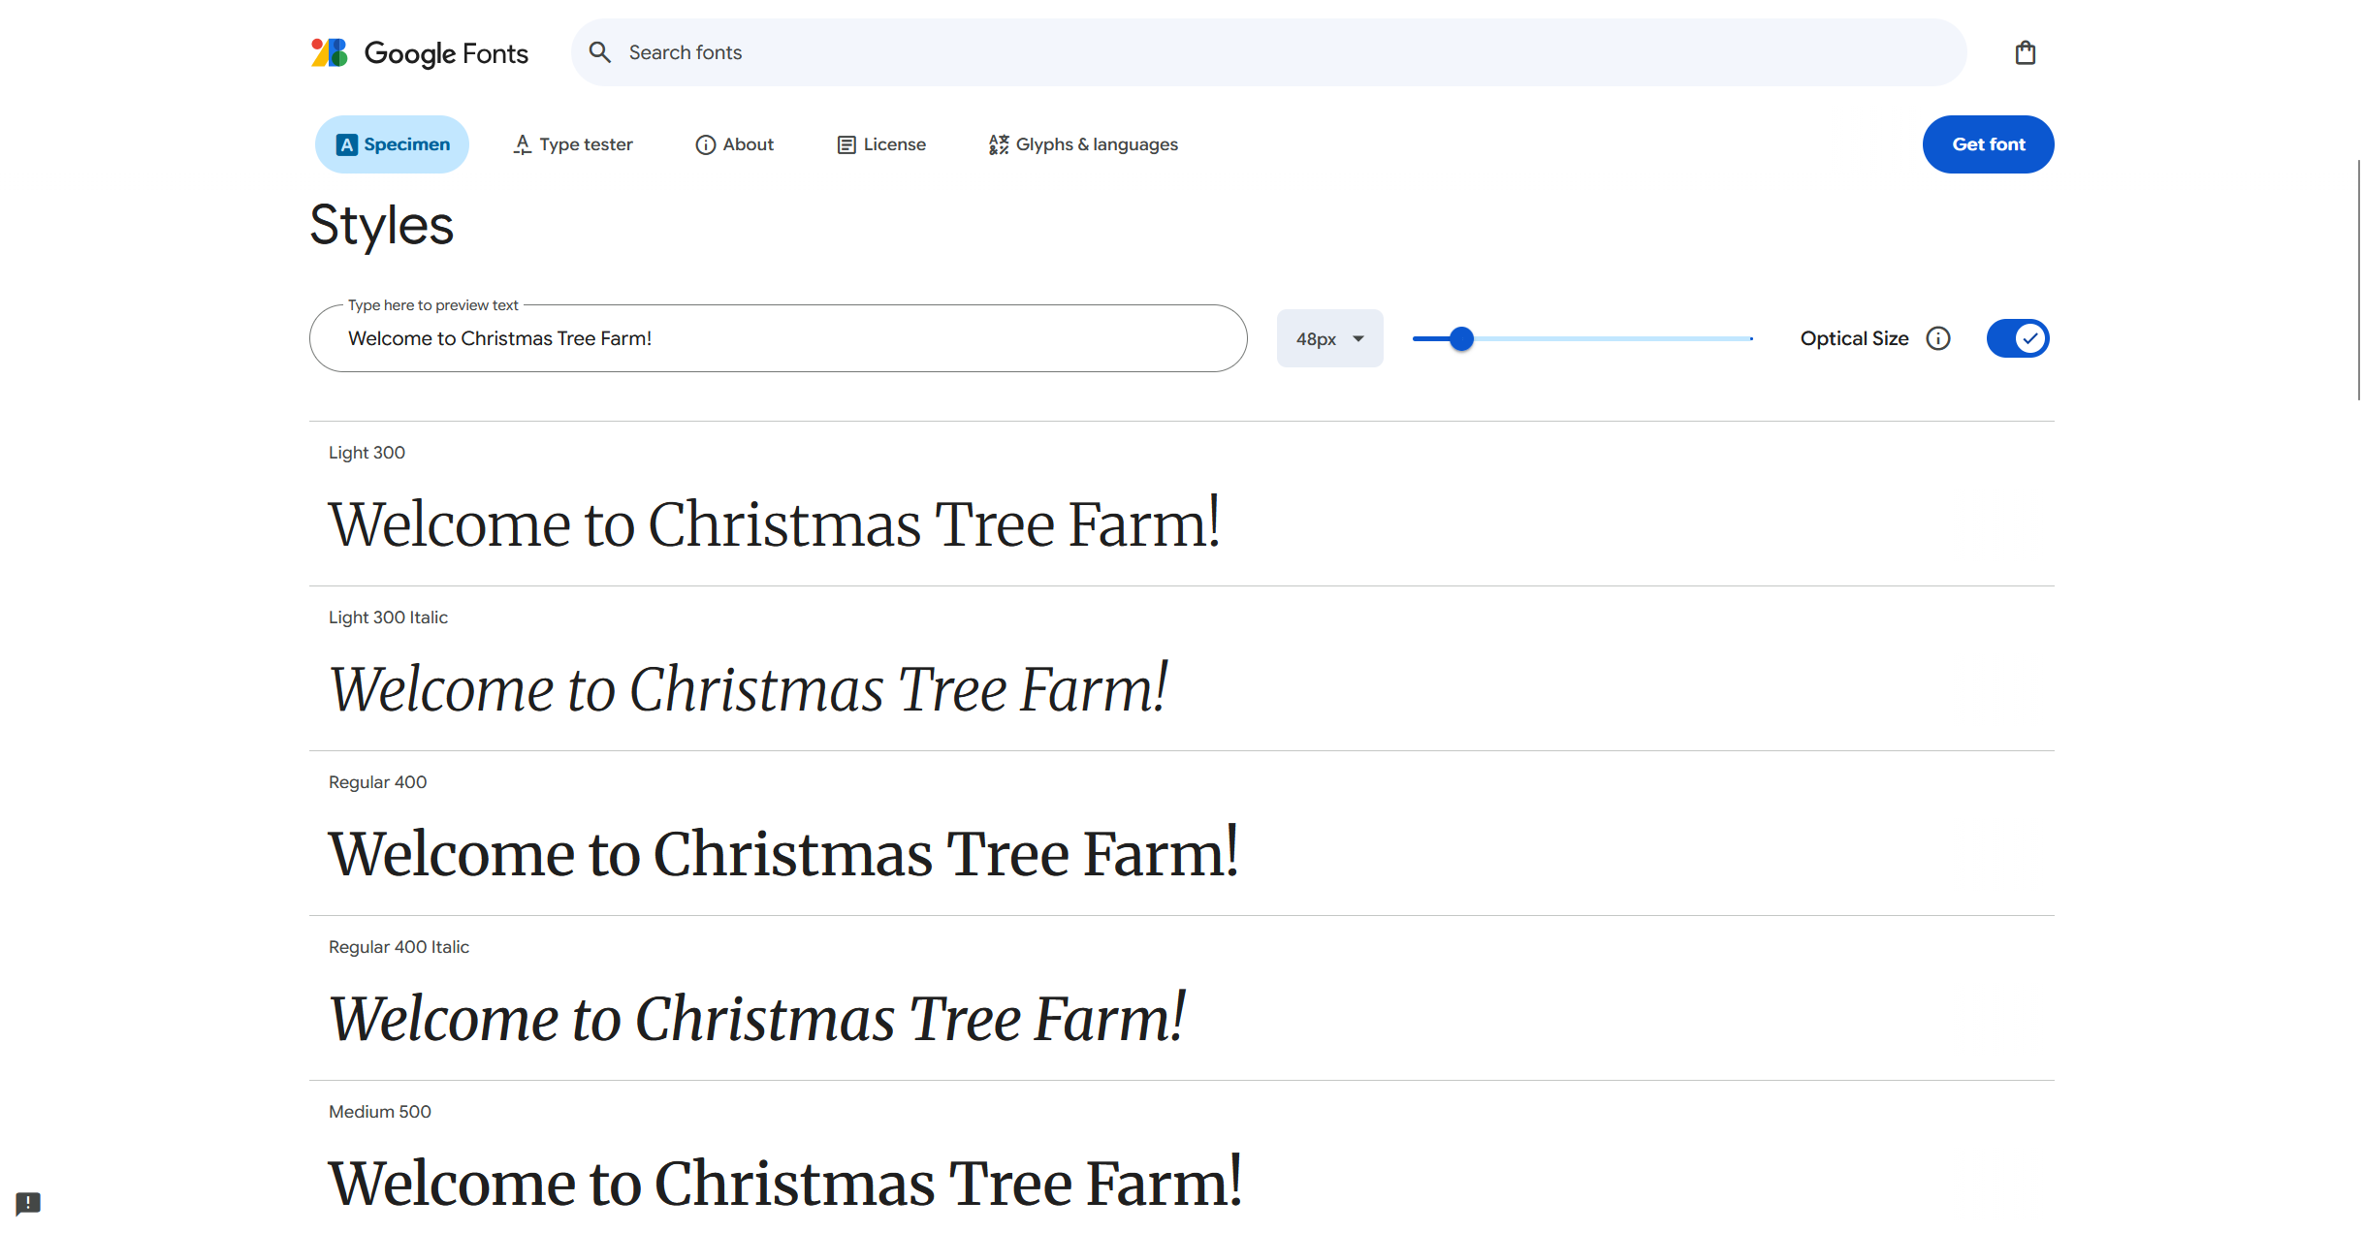
I decided to go with Merriweather because of its formality and traditional feeling. My ideal users focus on a traditional experience that is centered around creating lasting memories. This font builds that “warm” feeling while still maintaining a confident presence that is not gimmicky. This font has a rustic feel to it which separates it from more corporate attractions which the Xmas tree farm is trying to stray away from. This font also has excellent readability that is easily seen on smaller screens, allowing our ideal user to quickly scan for prices, hours and the location without wasting time.

Body Text: Open Sans
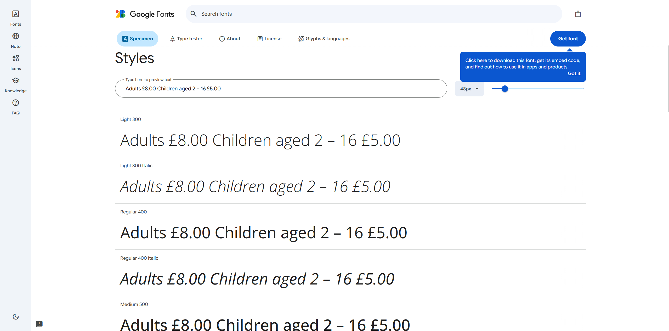
Next, I decided to choose Open Sans for the rest of the body text because this encompasses more of a friendly format. This makes up for Merriweather being more “professional” based therefore further solidifying a warm and family-friendly experience. It also has a flexible number of weights which will help with our list hierarchy for concession prices, ticket prices and attractions at the farm. The font is also spaced out to ensure maximum clarity for our ideal user since they want to have the important information readily visible. These gaps allow for quick and easy visualizations on mobile devices which is where most of our ideal users will be viewing the website on.

