Ethan Perdieu
December 8th, 2024
CIT-35600
Hardening with CIS Benchmarks

Windows Server 19 CIS Benchmark
Section 1.1 – Password Policy

The password policy settings from the CIS benchmark enforce password history, maximum and minimum password age, length, complexity and storing passwords using a reversible encryption to be disabled. The optimal settings in accordance with the CIS benchmark are listed in the picture below. This was the first hardening I decided to do on my system because this is one of the most common entry ways into someone’s computer. The default domain settings offer zero protection or requirements when it comes to password settings which would be a high threat vulnerability.

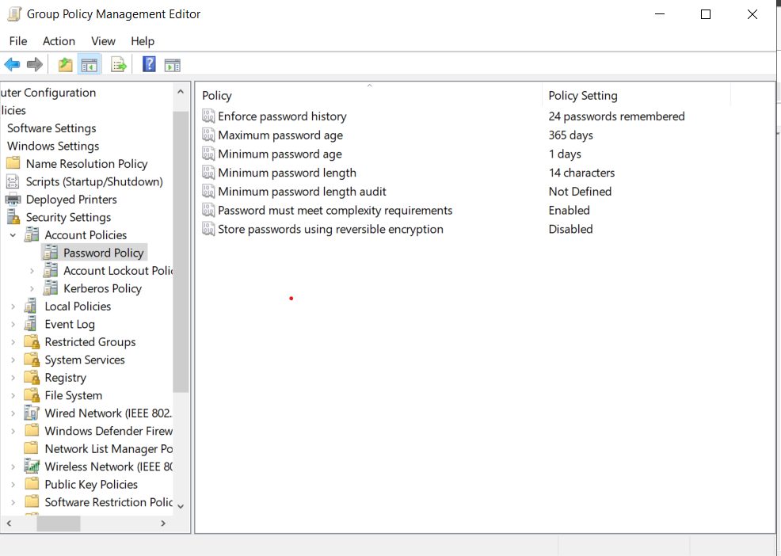
Section 1.2 – Account Lockout Policy

This second password policy helps secure access to a system because it sets an account lockout duration, threshold, allows the administrator’s account to lockout and reset the account lockout counter. I chose this because it is again a password policy, which is a very common entry point. It also stops attackers from using a brute force attack method by attempting all credentials into their system. Allowing the administrator account to be able to lockout is one of the upmost importance problems when it comes to securing a system. If an attacker was able to brute force an administrator account, then they would have major access to the domain controller and the policy settings.

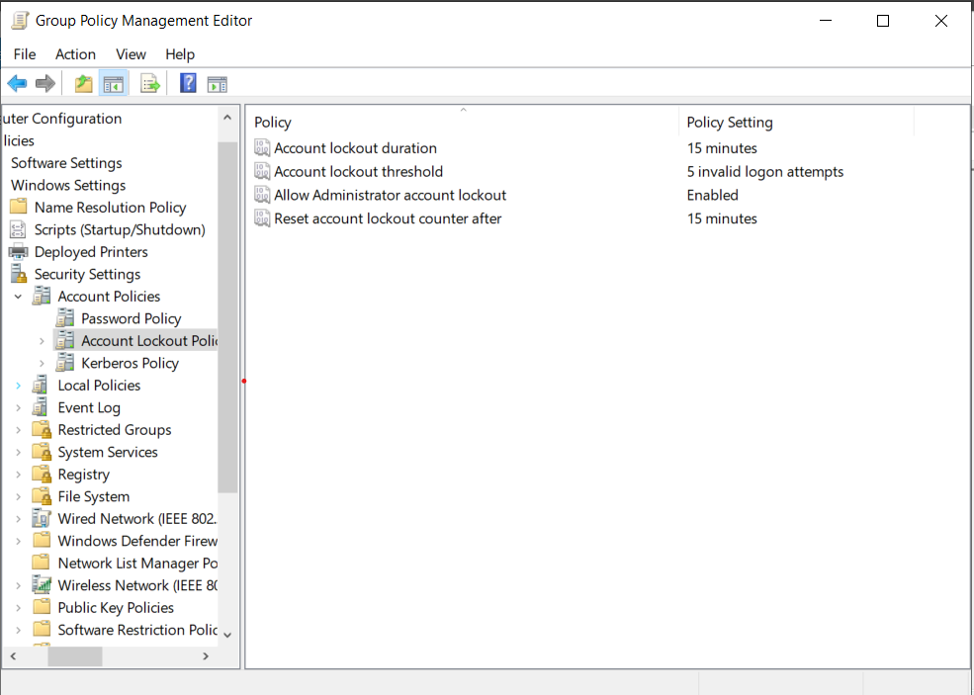

Section 5.1 – Ensure ‘Print Spooler (Spooler)’ is set to disabled for Domain Controller
This service handles interactions with printers in the Domain Controllers level and is recommended to be in the state disabled. This mitigates vulnerabilities such as the PrintNightmare vulnerability (CVE-2021-34527). This allows attackers who successfully exploit this vulnerability to execute arbitrary code with system privileges. This means the attacker can modify system files, install various malicious software or delete files. I chose this because experienced hackers can have easy access to all the computers data because this is already a known vulnerability that can easily be replicated.

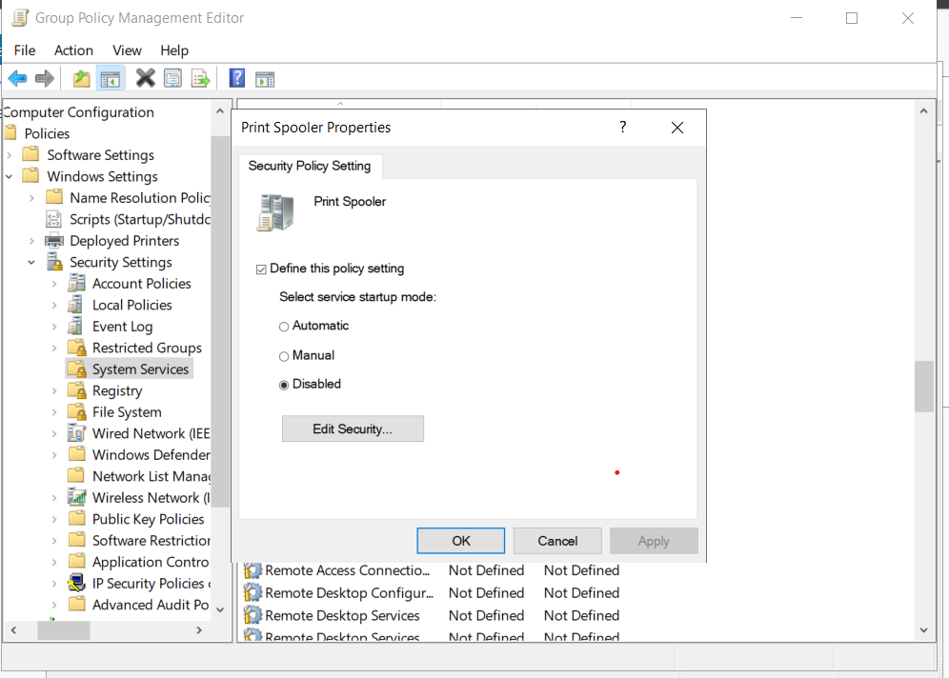

Section 5.2 – Ensure ‘Print Spooler (Spooler)’ is set to disabled for Member Server
This service is very alike to the previous section because it disables spools print jobs and interactions with printers on the Member Servers level. Once again, this protects against the PrintNightmare vulnerability (CVE-2021-34527) and other attacks against this service. Along with being able to delete data, it can also create new accounts with full user rights. This was chosen since it again is a known vulnerability, and if it did not work in the domain controller, then they may try against a member server.

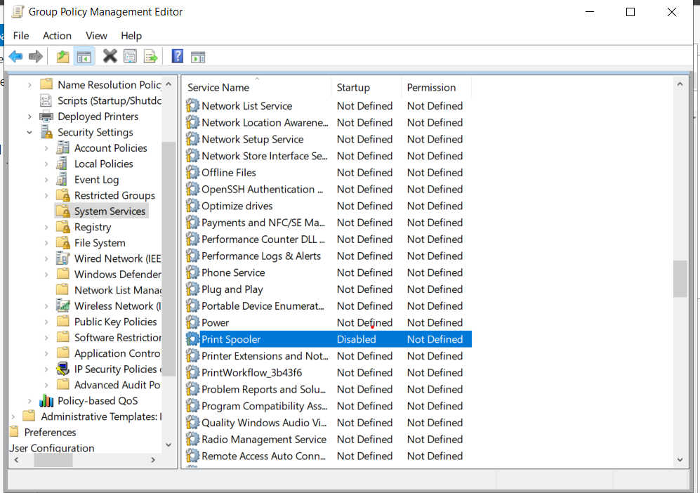

Section 9.1 – Domain Profile Windows Defender Firewall
This section ensures various settings when pertaining to the Windows Firewall for the domain profile. Firewall settings such as the state, inbound connections, notifications, logging names, logging size limit, logging dropped packets and logging successful connections were configured. I chose this section because a firewall can protect a system from outside connections and permit the connections wanted. If these services were not enabled for the domain profile, then that gives attackers an easier way to exploit a weakness in a network service. Below are the configurations recommended by the CIS Workbench.
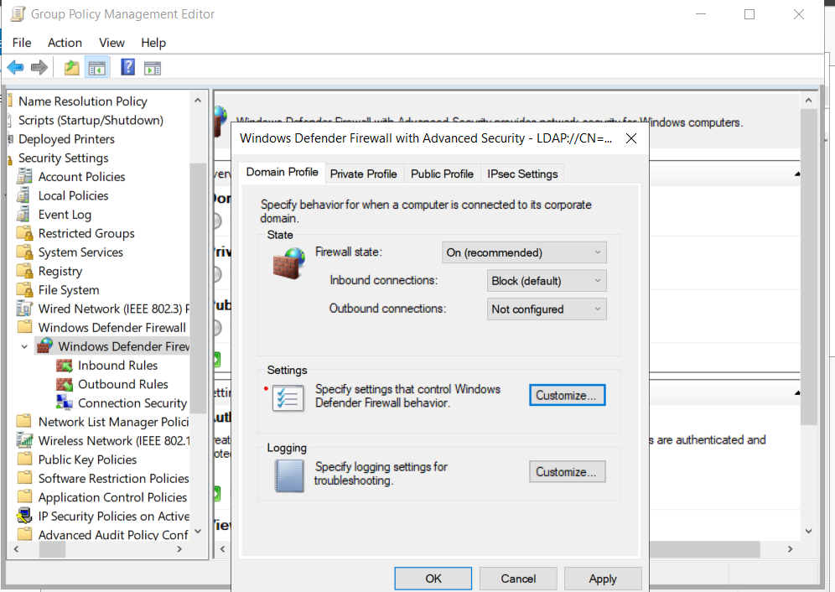
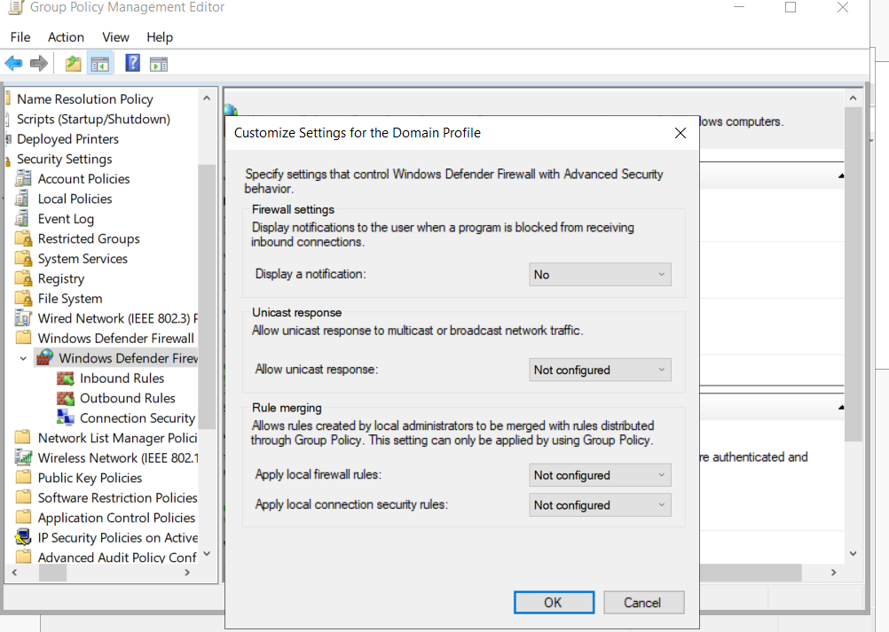
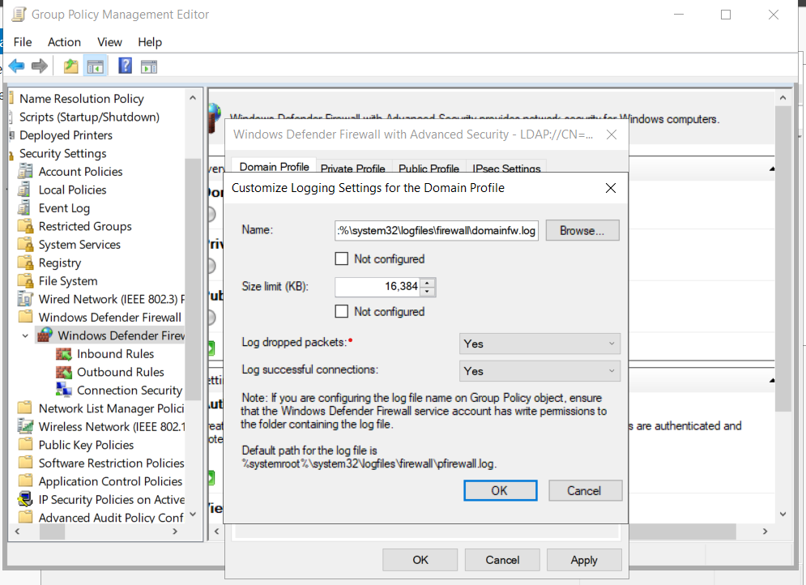

Section 17.1 – Account Logon
This service reports the results of validation tests on credentials submitted for a user account logon request. These events occur on which computer is authoritative for those credentials so local accounts the local computer is authoritative etc. This allows the systems to log both successful and unsuccessful login attempts. I chose this policy because it helps when investigating security incidents such as brute-force attacks or other malicious login attempts. This pairs greatly with the previous policy, 1.2, because it allows for easier detection of those attacks. This section also covers Domain Controller only polices such as logging of Kerberos authentication TGT requests and the results of events generated by Kerberos authentication TGT requests. Kerberos is the protocol used for network authentication, so it is another great resource to have when detecting intrusions since it is commonly used by the AD.

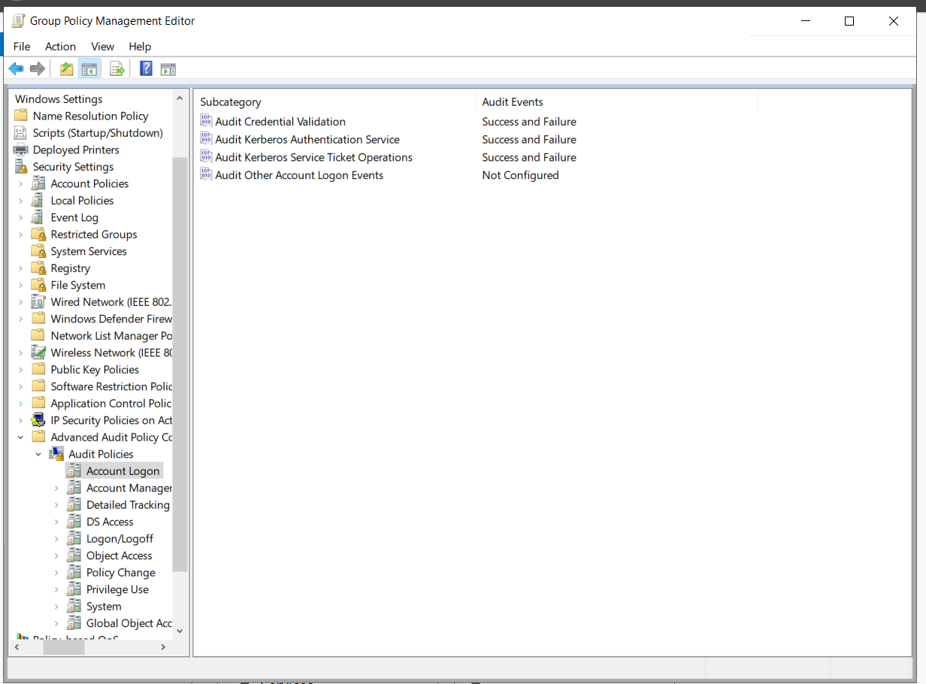

Section 17.2 – Account Management
This policy audits events generated by changes to application groups and account groups. These alterations can be alteration of a member, a member is added or removed, access to password hashes or API checks, and both local and global account changes. These logs are important for incident investigation by giving important information on new users and changes. This easily helps pinpoint the area of vulnerability and minimizes the time the attacker has access to the system. Below is what is expected of the CIS Workbench.

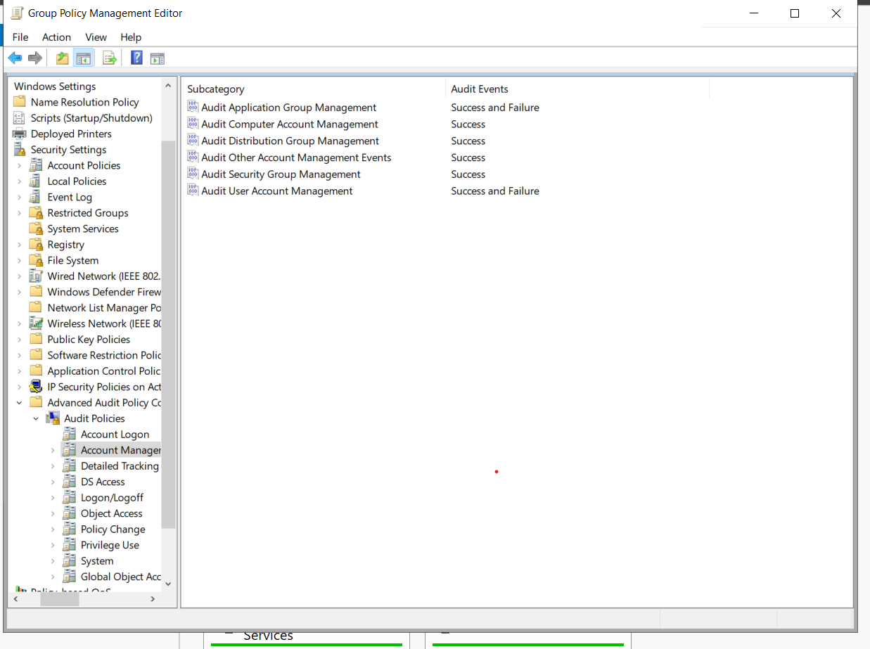

Section 17.3 – Detailed Tracking
This policy setting allows auditing of an external device when it is detected by plug and play. This is great for alerting IT staff if unapproved devices are plugged into certain devices. If this policy were not configured, incidents involving an external device such as hard drives can steal information would go undetected. The policy also audits if new processes are being created or assigned. This audits malicious software execution and unauthorized processes that may go undetected.

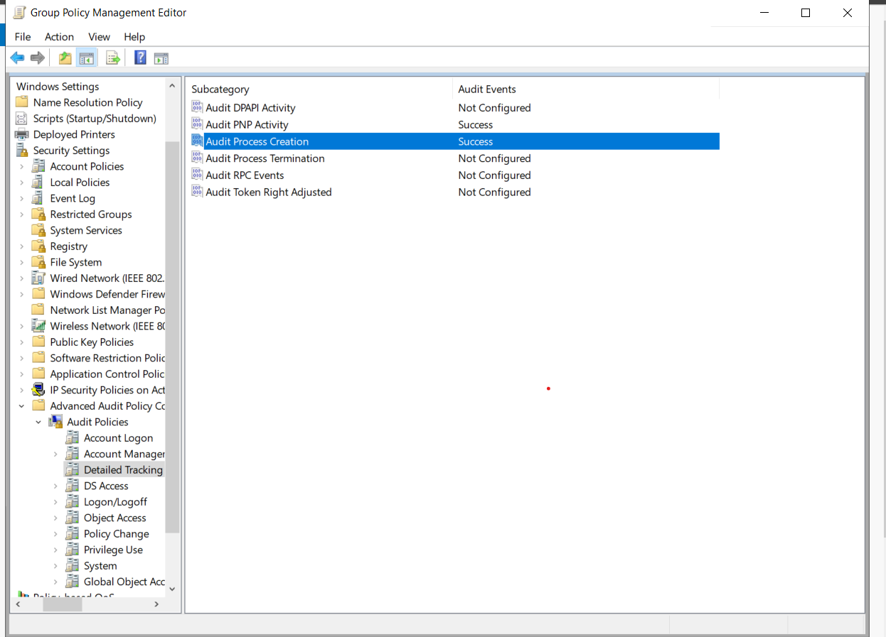

Section 17.8 – Privilege Use
This sections from CIS Workbench ensures that ‘Audit Sensitive Privilege Use’ is set to be Success and Failure. Sensitive privileges are considered such as, acting as a part of the OS, back up files and directories, debug programs, security audits, load and unload of device drives, restore files and directories and many more. These processes are all highly sensitive areas that contain valuable information. Having these actions audited can once again help pinpoint the vulnerability and stop the attacker.

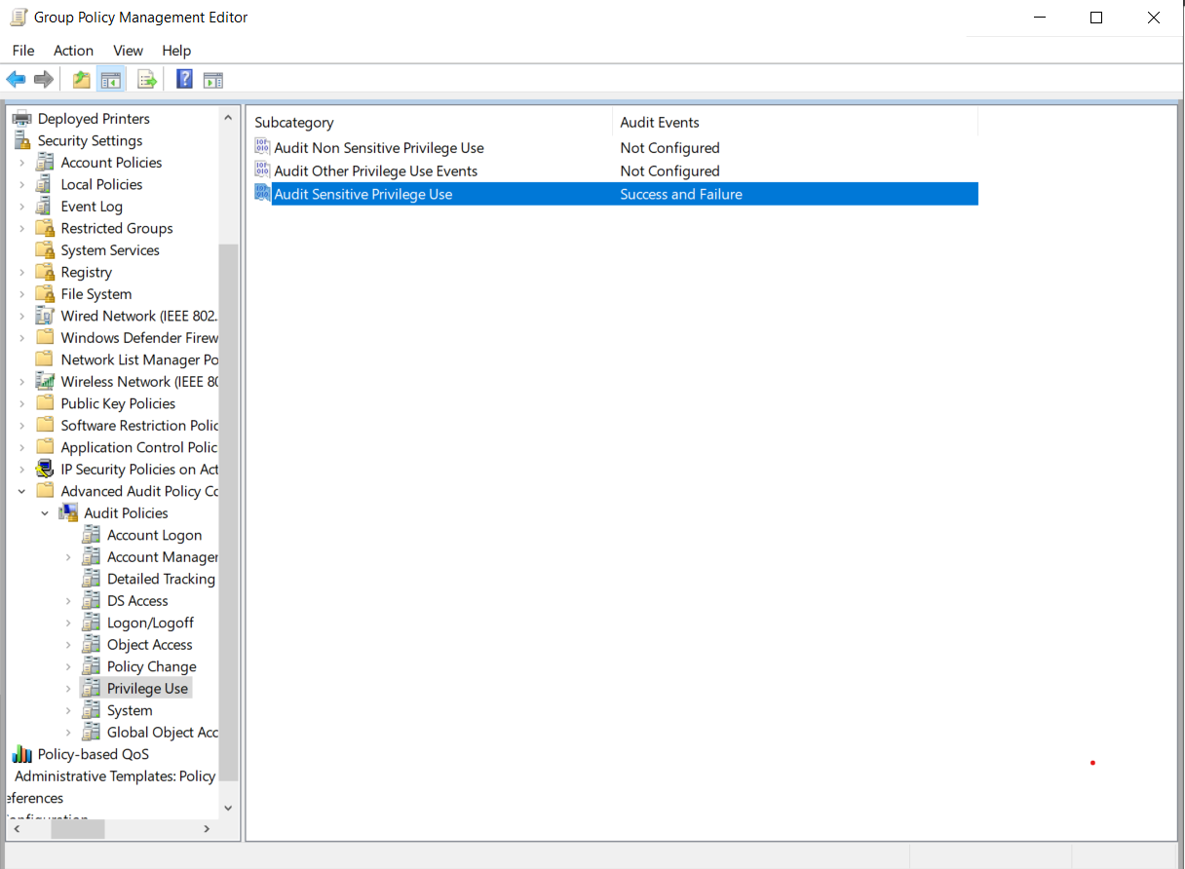

Section 19.5 – Start Menu and Taskbar Toast Notifications
Toast Notifications are the messages that appear on the screen to give the users important information or updates from various applications. When these messages are enabled, notifications can display sensitive personal or business information when the device is unattended. In a workplace or any other location, toast notifications offer an easily exploitable vulnerability that anyone with zero hacker experience can take advantage of. To mitigate this vulnerability, in policy settings it is best to ensure ‘Turn off toast notifications on the lock screen’ is set to enabled.

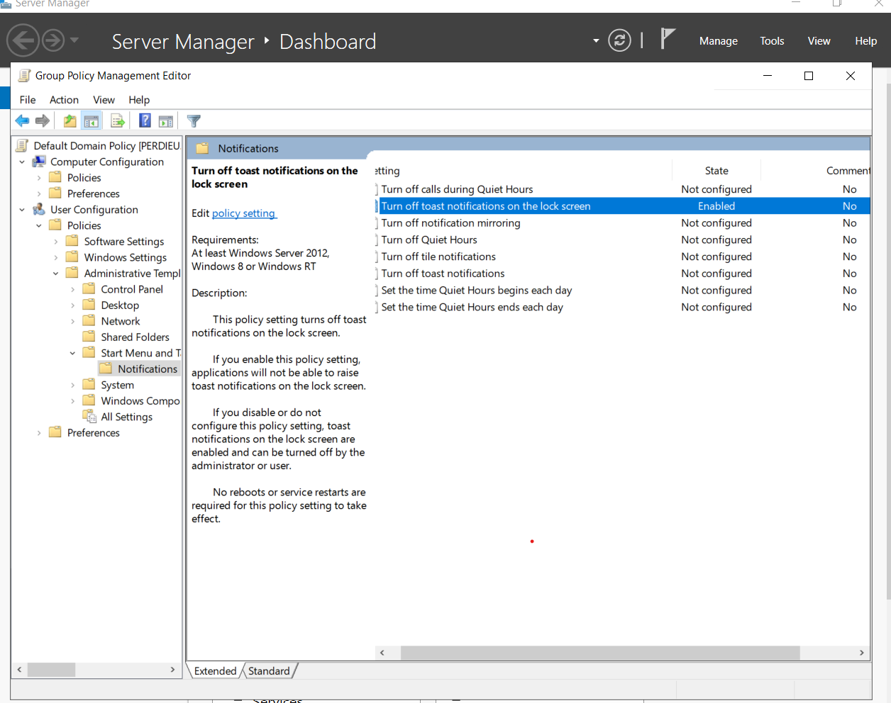

Group Policy Settings Screenshot
Accessed by running the command: gpresult /r
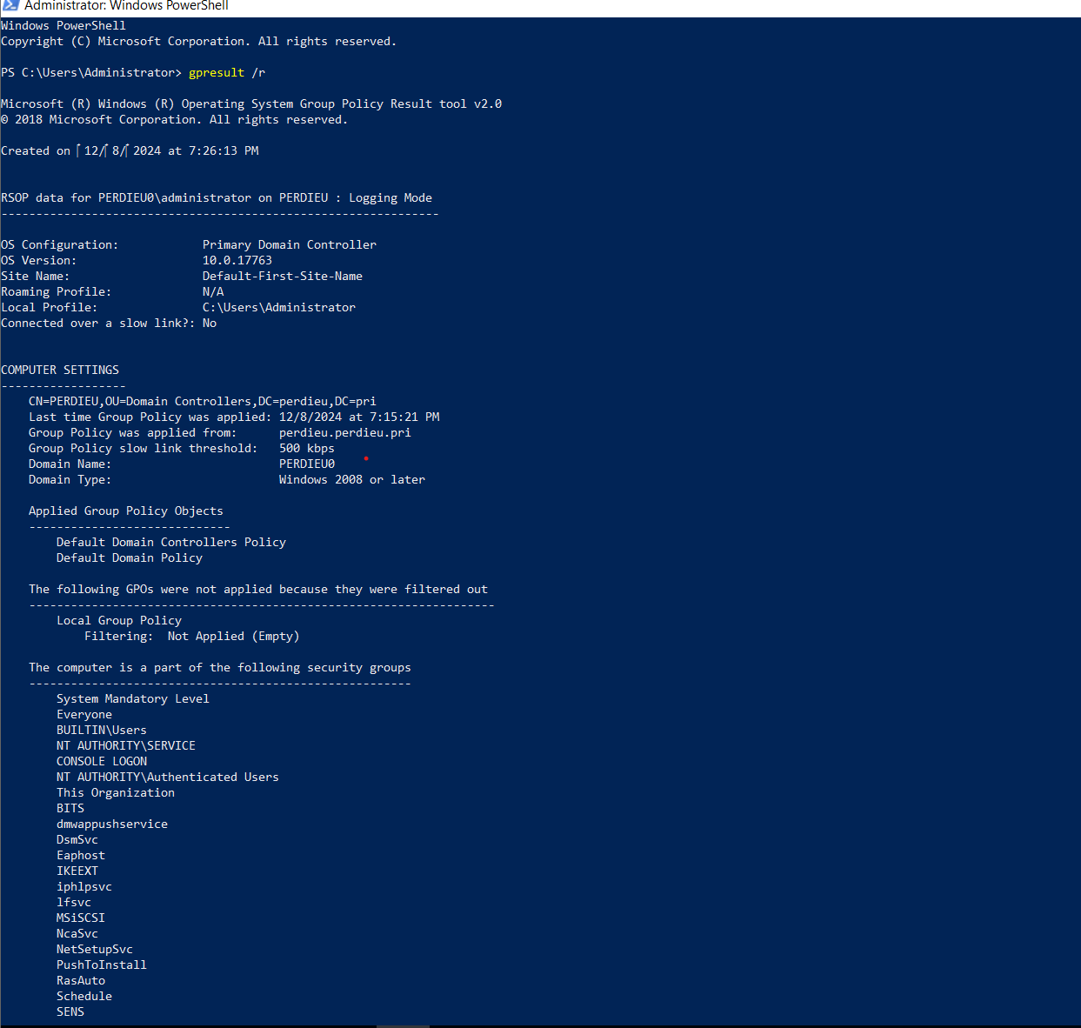
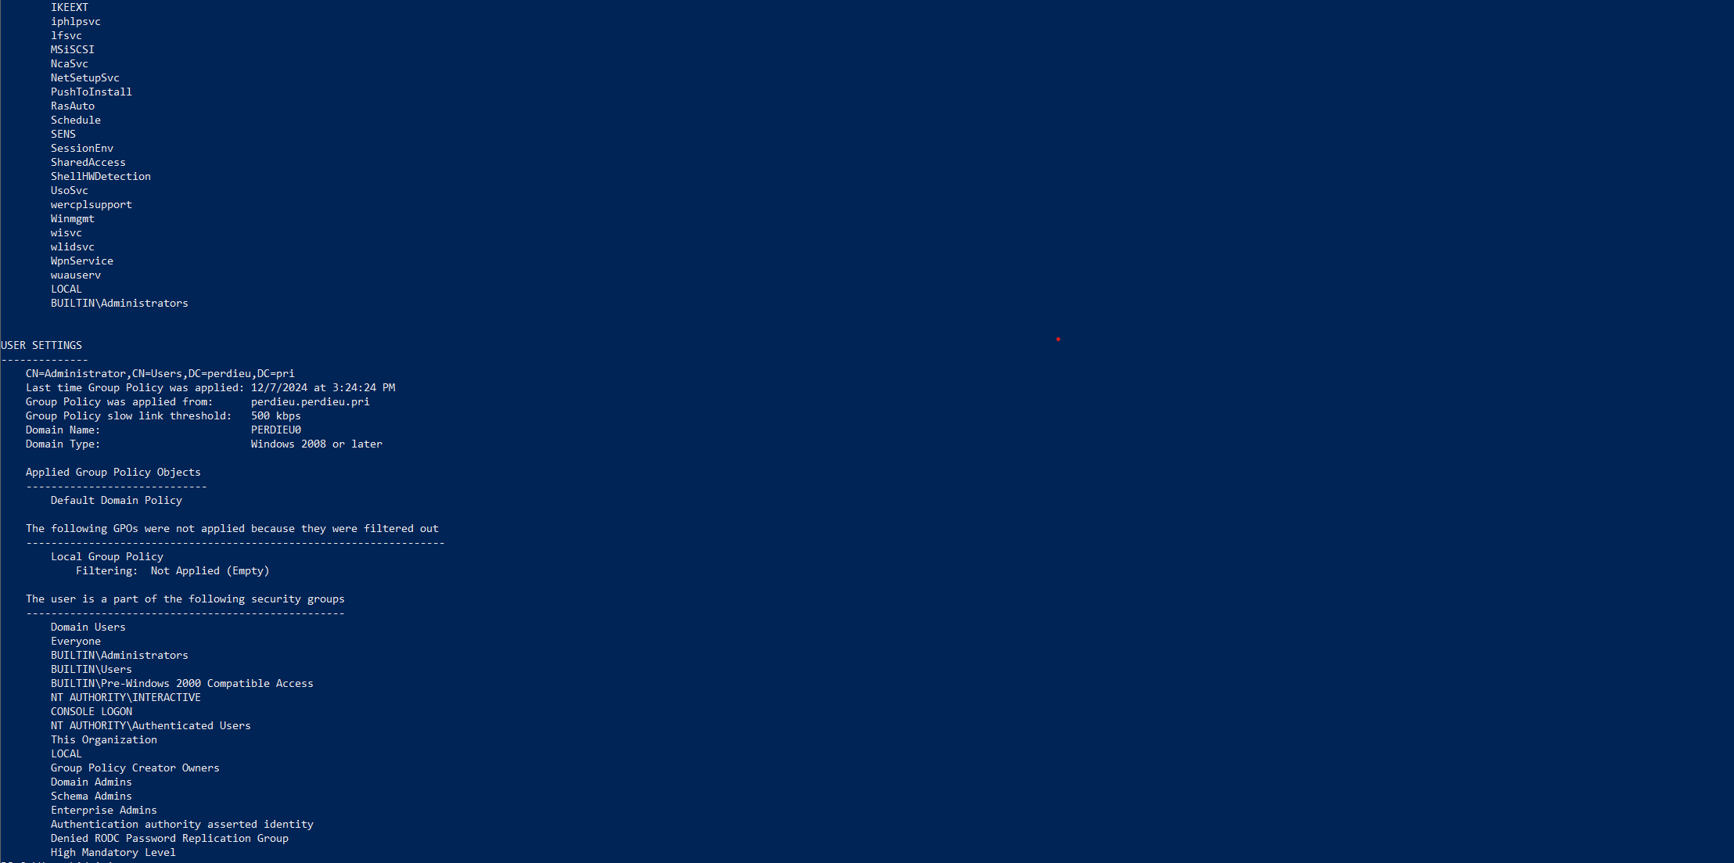
Ubuntu Linux CIS Benchmark
Section 1.2 – Package Management
Package managers implement GPG key signing to help verify package integrity during the installation process and ensure package manager repositories receive the latest patches and updates. This ensures updates are obtained from a valid source to help prevent spoofing and inadvertent installation of malware and prevent rouge repositories. The last policy ensures updates, patches and additional security software are installed during the setup. These newer patches can contain security enhancements, vulnerability fixes and more tools than can help keep them secure.

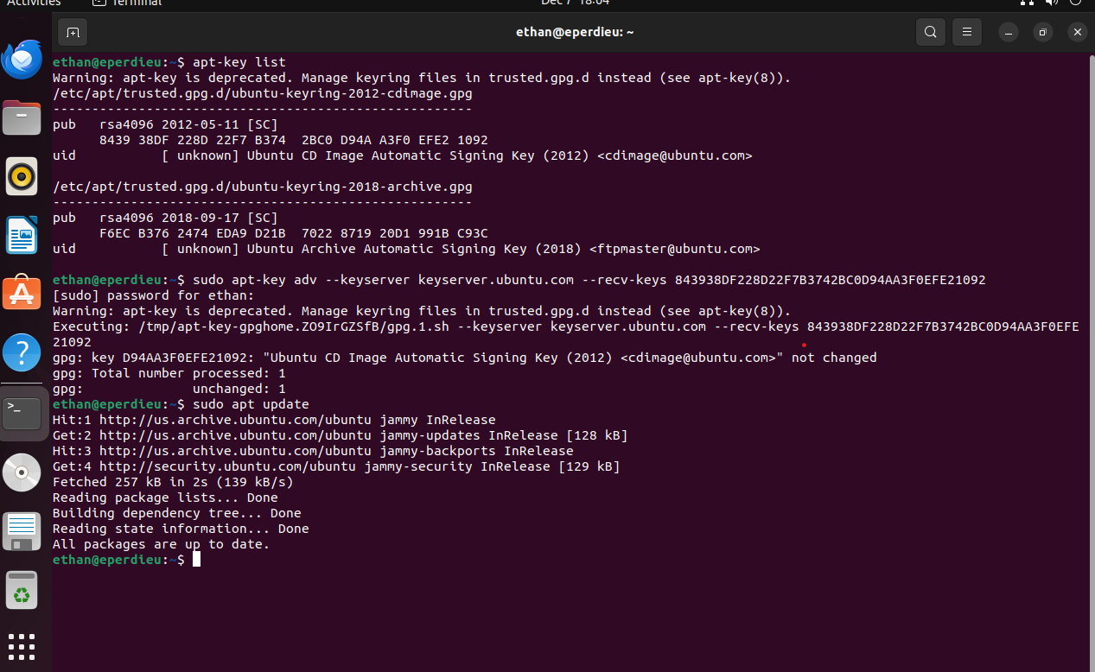

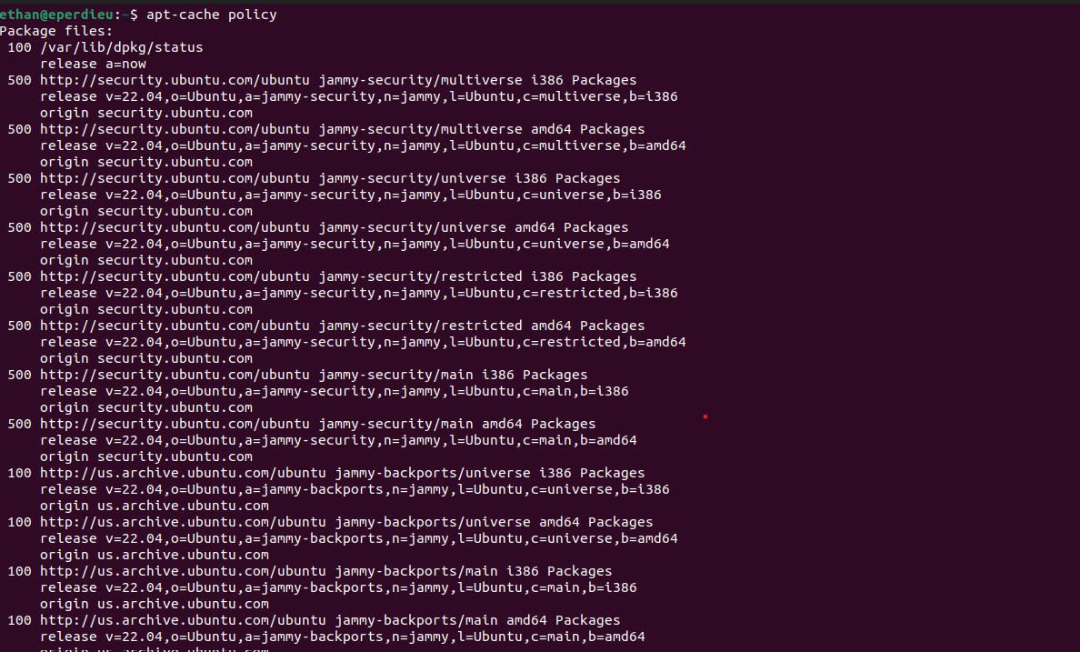

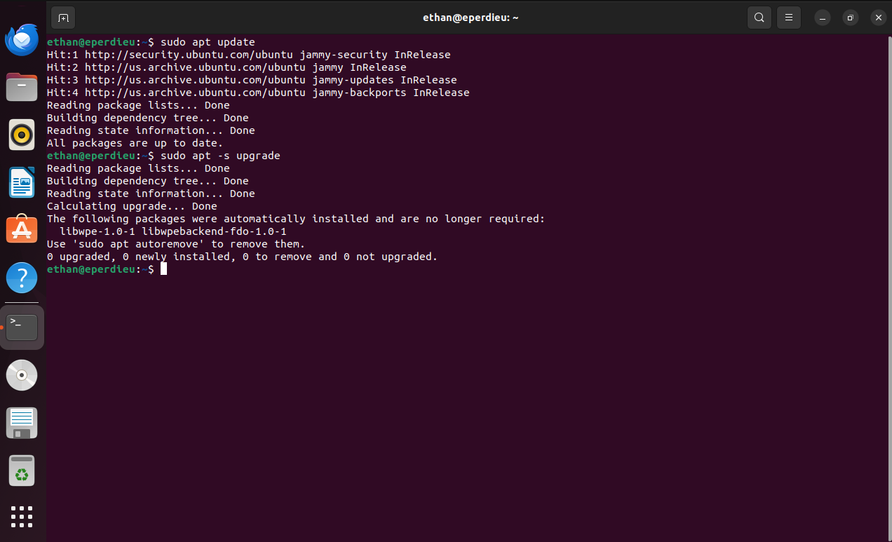

Section 1.3 – Mandatory Access Control
This process helps configure AppArmor which provides a MAC system that augments the default Discretionary Access Control (DAC) model. This helps automatically limit the damage that software can do to accessible files. I chose this process because it helps enforce access policies that do not deal with user permissions. As well, it again helps prevent unintended software damage and automatically limits access for third-party applications and services.

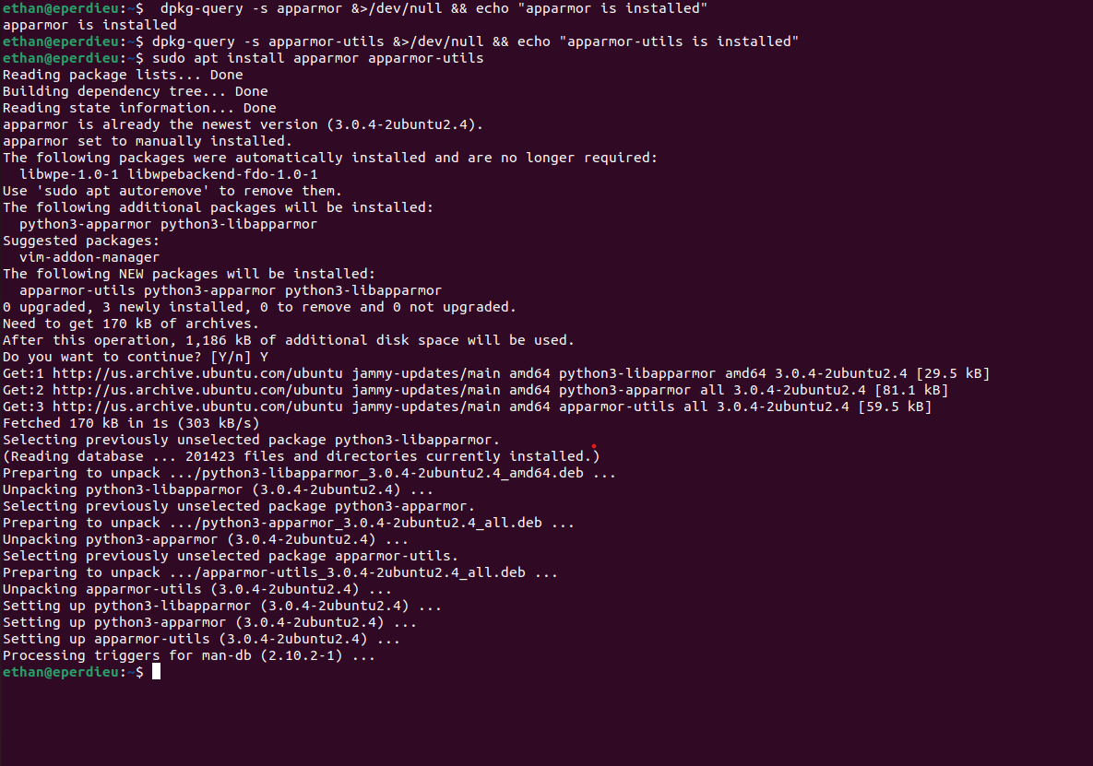

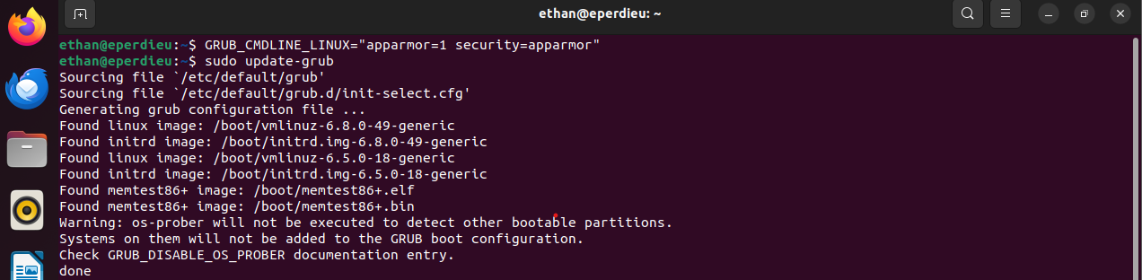

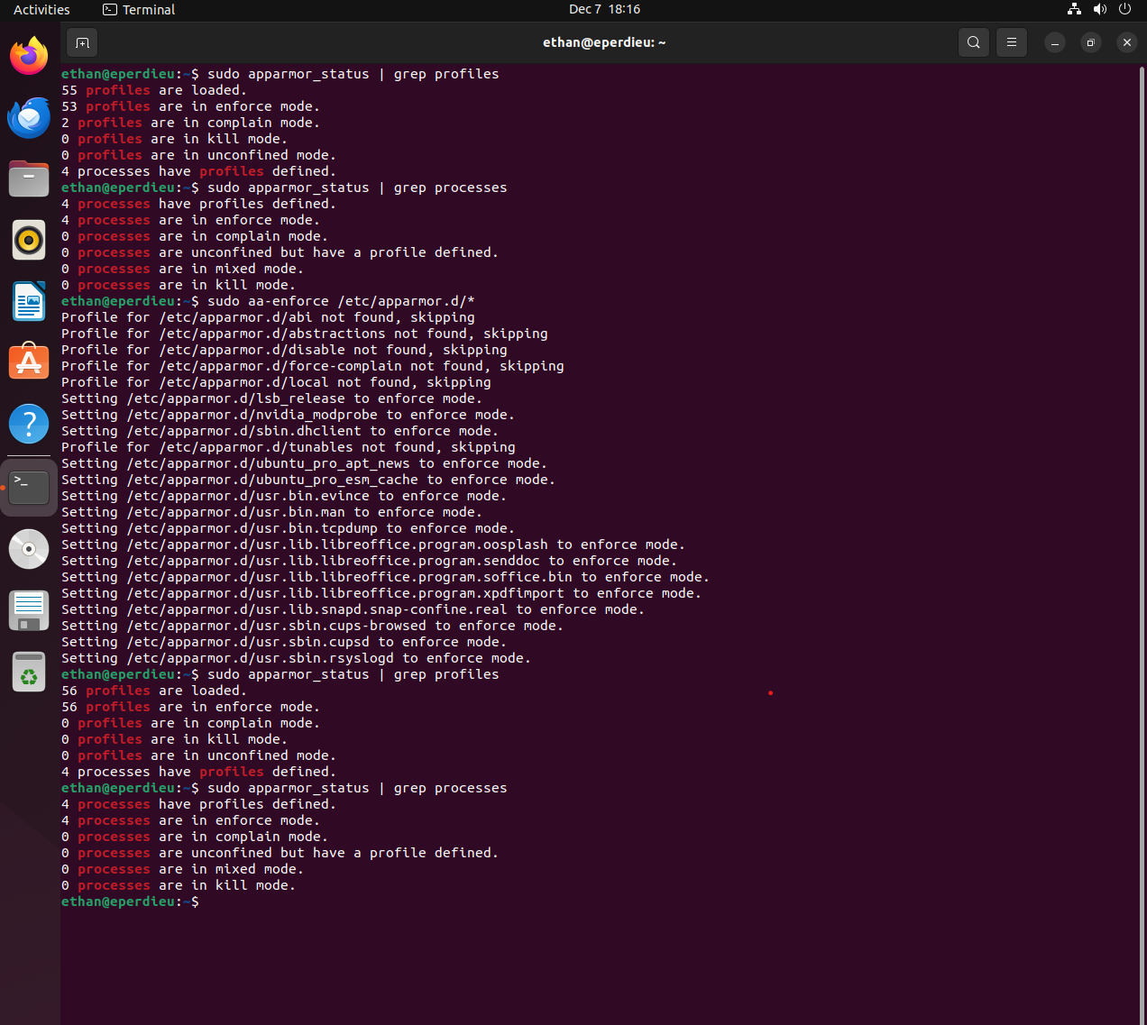

Section 1.4 – Configure Bootloader
This section focuses on securing the bootloader and its settings involved in those boot processes. Ensuring the bootloader has a password that will require anyone rebooting the system to enter before being able to set command line boot parameters can help prevent unauthorized personnel from having root access. This can help prevent weakening the security such as turning AppArmor off at boot time. The next section sets permissions to read and write for root users only, so non-root users can not see the boot parameters or be able to change them. This deters other users from being able to identify weaknesses found upon the boot.

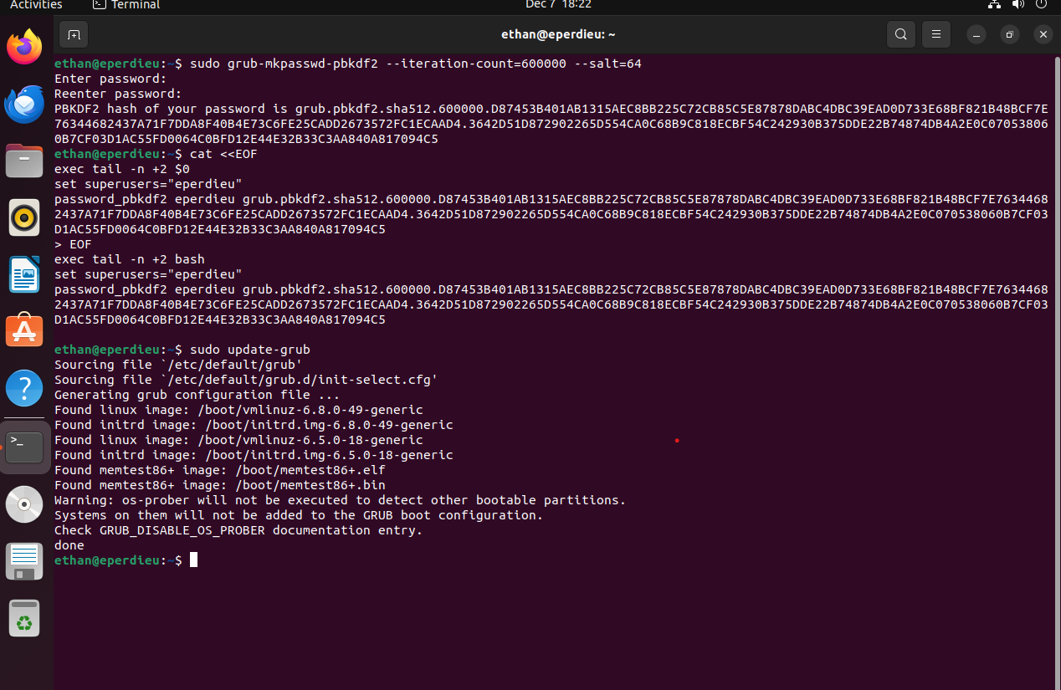

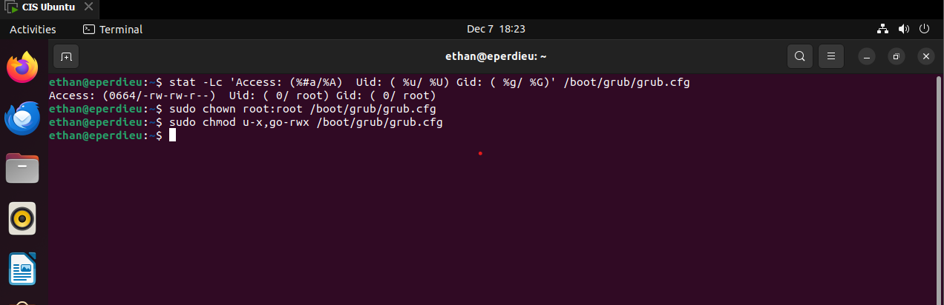
Section 1.5 – Configure Additional Process Hardening
This section focuses on various additional processes to help secure the system. The first subsection discusses a mitigation technique that randomly arranges address space of key data and areas of process. This makes exploits such as memory page exploits difficult to write because the memory is constantly shifting. The next two subsections restrict two processes being ptrace_scope and core dumps. If ptrace_scope is restricted, then it can limit the ability of a compromised process to reach other processes. This can help minimize the damage if a system does happen to get compromised. If a hard limit is set on core dumps, then it will prevent users from overriding the soft variable. The prelink program should not be installed because it interferes with AIDE because it changes binaries. If it is enabled or installed, then that increases system vulnerability if a hacker can infect a common library. Lastly, ensuring automatic error reporting is off so it can not collect sensitive data such as core dumps, and log files.

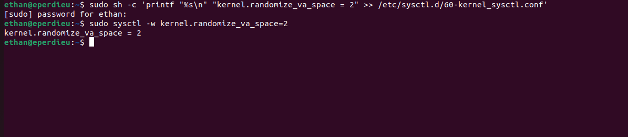

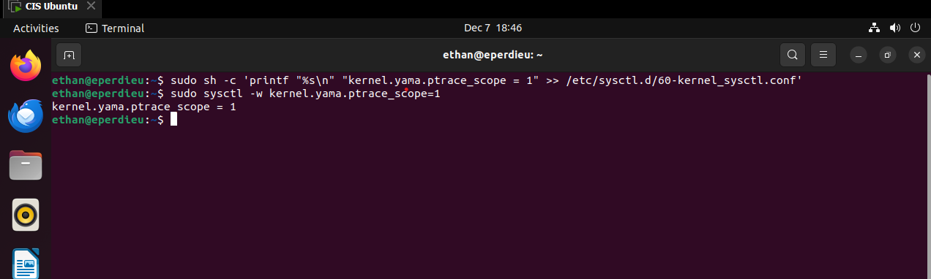

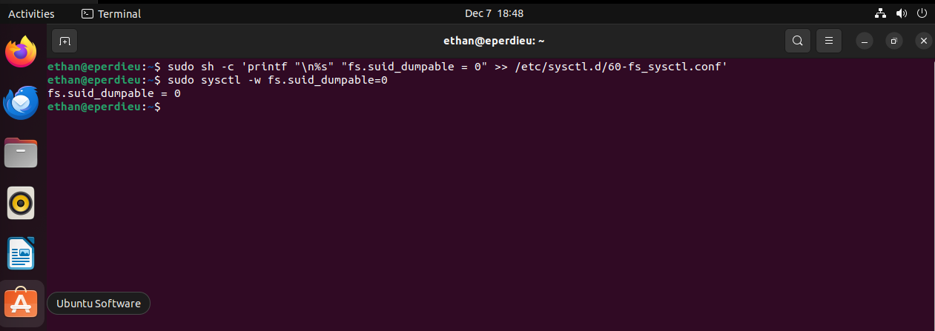

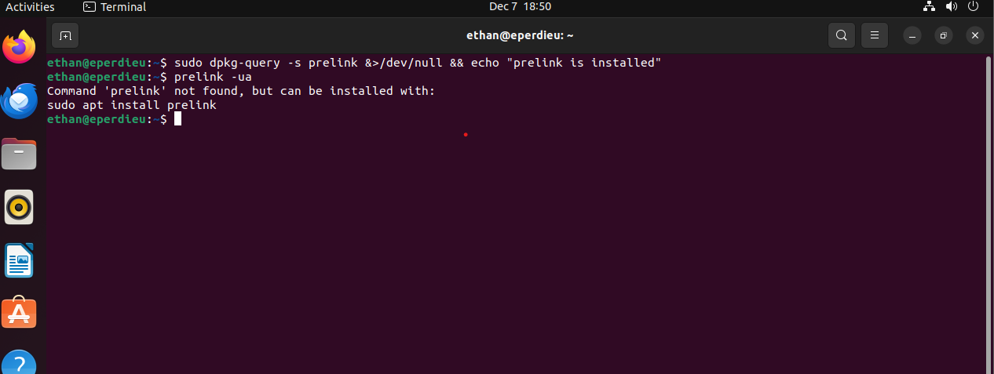

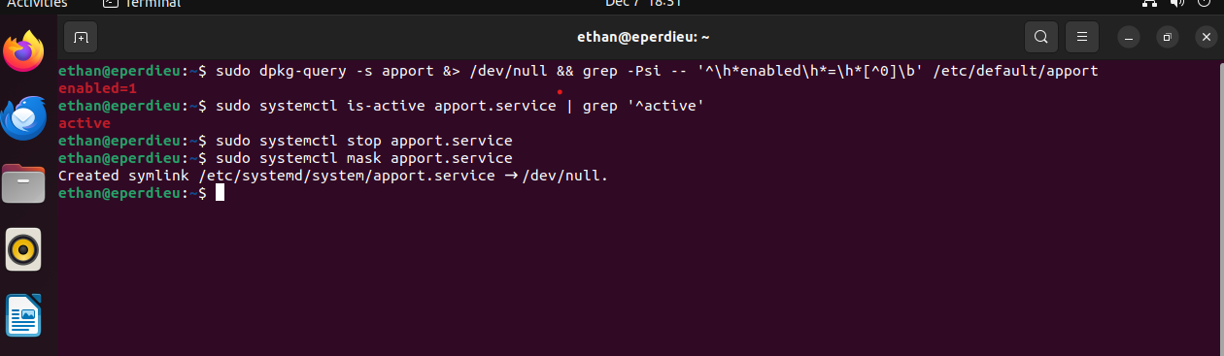

Section 2.2 – Configure Client Services
The focus of this section is making sure certain clients are not installed. Each of these clients either affects another service or is a vulnerability. The clients that should not be installed are NIS, rsh, talk, telnet, Ldap and ftp. The NIS client should not be installed because this client is insecure and is vulnerable to DOS attacks and buffer overflows. The rsh client is a legacy client so known vulnerabilities do not get fixed. The talk client and telnet client use unencrypted protocols for communication so it can easily be manipulated. Lastly, the LDAP client is to be removed because it is an unneeded potential attack surface.

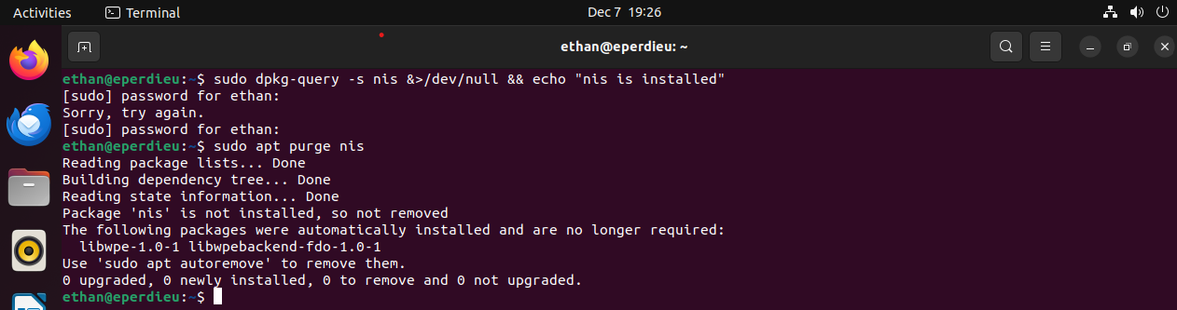

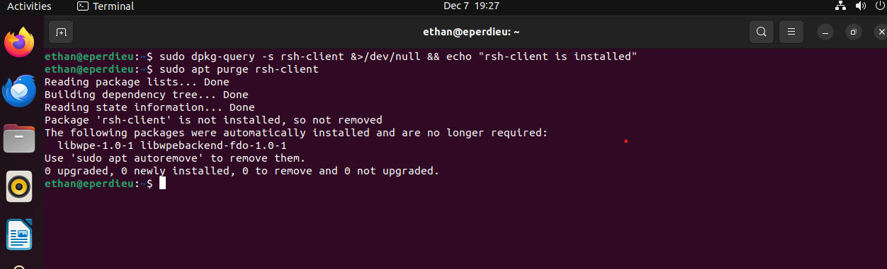

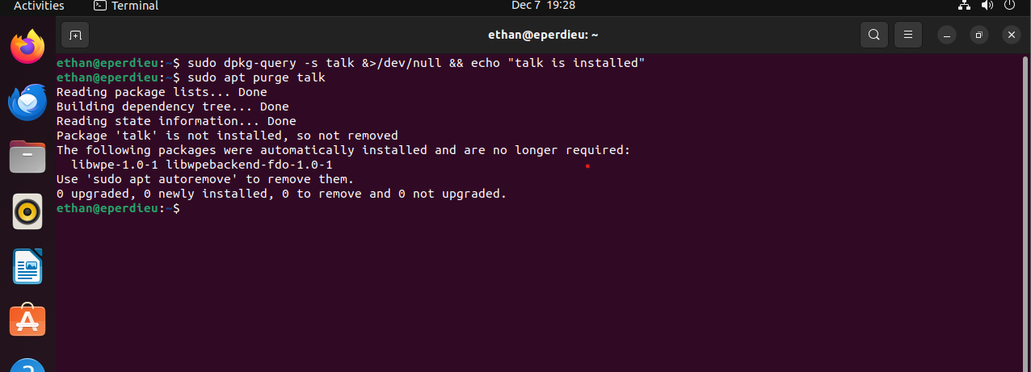
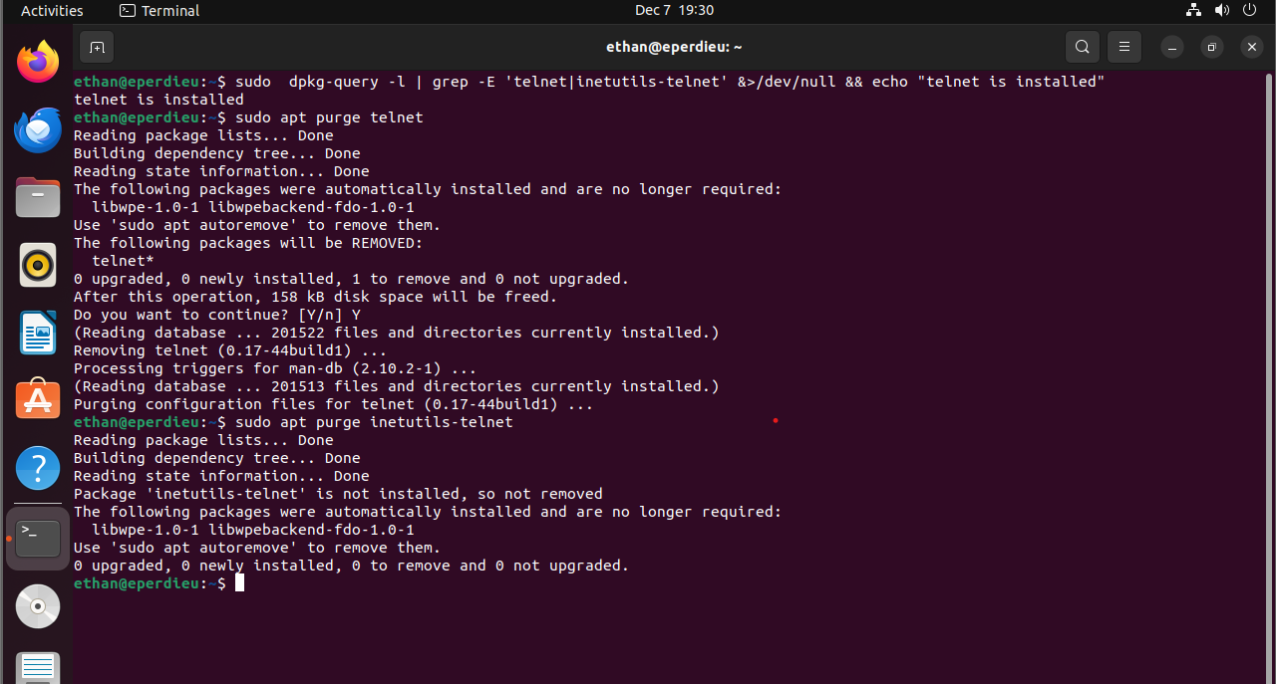

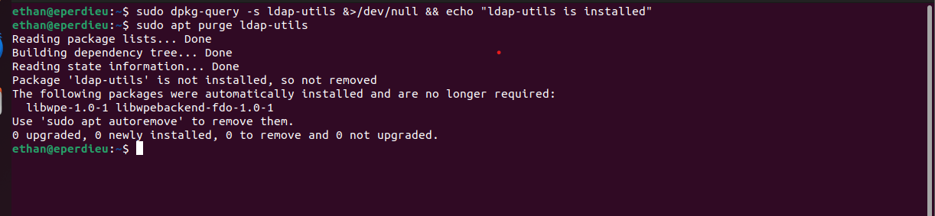

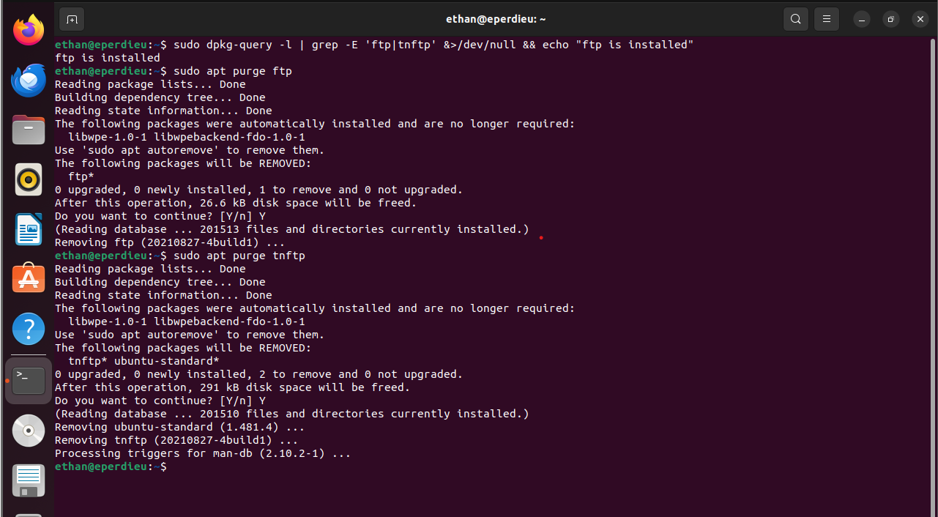
Section 3.1 – Configure Network Devices
This section focuses on unused network devices and disabling them to reduce the attack surface of a system. The first subsection is about ensuring the IPv6 is identified. IPv6 is the most recent version and is designed for additional security to support the growth of connected devices. I chose this so it can be on the most secure version of internet protocols. The next two sections ensure that wireless interfaces and Bluetooth services are not in use. Wireless interfaces should be disabled because they offer another attack surface for hackers. Ensuring Bluetooth services are not in use is important because of activities like bluesnarfing. That means attackers use a Bluetooth connection to steal information from other Bluetooth devices such as keyboards.

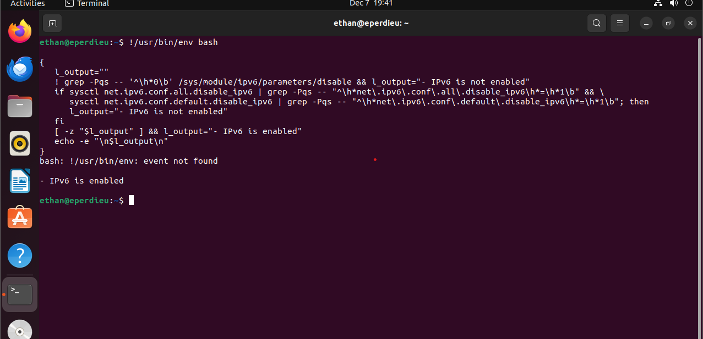
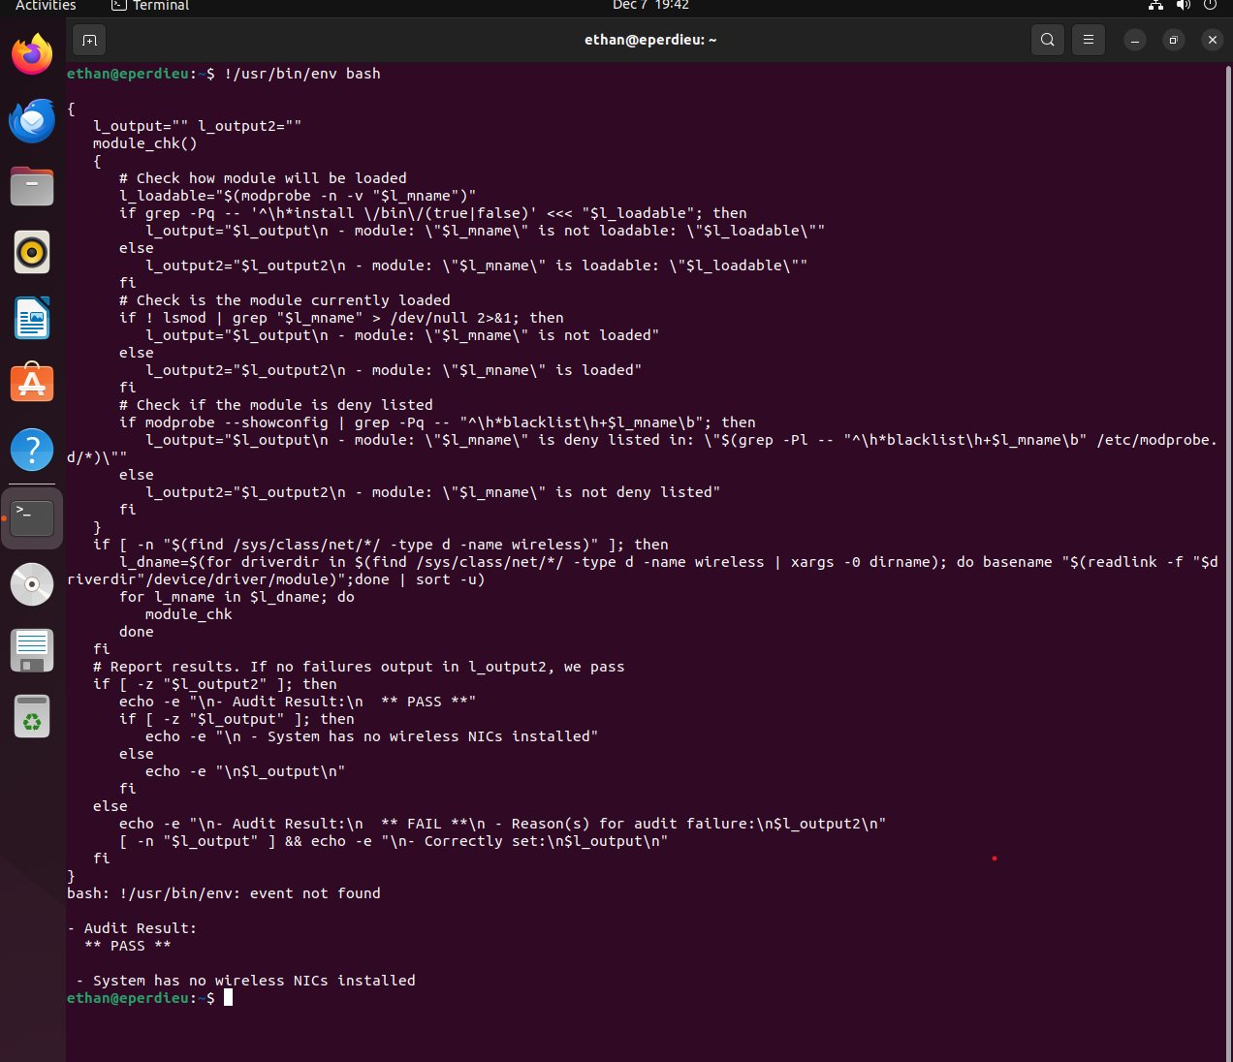

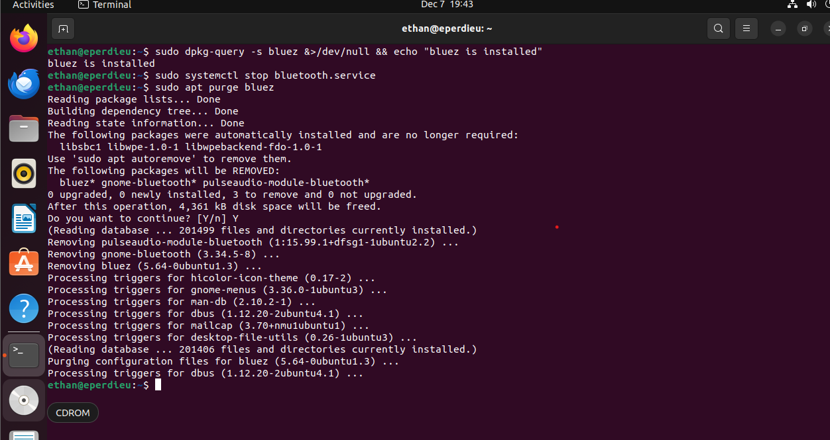
Section 3.2 – Configure Network Kernel Modules
The Linux kernel modules support network protocols which are not used very often and should be disabled if they are not needed. The four kernel modules that should be disabled are DCCP, TIPC, RDS and SCTP. All these protocols should be disabled to reduce the potential attack surface. The DCCP is a transport layer protocol that can give attackers access to congestion control so it should be disabled. The TIPC and RDS protocol can provide attackers with communication between cluster nodes. Lastly, the SCTP protocol should be disabled because there are similar functions such as TCP and UDP that offer more security.

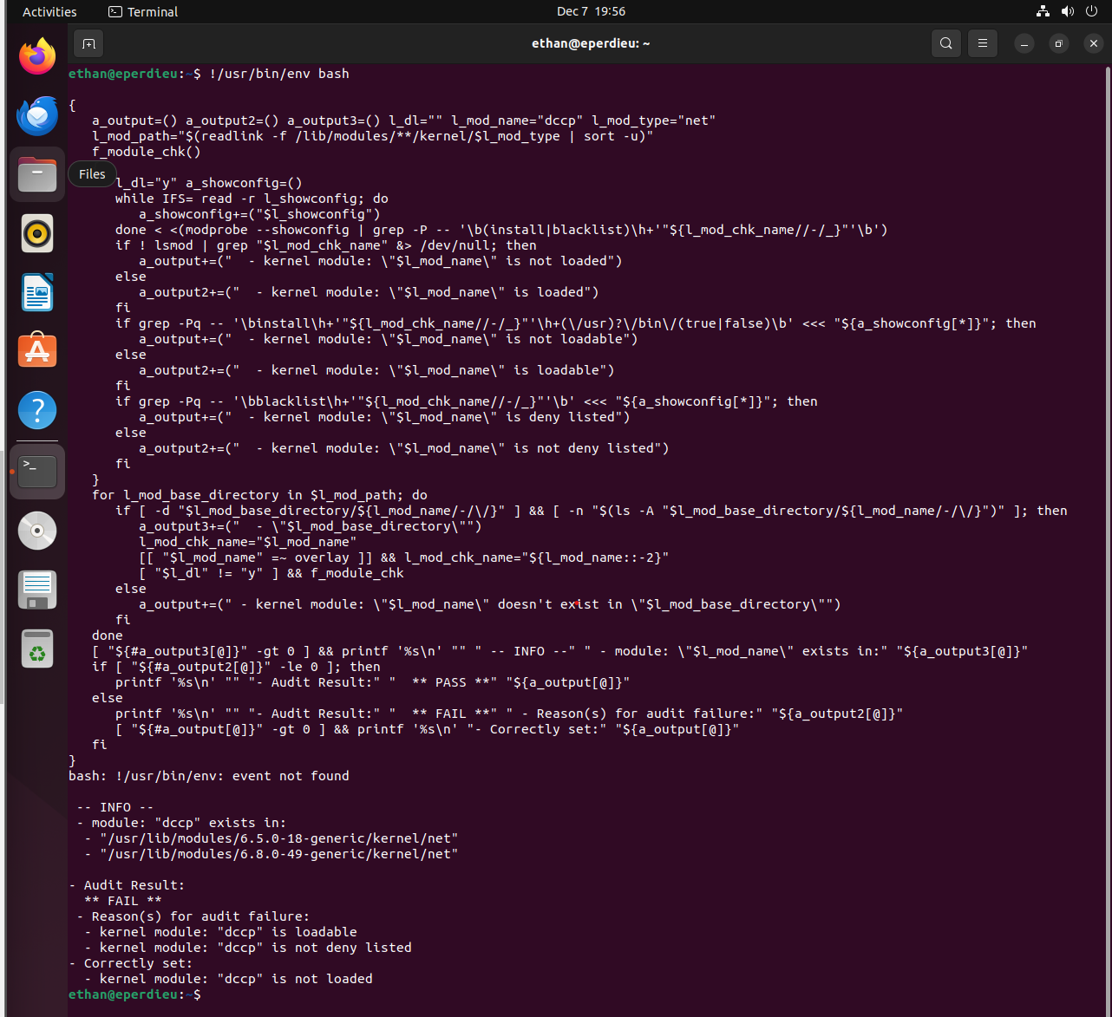
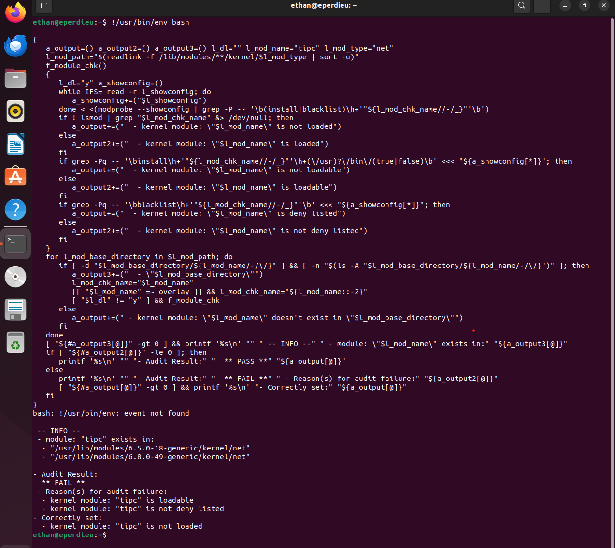

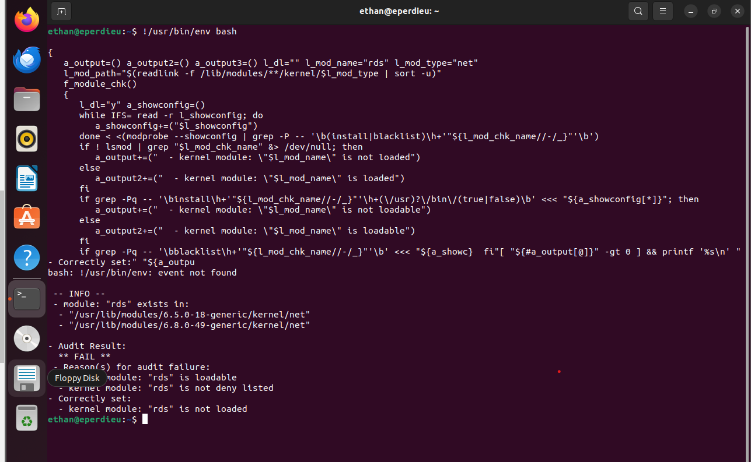
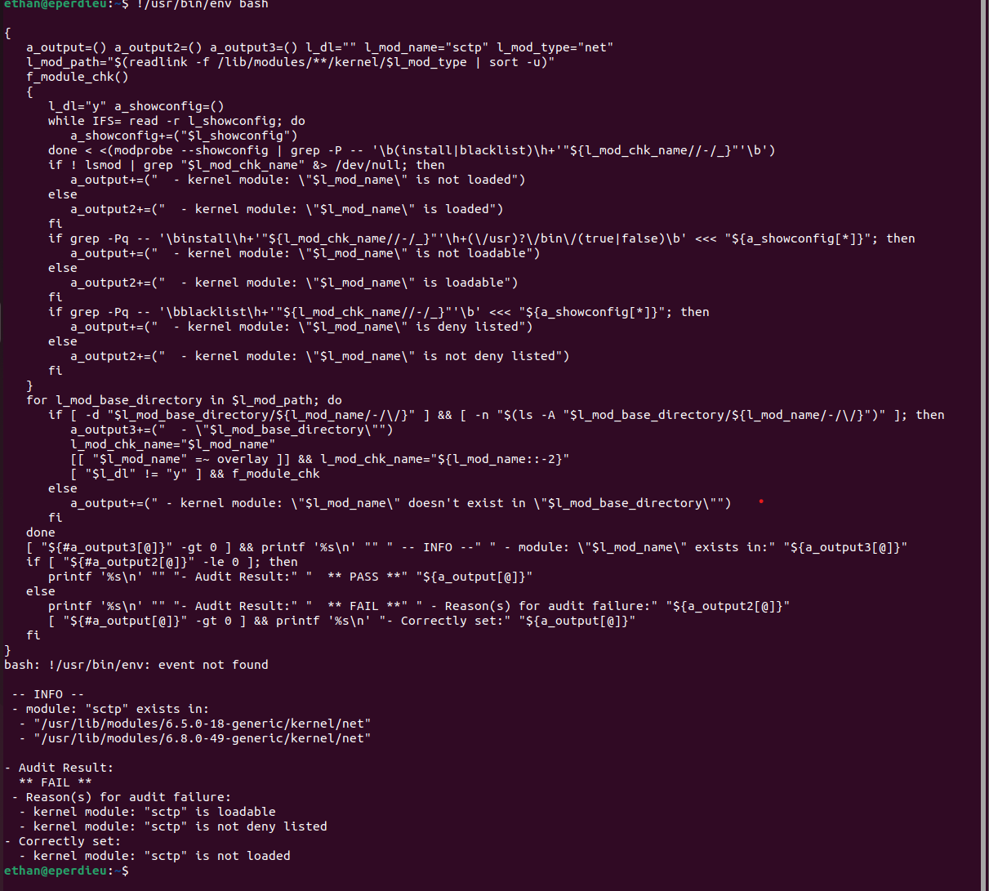

Section 4.1 – Configure a single firewall utility
This section specifies configuring a firewall for the system. In my opinion this is one of the most important steps because of how much control this gives the user over their system. Verifying that only one firewall is configured ensures that only legitimate traffic ends up getting processed. This will minimize cyber threats and protect data while avoiding vulnerabilities.

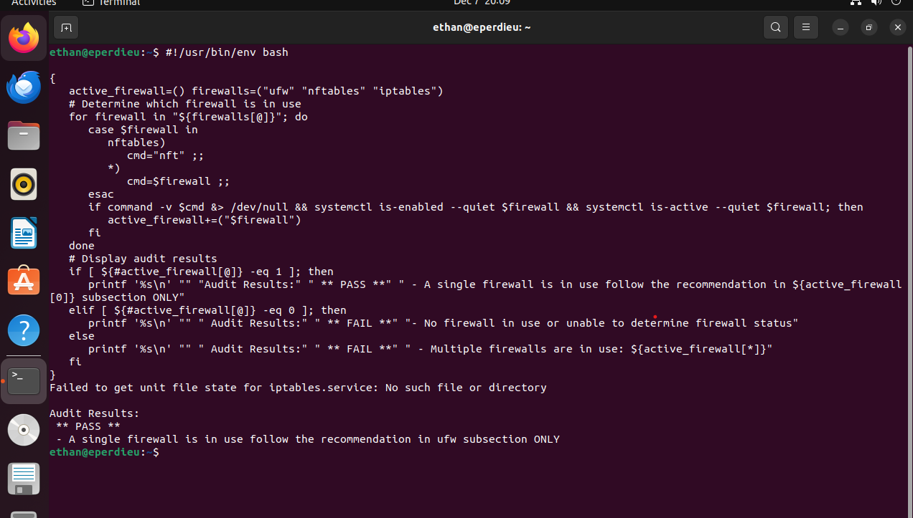

Section 4.2 – Configure UncomplicatedFirewall
The UFW is a program that manages a net filter firewall design for ease of use. It is done by using command-line interface and iptables for configuration. This was an important step I added because having UFW installed allows for command-line arguments to manipulate the firewall to the user’s desire. Other things that were verified in this section were ensuring outbound connections are configured, rules exist for all open ports and ensure UFW default deny policy. All these steps help reduce the attack surface of the system because all services and ports are blocked unless required.

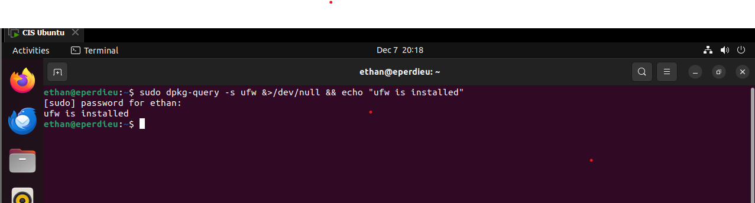

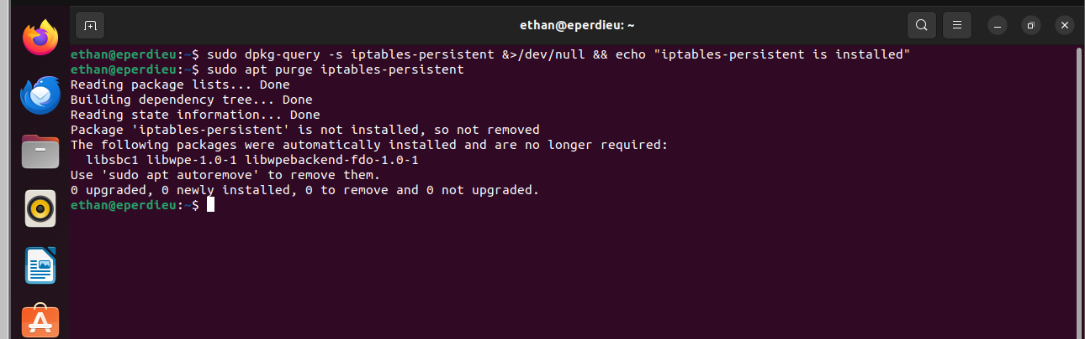

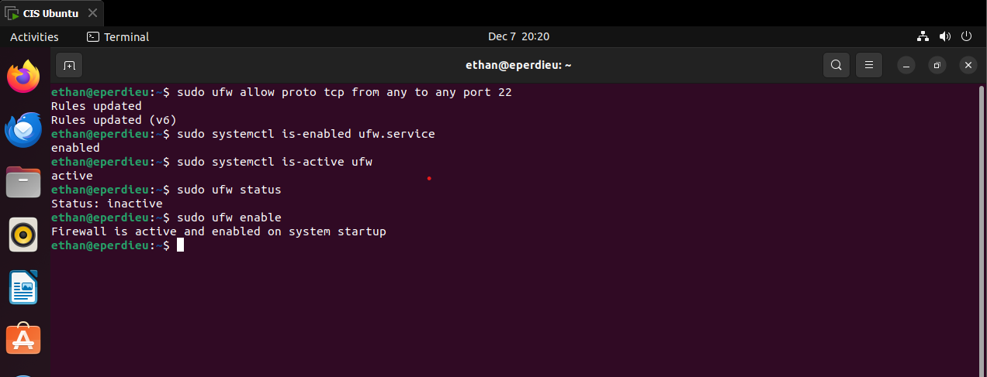
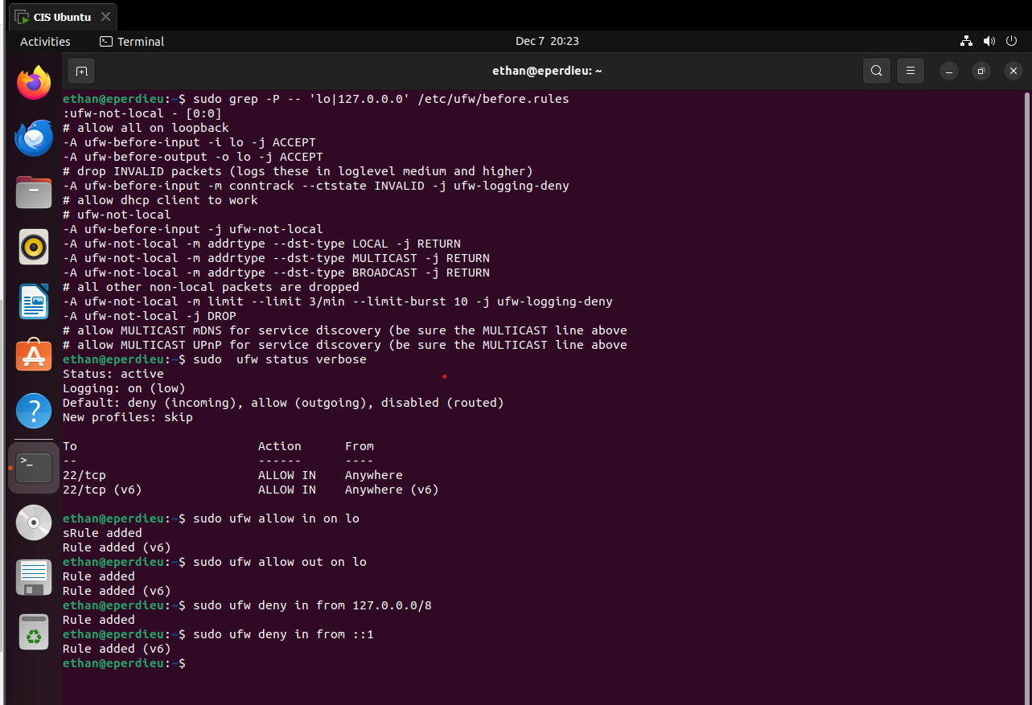
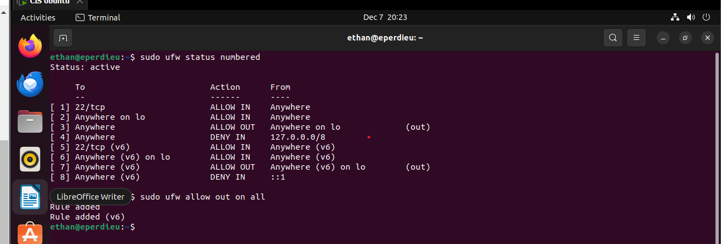

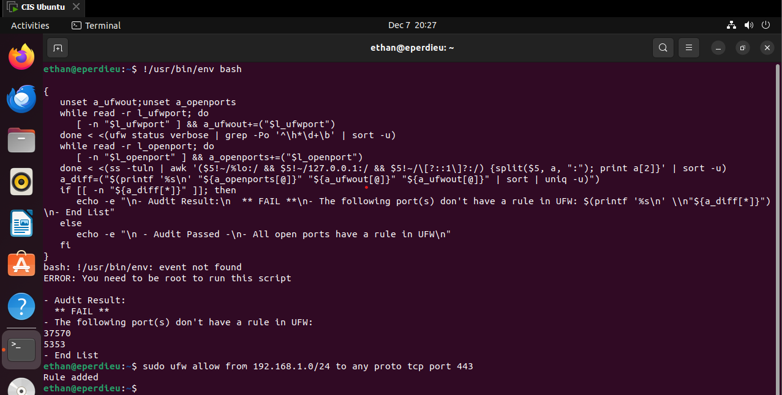

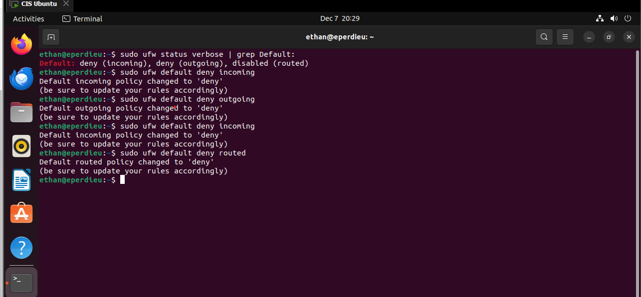

Section 6.3 – Configure Integrity Checking
This last section is all about the AIDE file integrity checking tool. This tool is used to detect unauthorized changes to config files and alerting when it happens. Ensuring the filesystem integrity is regularly checked to determine if critical files are affected. Lastly, ensuring the cryptographic mechanisms are used validates the integrity of the AIDE tool. Overall, this helps with locating incidents and where the vulnerability was found.
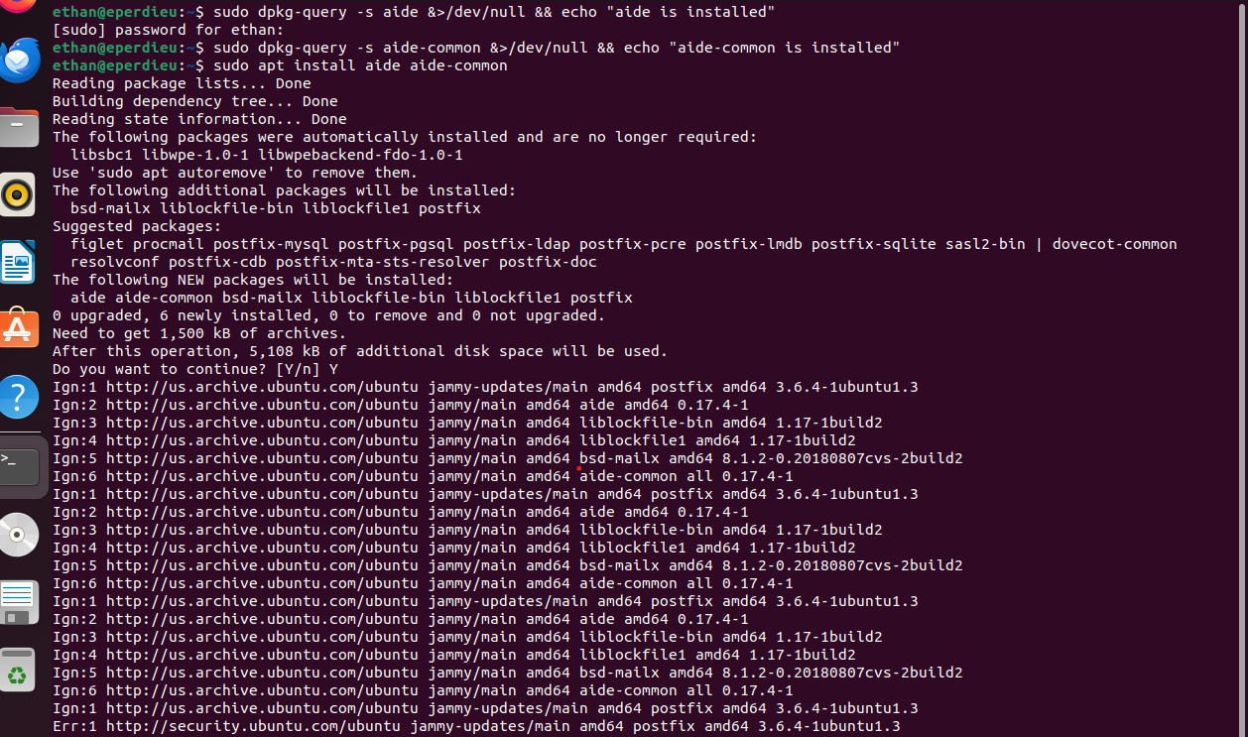

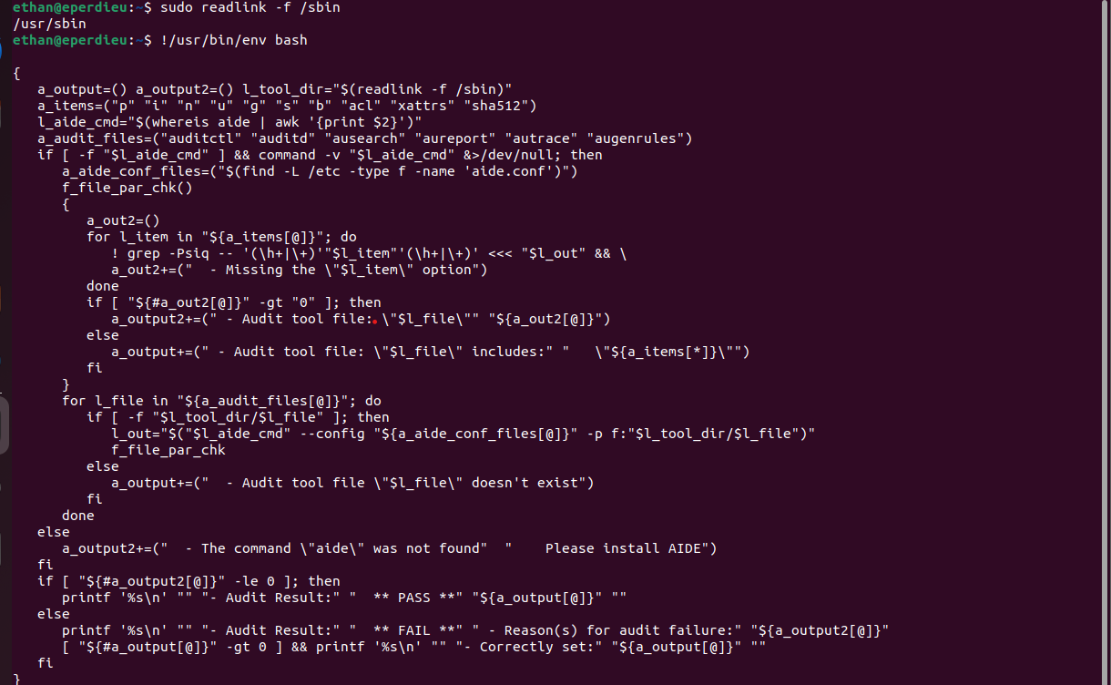
Works Cited

https://workbench.cisecurity.org/benchmarks/17689

https://workbench.cisecurity.org/benchmarks/18959

