Ethan Perdieu
CIT-40600
Vuln Lab
- Perform Vulnerability scan with the free version of Nessus on the OWASP BWA VM (credentialed or non-credentialed scan)
  - Provide a screenshot demonstrating the use of the tool

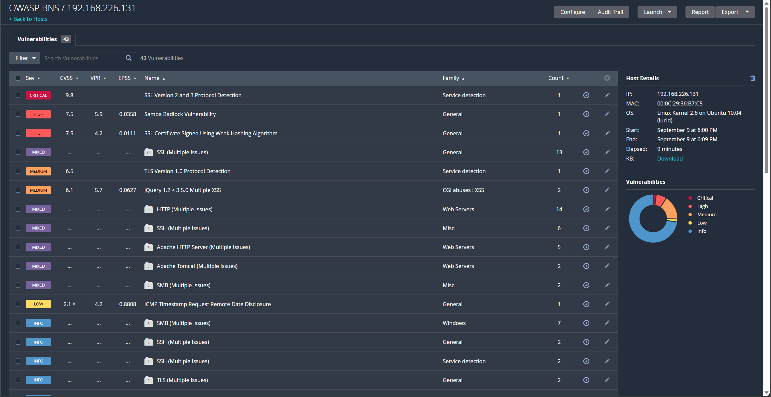

- Analyze the results from the Nessus report
  - Research and describe at least 2 to 3 of the findings in the high, medium, and low severity on the report
- Note: Looking into the various vulnerability or exploit databases could provide additional information
  - Make recommendations regarding what security controls can be implemented to mitigate/remediate the vulnerability

HIGH Severity
The first high severity security alert is a Samba Badlock Vulnerability. Samba is a CIFS/SMB server for Linux and Unix. Badlock is a flaw that exists in the Security Account Manager (SAM) and Local Security Authority protocols. This is due to improper authentication level negotiations over Remote Procedure Call (RPC) channels. This is occurring under port 445 which is primarily associated with the SMB protocol.
- A simple fix to this issue is upgrading the Samba version to 4.2.11 / 4.38 / 4.4.2 or later.

The second high severity alert is the SSL Certificate Signed using a weak hashing algorithm. The signature algorithm used is known to be vulnerable to collision attacks. A collision attack is when an attacker uses the same hash value to act like the affected service.
- The best way to solve this possible security breach is to get a new SSL certificate reissued by the Certificate Authority.

MEDIUM Severity
TLS Version 1.0 Detection is a remote service that accepts connections using TLS 1.0 which has an assortment of cryptographic design flaws. TLS 1.0 was disabled entirely by June 18, 2018.
- Enable support for TLS 1.2 and 1.3; Disable support for TLS 1.0

The next vulnerability was self-reported from jQuery because it is using an out-of-date version. This version is known to have multiple cross site scripting vulnerabilities.
- Upgrade to jQuery version 3.5.0 or later

Low Severity
The first low severity vulnerability is the SSL Certificate Chain contains RSA Keys less than 2048 bits. Some SSL implementations reject keys if they are found to be less than the 2048-bit mark. This was implemented January 1, 2014, where they started to require every new certificate to have at least 2048 bits.
- Replace the certificate in the chain with less than 2048 bits with a longer key

The next vulnerability is where SSH servers are allowing CBC encryption. The CBC Mode Ciphers is enabled which allows Cipher Block Chaining encryption. This allows attacks to recover plaintext message from that ciphertext.
- Disable CBC mode cipher encryption

The final vulnerability is an ICMP Timestamp Request Remote data disclose. The remote host answers ICMP timestamp requests. This allows attackers to know the data set on the targeted machine, which then allows remote attackers to defeat time-based authentication.
- Filter out ICMP timestamp requests and replies

