Ethan Perdieu
CIT-40600
Network Traffic Analysis LAB

Introduction:
During the Network Traffic Analysis Lab, we used industry-standard tools such as Wireshark and Tshark. These tools were used to record network traffic and read the information based on the filters set for various threats and vulnerabilities.
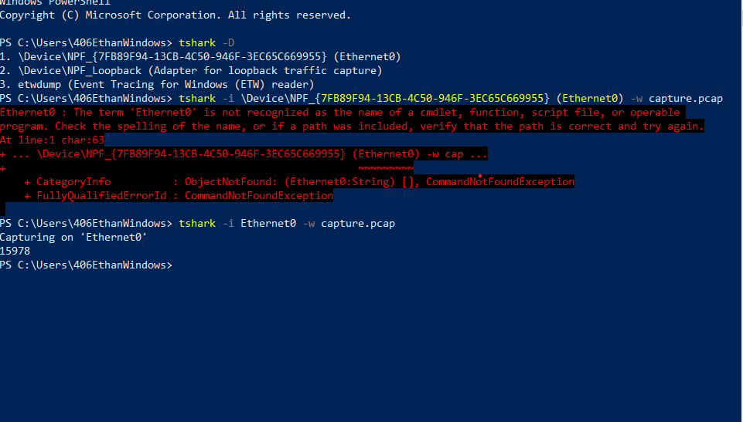
This was the first initial setup step during the lab, and this was the start of capturing the information on a network. The command tshark -D was used to identify the various network interfaces and help choose the preferred network to analyze. Secondly, the command tshark -I Ethernet0 -w capture.pcap was used to start capturing traffic from that network interface. Command tshark -r capture.pcap was used to read that capture file with various add-ons to that command such as -Y “http” or -Y “dns” to extract specific information. The tshark -r capture.pcap -Y “http” command was used to apply a filter that only displayed packets that match the HTTP protocol.

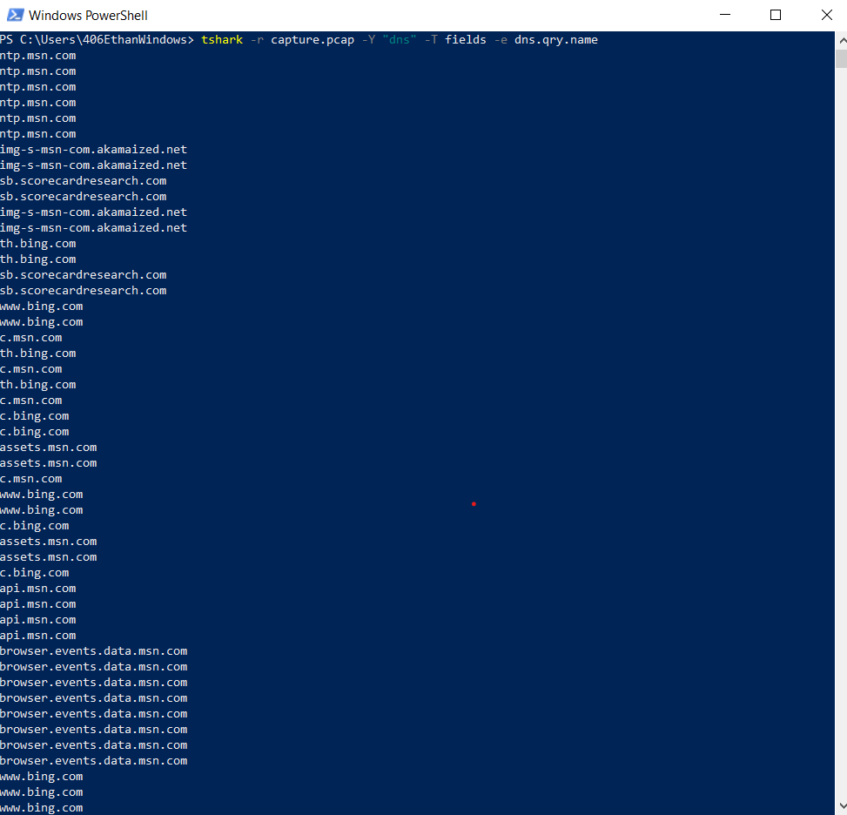

Reading the capture.pcap file while filtering it for DNS packets and has specifications so only the DNS query names will be displayed.

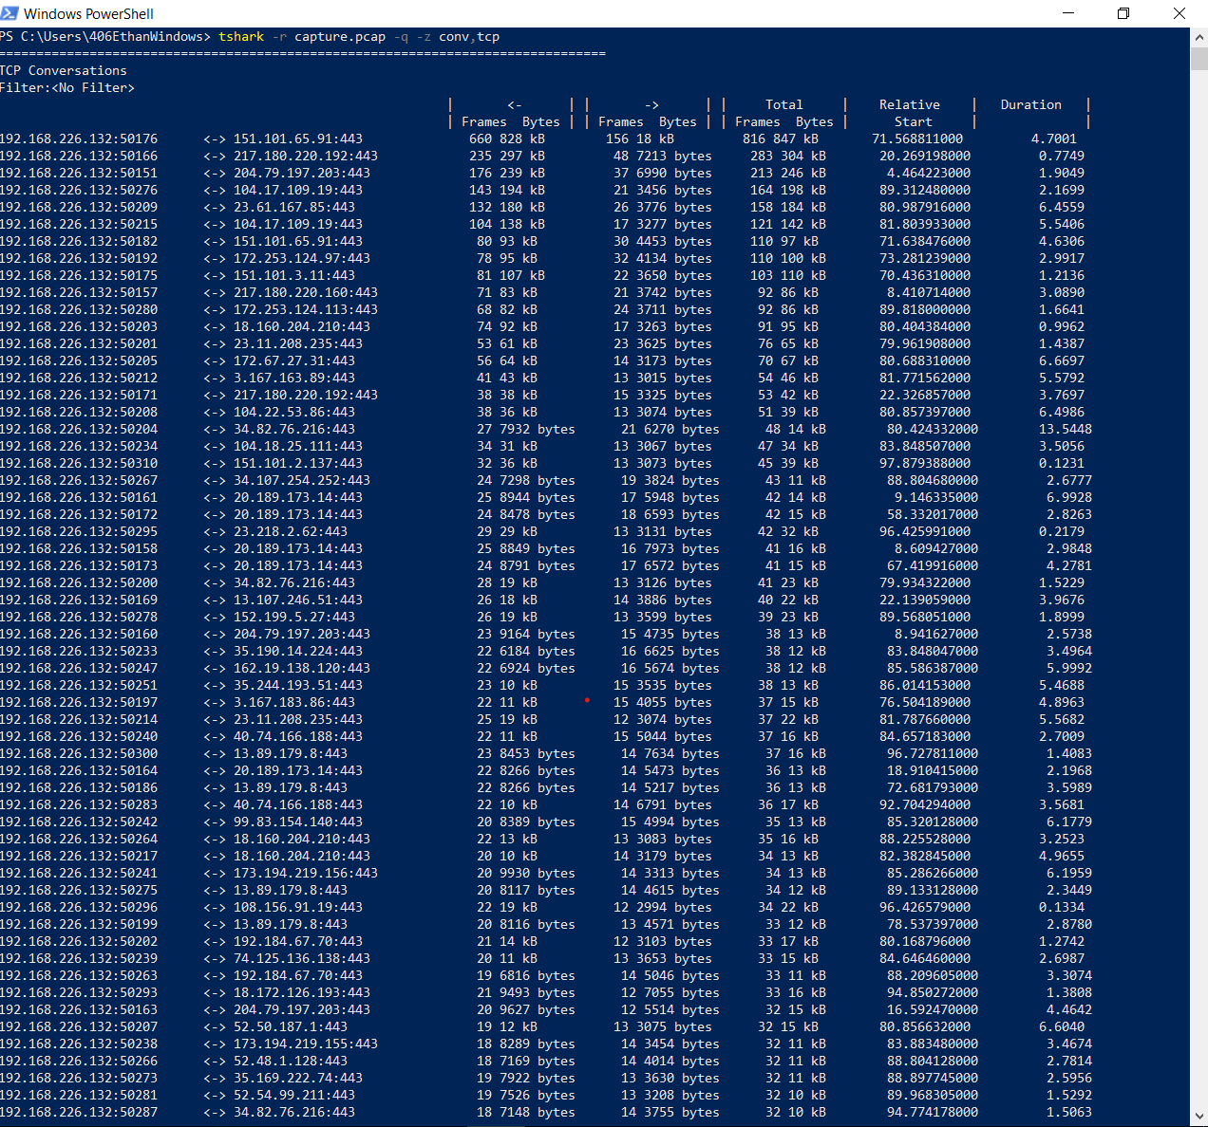
Viewing a generated list of conversation from TCP connections.

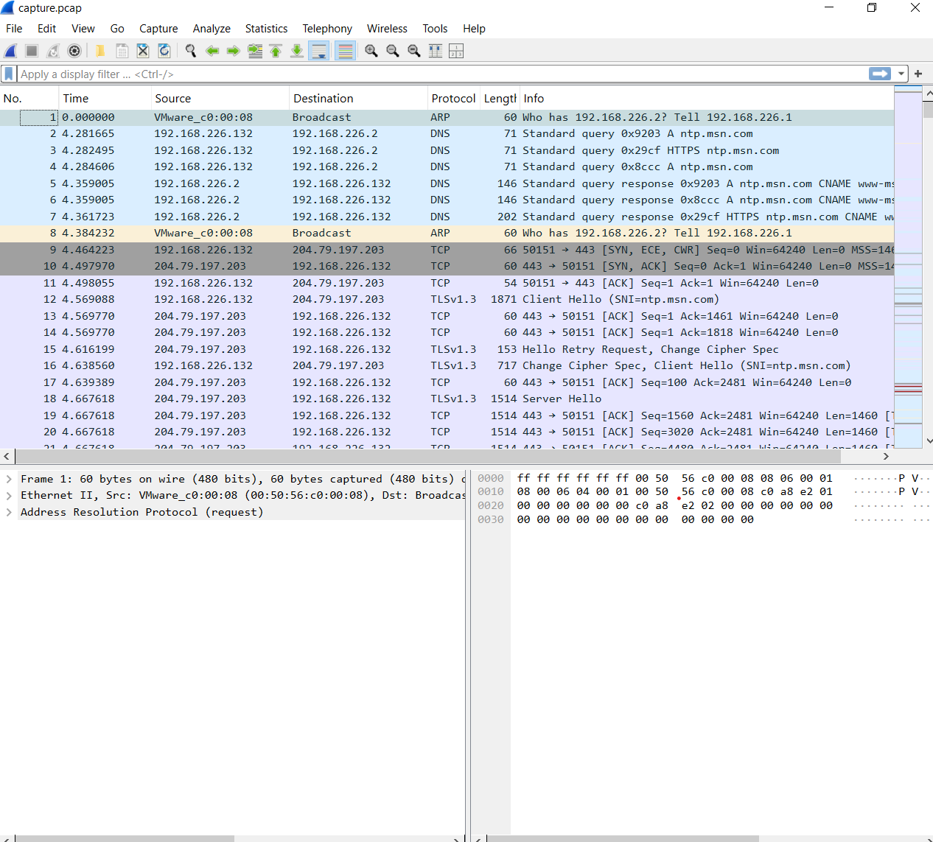

Lastly, using the command tshark -r capture.pcap -Y "http" -T fields -e frame.number -e ip.src -e ip.dst -e http.request.uri -E header=y -E separator=, > http_traffic.csv, allowed the capture.pcap to then be exported into a .csv file and put into Wireshark to analyze each data packet.

Findings:
Features found in the Wireshark tool when analyzing the capture.pcap file:
- Source
  - Allows to see the source of packets by displaying their IP or MAC address
- Time
  - Shows the time the packet was sent or received based on when the network traffic was first captured
- Destination
  - Shows the destination of where the packet sent is to arrive at
- Protocol
  - Shows which protocol that packet used (ex. ARP, DNS, TCP, TLSv1.3)
- Info
  - Has basic information on what the packet contained, such as acknowledgement (ACK), Standard query responses and Protected Payloads

When viewing specific packets, there are options to view the Frame, IPv4 source, Timestamps, SEQ/ACK analysis and how many bytes the payload is. You can further investigate a group of data packets by using filters to view certain protocols, sources, and destinations.

Using Wireshark I was able to look through the TELNET packets and find specific instances on which login was used. I then found the packet being sent for the Login Data. The next packet was then the username that was sent over.
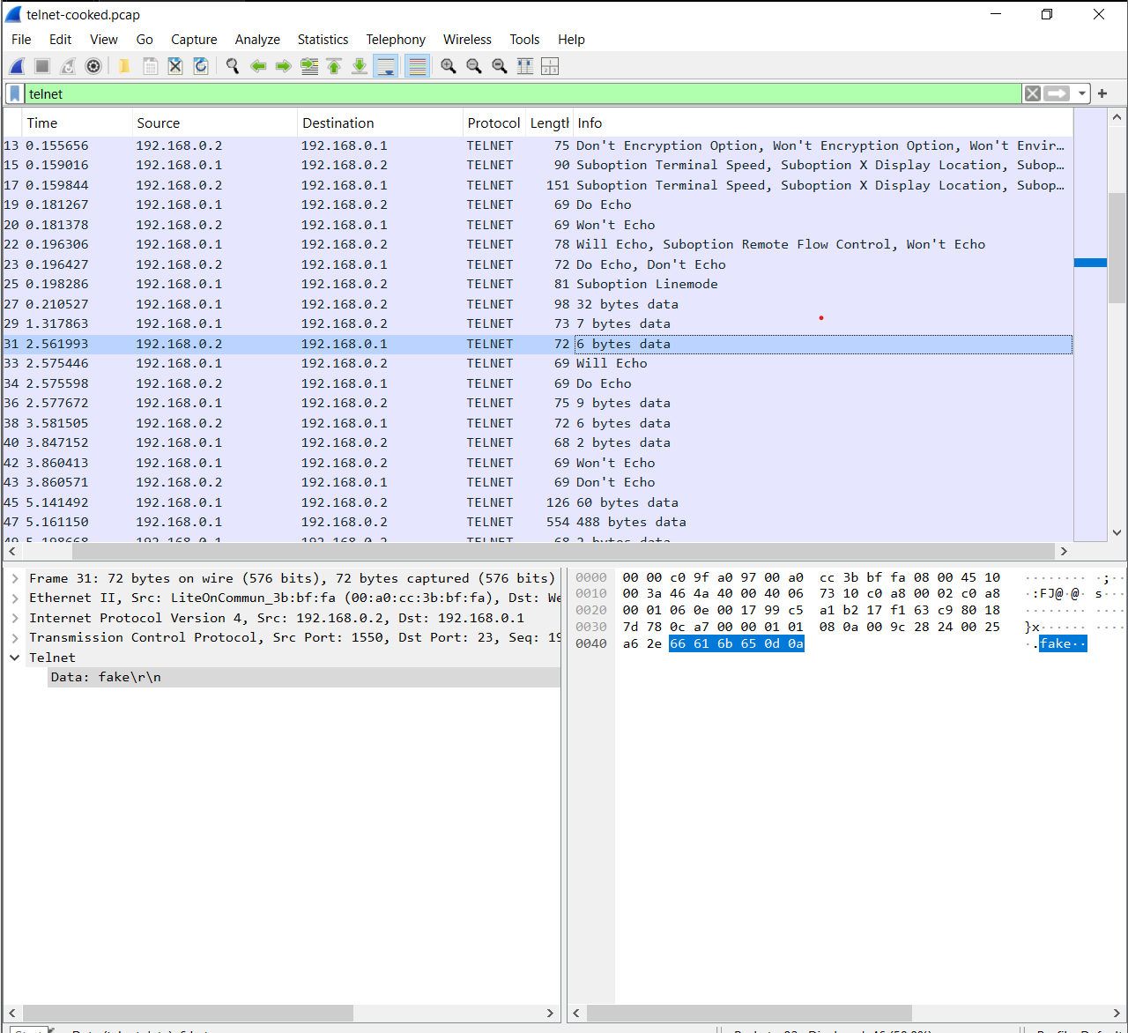

Then a few packets down, there was a packet using the TELNET protocol that was requesting a password. The next packet was then the password that again was set over the network.

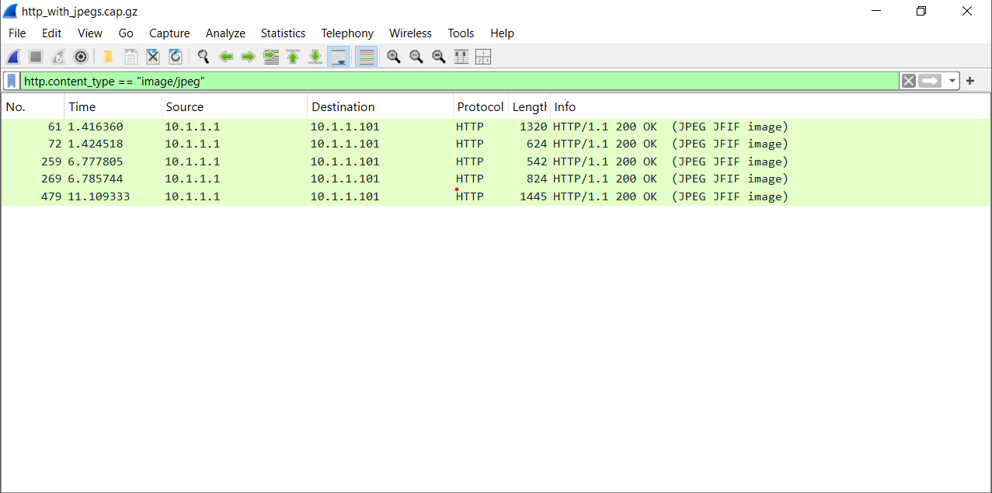
Once again using Wireshark, I was able to apply the filter, http.content_type == “image/jpeg” to the http_with_jpegs.cap.gz file to view how many jpeg files were captured. As shown, there were five jpeg files captured.

- What filter in Wireshark can you use to only filter for traffic related to the ping utility?
- The filter icmp is used when filtering for traffic related to the ping utility

- What does the color scheme mean in Wireshark when it highlights packets?
- The color schemes are directly related to which protocol they are using

- Explain how network traffic analysis can help you identify threats and discuss the potential impact of these threats on network security.
- Network traffic analysis can help identify threats by finding specific captured packets that are using incorrect protocols and find malicious packets on a network. If a certain packet is using an incorrect protocol, then that is a huge security issue because some protocols are not nearly as secure as its counterparts. Finding malicious packets are things such as commands being sent in a packet and finding what that command sent is trying to accomplish.

Conclusion:
During this lab, I learned to be able to capture data packets on a specific network and analyzing them using Wireshark and Tshark. Then using that captured information on the network, I was able to filter the packets to find certain protocols and conversations. With this insight on how Wireshark and tshark operates, I am now able to scan certain packets and filter them to gain information or find potential vulnerabilities within a network.

