Ethan Perdieu
December 8th, 2024
CIT-40600
Final Project: Adversary Emulation with Atomic Red Team

- Setup and Configuration:
When setting up and configuring Atomic Red Team on a Linux machine, checking for system updates should be the first step. The commands used were sudo apt update, and sudo apt upgrade -y These commands ensure the local package cache has the latest information from the repositories. This reduces the risk of issues when installing new software. Secondly, installing the dependencies needed for Atomic Red Team would be the next step. This includes git, python3, python3-pip and curl. The commands to install the dependencies are, sudo apt install -y git python3 python3-pip and sudo apt install curl as shown in the screenshot below.
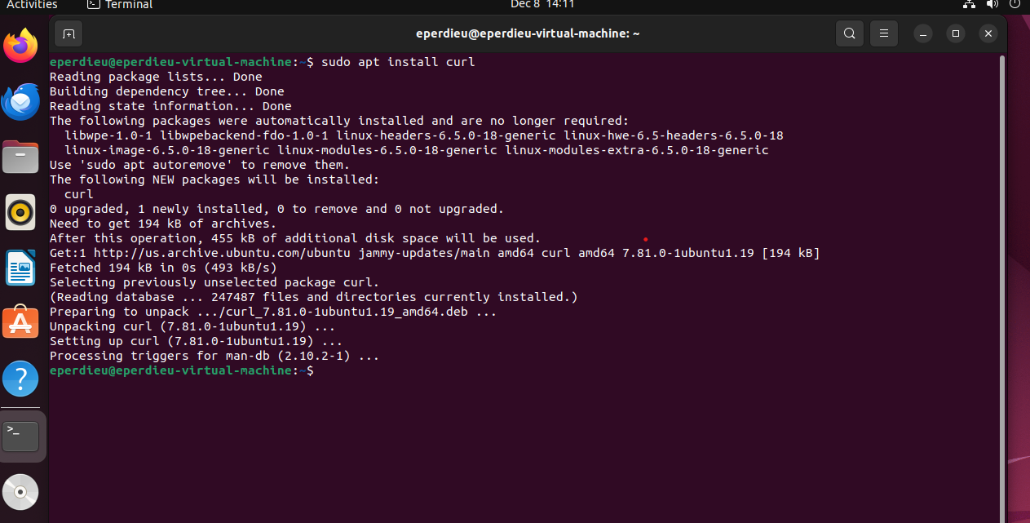

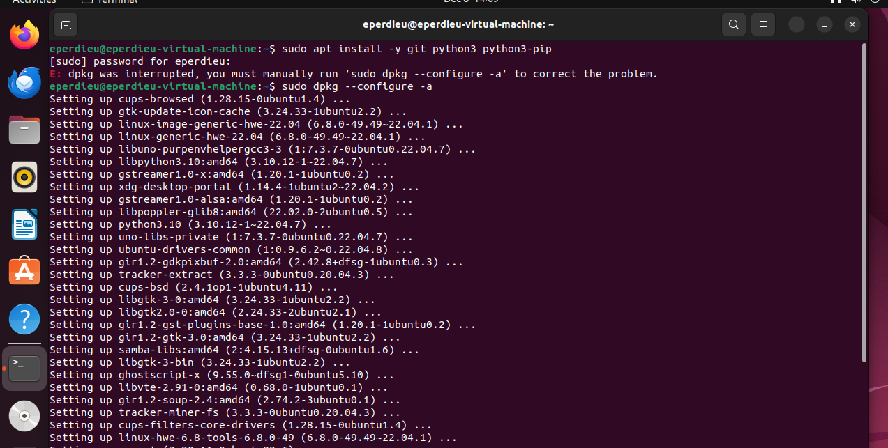
As shown above, I did run into one problem when running the command sudo apt install -y git python3 python3-pip. The error was “dpkg was interrupted, you must manually run 'sudo dpkg --configure -a' to correct the problem.” The dpkg package manager unpacked package files but failed to complete the configuration phase. This command fixed the unpacked packages and repaired some files.

Downloading PowerShell was the next step when viewing the Wiki getting started pages. I ran the command sudo apt install -y PowerShell but did end up getting an error. It was resolved by using the snap install powershell --classic. Eventually the command pwsh was used to start powershell.

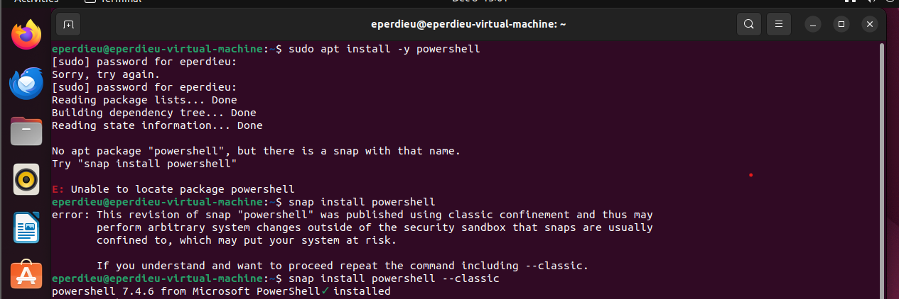
The next step after installing the necessary dependencies is downloading the Atomic Red Team repository. I first created a new directory with the mkdir command to store the repository. Then using the command shown below, I downloaded the repository into that directory.

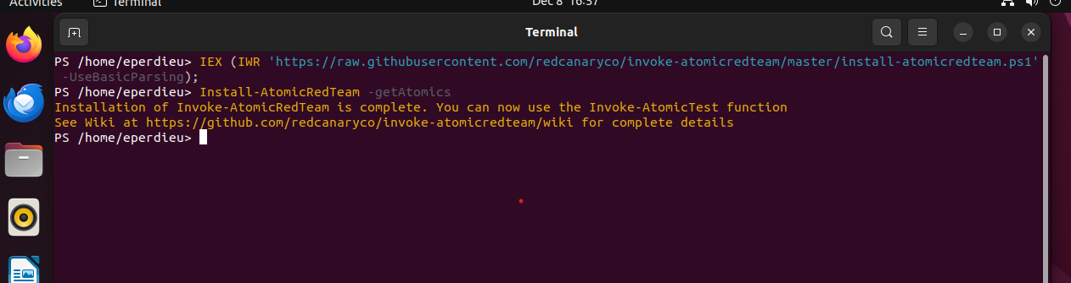

After using cd to get into the Atomic Red Team directory, I reviewed the pyproject.toml file which stated more dependencies were required. The command being install poetry. Running the command python3 runner.py --help allowed me to install the remaining dependencies that I missed. Some dependencies that were installed after running the previous command were, typer, pydantic, atomic_red_team, and mailutils. After this step, all required dependencies were installed and the environment was ready for atomic tests.
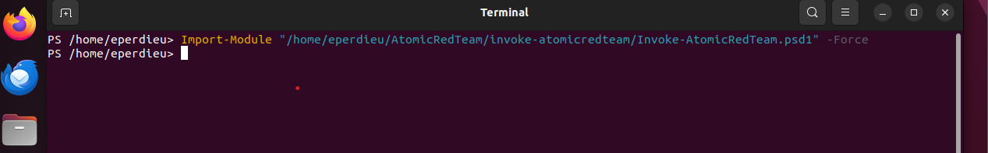
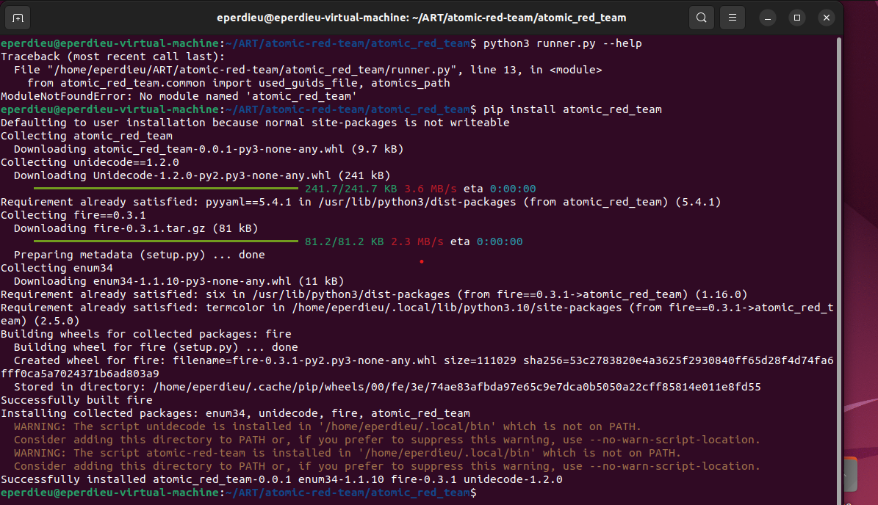

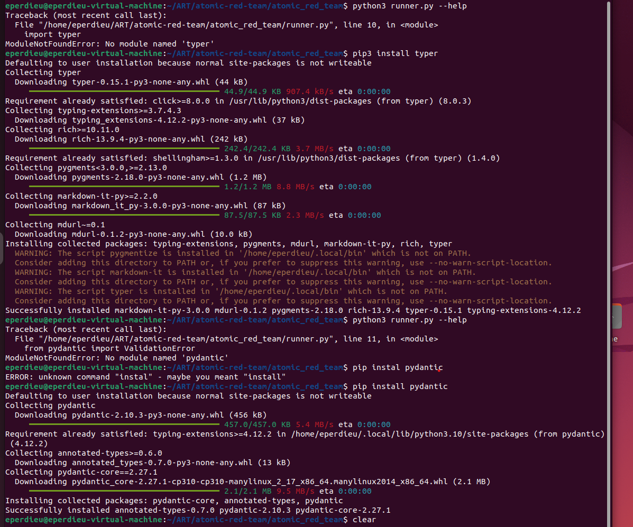

- Initial Reconnaissance:

When performing the initial reconnaissance, at first, I had to figure out which tests can run on a Linux based system, so I ran the command Invoke-AtomicTest All -ShowDetailsBrief to list all the tests.
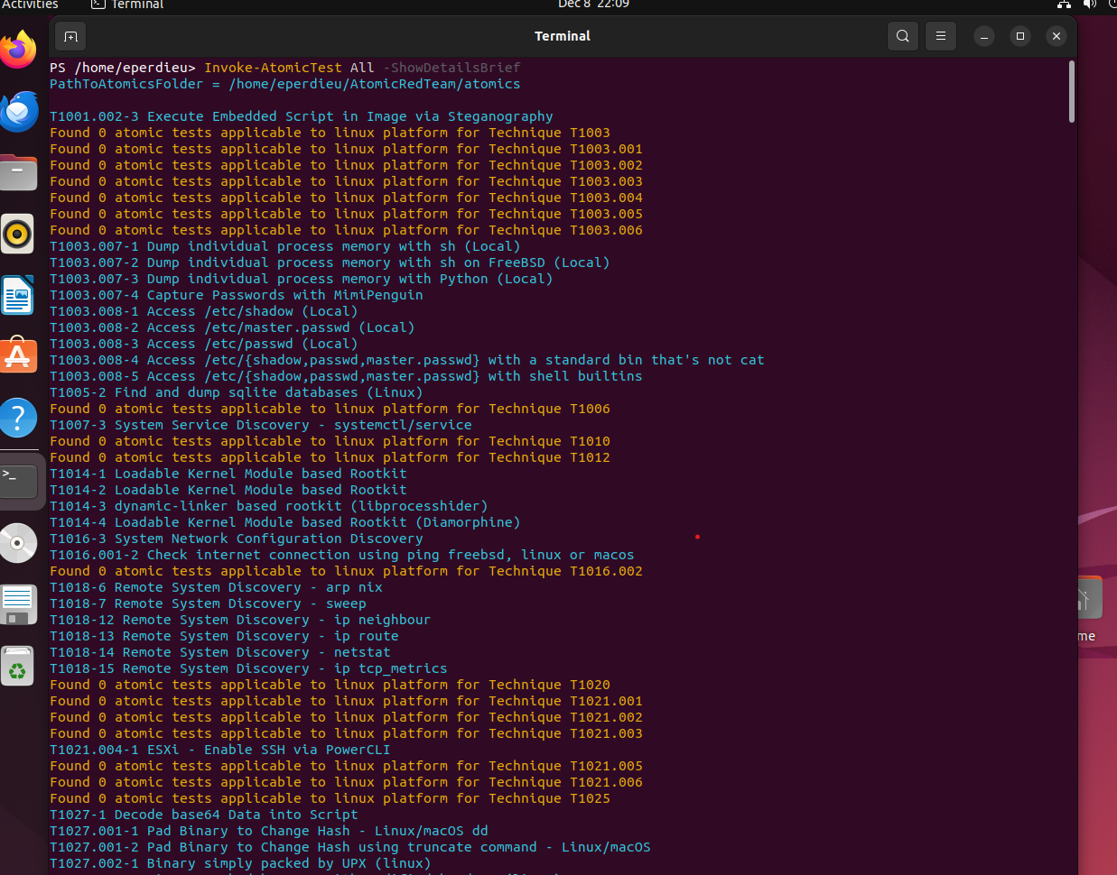

I then was able to perform my first test on T1016-3. Using the Invoke-AtomicTest 1016-3 -CheckPrereqs I was able to ensure the prerequisites were met for the T1016-3 System Network Configuration Discovery. After those were met, I then ran the same command without the -CheckPrereqs part and ran the first test.

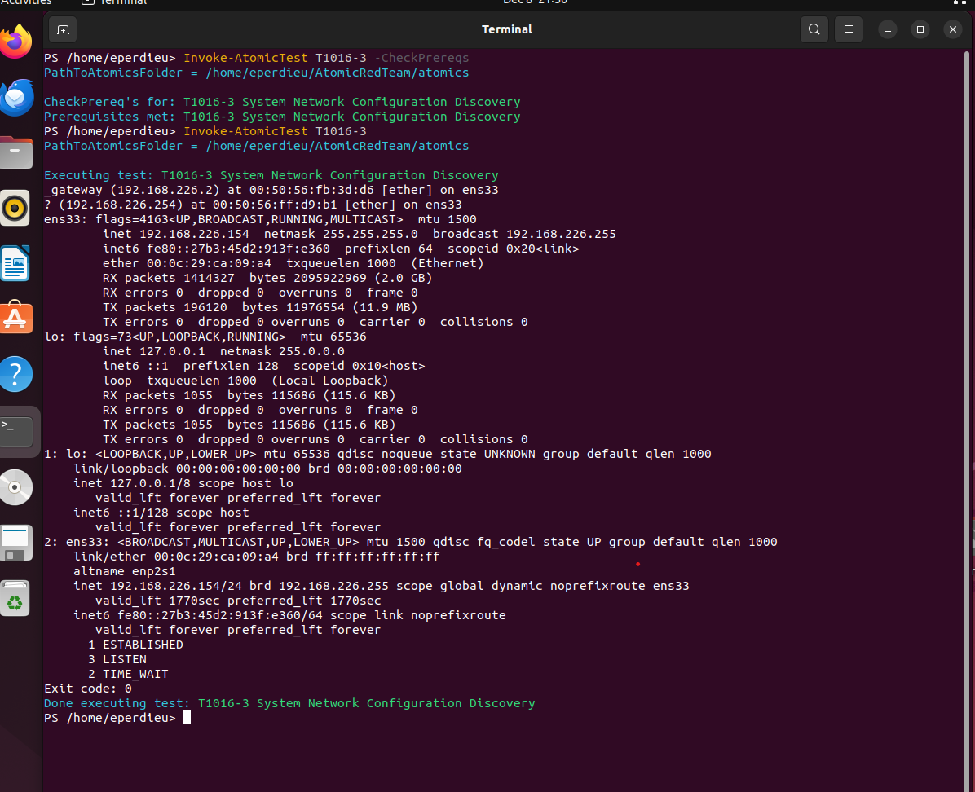

Some of the information that I was able to gain from this first test was the gateway at IP 192.168.226.2 with MAC address 00:50:56:fb:3d:d6. Secondly, an unknown device which could be a possible vulnerability having the Ip 192.168.226.254 and MAC address 00:50:56:ff:d9:b1 was found. Also, the ethernet interface IP address was discovered being 192.168.226.154. Lastly, I noted there was 1 ESTABLISHED connection, 3 LISTEN sockets and 2 TIME_WAIT connection on the system.

When performing the next test, I once again checked the prerequisites for T1018-12 Remote System Discovery – Ip neighbour. Once those were passed, I ran the test with the command Invoke-AtomicTest T1018-12.

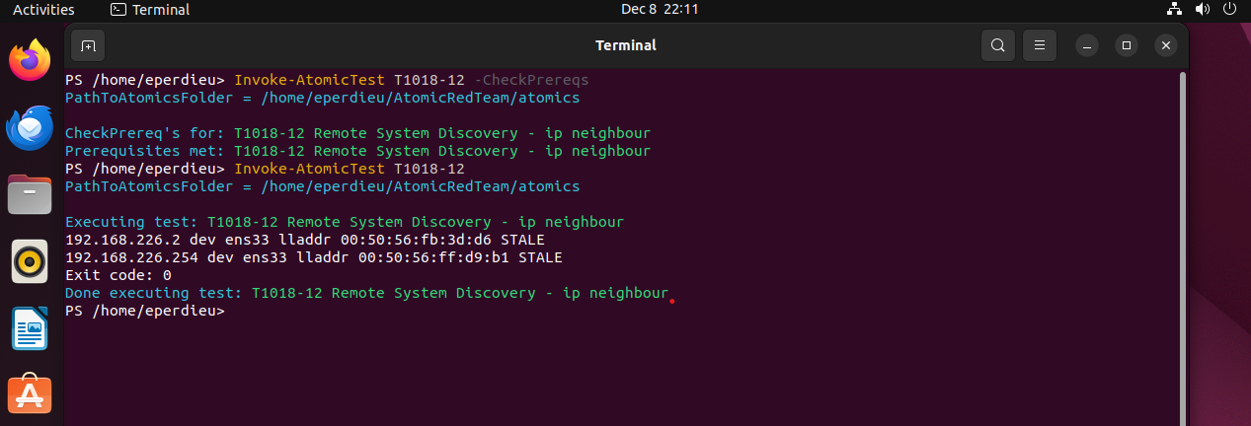

The output from T1018-12 Remote System Discovery – Ip neighbour revealed information about the local network systems through the Ip neighbour table. It identified two IP addresses, 192.168.226.2 and 192.168.226.264. These are possibly two network devices or gateways. However, they are marked STALE meaning they have been inactive for a long period of time.

- Execution of Adversary Techniques:

The screenshot below refers to a test with T1018-6 showing the Lateral Movement technique. This technique uses the ARP protocol to discover other systems on that local network. Attackers can leverage that information and that protocol to identify live hosts which help with their lateral movement. They could use commands such as sudo arp-scan –interface=etho0 –localnet to find potential targets which is a vulnerability. The test was run by the command Invoke-AtomicTest T1018-6.

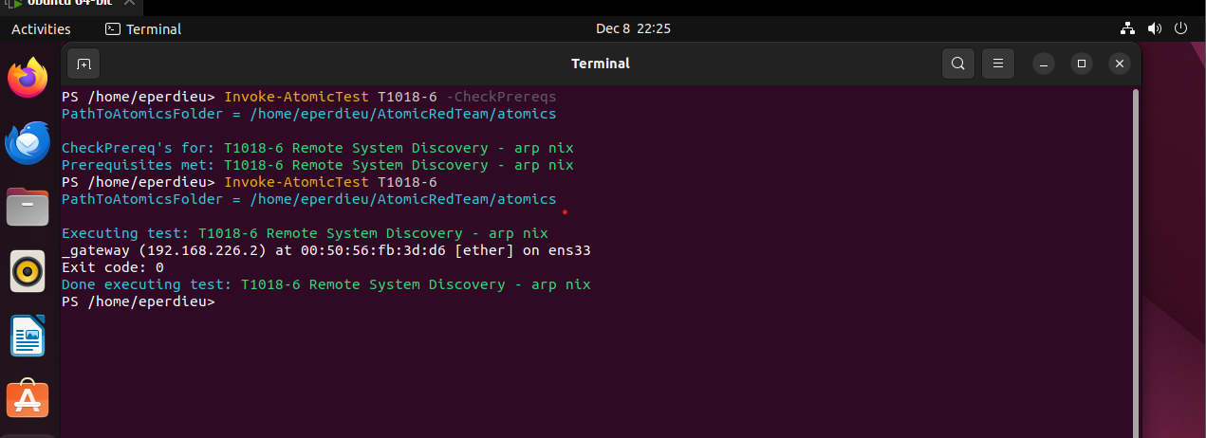

Some of the info received from the test T1018-6 Remote System Discovery – arp nix is the gateway 192.168.226.2.

Another lateral movement test being T1014-4 was a lateral movement test which tested for detecting the Diamorphine rootkit. That is a loadable kernel module which is used to hide malicious activity such as masking files or processes. This is another vulnerability that ended up being found.

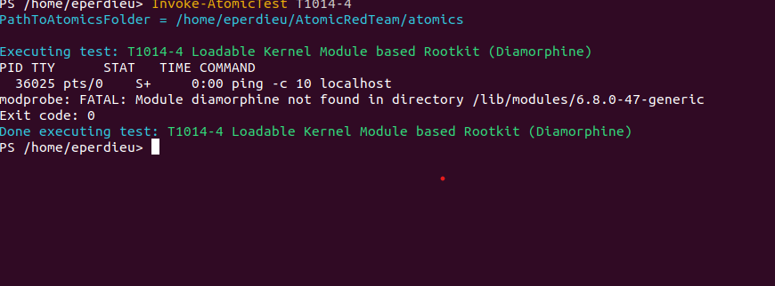

The important information that was able to be pulled from the test is the PID 36025 which is the process id of the running process. The process state was shown in S+ which is the sleeping state, so we know it’s not active.
- Detection and Monitoring:
For this section I first needed the necessary tools to perform detection on the network, so I ensured both Snort and Wireshark was installed on the Linux machine. This was done by the commands sudo apt-get install snort and sudo apt-get install Wireshark. After both networks were installed, I then ran the command sudo snort -A console -c /etc/snort/snort.conf -l ens33 to start the sniffing.
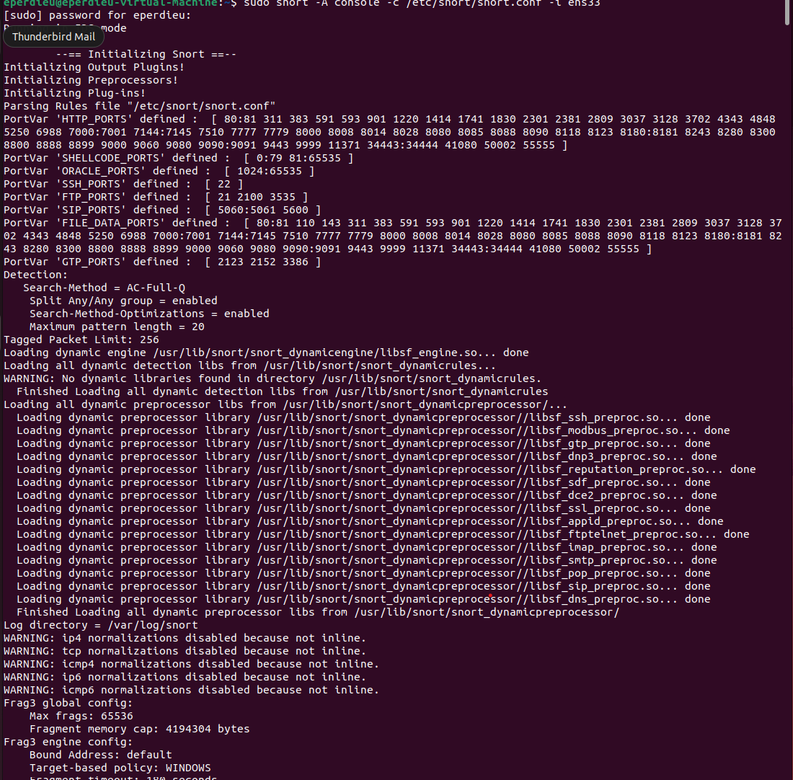

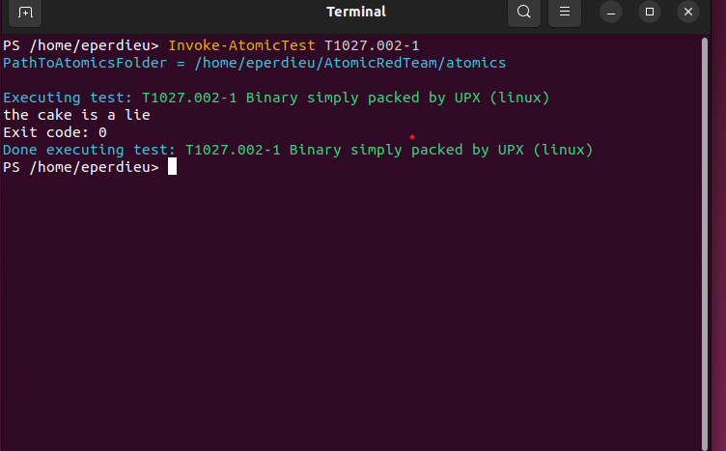
Once Snort was running, I then ran the test T1027.002-1: Obfuscated Files or Information which involves packing binaries with UPX which is a common method to evade detection. This was done with the command Invoke-AtomicTest T1027.002-1. Once this was done running, I then ended the snort capturing process and viewed the information it captured.
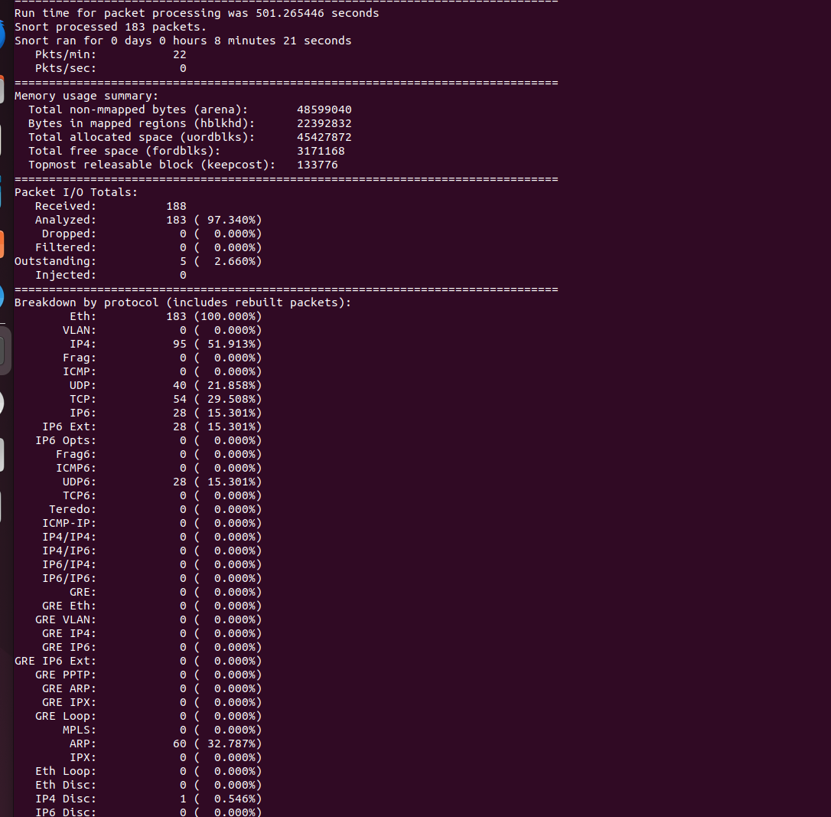

The Packet Processing ended up running for 501 seconds and processed a total of 183 packets. ARP has a total of 60 packets which is significant because ARP traffic is often targeted for attacks. However, Snort was never alerted and did not detect any behavior that matched attack signatures. Another thing to take note of was the number of packets whitelisted meaning if the whitelist is not monitored then this can be a major attack surface.

5. Incident Response:

The first step in creating an incident report is identifying the malicious activity based off the previous listed snort logs. As stated beforehand, there was an unusual amount of ARP traffic and bad checksums. I first checked for ARP spoofing or ARP poisoning by analyzing network traffic. I then ran a scan using the Ip neighbour command and found the two devices listed.

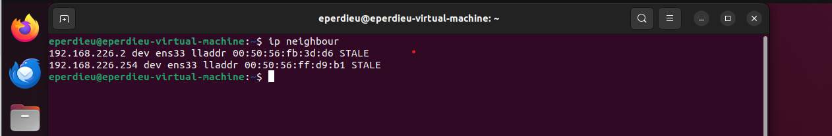

I then used the ps aux command to list the active processes and scan for various suspicious processes. I was able to contain some of the ARP processes and traffic based off the previous Ips listed in the screenshot above. Using firewall rules this was a great way to block malicious Ips and using network segmentation to isolate affected systems.
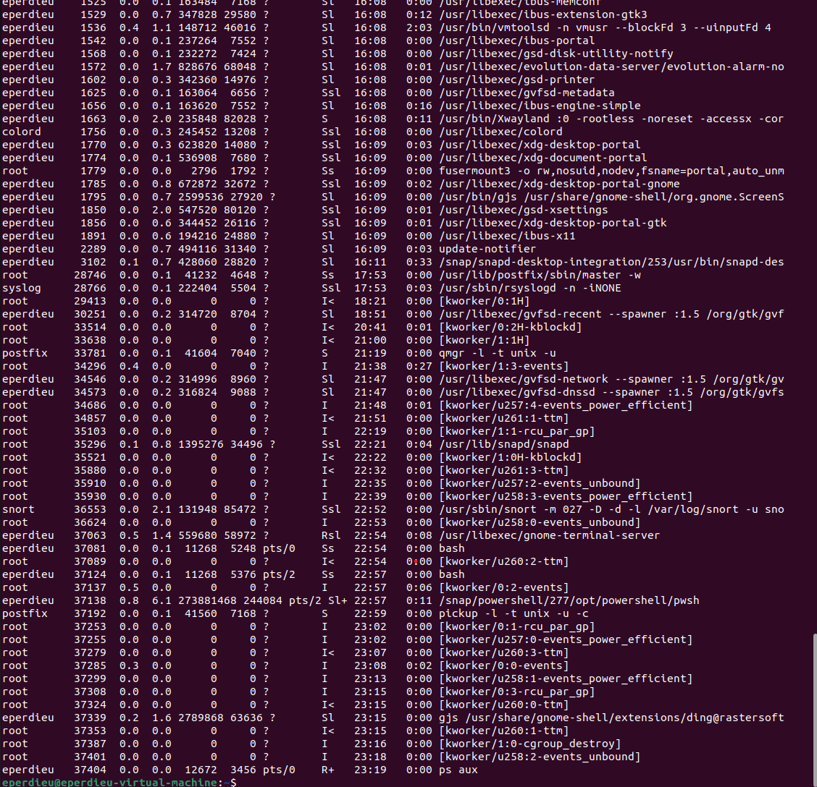
Once in the recovery phase, this is where you would restore the affected systems back to normal operation. As well as performing testing to the network to ensure the integrity is kept. This can be restored through backups or verified clean systems. I decided to validate the patch level to ensure that all systems have been fully patched and are running the latest security updates. This was done by running commands such as dpkg -l | grep -I security and sudo apt upgrade –dry-run.
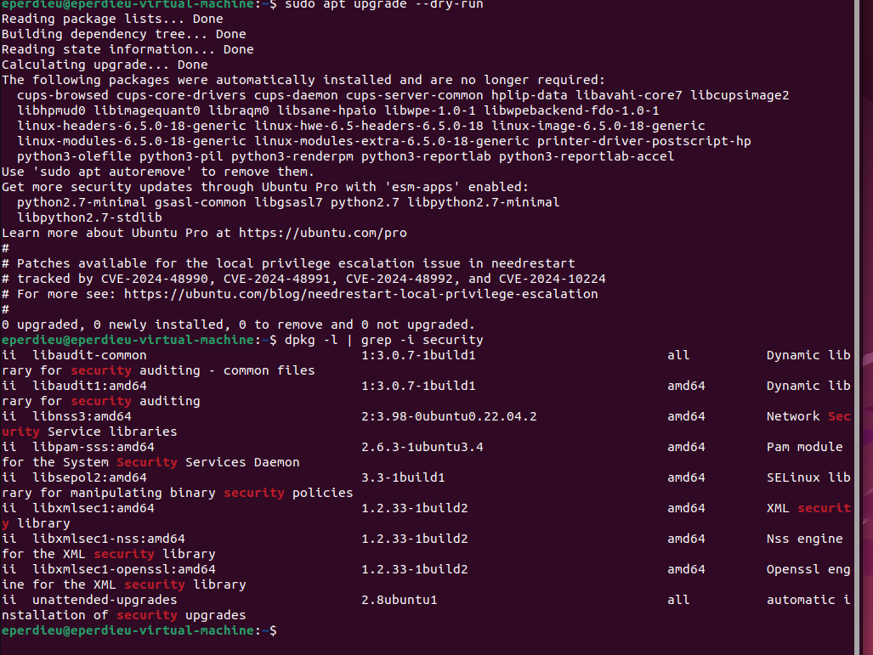

6. System Hardening:

The first step I took in my System Hardening was configuring a firewall and configuring its settings. This consisted of ensuring ufw service is enabled and loopback traffic is configured. Ensuring the ufw service is enabled allows the user with the framework for managing net filter as well as command-line and a GUI for manipulating the firewall itself. Loopback traffic is generated between processes on machine and is critical to operation. This ensures that the loopback interface is the only place where loopback network traffic can be seen. This is done as an anti-spoofing measure.

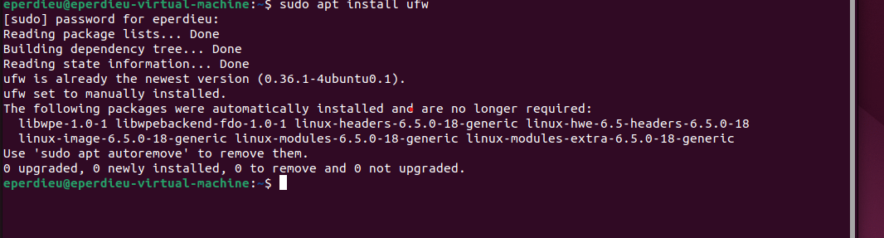

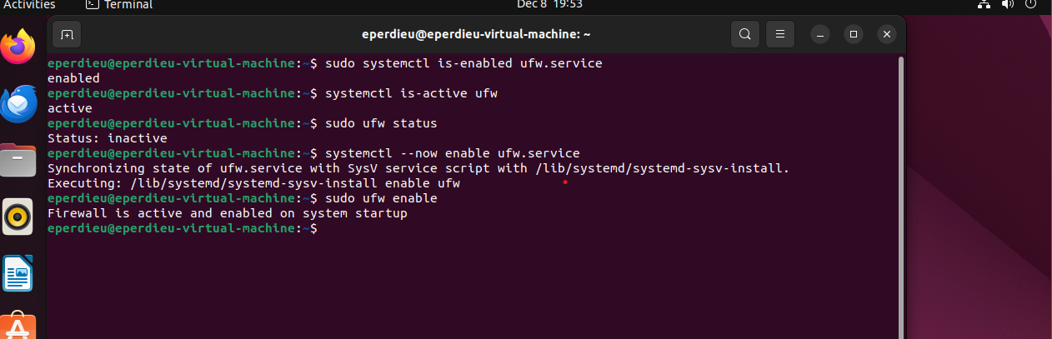

Configuring server services was the next big step to this server hardening. This lowers the potential attack surface by disabling the service or completely removing the service. Some services that were configured were avahi daemon, dhcp, dns, ftp, and web proxy services. Avahi daemon service automatically discovers network services which is not required for system functionality and is a known attack surface, so it is best disabled. Services like web proxy server and web server services offer a standard proxy server which is another potential attack surface.
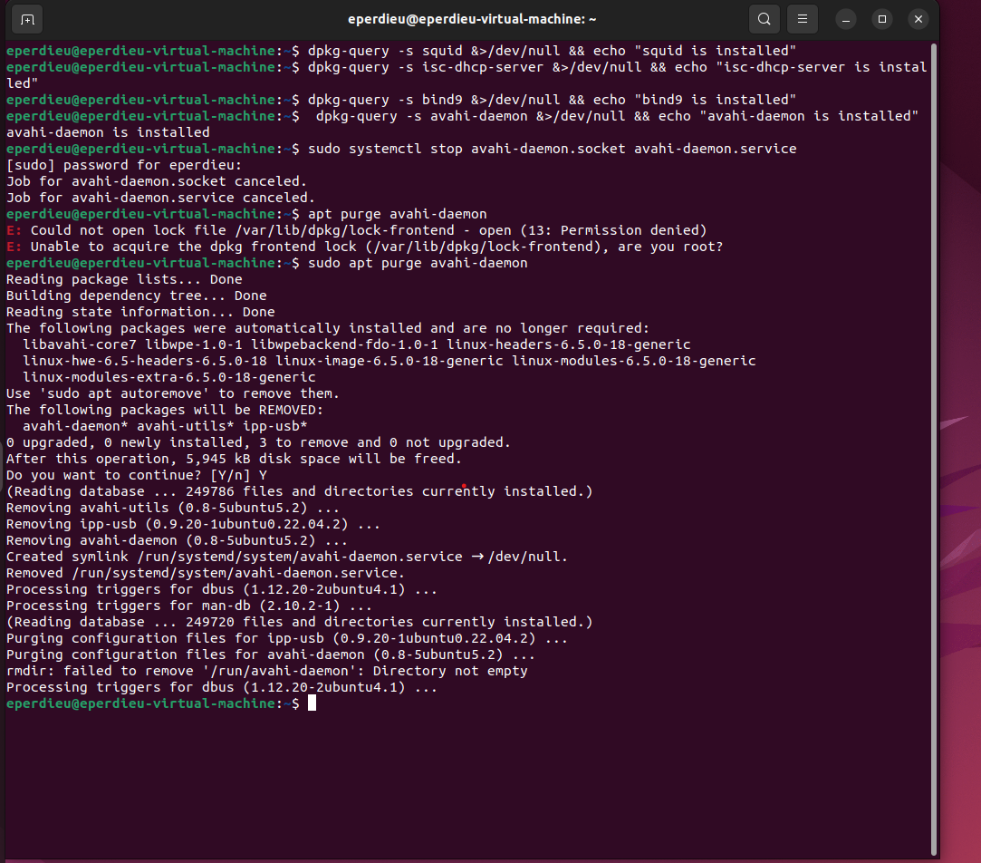

When ensuring services were not active, I found avahi-daemon was running. Above shows the stoppage and removal of the service.

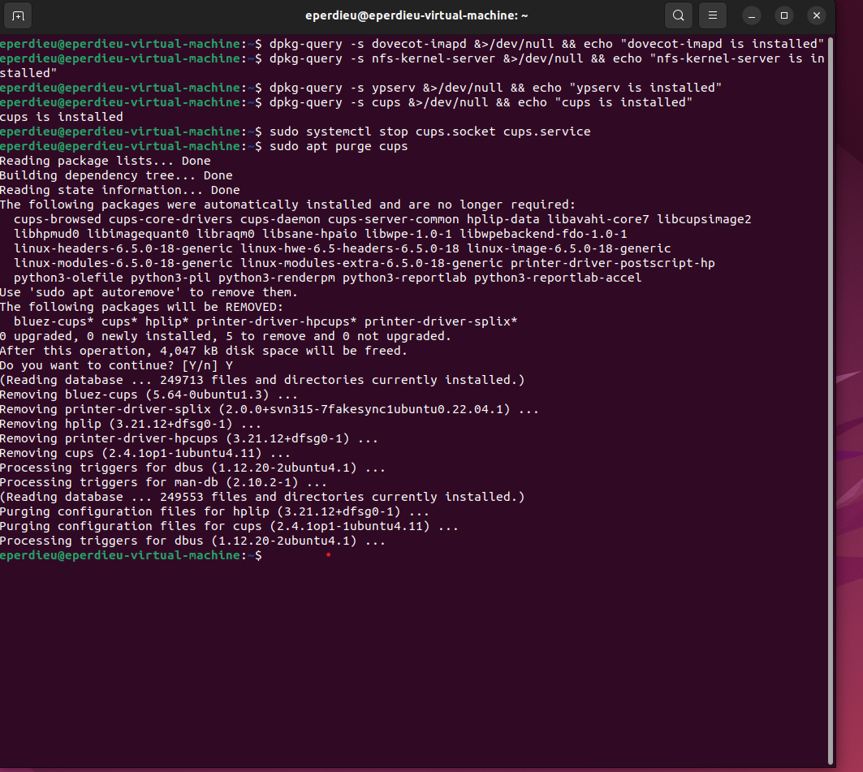
Once again, scanning services and terminating them to reduce the attack surface of the system.


