Ethan Perdieu
CIT-42000
HW1: Data Carving
January 28th, 2026
File # | Filename | Extension | File Type | SHA-256 Hash
1 | Recovery1 | .jpg | JPEG | df429bde3695716ffdc00fdb1206a6796d54c820cf9537cb4109d69908f1b925
2 | Recovery2 | .jpg | JPEG | 040a2e0836d0e79778a7b3af4a7d7f11ef2bbe954db1180bca8327886bc842de
3 | Recovery3 | .jpg | JPEG | df429bde3695716ffdc00fdb1206a6796d54c820cf9537cb4109d69908f1b925
4 | Recovery4 | .pdf | PDF | e89eb467984936502043e9ccb28667dba832c4c990e38262aaf578452365f59a
5 | Recovery5 | .docx | Word Doc | d7679831d53a474e3b95e00295799a99ab1341073a84b0a0eeaff7ebbfc4624d
6 | Recovery6 | .gif | GIF | 40c11856f89ed2911d0194f300d08e44fb90174eb3ea49a39b1ab1517ddc7558
7 | Recovery7 | .asf | ASF | c4a60ba3244dbc580f8b12ad5aaaf499e0612f06ac3e2c9aa5a381bdc6edf909
8 | Recovery8 | .asf | ASF | 520e992dfa9a54931f3760f64817fc9a356cde5bf1855278811dcb3f8c533bad
9 | Recovery9 | .xlsx | Excel | d7679831d53a474e3b95e00295799a99ab1341073a84b0a0eeaff7ebbfc4624d
10 | Recovery10 | .wav | Wave | 76ada0efdc7168b28745feebd563b2ae9be9f49f601e05b11ea583c0d34b4090
11 | Recovery11 | .jpg | JPEG | b1858da367a85d7a256a4cf8ead8d055a3dcac3a9f049ad667e5258d71aad218
12 | Recovery12 | .jpg | JPEG | dfbba1db8ac68cf568876c23d6c2949bf72289e4f0f38325788a9aad2fdff307
13 | Recovery13 | N/A | N/A | Could not locate
14 | Recovery14 | N/A | N/A | Could not locate
15 | Recovery15 | N/A | N/A | Could not locate

Work Process:
Opening the DD file with HxD editor
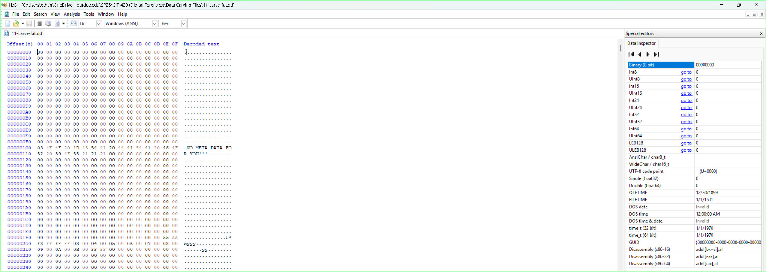

Searching for JPEG Files + Retrieving Start Offset for Full Block
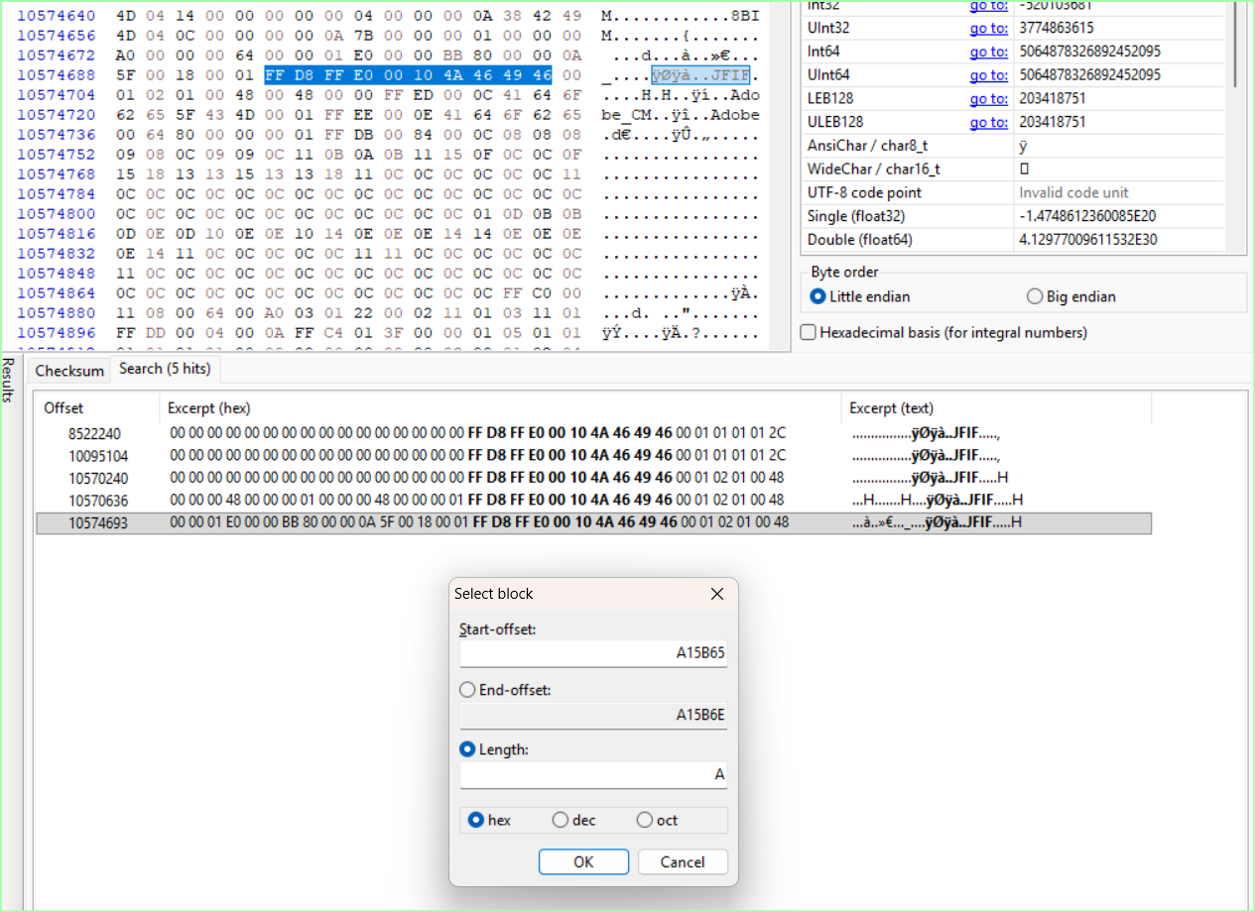

Retrieving End Offset for Full Block + Retrieving Full Block
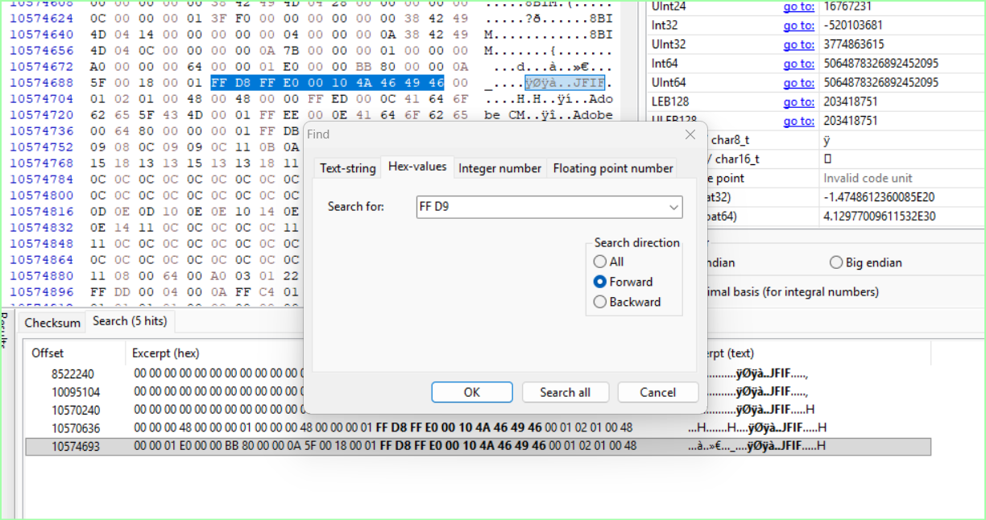
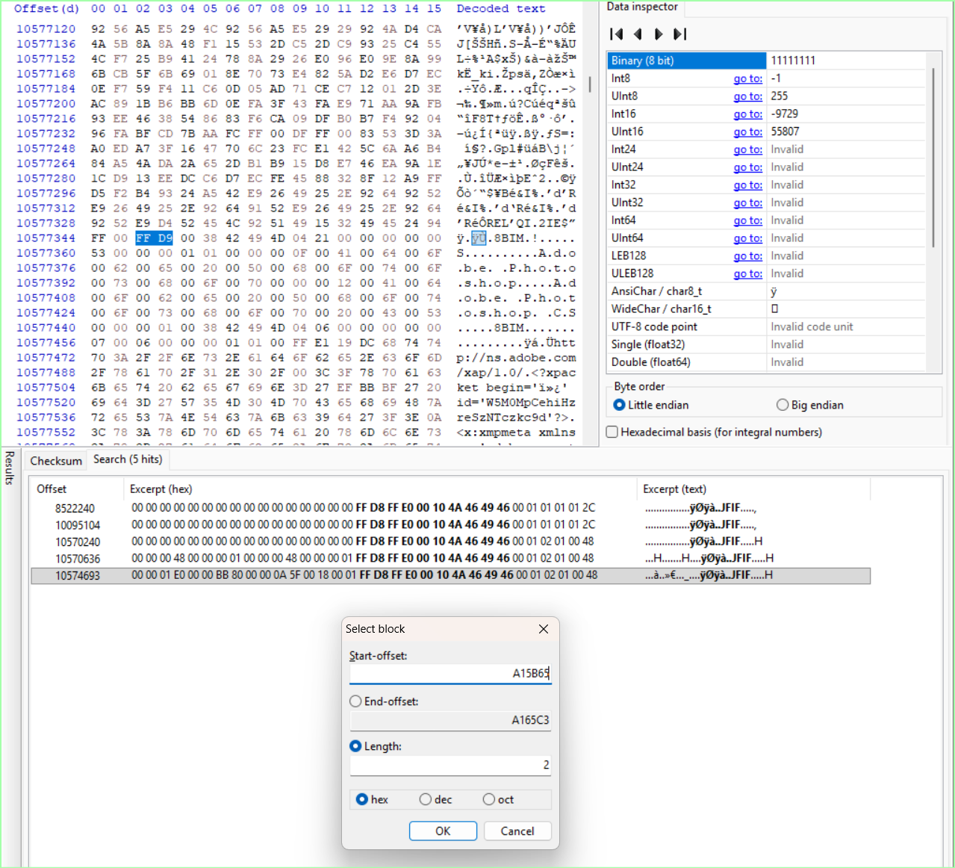

Copy and Pasted into Separate file + .jpg
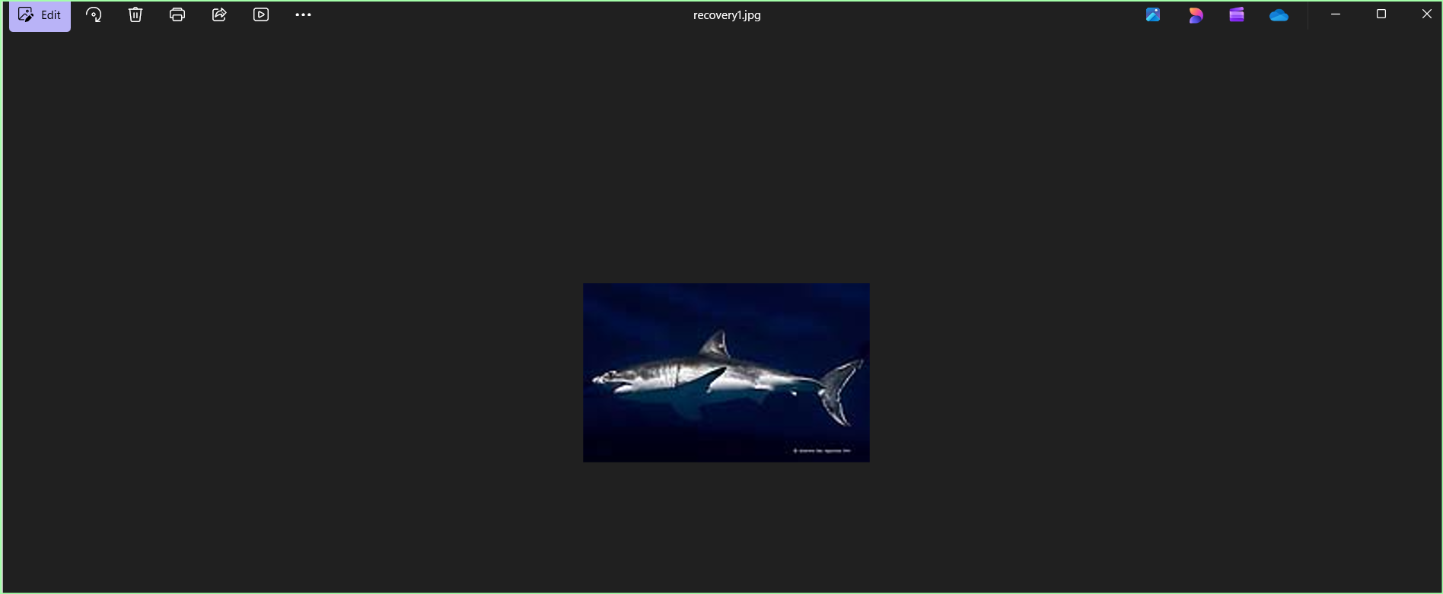

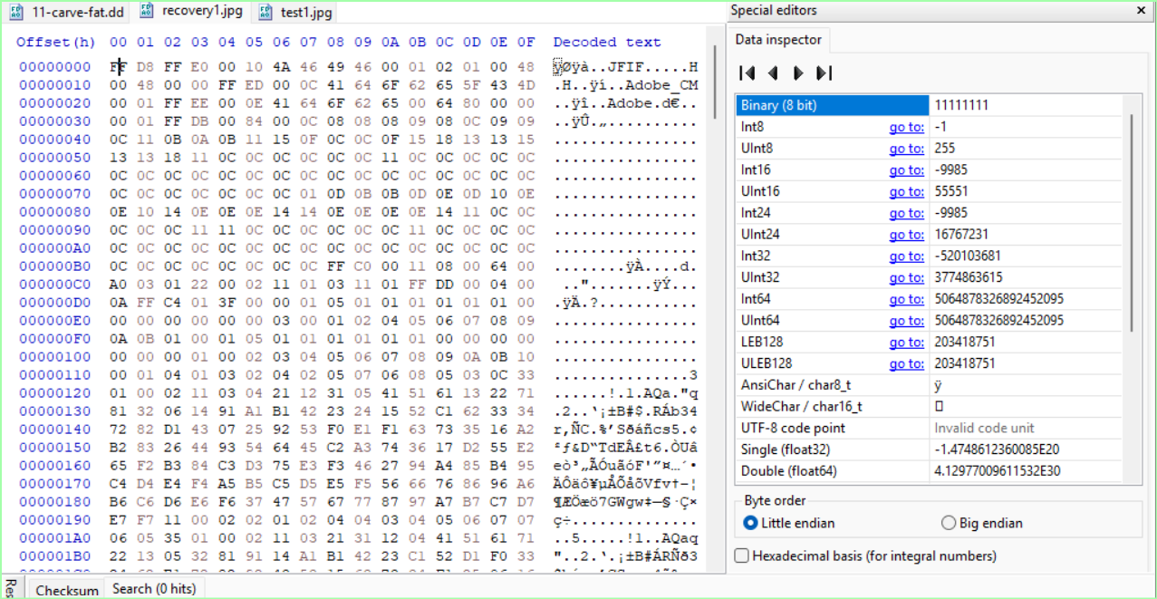

Retrieving the SHA-256 Hash Value
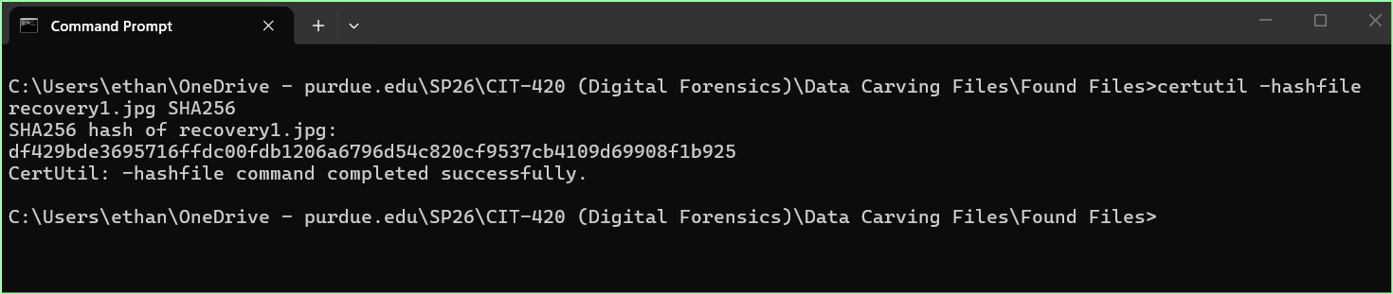

Repeated for 2 Other JPG files. (3 Total)
Starting Offsets:
- 9A0A00 (Recovery2.jpg)
- A14B8C (Recovery3.jpg) Same shark Picture but different starting offset
  - Shark picture appears twice after multiple tests.
- There were TWO jpg hits off the magic number that seemed to be corrupted.

Found ZERO PNG Files

Searching for PDF files (TWO hits)
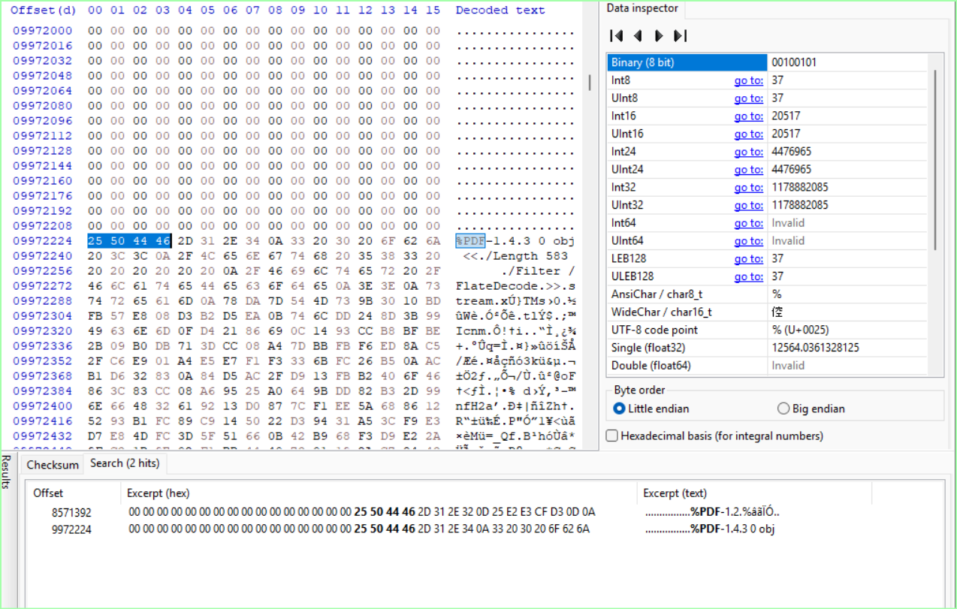
Starting Offsets:
- 82CA00 (FAILED)
- 982A00 (WORKED)

Locating END File Signature
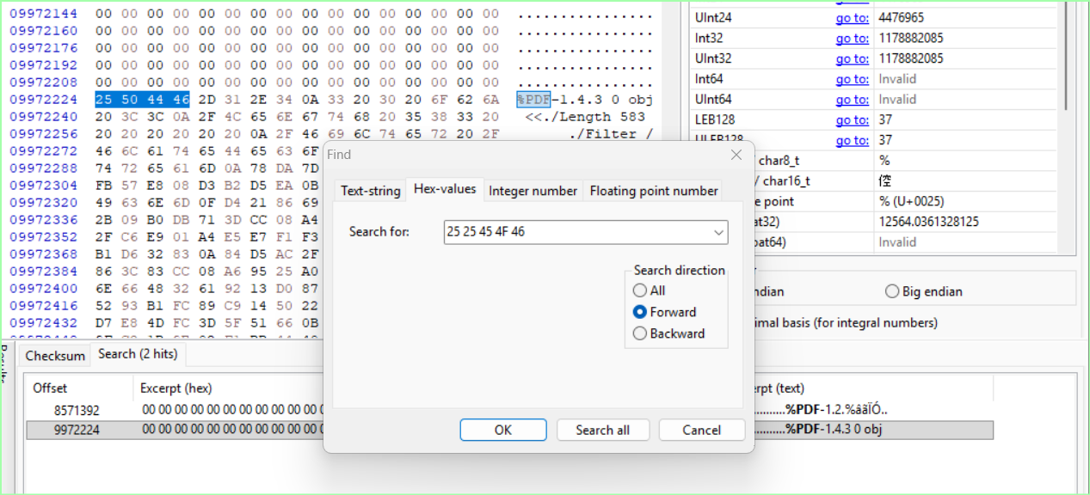

PDF File:
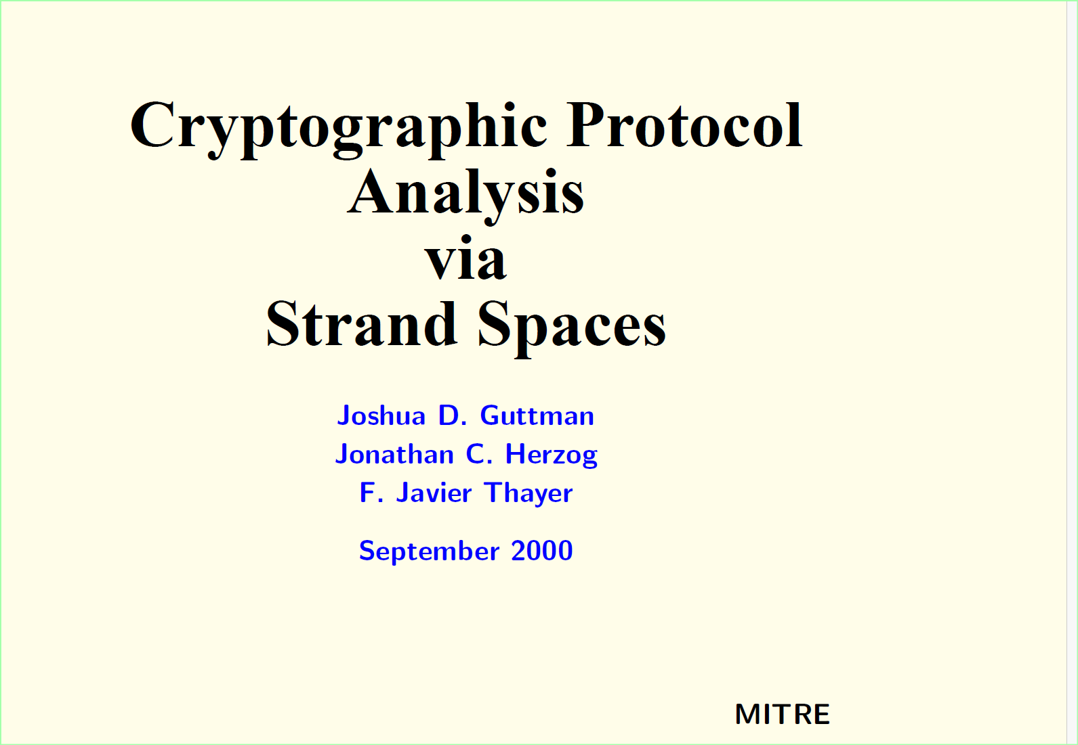

Searching for WORD Documents (ONE hit)
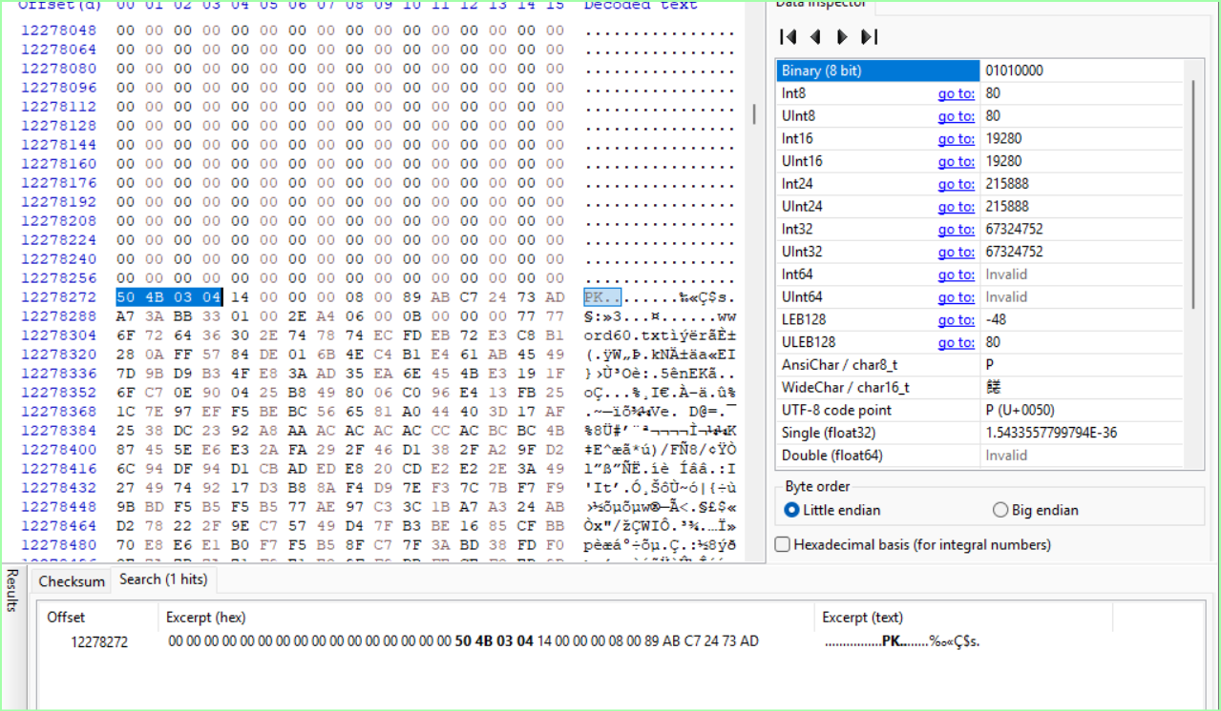
Starting Offset:
- BB5A00

Searching for ZIP END File Signature (50 4B 05 06)
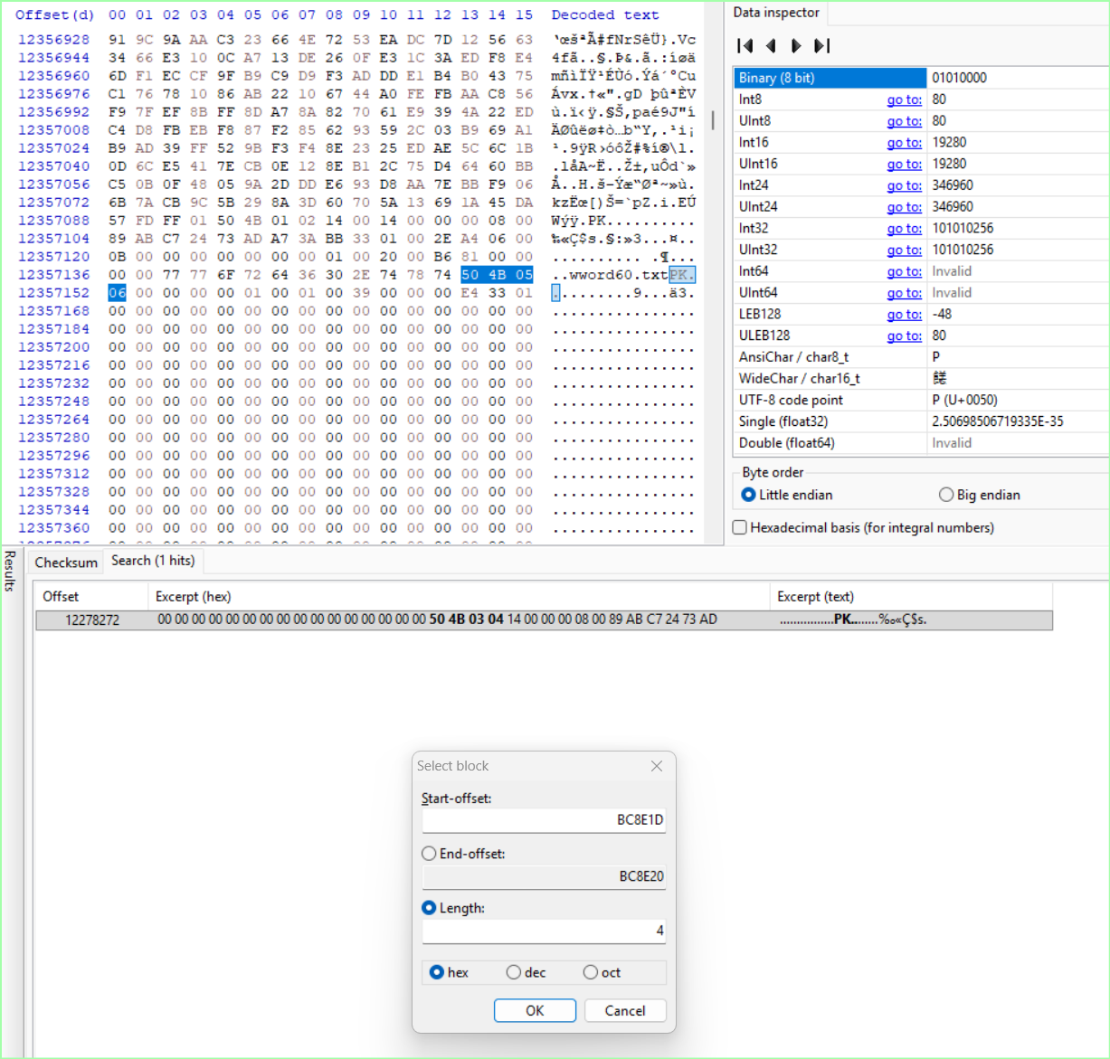
Found .docx file and it is recognized but the data is corrupt.

Searching for GIF Start Signatures
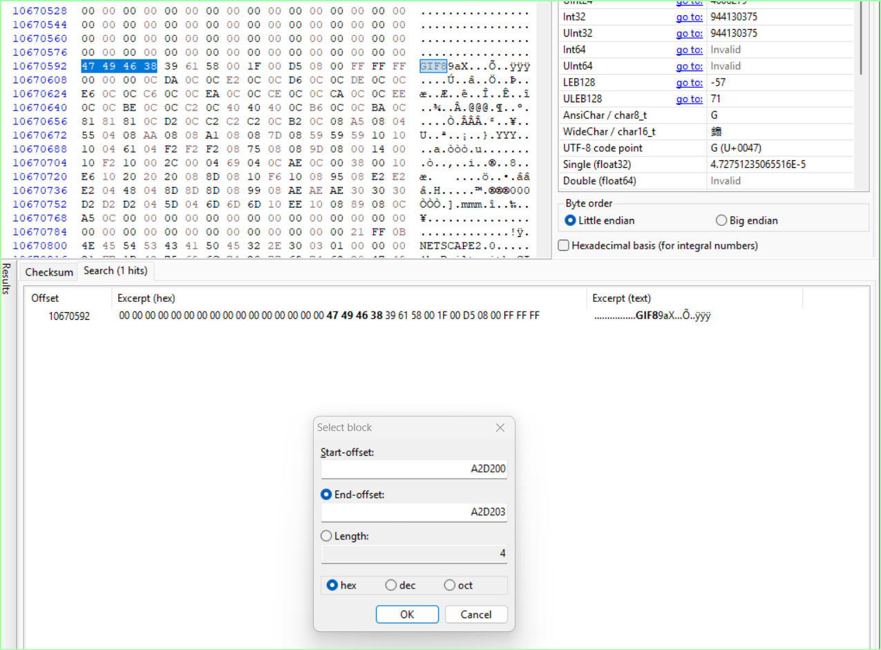

Locating End File Signature (3B Followed by 00 Padding)
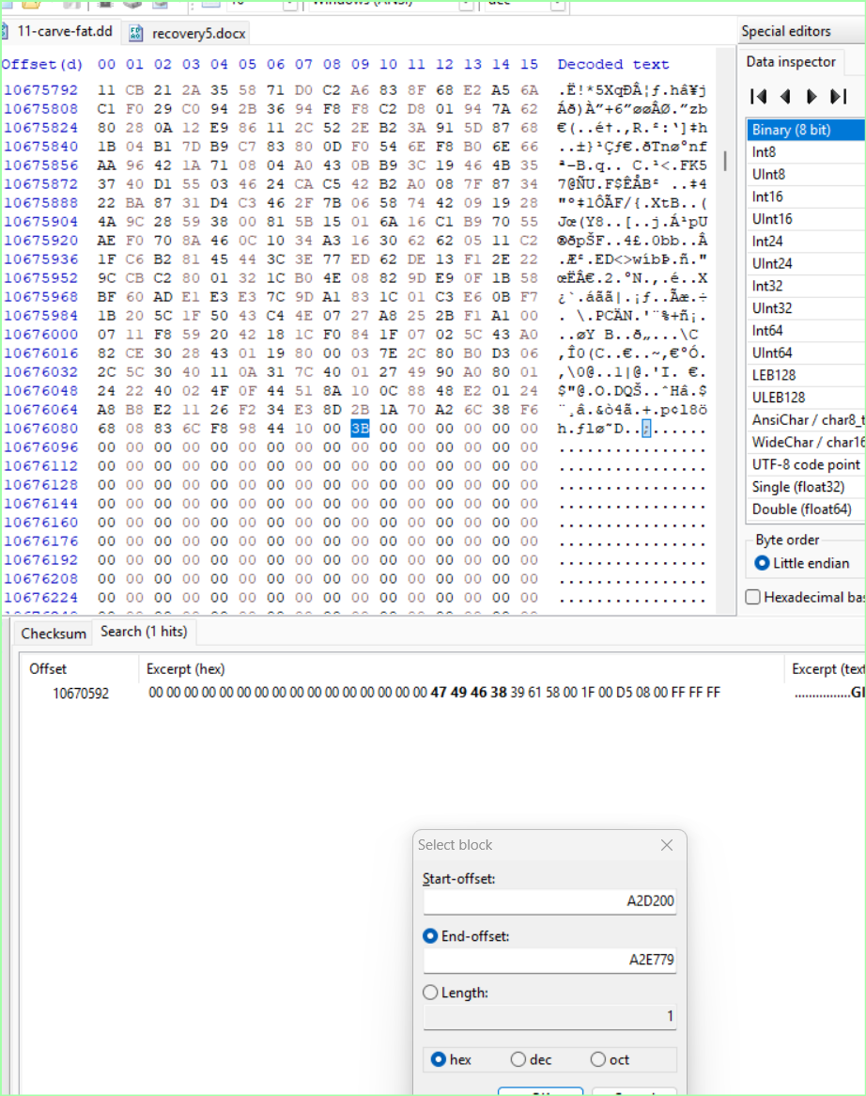

Recovered GIF:

Searching for ASF Files (0 26 B2 75 8E 66 CF 11 A6 D9 00 AA 00 62 CE 6C)
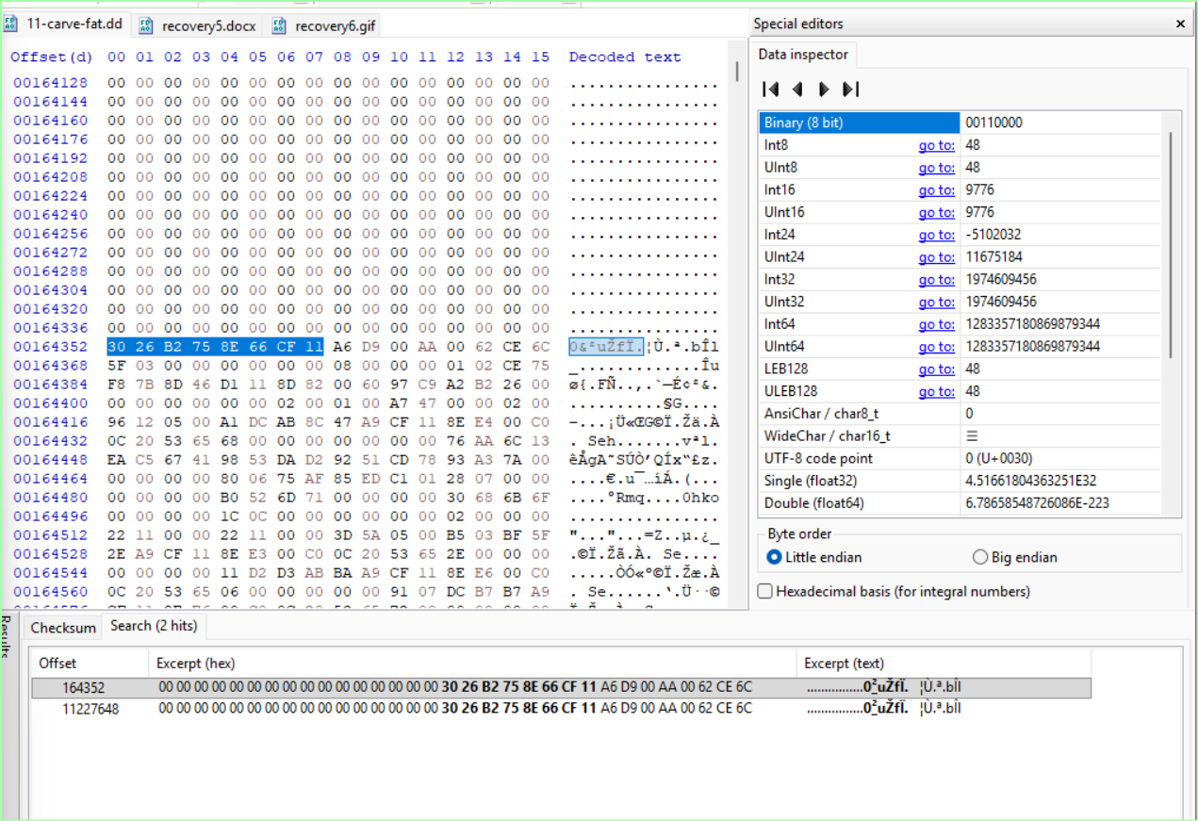
Starting Offset
- 28200
- AB5200

Locating ARF End File Signature
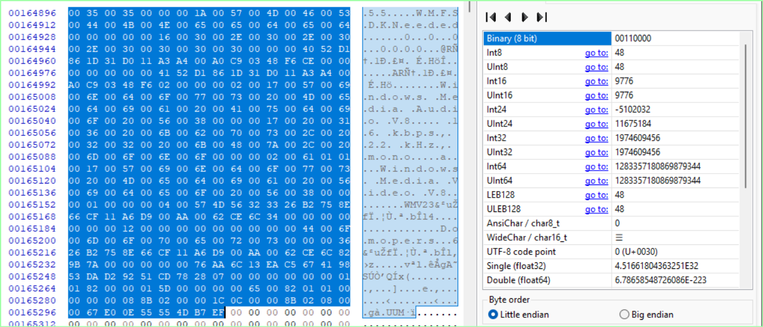
Retrieved 3 minutes and 7 second video.
Retrieved 36 second video of someone surfing.

Searching for EXCEL files (50 4B 03 04)
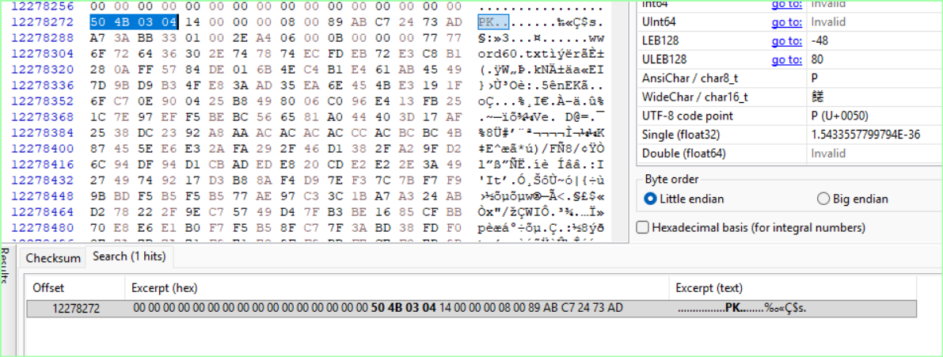
Got one Hit and scrolled until padding.

Locating a WAV File (52 49 46 46)
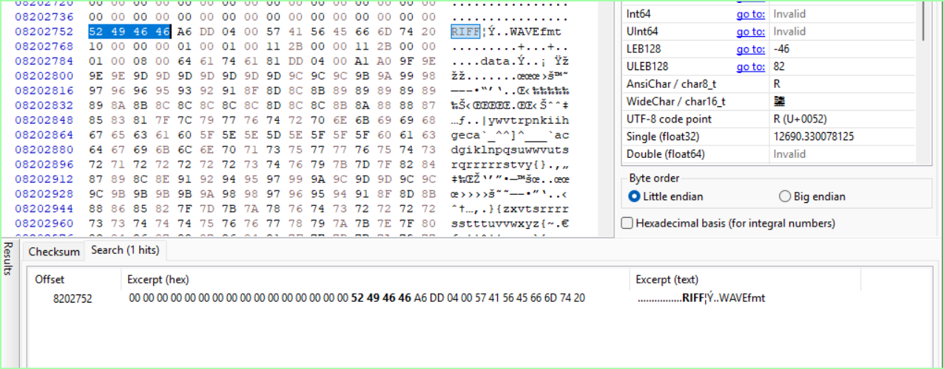

Locating the End Signature of the .wav file
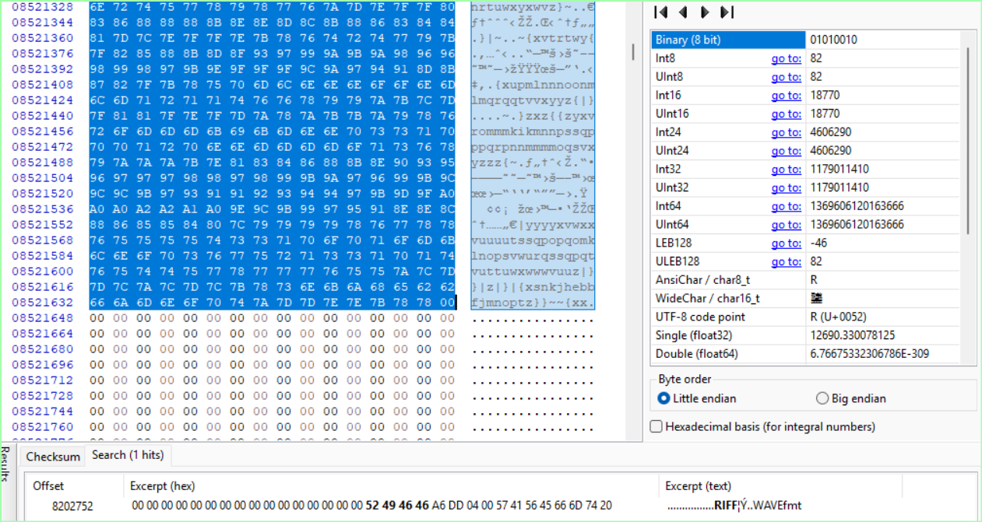

Audio File contained the captain of the USS enterprise speaking.

