HW5: You Got Mail! – National Gallery DC Attack

Ethan Perdieu
Department of Engineering and Technology
CIT-420: Digital Forensics
Dr. Lint
March 27th, 2026

- Executive Summary
Case 2 – 2012 National Gallery DC Attack
The examination was conducted to investigate a set of 12 email log files (.eml) on a MacBook Air belonging to the individual, Tracy Sumtwelve, who is an employee of the National Gallery in Washington, DC. The evidence was obtained from a verified link and was cross verified with correct evidence hashes to ensure the evidence was not tampered with. It consists of 12 .eml files spanning June 28th through July 12th, 2012, and the emails were generated by a keylogger known as LogKext. This was running as root on Tracy’s machine and captured keystrokes to external Gmail accounts. The analysis was performed using Autopsy 4.22.1.

Key Findings of the Investigation:
- Kernel-level keylogger (LogKext) was installed on Tracy Sumtwelve’s MacBook Air. Covertly operated with root privileges
- Tracy Sumtwelve communicated inside information about high-value contracts such as legalBee
- Encrypted gallery documents were transmitted to a contact named Perry using the password Hercules
- Tracy offered to bypass National Gallery Security to allow an authorized individual to bring a tablet into the exhibit
- A second user was identified on the machine, Terry Sumtwelve
- Multiple contacts were identified including legalBee, Perry, coralblue2@yahoo.com, coralbluestwo@hotmail.com, n.throsam@m57.biz and Carrym

Examiner: Ethan Perdieu Date: June 28, 2012 – July 12, 2012 (Evidence Date) / March 27th, 2026 (Analysis)
Course: CIT-42000 Digital Forensics

- Objectives

The following tasks were outlined for the forensic investigation of the 12 .eml files associated with the 2012 National Gallery DC Attack:
- Verify Evidence Integrity – Generate and compare the MD5 hash values to a verified source to ensure no tampering occurred
- Identify the Spyware and Functionality – Determine the type of malicious software and how it operates/what data it could capture and transmit
- Identify all Key Individuals Involved – Establish Owner and any additional users of the device and all external contacts that were referenced
- Build a Chronological Timeline – Construct a detailed timeline of the significant events captured within the 12 .eml log files
- Present all Findings – Present supporting evidence and investigative conclusions

- Evidence Analyzed

Hash values were calculated for each file prior to analysis to verify the integrity of the evidence:
File Name | MD5 Hash | Integrity Verified
logfile-2012-06-28- 1600.eml | df2f439f28af342ca8a8fd9f0b740f53 | ✓
logfile-2012-06-29- 1100.eml | c891901bb05b6a65228d6709a8e27173 | ✓
logfile-2012-07-02- 1200.eml | 88061c1ea9c7feb5ee2a4ff76c305a21 | ✓
logfile-2012-07-02- 1500.eml | d5d2132926e1dc71c4f477dc5f02f74f | ✓
logfile-2012-07-02- 1600.eml | a4f064444a8c62443e03e8e29735dcd2 | ✓
logfile-2012-07-03- 1000.eml | 68e9fa3bb0716a10a9021cf77bc5a0e7 | ✓
logfile-2012-07-06- 1100.eml | 630dd4a71d4e8a082d57a0eb7d8a168d | ✓
logfile-2012-07-06- 1400.eml | 970ab8abc50e5ef1a1241488c3b41adb | ✓
logfile-2012-07-09- 1300.eml | 7479cdc87ae4f0d96d4e692828e380d7 | ✓
logfile-2012-07-10- 1000.eml | dd23022018c86f474ba6c2961fdae35e | ✓
logfile-2012-07-11- 1500.eml | 59469076816371618619a028948df12a | ✓
logfile-2012-07-12- 1200.eml | a224f7fdf6af727a16bc4d7ae0bb9125 | ✓

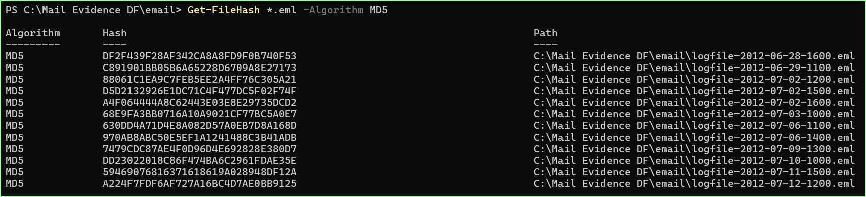
Figure 1: Process of identifying the MD5 Hash Values

- Relevant Findings

The following key findings were identified during the examination of the 12 .eml log files associated with the 2012 National Gallery DC Attack:
- Presence of Keylogging Spyware (LogKext)
  - Kernel-level keylogger known as LogKext was found on Tracy’s MacBook Air. The spyware had root privileges and was seen to automatically generate log files and keystrokes that then get transmitted through email. These emails were transmitted through the address joe.sum.tweleve@gmail.com.
- Primary Suspect IDed
  - The primary suspect of the device was identified as Tracy Sumtwelve aka. tracysumtwelve. Tracy seemed to be an employee at the National Gallery in Washington DC based on information within the emails themselves. This conclusion was made due to the emails referencing internal operations, new exhibits and security procedures.
- Insider Threat/Disclosure of Sensitive Information
  - Tracy was found to have repeatedly transmit sensitive information about the National Gallery to outside sources. Details such as incoming high-value exhibits, shipping costs and internal paperwork/memos related to the exhibits.
- Internal Documents transmitted
  - Tracy was observer using terminal commands to encrypt documents using the command zip -e with the password Hercules and then would transmit these files as Perry. The password was seen in a separate email than where the command was found.
- Allowing Unauthorized Access
  - Tracy offered an individual to bypass the security at the National Gallery. This was for the unauthorized individual to bring a tablet in.
- Secondary Device User
  - A second user known as Terry Sumtwelve was identified using a username terrysumtwelve. Terry is believed to be related to Tracy and was seen doing normal school behavior such as schoolwork and socializing.
- Abnormal Timestamps
  - Two timestamps dating to Dec 5, 2006, were identified within the LogKext logs. This could prove possible system clock manipulation.

- Supporting Details

Case 2 – 2012 National Gallery DC Attack
5.1 Evidence of LogKext Activity
The malicious software identified as LogKext, a open-source kernel-level keylogger on MacOS, was identified. Here you can see LogKext was automatically configured to create new log files and transmit them via joe.sum.twelve@gmail.com.

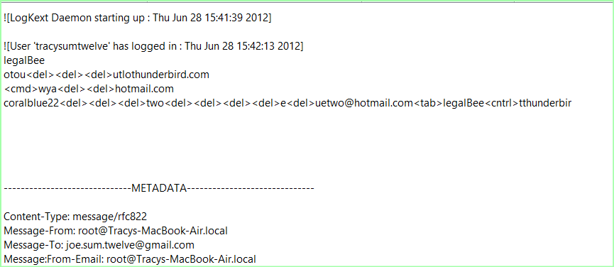
Figure 7: LogKext running as root and transmitting to joe.sum.twelve@gmail.com

5.2 Chronological Timeline of Events
Data & Time | User | Event | Source File
Jun 28 16:00 2012 | root | LogKext first detected and beings exfiltrating to joe.sun.twelve@gmail.com | logfile-2012-06-28-1600.eml
Jun 29 09:14 2012 | tracysumtwelve | Tracy Logged in, references documents and warns legalBee about getting introuble | logfile-2012-06-29-1100.eml
Jul 2 11:07 2012 | tracysumtwelve | First reference to National Gallery | logfile-2012-07-02-1500.eml
Jul 2 11:18 2012 | terrysumtwelve | Terry Sumtwelve was identified as the second user on the device | logfile-2012-07-02-1500.eml
Jul 2 ~2006 | root | Anomalous 2006 timestamps detected – showing possible clock manipulation | logfile-2012-07-02-1500.eml
Jul 2 15:00 2012 | tracysumtwelve | Tracy informs legalBee about high-value exhibits, notes, and cost anomaly’s | logfile-2012-07-02-1600.eml
Jul 3 09:18 2012 | tracysumtwelve | Tracy confirms rare stamp collection | logfile-2012-07-03-1000.eml
Jul 9 09:22 2012 | tracysumtwelve | Tracy encrypts internal documents using zip -e with password “Hercules” | logfile-2012-07-09-1300.eml
Jul 9 13:01 2012 | tracysumtwelve | Tracy emails encrypted documents to Perry with a password hint: “Your old dog’s name” | logfile-2012-07-09-1300.eml
Jul 10 09:15 2012 | tracysumtwelve | Tracy offers to bypass gallery security to allow tablet inside | logfile-2012-07-10-1000.eml
Jul 12 11:42 2012 | tracysumtwelve | Final log entry, Tracy accessed yahoo.com and received email coralblue2@yahoo.com | logfile-2012-07-12-1200.eml

5.3 Network of Contacts
The following individuals were identified throughout the keystroke logs:
Name | Identifier | Role
Tracy Sumtwelve | Tracysumtwelve / root@Tracys-MacBook-Air.local | Primary Subject, Employee at the National Gallery
Terry Sumtwelve | Terrysumtwelve/ just.terry.22@gmail.com | Family member of Tracy, Second Device user
Joe | Joe.sum.twelve@gmail.com | Spyware operator, Internal Document Recipient/Main Contact
legalBee | Unknown Email | Primary outside contact who received gallery information
Perry | Unknown Email | Received encrypted documents from Tracy
Coral | Coralblue2@yahoo.com / coralbluetwo@hotmail.com | Contact of Tracy who was referenced positively
Awen Throsam | n.throsam@m57.biz / awen.throsam@ | Contact of Terry
Carrym | Unknown Email | Social contact involving Tracy

5.4 Insider Communications – LegalBee
As seen in Figure 8, and across multiple other log files, Tracy Sumtwelve was seen sending messages to a contact LegalBee. This contained an assortment of sensitive internal information.

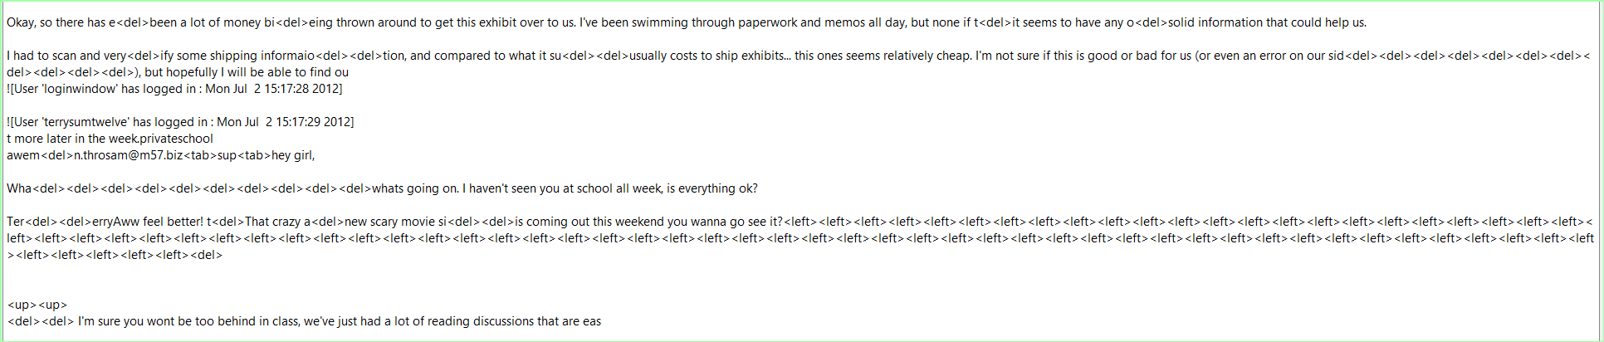
Figure 8: Tracy disclosing exhibit shipping information

5.5 Encryption and Transmission
As shown in Figure 9, Tracy uses the zip -e command to encrypt internal documents with the password Hercules. She then emailed this message to a contact named Perry with a message saying the password was Perry’s old dog name.

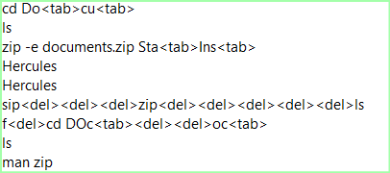
Figure 9: Document Encryption using zip -e and Hercules password

5.6 Unauthorized Access Facilitation
On July 10, 2012, Tracy Sumtwelve composed the following message:
“Yea sure, that shouldn't be much of a problem. I can definitely help get your tablet in. Our security guards can be pretty ridiculous sometimes! When would you want to get in and take a look around?”

This directly proves Tracy’s willingness to break rules and make exceptions at their own benefit.
Figure 10: Tracy’s communication of letting someone in

5.7 Anomalous Timestamps
Two LogKext entries were found bearing unusual timestamps, Sun Jun 16, 1985, and Tue Dec 5, 2006. These entries were found within the logfile-2012-07-02-1500.eml and were caused by the keylogger software.

Figure 11: Anomalous Timestamp

- Investigative Leads

The investigation of the National Gallery in Washington, DC has several areas that need to be further investigated:
- legalBee identity is still unknown and has a large extent of insider information
- Investigate joe.sum.twelve@gmail.com to determine who installed LogKext
- Recover encrypted files sent to Perry to determine what was transmitted
- Investigate Coral origins and a potential second insider
- Determine what the tablet was used for and why it was snuck inside

- Conclusion

Case 2 – 2012 National Gallery DC Attack
The forensic examination of the 12 .eml log files associated with the 2012 National Gallery DC attack revealed significant evidence of insider threats. Tracy Sumtwelve, a national gallery employee, was seen using a kernel-level keylogger to transmit sensitive information. The evidence strongly suggests that Tracy was involved in extremely malicious behavior. The case warrants further investigation and recovery of the documents that were transmitted.

