HW5: You Got Mail! – Nitroba Email Harrasment

Ethan Perdieu
Department of Engineering and Technology
CIT-420: Digital Forensics
Dr. Lint
March 27th, 2026

- Executive Summary
Case 1 – 2008 Nitroba University Email Harassment
The examination was conducted to investigate a network packet capture (.pcap) file associated with an email harassment case at Nitroba University in 2008. The evidence consists of a single .pcap file obtained from Digital Corpora. The analysis was conducted using Wireshark 4.6.3 and was aimed at identifying the party responsible for sending harassing emails to Chemistry 109 Professor Lily Tuckrige.

Key Findings of the Investigation:
- The harassing emails were traced to IP Address 192.168.15.4 originating from a student dormitory room
- The suspect used an anonymous email service called willselfdestruct.com to send the harassment message to lilytuckrige@yahoo.com
- The harassment message stated “you can’t find us. Stop teaching. Start running.” and found via HTTP POST on July 22, 2008, at 07:24:45 GMT
- The suspect’s device was identified as MAC Address 00:17:f2:e2:c0:ce which belonged to an apple device
- HTTP cookie analysis identified the suspect’s email as jcoachj@gmail.com matching Johnny Coach

Examiner: Ethan Perdieu Date: July 22nd, 2008 (Evidence Date) / March 27th, 2026 (Analysis)

- Objectives

The following tasks were outlined for the forensic investigation of the .pcap file associated with the 2008 Nitroba University Email Harassment:
- Verify Evidence Integrity – Generate and compare the MD5 hash values to a verified source to ensure no tampering occurred
- Identify the Source IP Address – Determine which IP address was response for accessing willselfdestruct.com and submitting harassing messages
- Recover the Harassment Message Content – Extract and document full message content
- Identify the Suspect’s Device – Link the MAC address of the device used to send the harassment message
- Identify the Suspect – Link the MAC address to a specific individual
- Build a Chronological Timeline – Construct a detailed timeline of the significant events captured within .pcap file
- Present all Findings – Present supporting evidence and investigative conclusions

- Evidence Analyzed

Hash values were calculated for each file prior to analysis to verify the integrity of the evidence:
File Name | MD5 Hash | Integrity Verified
Nitroba.pcap | 9981827f11968773ff815e39f5458ec8 | ✓

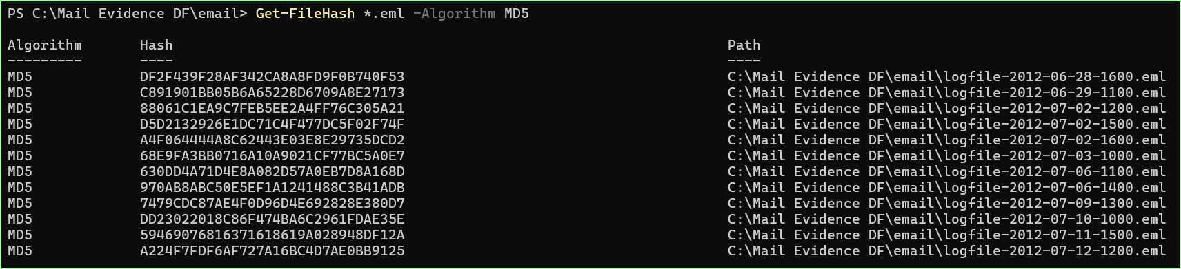
Figure 1: Process of identifying the MD5 Hash Values

- Relevant Findings

The following key findings were identified during the 2008 Nitroba University Email Harassment:
- Source IP Address Identified
  - Network traffic analysis confirmed the IP address 192.168.15.4 was used to access www.willselfdestruct.com and submit the malicious message. The destination IP was 69.25.94.22
- Harassment Message Recovered
  - An HTTP POST request submitted on www.willselfdestruct.com was recovered during the packet captured. This packet contained a message directed to lilytuckrige@yahoo.com with the content “You can’t find us. Stop teaching. Start Running.” Which was recorded on July 22, 2008, at 07:24:45 GMT
- Suspect Device Identified
  - The MAC address of the device used to submit the malicious message was 00:17:f2:e2:c0:ce which was confirmed to be an apple device
- Suspect Identity Established via Cookie Analysis
  - HTTP cookie analysis with the mac address 00:17:f2:e2:c0:ce revealed OL_SESSION=jcoachj@gmail.com-cal, identifying the Gmail Account
- Suspect Matched to Class Roster
  - Cross referencing allowed us to find a match with Johnny Coach, a student enrolled in Professor Lily Tuckrige’s Chemistry 109 class was responsible for the malicious messages.

- Supporting Details

Case 1 – 2008 Nitroba University Email Harassment
5.1 Source IP and Website Identification
Used the filter http.request.method == "GET" && http.host==www.willselfdestruct.com to confirm the IP address that accessed the website. The activity included /secure/submit and /secure/success showing that the form was processed successfully and that the message was sent.

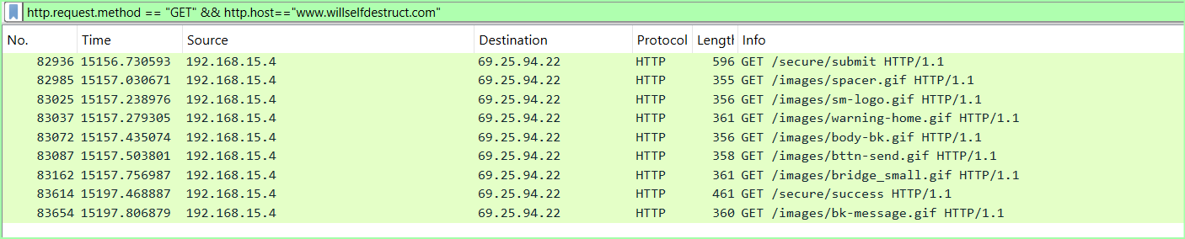
Figure 2: Wireshark filter results confirming 192.168.15.4 accessing willselfdestruct

5.2 Harassment Message Content
Used the filter (ip.src == 192.168.15.4) && (ip.dst == 69.25.94.22) I was able to locate Frame 83601 which was an HTTP POST to /secure/submit. This contained the exact contents of the malicious message.

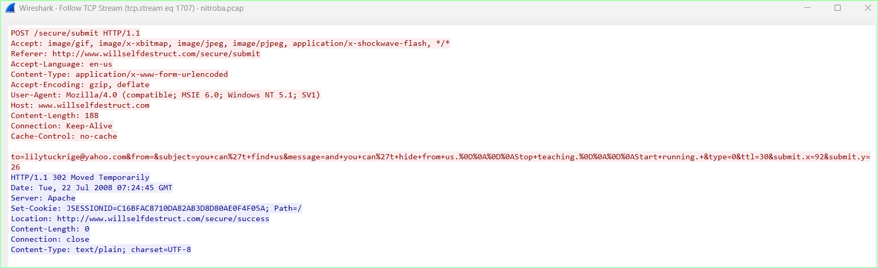
Figure 3:Frame 83601 containing the harassment message and recipient
5.3 Suspect Device Mac Address
The ethernet layer of Frame 83601 revealed the source MAC address. This was then able to be used to identify that the device was an Apple manufactured device.

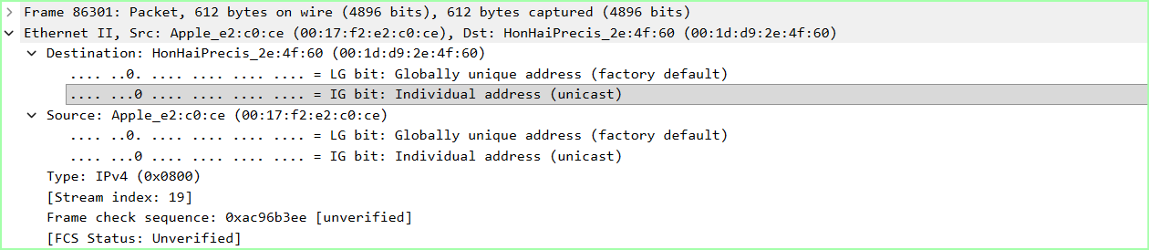
Figure 4: Packet details showing MAC Address

5.4 Cookie Analysis/Suspect Identification
Using the filter eth.src == 00:17:f2:e2:c0:ce && http.cookie contains "@" showed packets so the cookies could be analyzed for emails. This directly led us to OL_SESSION=jcoachj@gmail.com-cal, directly linking that email address to the harassment messages.

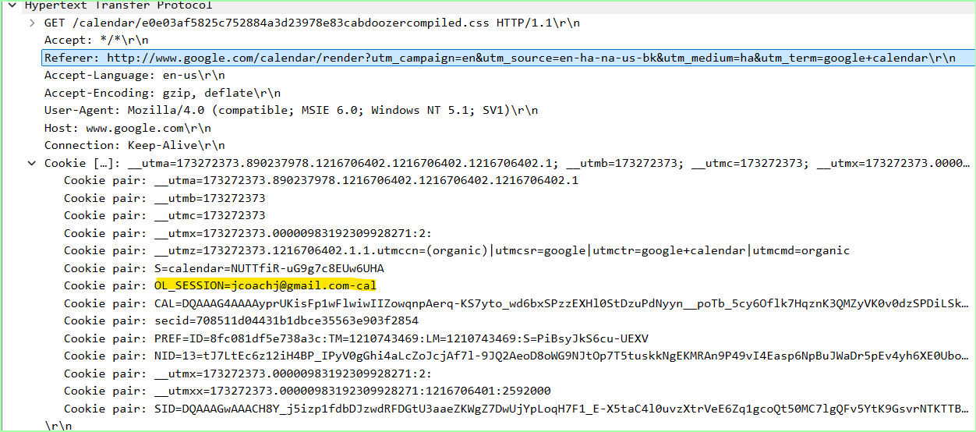
Figure 5: Email visible under Cookie Pair in HTTP Layer

5.5 Suspect Matched to Class Roster
The email involving jcoach was matched to Johnny Coach, a student enrolled in professor Tuckrige’s Chemistry 109 Class.

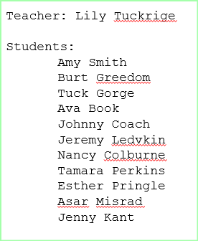
Figure 6: Class Roster supplied by verified GitHub Source

5.6 Chronological Timeline of Events
Data & Time | Event
Prior to Jul 22, 2008 | Professor Lily Tuckrige receives initial harassment email traced to IP 192.168.15.4
Jul 22, 2008 07:24:45 GMT | Suspect at 192.168.15.4 accessed www.willselfdestruct.com via apple device
Jul 22, 2008 07:24:45 GMT | HTTP POST submitted containing harassment message directed to lilytuckrige@yahoo.com
Jul 22, 2008 07:24:45 GMT | Server redirects to /secure/success confirming successful submit
Jul 22, 2008 ~07:25 GMT | Cookie analysis reveals OL_SESSION=jcoachj@gmail.com-cal, identifying suspect as Johnny Coach

- Investigative Leads
The investigation of the 2008 Nitroba University Email Harassment has several areas that need to be further investigated:
- Investigate whether Johnny Coach sent any additional harassment emails prior to captured network traffic
- Examine Johnny Coach’s device for any other related information to the harassment
- Determine if any of the roommates may have been involved since the reading came from a shared dormitory
- Review willselfdestruct.com server logs if possible.

- Conclusion
Case 1 – 2008 Nitroba University Email Harassment
The forensic examination of the .pcap file associated with the Nitroba University harassment was used to successfully identify the suspect. HTTP cookie analysis revealed Johnny Coach as the main harasser. The evidence recovered from the packet capture sufficiently proves Johnny Coach as the sender of the messages and warrant further investigation before the packet capture.

