HW7: IoT Investigation - Home

Ethan Perdieu
Department of Engineering and Technology
CIT-420: Digital Forensics
Dr. Lint
April 19th, 2026

- Executive Summary
A forensic examination was conducted on two EnCase forensic images, HomeyProPre.E01 and HomeyProPost.E01, captured from a Homey Pro smart home hub running Debian GNU/Linux 11 (Bullseye). The examination was performed to identify the device’s operating system, installed IoT software, network configurations, connected devices, user credentials and any forensically relevant artifacts.

Key Findings of the Investigation:
- File integrity was confirmed for both images via SHA-256 Hash Verification
- The device runs Debian GNU/Linux 11 (Bullseye) on a Raspberry Pi-based Homey Pro hub (Model: homey5q, Version 12.4.3)
- The primary IoT platform is Homey Pro, with two installed applications: Ikea Trafri
(v 2.8.2) and Datek Eva (v2.5.1)
- All IoT devices communicate exclusively over the Zigbee protocol
- Five IoT devices were identified across two zones, Home and Office (Second Floor)
- Wi-Fi Credentials were recovered in plaintext including SSID, BSSID and PSK
- A user account named “UC3’s Homey Pro” was identified as the Owner
- Recoverable password hash found, plaintext Wi-Fi credentials, and an exposed RSA private key

Examiner: Ethan Perdieu Date: April 19th, 2026 (Analysis)
- Objectives

The following tasks were outlined for the forensic investigation:
- Generate Evidence Hashes – Generate and verify SHA-256 hashes for both forensic images to confirm they have not been tampered with
- Examine the Forensic Images – Analyze HomeyProPre.E01 and HomeyProPost.E01 to identify the operating system, file system and user information
- Identify IoT Software and Technologies - Determine the IoT platform, protocols, installed applications, and device model in use
- Identify Site and User Configurations – Recover device locations, account credentials, and Wi-Fi credentials from the images
- Map IoT Devices – Identify all connected IoT devices, their unique identifiers, protocols, and physical layout within the home
- Identify Forensic Artifacts – Locate and document forensically relevant artifacts that may apply to an investigation
- Build a Chronological Timeline – Construct a timeline of significant events captured within the forensic images
- Present all Findings – Present supporting evidence and investigative conclusions

- Evidence Analyzed
Two Encase forensic image files were examined during the investigation. SHA-256 hash values were calculated for each file prior to analysis to verify integrity and ensure the evidence has not been tampered with.

Hash Verification
File Name | SHA256 Hash | Integrity Verified
HomeyProPre.E01 | b924fe3259b3109939bee99eb3c28d10a20a8565dc0c3d7e157c55efdf80cfa7 | YES
HomeyProPost.E01 | 3239ba054101b7f1c75970183aa1f4b4320c51b83f7b804b2a7ad6dc0be05842 | YES

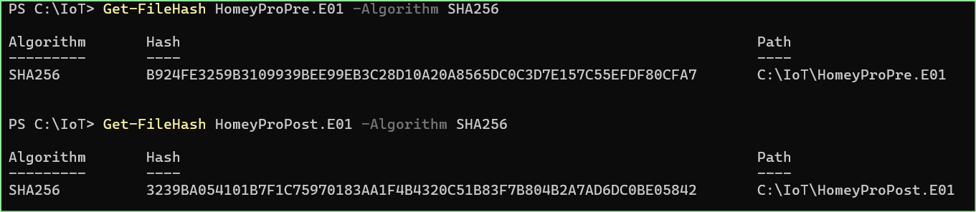
Figure 1: Hash Verification in PowerShell

Image Details
Both images were ingested into Autopsy 4.22.1 for analysis. The following details were identified for each image. No immediate discrepancies were found between the images.

Field | HomeyProPre.E01 | HomeyProPost.E01
File Type | EnCase E01 | EnCase E01
Operating System | Debian GNU/Linux 11 (Bullseye) | Debian GNU/Linux 11 (Bullseye)
Hostname | debuerreotype | debuerreotype
File System | Ext4 | Ext4
Block Size | 4096 Bytes | 4096 Bytes
Primary User | homey | homey

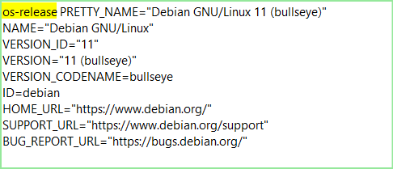
Figure 2: /etc/os-release OS Details

Partition Table
Both the Pre and Post images contained identical partition layouts, confirming no partitions were created, deleted or modified between the acquisition process.

Volume | Description | Starting Sector | Length | Flags
vol1 | Unallocated | 0 | 8192 | Unallocated
vol2 | Win95 FAT32 | 8192 | 67583 | Allocated
vol3 | Unallocated | 75775 | 8193 | Unallocated
vol6 | Win95 FAT32 | 83968 | 524287 | Allocated
vol9 | Unallocated | 608255 | 1 | Unallocated
vol10 | Linux (0x83) | 608256 | 4194303 | Allocated
vol13 | Unallocated | 4802559 | 1 | Unallocated
vol14 | Win95 FAT32 | 4802560 | 524287 | Allocated
vol17 | Unallocated | 5326847 | 1 | Unallocated
vol18 | Linux (0x83) | 5326848 | 4194303 | Allocated
vol21 | Unallocated | 9521151 | 1 | Unallocated
vol22 | Linux (0x83) | 9521152 | 5740545 | Allocated
vol23 | Unallocated | 15261697 | 8191 | Unallocated

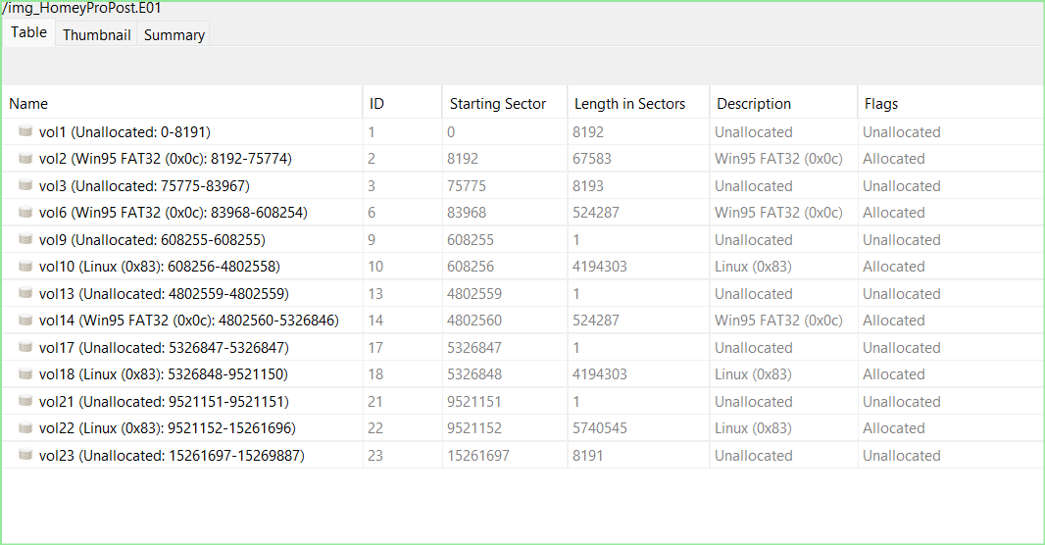
Figure 3: Partition Tree for HomeyProPost generated by Autopsy

Further examination of vol10 confirmed the primary Linux partition used the Ext4 file system with a block size of 4096 bytes and a block count of 524287.

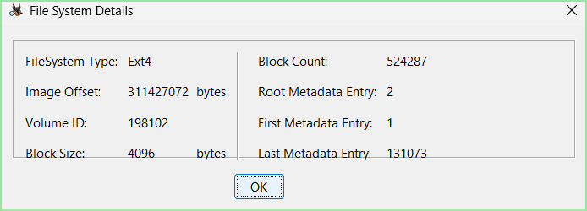
Figure 4: Autopsy File System Details for vol10 Partition

User Accounts
Examination of /etc/passwd and /etc/shadow revealed the following user accounts on the system. All system accounts were disabled with no login. Only the homey account contained a valid password hash.

Username | UID | GID | Home Directory | Shell | Password Hash
root | 0 | 0 | /root/ | /bin/ash | None
node | 1000 | 1000 | /home/node | /bin/sh | None
homey | - | - | - | - | $y$j9T$QrxuGJ16vDrYhaQgzwKxF1$Ph./U/ZQTk37mz4Au  BfJo2flpuo56z0v1hgdQ7Zy7Y.

Figure 5: Locating User Password via /etc/shadow

- Relevant Findings
The forensic examination of HomeyProPre.E01 and HomeyProPost.E01 revealed the following findings. All findings are supported by evidence collected during the analysis of the forensic images using Autopsy 4.22.1.

Finding 1 – IoT Software and Technologies
Examination of the device confirmed that Homey Pro smart home platform (Model: homey5q, Version 12.4.3) is the primary IoT software in use. The device runs multiple IoT protocols and services managed through a containerized Docker environment. Two applications were identified, IKEA Trådfri and Datek EVA, both installed via Homey.

Finding 2 – Site and User Specific Configurations
The db.sqlite database revealed the device is configured under the account “UC3’s Homey Pro” with owner privileges. Wi-Fi credentials were recovered from the NetworkManager File, and device zones were identified spanning the Home and Second Floor.

Finding 3 – IoT Devices
Five IoT devices were identified across two zones, all communication exclusively went through the Zigbee protocol via Homey Pro Hub. Devices include sensors for motion, water leakage, air quality, power monitoring and smart light bulbs.

Finding 4 – Forensic Artifacts
Several forensic artifacts were identified including a password hash, plaintext Wi-Fi credentials, an RSA private key, and detailed device activity timestamps.

- Supporting Details

IoT Software and Technologies
The motd file located at /var/lib/docker/overlay2 confirmed the device is running the Homey Pro SSH Sandbox. The services directory at /var/lib/docker/overlay2/…/diff/app/services revealed active services including ZigbeeDaemon.mjs, CPCDaemon.mjs and gateways confirming the protocols in use.

Figure 6: db.sqlite config entry

Examination of the db.sqlite confirmed the model as homey5q running version 12.4.3, with two installed applications.

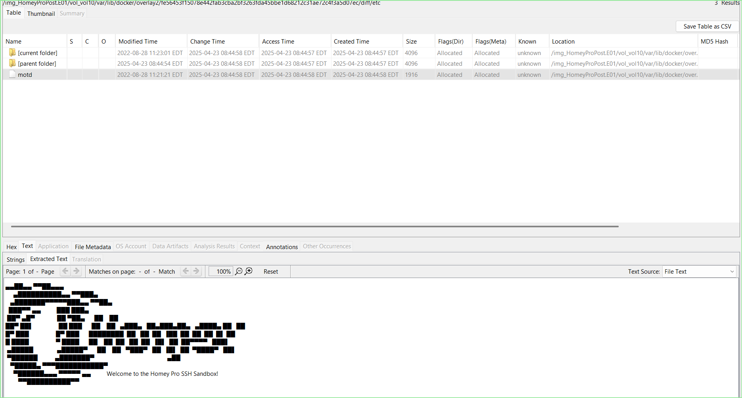
Figure 7: motd file confirming Homey Pro SSH Sandbox

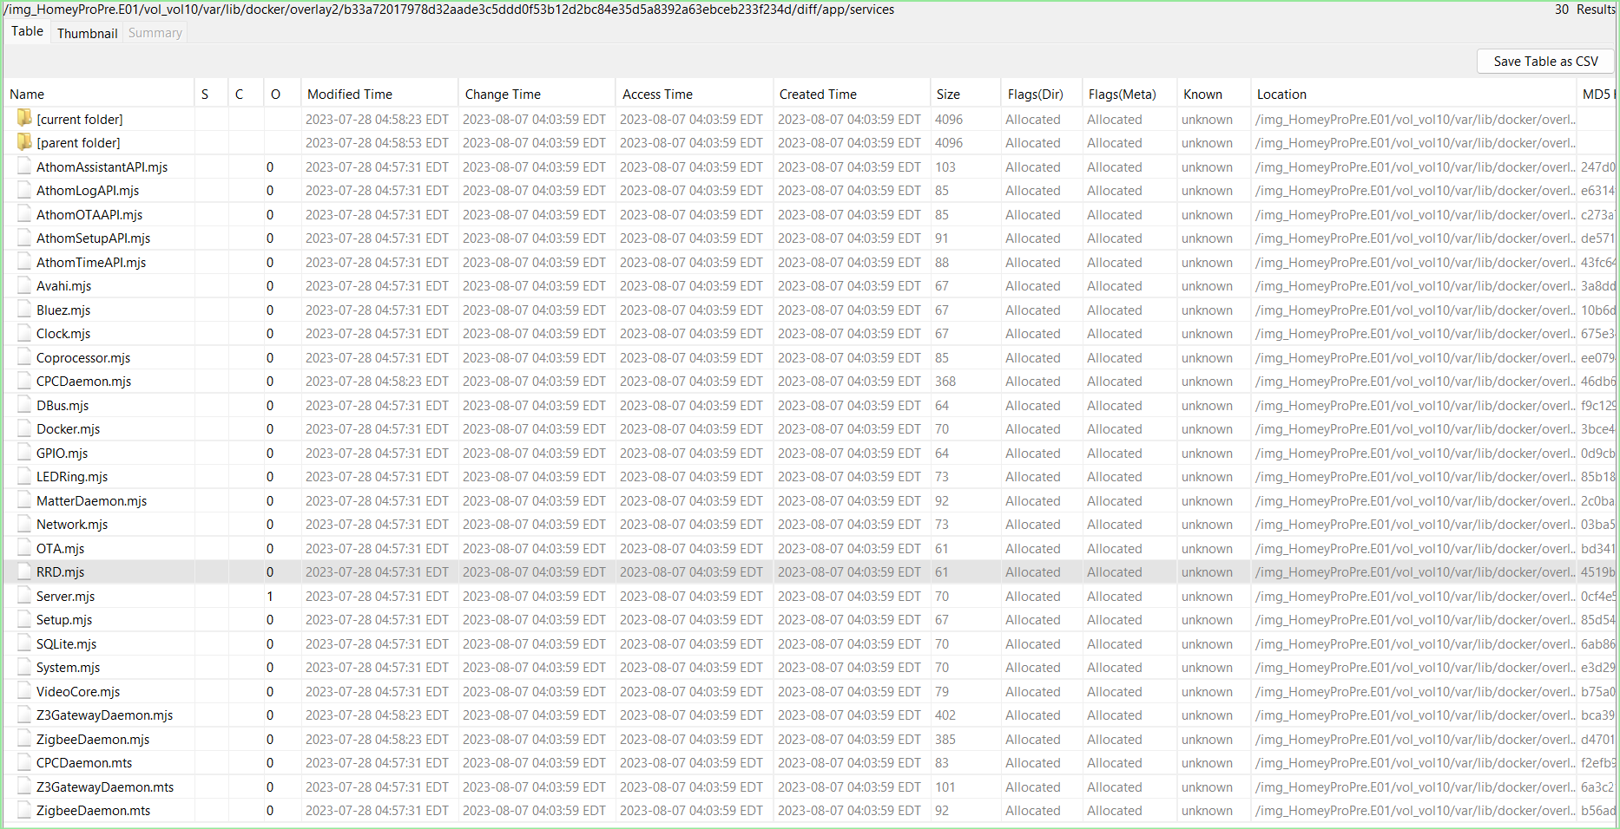
Figure 8: Services directory listing active IoT Services

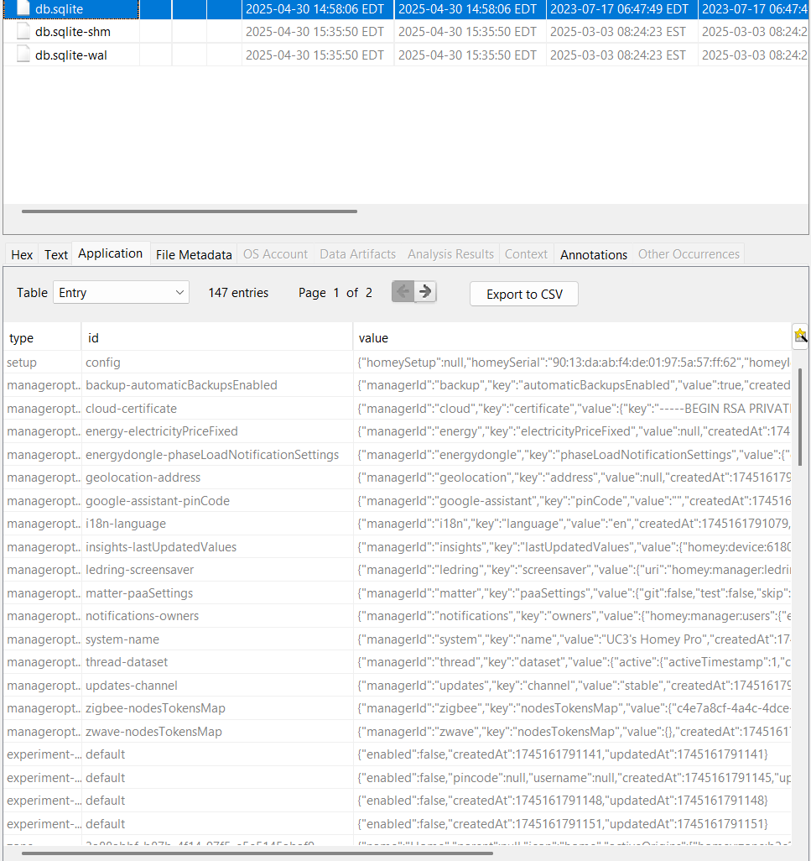
Figure 9: db.sqlite entries used to find IoT devices, zones etc.

Site and User Specific Configurations
The db.sqlite database contained 147 different configurations. The system-name entry confirmed the account name as UC3’s Homey Pro with Owner privileges. Wi-Fi credentials were recovered from network-manager-connections/Altibox443108.nmconnection in vol22, revealing the SSID, BSSID and plaintext PSK.

Field | Value
SSID | Altibox443108
Security | WPA-PSK
Password (PSK) | pqVPvReK
BSSID | D4:3D:F3:E0:45:E9
Cloned MAC | 90:13:DA:AB:F4:DE
UUID | 10446f52-e5c0-46cb-a98a-b429b153b1f9

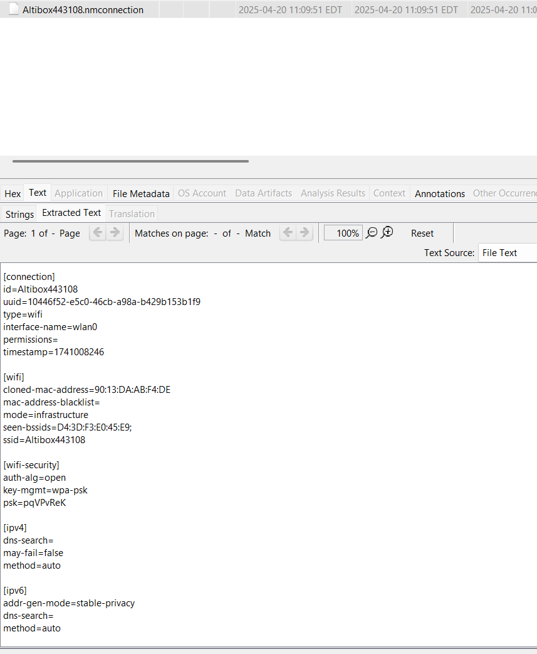
Figure 10: Altibox443108.nmconnection revealing plaintext Wi-Fi credentials
IoT Devices
Five IoT devices were identified through db.sqlite device entries. They all communicated over Zigbee through the Homey Pro Hub. The devices were distributed across two zones, Home and Office (Second Floor).
Device | ID | IEEE Address | Protocol | App
Badring Water Leakage Sensor | f8ba0750-f58c-4d0f-a5ae-b3638d00035d | 6c:fd:22:ff:fe:0e:62:15 | Zigbee | com.ikea.tradfri
Vallhorn Motion Sensor | dcb2257f-26cc-40ae-9e35-62b37498c725 | 70:c5:9c:ff:fe:bf:d7:c8 | Zigbee | com.ikea.tradfri
Eva Meter Reader | cd233f7e-e2a3-4329-91e6-49258e79fd9b | 54:0f:57:ff:fe:4c:55:86 | Zigbee | com.datek.eva
Vindstyrka Air Quality Sensor | 739bd0ba-7d1f-44e9-87d4-1fb1f3bc7018 | 44:e2:f8:ff:fe:0a:85:4e | Zigbee | com.ikea.tradfri
Dimmable Bulb (E27) | 6180ba50-440f-4f8d-bac2-6fca35aa5c9a | d4:48:67:ff:fe:32:b3:bf | Zigbee | com.ikea.tradfri

The devices were distributed across the following zones on the property:
Zone ID | Zone Name | Parent Zone
3a88abbf-b87b-4f14-97f5-e5e5145abaf9 | Home | None (Root)
b2c32c78-155e-45c4-b313-4247819e8e2d | Second Floor | Home
e5aafc4e-20bd-4fe4-be4a-658b6243492c | Office | Second Floor

Forensic Artifacts
Artifact | Location | Significance
Password Hash | /etc/shadow | Homey account hash, could be cracked
Wi-Fi PSK | /network-manager-connections/Altibox443108.nmconnection | Plaintext password recovered
RSA Private Key | db.sqlite – cloud-certificate entry | Exposed private key
Device Activity timestamps | db.sqlite | Full timeline of device setup and activity
Homey Serial/MAC | db.sqlite config entry | Device Identifications

The /etc/shadow file revealed the yescrypt password hash for the homey account:
$y$j9T$QrxuGJ16vDrYhaQgzwKxF1$Ph./U/ZQTk37mz4AuBfJo2flpuo56z0v1hgdQ7Zy7Y.

This hash could be subject to a brute force or dictionary attack using Hashcat or John the Ripper.

Device Serial and MAC Address
Field | Value
Homey Serial | 90:13:da:ab:f4:de:01:97:5a:57:ff:62
Homey ID | 6644a5c402f173b6441f84d5
Homey Name | UC3’s Homey Pro

Investigative Timeline
Timestamp | Event
2023-07-17 06:47:26 EDT | Homey user directory created in Docker overlay2
2023-07-28 04:57:31 EDT | Homey Pro application services last modified
2025-04-20 11:09:51 EDT | Wi-Fi profile Altibox443108 created
2025-04-20 15:04:45 EDT | Homey Pro device first configured (db.sqlite config)
2025-04-20 15:09:52 EDT | Device configuration last update
2025-04-20 15:51:38 EDT | Dimmable Bulb (E27) added to network
2025-04-20 15:56:54 EDT | Vindstyrka Air Quality Sensor added to network
2025-04-20 16:06:14 EDT | Eva Meter Reader added to network
2025-04-20 16:21:53 EDT | Vallhorn Motion Sensor added to network
2025-04-20 16:23:56 EDT | Badring Water Leakage Sensor added to network
2025-04-30 14:58:06 EDT | Last modification of db.sqlite
2025-04-30 19:35:50 EDT | Last recorded motion event in Office

- Investigative Leads
Based on the forensic examination of the Homey Pro device, the following investigative leads are recommended for further investigation:

Password Hash Cracking – The yescrypt password hash recovered from /etc/shadow for the homey account should be subject to cracking. Successfully cracking this hash could provide access credentials.

Wi-Fi Network Investigation – The recovered Wi-Fi credentials for Altibox443108 (PSK: pqVPvReK) could be used to investigate other devices on the network. The BSSID D4:3D:F3:E0:45:E9 could be used to find out the physical location of the device.

RSA Private Key – The exposed RSA private key recovered from db.sqlite entry should be investigated further to determine what communications used that key.

- Conclusion
The forensic examination of HomeyProPre.E01 and HomeyProPost.E01 successfully identified the operating system, IoT platform, connected devices, user credentials, and network configuration. Both forensic images were verified as intact through SHA-256 verification. Several forensic artifacts were recovered including a password hash, plaintext Wi-Fi credentials, and an RSA private key. These artifacts present security vulnerabilities that warrant further investigation.

