Windows Memory Forensics & Timeline Construction

Ethan Perdieu
Department of Engineering and Technology
CIT-420: Digital Forensics
Dr. G
February 20th, 2026

Windows Memory Forensics & Timeline Construction
Before the analysis can begin, I need to verify that Volatility (Forensic Tool) understood what kind of Operating System (OS) the memory dump came from. This step is known as identifying the image profile as shown below in Figure 1. The tool suggests that the OS was Windows 7, Service Pack 1. The scan also revealed the number of processors (1) and the image date and time which was January 6, 2019, at 3:09 UTC. (Universal Time)
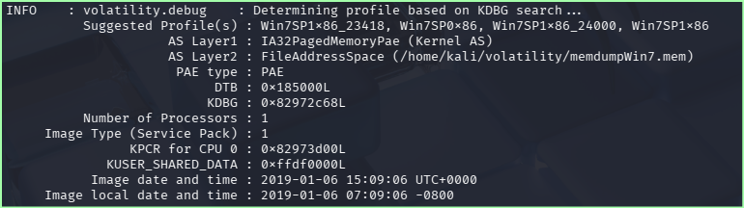
Figure 1: Identifying the Image Profile

- Information and Accounts of the Suspect

Figure 2 pulls information directly from the Windows Registry to view who was using the computer. The Registry acts as an information storage that stores key details of both the user and the computer.
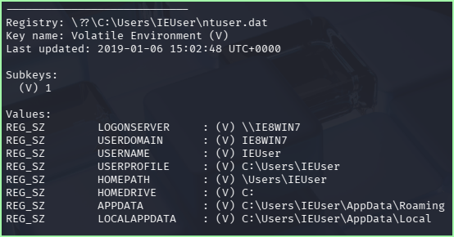
Figure 2: Identifying the Users
From Figure 2, we can confirm the following:
Username: IEUser
Computer Name: IE8WIN7
Home Drive: C:
User Path: C:\Users\IEUser

This screenshot shows the Profile List from the Windows Registry. Each user has a unique identifier known as an SID (Security Identifier). The two longest entries under the Subkey section are real users on the device. The other entries are built-in system accounts.
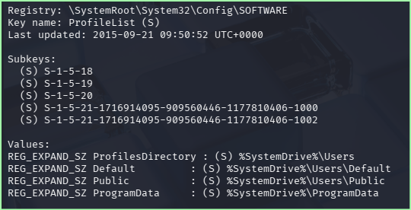
Figure 3: User Accounts on the Device

Figure 4 revealed that the second account (SID ending in 1002) belongs to a sshd_server. This is a secure shell which is a tool used to remotely access and transfer files between computers. This directly reveals that the suspect may have been moving company files illegally.
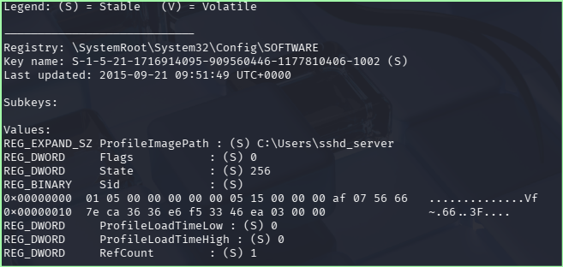
Figure 4: Second User Account Identified

The first account (SID ending in 1000) belongs to the user account stated earlier being IEUser. This means that this account was the first user created on the account since it has the SID ending in 1000. It was also revealed that it was last updated as of January 6th, 2019.
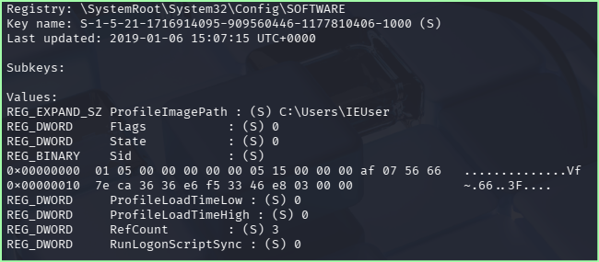
Figure 5: First User Account Identified

- Device Information

This lists all the registry hives within the memory dump. This confirms both users stated earlier being IEUser and sshd_sever. We see in Figure 6 that we need to look inside of \REGISTRY\MACHINE\HARDWARE to access the device information.
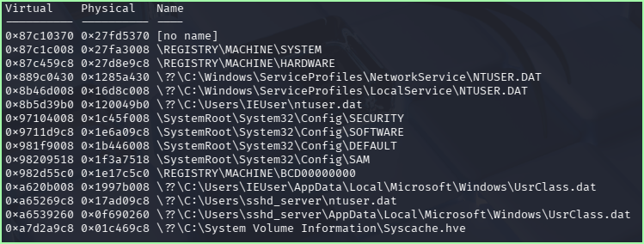
Figure 6: Registry Hives

This confirms the hardware that the suspect used:
- Processor: Intel Core i7-7700 @ 3.60GHz
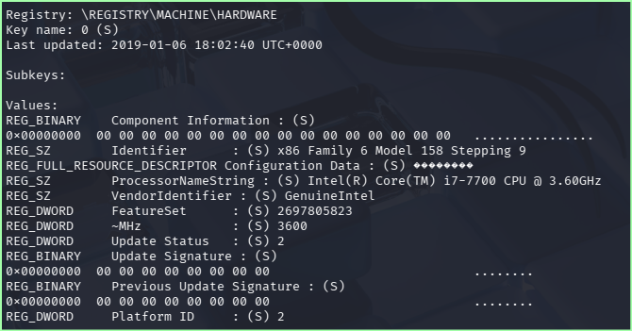
Figure 7: Device CPU Information

This reveals important information about the device itself:
- Bios Version: VBOX – Confirms suspect was using a virtual machine instead of an actual machine.
- Boot Architecture: x86 System
- BIOS Date: 6/23/99
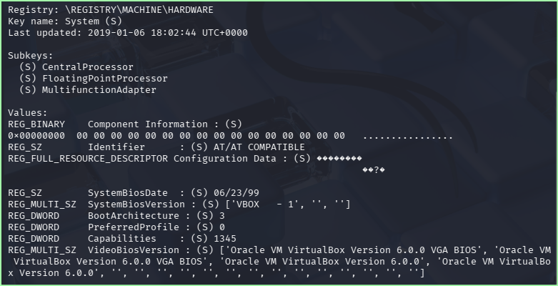
Figure 8: Device System Information

This listed the categories of hardware devices that were once connected to the machine. The main thing that sticks out is USBTOR which is a USB Storage device. This warrants a deeper investigation into the USB stick.
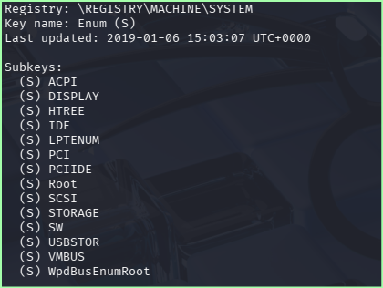
Figure 9: Connected Devices
- USB Information

This lists all the connected devices via the PCI. (Internal hardware communication) Each one of the entries below represents a component identified by their IDs.
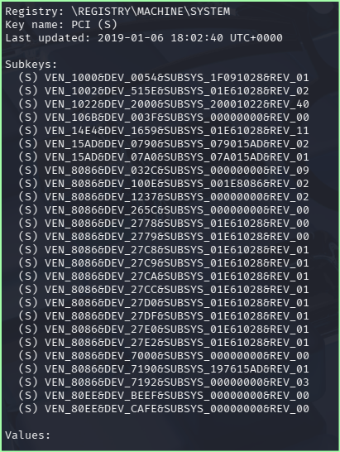
Figure 10: Connected Devices

This is a key finding showing that a USB Storage device was connected at some point. The device is named USBSTOR#Disk&Ven_General&Prod_UDisk&Rev_5.00. The other entries are virtual hard drives.
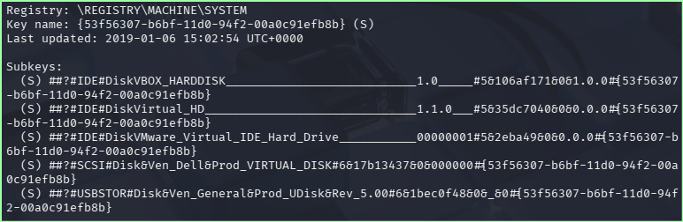
Figure 11: USB Storage Identified

This screenshot dives deeper into the USB instance by confirming its ID and when it was updated which will help with the final timeline.

Last Updated: January 6th, 2019 at 15:02:54 UTC
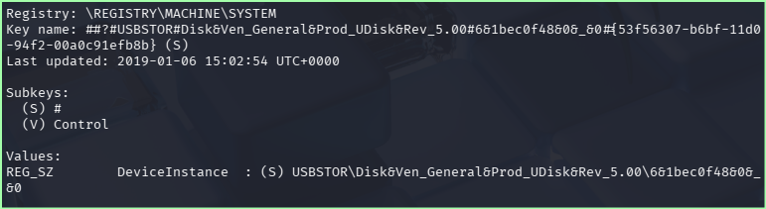
Figure 12: USB Device Information

This confirms the unique ID given to the USB drive: 6&1bec0f48&0&_&0

This is like a serial number that uniquely identifies the specific USB drive among any other devices connected to the machine. Similar to a VIN number on a car etc. The timestamp once again shows January 6th, 2019 at 15:02:54 UTC which was consistent with the previous finding.
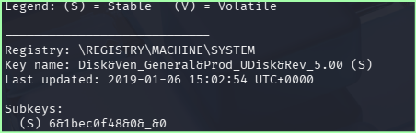
Figure 13: USB Instance ID

Figure 14 shows which drive letters window assigned to connected devices. The following were shown:
- C: - This is the main system drive
- D: - A secondary virtual drive
- E: - This is where the USB drive was mounted

Windows automatically assigned the drive letter to the USB so the user can actually access the USB stick. This directly confirms that the USB flash drive was accessible as Drive E:. This occurred on January 6th, 2019 at 15:02:54 UTC.
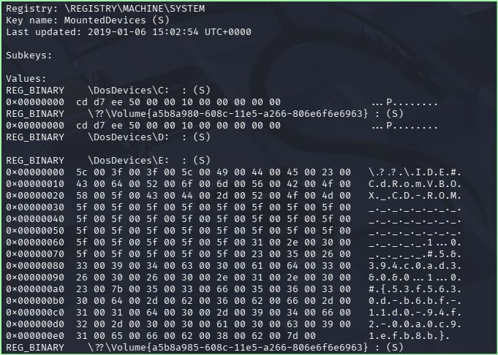
Figure 14: USB Drive Assignment

This shows the mount was registered under the suspect (IEUser). This directly links the USB connection on January 6th, 2019, at 15:03:07 UTC, showing the suspect’s account had active use on the USB.
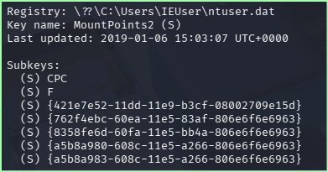
Figure 15: USB Drive Mounted by IEUser

Figure 16 shows directly when the USB was last attached to the device. This shows that it was last connected on January 6th, 2019, at 15:03:06 UTC.
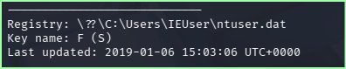
Figure 16: USB last Attached

- File Explorer History
This section focuses on view folder access activities specifically on January 6th, 2019.
I ran the command python2 vol.py -f memdumpWin7.mem --profile=Win7SP1x86_23418 shellbags | grep "Last updated: 2019-01-06" | sort

This resulted in entries with last updated UTC Times:
- Last updated: 2019-01-06 14:32:21 UTC+0000
- Last updated: 2019-01-06 14:32:53 UTC+0000
- Last updated: 2019-01-06 14:55:45 UTC+0000
- Last updated: 2019-01-06 15:04:40 UTC+0000
- Last updated: 2019-01-06 15:04:40 UTC+0000
- Last updated: 2019-01-06 15:04:40 UTC+0000
- Last updated: 2019-01-06 15:07:03 UTC+0000

This HTML Section ran into errors, so I received this from the slides:
Shellbags is how Windows remembers which folders a user has opened even after file deletion. Here it shows the IEUser accessed the downloads folder of January 6th, 2019 at 14:49:40 UTC.

We also see that the last write time was at 15:04:40 UTC which reflects when the display preferences were changed.
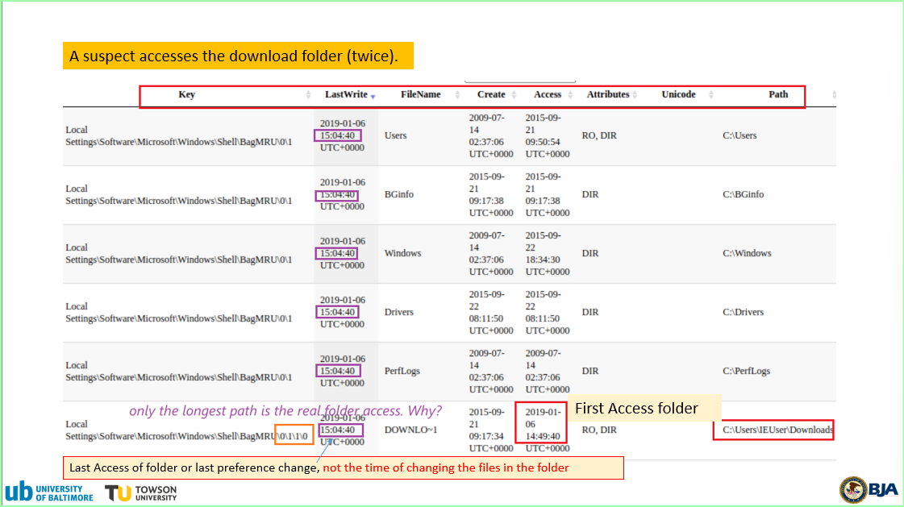
Figure 17: File Explorer via Shell bags

- Timeline

Time (UTC) | Event
2019-01-04 16:05:12 | Chrome.exe downloads files to downloads folder
2019-01-06 14:49:40 | IEUser opens Downloads folder in File Explorer
2019-01-06 15:02:54 | USB Flash drive plugged into the device; Assigned Drive E:
2019-01-06 15:03:06 | USB volume mounted my IEUser
2019-01-06 15:04:40 | IEUser last reviews the downloads folder
2019-01-06 15:06:11 | Command Prompt used copy command (Transferring to USB)
2019-01-06 15:06:15 | USB Device entry last updated
2019-01-06 15:09:06 | Memory dump captured

The timeline above tells the complete story of what the IEUser did with the files. The combination of the registry artifacts, shellbag history shows that IEUser tried to download, and transfer the files to an external USB device.

