HW7: You Got Mail!

Ethan Perdieu
Department of Engineering and Technology
CIT-420: Digital Forensics
Dr. Lint
April 5th, 2026

- Executive Summary
A forensic examination was conducted on disk images (nps-2008-jean.E01 and nps-2008-jean.E01) belonging to a device owned by Jean Jones who is the CFO of M57. The computer is identifiable as JEAN-13FBF038A3 and runs on Microsoft Windows XP Service Pack 3. The examination was conducted to investigate a spreadsheet containing sensitive PII information that was posted as an attachment on a forum. The forensic analysis was performed using Autopsy and suspicious activity was found in play.

Key Findings of the Investigation:
- Confidential spreadsheet m57biz.xls containing employee names, salaries and SSNs was created by Jean Jones on the M57.biz device
- Jean Jones was socially engineered by an unknown party impersonating to be Alison Smith (President of M57) via email to produce the confidential spreadsheet
- The impersonator used a combination of alison@m57.biz and a personal Gmail account (tuckgorge@gmail.com) to request and receive the file containing employee data while instructing Jean to keep secret
- The spreadsheet contained PII for 9 employees including full names, job titles, salaries and Social Security Numbers
- Total compensation data exposed was $1,311,700 in both salaries and benefits
- Employee Bob confirmed via email on 2008-07-20 that the SSN and salary data had been leaked and posted on the internet
- No direct evidence of the forum posting was found on Jean’s workstation suggesting the post occurred from an external device

Examiner: Ethan Perdieu Date: July 6th, 2008 – July 20th, 2008 (Evidence Date) / April 5th, 2026 (Analysis)
- Objectives

The following tasks were outlined for the forensic investigation:
- Generate Evidence Hashes – Generate evidence hashes for future tampering comparisons in the future
- Examine the Forensic Image – Determine how the confidential spreadsheet was leaked externally
- Identify the file – View the contents of the file in question
- Identify the Users – Identify all user accounts present on the system
- Review Email Communications – View email communications for evidence of the file being sent externally
- Review Web History – View web history and search activity for evidence of forum activity
- Build a Chronological Timeline – Construct a detailed timeline of the significant events captured within the Encase Image file
- Present all Findings – Present supporting evidence and investigative conclusions

- Evidence Analyzed
Two Encase forensic image files were examined during the investigation. Hash values were calculated for each file prior to analysis to verify integrity and ensure the evidence has not been tampered with.

Hash Table:
File Name | MD5 Hash | SHA1
nps-2008-jean.E01 | 647F22836426E071D8E1CCAC6DA54BAF | C0E06707C0326D33F1DE6C985745BC9D03925E24
nps-2008-jean.E02 | E8845C20BDD2C24E734B7C0BCD1A8EAB | 85BDCEF6390D18FCA1292A2FEFC15F924B54C5FC

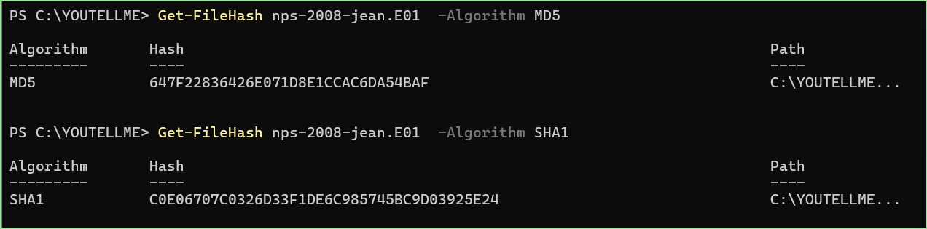
Figure 1: Process of identifying the MD5 and SHA1 Hash Values

The following table outlines the technical details of the primary forensic image loaded into Autopsy.

Image Table:
Field | Details
File Name | nps-2008-jean.E01
File Size | 10,737,418,240 bytes (10.7GB)
File Type | EnCase E01
Sector Size | 512 Bytes
Device ID | 6863b36e-b8a8-4bc9-bd74-907ef53f7bdc
Time zone | America/Indianapolis
Tool Used | Autopsy 4.22.1

The partition table was identified from the forensic image. The primary active partition was Vol2, which contained the NTFS file system where all user data and OS files were located.

Partition Table:
Partition | Type | Sectors
Vol1 | Unallocated | 0-62
Vol2 | NTFS / exFAT (0x07) | 63 – 20,948,759
Vol3 | Unallocated | 20,948,760 – 20,971,519

Figure 2: Partition Tree generated by Autopsy

The following operating system information was extracted from the ingest module ran using Autopsy. The system belonged to a user identified as Jean and was running Windows XP Service Pack 3.

Operating System Information:
Field | Value
Computer Name | JEAN-13FBF038A3
OS | Microsoft Windows XP Service Pack 3
Architecture | X86
Owner | Jean User
Windows Path | C:\WINDOWS
Temp Directory | %SystemRoot%\TEMP
Product ID | 55274-640-0690141-23940

- Relevant Findings
The following key findings were identified during the examination of the EnCase Image:
- Confidential Spreadsheet Identified
  - A confidential file by the name of m57biz.xls was located on the Desktop at C:\Documents and Settings\Jean\Desktop\m57biz.xls. The file contained PII including employee names, job titles, salaries, Social Security Numbers and compensation data.
- Primary Suspect Identified
  - The primary user of the workstation was Jean Jones who is the CFO of M57. The account name was jean and was registered as JEAN-13FBF038A3. This was confirmed through OS account records and file activity tied to the account.
- Social Engineering involved by Unknown Impersonator
  - An unknown party impersonating Alison Smith emailed Jean Jones from alison@m57.biz on 2008-07-19 requesting a spreadsheet containing employee names, salaries and SSNs under the pretense of an investor background check. The impersonator instructed Jean to not tell anyone.
- Confidential File was Transmitted Externally
  - Jean Jones replied to the impersonators file request on 2008-07-19 21:28:00 EDT with m57biz.xls attached.
- Use of Personal Email Account
  - The impersonator received the file using a personal Gmail account, tuckgorge@gmail.com on 2008-07-20 01:03:40 EDT. They instructed Jean to keep it a secret by stating “Once again, please don’t tell anyone about this.” Whether tuckgorge@gmail.com belongs to Alison Smith or a third party could not be determined without a reasonable doubt.
- No direct Evidence of Forum Posting
  - No evidence was found of posting the excel sheet to a competitor forum after analysis of the web activity. There is reasonable suspicion that the forum posting originated from Alison’s own device.
- Confirmation of Data Exposure
  - Employee Bob (bob@m57.biz) contacted Jean on 2008-07-20 19:53:19 EDT stating that employee SSNs and salary data had been posted on the internet. Jean’s response indicated he was unaware of the posting supporting the conclusion that she was a victim of social engineering rather than a willing participant.

- Supporting Details
The following section provides an in-depth breakdown of the artifacts identified during the forensic examination. All findings are presented in a logical order to support the conclusions in Relevant Findings.

A. User Accounts
A total of 13 user accounts were identified on the system using Autopsy’s OS Accounts ingest module. Three system-level accounts were identified and are not relevant to the investigation. The remaining accounts are local user accounts created between May 13th and May 14, 2008.

The account of interest is jean created on 2008-05-14 01:33:08 EDT, which corresponds to the owner Jean Jones, the CFO. All relevant file activity and communications were tied to this account.

OS Accounts
Account Name | Account Type | Creation Time
SYSTEM | NT Authority | ---
LOCAL SERVICE | NT Authority | ---
NETWORK SERVICE | NT Authority | ---
helpassistant | Local | 2008-05-13 17:24:45 EDT
support_38894a0 | Local | 2008-05-13 17:25:56 EDT
kim | Local | 2008-05-14 01:32:56 EDT
jean | Local | 2008-05-14 01:33:08 EDT
addison | Local | 2008-05-14 01:34:03 EDT
abijah | Local | 2008-05-14 01:34:43 EDT
devon | Local | 2008-05-14 01:34:54 EDT
sacha | Local | 2008-05-14 01:35:35 EDT
administrator | Local | 2008-05-13 18:20:14 EDT
guest | Local | 2008-05-13 18:20:14 EDT

B. Confidential Spreadsheet Identified
The file m57biz.xls was identified on Jean Jones Dektop at C:\Documents and Settings\Jean\Desktop\m57biz.xls. The file was last accessed on 2008-07-19 21:27:42 EDT and opened using Microsoft Excel. It was found in the Recent Documents artifact which confirmed it was actively being used by Jean shortly after being transmitted.
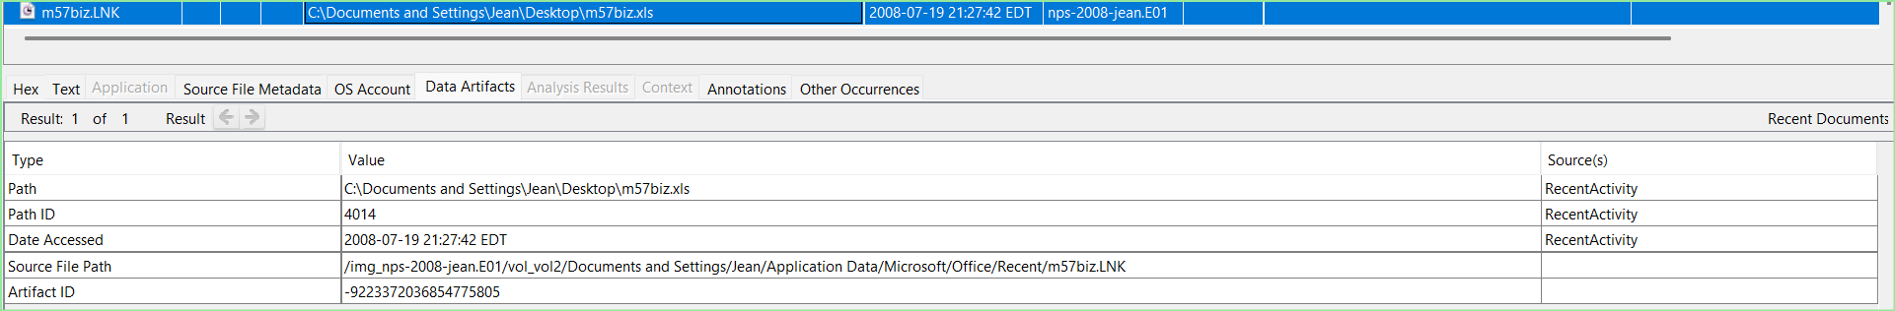
Figure 3: User “jean” accessed m57biz.xls from Desktop via Excel

The contents of m57biz.xls confirmed it contained sensitive employee PII for 9 M57 employees. This included full names, job titles, salaries and Social Security Numbers.

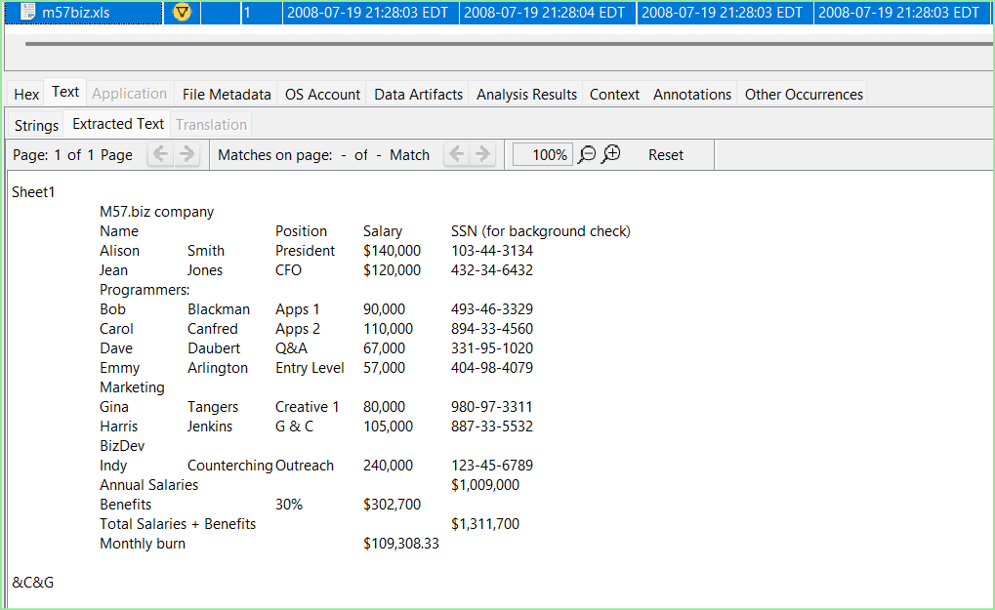
Figure 4: m57biz.xls contents containing Employee Data and Compensation

C. Email Communications
A total of 261 emails were recovered and were located at C:\Documents and Settings\Jean\Local Settings\Application Data\Microsoft\Outlook\outlook.pst. The following email accounts were active on the system:

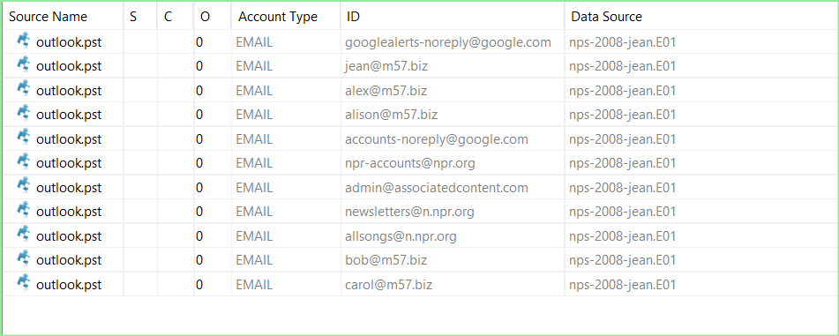
Figure 5: Email Accounts found on the OS
t
Of the accounts identified, jean@m57.biz, alison@m57.biz, and tuckgorge@gmai.com were directly relevant to the investigation. The emails exchanged between these accounts revealed a effort to transmit confidential PII data from the organization covertly.

The following emails were identified as directly relevant to the investigation and are presented in chronological order:
- Initial Request - 2008-07-19 19:39:57 EDT
  - The impersonator emailed Jean Jones from alison@m57.biz requesting a spreadsheet that contained employee names, salaries and SSNs. The request was said to be a background check. The impersonator explicitly said not to tell anyone to ensure confidentiality. This email directly proves social engineering involvement as seen in Figure 5.

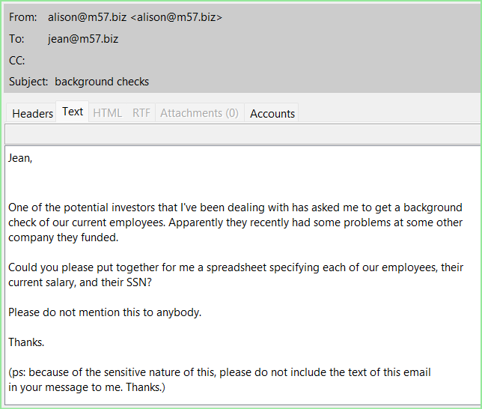
Figure 5: Employee Data Exfiltration Request

- Follow-Up Request - 2008-07-20 21:22:45 EDT
  - The impersonator followed up from her personal Gmail Account tuckgorge@gmail.com, reiterating the request for the excel sheet. They kept saying the pressure was from a “VC Guy.” This suggests that the impersonator was operating from an external account to avoid detection and receive the transmitted PII data.

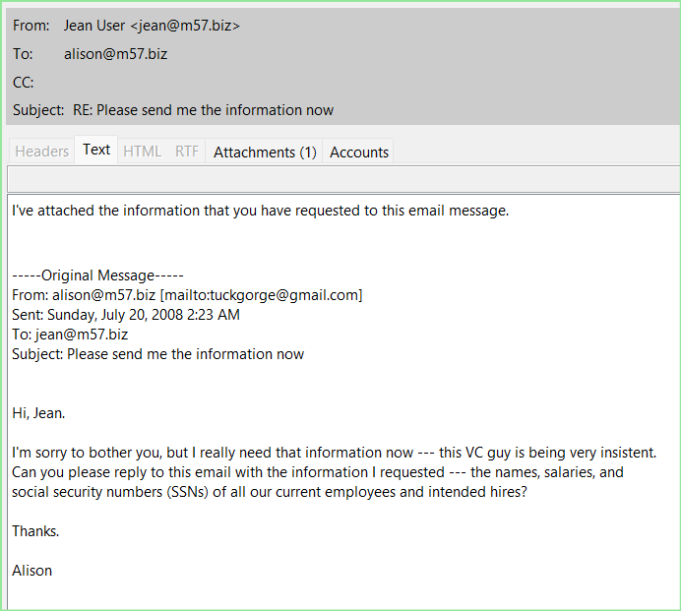
Figure 6: Persistent Requests + Email Attachments

- Jean’s Reply with Attachment - 2008-07-19 21:28:00 EDT
  - Jean Jones replied to the Impersonators request with m57biz.xls attached. The email stated, “I’ve attached the information that you have request to this email message.” The attachment was confirmed as m57biz.xls, stored within outlook.pst.

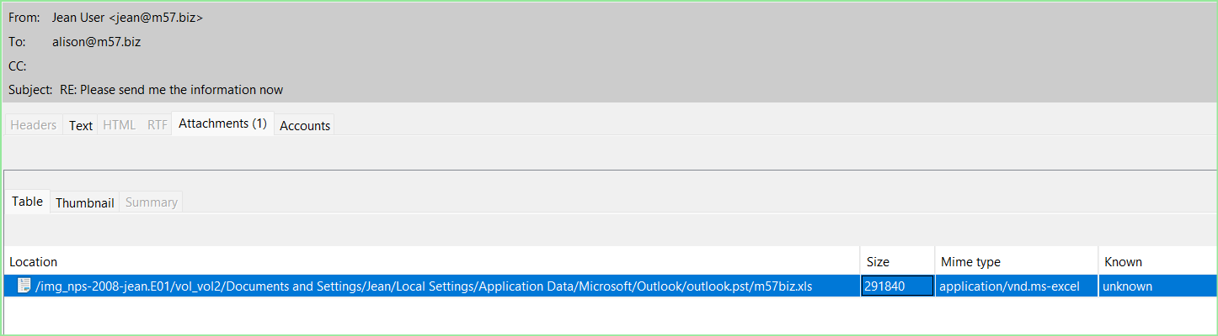
Figure 7: m57biz.xls containing Employee Data being emailed to outside source

- Confirmation of Data - 2008-07-20 01:03:40 EDT
  - The impersonator, operating from tuckgorge@gmail.com confirmed that she received the file stating “Thanks for the file. I’ll handle it from here. Once again, please don’t tell anyone about this.” This confirmed intentional covert exfiltration of the spreadsheet.

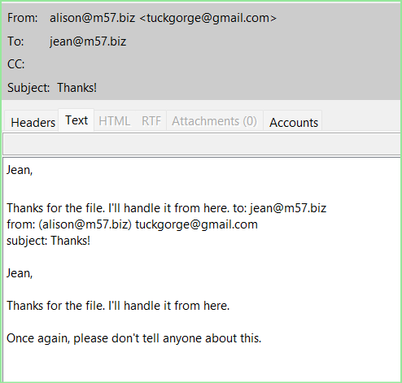
Figure 8: Confirmation of Intentional leak with tuckgorge@gmail.com
D. Web and Search Activity
Web history and search activity were reviewed and there was no evidence of the competitor forum URL or any related activity. General browsing activity included travel searches news sites and AOL/AIM usage. No forum related activity was identified.

E. Confirmation of Data Exposure
Employee Bob (bob@m57.biz) contacted Jean Jones on 2008-07-20 19:53:19 EDT asking if she had any knowledge of employee SSNs and salary data being posted on the internet. Jean’s response indicated she was unaware. Bob then verified Jean’s own SSN and salary in the follow up email. This supports the conclusion that Jean was a victim of social engineering.

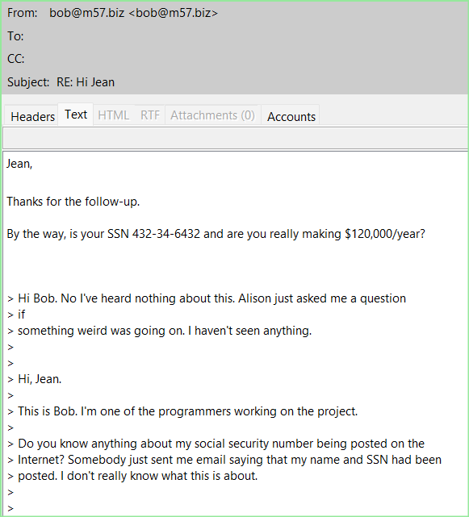
Figure 9: Bob email confirming SSN posting

F. Chronological Timeline of Events
Date/Time | Event
2008-07-06 15:25:09 EDT | Alison emails Jean about business plan deadline
2008-07-19 19:39:57 EDT | Unknown impersonator request employee names, salaries and SSNs via fake investor
2008-07-19 21:27:42 EDT | Jean open m57biz.xls on her Desktop via Excel
2008-07-19 21:28:00 EDT | Jean emails m57biz.xls to alison@m57.biz
2008-07-20 01:03:40 EDT | tuckgorge@gmail.com confirms receipt, instructs Jean to keep quiet
2008-07-20 19:53:19 EDT | Bob emails Jean asking about SSN posting
2008-07-20 20:02:59 EDT | Bob verifies Jean’s SSN and salary back to her, Jean claims fault
2008-07-20 21:22:45 EDT | tuckgorge@gmail.com requests more employee data citing VC pressure

- Investigative Leads
The investigation of evidence has several areas that need to be further investigated:
- Forensic Examination of Alison Smith’s Device
  - A forensic examination of Alison Smith’s personal devices is recommended to determine whether tuckgorge@gmail.com belongs to her or an unknown third party. This would either confirm or rule out Alison’s involvement and help identify how the spreadsheet was posted on the competitor forum.
- Investigation of tuckgorge@gmail.com
  - Google account records for tuckgorge@gmail.com is recommended to identify the account owner, login history, IP addresses and any emails sent containing the m57biz.xls attachment. This would directly link who was involved.
- Review of AIM Logs
  - Jean and Alison were both active on AIM around the time of the incident under screen name m57jean and alisonm57. The logs should be reviewed in case any additional information is revealed.
- Identification of Competitor Forum
  - The competitor forum where the spreadsheet was posted was not identified during the examination. Identifying the forum and obtaining access logs or post data can confirm who uploaded the file and when it was uploaded.
- Review Remaining Employee Devices
  - Other user accounts were identified on the system including kim, addison, abijah, devon, and sacha. Examination of those devices may reveal whether other employees were aware of or involved in the data leak.

- Conclusion
The forensic examination of nps-2008-jean.E01 and nps-2008-jean.E02 successfully revealed how the confidential spreadsheet, m57biz.xls, was leaked. Jean Jones, CFO of M57, was socially engineered by an unknown party impersonating Alison Smith into producing and emailing the confidential spreadsheet. The spreadsheet contained PII for 9 employees and was transmitted to alison@m57.biz and subsequently confirmed by tuckgorge@gmail.com, an external Gmail account. Employee Bob confirmed via email that the data had been posted online which also reinforced Jean Jones showing no awareness of the posting. The identity of tuckgorge@gmail.com is still unknown and to be determined.

