Windows Registry, MFT, Log Files and Shadow Copy Analysis
Ethan Perdieu

Goal:
- Familiarize yourself with identifying partition, volume, OS, and file system information
- Find and recover lost, hidden and deleted files

Resources:
- The evidence (.dd or .eo) can be downloaded from the following site directly or the github repository: https://cfreds-archive.nist.gov/data_leakage_case/data-leakage-case.html
- Make sure to download all parts for the PC (3 dd files, 4 eo files)
- Make sure to download all parts for rm#2 (1 dd file, 1 eo file)
- All tasks below are covered in the lab guides under the Investigating NIST Data Leakage section of the Github repository. These guides have additional background that can be helpful, but note that they focus on using the Linux command line SleuthKit workstation. The step by step instructions will not apply to the Autopsy GUI.
  - 08_CD_$MFT (*hint slide 45)
  - 10_Vol_Shadow
  - 12_CD-R_Data_Carving (*hint slide 8)

Instructions: [see Lecture 2 slides for details]
- Install Autopsy and/or Sleuthkit on your workstation
- Download the 2 sets of evidence files onto your workstation
- Load evidence into Autopsy and run analysis. I would load the PC evidence first as it will take longer and there are more things you need to find.
  - PC evidence → 12+ hours
  - USB device → 10 minutes

Tasks:
- Compare the hash values for both pieces of evidence to the values provided (in link above). In a table prove that they match

Evidence File | Algorithm | Calculated Hash | Published Hash | Match?
cfreds_2015_data_leakage_pc.E01 | SHA1 | 72432916933f5a309a8c456b40c9601d1f8d2a4f | 72432916933F5A309A8C456B40C9601D1F8D2A4F | YES
cfreds_2015_data_leakage_pc.E02 | SHA1 | 0caf4261ed8432a8b3baa019b1b28fdf96f79130 | 0CAF4261ED8432A8B3BAA019B1B28FDF96F79130 | YES
cfreds_2015_data_leakage_pc.E03 | SHA1 | be836c891736c4c0c2253c6803399bf0f2a599ba | BE836C891736C4C0C2253C6803399BF0F2A599BA | YES
cfreds_2015_data_leakage_pc.E04 | SHA1 | 9159bffd56097495f73fbbf967b75eb288b1e3de | 9159BFFD56097495F73FBBF967B75EB288B1E3DE | YES
cfreds_2015_data_leakage_rm#2.E01 | SHA1 | 2228554cd6fdd3c85bb80e0a0cd7f21a2364dc99 | 2228554CD6FDD3C85BB80E0A0CD7F21A2364DC99 | YES

How I calculated the Hashes:
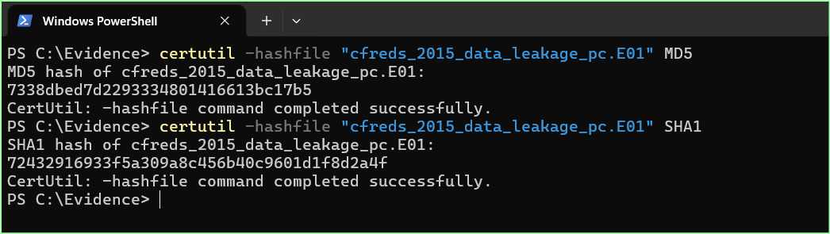

Use the PC evidence for the following:
- Identify the partition information of the PC image:
  - Create a table and list the starting sector, description, and flags.

Partition | Starting Sector | Description | Flags
Vol1 | 0 | Unallocated | Unallocated
Vol2 | 2048 | NFTS / exFAT (0x07) | Allocated
Vol3 | 206848 | NTFS / exFAT (0x07) | Allocated
Vol4 | 41940992 | Unallocated | Unallocated

- Find information about the Operating System:
  - Name, Version, and CurrentBuild of OS
This information was found under node “Operating System Information” + System32 config files

Name: INFORMANT-PC
OS Name: Windows 7 Ultimate Service Pack 1
Version: 6.1
Current Build: 7601.17514

  - Product ID of the OS

Product ID: 00426-292-0000007-85262

  - Hex value of install date

Install Date: March 25, 2015 at 07:09:15 EDT
Hex Value: 0x551302AB

  - List all accounts, identify who has a password hint and what it is

Accounts
- Admin11
- Default
- Informant
  - Hint: IAMAN
- Temporary
- Administrator
- Guest
- NETWORK SERVICE
- LOCAL SERVICE

  - Who was the last user to logon? When? Are they the registered owner?

Last User to Logon: informant
When: 2015-03-25 09:06:08 EDT
Registered Owner: YES

- What is the timezone setting?

Time zone: Americas/Indianapolis (US Eastern Daylight Time)

  - Hex value of Bias

Hex Value: 0x12C

  - Hex value of Daylight Bias

Hex Value: 0xFFFFFFC4

  - Explain what this means in English?

Bias is the offset based on UTC time in minutes. Daylight Bias is an additional adjustment applied during daylight savings time. In this case, the bias value is 300 minutes which means the system is 5 hours behind UTC time.

- Identifying application usage:
  - What application was used for e-mail communication?

- Outlook

  - What is the SHA-256 hash of the file where the emails are located?

SHA-256:
- 9c493e17becf7b346b0f63e52a1305cb410b9cd22d34fe1def2f49d849c05ad5

  - What is the suspect's e-mail account?

Email Account: iaman.informant@nist.gov.ost

- Find where the Shadow Volume is stored. [Hints → CLI: Find VSS in $MFT, use vshadowinfo, Autopsy: where are these in the Windows system files?]
  - What is the MD5 hash

MD5: | 8637c0e6d2f6494b905d21f7151b98a1

  - Where is the $LogFile Sequence Number

Sequence Number: 375233377

  - How big is the file (bytes)

Size: 335544320 bytes

  - When was it created (date and time)

Data and Time: 2015-03-25 10:57:24 EDT

- Anti-forensic artifacts, behaviors that should raise red flags:
  - What anti-forensic behavior artifacts can you find on the PC? List them in a table with appropriate date and time information.

Behavior | Date | Time | Location
File deletions (Recycle Bin) | 2015-03-24 | 16:11:42 EDT | C:\Users\informant\AppData\Local\Microsoft\Windows\Burn\Burn\desktop.ini
Creation of Eraser6 deletion task | 2015-03-25 | 11:29:37 EDT | C:\Users\informant\AppData\Local\Eraser 6\Task List.ersy
File Modifications (Secret Project) | 2015-03-23 | 14:38:21 EDT | /Users/informant/AppData/Roaming/Microsoft/Windows/Recent/[secret_project]_design_concept.lnk
CCleaner Ran | 2015-03-25 | 11:18:36 EDT | /img_cfreds_2015_data_leakage_pc.E01/vol_vol3/Program Files/CCleaner/CCleaner64.exe

  - What anti-forensic software did the user informant download?
    - Create a table with Software name, version, and applicable recent activity (date, time)

Software Name | Version | Last Execution
Eraser6 | v.6.2.2962 | 2015-03-25 11:29:37
CCleaner | UNKNOWN | 2015-03-25 10:58:35 EDT

  - What did the user informant do with the tools?
    - What did they do and where?
Modified files found under the recent documents tab. These are located under Appdata/roaming

    - Create a table with file names, extensions, and md5 hashes:

Filename | Extensions | Date/Time | MD5 Hash
Winter_whether_advisory.zip.lnk | ZIP | DELETED | d0fc6009fc98d582d313da853d01c5f4
[secret_project]_final_meeting | pptx | 2015-03-23 16:27:37 EDT | 670d88695e0d129a9b21756dfea17023
(secret_project)_pricing_decision | xlsx | 2015-03-23 16:26:53 EDT | a9a4d030a0e6124ef8610617ee9125fc
(secret_project)_design_concept | Xlsx | 2015-03-23 14:38:21 EDT | 16edd6867ac821df237c3724fc340250

- A file authored by Uncle Forensics seems mighty interesting, find it :)
  - Read the file, give me the MD5 hash to let me know you found it

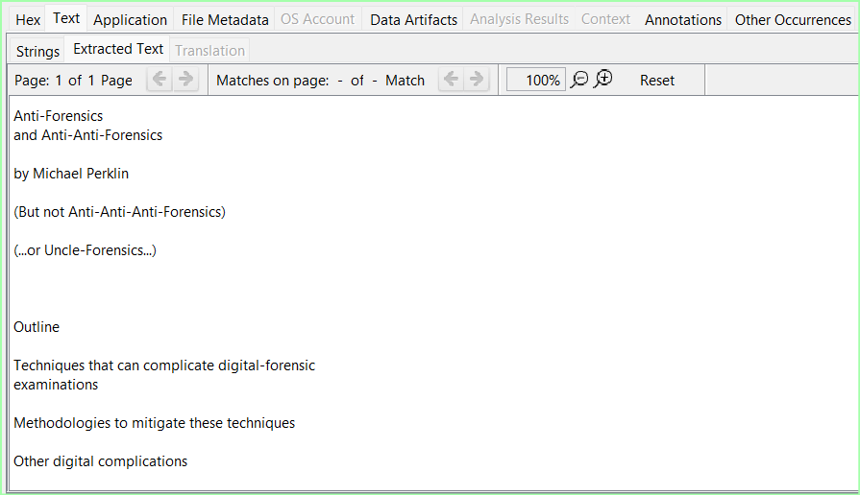
MD5 Hash: 28fadff413e4c9b5ed007d559200d993

Use the RM#2 evidence for the following:
- Finding files, identifying differences and carving out deleted files from USB:
  - Identify all artifacts related to renaming files on the Desktop on 3/24/2015 [there are 20]
    - Find the files that were deleted from the USB drive [there are 100+]
    - Compare the lists from (a) and (b) and find those in common
  - Use data carving and find the files that are on both lists [there are 17]
    - In a table list file names, extension, and md5 hash values

File Names | Extensions | MD5 Hash
[secret_project]_detailed_design | .pptx
[secret_project]progress#1 | .docx | 83e8b938071484d05baee23111a80768
[secret_project]progress#2 | .docx | 11a973841cf9db3255ffff84f5b277d2
[secret_project]progress#3 | .doc | 9e32861d49b1ddee6c233151bb4a8919
[secret_project]technical_review#1 | .docx | f7f1c40d7f647ee251d8282ca70a63d9
[secret_project]technical_review#2 | .docx | a9dbdb7177289f4ca1cc0d8748164b11
[secret_project]technical_review#3 | .doc | 2f500982aee7cbb0ba9a7ab9f46e902a
[secret_project]technical_review#3 | .ppt | 26eada303d94f2d1ef5407d44763ecb8
[secret_project]_proposal | .docx | 14c3030e006b9c2545be9d23fc0c284f
[secret_project]_revised_points | .ppt | 003cdff76991725251812f9e8ba8477c
[secret_project]_detailed_proposal | .docx | 109b7644287de12880a9a6d75c316c3a
(secret_project)_market_analysis | .xlsx | 0329d88f08a8cb2c8057a8fa9418f9f3
(secret_project)_market_shares | .xlsx | 2ebbbb59b8019a94c7416d9acbaad658
(secret_project)price_analysis#1 | .xlsx | 975d98575f92d2e466ecb96d39701fc8
(secret_project)price_analysis#2 | .xlsx | a23c3ed3cf482a3d5c420f6ff4fea6f6

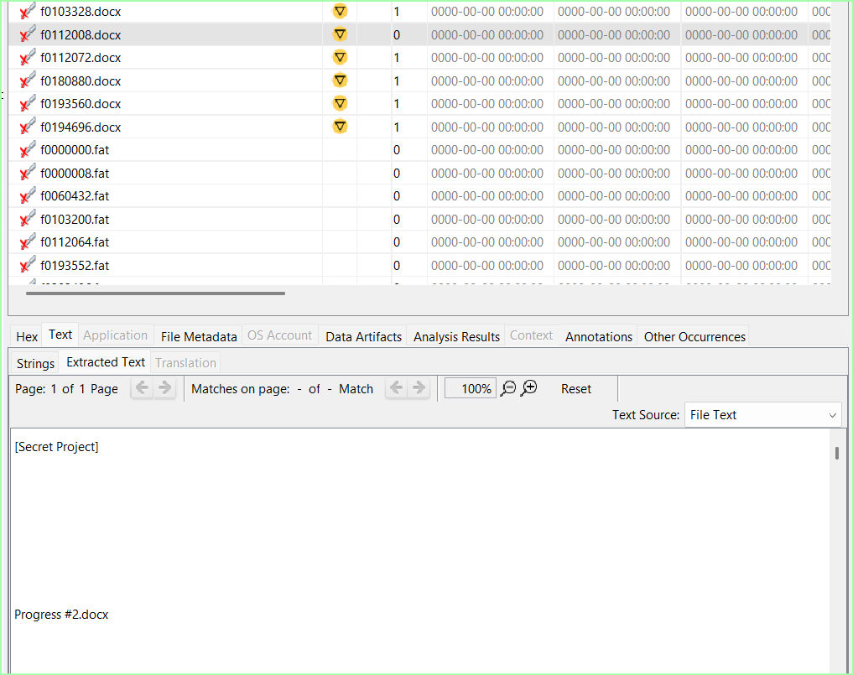
Viewed text to get file name and match it with the MD5 hash
  - Carve out (export from Autopsy) one of these files and submit

Was attached to submission

