Ethan Perdieu
CIT-40400
Lab – OSINT (Passive)
February 15th, 2026

Company: Spotify.com

- Overall Target
Company Name: Spotify Technology S.A. – HIGH via. Wikipedia, SEC Filing Data etc.
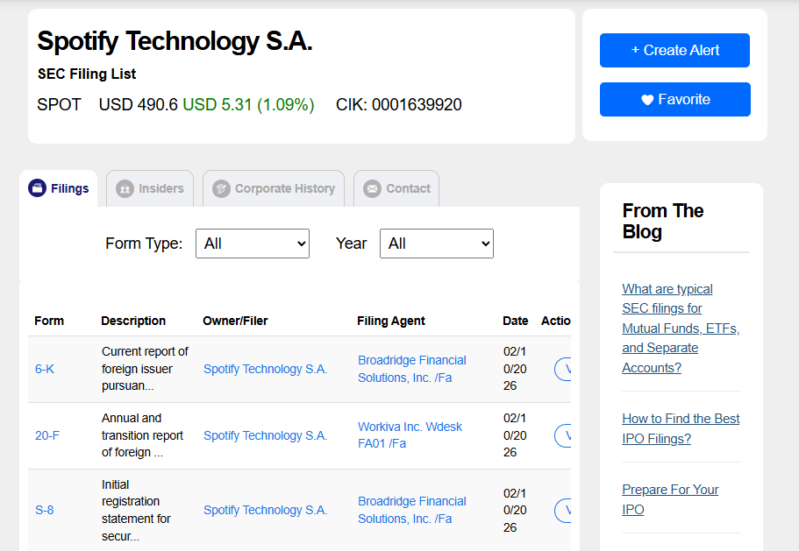
Industry: Audio Streaming / Media – HIGH
Domain: Spotify.com – HIGH (WHOIS confirmed)
Subsidiaries: Gimlet Media, Anchor FM, Loudr, Parcast, Soundtrap – MED via Links Below (News Releases and Wikipedia)
- https://newsroom.spotify.com/2019-02-06/audio-first/
- https://en.wikipedia.org/wiki/Spotify
Stock Ticker: SPOT – HIGH via SEC Filing Data, NYSE and RocketReach

- Footprint
Using WHOIS domain tool:
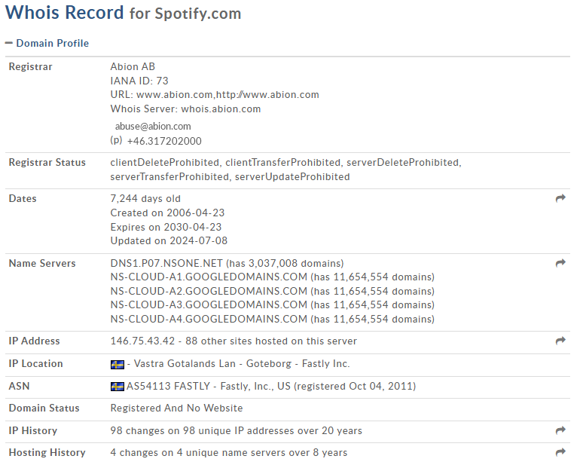

Registrar: Albion AB – HIGH via WHOIS
Registered On: April 23rd, 2006 – HIGH via WHOIS
Expiration: April 23rd, 2030 – HIGH via WHOIS
Last Updated: July 8th, 2024 – HIGH via WHOIS
Registrant Org: Spotify AB – HIGH via WHOIS
DNS Name Servers – HIGH via multiple WHOIS sources and nslookup
- DNS1.P07.NSONE.NET
- NS-CLOUD-A1.GOOGLEDOMAINS.COM
- NS-CLOUD-A2.GOOGLEDOMAINS.COM
- NS-CLOUD-A3.GOOGLEDOMAINS.COM
- NS-CLOUD-A4.GOOGLEDOMAINS.COM
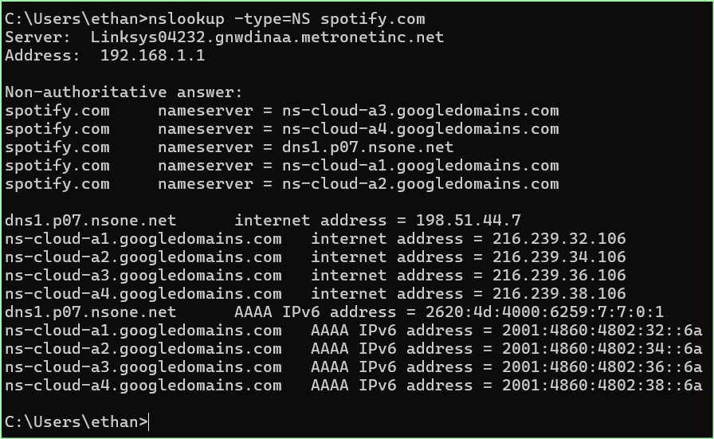
SSL Certificates (Clicked on the Servers to Gain more information)
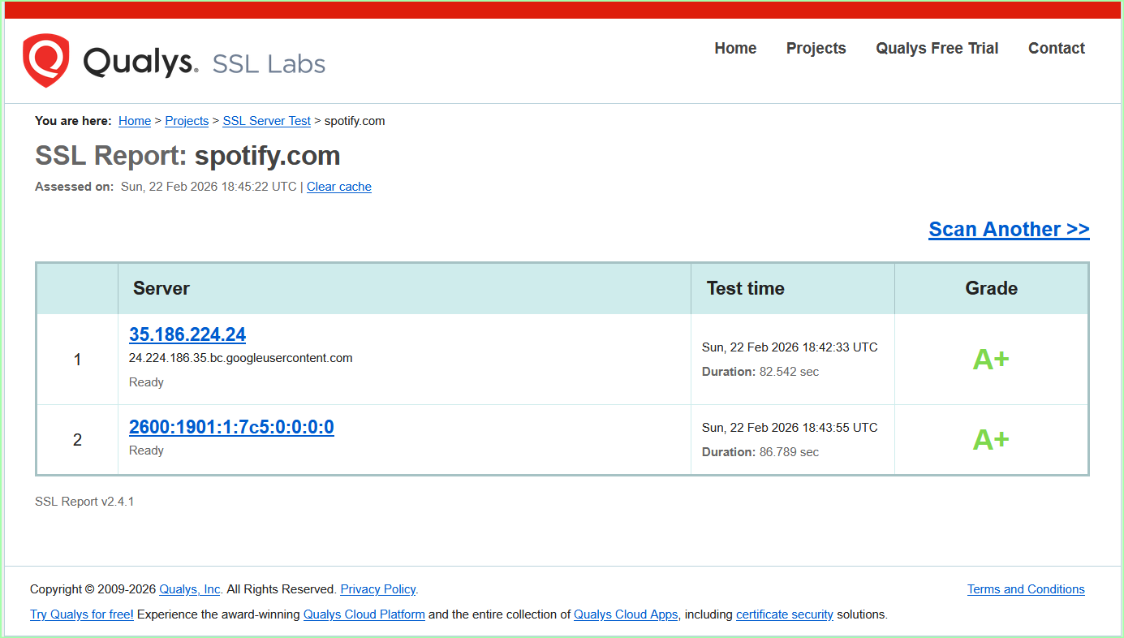
Issuer: DigiCert Global G2 TLS RSA SHA256 2020 CA1 – MED via Qualys for All
Subject: *.spotify.com (Covers all subdomains) – MED
Serial Number: 04a7b6ccec54b36cf146c0e8d8cc3839 – MED
Registrant on Certificate: Spotify AB, Stockholm, SE – MED
Algorithm: SHA256withRSA 2048 Bit – MED

Using DNSDumpster for Subdomains (More listed outside of screenshot)
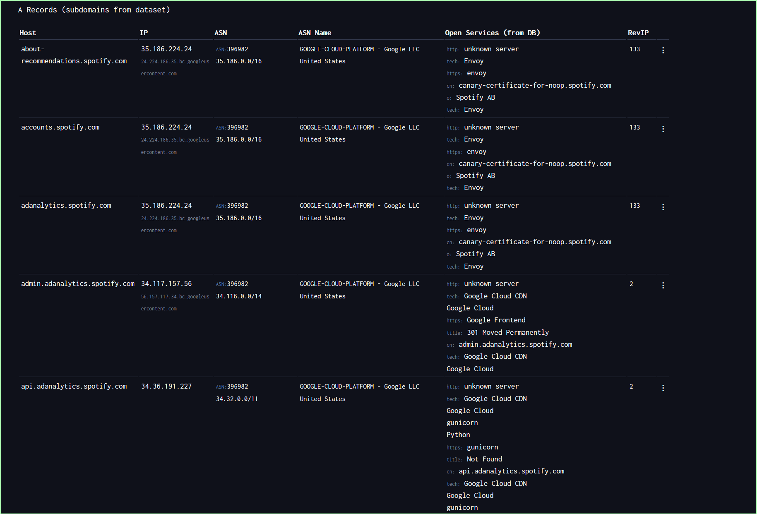
https://github.com/stepri/subdomains/blob/master/spotify.com (Helped with Verifications)
Subdomain | Purpose | Confidence Level
Accounts.spotify.com | Authentication/OAuth | HIGH
Api.spotify.com | Public Web API | HIGH
Api-partner.spotify.com | Partner Integrations | HIGH
Developer.spotify.com | Developer Portal | HIGH
Adstudio.spotify.com | Ad Creation Portal | HIGH
Analytics.spotify.com | Analytics Portal | HIGH
Open.spotify.com | Public Facing Web Player | HIGH
Apresolve.spotify.com | Access Point Routing | MED
Ads.spotify.com | Advertising | HIGH
Artists.spotify.com | Artists Portal | MED
Newsroom.spotify.com | News Releases | HIGH

- Organization
Email Formatting via RocketReach – MED
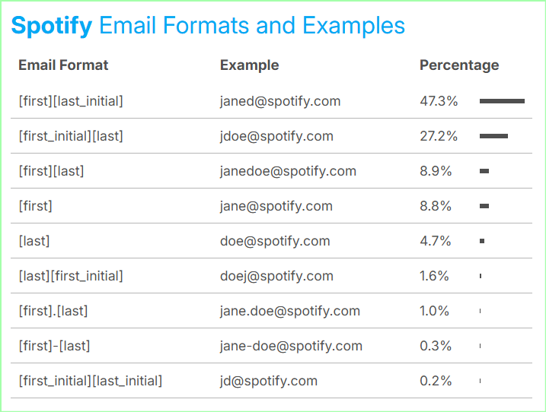
Employee Numbers based on Stock Analysis
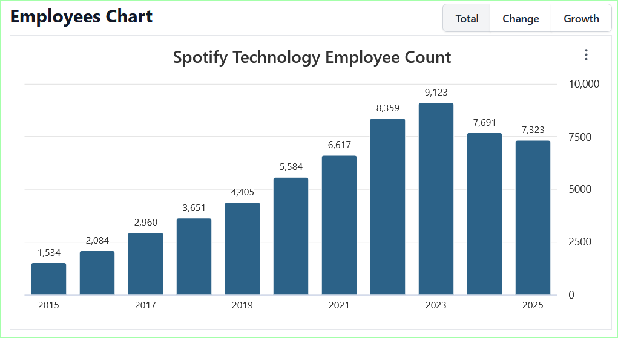
https://stockanalysis.com/stocks/spot/employees/

Number of Employees: 7323 Employees – LOW
Revenue FY2024: 17B Dollars USD – MED
- https://investors.spotify.com/financials/default.aspx (Helped find financial information)
Market Cap: $139B – MED
Monthly Active Users: ~751 million Users – MED
Brands/Products – HIGH via Subdomains and News Postings
- Spotify (Music/Podcast Streaming)
- Spotify for Artists
- Spotify Ad Studio
- Spotify Podcasts
- The Ringer
- Soundtrap
- Megaphone
Username Format: Users have free reign of choosing what their handle is – MED
Infrastructure – HIGH via Spotify Website and Wikipedia
- https://engineering.atspotify.com/
HQ: Stockholm, Sweden – HIGH
Major Offices: London, Boston, Gothenburg, New York – HIGH
Cloud: 100% Done through Google Cloud Platform (GCP) – Ended up migrating away from AWS in 2016 – HIGH
CDN Provider: Fastly, Verizon, Akamai – MED via Wikipedia Only
DNS: NS1 + Google Cloud DNS – HIGH

- Historical
Old Spotify View in July of 2010 via WaybackMachine
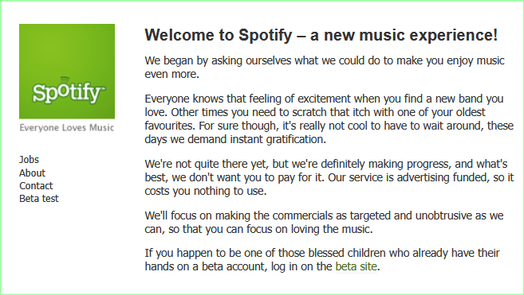

Spotify data breach site:bleepingcomputer.com – Used Google Dorking to find data breaches posted by bleepingcomputer.com, Threatposts etc which are reputable sources of data breaches
Year | Incident | Type | Impact
2020 (Nov) | Credential Stuffing Attack – 380M record Database | Third-Party credential stuffing | ~350,000 Accounts compromised
2020 (Dec) | Second Credential Stuffing Wave | Third-Party Credentials | ~100,000 Accounts
2025 (Jan) | Credential Stuffing Campaign Detected | Account Takeover | Scope was Unconfirmed
2025 (Dec) | “Anna’s Archive” metadata scrape | Content Scraping | 256M Track Records and 86M audio files; No user data was exposed

- https://www.bleepingcomputer.com/news/security/over-300k-spotify-accounts-hacked-in-credential-stuffing-attack/
- https://www.huntress.com/threat-library/data-breach/spotify-data-breach
- https://techcrunch.com/2025/12/23/pirate-group-annas-archive-says-it-has-scraped-86-million-songs-from-spotify/

- Summary

  - Explain what OSINT tools were most effective, and why?

- One of the OSINT tools that was most effective was the WHOIS website when looking for nameservers and domain profiles. It would neatly display the information to which I can easily double check using other websites such as ICANN. Another OSINT tool that I enjoyed using was SSL Labs during the certification search. Not only did it display the information clearly, but it also gave a grade on the certification, handshakes and the configuration setup.

  - Did you encounter missing, outdated, or conflicting information?
    - How did you validate or resolve it?

- Yes, the main area of conflicting information was encountered during the employee count. I got a plethora of different numbers via LinkedIn, SEC Filings and through the stock analysis website. I was able to resolve the information by cross-referencing the multiple sources and then going with the most logical answer. This is why my confidence rating was LOW for that section.

  - What errors or limitations did you encounter with the tools?
    - How did you work around them?

- One large limitation I faced was trying to use the crt.sh Certificate lookup tool. I was constantly faced with a routing error. I ended up asking AI for some other tools for certificate lookup which is how I got to the SSL labs website.

  - What surprised you the most about the target’s public footprint?

- The main surprise I found was just how much information is publicly available when just doing a bit of digging. Such as the entire Spotify cloud infrastructure and their transition from AWS to GCP in their engineering blog. I was also insanely surprised by the sheer number of subdomains they owned. Lastly, the credential stuffing was very surprising to see because they never had to directly breach Spotify’s systems. They were able to perform the credential stuffing through a Third-party source, meaning Spotifys’ own systems were never touched.

  - From a defender’s perspective, what information should this company consider reducing or better protecting?

- I think the main thing that should be protected better is subdomain exposure. I found a plethora of staging and development subdomains that may have less security. I also was surprised to see how email formatting is publicly available. This makes social engineering way easier since they know how Spotify employees’ emails are structured.

